S2 Slab Report — 1 ML PdO(101)/Pd(100) (√5×√5)R27° Surface Oxide
DMC formation DFT study — G2 clean slab | 2026-06-09

1. Structure Overview
Model: 1 monolayer PdO(101) film on Pd(100) substrate, (√5×√5)R27° commensurate surface oxide — the standard model from Todorova et al., Surf. Sci. 541 (2003) 101 (arXiv cond-mat/0304107) and Kostelník et al., Surf. Sci. 601 (2007) 1574.
Construction: Pd(100) substrate built in (√5×√5)R27° supercell from relaxed Pd fcc bulk (a = 3.8907 Å), 2×2 supercell, 5 layers. A single intact O–Pd–O sheet extracted from a validated standalone PdO(101) slab and strained ~1% to fit the substrate √5 mesh. Lateral registration optimized; rigid rotation aligns substrate Pd-Pd nn directions with lab x,y axes (literature framing).

2. Structure (lattice lines hidden)
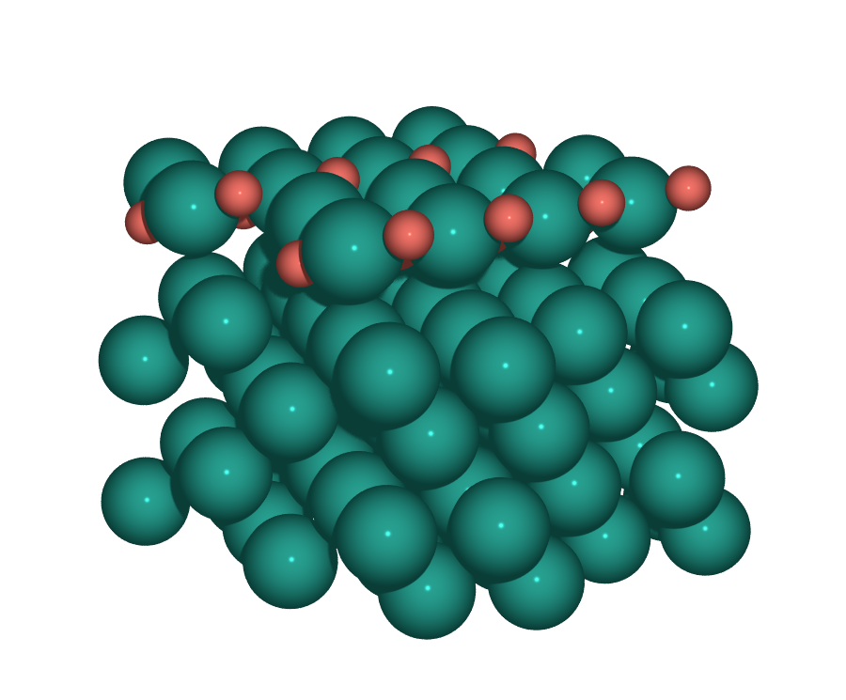
Perspective view — Pd(100) substrate (grey) below, single PdO(101) O–Pd–O sheet (Pd + red O) on top, O-terminated.
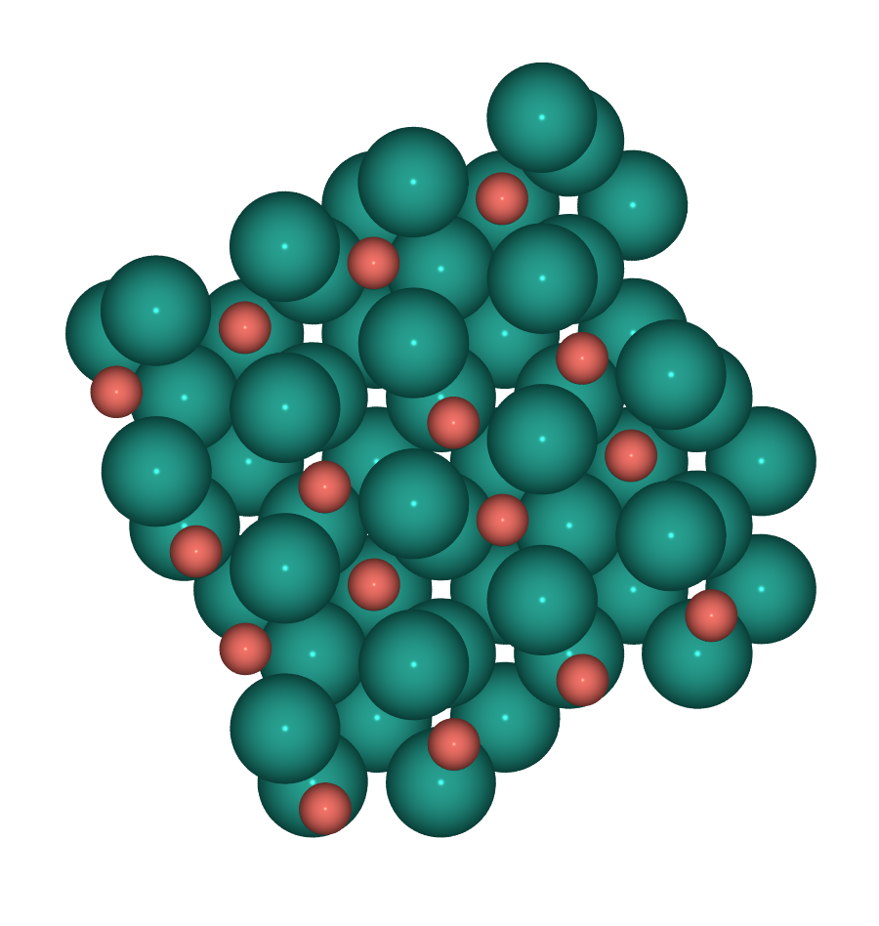
Top view — substrate Pd in regular square mesh; oxide rows at 27° (R27° rotation of the oxide relative to the substrate).
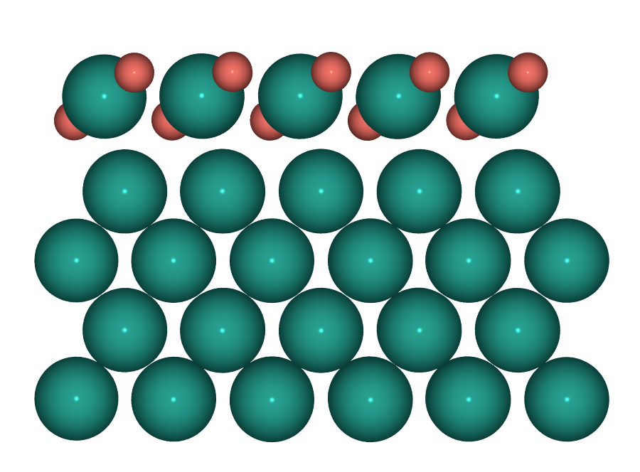
Side view — 5-layer Pd(100) substrate + 1 ML oxide. Vacuum 15 Å. Bottom 50% (substrate) fixed.

3. Comparison with Todorova 2003 / Kostelník 2007
Property | Literature | This work (S2) | Match
Model | PdO(101) film on Pd(100), √5R27° | Same | ✓ identical model
Per √5 cell composition | 4 Pd_oxide + 4 O | 4 Pd_oxide + 4 O | ✓
Pd coordination distribution | 2× 4-fold (Pd_Br/H) + 2× 2-fold (Pd_Br, Pd_H) | 2× 4-fold + 2× 2-fold | ✓
Surface termination | O-terminated (top O at +0.54 Å above Pd) | O-terminated, buckled O–Pd–O preserved | ✓
R27° rotation (oxide vs substrate) | 27° | 26.6° measured | ✓
√5 cell side | 6.236 Å (a_Pd ≈ 3.945, FP-LAPW) | 6.151 Å (a_Pd = 3.8907, PBE) | ≈ (1.4% from bulk a difference)
PdO(101) film strain | −1.4% (isotropic, from unstrained PdO(101)) | +0.7% / −0.9% (anisotropic) | ≈ (~1% scale)
Interface gap (oxide–Pd1) | 2.35 Å | 2.40 Å (initial; DFT will refine) | ≈
Top-substrate compression Pd1–Pd2 | 1.95 Å (−1.0% from bulk) | 1.945 Å (unrelaxed; DFT will compress) | ≈ (post-relax)
Pd–O bond length | ~2.02 Å (bulk PdO) | 2.02–2.47 Å (mean 2.09) | ✓
Result: All structural identifiers match the literature model — same √5R27° supercell, same 4+4 stoichiometry, same 2-fold + 4-fold Pd partition per √5, same O-terminated buckled sheet, same R27° rotation. Quantitative differences (cell size, strain sign distribution) trace to the bulk Pd / PdO lattice constants — the paper uses FP-LAPW GGA, this work uses VASP PBE. Both are at the ~1% scale and self-consistent with their respective bulk references.

4. Cell parameters and atom counts
Quantity | Value
Cell vector a | [11.001, 5.509, 0.000] (|a| = 12.303 Å)
Cell vector b | [-5.509, 11.001, 0.000] (|b| = 12.303 Å)
Cell vector c | [0.000, 0.000, 25.665] (|c| = 25.665 Å)
In-plane shape | (√5×√5)R27° × (2×2) of Pd(100) — note: lab frame rotated 27° to align substrate Pd-Pd with lab x,y
Vacuum | 15 Å (asymmetric, oxide on top face only; IDIPOL = 3 in INCAR)
Total atoms | 112 (96 Pd + 16 O)
Substrate | 80 Pd (5 layers × 16 Pd per layer in 2×2 √5 cell)
Oxide overlayer | 16 Pd + 16 O (1 ML PdO(101), single O–Pd–O sheet)
Fixed atoms | 60 / 112 (~50%, bottom Pd substrate layers, FixAtoms)
Species order in POSCAR | O (16) then Pd (96) — matches POTCAR (PAW_PBE O + PAW_PBE Pd_pv)

5. Pre-relaxation notes / what DFT will refine
- Initial atomic positions are reasonable but unrelaxed. DFT relaxation will refine: (a) interface gap from 2.40 → ~2.35 Å, (b) substrate top-layer compression Pd1–Pd2 to ~1.95 Å, (c) oxide rumpling pattern (Pd_Br +0.17 Å, Pd_H +0.07 Å, Pd_Br/H +0.03 Å — per literature Fig. 5), (d) top O protrusion to +0.54 Å above Pd, (e) Pd–O bond lengths to ~2.02 Å bulk-PdO value.
- The R27° relative angle and 4+4 per √5 stoichiometry are geometric properties of the supercell — DFT relaxation will not change them.
- Job 324 (S2_gpu) submitted with this structure (KSPACING = 0.25, IDIPOL = 3, ISPIN = 2, IVDW = 12). Energy and final relaxed coordinates will be the conclusive test against the literature minimum.

6. Files and provenance
POSCAR deployed: calculations/G2_slab/S2_PdO101_Pd100/POSCAR
Backup of replaced original (corrugated monolayer, structurally flawed): calculations/G2_slab/S2_PdO101_Pd100/POSCAR_corrugated_bak
Literature-framed POSCAR (this report's geometry): /tmp/S2_litframe.vasp
Build script: /tmp/build_s2_v7.py + /tmp/rotate_s2.py (rigid +26.6° rotation for literature lab frame)

