S1 Pd(100) — G3 Adsorbate Sampling Checkpoint
Phase 1 dry-run, Tasks T1.10–T1.13 | Pd / PdO / PdO₂ DMC formation DFT study | 2026-06-10
Heuristic-only generation (AutoAdsorbate). NO MLIP, NO DFT. Awaiting advisor checkpoint approval.

1. Setup
Input slab: G2-converged S1 Pd(100), 80 Pd atoms, p(4×4), 5 layers (bottom 2 fixed), 20 Å vacuum. Energy E = −434.408 eV.
SMILES (after correction):
- • CO* : Cl[C]=O (brackets prevent implicit H — gives pure CO fragment)
- • CH₃O* : ClOC (guideline)
AutoAdsorbate options:
- • CO* : mode='all', to_initialize=1, overlap_thr=1.25, sample_rotation=False
- • CH₃O* : mode='all', to_initialize=20, overlap_thr=1.25, sample_rotation=True, conformers_per_site_cap=3
- • Co-adsorption : custom site-pair wrapper (stride sampling 20×20 = 400 pairs for dry-run)

2. SMILES issue and resolution (checkpoint catch)
Guideline CO* SMILES Cl[C-]#[O+] (formal-charge representation) fails in current RDKit version with explicit-valence error. Initial dry-run used fallback ClC=O which produced CHO* (formyl with H), NOT pure CO*. This was caught at the checkpoint inspection. Resolution: use Cl[C]=O (brackets force no implicit H) — verified by trajectory inspection (first CO* structure non-Pd atoms = ['C', 'O'], no H).
Comparison (CHO* dry-run vs CO* fixed):
 | Initial run (ClC=O → CHO*) | Corrected (Cl[C]=O → CO*)
Fragment atoms | C + O + H (formyl) | C + O (pure CO) ✓
CO* candidates | 112 | 112
Set A (reactive) | 64 | 110
Set B (thermo) | 310 | 141
Set TS-like | 8 | 28
side-path | 9 | 23

3. Final counts (after SMILES fix)
Category | Count
T1.10 site map — total sites | 112 (16 atop + 32 bridge + 64 3-fold-ish)
T1.11 CO* candidates | 112 (mode='all', one per site)
T1.12 CH₃O* candidates | 336 (mode='all', rotation + 3 conformers/site)
T1.13 co-ads pairs generated (stride 20×20 dry-run) | 400
Set A (reactive, 2.3 – 4.0 Å) | 110 ← Phase 2 TS 탐색용 핵심
Set B (thermo, ≥ 5.0 Å) | 141
Set TS-like (1.7 – 2.3 Å) | 28
side-path (< 1.7 Å, includes atomic overlap) | 23
distance range | 0.59 – 7.39 Å, mean 4.27 Å

4. Visualizations (lattice hidden)
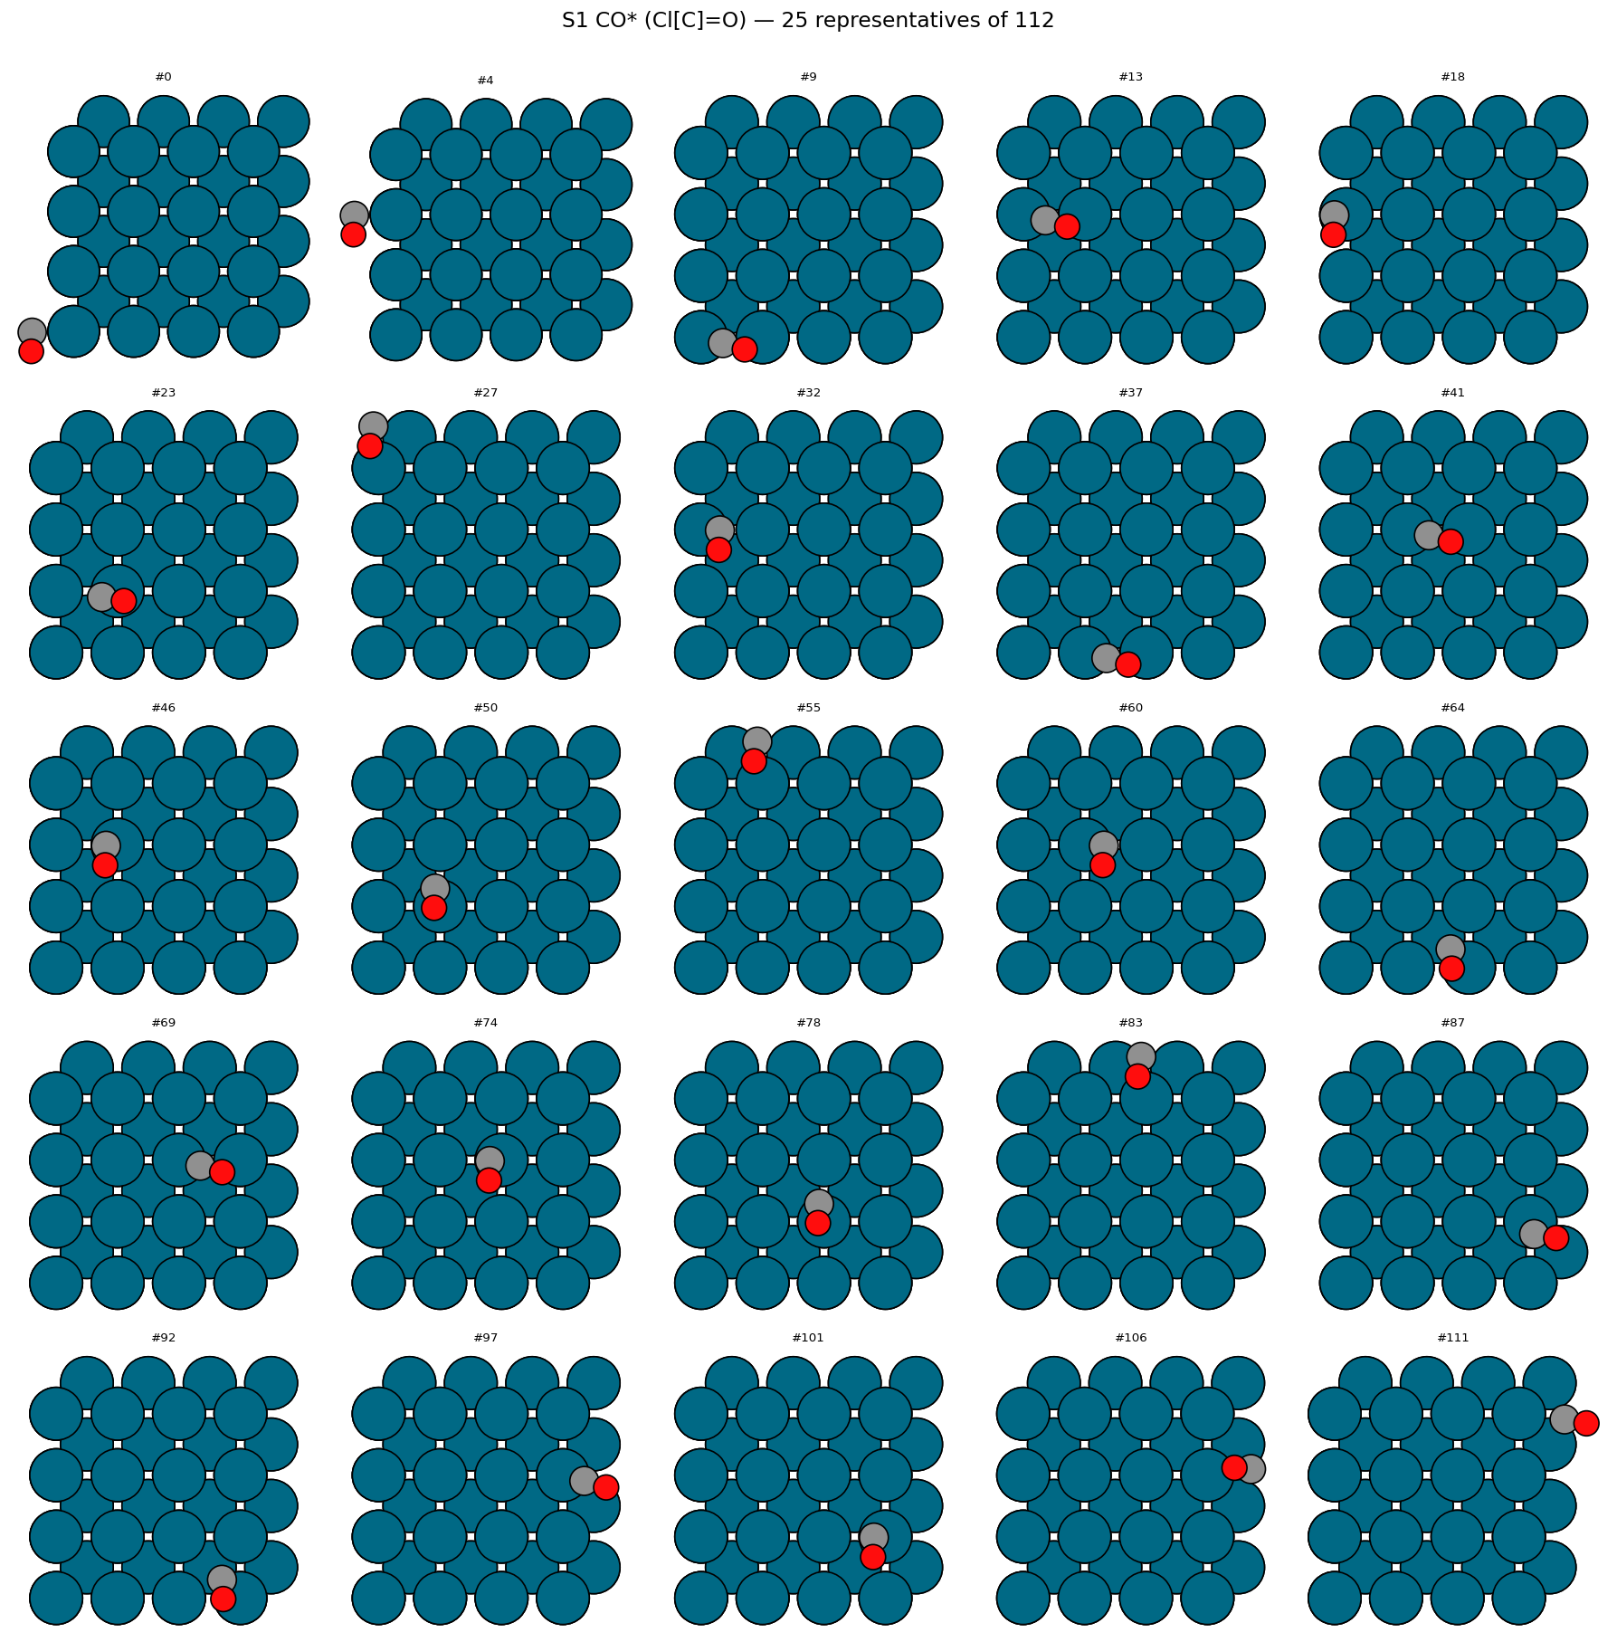
CO* (Cl[C]=O) — 25 representatives of 112 candidates. Pure C+O fragments on all atop/bridge/hollow sites.
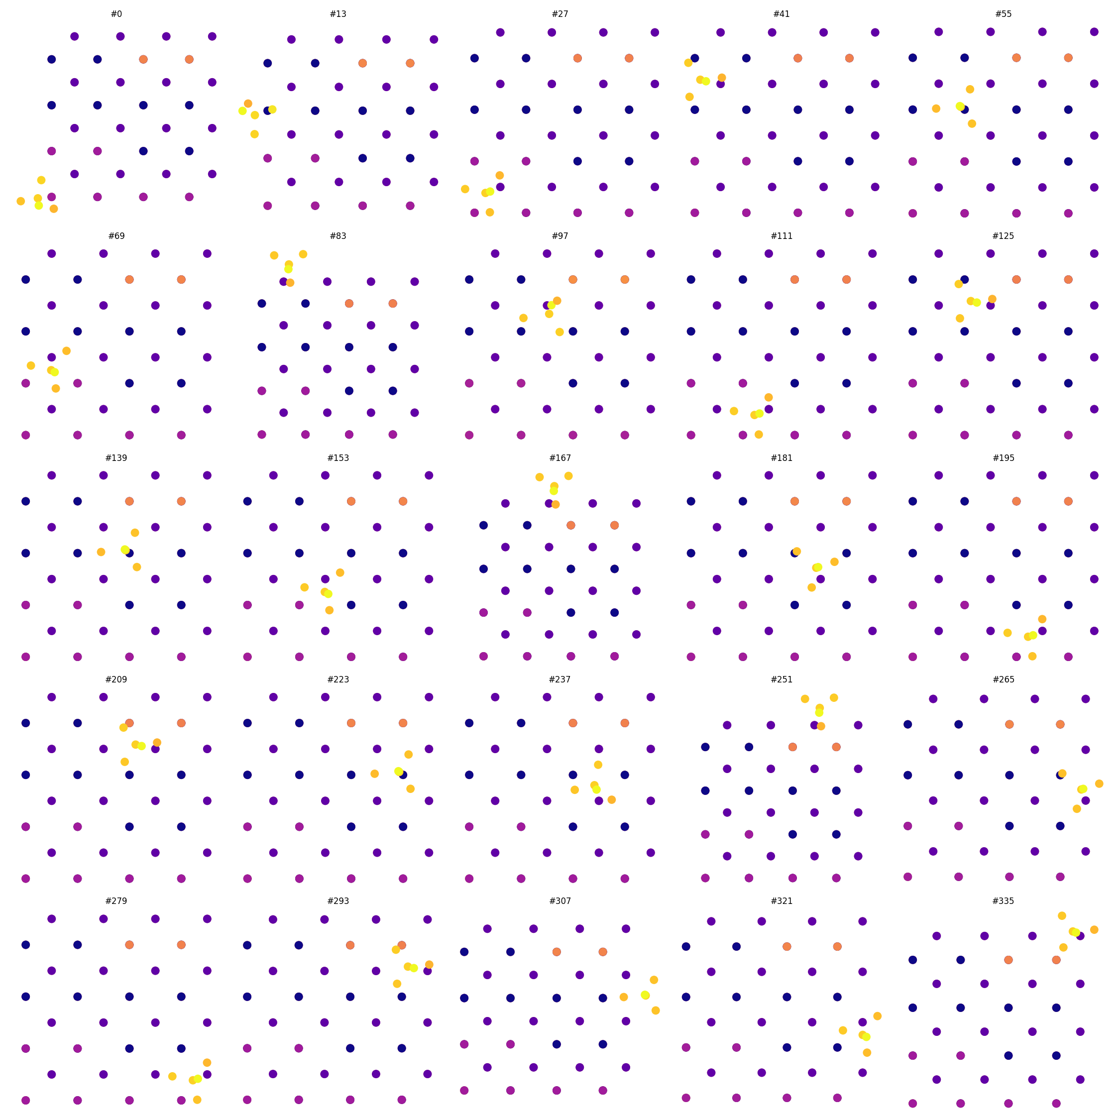
CH₃O* (ClOC) — 25 representatives of 336 candidates. Multiple orientations and conformers.
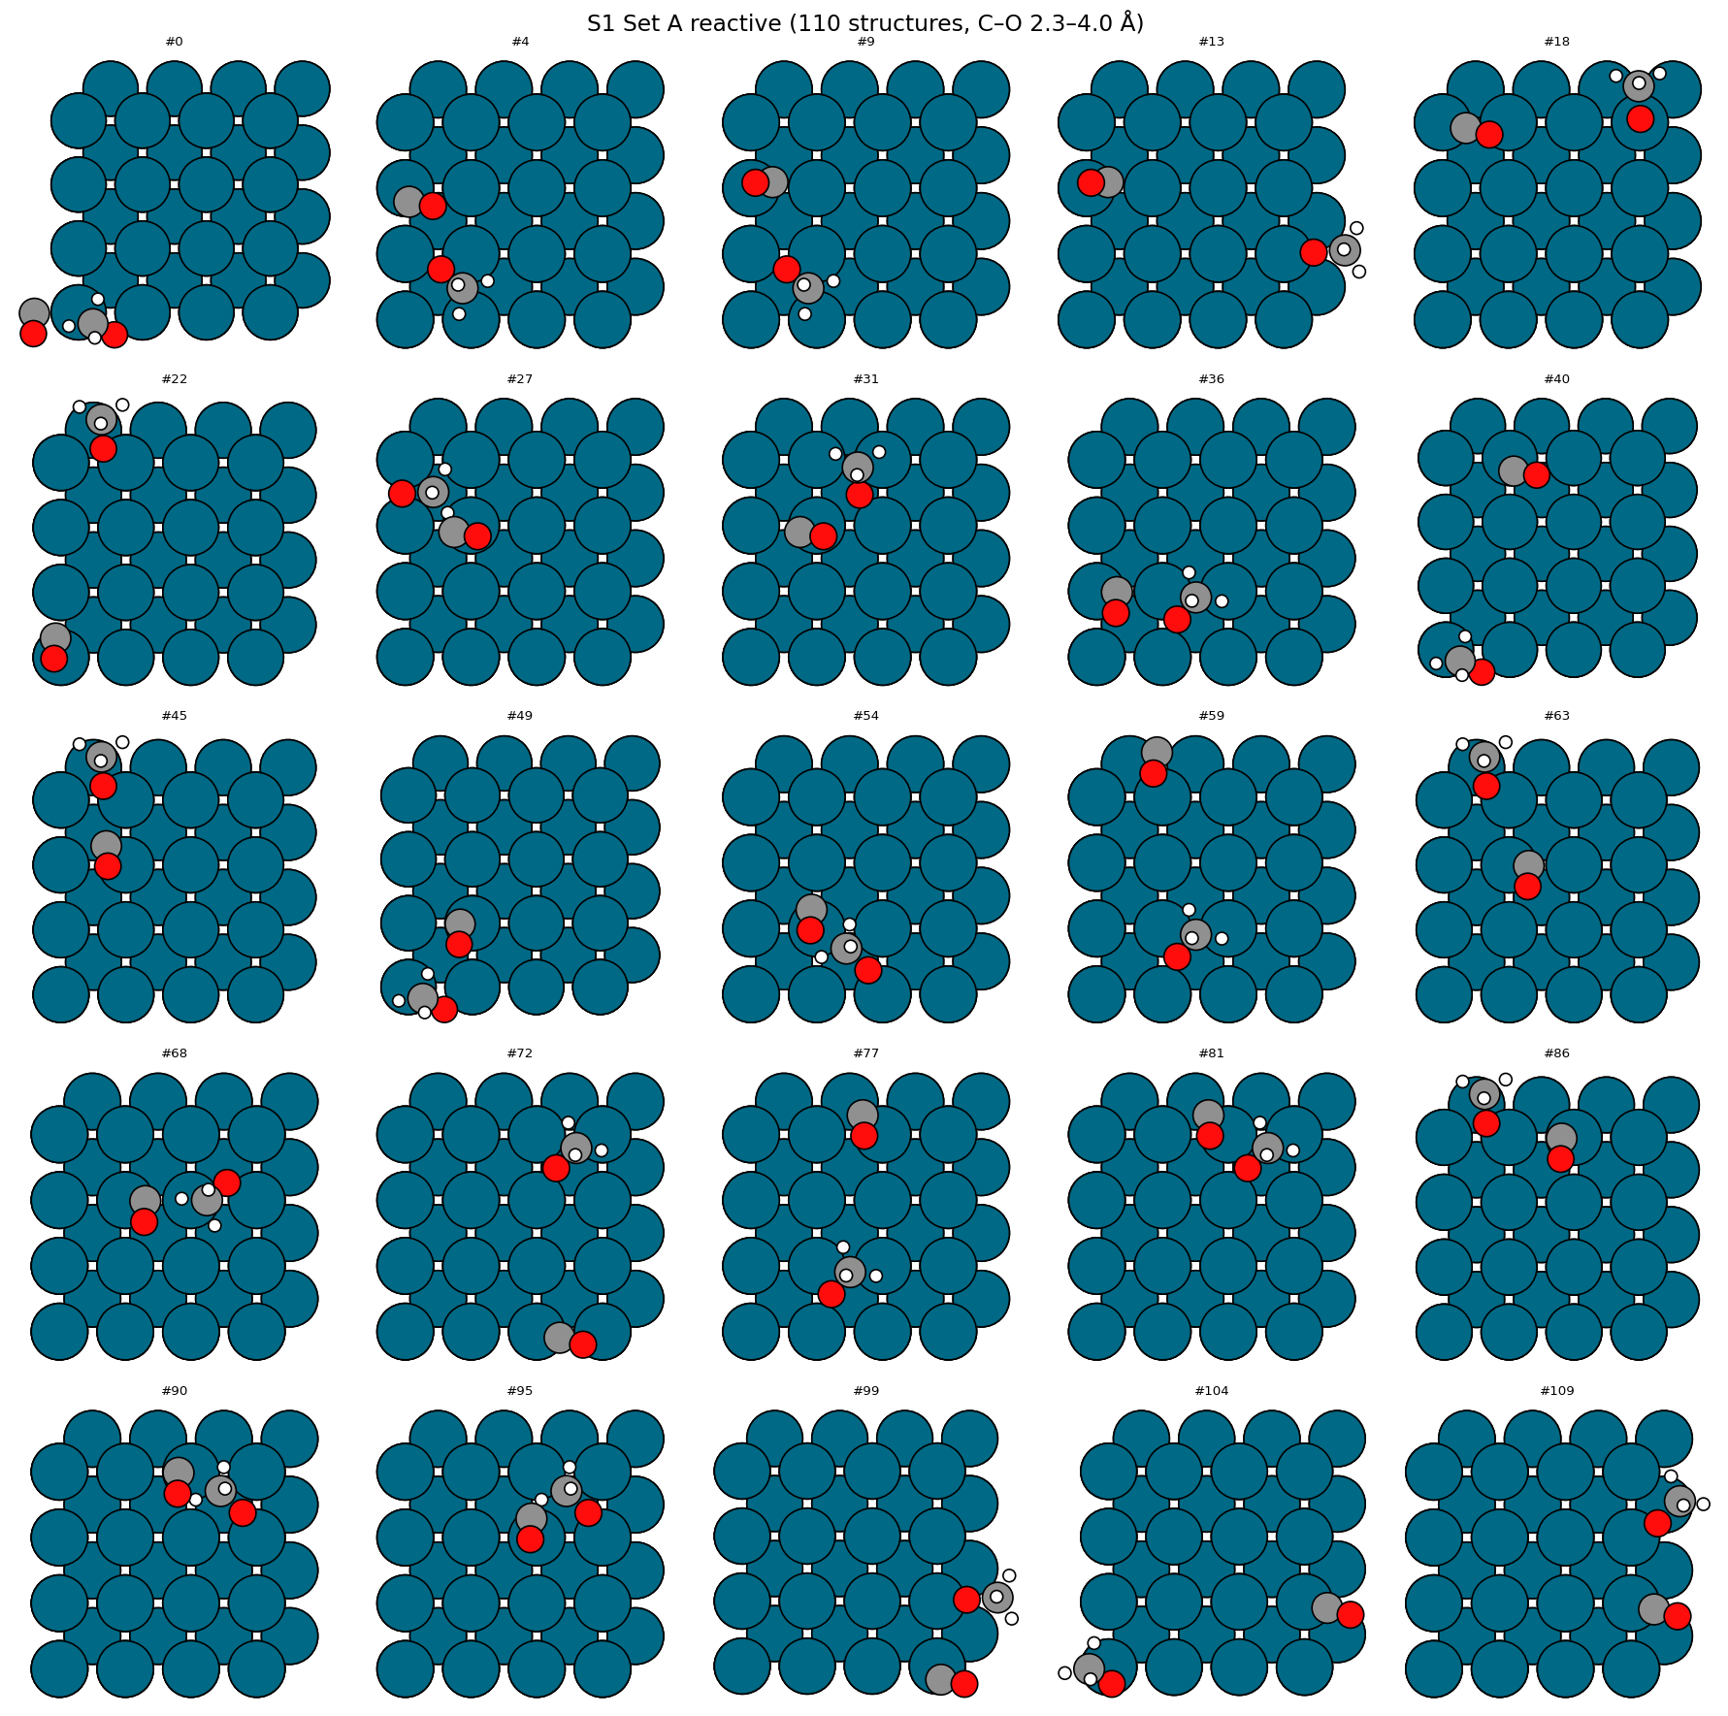
Set A (reactive co-ads, 2.3–4.0 Å C–O) — 25 representatives of 110. These pairs are candidates for TS1 search in Phase 2.
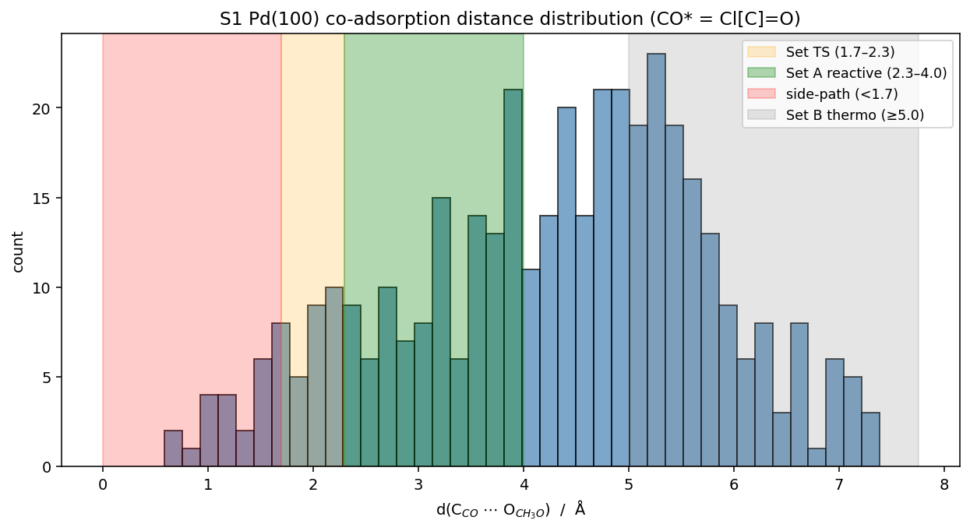
C_CO ⋯ O_CH₃O distance distribution over 400 pairs. Green = Set A reactive; orange = Set TS-like; gray = Set B thermo; red = side-path (overlap).

5. Notes / caveats
- Site type labels detected as {atop: 16, bridge: 32, 3-fold: 64} from AutoAdsorbate. The 3-fold on Pd(100) is unusual — Pd(100) typically presents 4-fold hollow. Likely a precision=0.25 artifact in coordination detection. Worth verifying.
- side-path bin (<1.7 Å) includes structures with atomic overlap (min = 0.59 Å). These are unphysical and should be discarded before any MLIP/DFT — or kept only as a 'rejected' diagnostic set.
- Stride sampling 20×20 = 400 pairs is dry-run scale. Production run will use full or denser sampling per workplan target (150–500 Set A).
- Pipeline is now validated for scaling to S2, S3 (O-term + PdO-term), S4 once G2 passes.
- All output trajectories: calculations/G3_adsorption/S1_Pd100/{CO,CH3O,coads}/

6. Stop point — awaiting advisor review
Per advisor instruction: heuristic structure generation complete, NO MLIP or DFT proceeded. Awaiting approval before:
- (a) Scaling to S2 / S3-O / S3-PdO / S4 (after their G2 relaxations complete)
- (b) Running T1.14 — MACE foundation MLIP relaxation + ranking
- (c) Selecting DFT shortlist (per workplan: ≈ 5–10 / cell, distance-bin representatives)
- (d) Submitting T1.16 DFT Level 1 (vacuum) jobs

