SOE FISCAL RISK ASSESSMENT
Hands-On Training Workbook
Choose an SOE and follow it through the tool
Participant Name: |  | Group:
Date: |  | Duration: | 35 minutes
SOE I chose: |  | Sector:

In this exercise you will use the live SOE tool, WB-KDIs Training : SOE Fiscal Risk (training link: https://wb-kdis-soe-training-beta.streamlit.app). You will load the practice data, choose one of its eight state-owned enterprises (SOE A to SOE H) and follow it through the tool: its financial ratios, its distress score, what it could cost the budget, the early-warning signal it triggers and how it reacts to a fuel price shock. Look at the tool and tell the story of your SOE: you do not need to open the Excel file or calculate anything by hand.

How to use this workbook: Each step tells you which tab of the tool to open and what to choose. Use the same SOE and the year 2024 throughout. Write values as the tool shows them (bn = billions, m = millions of FCFA), then answer the questions in a few sentences.
THE SETTING
The 8 SOEs in the practice file are invented. They all belong to the same fictitious country, which has a nominal GDP of 8,000 bn FCFA (2024) and a BB+ sovereign credit rating. The government owns all eight, supports several of them with tariff compensation, subsidies, grants and loan guarantees, and has made clear that it would not let any of them fail.
Your task: Using the SOE tool, assess how financially healthy your SOE is and what it could cost the government - under current conditions and under a fuel price shock - and brief the Minister of Finance.
SETUP: LOAD THE DATA AND CHOOSE YOUR SOE (5 MINUTES)
Step 1: Download and load the practice data  On the Home tab, under Load data, find Practice files: WB-KDIs training and click ⬇ Excel data (.xlsx) (⬇ Workbook (Word) gives you this workbook). Drag the file onto Drop a CSV or Excel file here, or click Choose a file. The tool confirms it with a green line: ✓ Loaded 8 SOEs, 80 SOE-year rows from WB-KDIs_SOE_training_data_2015-2024.xlsx.  Step 2: Choose your SOE  Pick one of SOE A to SOE H, or the one your facilitator gives you, and write it and its sector on the cover. Keep the Sector bar at the top of the tool on All. | 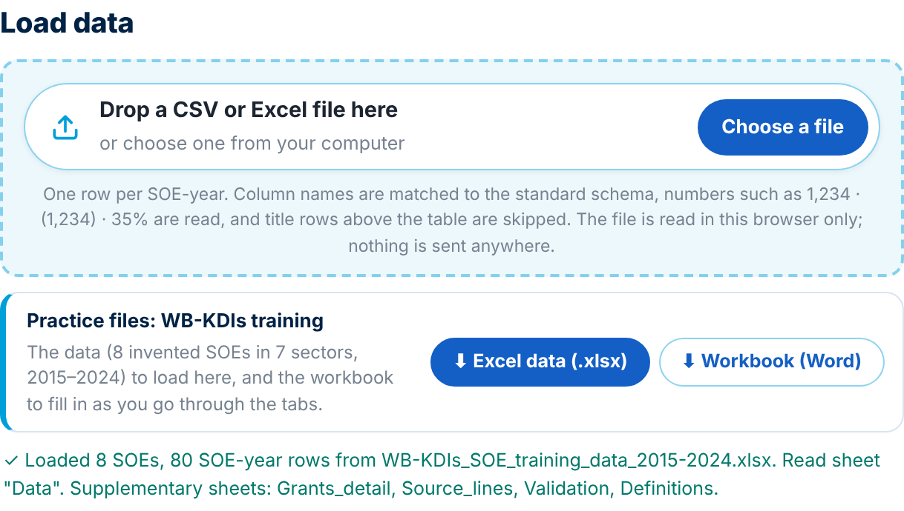
MODULE 1: KPI ASSESSMENT (6 MINUTES)
Step 3: Open the KPI Dashboard
Under View, keep Trend for one SOE and choose your SOE. Each of the four columns (Profitability, Liquidity, Solvency, Fiscal dependency) has a Ratio dropdown. The blue dot is 2024, the red dashed line the alert cutoff, the green dashed line the good cutoff.
Step 4: Assess your SOE's performance
Using the tool, assess your SOE from the profitability, liquidity and solvency perspective, and its dependence on the government. Pick at most three KPIs in each category (for profitability, for example, return on assets, return on equity and cost recovery) and note their 2024 value and whether they are in alert, watch or good.
Profitability: ______________________________________________________________
Liquidity: ________________________________________________________________
Solvency: _________________________________________________________________
Fiscal dependency: _________________________________________________________
Number of ratios in alert (View → Full scorecard, your SOE's row, last column): ______ of 15

Q1. Which single KPI concerns you most as a signal of near-term financial distress for your SOE, and why? If no ratio is in alert, which one would you keep an eye on?

Q2. Look at interest coverage (EBIT ÷ interest expense). What does your SOE's value mean in plain terms for its ability to pay its interest? What would a value below 1.0× mean?

MODULE 2: DISTRESS SCORE - ALTMAN Z″ (6 MINUTES)
Step 5: Open the Distress Indicator
Under View, keep Components for one SOE and choose your SOE. The four boxes at the top change with the SOE you choose: whether it is in distress, its distress score (Altman Z″), its shadow credit rating and its probability of default (PD) in 2024. The charts X1-X4 show the four components of the score.
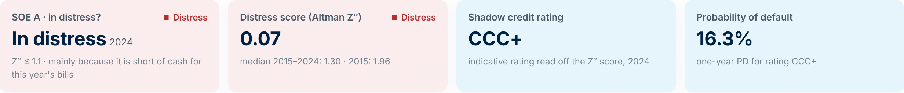
Zone: ______________ Distress score (Z″): __________ Shadow rating: __________ PD: __________

Q3. Compare your KPI analysis (Module 1) with the distress score. Are the results consistent? Does the tool show that your SOE is safe, vulnerable (grey zone) or in distress?

Q4. Which of the four components (X1-X4) pulls your SOE's score down the most - or, if all are positive, contributes the least? What does this tell you about the main source of weakness, and which KPI from Module 1 points the same way?

Q5. The score places your SOE in the ____________ zone. In a few sentences, explain this result to a Finance Minister who has never seen a Z-score before (the score captures financial distress: in the distress zone, the SOE is at high risk of distress or default within about two years).

MODULE 3: EXPECTED FISCAL COST (5 MINUTES)
Step 6: Open the Expected Fiscal Cost tab
- Under Settings, keep Year 2024, LGD 70% and EAD: share of total liabilities 100% (the defaults).
- Under Country GDP, type 8000 in the GDP box and keep the units at Billions. The GDP carries over to the Shock Scenarios tab.
- Find your SOE in the EFC results table, under the two charts.
EFC = PD × EAD × LGD: the probability of default from the shadow rating × the exposure at default (here all of the SOE's liabilities, because the government stands behind them) × the share of that exposure the government would end up paying (LGD).

Your SOE's expected fiscal cost, 2024: EFC / GDP ________ % Share of portfolio EFC ________ %

Q6. Why is the EFC as a percentage of GDP a more useful way to present the number to a policymaker than an amount in FCFA? This money does not appear in the current budget: how would you explain that to a non-economist audience?

MODULE 4: EARLY WARNING (4 MINUTES)
Step 7: Open the Early Warning tab
Find your SOE on the Signal board and click it. The Action plan lists the trigger rules your SOE fires and the follow-up each one calls for (for example, a liquidity squeeze calls for a monthly cash-flow forecast sent to the oversight unit).
Signal (Alert / Watch / Good): __________ Rules that fire: ________________________________________

Q7. Do the triggers point to the same weakness as the component you found in Q4? If you were advising the Ministry of Finance, what is the single most important action it should take in the next 12 months to reduce your SOE's fiscal risk - without cutting the service the SOE provides?

MODULE 5: SHOCK SIMULATION (6 MINUTES)
Shock scenario: The government is worried that world fuel prices could rise by 60% next year (2025) and stay high for two years. If your SOE is healthy, how would the shock affect it and how should it prepare? If it is already in distress, how much would the shock add to the fiscal cost the government already faces? The SOE may not pass the increase on to customers, and the State does not compensate it.

Step 8: Open the Shock Scenarios tab (the last tab)  Keep View: One SOE, then:  - Panel 1: your SOE, Base year 2024.  - Panel 2: keep LGD 70% and EAD 100%; under Show costs as a share of GDP, check that GDP shows 8,000.  - Panel 3: click No shock. The charts show where your SOE would be with no shock.  - Panel 3: click Custom shock, keep Fuel price and, under Size guide, click Severe +60%.  - Under Structural factors, drag Passed on to customers through tariffs to 0%; leave Compensated by the State at 0%.  - Read the Distress score path and the Expected fiscal cost / GDP - path: grey is the no-shock path, blue the path with the shock. Hover over 2027 to see both values. | 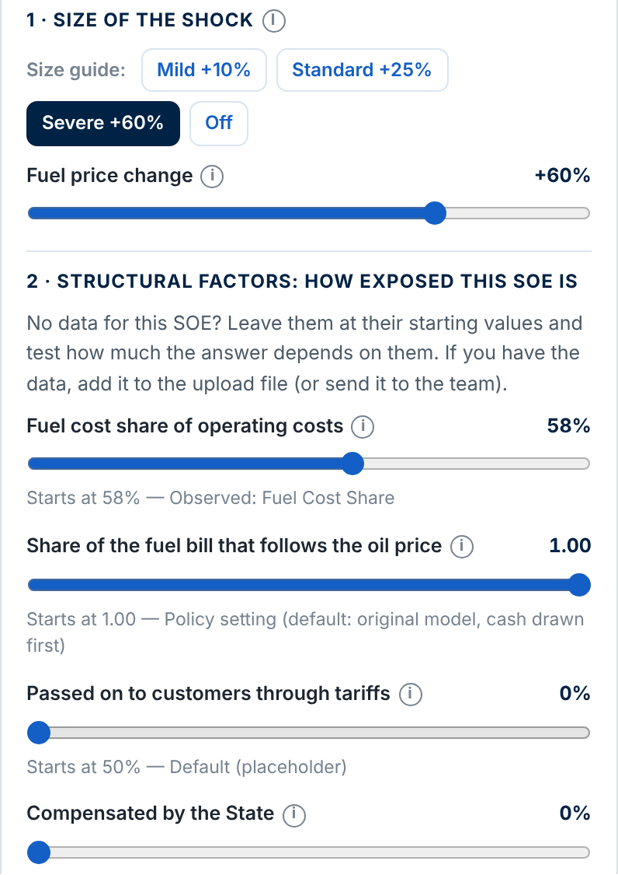

Distress score, 2027: no shock ________ → with the shock ________ (zone ____________ → ____________)
EFC / GDP, 2027: no shock ________ % → with the shock ________ %
Compare with the no-shock path, not with 2024: the tool rolls the accounts forward.
Q8. By how much does the fuel shock lower your SOE's distress score and raise its expected fiscal cost (in % of GDP) by 2027? In a few sentences, explain to the Minister of Finance what the shock would cost and how the government should prepare.

Q9. Now drag Passed on to customers through tariffs to 100% (full pass-through) and compare with 0% (no pass-through). What happens to the distress score and the expected fiscal cost? What is the policy implication: who bears the cost of the shock in each case?

EXECUTIVE SUMMARY: YOUR SOE ASSESSMENT (3 MINUTES)
Brief. Write a short executive summary for the Minister of Finance (5 to 8 sentences): how your SOE has performed over the last two years according to its KPIs, what the distress score says, what it could cost the budget (EFC as % of GDP), which early-warning signal it triggers, and what the fuel shock would add.

Quick reference: Safe Z″ > 2.6 | Grey 1.1 < Z″ ≤ 2.6 | Distress Z″ ≤ 1.1. EFC = PD × EAD × LGD is the expected annual cost of the SOE's distress for the budget. It is not the same as the government's direct transfers to the SOE (such as tariff compensation): it is the probability-weighted cost of a contingent liability, which does not appear in the budget until it crystallises.

