Appendix1. Description of Information System
Application No.: (To be filled in by Contest Committee)
Title of Information System: Haru: A Daily Cognitive Routine Kiosk with Speech Recognition and Memory-Grounded Personalization
University / Institution: Institute for Universal Education
Department / Faculty: Haru Development Team

- Preface
Haru is an institution-installed daily cognitive routine for adults aged 65 and above. It addresses the gap between occasional phone calls and repeated care observation: older adults may struggle with small smartphone screens, while institutions cannot collect the same structured record every day. Haru offers a calm three-to-five-minute routine that supports conversation and professional follow-up; it is not a diagnostic device.
- Innovation Description
Haru combines an accessible 2×2 physical-button kiosk, speech-to-text recording, and memory-grounded question personalization. Its innovation is a closed loop: an easy daily interaction becomes a structured personal record and then a relevant next-day question.
Accessible routine | → | Voice / button record | → | Related memory retrieval | → | Next-day prompt | → | Support report

Screen positions and button positions correspond. The first press selects an answer and the same button pressed again confirms it, so participants do not need to memorize button labels or learn a separate cancel flow.
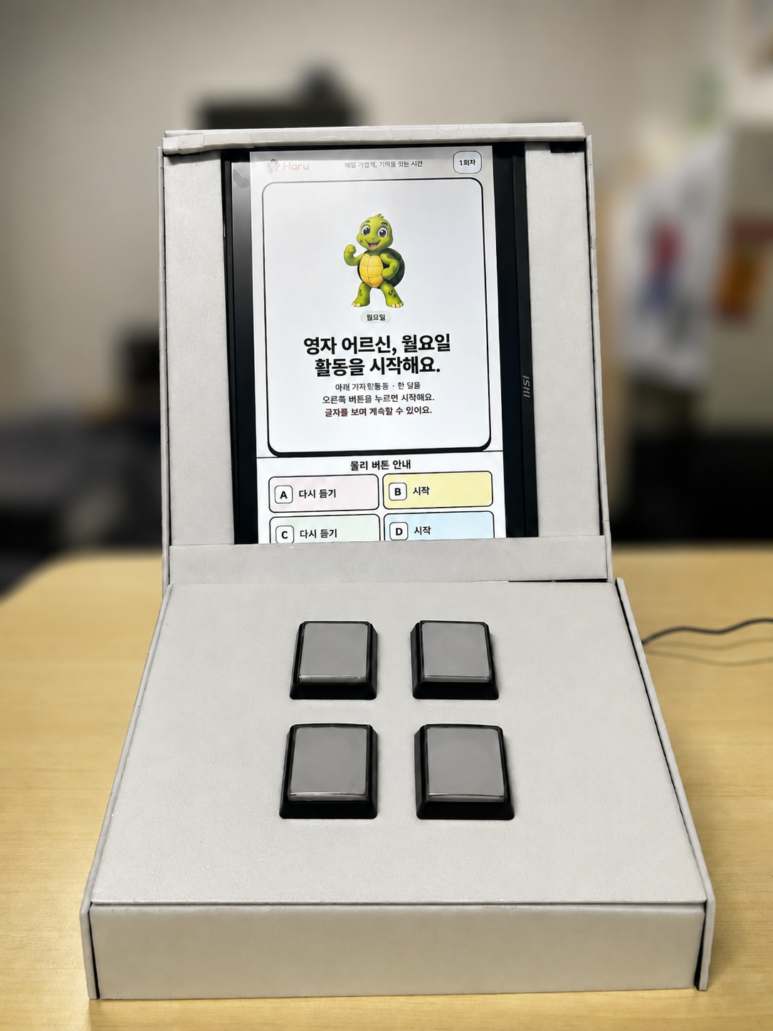  Physical prototype | 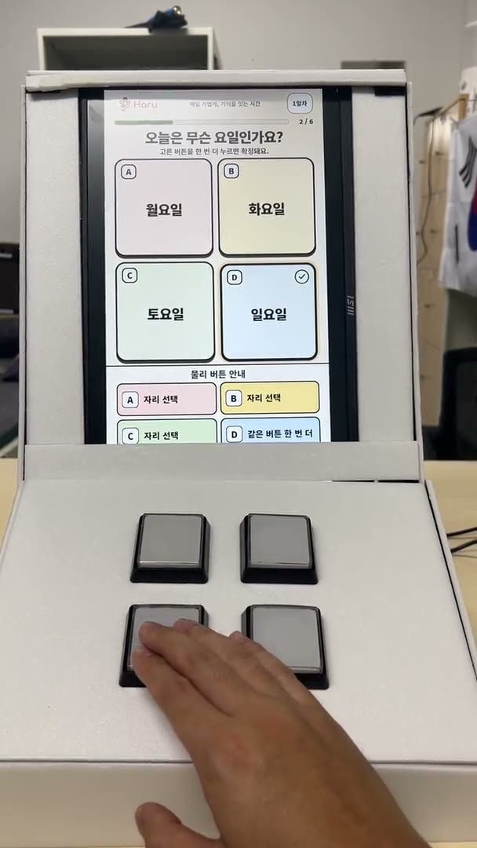  Button interaction

Figure 1. Team prototype photographs reproduced from the E5 presentation materials.
- System Functions
Participant access. An NFC tap opens the routine with a pseudonymous card ID; the device does not display the participant's name.
Routine and speech. Six short activities run once per day across a 42-activity, seven-day structure. Voice prompts and recordings are transcribed by STT; a retry path keeps recognition failure from blocking completion.
Personalized prompt. Past responses are stored with dates and extracted cues. Related memories are retrieved to ground a follow-up question instead of selecting one at random.
Role-based report. Participants see their routine result; caregivers see consented conversation cues; welfare staff manage registration and participation; counselors or clinicians review summarized observations.
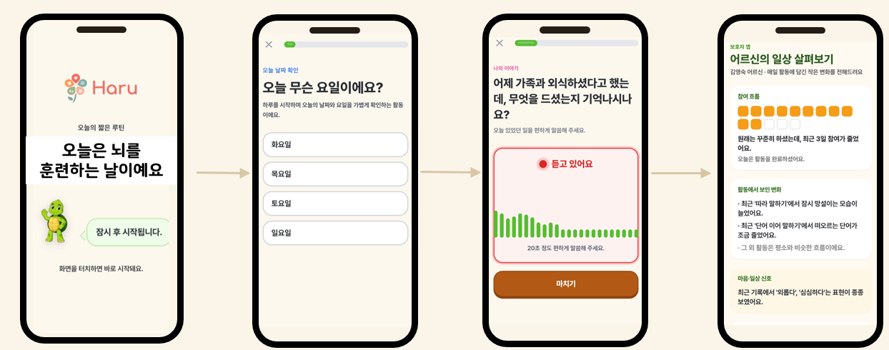
Routine-to-report screen sequence

Figure 2. User-facing screens reproduced from the E5 presentation materials.
- System Features
Accessibility and recovery. Large type, high contrast, four large touch targets, spoken guidance, and spatially matched buttons reduce visual and menu burden. Separate selection and confirmation make mistakes recoverable; speech can be retried without cancelling the session.
Grounded personalization. Each generated prompt is constrained by a retrieved personal-memory record with a date and topic, so the source of the prompt can be explained rather than hidden behind a random question.
Privacy and safety. Names stay with the registering institution. The kiosk uses a pseudonymous ID, consent scopes, role-based access, and deletion or withdrawal procedures. Reports describe supportive changes, not a diagnosis or clinical score.
Validation readiness. A formative 20-person beta test drove the kiosk redesign. A separate IRB study will test independent target-age participants in Korea and Japan.
- System Development Tools and Techniques
The system uses a browser kiosk client and a speech-and-memory pipeline. The client presents the routine and records events; the services return structured evidence for reports and future prompts.
Audio + consent | → | DPO-adapted STT | → | Structured memory | → | Vector retrieval | → | Grounded question

Speech recognition adaptation. The prototype starts from the open-source Qwen/Qwen3-ASR-1.7B checkpoint. Consent-scoped recordings from the 20-person formative beta test form the Haru speech-adaptation corpus. Each utterance is converted to 16 kHz mono, segmented around speech, and de-identified; the research team verifies a reference transcript while retaining the original audio and annotation version.
Direct Preference Optimization (DPO). For the same audio x, the research-team-verified transcript y+ is the preferred response and the unedited base-model transcript y− is the rejected response. We optimize the ASR policy against a frozen reference policy: L_DPO = −log σ(β[(log πθ(y+|x) − log πref(y+|x)) − (log πθ(y−|x) − log πref(y−|x))]). This increases preference for faithful wording and decreases omissions, insertions, and unsupported words without training a separate reward model. Speaker-disjoint validation is required to prevent participant leakage. FLEURS context: Qwen3-ASR versus Whisper large-v3 CER was 2.96% versus 3.01% for Korean and 5.28% versus 5.56% for Japanese; these are benchmark references, not clinical validation of Haru.
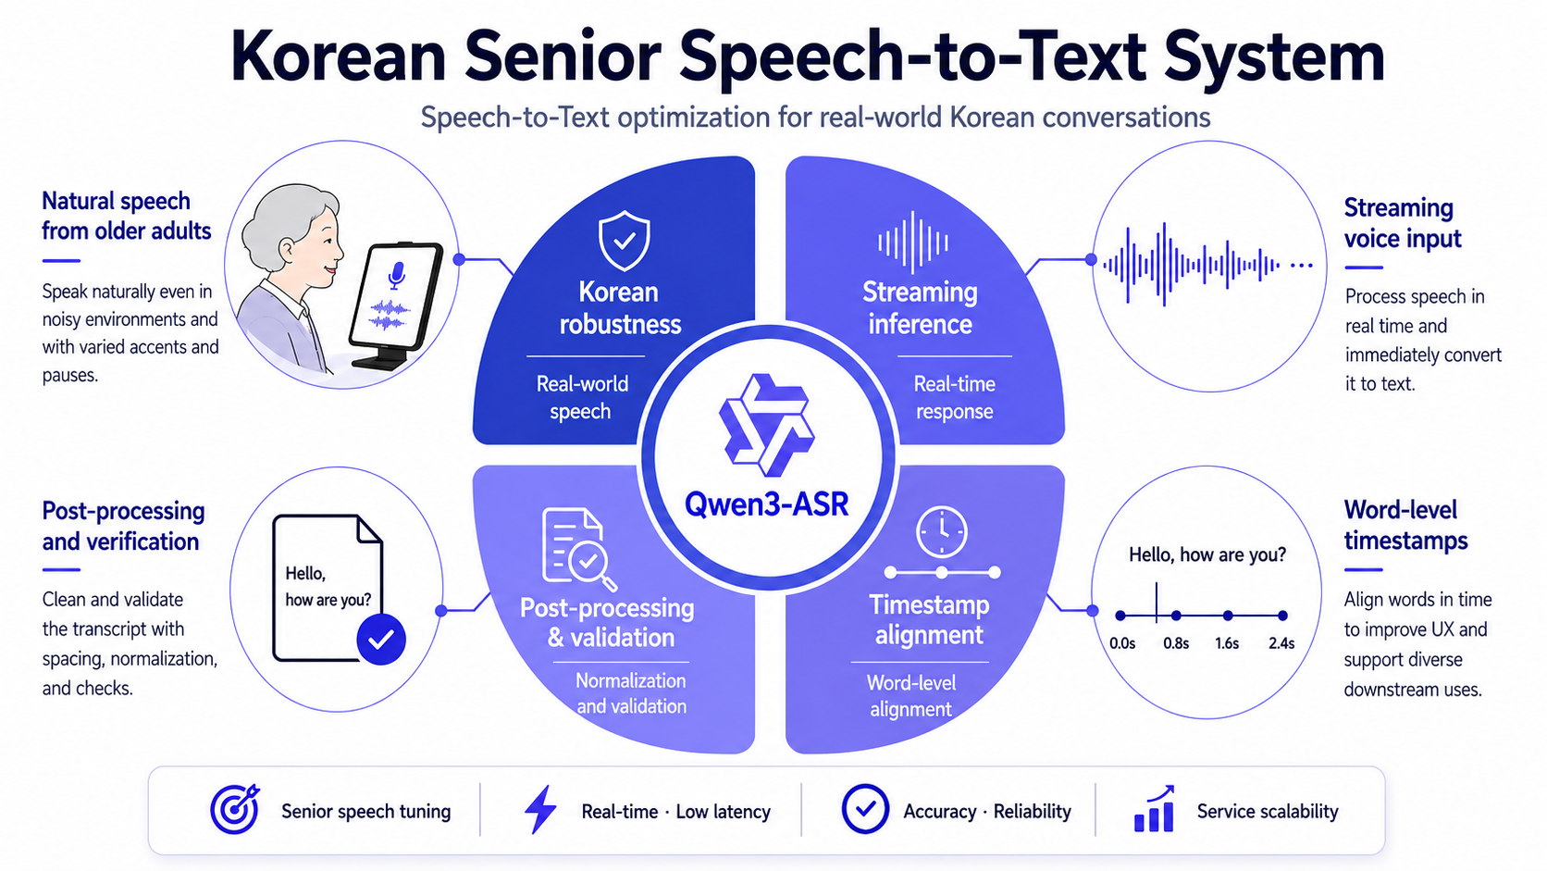
English STT architecture figure

Technical figure specification — STT fine-tuning and DPO (update the architecture figure)
Keep the microphone, waveform, four-quadrant architecture, and timeline. Add a left-to-right training inset: 20-speaker consented beta audio → 16 kHz preprocessing → base Qwen/Qwen3-ASR-1.7B candidate (y−) alongside the research-team-verified transcript (y+) → DPO policy update with a frozen reference policy → speaker-disjoint evaluation. Label the pair (x, y+, y−), show the DPO loss above, and report CER/WER, omission/insertion/substitution counts, latency, and transcript acceptability. Keep the Korean/Japanese FLEURS values as external benchmark context.

Technical figure specification — RAG personalization (extend the existing conceptual flow)
Extend story record → memory store → related-memory search → new question with two explicit open-source model blocks. Qwen/Qwen3-8B extracts a strict JSON record from each consented transcript: date, people, place, event, object, emotion, cue, sensitivity, sourceTranscript, and consentScope. BAAI/bge-m3 creates a multilingual embedding; a participant-scoped FAISS/vector index stores the embedding with a pseudonymous user ID and source-record ID. At generation time, filter by consent and participant, retrieve top-k records, and pass only those records plus a short template to Qwen/Qwen3-8B. Write the question with source-memory IDs and a model/version stamp. Add: “I ate out with my daughter yesterday” → “What did you have when you ate out with your daughter?” Keep personal data and generated text in separate colors.

- System Users
The system separates the learner-facing experience from the support-facing views. Access is scoped to the role and to the consent recorded by the registering institution.
User | Primary use
Older adult | Taps an NFC card, completes six activities, and answers by voice or button.
Welfare-center staff | Registers consent and the pseudonymous card ID, then checks participation.
Caregiver | Views consented check-in and conversation cues, not a clinical score.
Counselor / clinician | Reviews summarized observations to prepare a professional conversation.

The 20-person beta test is formative usability evidence. The IRB study will test independent participants, consent, speech performance, completion burden, and report usefulness.
- System Environment
Layer | Description
Hardware | Raspberry Pi, portrait display, four 2×2 buttons, NFC reader, microphone, speaker, and enclosure.
Client software | A large-text kiosk web client for one-person, click-first operation; Korean and Japanese are supported.
Data path | The card supplies a pseudonymous ID. Responses, transcripts, and consent-scoped summaries stay separate from names.
Operating site | Staff register cards and participants; the older adult starts by tapping the card at the installed kiosk.

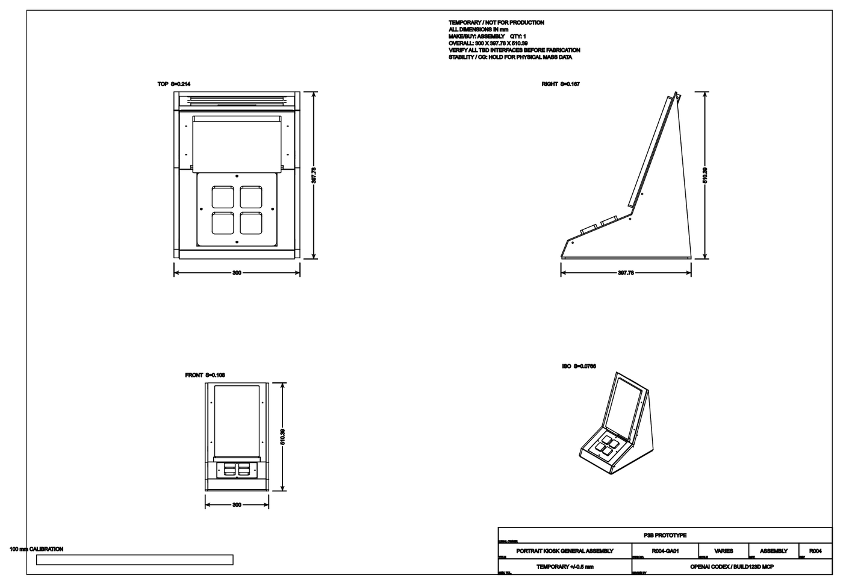
Prototype fabrication drawing

Figure 3. Prototype fabrication drawing reproduced from the E5 presentation materials.
- Conclusion
Haru closes a practical care loop: a low-friction physical interaction makes daily participation possible; STT turns spoken answers into searchable records; RAG uses those records to create relevant next-day prompts; and consent-scoped summaries give families and care professionals material for a conversation. The prototype, NFC flow, bilingual interface, report path, and formative usability changes are implemented.
The next step is field validation, not a clinical claim: the team will complete the IRB process, run the Korea and Japan studies, measure independent completion, time, speech-recognition success, repeat-use intention, and report usefulness, and then refine the product. Any final technical figure should be checked against the running data pipeline, especially the exact embedding/index implementation and the verified status of the selected ASR model.
Submission note
All photographs, screenshots, diagrams, and prototype drawings in this description are team-owned assets reproduced from the supplied Haru presentation materials. The system is presented as a supportive routine and observation aid, not as a substitute for professional diagnosis.

