Observation& Rectified Report

Date: |  |  | 2026/05/21
Ship's Name | MONDIAL COSMOS
IMO Number | 9801196 | Flag |  | PANAMA
Keel Lay | 2015/11/20 | Delivery |  | 2017/06/26
Gross Tonnage | 43,473 | Deadweight |  | 81,611
Owner | MC SHIPPING LTD | Manning Company |  | MLS
Crew nationality | PHILIPPINES | Number of Crew |  | 19
Date of Inspection | 2026/05/19-21
Port of Inspection | Longkou, China | Inspector |  | K. Doi/ Lee Deokjun
Due date to rectify | 2023/04/18 | Date of Rectified
Master | Jonel B Pescador
Chief officer | Rano Carlos Jr Resentes | Chief engineer |  | Bernard S Tan

Click on the cell where you want to insert the photo, then drag & drop the photo.
No | Observation/Requisitionitems
1 | Rust stains from the Fairey loader are noticeable on the stern side of the hull plating.
 | Before | After
 | 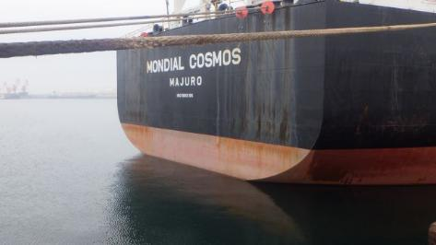
 | Date of Rectified (yyyy/mm/dd):

2 | The protector on the loop that holds the mooring line bit is deteriorated.
 | Before | After
 | 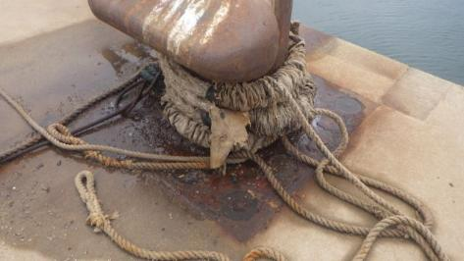
 | Date of Rectified (yyyy/mm/dd)：
 | Remark:

3 | Is there a certificate for the tail rope of the mooring line?
 | Before | After
 | 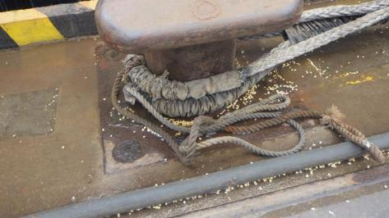
 | Date of Rectified (yyyy/mm/dd)：
 | Remark:

4 | The brake lining (brake band end) of the port side mooring winch on the poop deck is worn down to about 5 mm, so replacement is recommended.
 | Before | After
 | 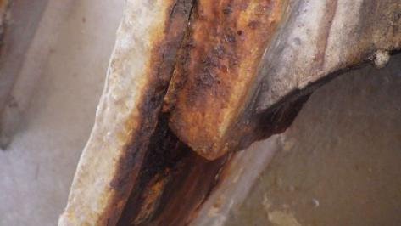
 | Date of Rectified (yyyy/mm/dd)：
 | Remark:

5 | All Fairley Loaders on the Poop Deck side won’t spin, so we recommend overhaul them up for maintenance.
 | Before | After
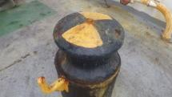
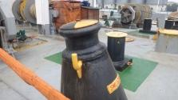
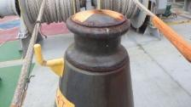
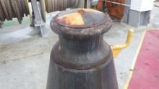
 | Date of Rectified (yyyy/mm/dd):
 | Remark:

6 | The rendering marks for Poop Deck Mooring Winch are misaligned, so please perform another rendering test and adjust them.
 | Before | After
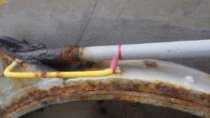
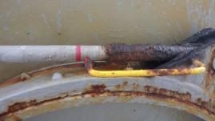
 | Date of Rectified (yyyy/mm/dd)：
 | Remark:

7 | The area around the All brake band's stopper bolt is swollen with rust, making it difficult to see the gap, so rust removal is recommended.
 | Before | After
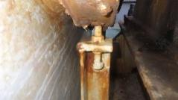
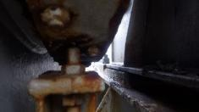
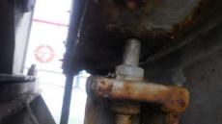
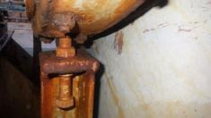
 | Date of Rectified (yyyy/mm/dd)：
 | Remark:

8 | The IMO symbol on the deck is degraded, so it needs to be replaced.
 | Before | After
 | 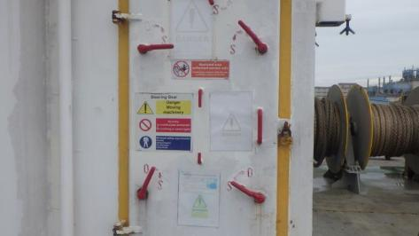
 | Date of Rectified (yyyy/mm/dd):
 | Remark:

9 | The rendering marks on the Mooring Winch of HCNo.7 and 6 Cross Deck have been erased by the paint, so please redraw the rendering marks immediately.
 | Before | After
 | 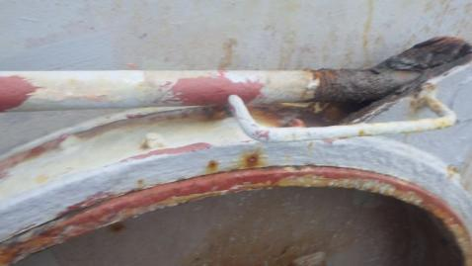
 | Date of Rectified (yyyy/mm/dd)：
 | Remark:

10 | The stopper chain for the mooring winch on HCNo.7 and HCNo.6 Cross Deck is missing, so please install it immediately.
 | Before | After
 | 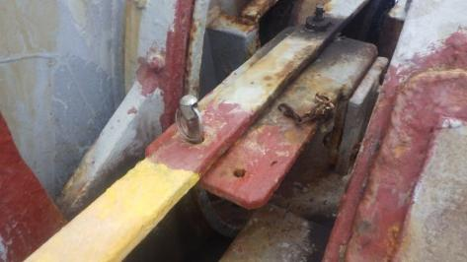
 | Date of Rectified (yyyy/mm/dd)：
 | Remark:

11 | The gearbox cover for the Mooring Winch on HC No. 7 and 6 Cross Deck is corroded and missing, so repair is recommended.
 | Before | After
 | 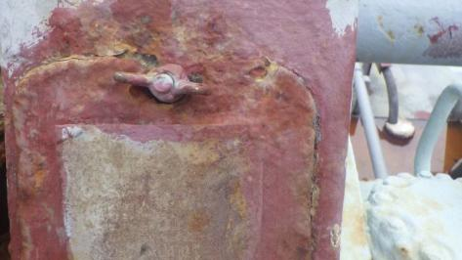
 | Date of Rectified (yyyy/mm/dd)：
 | Remark:

12 | All Mooring Winch gearboxes have warning plates that have deteriorated and become difficult to read, so we recommend ordering and replacing the plates.
 | Before | After
 | 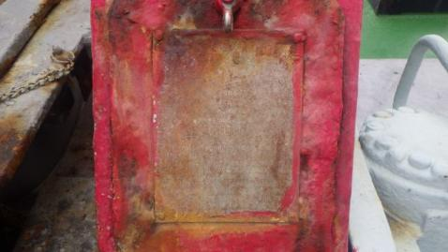
 | Date of Rectified (yyyy/mm/dd):
 | Remark:

13 | The top safety chain is less than 1 meter high (Lightship requirement), so it is recommended to adjust it to 1 meter or more.
 | Before | After
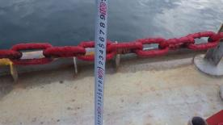
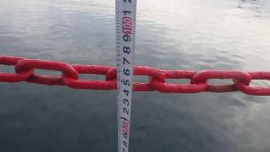
 | Date of Rectified (yyyy/mm/dd)：
 | Remark:

14 | Many manhole covers have been repainted after de-rusting, but the tank names are not painted on, so they should be painted after departure.
 | Before | After
 | 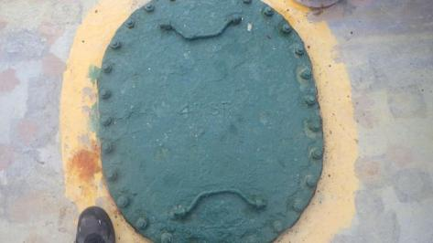
 | Date of Rectified (yyyy/mm/dd)：
 | Remark:

16 | The clutch stopper on the mooring winch of the Cross Deck CH No. 1 and 2 is not engaged. The clutch is not aligned with the stopper hole, but why is it not being adjusted?
 | Before | After
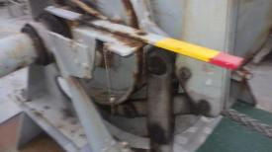
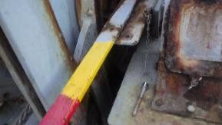
 | Date of Rectified (yyyy/mm/dd)：
 | Remark :

17 | The hydraulic hoses for the HC drive motor pump and controller were not replaced, and Ultra Felx 5000 coating was not applied.The hydraulic hoses in question should be requested.
 | Before | After
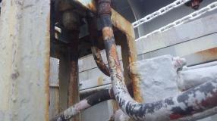
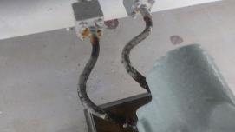
 | Date of Rectified (yyyy/mm/dd)：
 | Remark:

18 | De-rust and painting of the hydraulic piping for HC No. 1-3 have not yet been carried out. A separate document outlining the piping maintenance plan on the deck will be sent at a later date; please carry out the maintenance sequentially after departure.
 | Before | After
 | 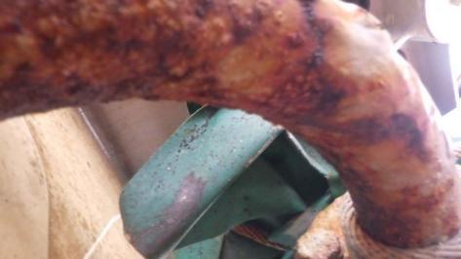
 | Date of Rectified (yyyy/mm/dd)：
 | Remark:

19 | Several of the HC cleats are stuck, and the cleats themselves are rusting, giving them a shabby appearance, so they will need to be serviced sequentially.
 | Before | After
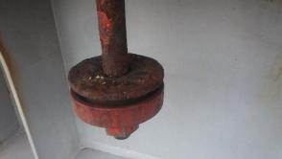
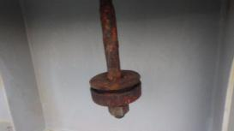
 | Date of Rectified (yyyy/mm/dd):
 | Remark:

20 | The U-bolt piping on deck has not been replaced. A maintenance plan will be sent later, so please replace them in due course.
 | Before | After
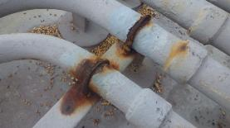
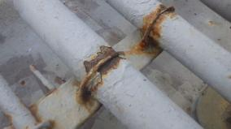
 | Date of Rectified (yyyy/mm/dd)：
 | Remark:

21 | HC No.5 AFT Center side lift heads have two steel plates inserted to adjust the height, so remove the lift heads and adjust the height by build-up welding.
 | Before | After
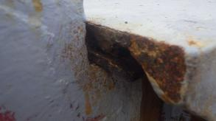
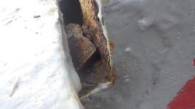
 | Date of Rectified (yyyy/mm/dd)：
 | Remark:

22 | Perform maintenance and cleaning on the HC drain valve as described below.
 | Before | After
HC No.1 Fwd side Center blockage
HC No.1 Fwd side Starboard blockage
HC No.2 Aft side Center stocked
HC No.3 Aft side Port stocked
HC No.4 Fwd side Center stocked
HC No.6 Fwd side Starboard stocked
HC No.7 Fwd side Starboard and Center side drain valve does not close under its own weight.
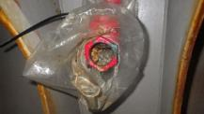
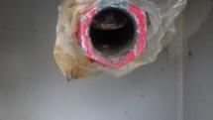
 | Date of Rectified (yyyy/mm/dd)： | Date of Rectified (yyyy/mm/dd)
 | Remark:

23 | The air vent body of the APT, STCW Tank is missing due to corrosion; therefore, please request and replace the air vent. Please also check the condition of other air vents and request additional replacements if necessary.
 | Before | After
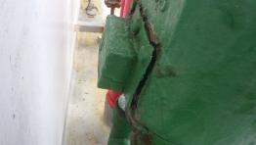
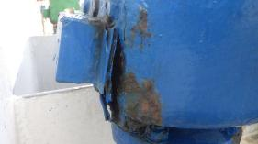
 | Date of Rectified (yyyy/mm/dd):
 | Remark:

24 | The gasket channels on the HC ventilation covers are mostly unmaintained, so I will send a maintenance plan later. Please apply de-rust and paint them in order. Also, please check the stock of packing materials.
 | Before | After
 | 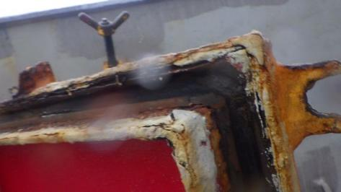
 | Date of Rectified (yyyy/mm/dd)：
 | Remark:

25 | The Forecastle's chimney-type Fairey loader is no longer rotating, so we recommend overhaul maintenance.
 | Before | After
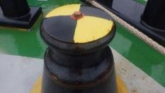
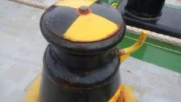
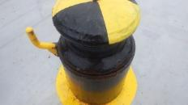
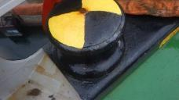
 | Date of Rectified (yyyy/mm/dd)：
 | Remark:

26 | The gearbox cover on the Mooring Winch in the center of the Forecastle is worn out, so I recommend making a replacement cover.
 | Before | After
 | 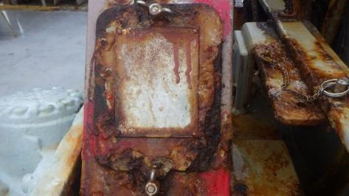
 | Date of Rectified (yyyy/mm/dd)：
 | Remark:

27 | The Fairey loader cover on the port side of the forecastle was torn, so it should be temporarily repaired with double plates or similar. Also, request a spare cover.
 | Before | After
 | 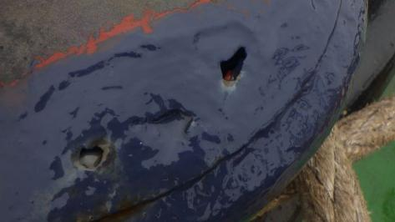
 | Date of Rectified (yyyy/mm/dd)：
 | Remark:

28 | The wire entry cover at Bosun Store is corroded and falling apart, so it needs to be repaired.
 | Before | After
 | 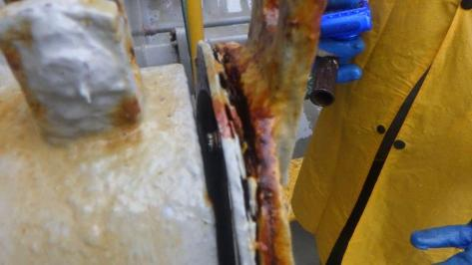
 | Date of Rectified (yyyy/mm/dd)：
 | Remark:

29 | The bosun store is overflowing with waste (used home improvement chains, broken HP machines, old mooring ropes, empty pails, empty drums, etc.), so it needs to be disposed of at a port where it can be landing.
 | Before | After
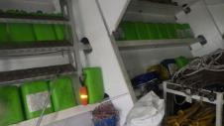
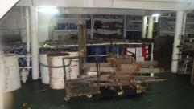
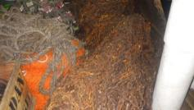
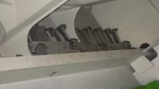
 | Date of Rectified (yyyy/mm/dd)：
 | Remark:

30 | All the stoppers on the chain block hooks stored at the bosun's store are missing, so we will gradually replace them with new ones and then dispose of the old ones.
 | Before | After
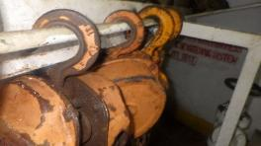
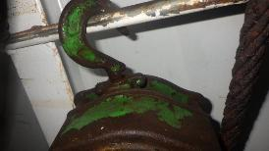
 | Date of Rectified (yyyy/mm/dd)：
 | Remark:

31 | The SWL mark on the Forecastle bollard is not painted.
 | Before | After
 | 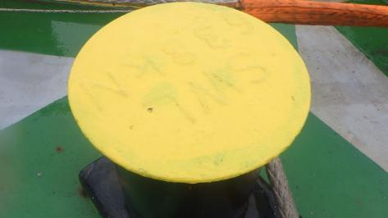
 | Date of Rectified (yyyy/mm/dd)：
 | Remark:

32 | The tightening bolts on the CH No.2 Vertical ladder cover are bent; they need to be replaced or adjusted.
 | Before | After
 | 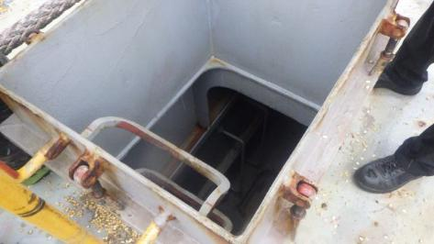
 | Date of Rectified (yyyy/mm/dd)：
 | Remark:

33 | The fixing plates for the CH No.1 spiral ladder and the CH No.2 Vertical ladder cover are severely bent due to repeated excessive tightening; they need to be adjusted or replaced to be flat.
 | Before | After
 | Date of Rectified (yyyy/mm/dd)：
 | Remark:

34 | The power cable box on the port side Provision Crane is showing signs of corrosion, so it should be de-rust painted.
 | Before | After
 | 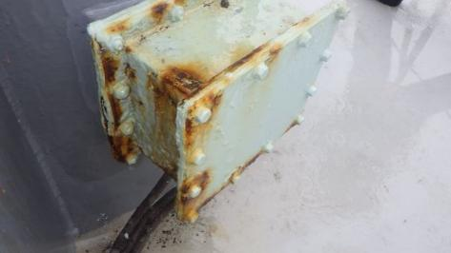
 | Date of Rectified (yyyy/mm/dd)：
 | Remark:

35 | The stopper on the Life Boat's suspension hook is stuck, so apply grease to make it move smoothly.
 | Before | After
 | 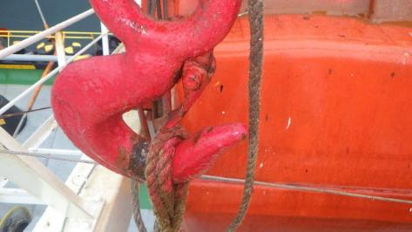
 | Date of Rectified (yyyy/mm/dd)：
 | Remark:

36 | The Fire Control Plan has not been updated regarding the locations of firefighting transceivers, so we are providing a sample; please update it immediately.
 | Before | After
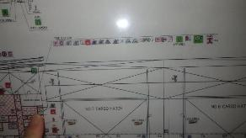
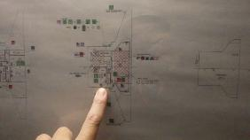
 | Date of Rectified (yyyy/mm/dd)：
 | Remark:

37 | The lid of the International Shore Connection Box is stuck against the wall, making it difficult to remove, so extend the stand forward to allow the lid to fully open.
 | Before | After
 | 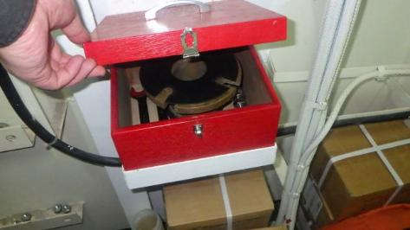
 | Date of Rectified (yyyy/mm/dd)：
 | Remark:

38 | There are discarded batteries scattered all over the vacant spaces in the residential area, so they should all be disposed of at a port where they can be unloaded.
 | Before | After
 | 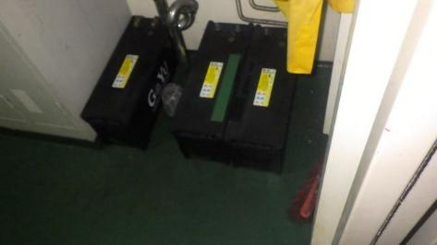
 | Date of Rectified (yyyy/mm/dd)：
 | Remark:

39 | The cover of the viewing window on the evaporator outlet duct of the residential air conditioner is fixed with rivets, making it impossible to open.
 | Before | After
 | 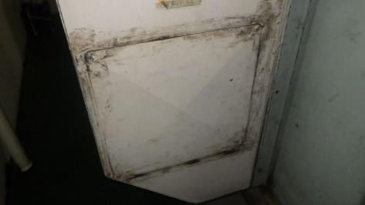
 | Date of Rectified (yyyy/mm/dd)：
 | Remark:

40 | The air conditioning unit's package frame for the galley is severely corroded and needs repair.
 | Before | After
 | 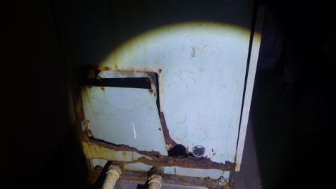
 | Date of Rectified (yyyy/mm/dd)：
 | Remark:

41 | The duct from the galley air conditioner is cracked due to corrosion, so it needs to be temporarily repaired.
 | Before | After
 | 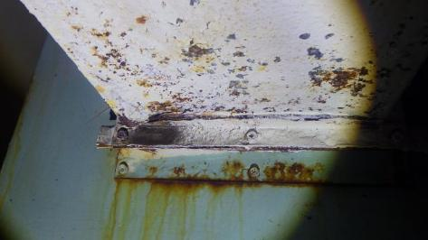
 | Date of Rectified (yyyy/mm/dd)：
 | Remark:

42 | The air conditioning ducts have deteriorated further since last year's inspection, so temporary repairs will be carried out.
 | Before | After
 | 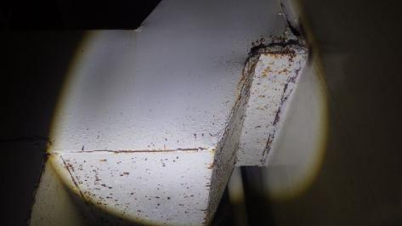
 | Date of Rectified (yyyy/mm/dd)：
 | Remark:

43 | The draft gauge at the Ships office is malfunctioning. Please check the current situation and report it.
 | Before | After
 | 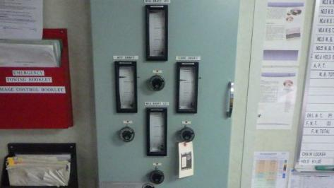
 | Date of Rectified (yyyy/mm/dd)：
 | Remark:

44 | Since using an empty can as an ashtray, I'm requesting an ashtray with a lid.
 | Before | After
 | 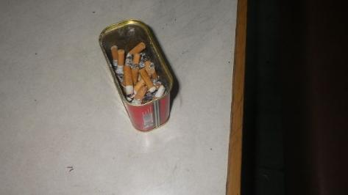
 | Date of Rectified (yyyy/mm/dd)：
 | Remark:

45 | Report the reason why the chamber's set temperature has increased by 1°C.
 | Before | After
 | 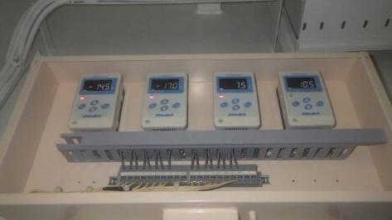
 | Date of Rectified (yyyy/mm/dd)：
 | Remark:

46 | The dryer filter at Officers Landrey was clogged, so ensure that all crew members who use the dryer clean the filter.
 | Before | After
 | 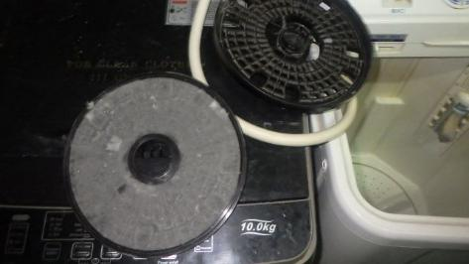
 | Date of Rectified (yyyy/mm/dd)：
 | Remark:

47 | The spare parts in the engine compartment are stored haphazardly, so we will provide you with a storage box. Please store them neatly.
 | Before | After
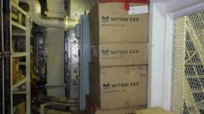
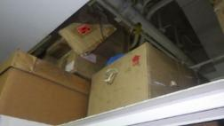
 | Date of Rectified (yyyy/mm/dd)：
 | Remark:

48 | The barometer must be calibrated when calling at a port in Japan.
 | Before | After
 | 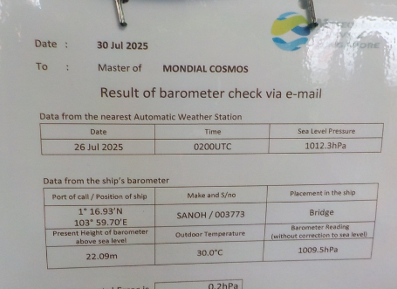
 | Date of Rectified (yyyy/mm/dd)：
 | Remark:

49 | The pails (grease and miscellaneous oils) in the Steering Gear Room don't fit in the cabinet and are being stored on the floor, so the cabinet needs to be expanded to accommodate them.
 | Before | After
 | 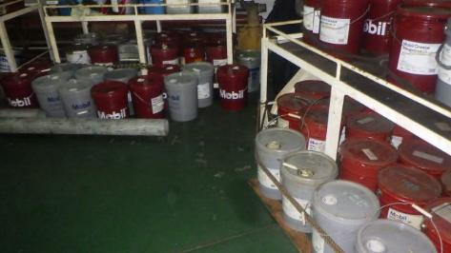
 | Date of Rectified (yyyy/mm/dd)：
 | Remark:

50 | We found the materials for the sacrificial tube, but we haven't manufactured it yet, so please check again and then manufacture it.
 | Before | After
 | 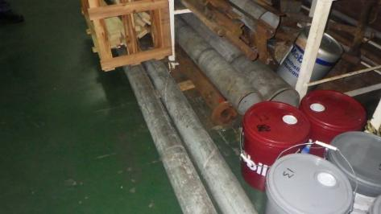
 | Date of Rectified (yyyy/mm/dd)：
 | Remark:

51 | The Steering Gear's LOStore tank level is at minimum, so refill it.
 | Before | After
 | 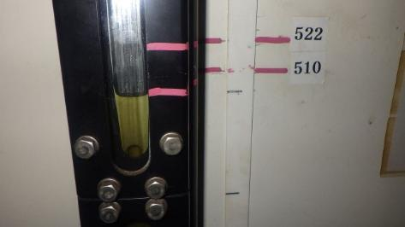
 | Date of Rectified (yyyy/mm/dd)：
 | Remark:

52 | Since the filter in the hydraulic system on the Poop Deck has not been replaced since October 2023, please replace it if you have a spare filter.
 | Before | After
 | 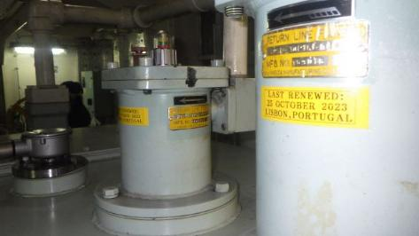
 | Date of Rectified (yyyy/mm/dd)：
 | Remark:

53 | Oil has in the oil pan under the steering gear rim cylinder, so clean it before entering port.
 | Before | After
 | 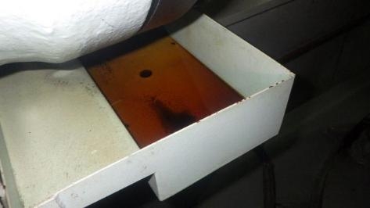
 | Date of Rectified (yyyy/mm/dd)：
 | Remark:

54 | There is still combustible waste in the 2nd deck of the engine compartment; please move it to the designated garbage collection point. Also, please move the combustible waste to the garbage collection point on the same day.
 | Before | After
 | 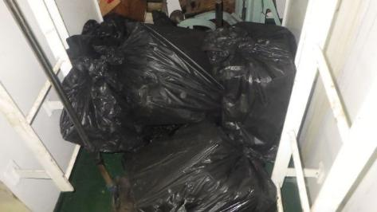
 | Date of Rectified (yyyy/mm/dd)：
 | Remark:

55 | The boiler water level gauge is stained with paint, so clean it.
 | Before | After
 | 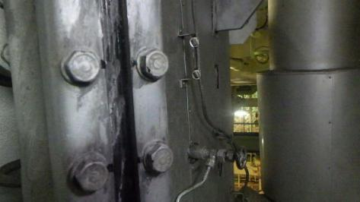
 | Date of Rectified (yyyy/mm/dd)：
 | Remark:

56 | The boiler differential pressure gauge is not at the "zero" position, so please adjust it.
 | Before | After
 | 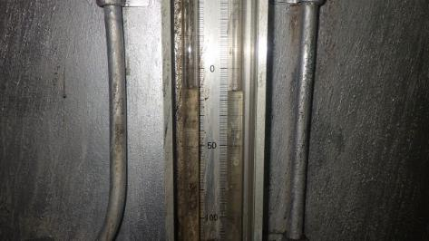
 | Date of Rectified (yyyy/mm/dd)：
 | Remark:

57 | I don't know when the sterilization lamp in the Sewage Plant system needs replacing, but if it's been more than a year, it should be replaced.
 | Before | After
 | 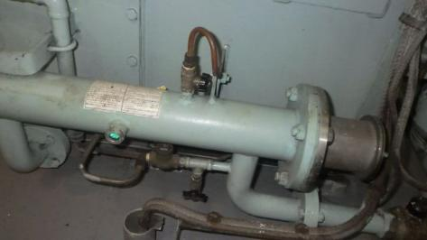
 | Date of Rectified (yyyy/mm/dd)：
 | Remark:

58 | No.2 The GE T/C inlet temperature gauge is malfunctioning and needs to be replaced.
 | Before | After
 | 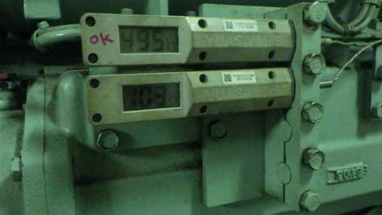
 | Date of Rectified (yyyy/mm/dd)：
 | Remark:

59 | Drying clothes in the engine compartment is not recommended.
 | Before | After
 | 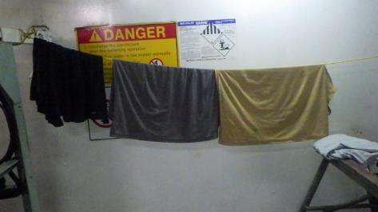
 | Date of Rectified (yyyy/mm/dd)：
 | Remark:

60 | The indicator on the No. 2 GE intake pressure gauge is not visible, so replace the glycol. If replacing it doesn't work, replace the entire unit.
 | Before | After
 | 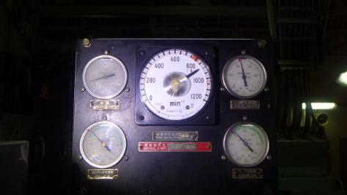
 | Date of Rectified (yyyy/mm/dd)：
 | Remark:

61 | The level gauges on the FW and DW pressure tanks are too dirty to read the water level, so please clean them.
 | Before | After
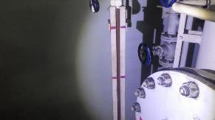
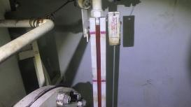
 | Date of Rectified (yyyy/mm/dd)：
 | Remark:

62 | The hinge on the cascade tank cover is broken, so it needs to be repaired.
 | Before | After
 | 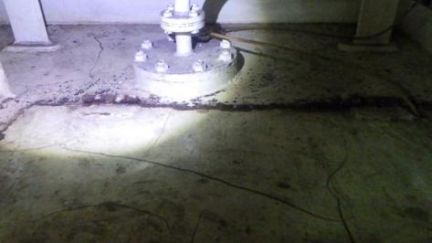
 | Date of Rectified (yyyy/mm/dd)：
 | Remark:

63 | The water in the ME T/C differential pressure gauge has evaporated, so please replenish it.
 | Before | After
 | 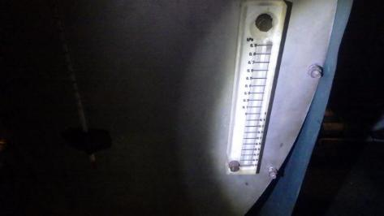
 | Date of Rectified (yyyy/mm/dd)：
 | Remark:

64 | The slight glass on the ME air cooler drain catcher is dirty, so clean it.
 | Before | After
 | 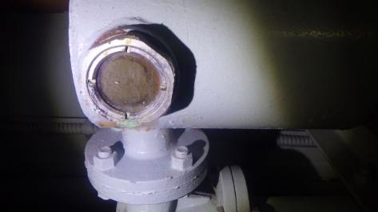
 | Date of Rectified (yyyy/mm/dd)：
 | Remark:

65 | The damper on the Galley Natural Air Inlet is a bit stuck, so I'll test it open and close once a week and apply grease.
 | Before | After
 | 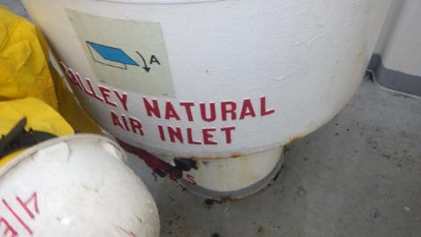
 | Date of Rectified (yyyy/mm/dd)：
 | Remark:

66 | The Marpol sample drum is disproportionately large compared to the size of the paint store.  I recommend replacing it with a slightly smaller one to secure more space for paint storage.
 | Before | After
 | 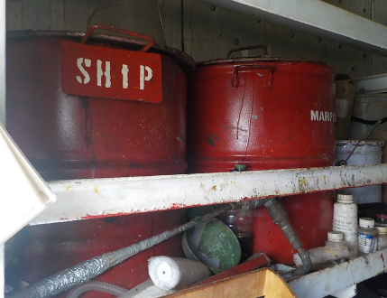
 | Date of Rectified (yyyy/mm/dd)：
 | Remark:

67 | The ER sky door hatch has been severely corroded.  It is recommended to carry out de-rusting and weld the areas that have deteriorated due to corrosion.
 | Before | After
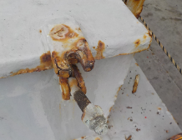
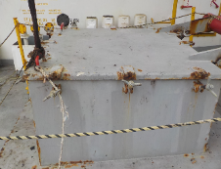
 | Date of Rectified (yyyy/mm/dd)：
 | Remark:

68 | Since the fuel for the EMCY GE is MGO, please paint it in pink the valve.
 | Before | After
 | 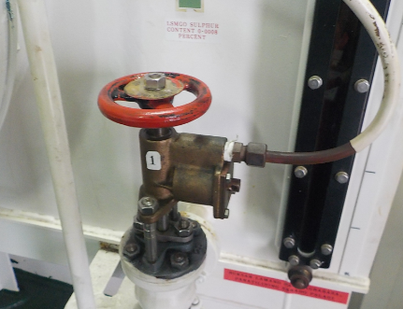
 | Date of Rectified (yyyy/mm/dd)：
 | Remark:

69 | The pipe step plate has been torn.  Since a spare is available, please replace it immediately after departure.
 | Before | After
 | 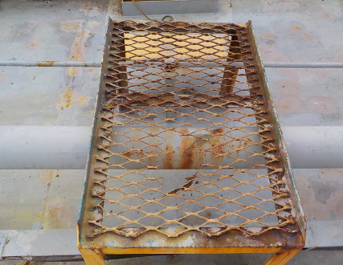
 | Date of Rectified (yyyy/mm/dd)：
 | Remark:

70 | The embarkation ladder cover has been torn. Please stitch it and carry out maintenance.
 | Before | After
 | 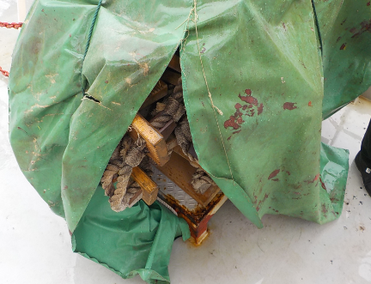
 | Date of Rectified (yyyy/mm/dd)：
 | Remark:

71 | The fire fighting transceiver is not of the hands-free type. Please order a hands-free type instead.
 | Before | After
 | 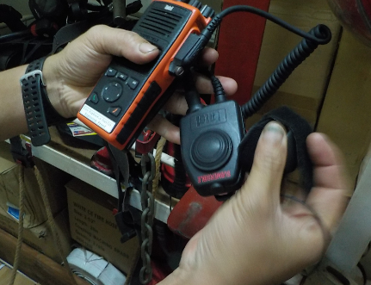
 | Date of Rectified (yyyy/mm/dd)：
 | Remark:

72 | There is no spare sacrifice pipe for the accommodation air conditioner.  Since the material is available, please fabricate and store it in the aircon room.
 | Before | After
 | 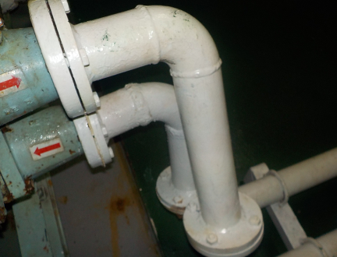
 | Date of Rectified (yyyy/mm/dd)：
 | Remark:

73 | The shelf machine has no guard. Please measure the size and prepare an order sheet.
 | Before | After
 | 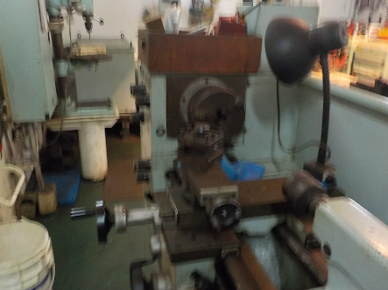
 | Date of Rectified (yyyy/mm/dd)：
 | Remark:

74 | Water is dripping from the galley faucet at a rate of one drop every two seconds.  Confirm the spare, and make an ordersheet if no have spare.
 | Before | After
 | 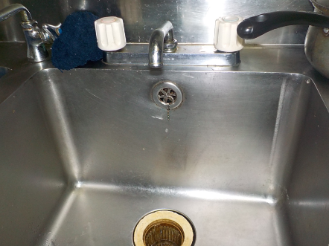
 | Date of Rectified (yyyy/mm/dd)：
 | Remark:

75 | Please do not store vacuum cleaners or other items in the electrical cable room.
 | Before | After
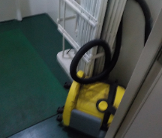
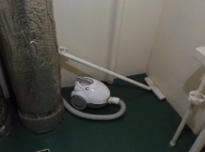
 | Date of Rectified (yyyy/mm/dd)：
 | Remark:

76 | The HC controller cover has holes due to corrosion.  Please carry out de-rusting and weld the affected areas to repair it.(No.2,3,4,5)
 | Before | After
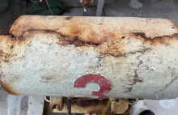
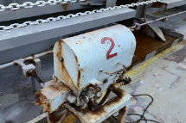
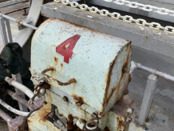
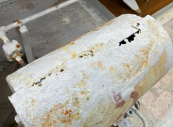
 | Date of Rectified (yyyy/mm/dd)：
 | Remark:

77 | Please locate and install the cover for the No.1 HC hydraulic jack head support.
 | Before | After
 | 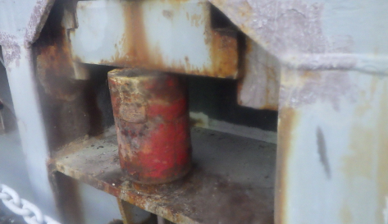
 | Date of Rectified (yyyy/mm/dd)：
 | Remark:

Visitor’s Name / Signature
K .Doi / Lee
Master's Name / Signature
Jonel B Pescador
C/E's Name / Signature
Rano Carlos Jr Resentes
C/O's Name / Signature
Bernard S Tan

