12/1
In dominancy4, different genotypes’ fitness affect the surviving alleles.

coexistence possible, but not through additive?
In what regions of d, d2, and a1 is coexistence possible.

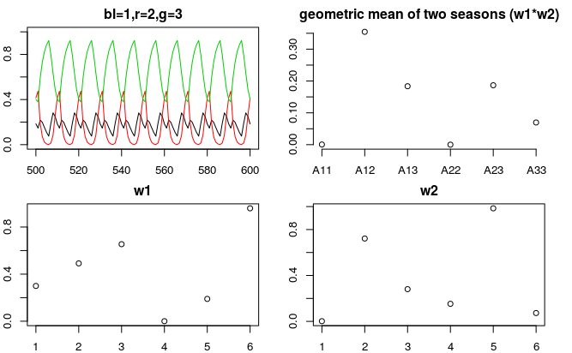
Upon enlarging A13 values in w2, we see coexistence of allele 2 and 3 to the coexistence of all.
Now, would this complete coexistence be achievable without manipulating the fitness level manually?
In other words, would total coexistence be possible with the given the fitness topology of two normal dist.?
YES coexistence is possible with the current fitness landscape.

How would number of generations between seasons affect the plot? What if there were different number of generations per season ?

1/11/18
This week we delved into the 2 main questions that prof. Yuseob suggested.

1. Can you find the equilibrium frequency given seasonal fluctuations of the fitness?

Analytically finding the equilibrium frequency in 2 allele situation seem rather difficult. Upon deterministic simulation of the frequency depending on the seasonal fluctuation, I found several factors other than fitness that contribute to the equilibrium allele frequency. Also, I redefined the genotype’s expression level (A11 as 2a, A12 as a+d, and A22 as 2d), and the resulting conditions of ‘a’ and ‘d’ for marginal overdominance seem quite odd. It would be helpful if you could review it and see if there’s any error in my proof.

First, let’s go over the analytical solution I wrote. This time I’ll write it fairly detailed so you could catch any possible errors in my solution.

So…. It comes out as either a or d has to be negative (which cannot be). I’m kind of confused how to interpret this…

There’s another approach to finding the condition of a and d. Turns out in two normal distribution with same variance, the maximum geometric mean is always the intersection of the two distribution.

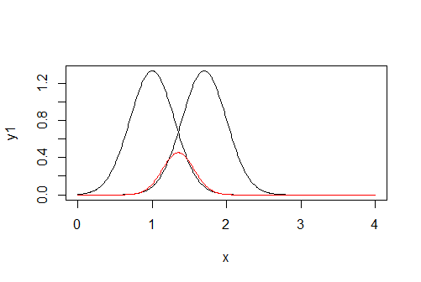
The red curve in the graph is the geometric mean of the two seasons’ fitness curves.
If we define c as the peak of the geometric mean, we can quickly realize that

I think this works even if the variance of the two distribution is not equal, because in all different types of curves I explored there seems to be only one maxima like above figure.

Although not analytically, I looked at how the equilibrium of the allele frequency changes with different mean fitness among genotypes in a two allele settings using a deterministic model. The code is in R, but the code is rather simple, so you might be able to follow. The model is based on the lecture note I have from Cornell (pg52-53) if you want to check it out. Bottom line is, if the heterozygote’s mean fitness is higher than the homozygotes’, polymorphism occurs. And higher heterozygote mean fitness puts equilibrium frequency closer to 0.5, while having an unequal homozygotes’ mean fitness puts equilibrium frequency higher for the allele with higher mean fitness as a homozygote. However, marginal over-dominance is not necessary for polymorphism to occur.

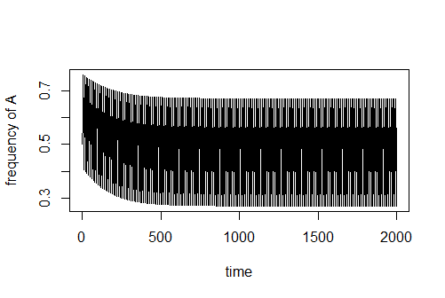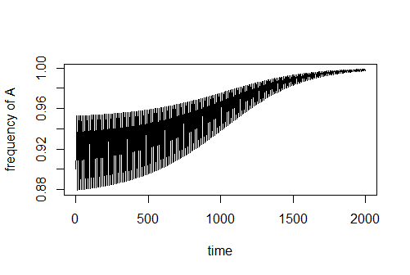
Both plot has mean fitness of 0.24 for aa, 0.25 for Aa, and 0.252 for AA. The initial frequency of A in left is 0.5, and right 0.9. As you can see, the initial frequency determined whether or not polymorphism is maintained. However, the effect of initial frequency is fairly small as it requires small difference between the mean fitness between heterozygote and homozygote.

Another factor that has effect on the equilibrium frequency is the difference of the two homozygotes’ fitness in a season. This effect is better understood in a table.

 | Fitness of AA | Fitness of aa | AA-aa
Season1 | 0.8 | 0.4 | 0.4
Season2 | 0.3 | 0.6 | -0.3
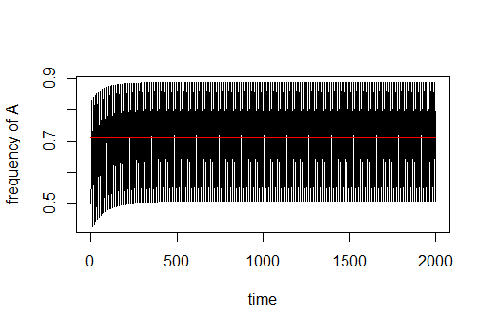
In this scenario, initial frequency is 0.5, and homozygote fitness is 0.5 in both seasons, so polymorphism occurs. Note that mean fitness of AA and aa are the same with 0.24. Normally, if both genotype had 0.3 and 0.8, the equilibrium frequency would be 0.5. However, here the equilibrium frequency is about 0.71 for A allele. If you take a look at the table, in season1, fitness of AA is higher by 0.4, but in season2, fitness of aa is higher only by 0.3. Supremacy of fitness AA is therefore greater, thus leading to higher A allele frequency. This is only a hypothesis, but it works the same way for 0.2 and 0.9 as fitness of AA and 0.3 and 0.6 as fitness of aa. Also if you flip the values for AA and aa in the above table, it works reversely giving a allele higher frequency:

 | Fitness of AA | Fitness of aa | AA-aa
Season1 | 0.4 | 0.8 | -0.4
Season2 | 0.6 | 0.3 | 0.3
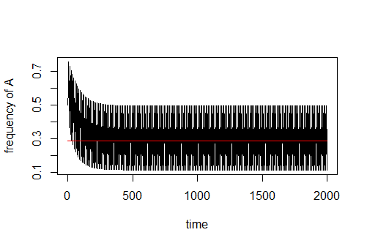

One interesting thing I found that may be trivial is that when there’s no marginal over-dominance and an allele goes to fixation, which season goes first in the times series has an effect on which allele goes to fixation. In the first scenario, initial frequency is 0.5, and mean fitness of both homozygotes are the same and are both higher than homozygote mean fitness (0.16). The frequency of A allele fixes to 1.
 | Fitness of AA | Fitness of aa
Season1 | 0.8 | 0.3
Season2 | 0.3 | 0.8
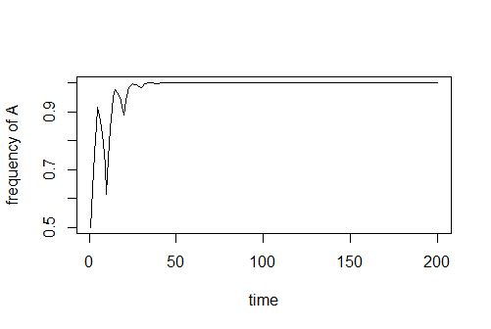

In the second scenario, everything stays the same, but the fitness of aa now have fitness of 0.8 in season 1 and 0.3 in season2. The frequency of a allele fixes to 1.
 | Fitness of AA | Fitness of aa
Season1 | 0.3 | 0.8
Season2 | 0.8 | 0.3
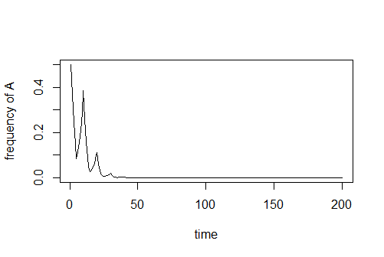

Swapping the first season does not seem to have much effect on the equilibrium frequency when there is marginal over-dominance however…

To sum up, here are the main points:

1. marginal over-dominance is sufficient but not necessary for polymorphism.
2. higher mean heterozygote fitness drive equilibrium frequency to 0.5. Higher mean homozygote fitness drive equilibrium frequency higher for the homozygote’s component allele.
3. Initial frequency has a relatively small effect on the equilibrium frequency of the dominant allele.
4. Difference of a difference of fitness in a season for the homozygotes (confusing… I know..) have effect on the equilibrium frequency.
5. Which season comes first has effect on which allele gets fixed when there’s no marginal over-dominance.

On top of this, I also found that marginal over-dominance does not necessarily mean that there is a reversal of dominance between the seasons. The proof is in the previous email I sent you. This may have some significant consequence in what we’re trying to show in our study.

2. Can you find the conditions of new 3rd allele expression that’s needed for that new allele to stay at a stable equilibrium?

As I went on to 3 alleles, things got a little more complex and I found some other factors that may contribute to which alleles form polymorphism. As the analytical method got out of hand from the 2 allele model, I couldn’t proceed to 3 allele situation analytically. I mainly ran a deterministic model with different expression values for each allele and tried to come up with set of algorithm which would predict which alleles would survive. Here’s the algorithm:

1. find the homozygote with the largest mean fitness
2. find the two heterozygotes that has the allele of the homozygote from step 1.
3. Pick the heterozygote that has larger mean fitness.
4. If the heterozygote’s mean fitness is larger than the homozygote’s, the two alleles for the heterozygote form polymorphism. If not, the allele of the homozygote fixes.

This algorithm predicted the surviving alleles correctly 98% for couple hundred simulations. Those times when it didn’t predict correctly within a given time step, the trajectories of the frequencies were all heading towards the predicted frequency. From this, we can see that homozygote’s mean fitness has important role in which polymorphism forms, which is interesting.

To further explore the dynamics of the mean fitness between the genotypes, I did some perturbation study where I manually changed the mean fitness values. Unfortunately under perturbation, I found that my above algorithm started to fail to predict in some situations, especially with the ability of all three alleles to form polymorphism in certain cases…

Let’s look at a particular case where my algorithm breaks down.

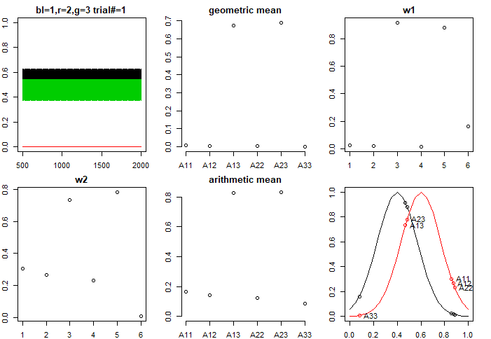
For this scenario the geometric mean is

A11 0.006985599
A12 0.004860096
A13 0.674028128
A22 0.003335111
A23 0.690125368
A33 0.001260989

Here A11 has the highest mean fitnesss, and A13 mean fitness is higher than A12’s, so allele 1 and 3 survive. So the algorithm works, but as I increase the genotype22’s mean fitness a bit by increasing its season 1 fitness (w1) by 0.2, I get the following:

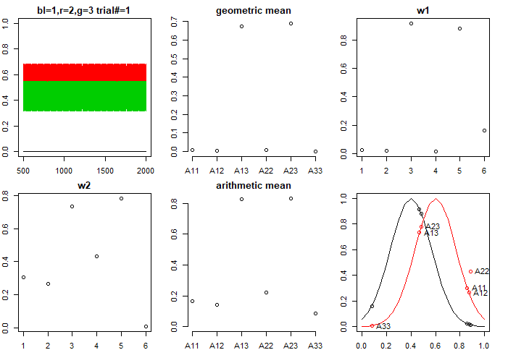

Geometric mean:
A11 0.006985599
A12 0.004860096
A13 0.674028128
A22 0.006217069
A23 0.690125368
A33 0.001260989

A22’s fitness is still lower than A11’s but the polymorphism now form between allele 2 and 3, and my algorithm now predicts wrong.

Trying to get allele 1 to survive again, I try increasing w1 of A11 by 0.2:

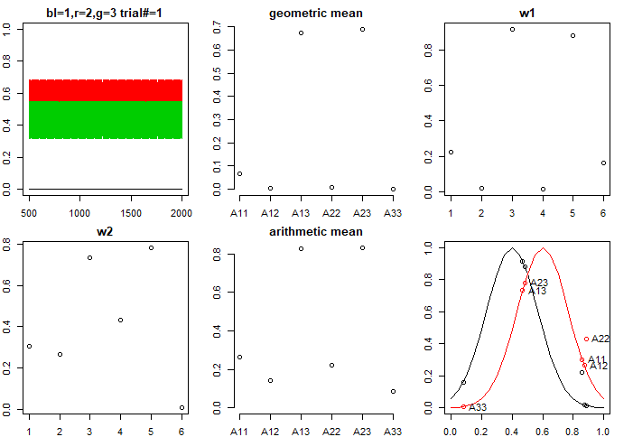

Geometric mean:
A11 0.067625647
A12 0.004860096
A13 0.674028128
A22 0.006217069
A23 0.690125368
A33 0.001260989

A11’s mean fitness is now higher but polymorphism is still between allele 2 and 3.
Now I try increasing w2 fitness of A11 by 0.2:

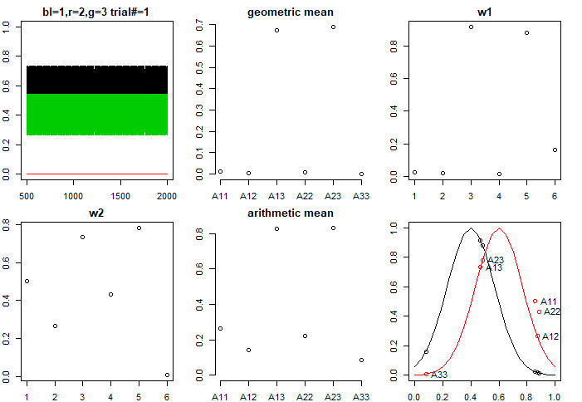

Geometric mean:
A11 0.011593510
A12 0.004860096
A13 0.674028128
A22 0.006217069
A23 0.690125368
A33 0.001260989

Surprisingly, A11’s mean fitness has not increased as much when I perturbed w1’s fitness, but the polymorphism now forms between 1 and 3! This suggests that the dynamics of fitness between genotypes within a season matters as well as the mean fitness of both seasons. This was somewhat hinted at in the 2 allele model from summary point 4, where dynamics of fitness within a season affected the equilibrium frequency.

Finally instead of increasing A11’s fitness I tried increasing A12’s fitness in w2 by 0.4:
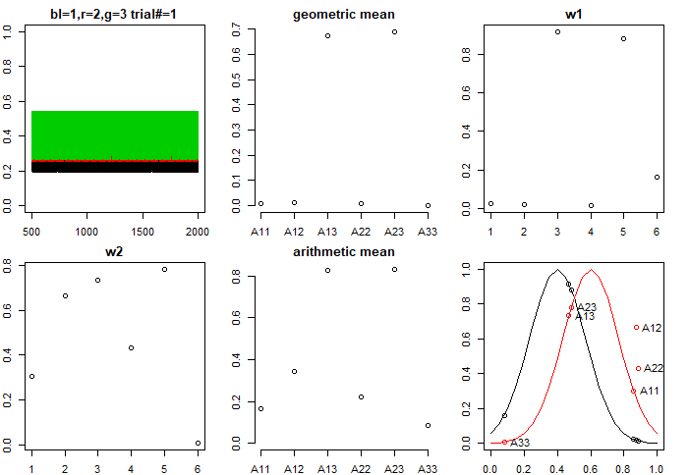
Geometric mean:
A11 0.006985599
A12 0.012173503
A13 0.674028128
A22 0.006217069
A23 0.690125368
A33 0.001260989

You get stable coexistence of all 3 alleles!! I tried getting stable polymorphism of all 3 alleles without perturbation, but couldn’t get one with about 5000 trials. Given that I was able to get stable coexistence through perturbation experiment quite often, I think qualitative difference such as which alleles survive can depend on the fitness landscape. And this goes to show that my algorithm, predicting correct for most simulation, but incorrect a lot of times in perturbation study, shows that it only works in specified fitness landscape.

From 3 allele model, we see that the dynamics between the genotype’s fitness is rather complex. And an analytical solution for conditions of equilibrium in multi-allele model may be quite unwieldy with so many variables affecting which alleles survive. Howver, to summarize general trend from 3 allele model:

1. Homozygotes with higher fitness tend to determine which heterozygote’s alleles form polymorphism.
2. Heterozygotes with higher fitness tend to promote polymorphism of its alleles.
3. Dynamics of genotypes’ fitness within a season determines equilibrium frequency.

