Part 1
a) CartPole (no baseline):
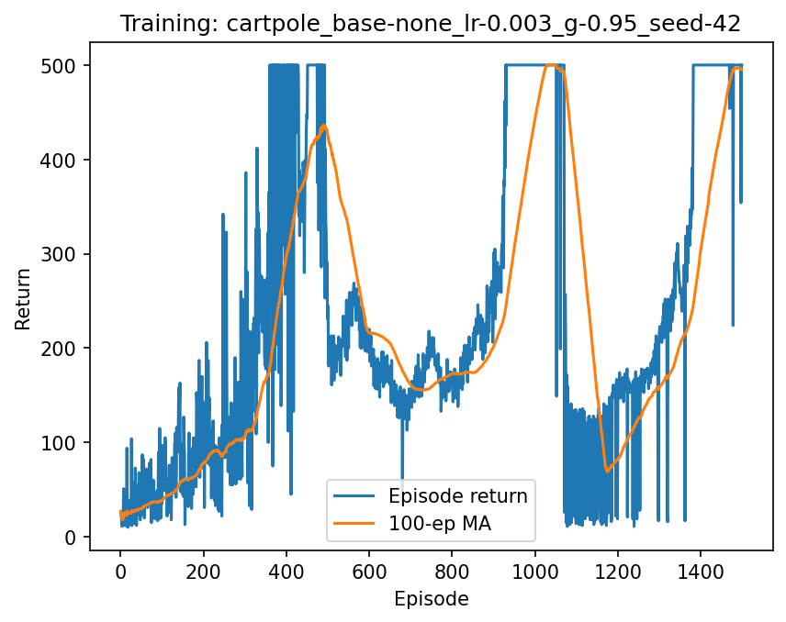
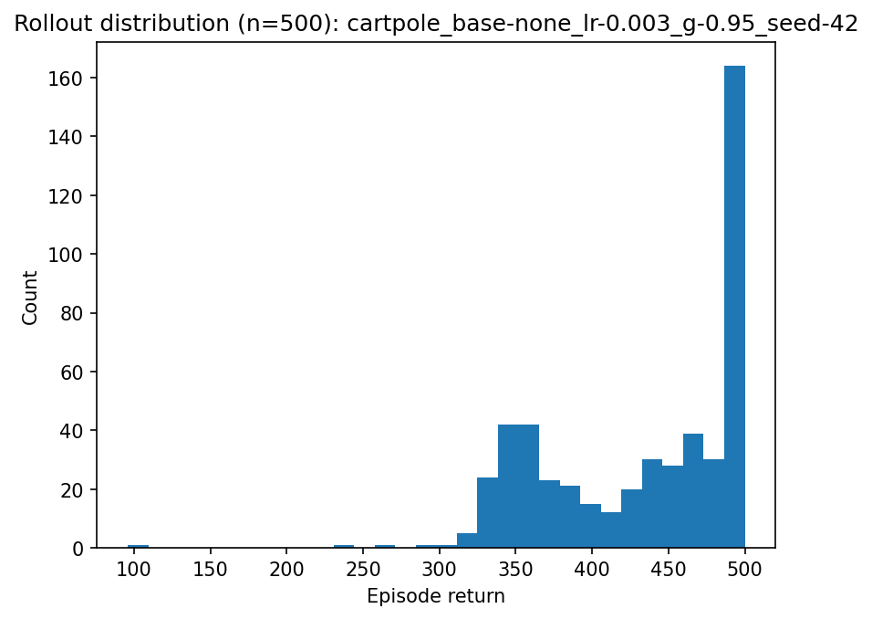
Rollout mean: 433.386 | std: 64.566
Vanilla REINFORCE on CartPole showed high variance: the 100-episode moving average climbed to near-optimal, regressed, and later recovered; the 500-episode rollout distribution remained wide. Adding a moving-average baseline centered the return signal, reduced gradient variance, and stabilized training; yielding a near-degenerate distribution at the 500-step cap. This demonstrates the variance-reduction benefit of baselines without introducing bias to the policy gradient.

b) Pong(no baseline)
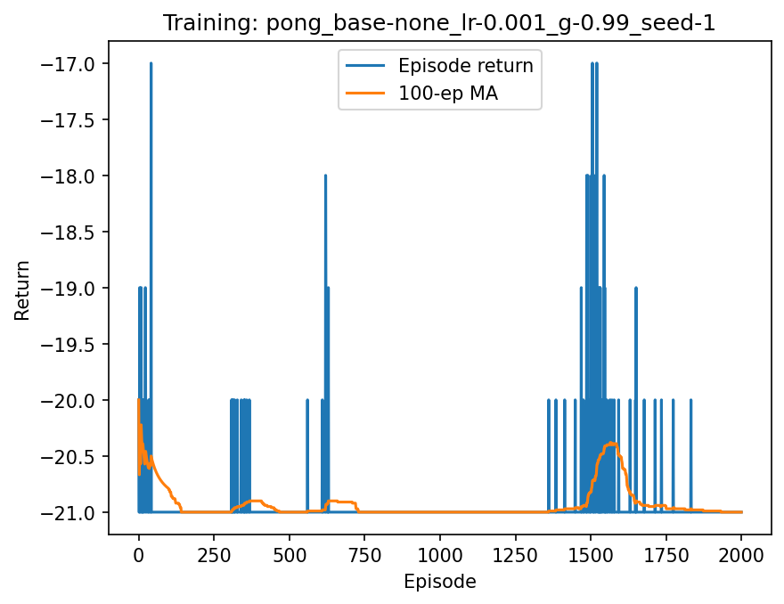
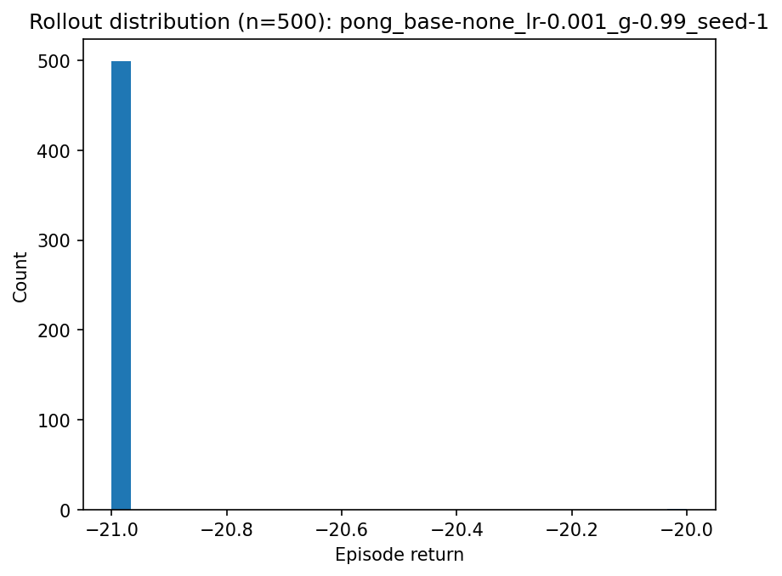
Rollout mean: -20.998 | std: 0.045
REINFORCE without a baseline did not learn. The 100-ep moving average stays pinned near -21 (losing every game) for all 2k episodes. The 500-episode rollout is a degenerate spike at -21, with mean ≈ -21.0 and tiny std (≈ 0.05). Conclusion: on pixel Pong, variance is too high and the baseline-free policy gradient fails under this budget.

Part 2
CartPole (moving_avg):
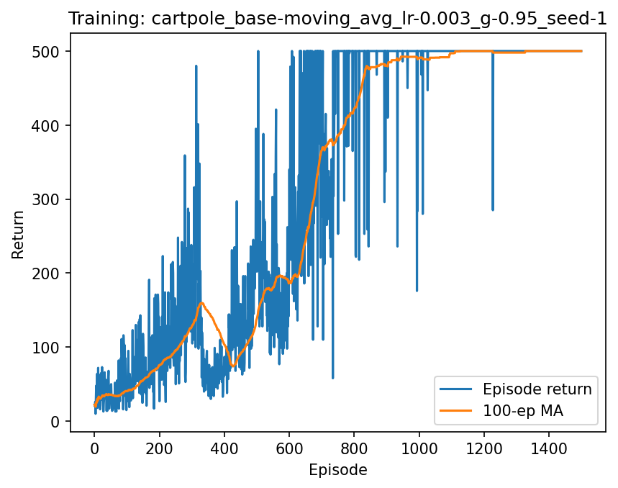
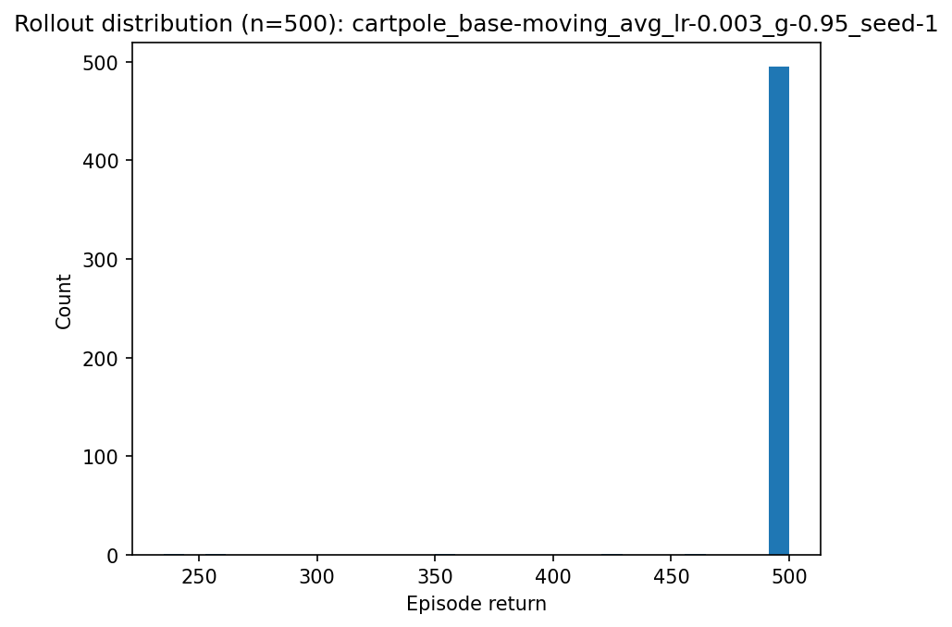
Rollout mean: 498.470 | std: 17.746
Using an exponential moving-average baseline (β=0.99) with REINFORCE on CartPole-v1 (γ=0.95, lr=0.003, 1,500 episodes) markedly reduced gradient variance and stabilized learning versus the no-baseline run. The 100-episode moving average climbed steadily and saturated at the 500-step cap; the 500-episode evaluation produced a tight distribution near the cap with mean 498.47 and std 17.75. Because subtracting a baseline leaves the expected policy gradient unbiased, these gains reflect variance reduction rather than optimization bias.
Pong (moving_avg):

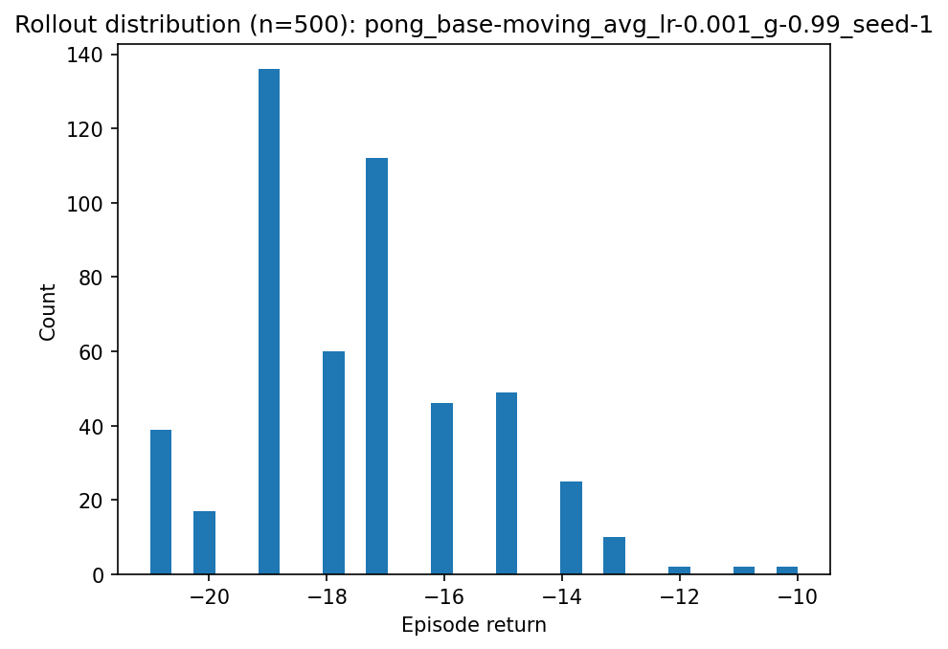
Rollout mean: -17.488 | std: 2.056
“Adding a moving-average baseline reduced variance and produced gradual gains. The 100-ep MA improves from ~−21 to ~−16 by 2k episodes. 500-ep rollout: mean −17.488, std 2.056, with most returns in [−18, −16] and occasional much better episodes (≈ −12 to −10). Baseline helps, but plain REINFORCE on raw RGB still doesn’t reach positive scores under this budget.”

