Foundations of Computer Science

ICA: Max Flow

last updated: March 30, 2022

Consider the flow network below with source *s*, sink *t* and capacities in boxes.

For example, the capacity between the source and node 1 is 16.

**Instructions**: Provide answers to each question and submit your document (word or pdf format) through Collab.

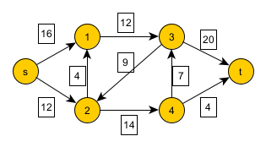

1) Write the flow on each edge to maximize flow over this network.

2) What is the maximum flow?

3) For all nodes that are not source or sink, what can be said about their net flow?

4) What can be said about the net flow for the source?

5) What can be said about the net flow for the sink?

Rubric: 100 total points

1) 10 points for correct flow on each edge (90 pts total)

2) 5 points

3) 2.5 points

4) 2.5 points

5) 1 point