Paper Title* (use style: paper title)
*Note: Sub-titles are not captured in Xplore and should not be used

line 1: 1st Given Name Surname
line 2: dept. name of organization
(of Affiliation)
line 3: name of organization
(of Affiliation)
line 4: City, Country
line 5: email address or ORCID
line 1: 4th Given Name Surname
line 2: dept. name of organization
(of Affiliation)
line 3: name of organization
(of Affiliation)
line 4: City, Country
line 5: email address or ORCID
line 1: 2nd Given Name Surname
line 2: dept. name of organization
(of Affiliation)
line 3: name of organization
(of Affiliation)
line 4: City, Country
line 5: email address or ORCID
line 1: 5th Given Name Surname
line 2: dept. name of organization
(of Affiliation)
line 3: name of organization
(of Affiliation)
line 4: City, Country
line 5: email address or ORCID
line 1: 3rd Given Name Surname
line 2: dept. name of organization
(of Affiliation)
line 3: name of organization
(of Affiliation)
line 4: City, Country
line 5: email address or ORCID
line 1: 6th Given Name Surname
line 2: dept. name of organization
(of Affiliation)
line 3: name of organization
(of Affiliation)
line 4: City, Country
line 5: email address or ORCID

Abstract— Nonlinearities such as the dead time, the switching time, the delay time, voltage drops on the power switch, the parasitic capacitance of the power switch etc. are considered to be the main sources of the output voltage distortions of the voltage source inverter (VSI). These distortions result in low order harmonic components in the output current of the inverter which in turn increase iron/core losses and create torque ripples. Hence especially in the low speed and low torque applications the control performance and stability of the system are degraded substantially. Although as the switching frequency increases the effects of the dead-time, the switching time and the delay time become more notable, to achieve a high current control bandwidth higher switching frequencies are required. High performance VSI-fed motor drive can be realized both by reducing the effects of the VSI nonlinearities and having a high current control bandwidth. In this work, GaN transistor based VSI-fed permanent magnet synchronous motor (PMSM) drive is used to achieve high current control bandwidths. Since the current loop is the inner most loop of the control loop, it enables the outer speed and position loops to be faster. This high performance servo motor drive can be used in applications such as control of pedestals, robot arms, optic stabilizers, CNC machines, active vibration cancellers etc. that require high control bandwidths.
Keywords—nonlinearities, voltage source inverter, GaN, (key words)

Introduction (Heading 1)
Pulse width modulation (PWM) VSIs are widely used in industrial applications to drive PMSMs. The dead time should be inserted to prevent conduction at the same time of the lag power switches so to avoid dc bus shoot through. Nonlinearities such as the dead time, the switching time of the power switch/gate driver, the delay time of the power switch/gate driver, voltage drops on the power switch, output capacitance of the power switch are the main sources of the output voltage distortions of the VSI. Effect of these distortions on the output voltage depends on the switching frequency, the modulation index and also the output frequency. Output voltage distortions cause low order harmonic components in the output current of the inverter and deformation of the phase currents, especially in the current zero-crossing regions. This situation effects the control performance of the applications that require low speed & low torque and degrades the efficiency and increases the torque ripple [1]-[4]. As the switching frequency increases effects of the dead time, the delay time and the switching time will also increases. But to get high current control bandwidth, higher switching frequency is needed, especially to control low inductance PMSMs. High performance VSI-fed PMSM motor drive can be achieved by having high current control bandwidth where effect of the VSI nonlinearities are reduced. High performance VSI-fed PMSM motor drive will be more crucial for the applications which have the following properties, low magnitude dc link, low torque, low inductance machine, high precision position control for example control of gimbal (rf, optic etc.), robot arm, optic stabilizer, CNC machines, active vibration canceller etc.
Various nonlinearity compensations methods of the PWM VSI are presented in the literature which are mainly focuses on the dead time component. [5] uses eCAP module of the DSP to compensate the dead-time effect. [6] compensates voltage distortion error by a graphical way. [7] uses an adaptive dead-time compensation method by using PWM predictive control. In [8], disturbance voltage is determined by using an observer which is based on harmonic analysis and Kalman filter. [9] uses revised repetitive controller (RRC), to decrease distortion of the phase current which is caused by the dead time. In [10], a least mean square (LMS) based algorithm which is basis for artificial networks, is used to reduce current harmonics caused by dead time in PMSM V/f control. [11] uses an adaptive linear neuron based algorithm to reduce voltage distortion caused by dead time effects. [12] compensation of the inverter nonlinearity and dead time effect is done by monitoring the harmonic distortion in the d axis current.
In this paper, first of all, the background of the dominant components of the nonlinearities will be given based on metal oxide semiconductor field effect transistor (MOSFET) based VSI-fed PMSM drive. Next part, effect of these nonlinearities on phase current and also the d-q axis current are observed from the measurement experimental data. Then after, effect of the switching frequency on the nonlinearity will be observed by using Id current controller. Ud voltage versus Id current are imported to the MATLAB Simulink to find f(id) function to compensate nonlinearity. Effect of the compensation will be observed first in Simulink Id current control and then in experimental setup. Difficulties to find function of f(id) will be mentioned. And then to decrease effect of the dead time, the switching time and the delay time, a wideband gap GaN transistor based VSI-fed PMSM drive will be used. Bandwidth measurements of id and iq controller will be demonstrated with different switching frequency based on the GaN based VSI-fed PMSM drive. Lastly, conclusion and future work will be given.

Nonlinearıty Analysıs of MOSFET Based VSI)
A typical MOSFET based VSI-fed PMSM drive which includes gate driver and digital signal processor (DSP) as a block is given in Fig. 1.
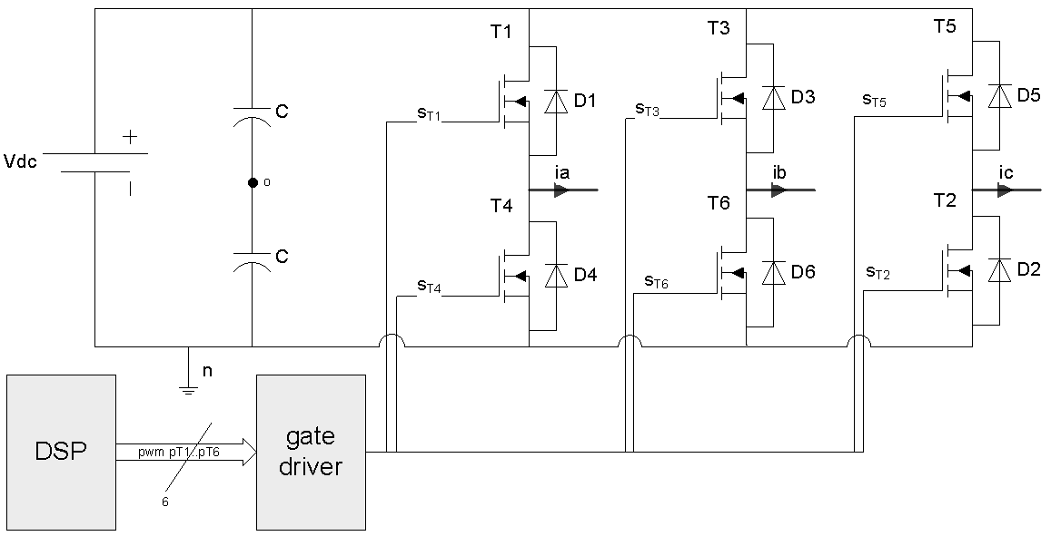
- MOSFET based VSI-fed PMSM drive block schema. (figure caption)
In Fig. 2, gate signals (pT1&pT4) from DSP output to MOSFETs input (sT1&sT4) are given. The dead time (t_{dead}), the turn on/off delay time, the rise/fall time of the gate driver/MOSFET, the voltage drops on drain to source (V_{ds}) and on freewheeling diode (V_{FWD_on}) of the MOSFET are all included to get actual output voltage of the lag A midpoint. Note that parasitic capacitances and zero-current clamp effects are beyond the scope of this work.
The phase current out of the inverter is assumed to be positive. When the phase current ia is positive, the current goes through the freewheeling diode D4 and when the phase current ia is negative the current goes through the freewheeling diode D1 during the dead time plus turn on/off times. Due to output voltage depends on the direction of the current it introduce uncontrollability region when the power switches do not conduct. As can be seen in Fig. 2. when the phase current ia is positive, average actual output voltage is less than the ideal output voltage, this situation is versa visa when ia is negative.
Analysis demonstrates that this output voltage distortion due to nonlinearities introduces fifth and seventh harmonics in the phase current in the stationary reference frame and sixth harmonics and its multiples in the d and q current in the d-q reference frame [9]. This situation causes the ripple on the phase current and also d-q currents, torque pulsations, reduce the control performance and also reduce efficacy of the field oriented vector control.
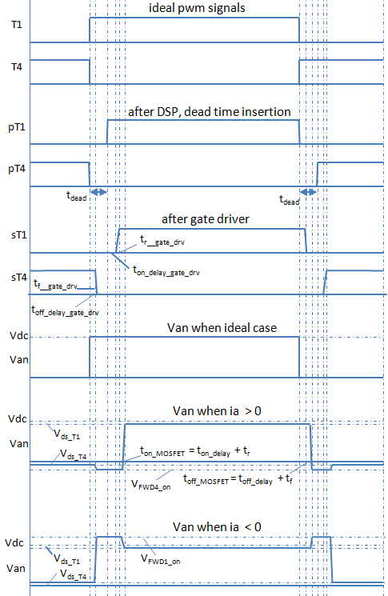
- Gate signals and lag A output voltages of the MOSFET based VSI-fed PMSM drive

Experımental Works
In thi

Observation of current harmonics due to nonlinear effects
To observe current harmonics in the phase current and also in the d-q reference frame currents, an air cored (ironless winding) low inductance PMSM is driven by MOSFET based two level three phase VSI-fed motor drive at open loop. SUM90N10 type MOSFET, irs2336d type gate driver and C2000 F28335 type DSP is used. Some of parameters of the motor is given in Table I.
- PMSM Parameters
Parameters of the PMSM
Parameters | Value | Parameters | Value
nominal voltage [V] | 24 | torque constant [mNm/A] | 12.8
nominal torque [mNm] | 63.3 | terminal inductance [mH] | 0.0295
nominal speed [rpm] | 16700 | terminal resistance [Ohm] | 0.248
nominal current [A] | 5.45 | number of pole pairs [-] | 2

efine abbreviations and acronyms the first time they are used in the text, even after they have been defined in the abstract. Abbreviations such as IEEE, SI, MKS, CGS, sc, dc, and rms do not have to be defined. Do not use abbreviations in the title or heads unless they are unavoidable.

Units
- Use either SI (MKS) or CGS as primary units. (SI units are encouraged.) English units may be used as secondary units (in parentheses). An exception would be the use of English units as identifiers in trade, such as “3.5-inch disk drive”.
- Avoid combining SI and CGS units, such as current in amperes and magnetic field in oersteds. This often leads to confusion because equations do not balance dimensionally. If you must use mixed units, clearly state the units for each quantity that you use in an equation.
- Do not mix complete spellings and abbreviations of units: “Wb/m2” or “webers per square meter”, not “webers/m2”. Spell out units when they appear in text: “. . . a few henries”, not “. . . a few H”.
- Use a zero before decimal points: “0.25”, not “.25”. Use “cm3”, not “cc”. (bullet list)
Identify applicable funding agency here. If none, delete this text box.

Equations
The equations are an exception to the prescribed specifications of this template. You will need to determine whether or not your equation should be typed using either the Times New Roman or the Symbol font (please no other font). To create multileveled equations, it may be necessary to treat the equation as a graphic and insert it into the text after your paper is styled.
Number equations consecutively. Equation numbers, within parentheses, are to position flush right, as in (1), using a right tab stop. To make your equations more compact, you may use the solidus ( / ), the exp function, or appropriate exponents. Italicize Roman symbols for quantities and variables, but not Greek symbols. Use a long dash rather than a hyphen for a minus sign. Punctuate equations with commas or periods when they are part of a sentence, as in:
a  b    
Note that the equation is centered using a center tab stop. Be sure that the symbols in your equation have been defined before or immediately following the equation. Use “(1)”, not “Eq. (1)” or “equation (1)”, except at the beginning of a sentence: “Equation (1) is . . .”

Some Common Mistakes
- The word “data” is plural, not singular.
- The subscript for the permeability of vacuum μ₀, and other common scientific constants, is zero with subscript formatting, not a lowercase letter “o”.
- In American English, commas, semicolons, periods, question and exclamation marks are located within quotation marks only when a complete thought or name is cited, such as a title or full quotation. When quotation marks are used, instead of a bold or italic typeface, to highlight a word or phrase, punctuation should appear outside of the quotation marks. A parenthetical phrase or statement at the end of a sentence is punctuated outside of the closing parenthesis (like this). (A parenthetical sentence is punctuated within the parentheses.)
- A graph within a graph is an “inset”, not an “insert”. The word alternatively is preferred to the word “alternately” (unless you really mean something that alternates).
- Do not use the word “essentially” to mean “approximately” or “effectively”.
- In your paper title, if the words “that uses” can accurately replace the word “using”, capitalize the “u”; if not, keep using lower-cased.
- Be aware of the different meanings of the homophones “affect” and “effect”, “complement” and “compliment”, “discreet” and “discrete”, “principal” and “principle”.
- Do not confuse “imply” and “infer”.
- The prefix “non” is not a word; it should be joined to the word it modifies, usually without a hyphen.
- There is no period after the “et” in the Latin abbreviation “et al.”.
- The abbreviation “i.e.” means “that is”, and the abbreviation “e.g.” means “for example”.
An excellent style manual for science writers is [7].

Using the Template
After the text edit has been completed, the paper is ready for the template. Duplicate the template file by using the Save As command, and use the naming convention prescribed by your conference for the name of your paper. In this newly created file, highlight all of the contents and import your prepared text file. You are now ready to style your paper; use the scroll down window on the left of the MS Word Formatting toolbar.

Authors and Affiliations
The template is designed for, but not limited to, six authors. A minimum of one author is required for all conference articles. Author names should be listed starting from left to right and then moving down to the next line. This is the author sequence that will be used in future citations and by indexing services. Names should not be listed in columns nor group by affiliation. Please keep your affiliations as succinct as possible (for example, do not differentiate among departments of the same organization).

For papers with more than six authors: Add author names horizontally, moving to a third row if needed for more than 8 authors.

For papers with less than six authors: To change the default, adjust the template as follows.

Selection: Highlight all author and affiliation lines.

Change number of columns: Select the Columns icon from the MS Word Standard toolbar and then select the correct number of columns from the selection palette.

Deletion: Delete the author and affiliation lines for the extra authors.

Identify the Headings
Headings, or heads, are organizational devices that guide the reader through your paper. There are two types: component heads and text heads.
Component heads identify the different components of your paper and are not topically subordinate to each other. Examples include Acknowledgments and References and, for these, the correct style to use is “Heading 5”. Use “figure caption” for your Figure captions, and “table head” for your table title. Run-in heads, such as “Abstract”, will require you to apply a style (in this case, italic) in addition to the style provided by the drop down menu to differentiate the head from the text.
Text heads organize the topics on a relational, hierarchical basis. For example, the paper title is the primary text head because all subsequent material relates and elaborates on this one topic. If there are two or more sub-topics, the next level head (uppercase Roman numerals) should be used and, conversely, if there are not at least two sub-topics, then no subheads should be introduced. Styles named “Heading 1”, “Heading 2”, “Heading 3”, and “Heading 4” are prescribed.

Figures and Tables

Positioning Figures and Tables: Place figures and tables at the top and bottom of columns. Avoid placing them in the middle of columns. Large figures and tables may span across both columns. Figure captions should be below the figures; table heads should appear above the tables. Insert figures and tables after they are cited in the text. Use the abbreviation “Fig. 1”, even at the beginning of a sentence.
- Table Type Styles
Table Head | Table Column Head
Table Head | Table column subhead | Subhead | Subhead
copy | More table copyª
- Sample of a Table footnote. (Table footnote)
- Example of a figure caption. (figure caption)
Figure Labels: Use 8 point Times New Roman for Figure labels. Use words rather than symbols or abbreviations when writing Figure axis labels to avoid confusing the reader. As an example, write the quantity “Magnetization”, or “Magnetization, M”, not just “M”. If including units in the label, present them within parentheses. Do not label axes only with units. In the example, write “Magnetization (A/m)” or “Magnetization {A[m(1)]}”, not just “A/m”. Do not label axes with a ratio of quantities and units. For example, write “Temperature (K)”, not “Temperature/K”.

Acknowledgment (Heading 5)
The preferred spelling of the word “acknowledgment” in America is without an “e” after the “g”. Avoid the stilted expression “one of us (R. B. G.) thanks ...”. Instead, try “R. B. G. thanks...”. Put sponsor acknowledgments in the unnumbered footnote on the first page.

References
The template will number citations consecutively within brackets [1]. The sentence punctuation follows the bracket [2]. Refer simply to the reference number, as in [3]—do not use “Ref. [3]” or “reference [3]” except at the beginning of a sentence: “Reference [3] was the first ...”
Number footnotes separately in superscripts. Place the actual footnote at the bottom of the column in which it was cited. Do not put footnotes in the abstract or reference list. Use letters for table footnotes.
Unless there are six authors or more give all authors’ names; do not use “et al.”. Papers that have not been published, even if they have been submitted for publication, should be cited as “unpublished” [4]. Papers that have been accepted for publication should be cited as “in press” [5]. Capitalize only the first word in a paper title, except for proper nouns and element symbols.
For papers published in translation journals, please give the English citation first, followed by the original foreign-language citation [6].

- Y.Murai, T.Watanabe, and H. Iwasaki, “Waveform distortion and correc- tion circuit for PWMinverter with switching lag-times,” IEEE Trans. Ind. Appl., vol. 23, no. 5, pp. 881–886, Sep./Oct. 1987
- J.-W. Choi and S.-K. Sul, “Inverter output voltage synthesis using novel dead time compensation,” Power Electronics, IEEE Transactions on, vol. 11, no. 2, pp. 221–227, Mar 1996
- K. Yamamoto, K. Shinohara, and H. Ohga, “Effect of parasitic capac- itance of power device on output voltage deviation during switching dead-time in voltage-fed pwm inverter,” in Power Conversion Confer- ence - Nagaoka 1997., Proceedings of the, vol. 2, Aug 1997, pp. 777– 782 vol.2.
- A. R.Munoz and T. A. Lipo, “Online dead-time compensation technique for open-loop PWM-VSI drives,” IEEE Trans. Power Electron., vol. 14, no. 4, pp. 683–689, Jul. 1999.
- S. J. Chee, J. Kim, and S. K. Sul, “Dead-time compensation based on pole voltage measurement,” 2015 IEEE Energy Convers. Congr. Expo. ECCE 2015, pp. 1549–1555, 2015.
- Y. Wang, S. Member, W. Xie, and X. Wang, “A Precise Voltage Distortion Compensation Strategy for Voltage Source Inverters,” vol. 65, no. 1, pp. 59–66, IEEE TRANSACTIONS ON INDUSTRIAL ELECTRONICS, VOL. 65, NO. 1, JANUARY 2018
- K. Yang, M. Yang, Z. Lang, and D. Xu, “An Adaptive Dead-time Compensation Method based on Predictive Current Control,” vol. 1, no. I, pp. 1–5, 2016.
- L. Buchta and L. Otava, “Adaptive compensation of inverter non-linearities based on the Kalman filter,” IECON Proc. (Industrial Electron. Conf., pp. 4301–4306, 2016.
- Z. Tang and B. Akin, “Compensation of dead-time effects based on revised repetitive controller for PMSM drives,” Conf. Proc. - IEEE Appl. Power Electron. Conf. Expo. - APEC, vol. 32, no. 3, pp. 2730–2737, 2017.
- Z. Tang, S. Member, B. Akin, and S. Mmeber, “A New LMS Based Algorithm to Suppress Dead- Time Effects in PMSM V / f Drives,” pp. 3156–3162, 2017.
- Y. C. Pai, J. P. Chang, M. Y. Cheng, and T. J. Liang, “Dead-time effects compensation for PMSM drives - An adaptive linear neuron approach,” 2017 IEEE 3rd Int. Futur. Energy Electron. Conf. ECCE Asia, IFEEC - ECCE Asia 2017, pp. 1025–1030, 2017.
- B. Ludek and O. Lukas, “Online adaptive compensation scheme for inverter nonlinearity in PMSM drive,” in Proc 7th Int. Congr. Ultra Mod. Telecommun. Control Syst. Workshops, Jan. 2016, pp. 166–171

- G. Eason, B. Noble, and I. N. Sneddon, “On certain integrals of Lipschitz-Hankel type involving products of Bessel functions,” Phil. Trans. Roy. Soc. London, vol. A247, pp. 529–551, April 1955. (references)
- J. Clerk Maxwell, A Treatise on Electricity and Magnetism, 3rd ed., vol. 2. Oxford: Clarendon, 1892, pp.68–73.
- I. S. Jacobs and C. P. Bean, “Fine particles, thin films and exchange anisotropy,” in Magnetism, vol. III, G. T. Rado and H. Suhl, Eds. New York: Academic, 1963, pp. 271–350.
- K. Elissa, “Title of paper if known,” unpublished.
- R. Nicole, “Title of paper with only first word capitalized,” J. Name Stand. Abbrev., in press.
- Y. Yorozu, M. Hirano, K. Oka, and Y. Tagawa, “Electron spectroscopy studies on magneto-optical media and plastic substrate interface,” IEEE Transl. J. Magn. Japan, vol. 2, pp. 740–741, August 1987 [Digests 9th Annual Conf. Magnetics Japan, p. 301, 1982].
- M. Young, The Technical Writer’s Handbook. Mill Valley, CA: University Science, 1989.

IEEE conference templates contain guidance text for composing and formatting conference papers. Please ensure that all template text is removed from your conference paper prior to submission to the conference. Failure to remove template text from your paper may result in your paper not being published.

We suggest that you use a text box to insert a graphic (which is ideally a 300 dpi TIFF or EPS file, with all fonts embedded) because, in an MSW document, this method is somewhat more stable than directly inserting a picture.
To have non-visible rules on your frame, use the MSWord “Format” pull-down menu, select Text Box > Colors and Lines to choose No Fill and No Line.

