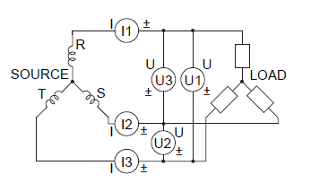

Open loop

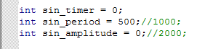

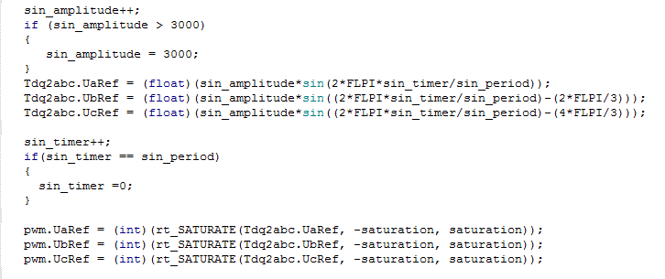

**40hz**

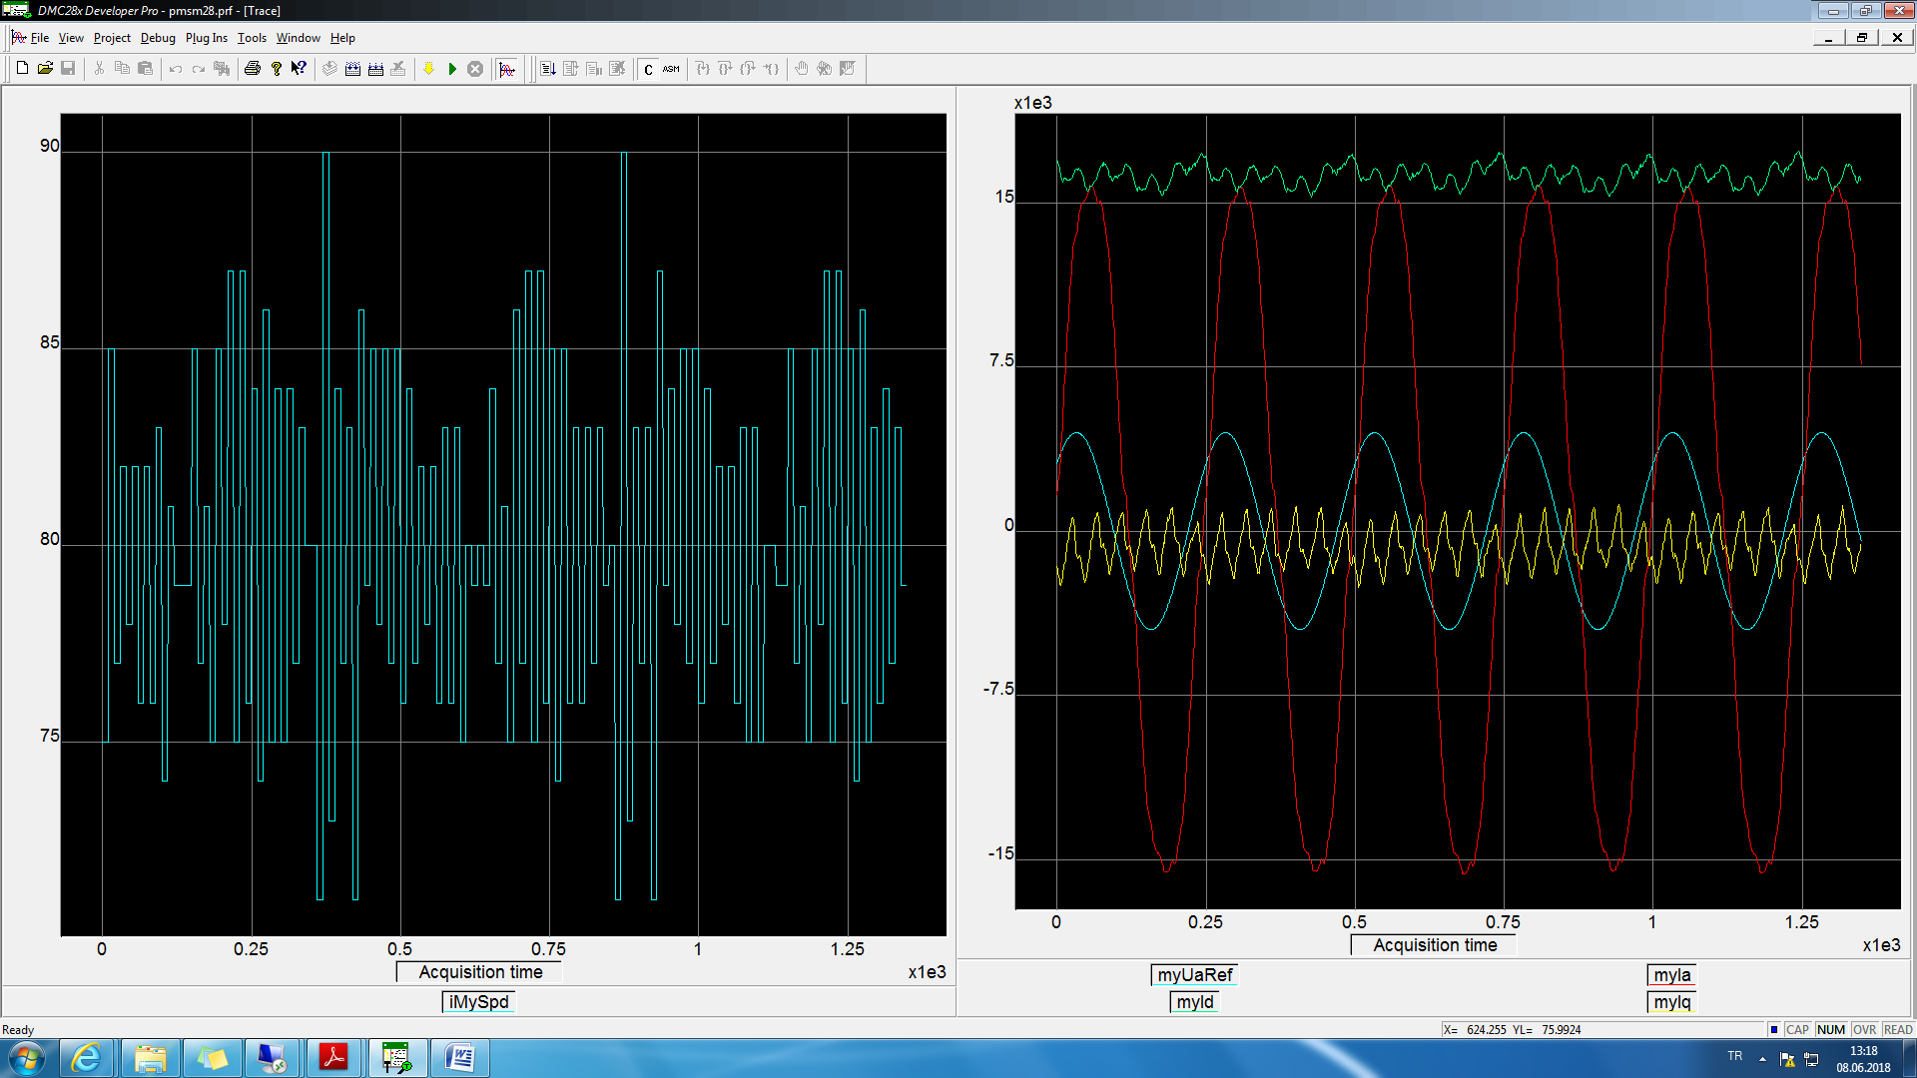

wave40hzWithoutReductor.txt

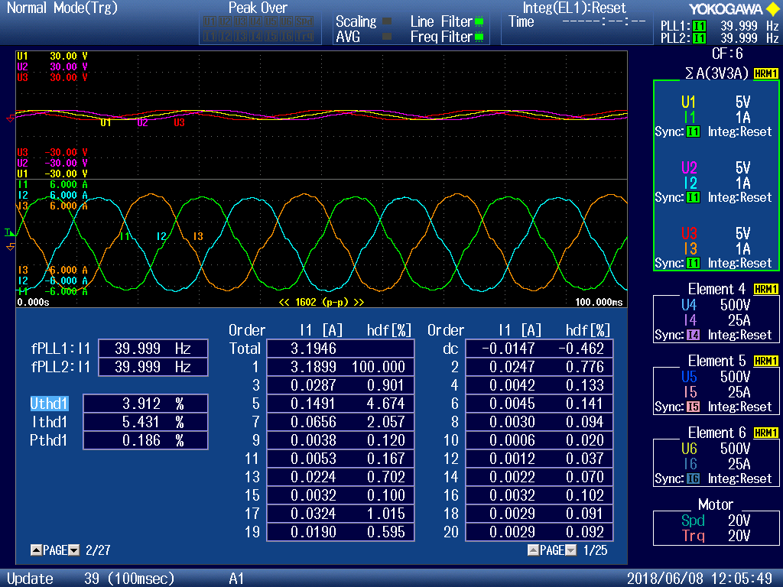

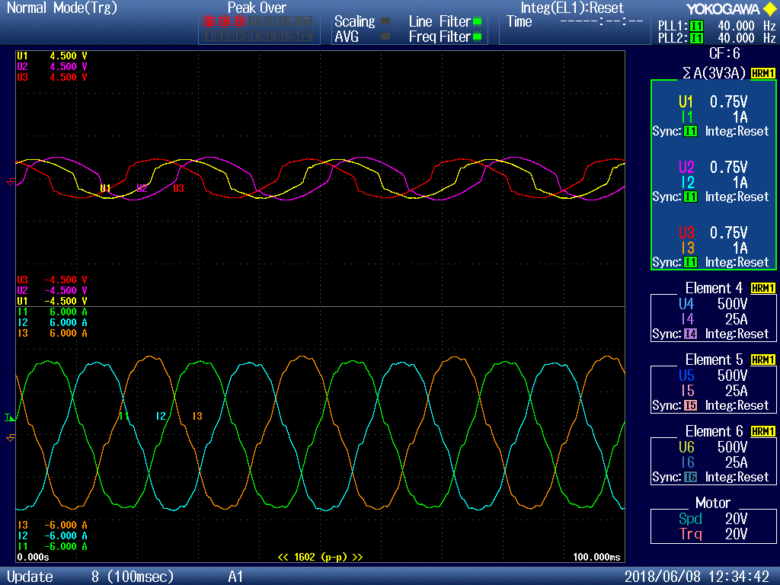

BMP0,06

**20hz**

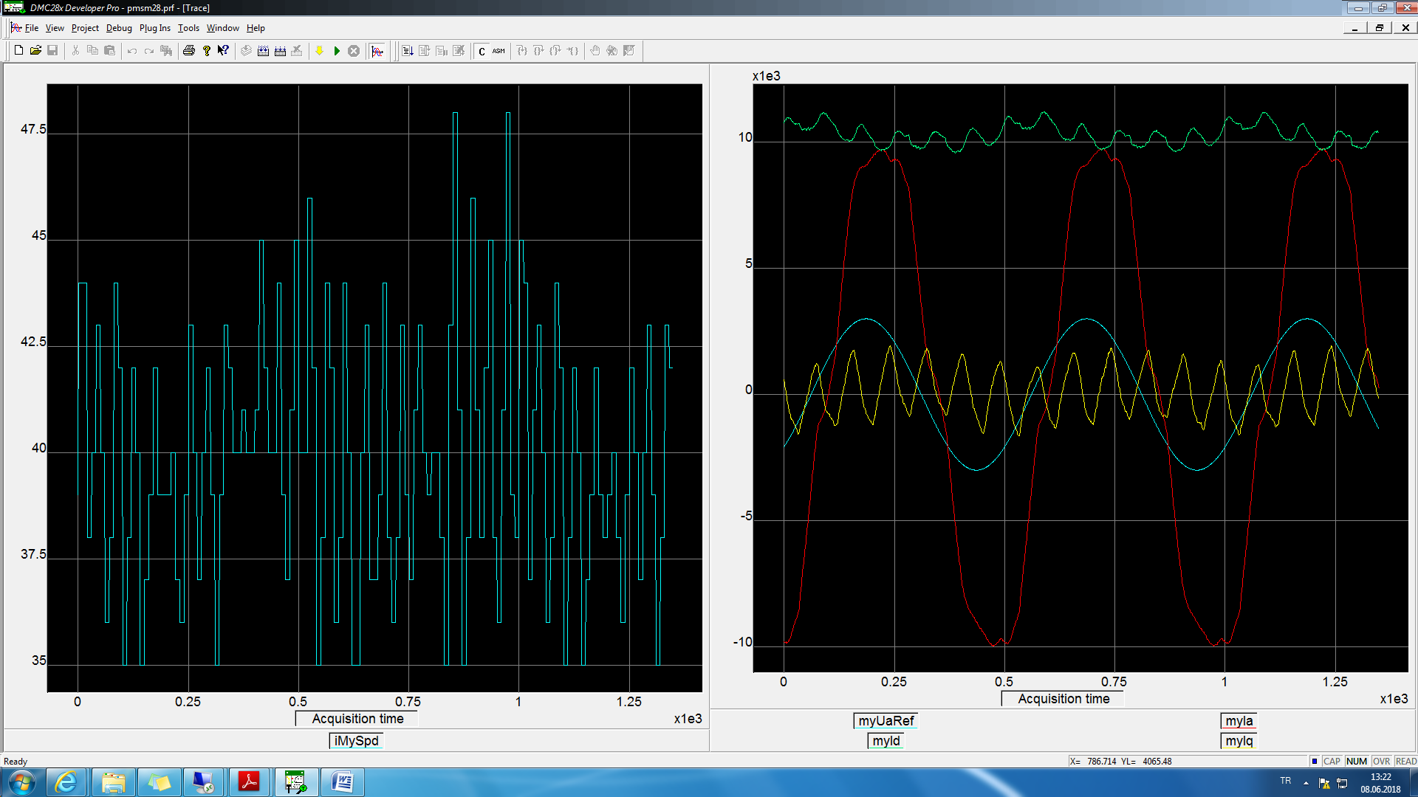

wave20hzWithoutReductor.txt

BMP01,07

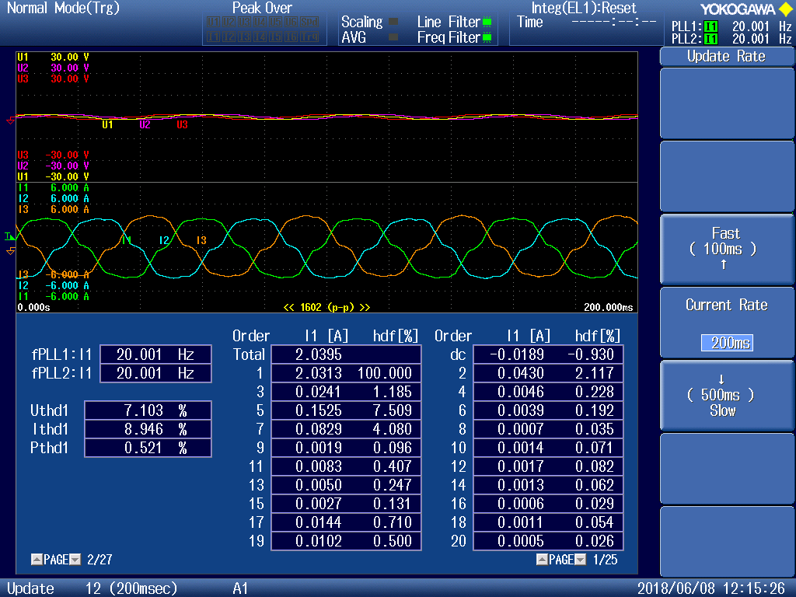

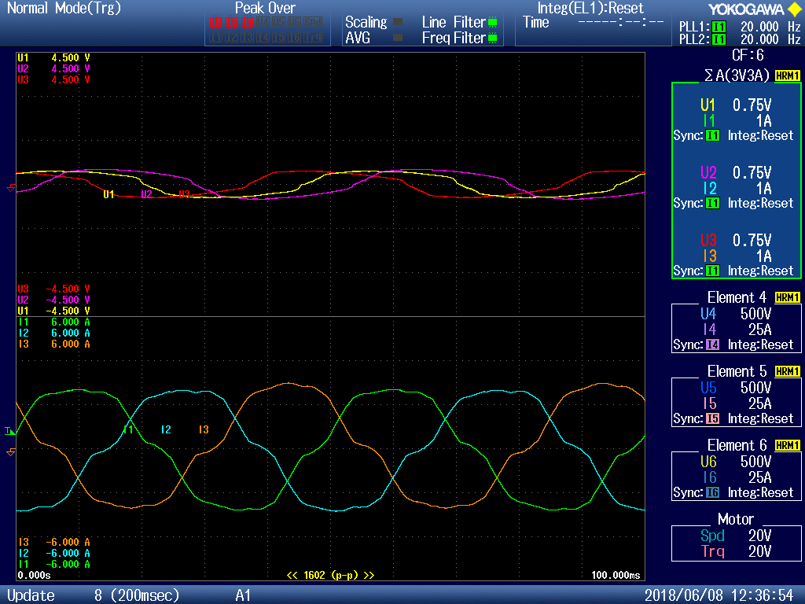

**10hz**

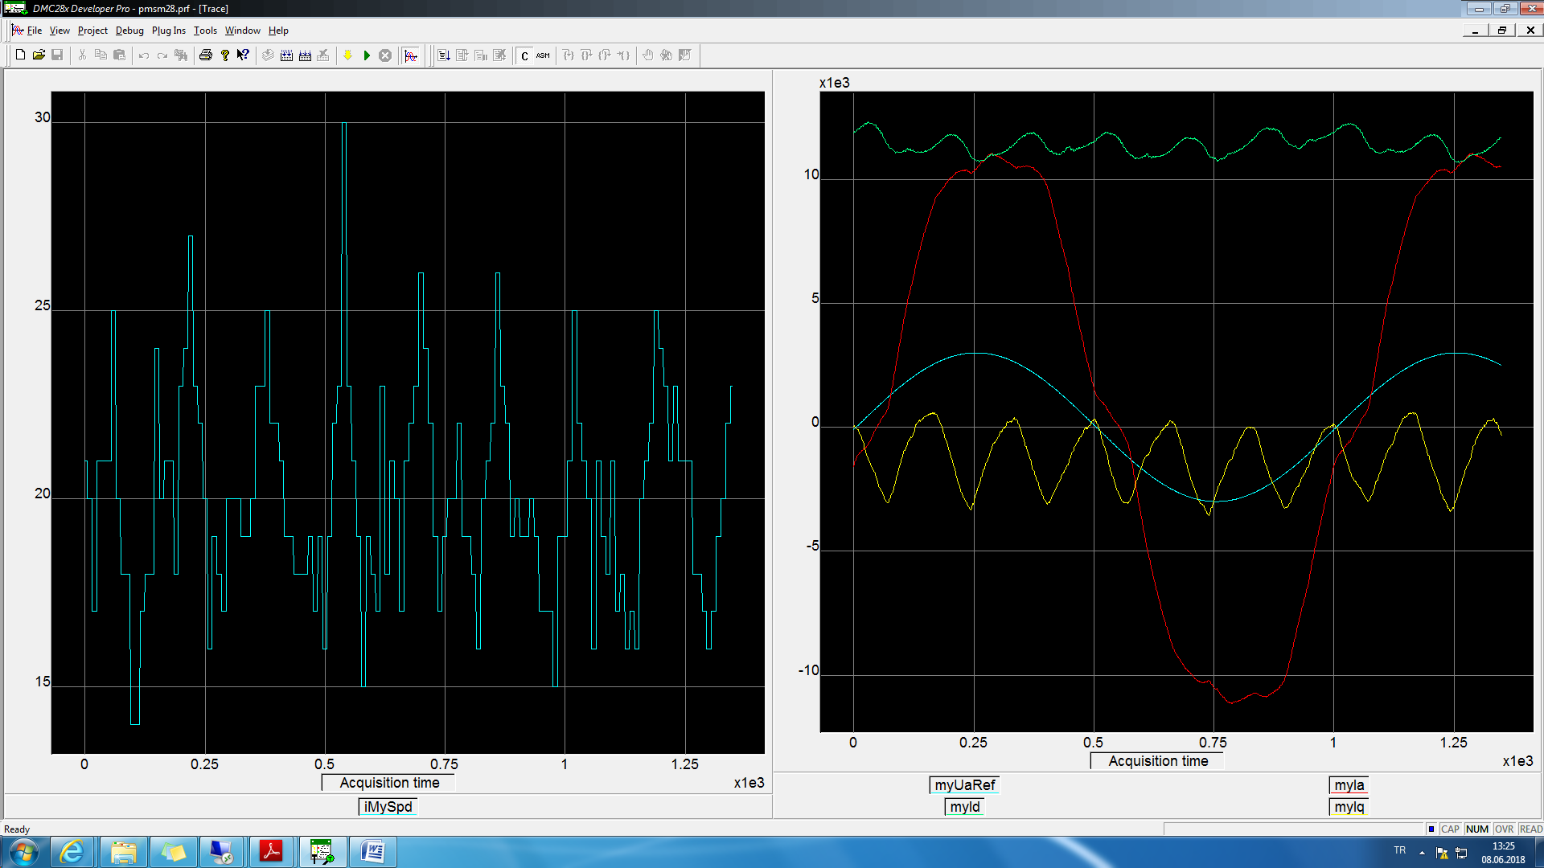

wave10hzWithoutReductor.txt

BMP02,08

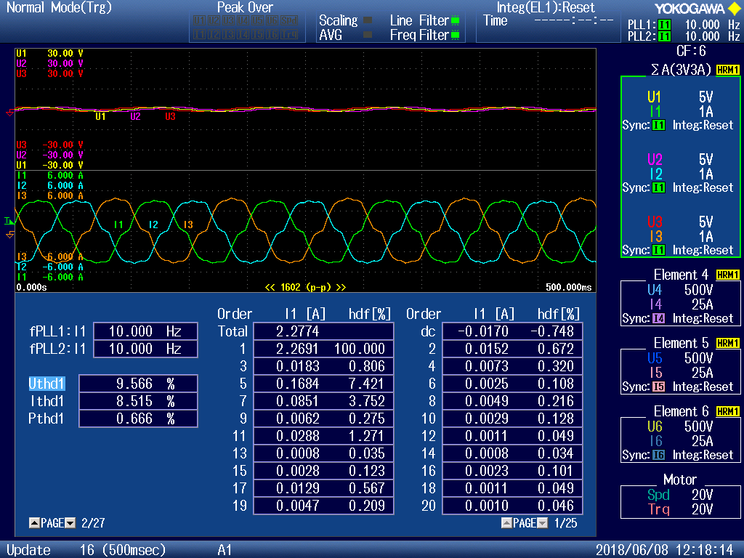

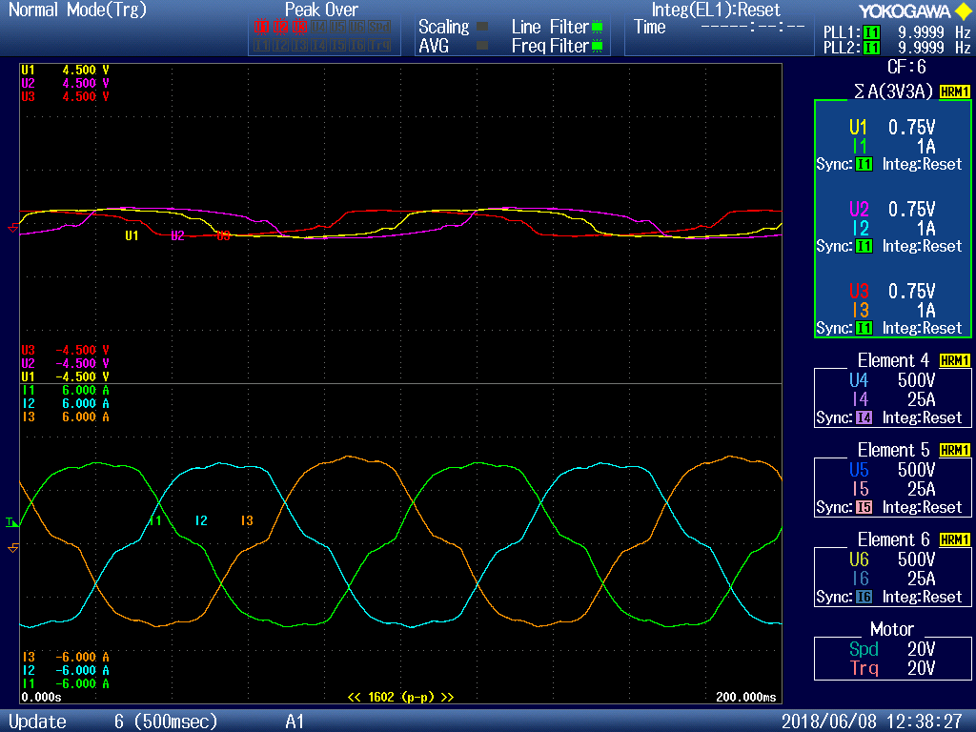

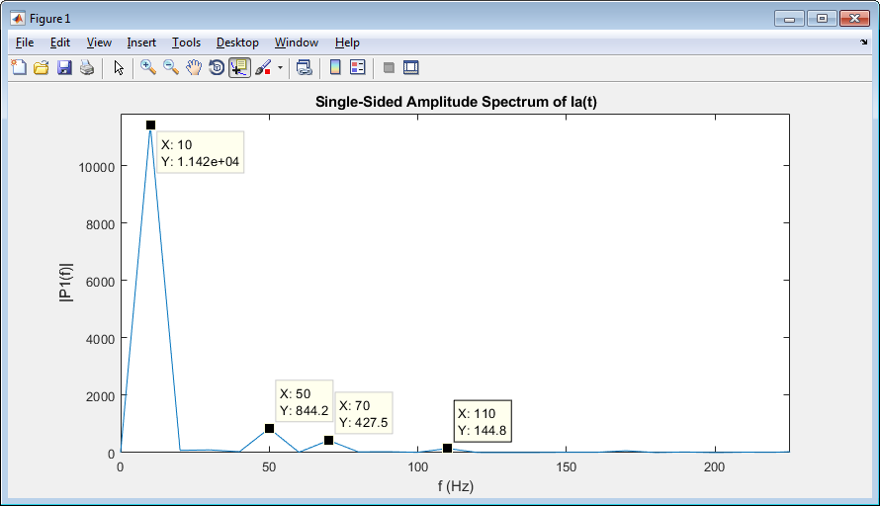

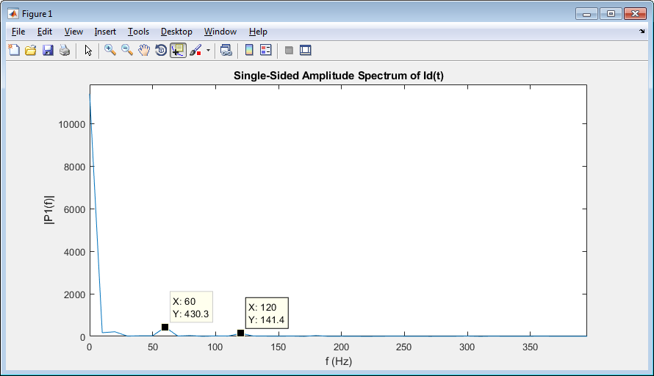

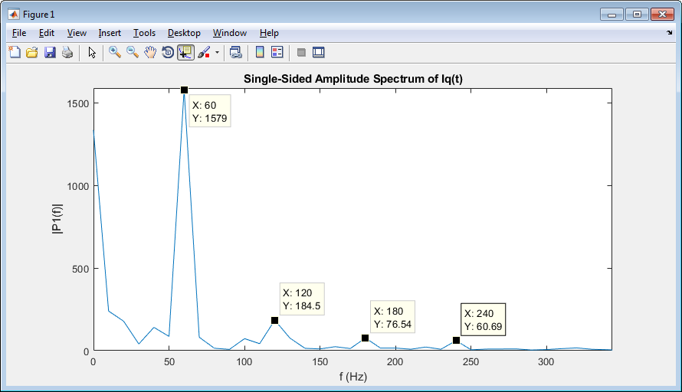

**5Hz**

if (2 == cLogcntr)

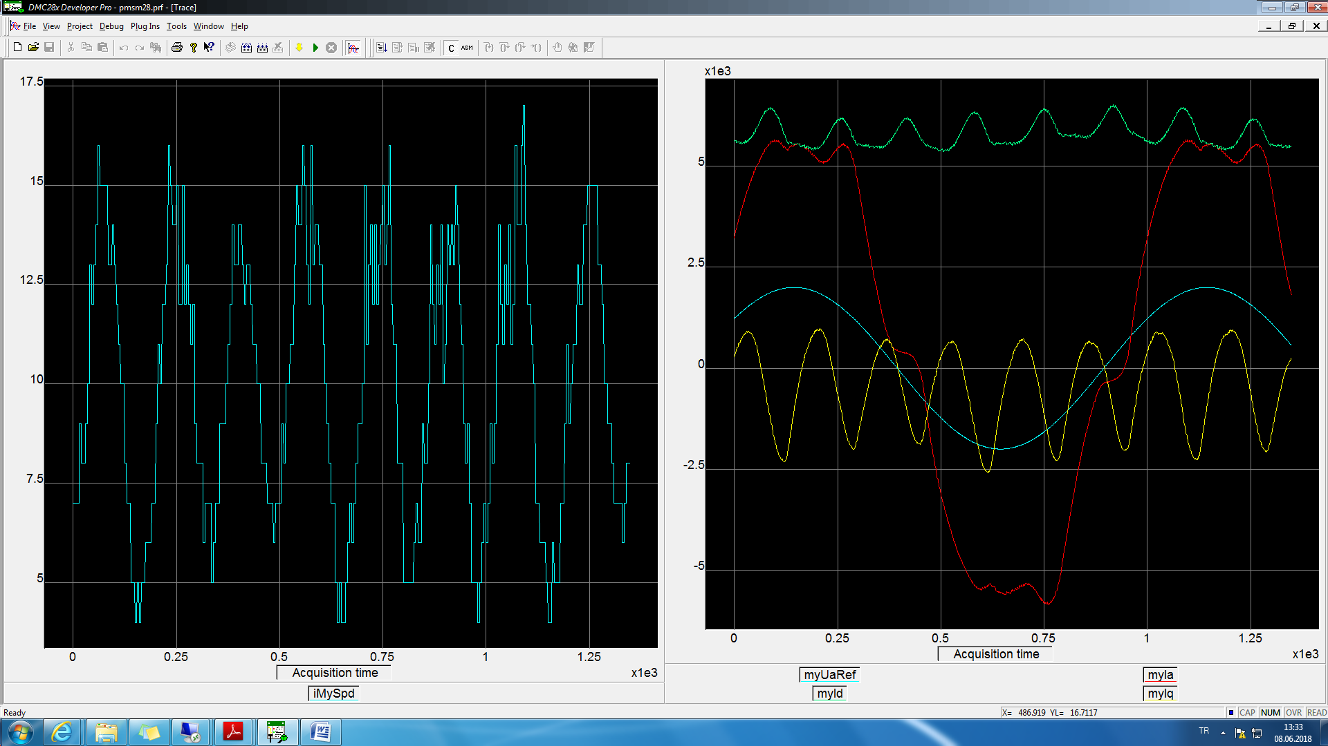

wave5hzWithoutReductor.txt

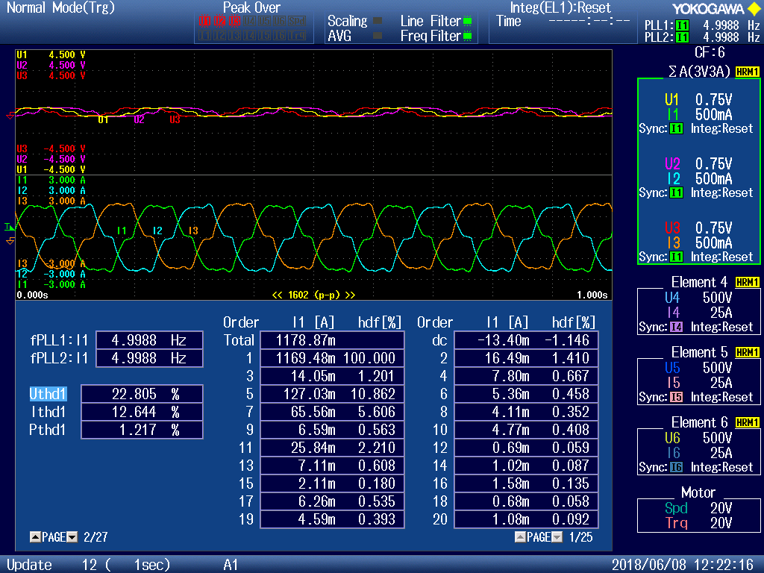

BMP03

2.5Hz

if (5 == cLogcntr)

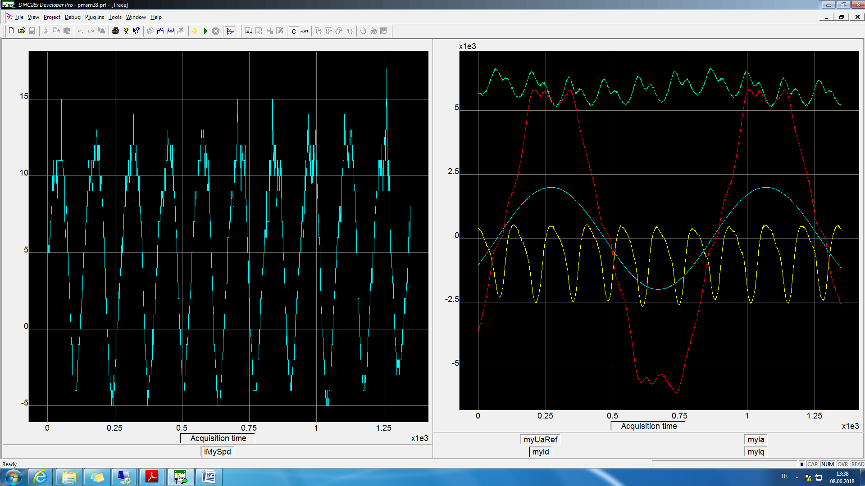

wave2p5hzWithoutReductor.txt

BMP04,05

