Open loop

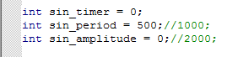

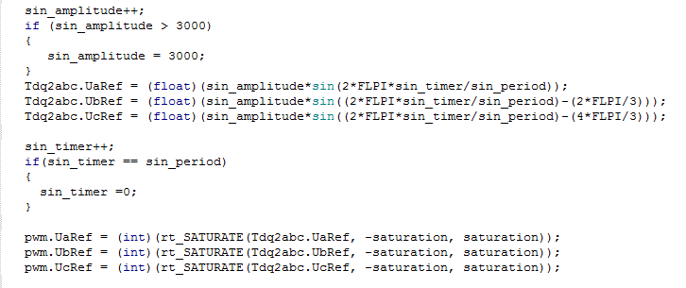

**10hz**

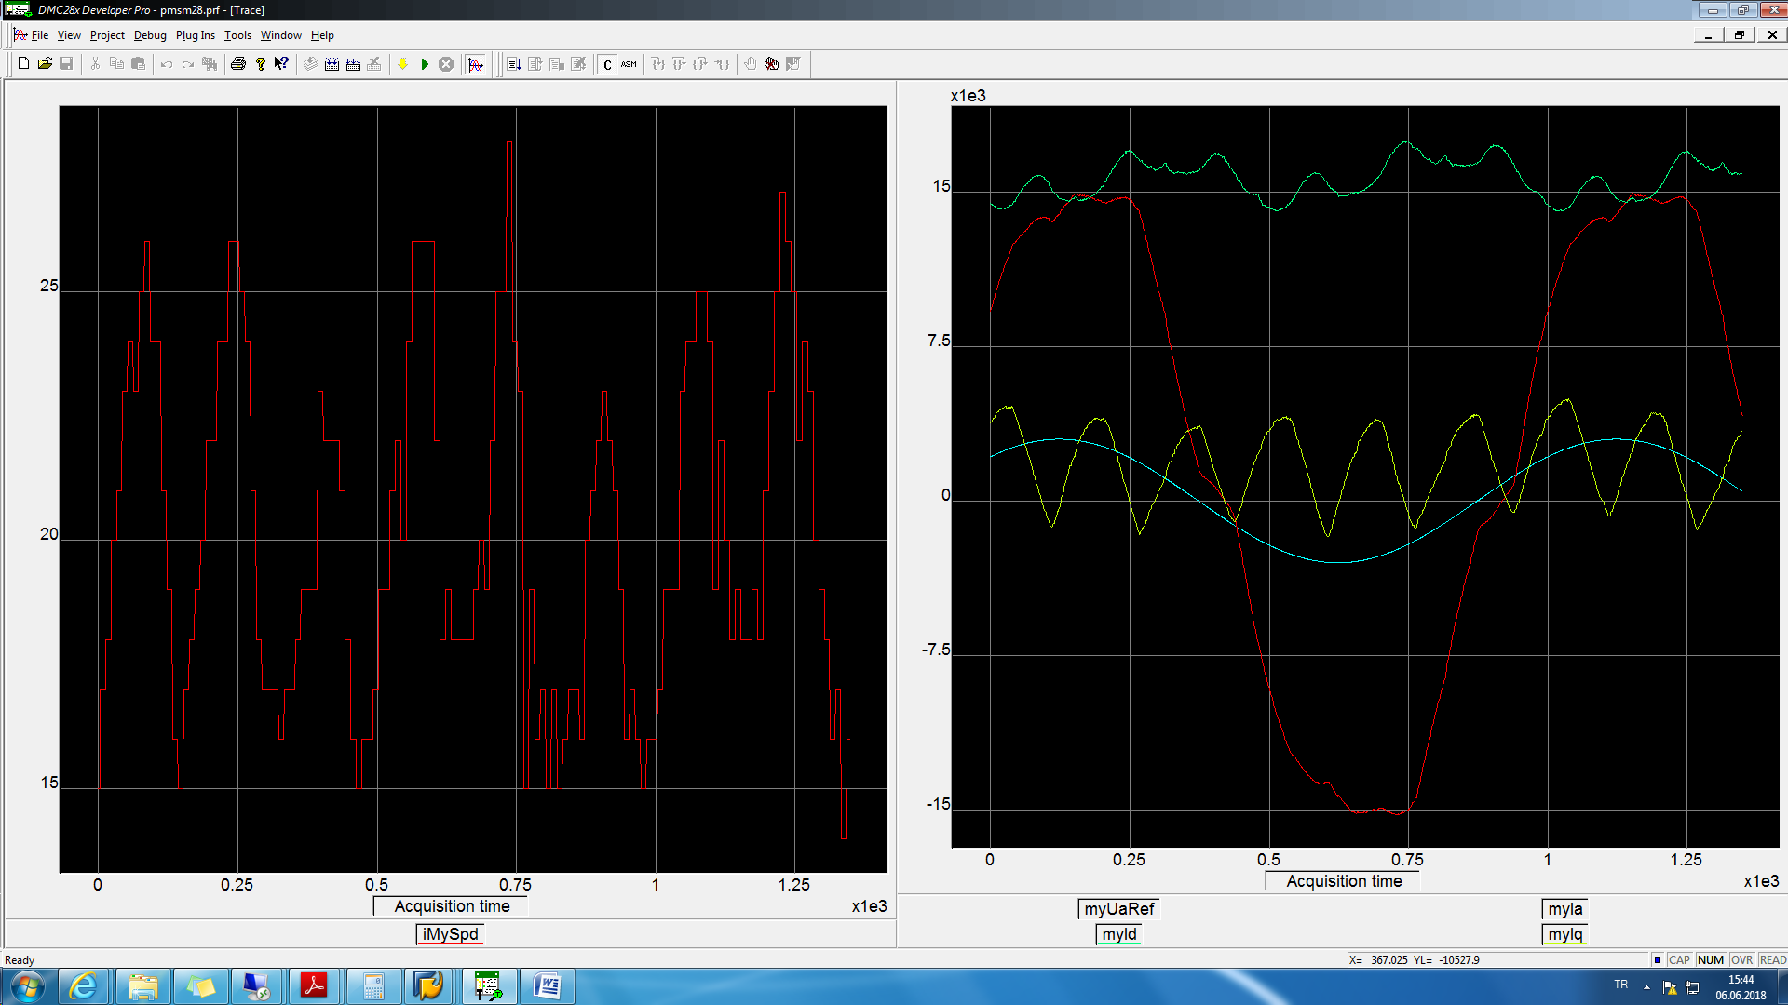

wave10hz.txt

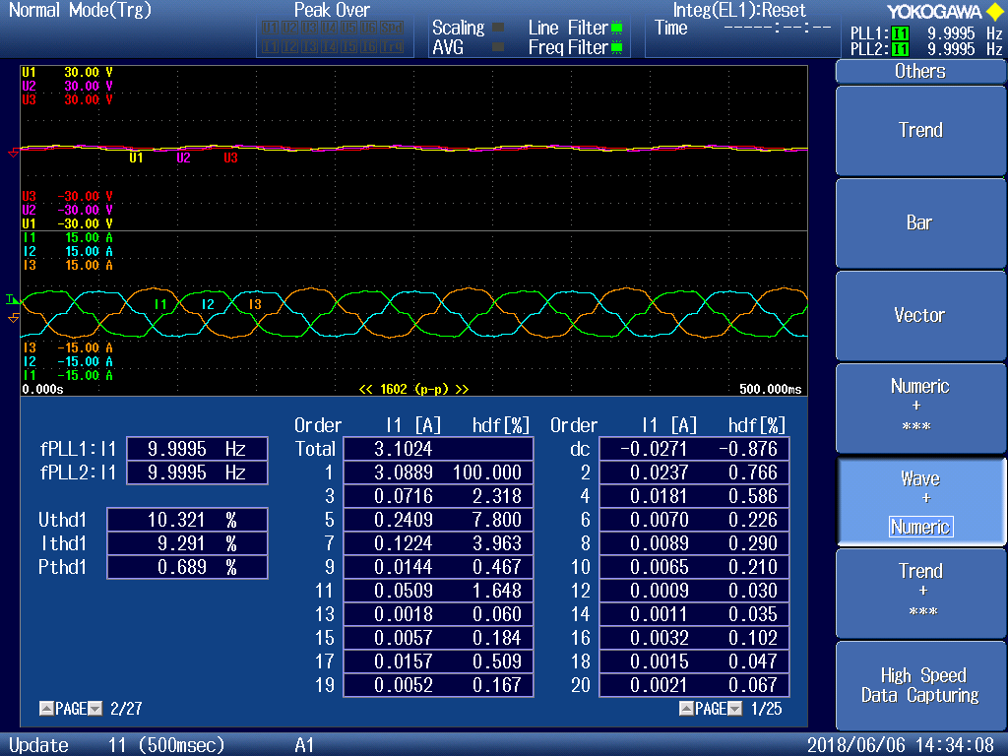

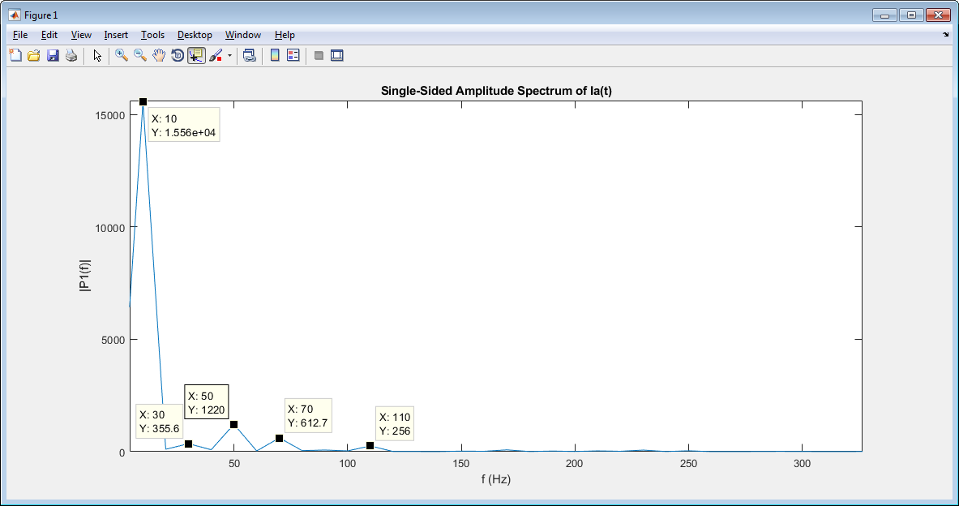

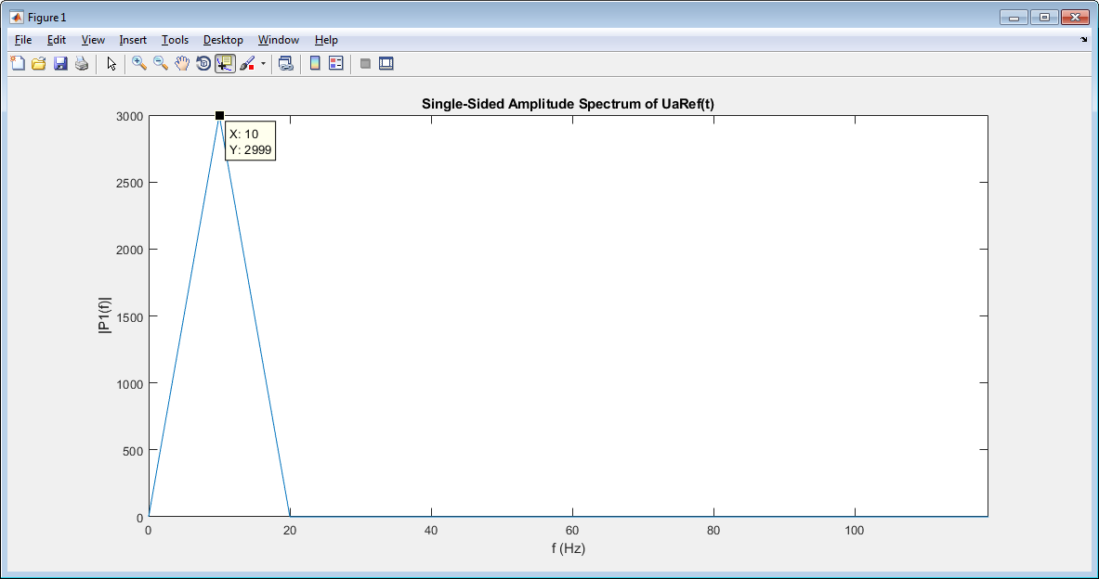

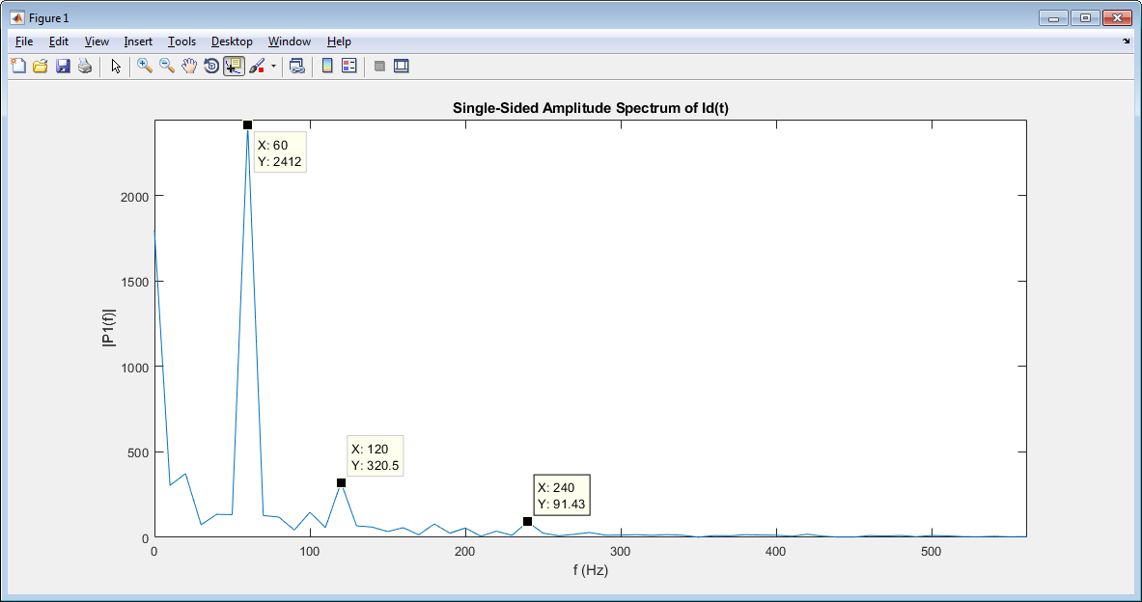

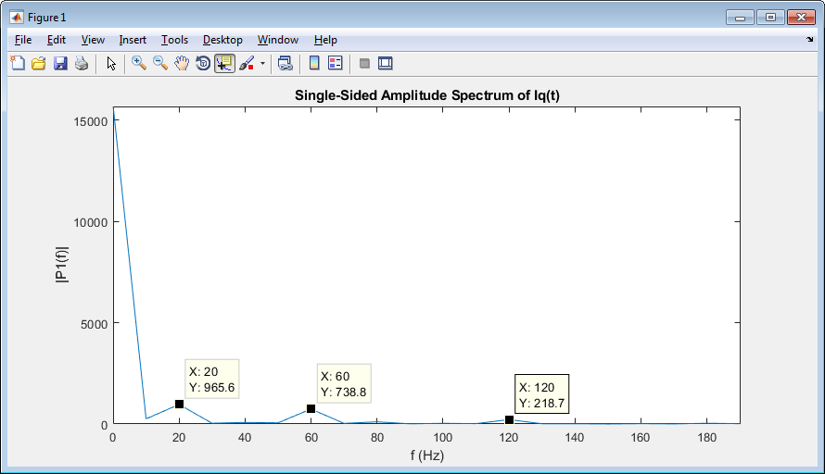

**20Hz**

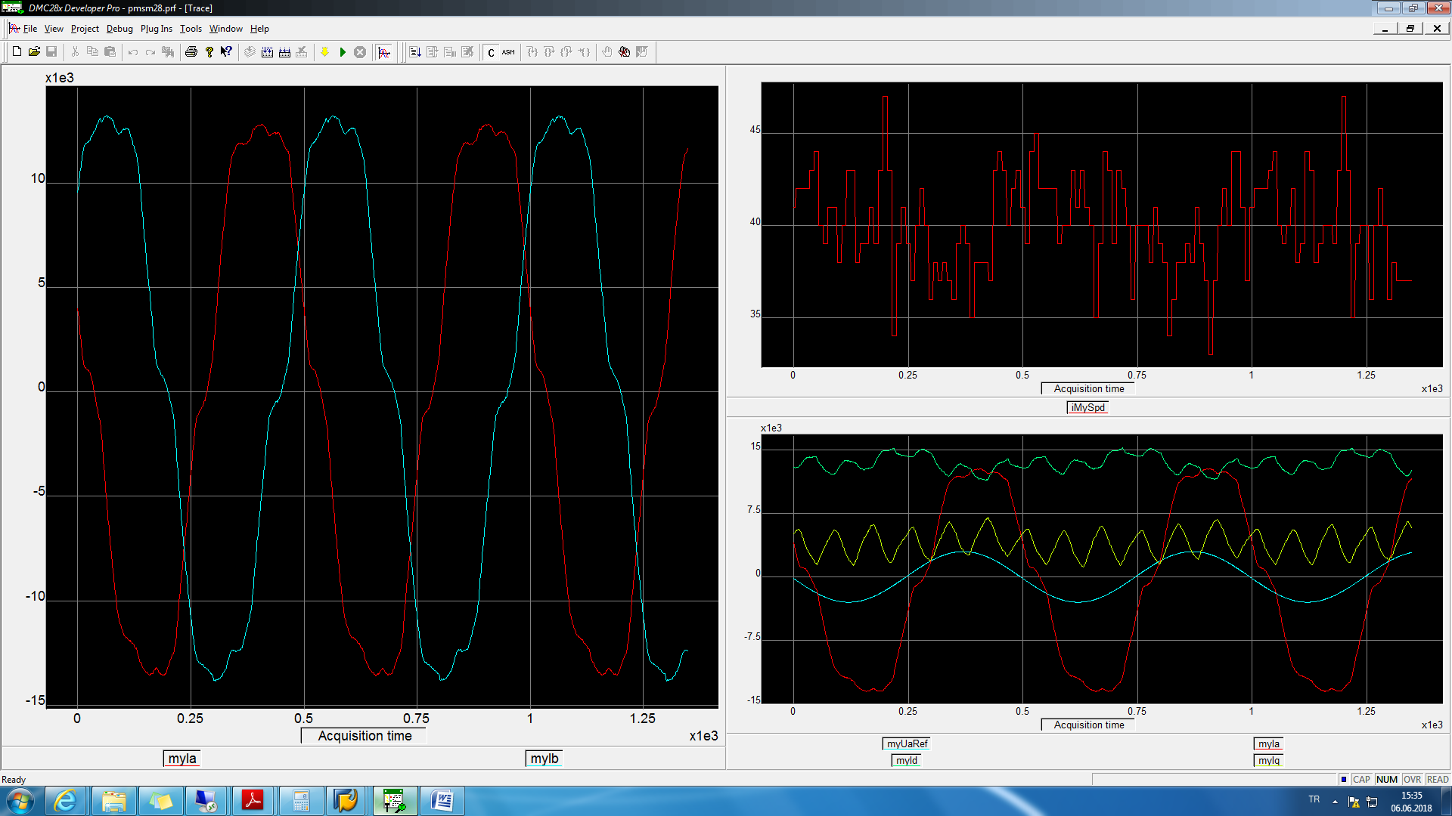

wave20hz.txt

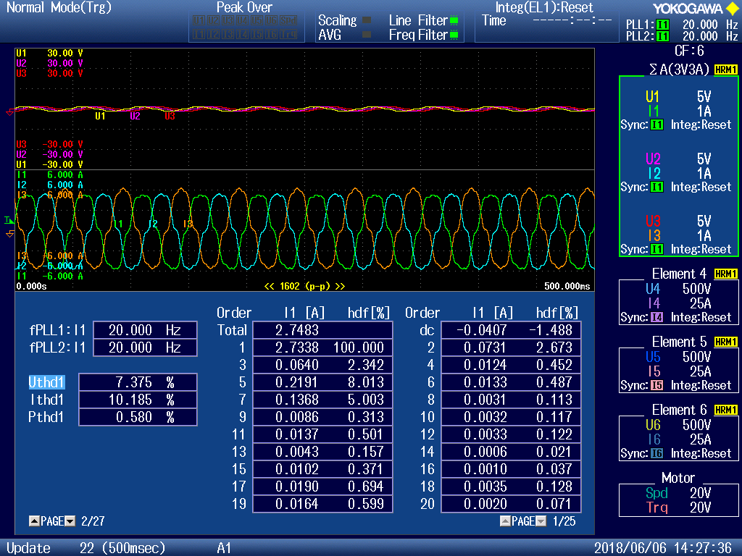

**25hz**

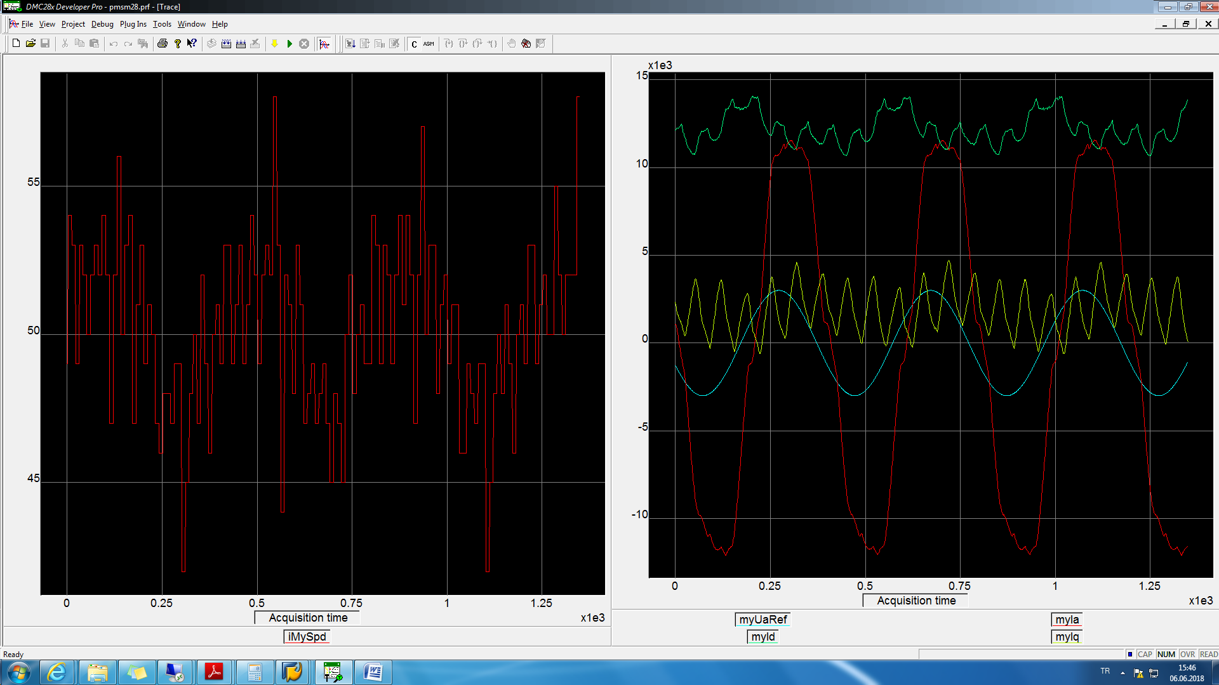

wave25hz.txt

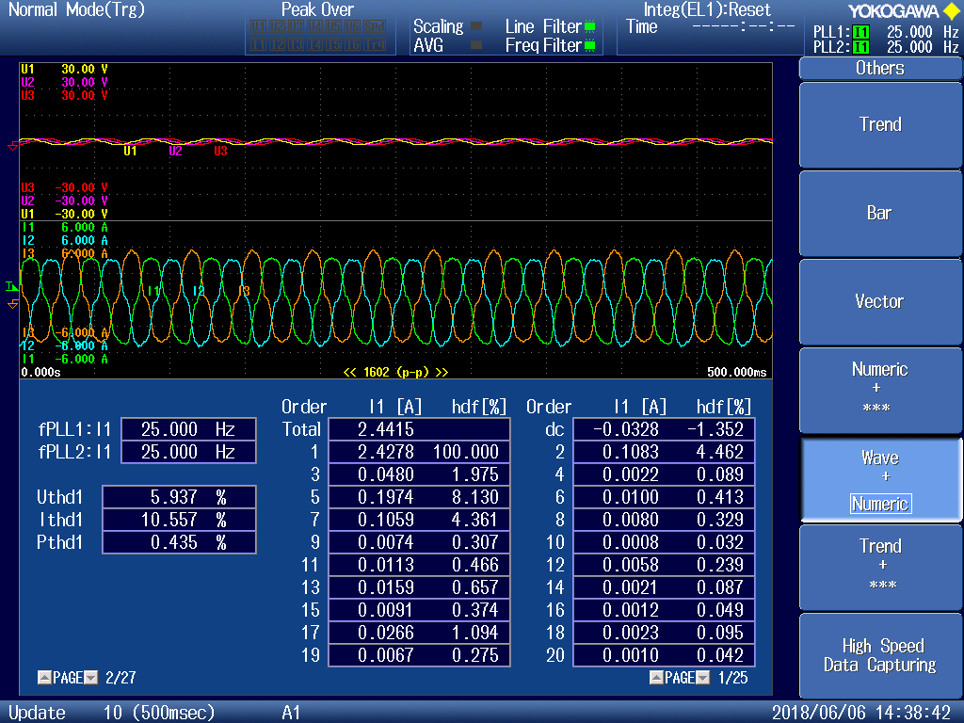

**40Hz**

sin_amplitude = 4000;

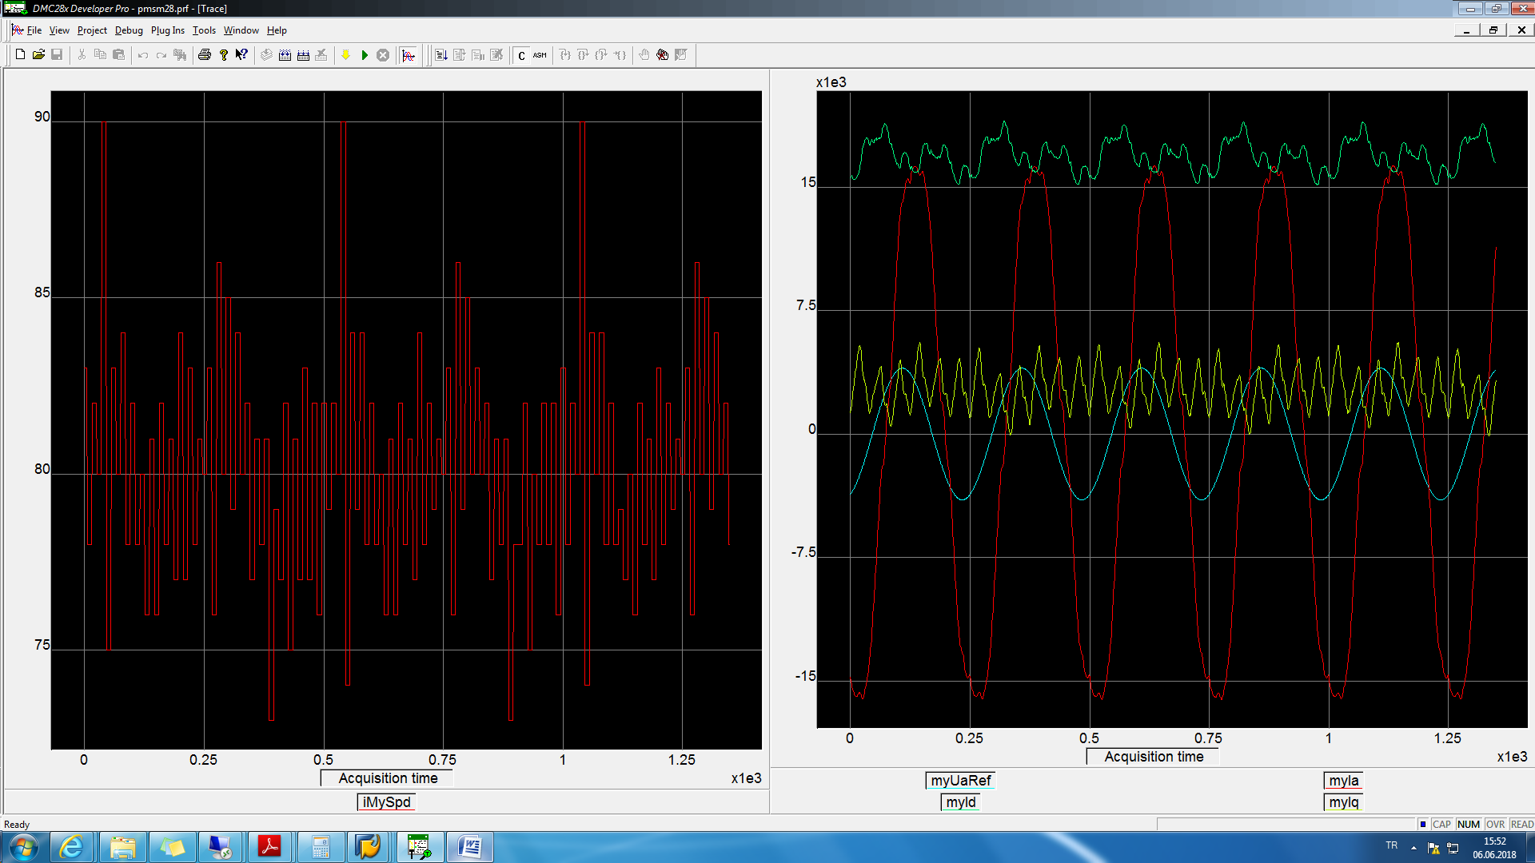

wave40hz.txt

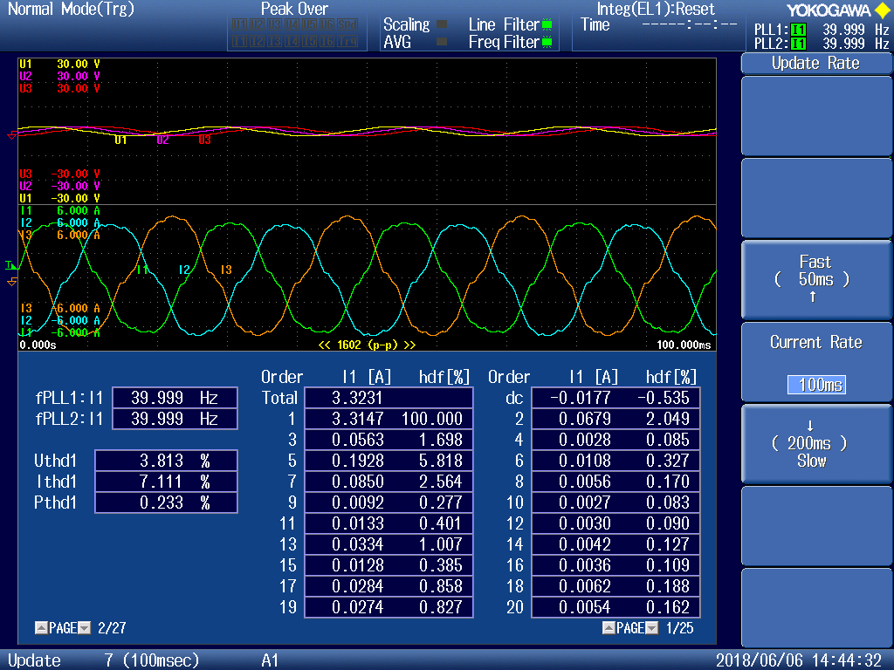

**Voltage test**

**10Hz**

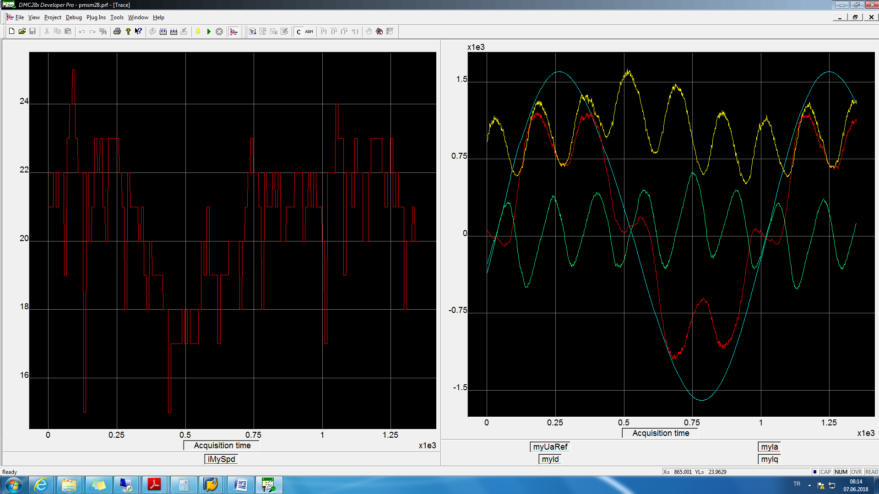

wave10hzVoltage.txt

BMP07

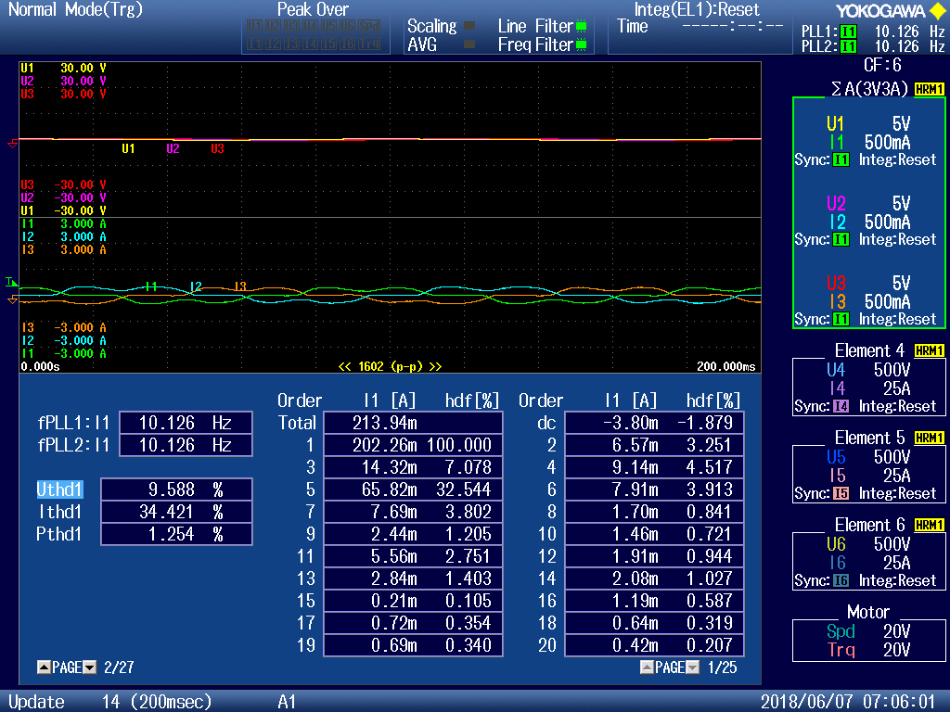

**20Hz**

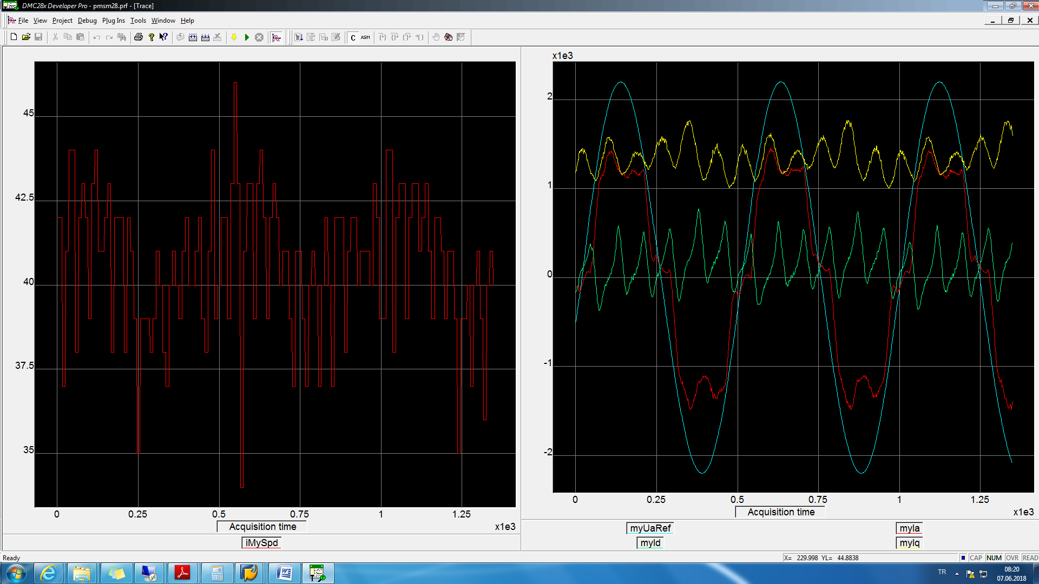

wave20hzVoltage.txt

BMP08

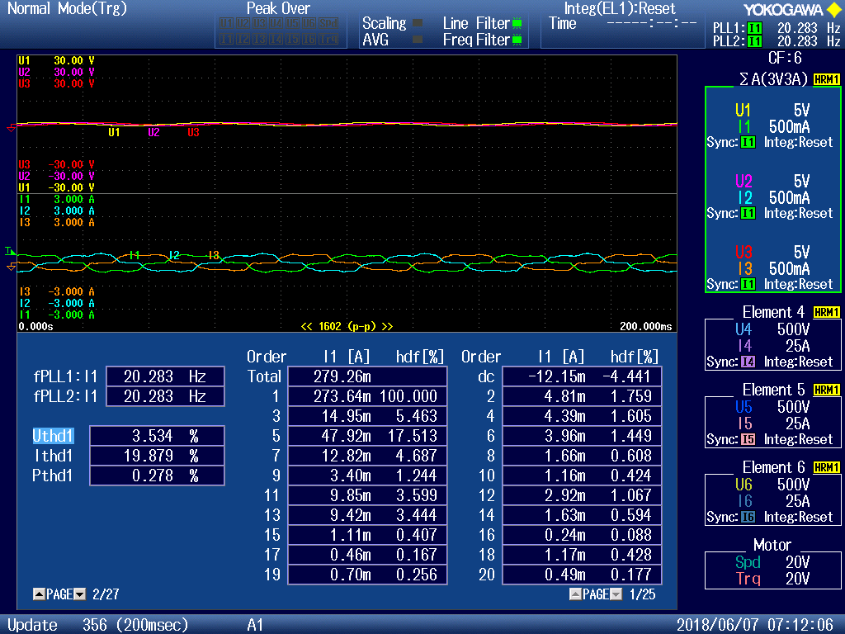

**25Hz**

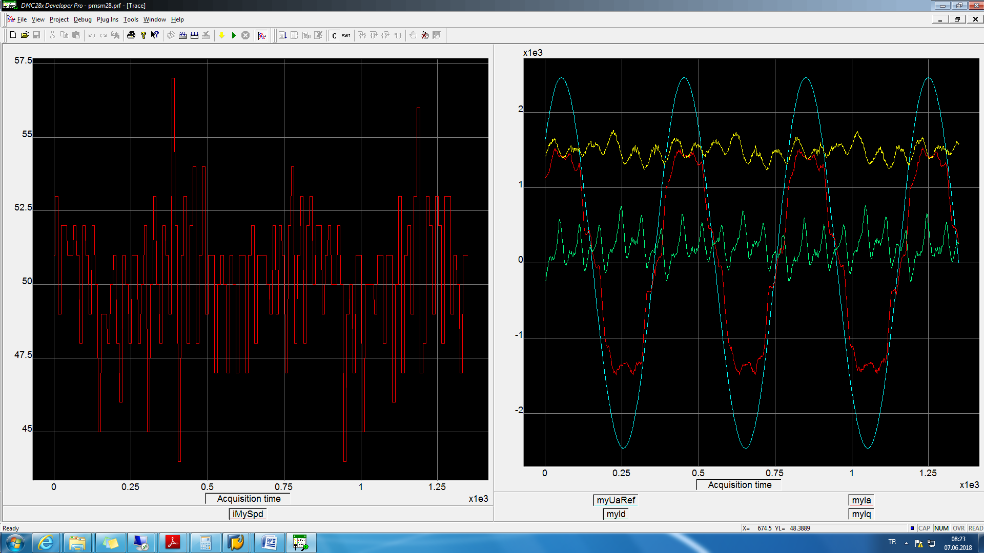

wave25hzVoltage.txt

BMP09

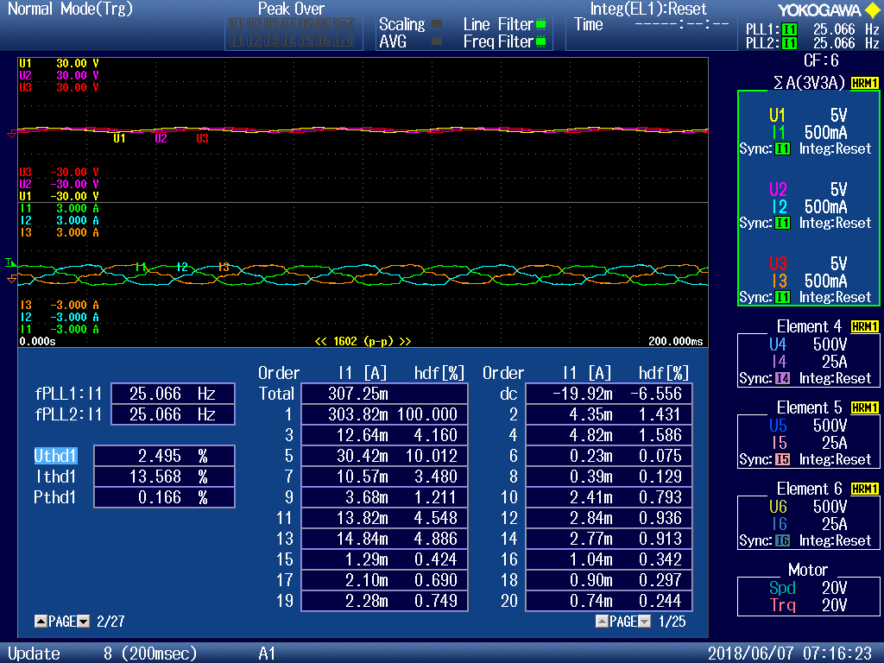

**40Hz**

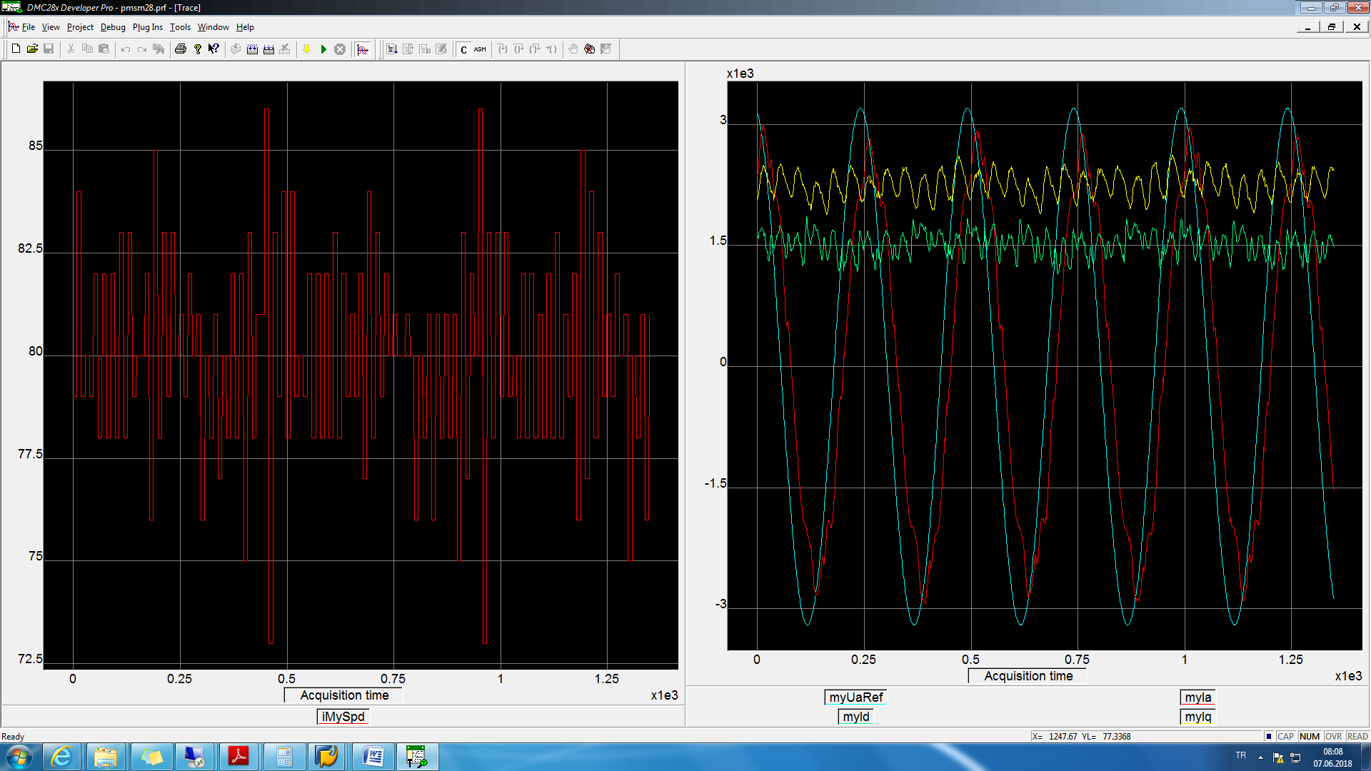

wave40hzVoltage.txt

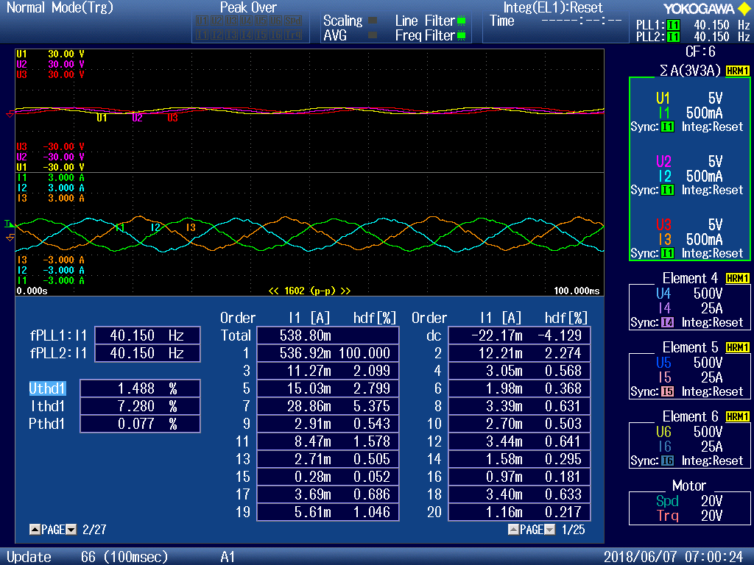

BMP06

**Speed test**

**10Hz**

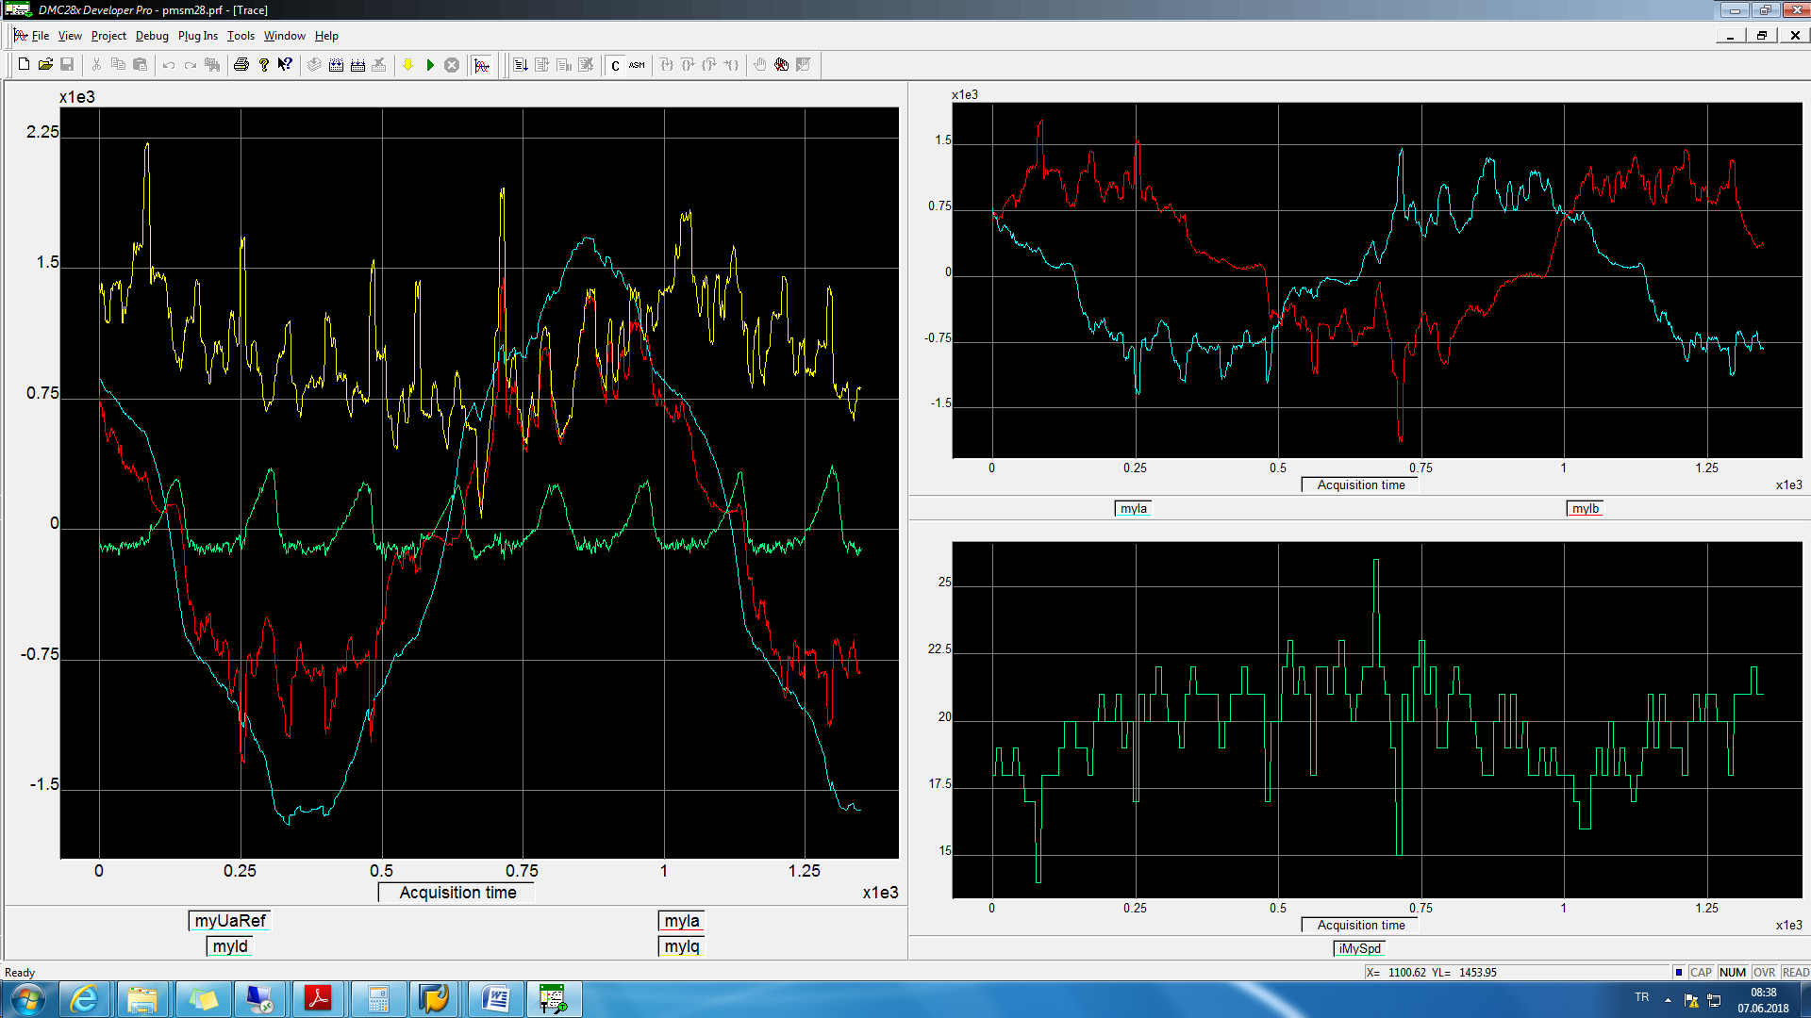

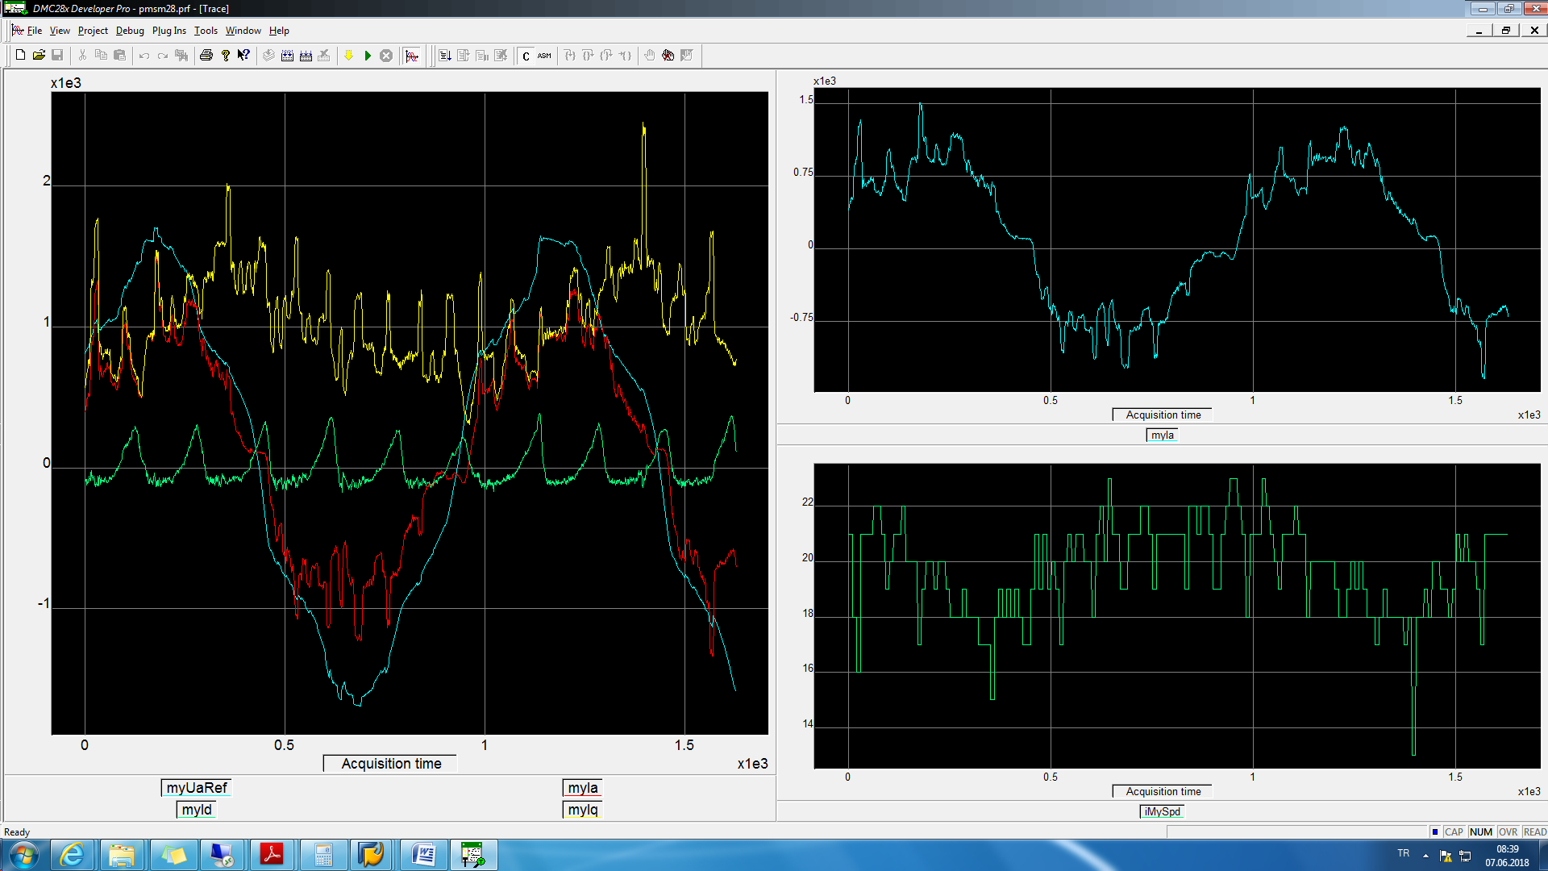

wave10hzSpeed.txt

BMP10

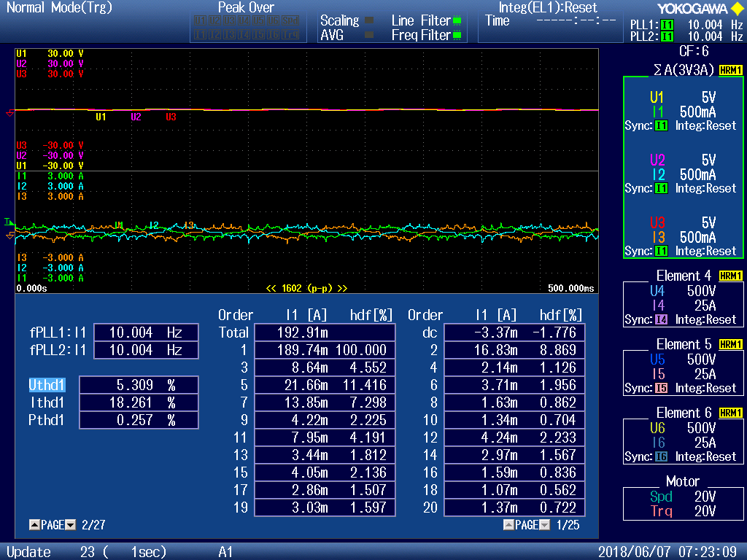

**20Hz**

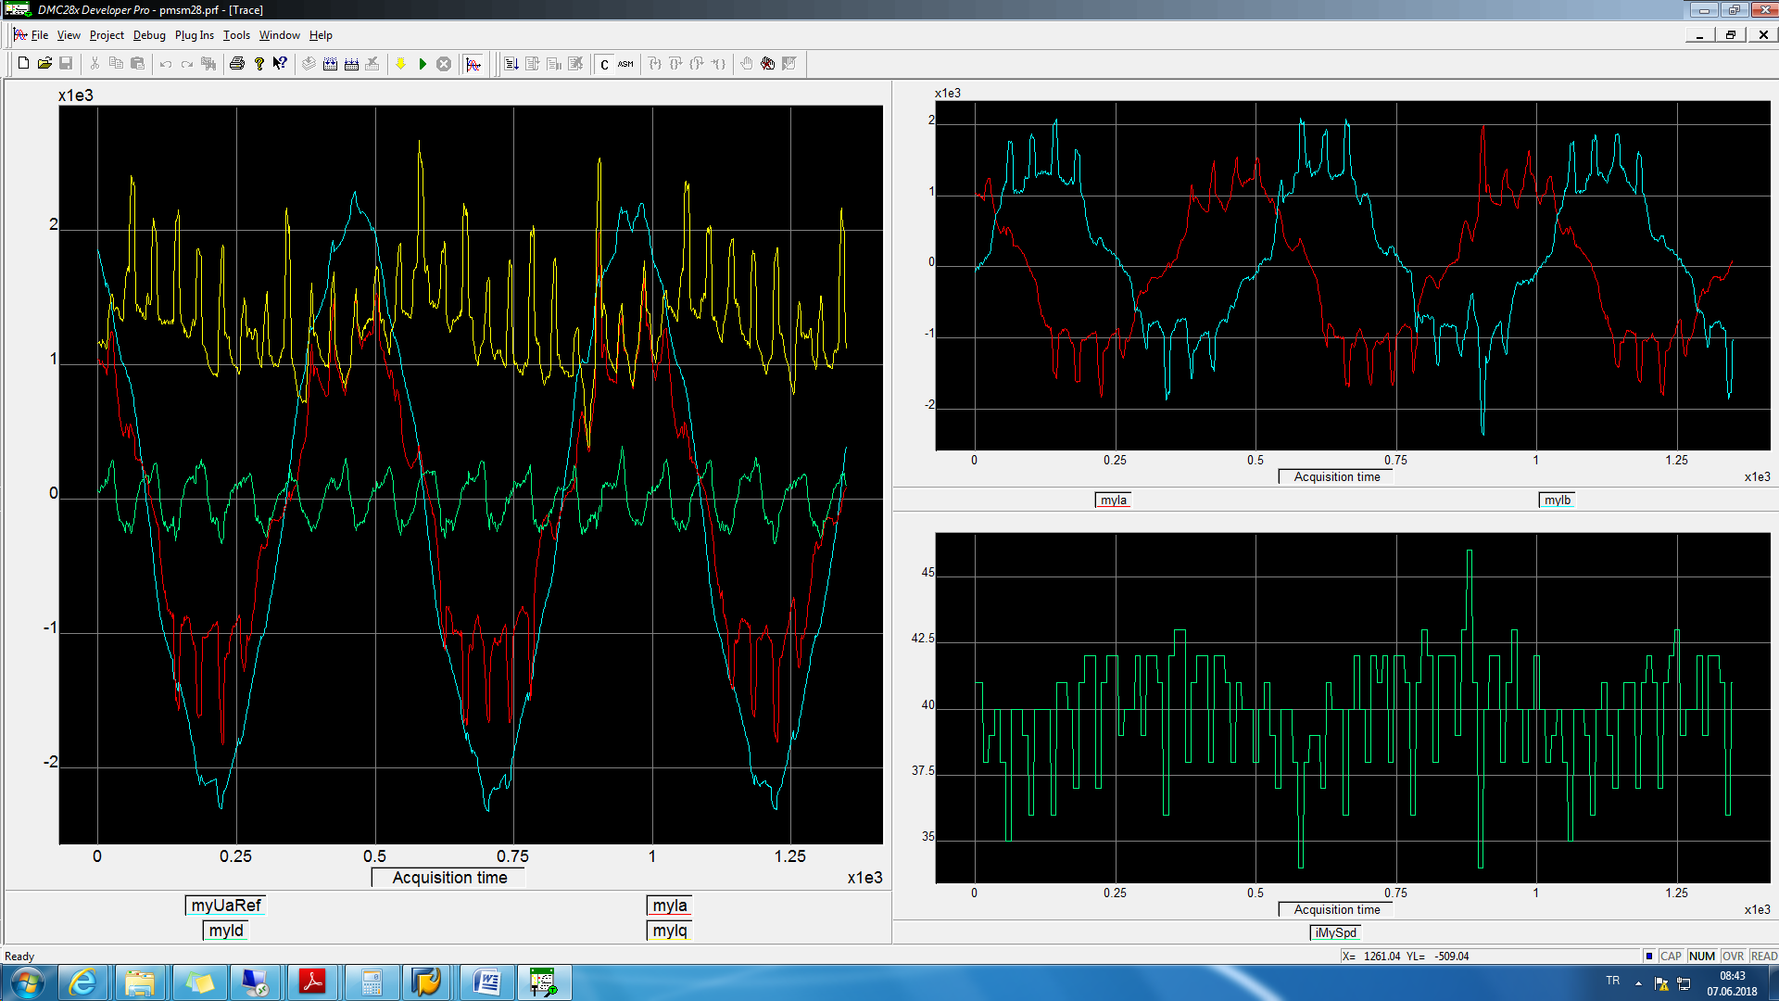

wave20hzSpeed.txt

BMP11

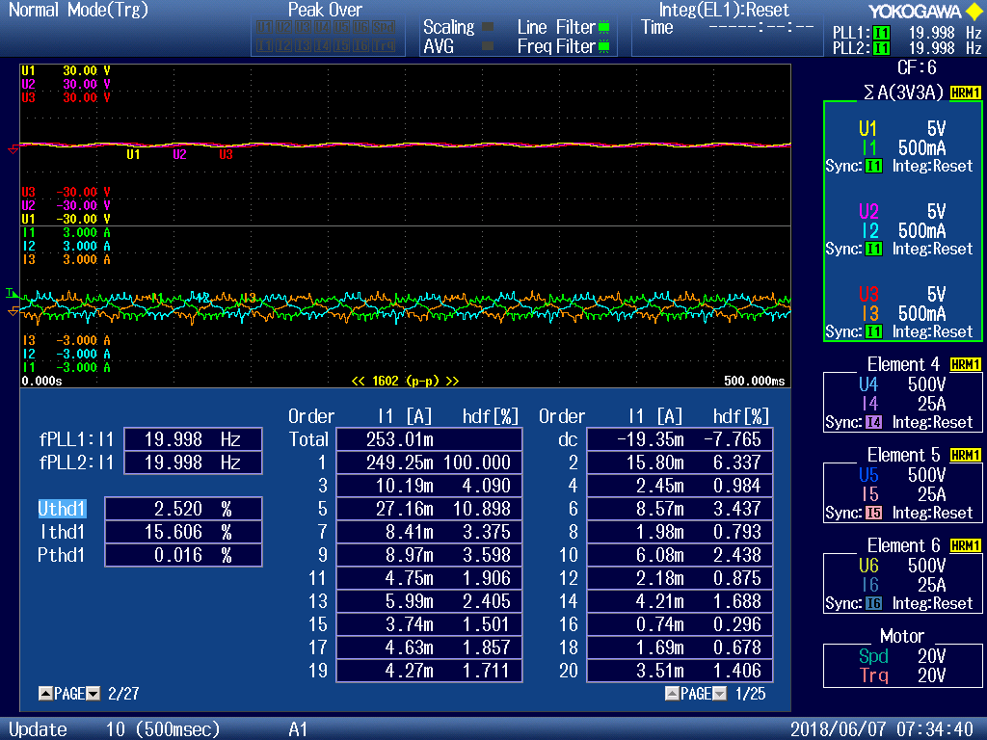

**25Hz**

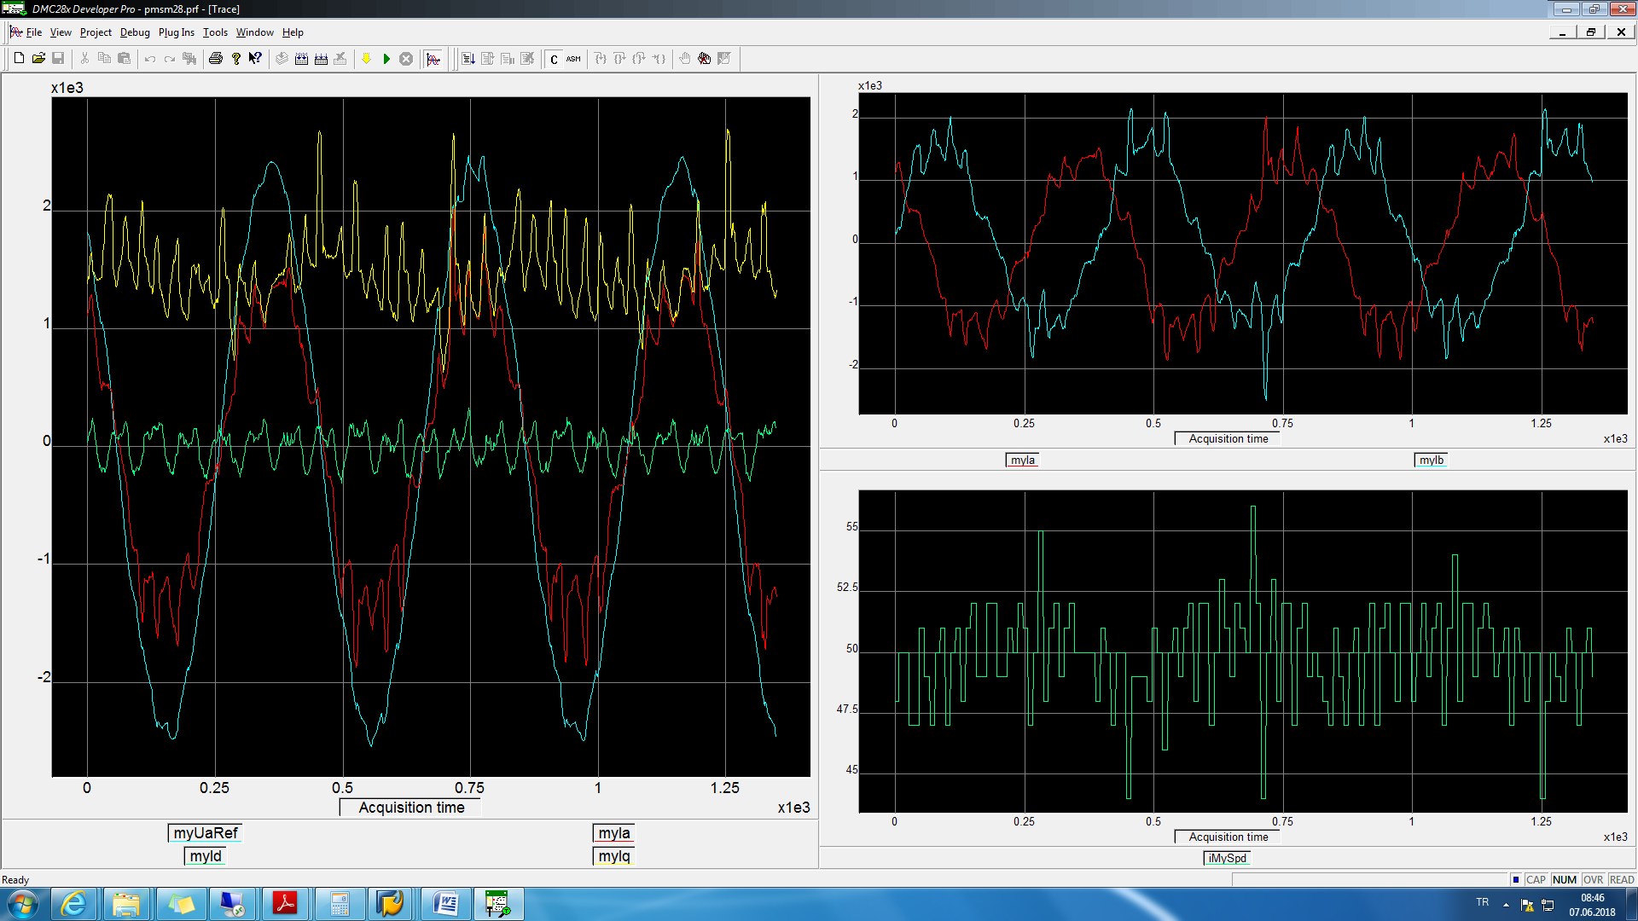

wave25hzSpeed.txt

BMP12

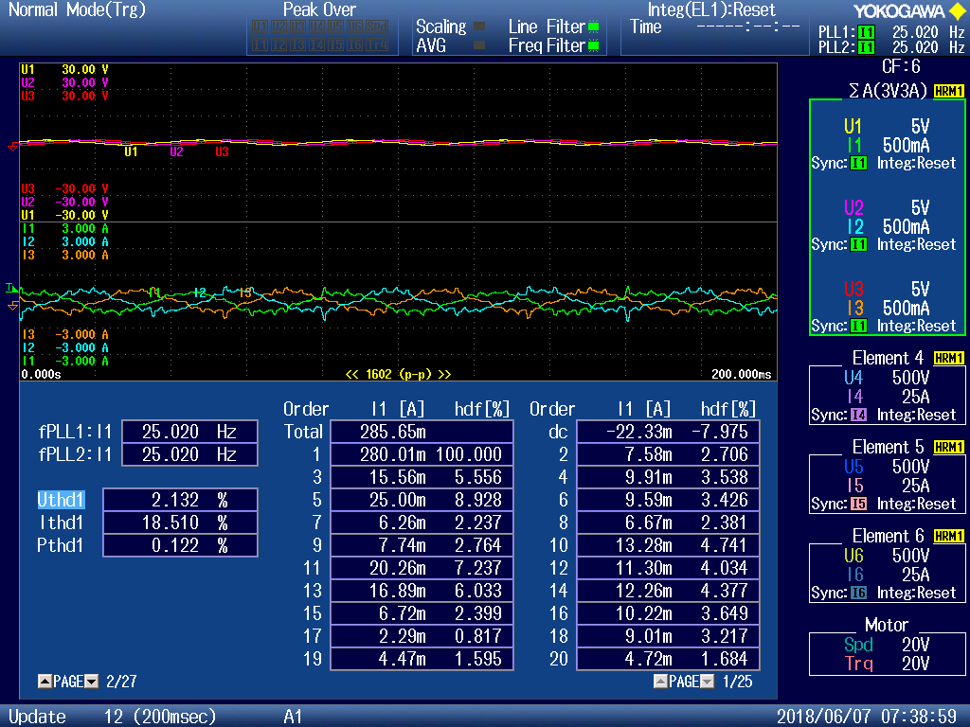

**40Hz**

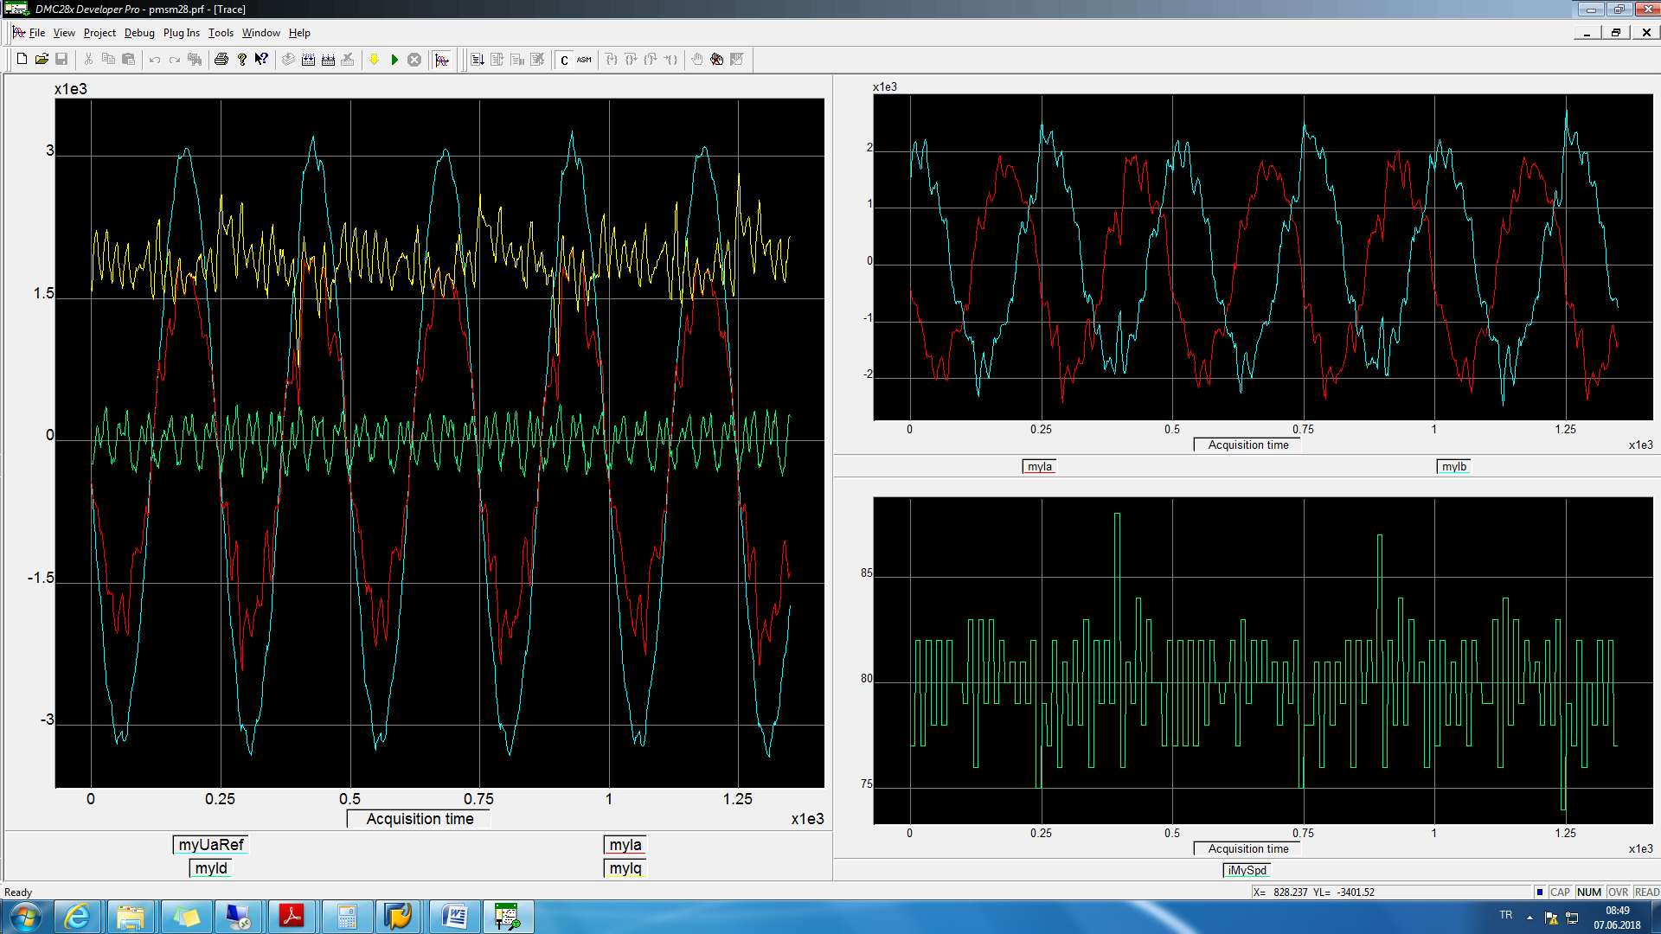

wave40hzSpeed.txt

BMP13

