# Compensation of Nonlinearities of the Voltage Source Inverters for High Precision Position Control Applications

## Progressive Report

Hüseyin YÜRÜK

Table of Contents

Compensation of Nonlinearities of the Voltage Source Inverters for High Precision Position Control Applications 1

Progressive Report 1

Problem Definition: 2

Nonlinearities 2

Experimental works 3

Observation of current harmonics 3

## Problem Definition:

Following nonlinearities cause distortion on the output voltage of the VSI

* dead-time
* switching time
* delay time
* voltage drops on the power switch and the freewheeling diode
* parasitic capacitance of the power switch

Output voltage distortion causes

* low order harmonic components in the output current of the inverter
* deformation of the phase currents, especially in the current zero-crossing region
  + these distortions
    - effects the control performance of the applications that require low speed & low torque
    - degrades the efficiency and increases the torque ripple

### Nonlinearities

Three phase PWM VSI with a PMSM load and ideal and actual output voltages.

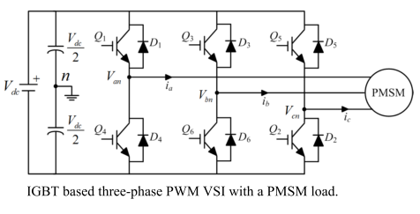

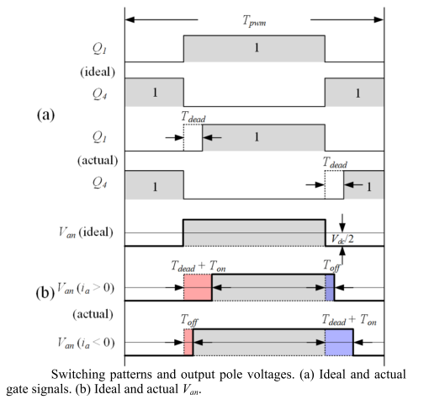 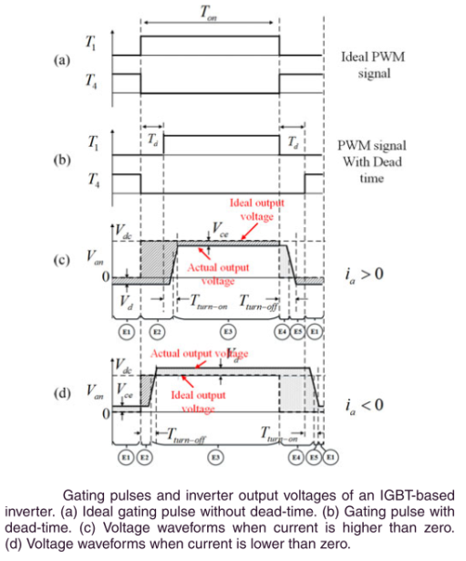

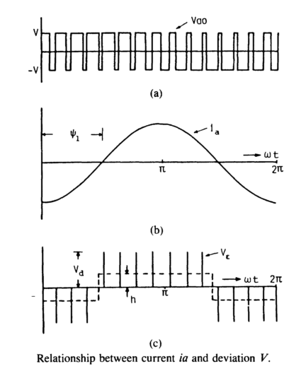

VƐ = Vao – Va

VƐ = Vd * tdead  (in simple way)

h * To/2 = (fs / fo) / 2 * VƐ

h = fs * VƐ

* so as fs ↗ distortion also ↗
* effect of the distortion gets more severe when
  + output frequency fo is low & output magnitude is low
  + iron and core losses and torque ripple increases

Analysis demonstrates that the nonlinear effects mainly produce 5th and 7th harmonics in the α-β reference frame and 6th voltage harmonic and its multiples in the d-q reference frame which cause current harmonics

## Experimental works

### Observation of current harmonics due to nonlinear effects

To observe current harmonics in the phase current and also in the d-q reference frame currents, an air cored (ironless winding) servo motor is driven by MOSFET based PWM VSI inverter at open loop.

#### Motor parameters:

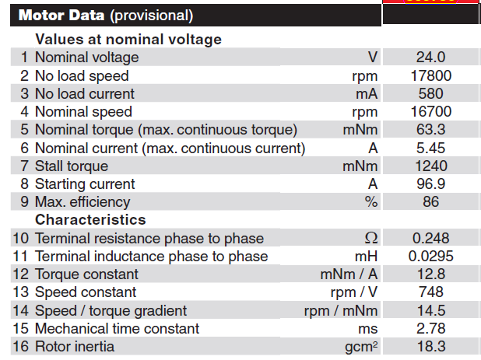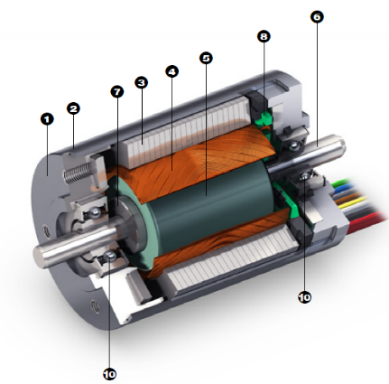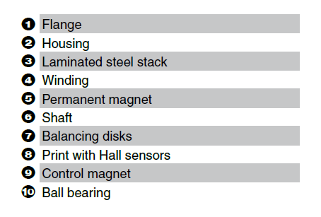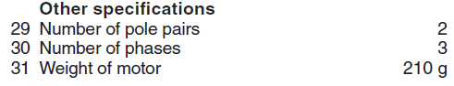

#### VSI inverter parameters:

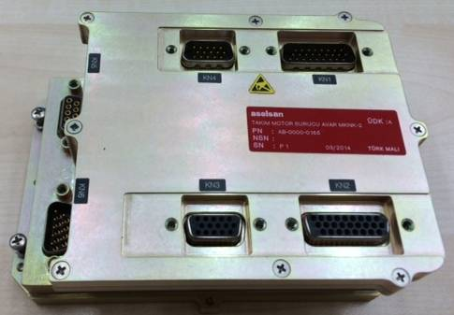

* AVAR servo driver (REHİS-MMTM design)
  + Input voltage 18-50VDC
  + 5Arms output current
  + Resolver, QEP, Hall, Abs Encoder feedback
  + CAN, RS422, Ethernet communication
  + ΔΣ phase current sensing
  + MOSFET (SUM90N10), gate driver (IRS2336D)
  + TMS320F28235 DSP

#### Measurements

Motor is driven by SPWM at ***open-loop*** @10Hz reference speed & @switching frequency fsw 20kHz

Note that graphs,

* for speed, 1cnt 🡪 0.5Hz
* for current, 1cnt 🡪 0.25mA

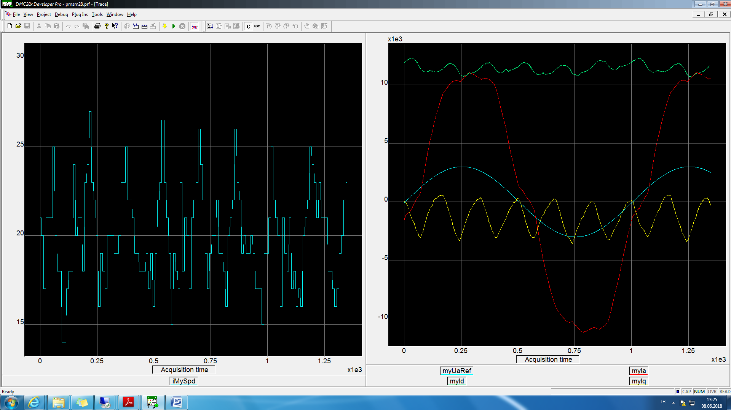

Figure 1 Left figure motor speed, right figure blue phaseA pwm reference, red phaseA, green Id, yellow Iq current @10Hz

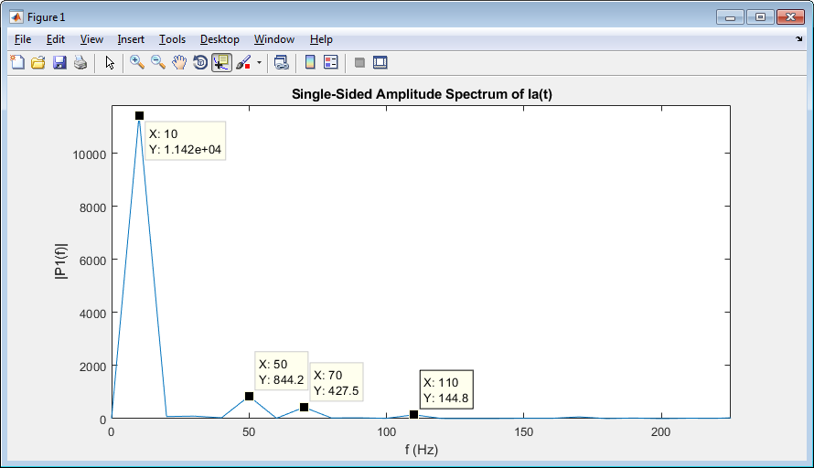

Figure 1 phaseA current, FFT analysis @10Hz

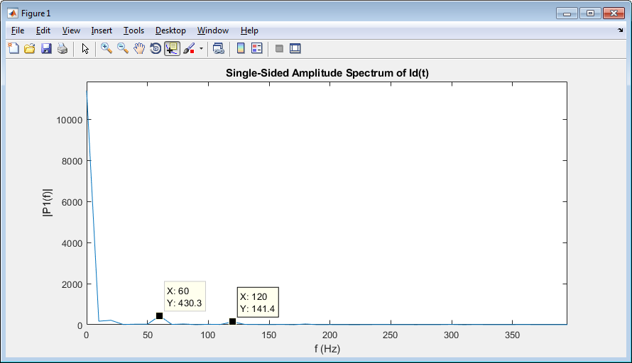

Figure 1 Id current, FFT analysis @10Hz

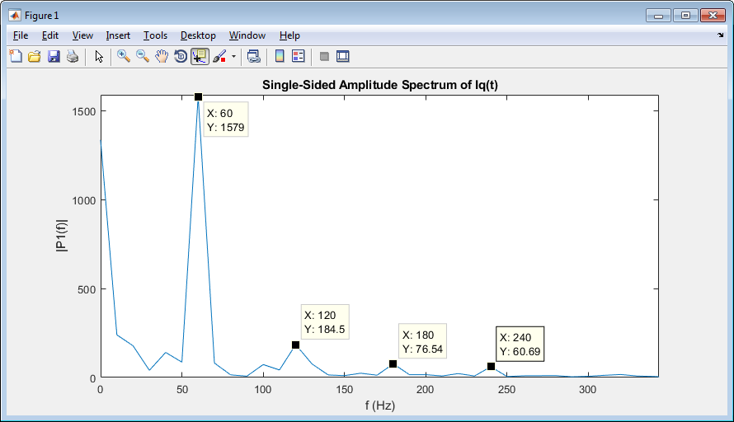

Figure 1 Iq current, FFT analysis @10Hz

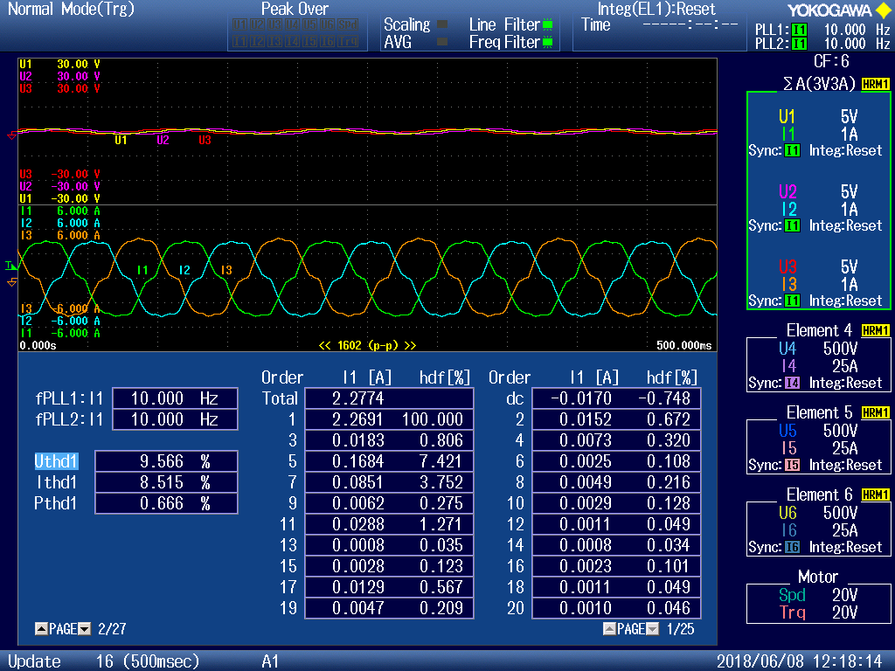

Figure 1 phase voltage and currents, and current harmonic distortions @10Hz @open loop

As can be seen above figures, nonlinear effects mainly produce 5th and 7th harmonics in the phase current, 6th and its multiples in the d-q reference frame currents.

as the output frequency increases i.e. speed increases, current distortion decreases which can be seen below figure.

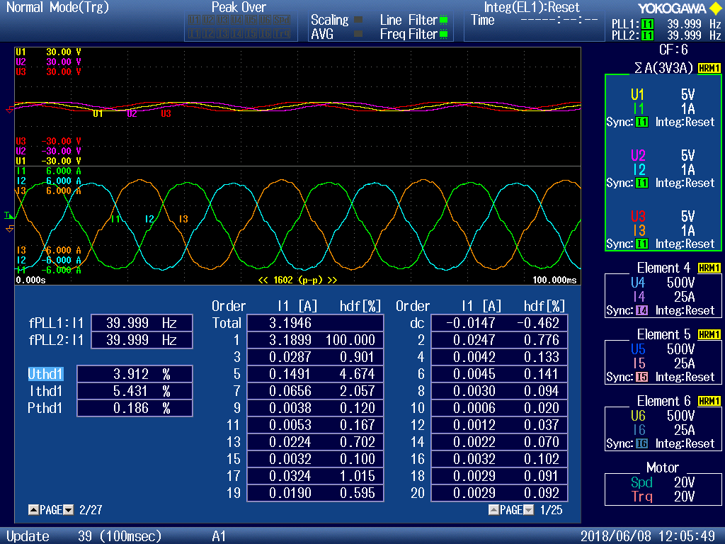

Figure 1 phase voltage and currents, and current harmonic distortions @40Hz @open loop

### Observation of nonlinearities on the current control

To observe effects of switching frequency on the effect of nonlinearities, regular PI current control is used. To eliminate effect of the back emf voltage, iq_ref is given zero. And to eliminate Ls effect id_ref is varied so slow then only remains Rs value. Ideal case for required id current you need Vd which equals Vd = Rs * id at this situation. But due to nonlinearities this equation is not linear. So the control performance and stability of the system will be degraded substantially.

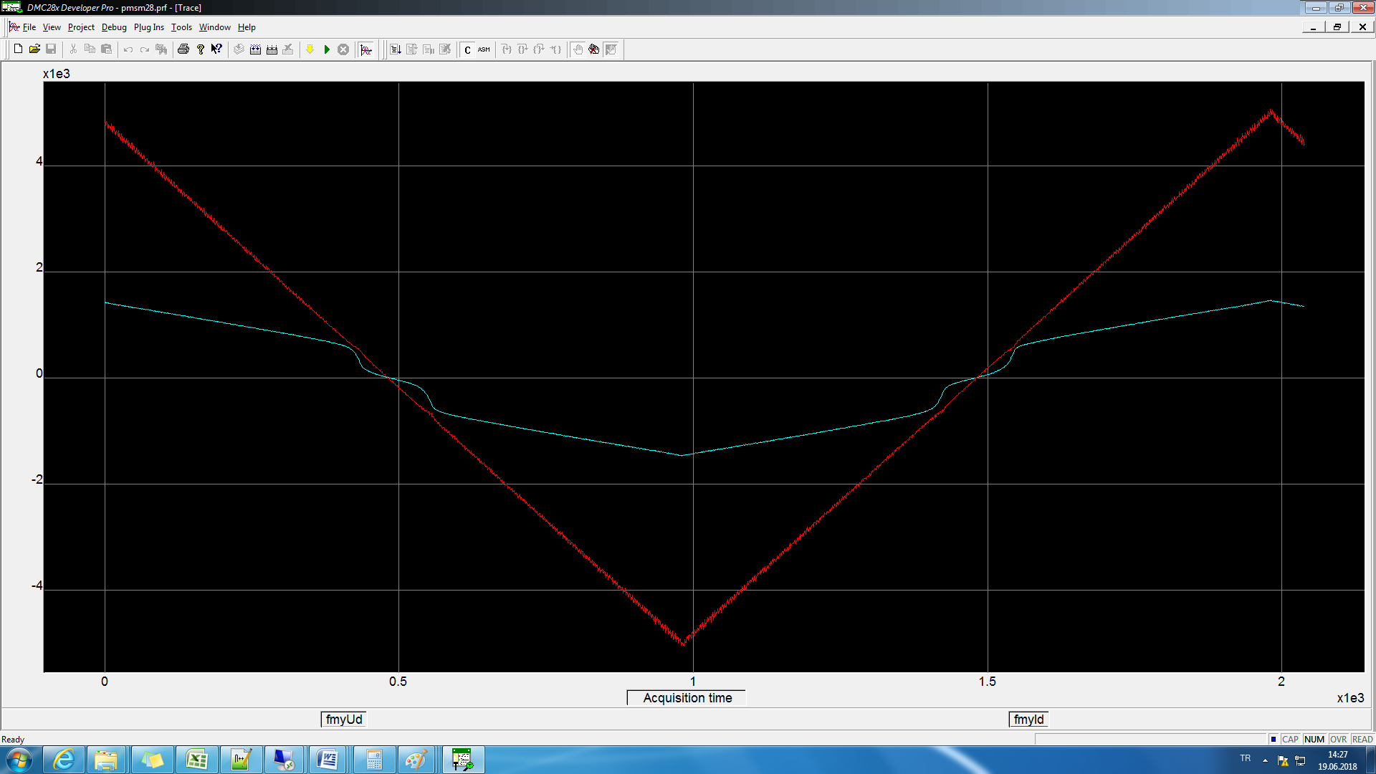

Figure 1 red Id current and blue Vd voltage, @fsw=10kHz @current loop

ToId vs. Vd graph is investigated at various fsw values in this experiment. Id reference is so slow varying to eliminate Ls effect and there remains only Rs value.