P1-(c)

1.insertion sort

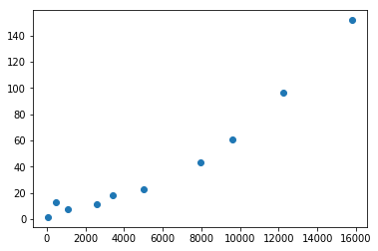

2.merge sort

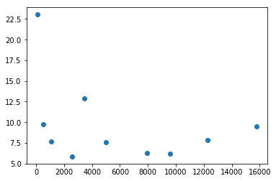

(x軸接為樣本大小，y軸皆為秒)

P1-(d)

1. Insertion sort

T(n) = 5.78734971374141E-07 * n^2 + 8.05115222119316

|  |  |  |  |  |
| --- | --- | --- | --- | --- |
|  | 係數 | 標準誤 | t 統計 | P-值 |
| 截距 | 8.051152 | 1.2445 | 6.469385 | 0.000194 |
| N^2 | 5.79E-07 | 1.26E-08 | 45.99077 | 5.52E-11 |

1. Merge sort

T(n) = 0.00089487358041356 * n * log (n) + (-4.62011891832959)

|  |  |  |  |  |
| --- | --- | --- | --- | --- |
|  | 係數 | 標準誤 | t 統計 | P-值 |
| 截距 | -4.62012 | 5.704622 | -0.80989 | 0.441425 |
| n log n | 0.000895 | 7.88E-05 | 11.36264 | 3.25E-06 |