**CS4442: ASSIGNMENT 2 REPORT**

**Q1b:**

Sum of absolute values in the output image: 7227422

This filter is useful for horizontal edge detection.

*swanfiltered.png* :

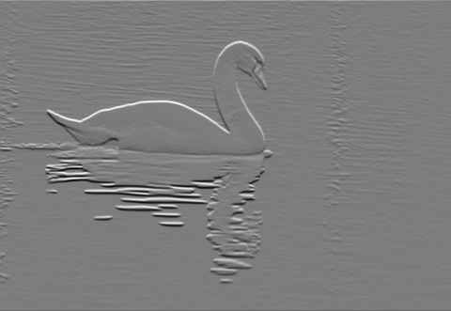

**Q2b:**

Sum of absolute values in the eng image: 3522016

*faceEngG.jpg* :



**Q3b:**

Sum of absolute values in the eng image: -58999407

*catEngC.png* :



**Q4k:**

Total Cost of All Seams (cat.png): -1010948

Total Cost of All Seams (face.jpg): -402569

*catResized.png* :



*faceResized.png* :



**My Own Example (pigs.png)**

pigsResized.png

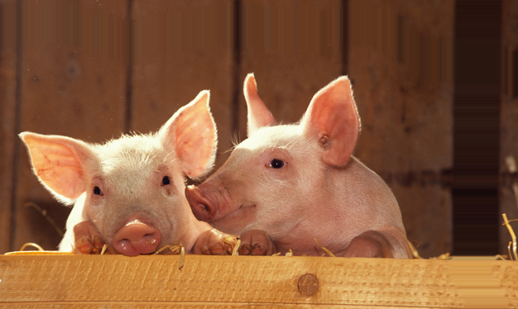

I used a weight vector of [2 -3 2] to calculate the color energy and inserted 50 horizontal and 50 vertical seams.

**Q5b:**

Final Energy (face.jpg): 152303

Final Energy (lift.jpg): 903123

------------------------------------------------------------------

*faceL.png* :

**

*liftL.png* :

**

I used the regular-sized images and the images were segmented by 0 for background intensity and 255 for foreground intensity.

**Q6:**

I tried to create a function that inserts seams based on the order of removal (OOR) of seams. That way, the same optimal seam will not be constantly duplicated and look very repetitive. Currently the function is only implemented for adding seams one dimension at a time.

*E.g. Adding 100 Vertical Seams*

Original Output: pigsResizedv100.png

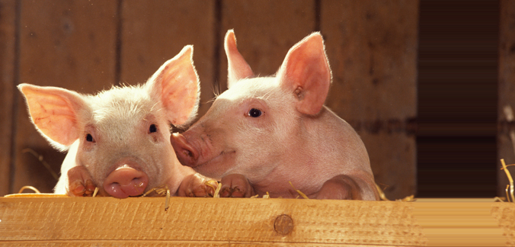

Modified Function (OOR): *pigsResizedv100OOR.png*

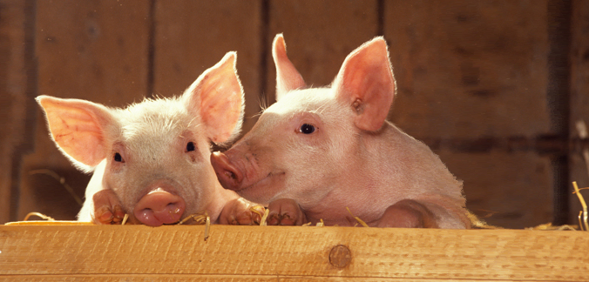

The modified algorithm for seam insertion works by selecting the optimal seam and inserting it. Then, the next best seam will be determined and inserted in the same way. This repeats until all needed insertions are made.

The functions I modified are:

increaseHeight 🡺**increaseHeightOOR(im4, seam)**

It will now take a seam instead of and energy matrix and directly remove the seam from im4. Output variables were not changed.

increaseWidth 🡺**increaseWidthOOR(im4, seam)**

It will now take a seam instead of and energy matrix and directly remove the seam from im4. Output variables were not changed.

intelligentResize 🡺**intelligentResizeOOR(im,v,h,W,mask,maskWeight)**

Requires user to do one dimensional seam operations. Keeps track of the OOR matrix to determine what seams should be inserted. Only outputs the output 3-channel matrix and no longer outputs total cost. Input variables were not chan­ged.