Large Area Vision Based Tactile Sensing
with Folded Optics
Yushen Xue^{1,†}, Bin Chen^{2,†}, Haoran Li and Zhenyu Lu^{2,*}
¹ Harbin Institute of Technology, Shenzhen, China
² South China University of Technology, Guangzhou, China
†These authors contributed equally. *Corresponding author: Zhenyu Lu (luzhenyu@scut.edu.cn).

Abstract—Extending vision-based tactile sensing beyond fingertips requires balancing optical coverage, packaging, and deformation-dependent estimation errors. This work in progress presents a four-camera prototype that uses a planar mirror to fold the imaging paths over an 86 mm × 86 mm silicone contact surface within a 47 mm-thick package. The shared image streams support shape classification, contact-trajectory recognition, and multiview deformation reconstruction. Preliminary tests achieve 96.73% three-shape accuracy and improve handwritten-digit recognition from 77.5% to 94.0% using learned coordinate correction. Indentation experiments yield 0.06 mm mean absolute error for averaged measurements over 3.5–7.0 mm, with increasing underestimation at larger depths. These results establish feasibility for one prototype; broader generalization, the cause of depth bias, and long-term stability remain to be evaluated.
Index Terms—Optical tactile sensing, folded optics, multiview geometry, trajectory recognition.

I. Motivation and Scope
Optical tactile sensors infer contact from images of a deformable surface, providing geometric cues for robot interaction [1]. Enlarging a sensing patch requires optical coverage without proportionally increasing package depth. Mirror-based compact imaging has already been demonstrated in GelSlim [2]; our contribution is therefore not the use of a mirror alone.
We investigate whether a four-view folded-optics patch can support complementary two- and three-dimensional measurements on the same surface. The current contribution is an integrated prototype and preliminary evaluation of shape recognition, trajectory correction for handwriting, and marker-based deformation reconstruction. We report laboratory feasibility rather than a validated whole-body robotic skin or a force sensor.

II. Prototype and Perception Methods
The prototype combines a removable silicone sensing layer with a 3D-printed imaging module (Fig. 1). Four corner-mounted USB cameras view the inner surface through a bottom planar mirror; their optical axes are inclined by 45° to the horizontal. The black silicone skin is backed by transparent gel, with lateral LED illumination and a 2 mm acrylic window. White-tipped cylindrical markers follow a hexagonal lattice with 1.6 mm diameter, 3 mm height, and 3.3 mm pitch. The contact surface measures 86 mm × 86 mm, and the total thickness is 47 mm.
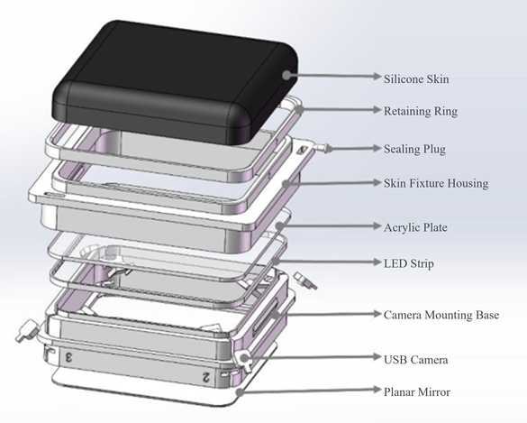
Fig. 1. Exploded prototype architecture. The planar mirror folds the camera paths toward the silicone sensing layer.
Shape classification. Polygonal region-of-interest masks exclude the housing and lighting. Cropped views are resized and concatenated into a 2 × 2 mosaic, then classified using EfficientNet-B0 [3]. Augmentation, weighted sampling, and weighted cross-entropy address variation in contact position, scale, and class frequency.
Trajectory recognition. A Gaussian-mixture background model locates contact regions. Image-moment centroids are smoothed by an exponential moving average (α = 0.35). A multilayer perceptron (MLP) regresses the four-view centroids to physical two-dimensional coordinates. After 40-point arc-length resampling, centering, and scale normalization, an 80–128–64–10 feedforward network recognizes digits 0–9; 0.8 s without contact terminates a sequence.
Deformation reconstruction. Planar calibration [4] establishes camera projection matrices; global marker correspondences are initialized and tracked with pyramidal Lucas–Kanade optical flow [5]. Markers visible in at least two views are triangulated using a singular-value-decomposition solution of the homogeneous projection constraints. Per-marker displacement relative to an unloaded reference is interpolated by Delaunay triangulation to visualize normal deformation.

III. Preliminary Evidence
Table I summarizes the principal results; MAE denotes mean absolute error. Static evaluation uses 306 images of triangle, circle, and square contacts, with three indenter sizes per shape and randomized contact positions. The handwriting comparison uses 200 sequences (20 per digit), alternating between central and peripheral regions. Normalization and classification are unchanged; replacing homography correction with MLP regression provides a 16.5-percentage-point accuracy gain.
TABLE I
PRELIMINARY PROTOTYPE RESULTS
Task | Evaluation | Result
Shape recognition | 306 images  3 classes | 96.73% accuracy  Macro-F1 0.9675
Digit recognition | 200 sequences  10 classes | 77.5% homography  94.0% MLP
Depth estimation | 3.5–7.0 mm  Four-trial means | MAE 0.06 mm  Max. error 0.14 mm
A 200-image CPU inference benchmark reports 16.34 ms per image. Its reciprocal throughput of 61.20 images/s is not the measured end-to-end sensor rate; the cameras acquire at 30 frames/s.
Spherical indentation spans 3.5–10.0 mm in 0.5 mm steps, with finer 0.2 mm sampling between 7.0 and 8.0 mm. The depth error in Table I is calculated from depth-wise means across four trials, not individual-frame errors. Underestimation grows above 7.0 mm, with a reported response change near 7.4 mm and 0.57 mm absolute error at 10.0 mm. Qualitative tests with flat, hemispherical, and arrayed indenters show distinct deformation patterns.

IV. Open Questions and Next Steps
Current evidence comes from one prototype, three static classes, and a limited handwriting set; it does not establish performance on unseen writers, sessions, irregular objects, or independently fabricated modules. Next experiments will separate sessions and writers, vary contact angle and depth, and report uncertainty and position-wise errors.
The high-depth response should not yet be treated as a confirmed strain-hardening threshold. Material nonlinearity is a hypothesis; calibration, refraction, and tracking errors remain possible contributors. We plan loading–unloading tests with simultaneous displacement, force, and marker measurements before testing piecewise depth compensation. Compensation must be evaluated on held-out loading conditions.
Cycle loading will assess marker loss, drift, and recovery; end-to-end timing will include acquisition, tracking, fusion, and inference. Tiled patches further require seam handling, shared coordinates, and camera synchronization. The present results support prototype feasibility, while these remaining tests define the path toward broader robotic-skin use.

References
[1] W. Yuan, S. Dong, and E. H. Adelson, “GelSight: High-resolution robot tactile sensors for estimating geometry and force,” Sensors, vol. 17, no. 12, Art. no. 2762, 2017, doi: 10.3390/s17122762.
[2] E. Donlon, S. Dong, M. Liu, J. Li, E. H. Adelson, and A. Rodriguez, “GelSlim: A high-resolution, compact, robust, and calibrated tactile-sensing finger,” in Proc. IEEE/RSJ Int. Conf. Intell. Robots Syst. (IROS), 2018, pp. 1927–1934, doi: 10.1109/IROS.2018.8593661.
[3] M. Tan and Q. V. Le, “EfficientNet: Rethinking model scaling for convolutional neural networks,” in Proc. Int. Conf. Mach. Learn., vol. 97, 2019, pp. 6105–6114.
[4] Z. Zhang, “A flexible new technique for camera calibration,” IEEE Trans. Pattern Anal. Mach. Intell., vol. 22, no. 11, pp. 1330–1334, 2000, doi: 10.1109/34.888718.
[5] B. D. Lucas and T. Kanade, “An iterative image registration technique with an application to stereo vision,” in Proc. Int. Joint Conf. Artif. Intell., 1981, pp. 674–679.

