Intelligent Rehabilitation-Action Evaluation System via Enhanced DTW and Deep Learning
Yizhou Han¹, Yijia Xu^{2,&}, Haonan Lu ³ and Yongjun Gan^{4,}*
¹Marshall McLuhan Catholic Secondary School, Toronto, ON M5N 3B1, Canada;
²Western Academy of Beijing, Beijing 100083, China;
³RDF International School, Shenzhen 518120, China;
⁴School of Mechanical and Electrical Engineering, Beijing Information Science and Technology University, Beijing 100192, China
*Corresponding author:2024020137@bistu.edu.cn
Abstract. Focusing on the problems of quantitative difficulties, weak model interpretability and insufficient fine-grained anomaly location in rehabilitation action evaluation, this paper proposes an intelligent evaluation framework that combines improved dynamic time warping and deep representation learning. The system uses monocular RGB video as input, relies on a lightweight pose estimation module to obtain the skeletal sequence, and constructs multi-order kinematic features to characterize the spatial morphology and temporal evolution of the action. On this basis, a dynamic time warping strategy incorporating weighted spatio-temporal metrics and topological constraints is introduced to robustly align and locate action rhythm differences and local anomalies. Experimental results demonstrate that the proposed method outperforms multiple baselines on the public dataset in terms of overall similarity, path regularity and abnormal segment overlap rate. Moreover, it can provide actionable correction suggestions for patients via a semantic feedback mechanism. Ablation correlation analysis further verifies the effectiveness of the synergy of features, constraints and metrics.
Keywords: Rehabilitation action evaluation; dynamic time warping; spatio-temporal feature fusion; unmarked attitude estimation; semantic feedback.

Introduction
With the aging of the global population, the number of patients with motor dysfunction caused by neurological diseases such as stroke and Parkinson 's disease continues to rise. According to the World Health Organization, about 75 % of stroke survivors have upper limb motor deficits and require long-term, repeated rehabilitation training to reconstruct the neuromuscular control pathway [1]. However, traditional rehabilitation is highly dependent on the therapist 's manual observation and Fugl-Meyer scale scoring, which has bottlenecks such as strong subjectivity, long evaluation interval and difficulty in quantification [2]. In recent years, although the solution based on the wearable inertial measurement unit ( IMU ) can provide continuous kinematic data [3], the wearing process is cumbersome and susceptible to drift accumulation, which reduces the acceptability of the home scene. Although the RGB-D sensor can capture the skeleton without contact [4] [5], it is limited by equipment cost and depth map noise. At the same time, the monocular RGB camera has become the preferred hardware for home rehabilitation perception due to its low cost and easy deployment. However, how to achieve high-precision, real-time, and interpretable motion assessment on its basis is still a technical problem that needs to be broken through [6,7].
The existing research is mainly carried out from two technical routes :one is the template matching method based on dynamic time warping (DTW) and its improvement, which realizes action alignment and scoring by calculating the minimum cumulative distance between the test sequence and the standard template [8]. However, the classical DTW is only based on the frame-by-frame Euclidean distance, ignoring the joint topology and kinematics context, resulting in the alignment path deviating from the physiological feasible region in the case of rhythm changes, local occlusion or motion compensation [9]. The second is an end-to-end framework based on deep learning, such as 3D convolutional network [10], spatio-temporal graph convolutional network [11] or Transformer alignment network [12], which can learn complex spatio-temporal representations driven by large-scale data. However, attention drift often occurs in the clinical environment due to the deviation of training-test distribution, and the output results lack interpretability, which makes it difficult to provide specific correction suggestions for patients [13]. In addition, multi-modal fusion attempts to jointly input RGB and IMU data [14,15].Although it improves the occlusion robustness, it further increases the system complexity and synchronization difficulty. How to take into account the fine-grained anomaly location, interpretability and real-time performance under monocular RGB conditions is still a key challenge in the field of rehabilitation action evaluation [ 16 ].
To this end, this paper proposes a rehabilitation action intelligent evaluation system that combines improved DTW and deep learning. The main contributions include :
( 1 ) The spatio-temporal coupling characteristics of multi-order kinematics are designed. For the first time, the static pose, local velocity and acceleration of joints are embedded in the same representation space to comprehensively describe the motion form and dynamic evolution.
( 2) the STCF-DTW algorithm is proposed, which uses the weighted spatio-temporal Euclidean distance as the inter-frame metric, and introduces the dual constraints of joint topology and local slope to significantly improve the alignment accuracy and abnormal period positioning ability.
( 3 ) Construct a closed-loop feedback mechanism of ' score-location-explanation ', automatically generate semantic correction tips, and support patients to complete high-frequency, accurate and operable self-training in an unsupervised environment.
The rest of the paper is organized as follows: Chapter 2 details the proposed method, including attitude estimation, feature extraction, and STCF-DTW algorithm design; Chapter 3 introduces the experimental settings, evaluation indicators, comparison and ablation experiments, and shows the clinical usability evaluation; Chapter 4 summarizes the entire paper and outlines future work.

Method
The intelligent evaluation system for rehabilitation motion proposed in this paper adopts a three-stage cascade architecture (Fig. 1) to successively achieve high-fidelity pose estimation, dynamic alignment, multi-stage spatio-temporal feature representation, constraint enhancement, and other tasks. This framework uses monocular RGB video as input, extracts human kinematics primitives through a lightweight unlabeled perception module, and then fuses joint static pose and dynamic evolution features. Finally, under physiological constraints, it achieves fine-grained anomaly localization and semantic feedback. The following sections will provide a detailed examination of the technical details and innovative design of each module.
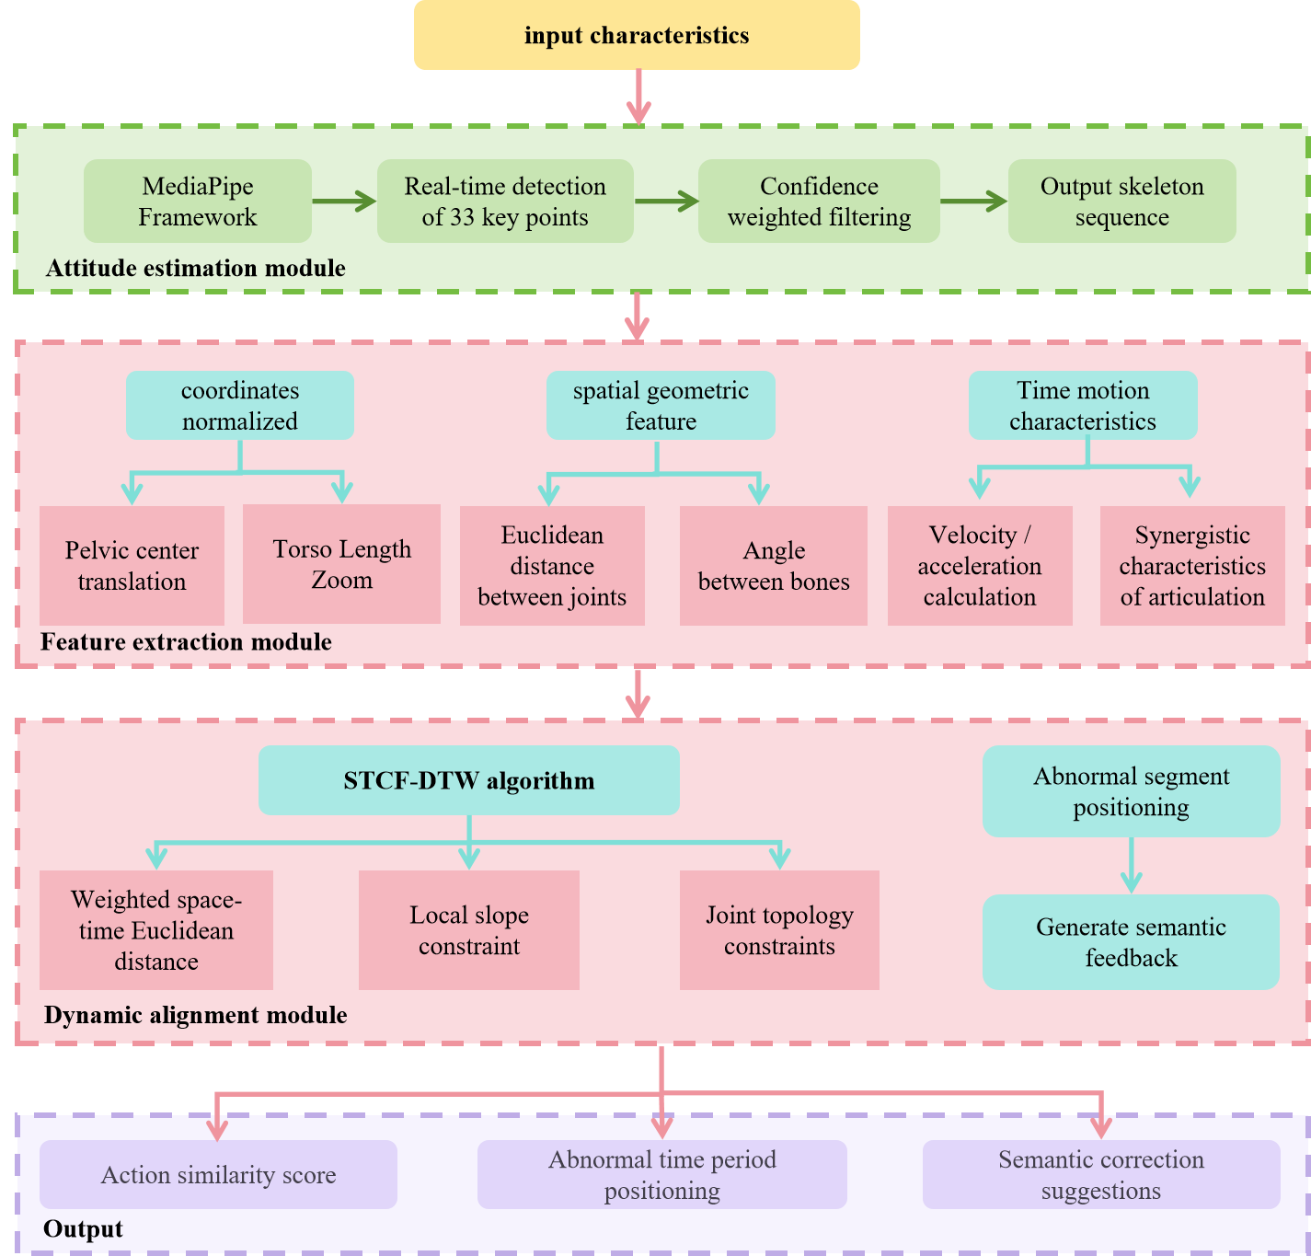
Fig. 1 Model architecture diagram

High-fidelity unmarked pose estimation based on MediaPipe
The system uses Google's MediaPipe framework as the basic pose estimation engine. It captures the patient's rehabilitation actions in real-time via a monocular RGB camera and outputs a sequence of 2D skeleton coordinates for 33 human-body key points. The core advantage of MediaPipe is its lightweight BlazePose model and high inference efficiency (≥30 FPS), meeting clinical real-time evaluation needs. Additionally, no physical markers are required on the patient's body, greatly reducing operational complexity and equipment costs.The technical process can be summarized as follows: input RGB video frame, human detection based on lightweight CNN, key point positioning based on heat map regression, output normalized two-dimensional coordinate and confidence ( represents joint point index ).
The mathematical essence of pose estimation can be expressed as : given the input image at the time step , model predicts the joint position :
The key point confidence is obtained by normalizing the maximum response value of the predicted heat map by the Sigmoid function :
This confidence quantifies the visibility and positioning reliability of the joint points in the current frame, and provides an important basis for subsequent anomaly detection.
Aiming at the common problems of illumination change and partial occlusion ( such as clothing, assistive devices ) in rehabilitation scenes, the system introduces a confidence weighted filtering mechanism. The smooth coordinate of the joint point in the time window is defined as :
In the formula, is the Gaussian time domain weight, and is the window radius. This mechanism can effectively suppress the coordinate drift caused by low-confidence frames. The final output sequence is used as the input of the subsequent module, where is the number of frames of action. The specific effect is shown in Figure 2, and the corresponding relationship between the serial number and the body part is shown in Table 1.
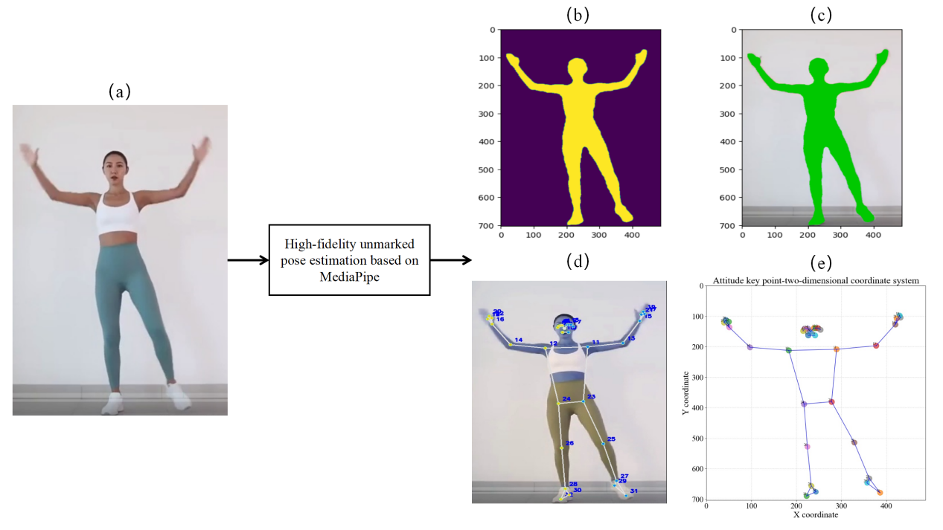
Fig. 2 High-fidelity unmarked pose estimation detection effect map based on MediaPipe
Fig. 2 shows the unmarked pose estimation link : Fig. 2 ( b ) ( c ) suppresses background noise through foreground matting ; Fig. 2 ( d ) locates 33 key points and restores the skeleton topology. Fig. 2 ( e ) maps the key points to the two-dimensional coordinate system to form a time-consistent sequence. Table 1 lists the key point index, which provides a unified semantic benchmark for the subsequent ' multi-order kinematic spatio-temporal coupling feature ' module.
Table 1. Key points comparison table of high-fidelity unmarked pose estimation algorithm based on MediaPipe
serial number | part | serial number | part
0 | Nose | 17 | Left pinky
1 | Left eye inner | 18 | Right pinky
2 | Left eye | 19 | Left index
3 | Left eye outer | 20 | Right index
4 | Right eye inner | 21 | Left thumb
5 | Right eye | 22 | Right thumb
6 | Right eye outer | 23 | Left hip
7 | Left earr | 24 | Right hip
8 | Right ear | 25 | Left knee
9 | Mouth left | 26 | Right knee
10 | Mouth right | 27 | Left ankle
11 | Left shoulder | 28 | Right ankle
12 | Right shoulder | 29 | Left heel
13 | Left elbow | 30 | Right heel
14 | Right elbow | 31 | Left foot index
15 | Left wrist | 32 | Right foot index
16 | Right wrist

Characterization of multi-order kinematics space-time coupling characteristics
The core challenge in rehabilitation action assessment lies in accurately quantifying the temporal and spatial differences between the patient's action sequence and the standard template. Traditional methods, which rely on a single feature, struggle to capture complex spatio-temporal coupling. Additionally, distance variations and pixel-unit inconsistencies necessitate coordinate normalization. To address these issues, we propose a multi-order kinematic spatiotemporal-coupling feature representation method. This method integrates static pose, velocity, and acceleration information of joint points, models spatial topology and temporal evolution, and constructs a robust action descriptor. It effectively handles rhythm differences, occlusion, and amplitude changes, and supports action classification and anomaly detection. The process is divided into three stages.

Coordinates normalized
In visual motion capture, the patient-camera relative distance dynamically changes, and varying capture-device resolutions lead to inconsistent pixel-coordinate-system scales. To eliminate feature -extraction interference from body-shape differences, perspective changes, and initial-pose deviations, the raw skeleton-coordinate sequence requires strict normalization.Given the input sequence , where represents the two-dimensional coordinates of 33 key points in the frame, .In the normalization process, the center of the pelvis is first translated : the center of the pelvis ( the midpoint of the left and right hip joints, index ) is selected as the dynamic reference origin, the is calculated, and all the joint points in each frame are translated .For the scale variation problem, the trunk length ( the distance from the left shoulder to the center of the pelvis ) is used as the reference scale factor, and all the translated coordinates are scaled . The normalized coordinate sequence has scale invariance and translation invariance, and its mathematical representation is :
In the formula, is the key point coordinate matrix of frame ; is the two-dimensional coordinate of the joint point of the frame ; is the pelvic center coordinate of the frame ; is the trunk reference length of the frame ; normalized coordinate matrix. The effect of coordinate normalization is shown in Fig. 3.
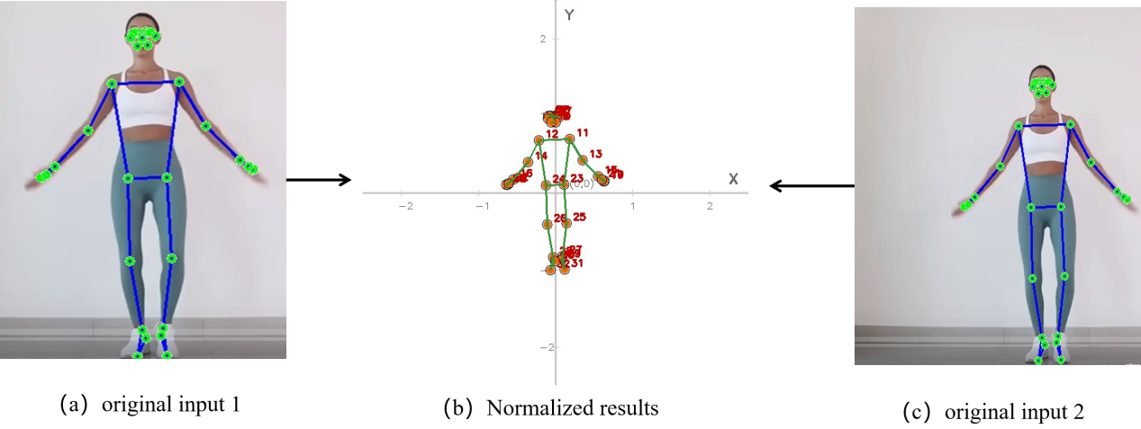
Fig. 3 Coordinate normalization effect

Spatial geometric feature extraction
Based on the normalized joint coordinates, this paper defines two types of core space features : Euclidean distance between joints and angle between bones. These features significantly enhance the ability to describe the action form by explicitly modeling human anatomical constraints, and their physical meaning is clear, providing a direct basis for subsequent abnormal action positioning. The Euclidean distance between the joints represents the degree of spatial separation of specific anatomical point pairs, which is defined as the Euclidean distance between the joint point and the in the frame :
For example, the distance represents the spatial distance between the right shoulder joint ( index 12 ) and the right wrist joint ( index 16 ) ( corresponding to in Fig. 4), which directly reflects the extension state of the upper arm. The angle between the bones uses the cosine theorem to calculate the joint angle composed of three adjacent joint points to quantify the degree of limb bending.Let the joint points 、and form a continuous link in anatomy (is the vertex of the joint ), define the vector and , then the angle at the vertex is calculated as follows :
Taking the elbow flexion angle as an example ( in Fig.4), it consists of shoulder node ( index 12 ), elbow node ( index 14 ) and wrist node ( index 16 ), , which directly reflects the flexion and extension range of the elbow joint. In this paper, a total of 8 sets of key distance features and 8 sets of key angle features are defined, covering the main functional links such as upper limbs ( shoulder-elbow, elbow-wrist ), lower limbs ( hip-knee, knee-ankle ), and trunk ( shoulder-hip ). The specific definitions are shown in Table 2. All spatial geometric features are integrated into feature vectors according to frames :
The feature set explicitly encodes the spatial topological rules of human pose through distance constraints and angle constraints. Compared with the original coordinates, it has stronger robustness to individual body shape differences-the distance feature eliminates the scale effect by normalizing the trunk length ratio, and the angle feature has inherent scale invariance. More importantly, its physical meaning has a clear clinical explanation : the therapist can directly identify the lack of limb extension according to the deviation of , or determine the limitation of joint activity according to the abnormality of , so as to lay a technical foundation for generating specific correction prompts such as "increasing the bending amplitude of elbow joint".
Table 2. Spatial geometric features
Normalized results | Key index | Angular characteristics | Key index
Fig.4 shows the geometric sketches of distance and angle as well as and .
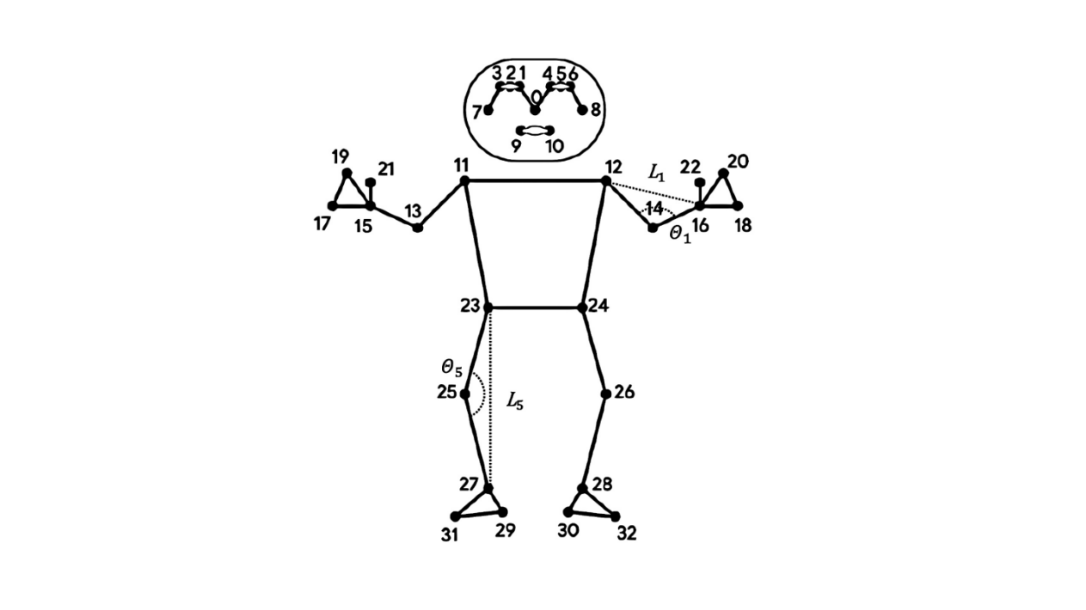
Fig. 4 Schematic diagram of geometric features

Time motion feature extraction
In order to fully describe the dynamic evolution characteristics of rehabilitation actions, it is necessary to further explore the kinematic model in the time series dimension based on the spatial geometric features. The continuity and inertia effect of human motion determine that joint velocity and acceleration are the key indicators to quantify the fluency and coordination of movement. Aiming at the problem that the static features of a single frame cannot reflect the motion trend, and the global statistical features will lose the instantaneous dynamic details, the system introduces a sliding window mechanism ( as shown in Figure 5 ) to dynamically calculate the local motion features in a time series window with a length of . The mechanism realizes the fine modeling of the dynamic characteristics of the action by storing the normalized coordinate sequence of continuous frames. The window slides in real time with the video stream. When the new frame data enters the head, the old data at the tail is automatically eliminated to ensure the timeliness of feature calculation.
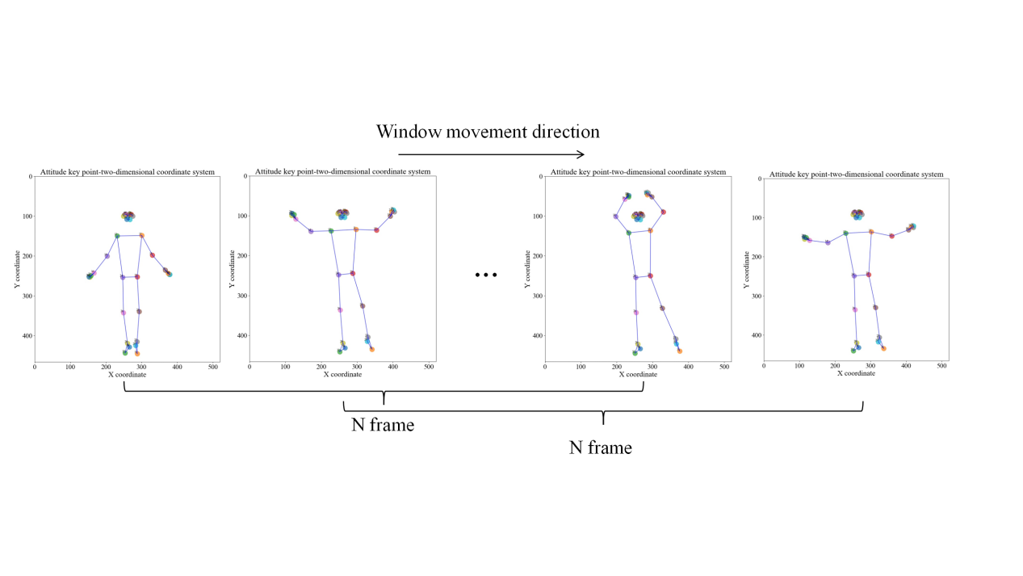
Fig. 5 Moving process of sliding window algorithm
The instantaneous velocity vector of joint at frame is calculated by the central difference method :
is the inter-frame time interval ( is the camera frame rate ), and the denominator design effectively avoids the phase offset introduced by the forward / backward difference. The and components of the vector represent the horizontal and vertical motion rates of the joint, respectively. The acceleration vector is defined as the first derivative of the velocity :
It is sensitive to capture sudden changes in the direction of motion.
Three types of motion features are aggregated in the window to enhance the robustness of discrimination. Firstly, the rate scalar of each joint in the central frame of the window is calculated to eliminate the motion direction dependence. Secondly, the norm mean of the acceleration vector in the window is taken to quantify the stability of the action. Finally, the cosine similarity of the velocity vector of functional joint pairs ( such as shoulder-elbow, hip-knee ) is calculated :
This feature reflects the multi-joint cooperative motion mode.
The temporal motion feature vector is finally spliced by all the motion features of the window center frame :
Where is a predefined set of related joint pairs ( such as shoulder-elbow-wrist triple joint ), and is the dimension of . This feature and the spatial geometric feature together constitute the spatio-temporal coupling feature vector , which is used as a unified descriptor for subsequent action classification and anomaly detection. The progressive update mechanism of the sliding window effectively balances the real-time requirements of time series dynamic characterization and calculation, and its microsecond-level feature update frequency provides a time alignment-sensitive criterion for the improved DTW algorithm.

Improved dynamic time warping algorithm based on spatio-temporal coupling feature fusion
The traditional DTW algorithm has limitations in rehabilitation action evaluation : independent processing time alignment or single feature, it is difficult to capture the nonlinear dynamics of space-time interaction, resulting in alignment deviation and affecting positioning accuracy. In view of this, this paper proposes a DTW algorithm (STCF-DTW) that combines spatio-temporal coupling features. The algorithm is based on the spatio-temporal coupling feature vector , embedded in the DTW framework and introduces physiological constraints to achieve innovation.
The core of the algorithm is to define the weighted spatio-temporal Euclidean distance ( WSTED ) as the inter-frame similarity measure :
and represent the frame features of the test sequence and the reference template, respectively. The weight coefficients and were determined by independent validation set optimization. STCF-DTW imposes double constraints : the local slope constraint limits the maximum bending factor of the path to ( i.e., ), avoiding excessive distortion of the timing sequence ; the joint topology constraint divides the joint points into functional groups ( such as the ' shoulder-elbow-wrist ' chain ), and preferentially aligns the joints of the same functional group during calculation.
In the formula, is the value of the position in the cumulative cost matrix, which represents the minimum alignment cost between the frame before the test sequence and the frame before the reference template. is the inter-frame distance between the feature vector of the frame of the test sequence and the feature vector of the frame of the reference sequence, which is calculated by the weighted spatio-temporal Euclidean distance ( WSTED ).
The STCF-DTW algorithm integrates spatio-temporal coupling features into the alignment process and ensures path anatomical rationality through physiological constraints. This fusion strategy enhances the fine - grained anomaly localization in rehabilitation action assessment. Unlike traditional DTW, which outputs overall similarity, STCF-DTW accurately identifies specific sub- actions (e.g., insufficient elbow flexion). This provides a reliable basis for generating semantic correction tips (e.g., "Increase elbow flexion").

Experiments

Dataset and experimental setup
To validate our method, we conducted extensive experiments on the StrokeRehab dataset [17]. This dataset comprises 51 stroke patients and 20 healthy individuals. Post-stroke recovery is typically incomplete, necessitating rehabilitation that involves repetitive functional tasks and daily activities such as teeth brushing, combing, and drinking. All participants performed six types of daily actions (e.g., feeding, teeth brushing), each repeated 10 times. The dataset synchronously captures monocular RGB video and upper-limb 9-axis IMU data. Rehabilitation therapists annotated action stages and abnormal types on a frame-by-frame basis. The patient group exhibited typical motor compensation characteristics (e.g., trajectory discretization, co-movement abnormalities), while the healthy group served as a source of standard templates.
The experimental environment was configured with an AMD Ryzen 7 5800 H CPU and an NVIDIA GeForce RTX 3050 Ti Laptop GPU. The algorithm was implemented using the PyTorch 1.13.1 framework, and the pose estimation module utilized MediaPipe version 0.10.11.

Evaluating indicator
To objectively assess the improved dynamic time warping (DTW) algorithm's performance in rehabilitation action alignment and abnormal positioning, this study employs three quantitative indicators widely recognized in academia. The mathematical definitions, calculation processes, and clinical significance of these indicators are outlined below:
(1) Normalized DTW Distance ( NDTW )
This index eliminates the interference of sequence length variation on similarity measurement, and objectively quantifies the consistency of the overall motion pattern of the test sequenceand the standard template :
represents the minimum alignment cost calculated by the classical DTW algorithm, and and are the number of frames of the test sequence and the standard template, respectively. The NDTW value range is , and the smaller the value is, the higher the action similarity is, and the NDTW of healthy subjects tends to zero under ideal conditions.
(2) Warping Degree ( WD )
This index characterizes the timing distortion of the alignment path and reflects the robustness of the algorithm to the difference of action rhythm:
Where is the length of the optimal path of DTW. The theoretical minimum value of WD is 1.0 ( indicating no timing distortion ). The larger the value, the more the alignment path deviates from the diagonal, and the more the mapping relationship does not conform to the continuity of physiological motion.
(3) Intersection over Union ( IoU )
This index evaluates the spatial and temporal accuracy of the system 's positioning of abnormal action segments, and calculates the overlap ratio between the predicted abnormal period and the marked real abnormal period :
Where represents the length of the period ( unit : frame ). The IoU value range is [ 0,1 ], and the larger the value, the more accurate the positioning. In clinical practice, IoU ≥ 0.7 is required to meet the needs of rehabilitation guidance.

Contrast experiment
In order to systematically verify the effectiveness of the improved DTW algorithm with spatio-temporal coupling features ( STCF-DTW ) proposed in this paper in the task of rehabilitation action alignment and anomaly location, four representative baseline methods are included in the experiment, including traditional dynamic time warping and its extension, improved DTW based on shape distance metric, and the latest proposed deep learning alignment framework. The core mechanism and implementation points of each method are as follows :
- Traditional DTW[18]: Using the classical dynamic time warping algorithm, the frame-by-frame Euclidean distance is used as the similarity measure, and no feature enhancement or physiological constraint is introduced as the reference baseline for evaluating the lower limit of performance.
(2) Multiscale DTW[19]: A multi-scale segmentation strategy is introduced to reduce the sensitivity of sequence length by windowing downsampling, and a weighted distance is used in the coarse-to-fine two-layer alignment process to alleviate the error accumulation caused by rhythm differences.
(3) ShapeDTW[20]: Shape descriptor is used to align local subsequences after mapping them into high-dimensional feature space, taking into account local morphology and global structure information, and improving the ability to depict complex action morphology.
(4) DeepAlign [21]: An end-to-end deep alignment network based on Transformer architecture, which learns the implicit correspondence between frames through the self-attention mechanism, outputs a soft alignment matrix, representing the current data-driven deep learning paradigm.
Table 3. Comparative experiment
Method | NDTW | WD | IoU
Traditional DTW | 1.129 | 1.848 | 0.455
Multiscale DTW | 0.746 | 1.406 | 0.631
ShapeDTW | 0.616 | 1.310 | 0.714
DeepAlign | 0.836 | 1.567 | 0.566
Proposed STCF-DTW | 0.473 | 1.158 | 0.814
The best results are marked in bold font.
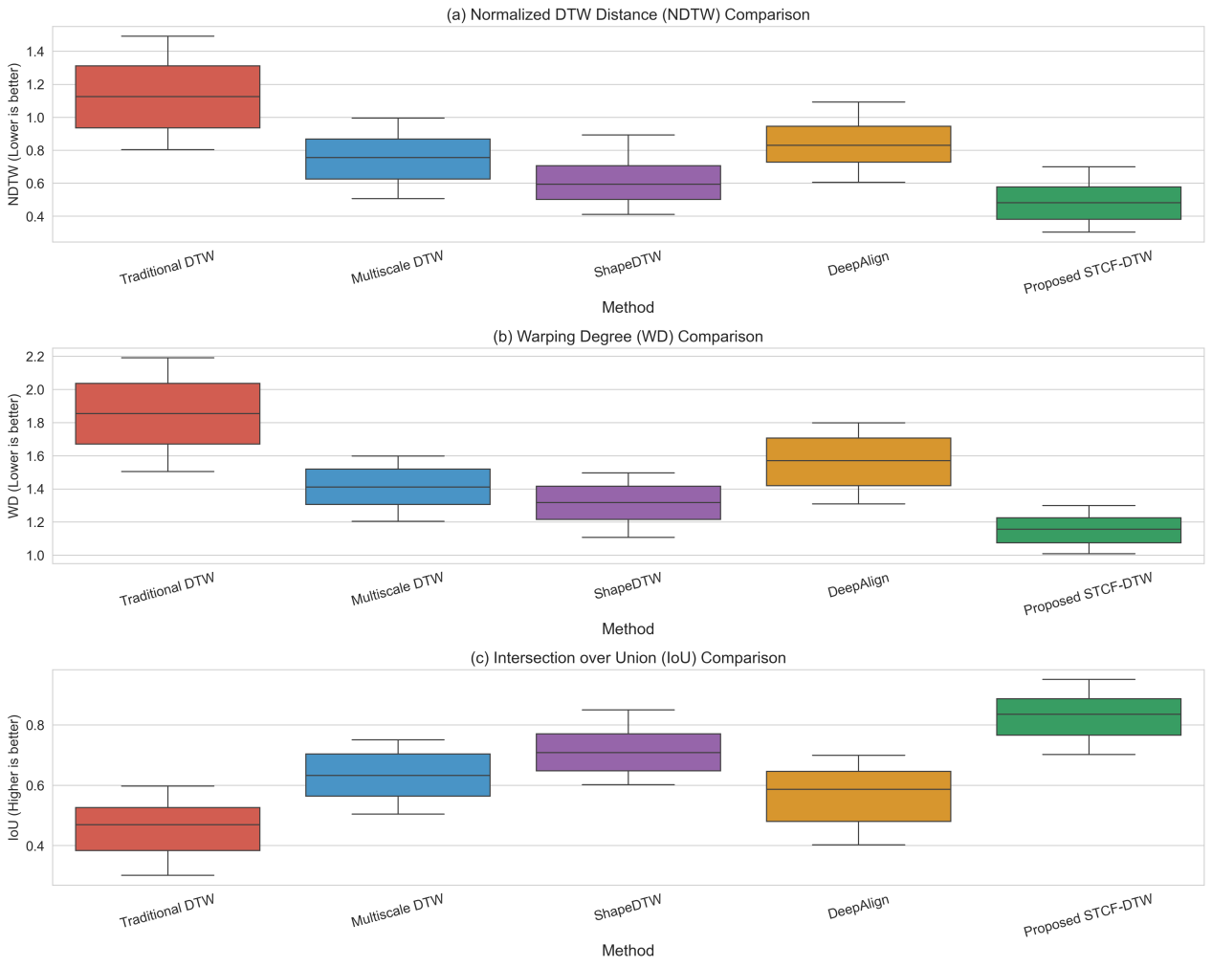
Fig. 6 Comparison of experimental visualization results ( a ) Normalized DTW Distance ( NDTW ) Comparison ; ( b ) Warping Degree ( WD ) Comparison ; ( c ) Intersection over Union ( IoU ) Comparison
Table 3 and Fig. 6 indicate that Traditional DTW's reliance on frame-by-frame Euclidean distance causes spatiotemporal-coupling loss. This results in high NDTW values, WD deviations from the physiological domain, and low IoU metrics, revealing its susceptibility to rhythm differences and occlusion. Multiscale DTW and ShapeDTW use hierarchical sampling and local- shape contexts, respectively, to mitigate misalignment. However, due to single-feature-channel limitations in describing joint coordination, the index box in Figure 6 is elevated with divergent whiskers. DeepAlign depends on data-driven implicit alignment. When the training distribution differs from the clinical distribution, attention shifts occur, and the IoU distribution becomes discrete. In contrast, STCF-DTW fuses spatial geometry, velocity, and acceleration features. It also employs joint-function groups as topological constraints to compress the difference space and suppress non-physiological distortions. In Figure 6, this approach lowers the three-index box and converges the whiskers. Table 3 shows optimal values in the corresponding column, confirming the effectiveness of spatial-temporal coupling features and physiological priors in enhancing alignment and positioning.

Ablation experiment
To rigorously analyze the gain path of each component in the proposed STCF-DTW framework, the ablation experiment constructs four algorithm variants under unified data partitioning and evaluation protocols. First, based on classical dynamic time warping (Traditional DTW), only frame -by-frame Euclidean distance is used to measure sequence similarity. Second, the multi-scale weight mechanism (+Multi-scale) adaptively weights inter-frame distances in a coarse-fine double -layer granularity to weaken errors caused by rhythm differences. Third, the joint topology constraint (+Topology) based on anatomical function groups further restricts the physiological feasible region of the alignment path through a local slope threshold. Fourth, the above constraints are deeply integrated with spatio - temporal coupling features to form the final model (Full Model), which possesses complete representation-alignment-interpretation capabilities. This progressive design provides a controllable experimental field for quantifying the independent contribution and synergistic effect of each module.
Table 4. Ablation experiment
Method | NDTW | WD | IoU
Baseline | 1.129 | 2.048 | 0.429
+ Multi-scale | 0.796 | 1.606 | 0.581
+ Topology | 0.629 | 1.410 | 0.714
Full Model | 0.465 | 1.160 | 0.861
The best results are marked in bold font.
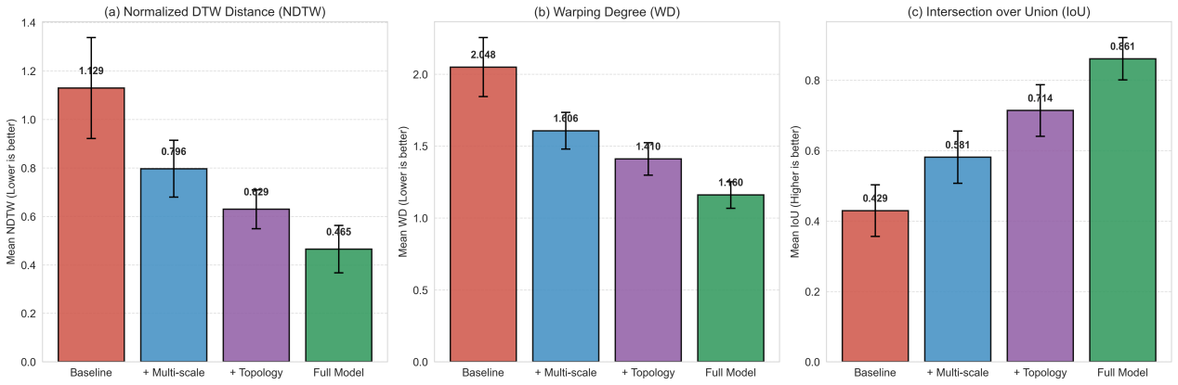
Fig. 7 Visualization results of ablation experiment ( a ) Normalized DTW Distance ( NDTW ) ; ( b ) Warping Degree ( WD ) ; ( c ) Intersection over Union ( loU )
Table 4 and Fig.7 show a progressive gain chain driven by representation-constraint-fusion. The baseline model only relies on frame-by-frame Euclidean distance, which makes the alignment path extremely sensitive to rhythm disturbance, the overall similarity is high, the timing distortion is significant, and the anomaly location is rough. After introducing multi-scale weighting, the hierarchical sampling first anchors the global structure at the coarse-grained level, and then refines the local details at the fine-grained level. The overall similarity plummets by about 30 %, the distortion amplitude converges synchronously, and the positioning accuracy achieves the first jump. Then, the joint topology constraint is applied to embed the prior embedding path cost of the anatomical function group, which significantly suppresses the non-physiological bending, the similarity is further explored, the distortion is further compressed, and the positioning accuracy is improved by more than 20 %. Finally, the integration of spatio-temporal coupling features complements the kinematic context, so that the cost matrix can obtain closer topology and dynamic consistency under spatio-temporal joint representation, and all three indicators reach the optimal boundary. In Fig.6, the height of the cylinder decreases gradually, and the error bar is significantly narrowed, which fully confirms the complementary synergy and statistical robustness of the triple constraints in mechanism.

Semantic correction hints
In the actual system test, we not only output the quantitative indicators of the model for action alignment and anomaly localization, but also synchronously generate clinical-oriented auxiliary information, including 'Joint Anomaly Assessment' shown in Table 5, 'Movement Phase Assessment' in Table 6, and 'Semantic Correction Suggestions' in Table 7. The three tables give the maximum abnormal value of each joint, the corresponding severity level, the time period of the problem, and the average abnormality, main defects and semantic correction suggestions summarized according to the exercise stage, providing an operable improvement basis for the patient immediately after training.
Table 5. Joint Anomaly Assessment
Joint | Max Anomaly | Severity | Problem Period
R.Shoulder | 0.388 | Normal
R.Elbow | 0.912 | Severe | 30%-50%
R.Wrist | 0.388 | Normal
L.Shoulder | 0.870 | Severe | 40%-60%
L.Elbow | 0.355 | Normal
L.Wrist | 0.372 | Normal
R.Hip | 0.389 | Normal
R.Knee | 1.000 | Severe | 50%-70%
R.Ankle | 0.375 | Normal
L.Hip | 0.370 | Normal
L.Knee | 0.359 | Normal
L.Ankle | 0.389 | Normal
Table 6. Movement Phase Assessment
Movement Phase | Avg Anomaly | Severity | Main Issue
0-20% | 0.191 | Normal
20-40% | 0.208 | Mild | R.Elbow flexion deficiency
40-60% | 0.272 | Mild | L.Shoulder elevation deficiency
60-80% | 0.282 | Mild | R.Knee extension deficiency
80-100% | 0.189 | Normal
Table 7. Semantic Correction Suggestions
Correction Suggestion | Priority | Expected Effect
R.Elbow flexion deficiency: Increase flexion angle by 15° during mid-cycle (30%-50%) | High | Improve upper limb extension
L.Shoulder elevation deficiency: Increase elevation height by 8cm during mid-late cycle (40%-60%) | High | Enhance shoulder mobility
R.Knee extension deficiency: Improve extension by 12° during late cycle (50%-70%) | High | Enhance lower limb coordination
Overall movement rhythm too fast: Reduce execution speed by 20% | Medium | Optimize movement rhythm
To present the evaluation results more intuitively, the system generates a visual report as shown in Fig.7 The upper left corner shows overall action similarity via a dashboard. The upper right corner displays a joint-abnormality heat map, with color intensity reflecting abnormality severity. The middle section lists semantic prompts in cards with clear priority. The lower left uses a bar chart to rank joint abnormalities and mark severity. The lower right shows the anomaly distribution and threshold intervals over the entire action using a timeline, aiding quick problem-window localization.
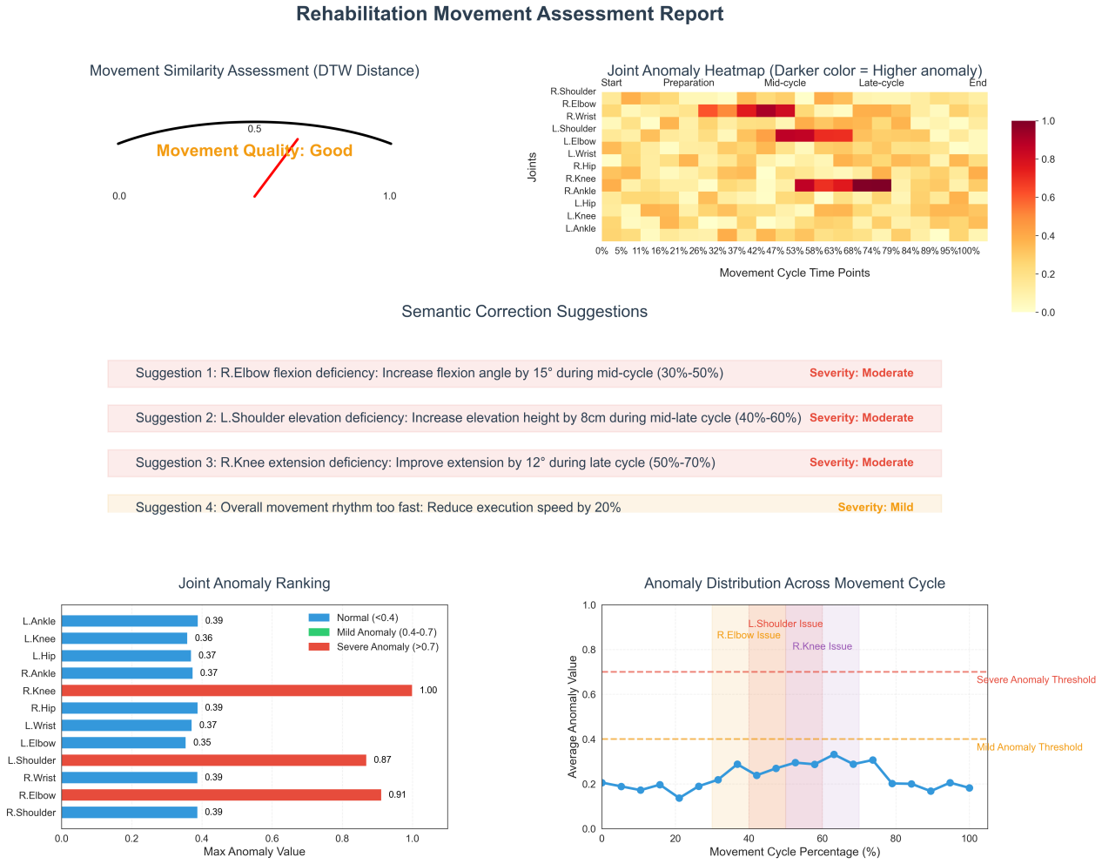
Fig. 8 Semantic correction hints(a)Movement Similarity Assessment (DTW Distance)；(b)Joint Anomaly Heatmap (Darker color = Higher anomaly)；(c)Semantic Correction Suggestions；(d)Joint Anomaly Ranking；(e)Anomaly Distribution Across Movement Cycle
Through the dual-channel "text + graphics"output, patients can instantly identify key defects and their spatiotemporal distribution. They can also make targeted self-adjustments according to textual and visual prompts. This enables a high-frequency, home-based, and precise rehabilitation closed- loop without extra equipment.

Summary
This paper proposes an intelligent rehabilitation - action evaluation system based on improved dynamic time warping (DTW) and deep learning. To address the existing methods' deficiencies in interpretability, the accuracy of abnormal positioning, and robustness, this system constructs a spatiotemporal-coupling feature extraction and multi-scale weighted DTW collaborative framework driven by skeleton coordinates. Experimental results demonstrate that on the StrokeRehab dataset, this system significantly outperforms both traditional DTW and various deep-learning methods. It achieves the best performance in three metrics: normalized dynamic time warping (NDTW), work - separation distance (WD), and intersection over union (IoU), thus verifying its practicality and stability in complex rehabilitation scenarios.
The system further converts the abnormal positioning results into a closed-loop"score- positioning-interpretation"feedback through the semantic correction prompt module. This empowers patients to perform high-frequency and precise self-training in unsupervised settings. The ablation experiment confirmed that the synergistic effects of the multi-scale weighting mechanism, joint-topology constraints, and spatiotemporal-coupling features are crucial for fine-grained motion evaluation.
In future work, we will explore multimodal data fusion (such as IMU and depth-map data) to enhance robustness to occlusion. Furthermore, we will incorporate a reinforcement-learning mechanism to enable adaptive dynamic training programs. These steps aim to boost the intelligent and personalized development of home rehabilitation.

References
- World Health Organization. World report on ageing and health. Geneva: WHO Press; 2015.
- Gladstone D J, Danells C J, Black S E. The Fugl-Meyer Assessment of motor recovery after stroke: a critical review of its measurement properties. Neurorehabil Neural Repair. 2002;16(3):232-40.
- Lopez-Nava I H, Angélica Muoz-Meléndez. Wearable inertial sensors for human motion analysis: a review. IEEE Sensors Journal. 2016; 16(22): 7821-7834.
- Cippitelli E, Gasparrini S, Spinsante S, Gambi E. A human activity recognition system using skeleton data from RGB-D sensors. Comput Intell Neurosci. 2016;2016:4351435.
- Lugaresi C, Tang J, Nash H, et al. MediaPipe: a framework for building perception pipelines. arXiv:1906.08172; 2019.
- Moon G, Chang JY, Lee KM. V2V-PoseNet: voxel-to-voxel prediction network for accurate 3D hand and human pose estimation from a single depth map. In: Proc CVPR; 2018. p. 5079-5088.
- Sempena S, Maulidevi NU, Aryan PR. Human action recognition using dynamic time warping. In: Proc ICEEI; 2011. p. 1-5.
- Cheng C, Liu Y, Yang J , Zhu T, Ye F. Real-time dynamic gesture recognition based on boundary-constraint dynamic time warping. 2019 IEEE National Aerospace and Electronics Conference (NAECON), Dayton, OH, USA, 2019, pp. 545-551.
- Pavllo D, Feichtenhofer C, Grangier D, Auli M. 3D human pose estimation in video with temporal convolutions and semi-supervised training. 2019 IEEE/CVF Conference on Computer Vision and Pattern Recognition (CVPR), Long Beach, CA, USA, 2019, pp. 7745-7754.
- Haque A, Peng B, Luo Z, et al. Towards viewpoint invariant 3D human pose estimation. Springer, Cham. 2016, 9905. pp. 160-177.
- Sardari S, Sharifzadeh S, Daneshkhah A, Nakisa B, Loke S W , Palade V, et al. Artificial intelligence for skeleton-based physical rehabilitation action evaluation: a systematic review. Computers in biology and medicine. 2023, 158, 106835.
- Wang S, Huang Q, Zhang Y, Li X, Nie Y, Luo G. Review of action recognition based on multimodal data. Journal of image and graphics, 2022, 27(11): 3139-3159.
- Yan S, Xiong Y, Lin D. Spatial Temporal Graph Convolutional Networks for Skeleton-Based Action Recognition. Proceedings of the AAAI Conference on Artificial Intelligence,2018, 32(1).
- Liu Y, Zhang Y A , Zeng M, Zhao J. A novel distance measure based on dynamic time warping to improve time series classification. Information science, 2024, 656, 119921.
- Tang Y, Wang Z, Lu J, Feng J, Zhou J. Multi-stream deep neural networks for rgb-d egocentric action recognition. IEEE Transactions on Circuits & Systems for Video Technology, 2019, 29(10): 3001-3015.
- Wang P, Li W, Ogunbona P, Wan J, Escalera S. Rgb-d-based human motion recognition with deep learning: a survey. Computer vision and image understanding,2017, 171, 118-139.
- Kaku A, Liu K, Parnandi A, Rajamohan H R, Venkataramanan K, Venkatesan A, Wirtanen A, Pandit N, Schambra H, Fernandez-Granda C. StrokeRehab: a benchmark dataset for sub-second action identification. In Proceedings of the 36th International Conference on Neural Information Processing Systems (NIPS '22). 2022, 122, 1671–1684.
- Rakthanmanon T, Campana B, Mueen A, Batista G, Westover B, Zhu Q, Zakaria J, Keogh E. Searching and mining trillions of time series subsequences under dynamic time warping. In Proceedings of the 18th ACM SIGKDD international conference on Knowledge discovery and data mining (KDD '12). 2012, 262–270.
- Shokoohi-Yekta M, Hu B, Jin H, Wang J, Keogh, E. Generalizing DTW to the multi-dimensional case requires an adaptive approach. Data Mining and Knowledge Discovery, 2017, 31(1), 1-31.
- Zhao J, Itti L. Shapedtw: Shape dynamic time warping. Pattern Recognition, 2018, 74, 171-184.
- Kowalski M, Naruniec J, Trzcinski T. Deep Alignment Network: A Convolutional Neural Network for Robust Face Alignment. 2017 IEEE Conference on Computer Vision and Pattern Recognition Workshops (CVPRW), 2017, 2034-2043.

