PRODUCT SPECIFICATION

Customer : ______________
Part No : JLF -0603-1-ER/ERC
Developed No : ________________
Date : ________________

CUSTOMER APPROVED BY

APPROVED | Q.C. | R&D
_______________________________________________________________
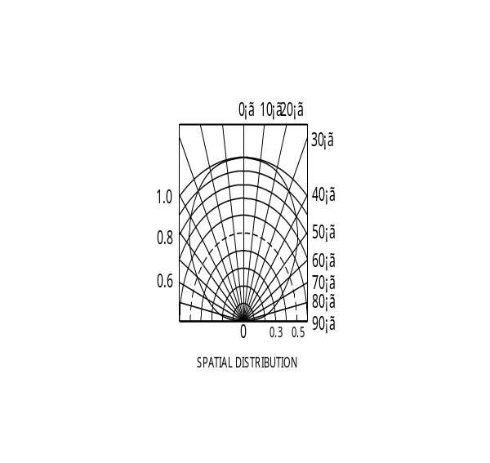
- Outline Dimension:
Notes:
- All dimensions are in millimeters.
- Tolerance is ±0.1 unless otherwise noted.
- Specifications are subject to change without notice.
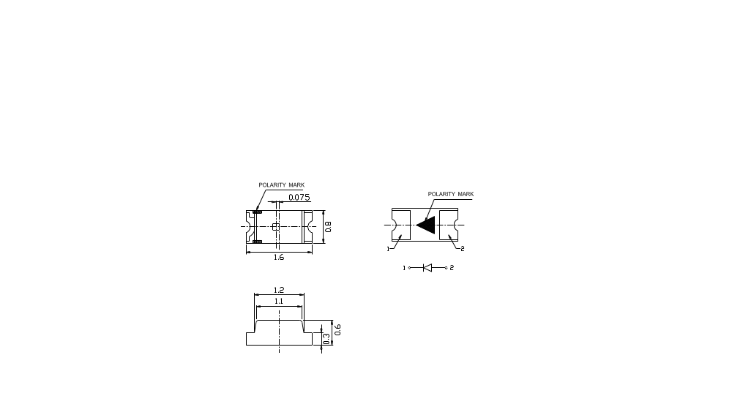
- View Angle:

1

- Typical Electrical & Optical Characteristics(Ta=25°)

Items | Symbol | Condition | Min | Typ | Max | Unit
Forward Voltage | VF | IF =20mA | 1.9 | 2.0 | 2.2 | V
Reverse Current | IR | VR =5V | --- | --- | 5 | μA
Dominant Wavelength | λd | IF =20mA | 625 | 627 | --- | nm
Luminous Intensity | Iv | IF =20mA | 100 | 120 | --- | mcd
View Angle | 2θ1/2 | IF =20mA | --- | 120 | --- | Deg

- Absolute Maximum Ratings (Ta = 25℃)

Items | Symbol | Absolute maximum Rating | Unit
Power Dissipation | PD | 120 | mW
Forward Current(DC) | IF | 30 | mA
Peak Forward Current | IFP | 120 | mA
Reverse Voltage | VR | 5 | V
Operation Temperature | Topr | ﹣40～﹢85 | ℃
Storage Temperature | Tstg | ﹣40～﹢85 | ℃

Note :1/10 Duty Cycle，0.1 ms Pulse Width.

- Typical Electrical/Optical Characteristics Curves:
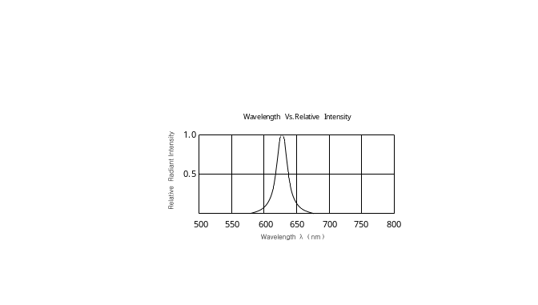

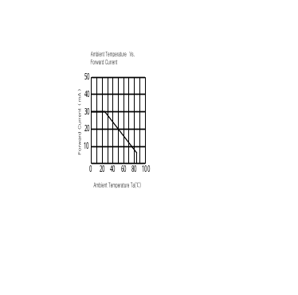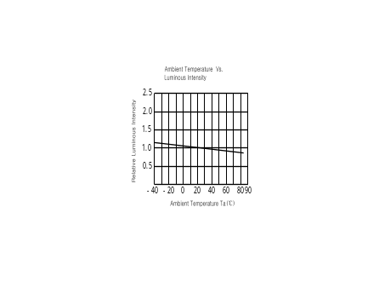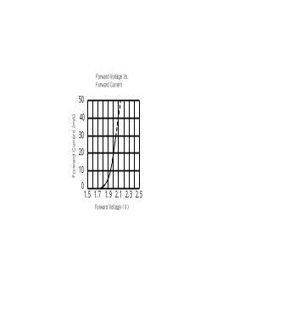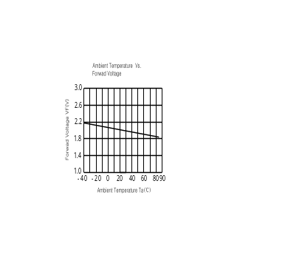

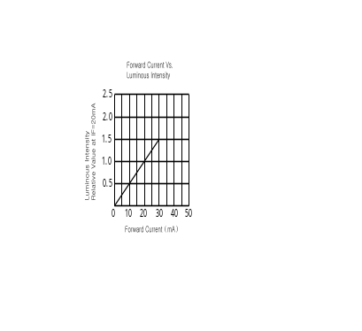

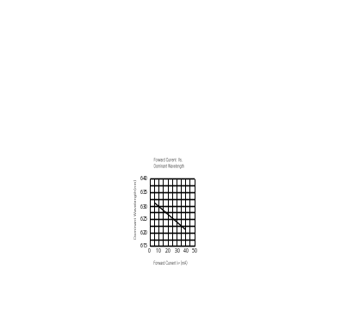

- Reliability Test :

Classification | Test Item | Test Conditions | Duration | Units  Tested | Number of Damaged
Life Test | Operating Life Test | Ta =25℃±5℃,  RH=55±20%RH,  IF=30mA | 1000hrs | 22 | 0/22
Environment  Test | High Temperature Storage | Ta =100℃±10℃ | 1000hrs | 22 | 0/22
Environment  Test | Low Temperature Storage | Ta =﹣40℃Combin℃ | 1000hrs | 22 | 0/22
Environment  Test | Temp &Humidity Storage | Ta =85℃Combin ℃  RH=85\s\up 6( +)\s\up 5( 5) %RH | 1000hrs | 22 | 0/22
Environment  Test | Thermal Shock Test | Ta=﹣40℃Combin℃～  100℃Combin ℃  T=5min - 5min | 100  Cycles | 22 | 0/22
Environment  Test | Temperature Cycling Test | Ta=﹣40Combin ℃～25℃～100Combin℃～25℃  T=30min-5min-30min- 5min | 10Cycles | 22 | 0/22
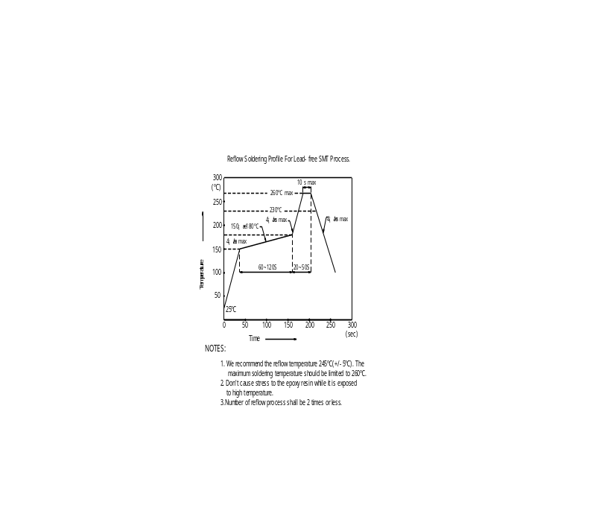

- Recommended Soldering Pattern:
( Units:mm)
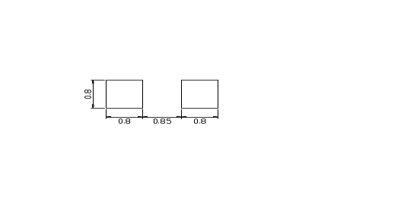

- Tape Specifications:
(Units:mm)

