EE533_lab4

1. Generating bit files

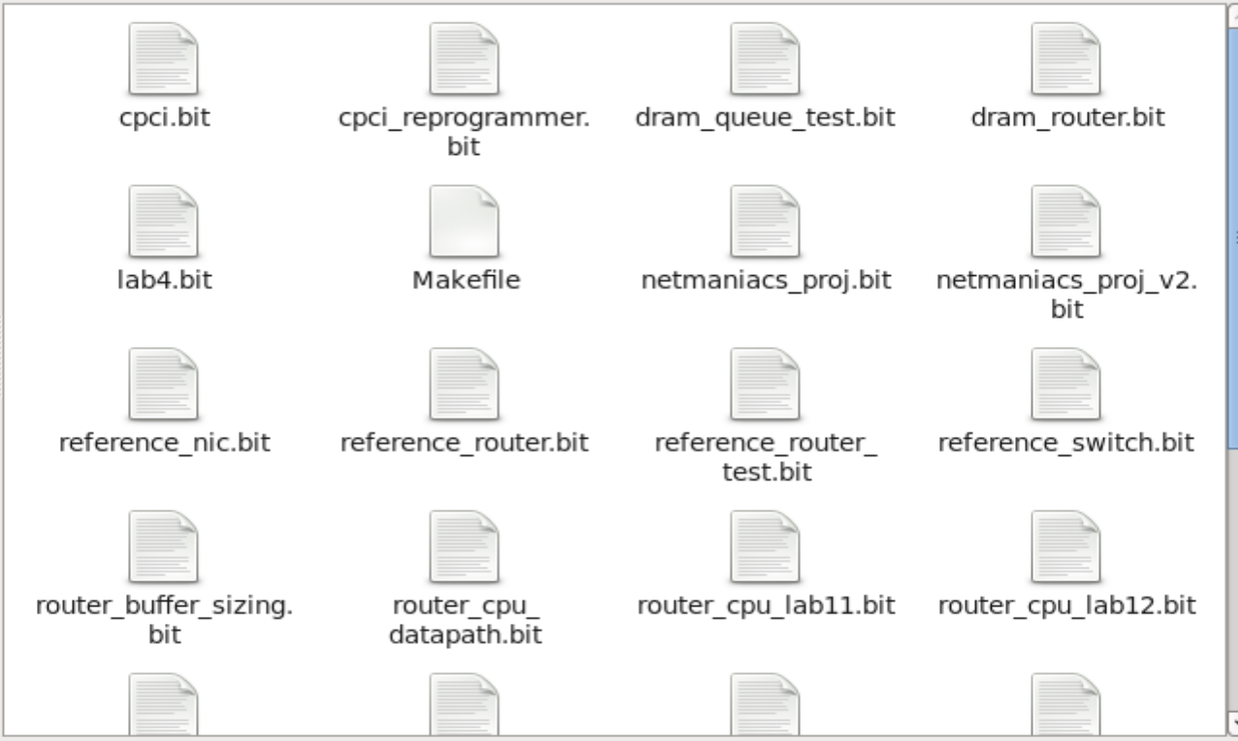

Fig.1.1 bitfiles

1. Setting up NetFPGA Environment

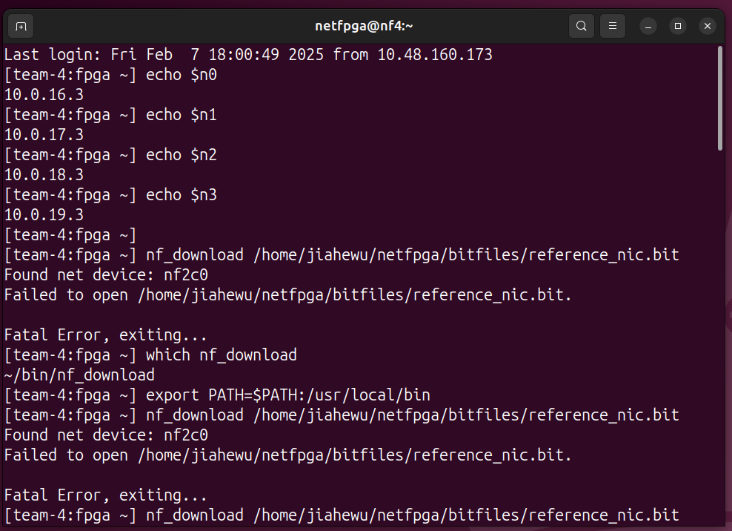

Fig.2.1 NetFPGA node

1. Iperf tests for bandwidth between nodes

We used Python to generate 5 figures showing the bandwidth versus time interval between different tests.

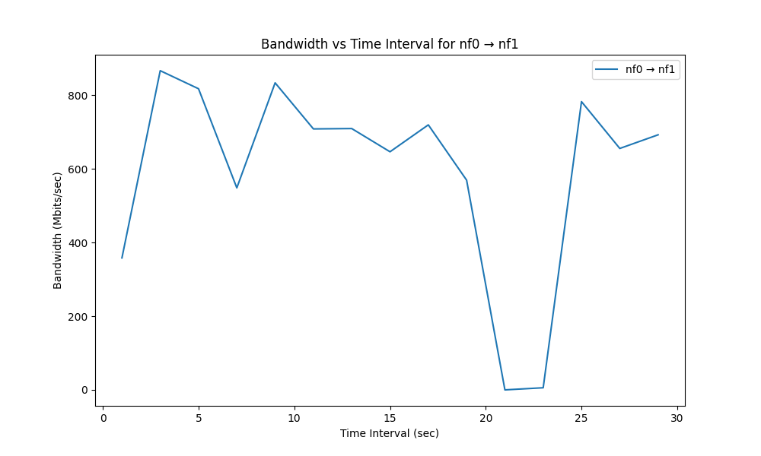

Fig.3.1 nf0->nf1

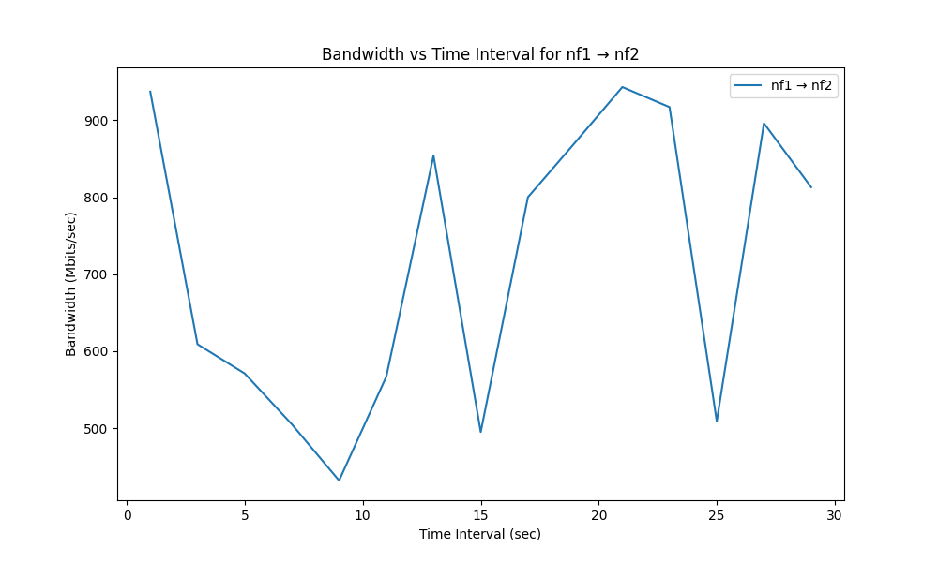

Fig.3.2 nf1->nf2

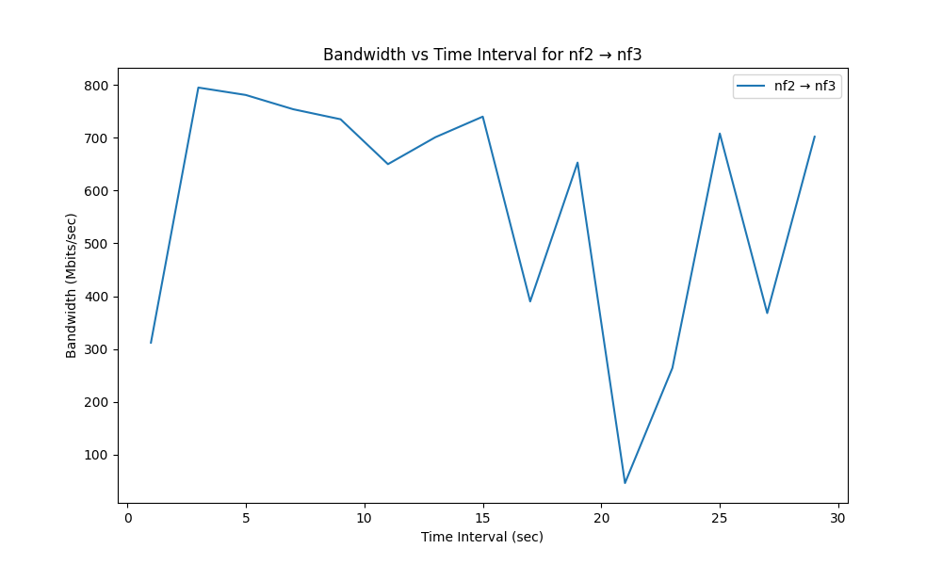

Fig.3.3 nf2->nf3

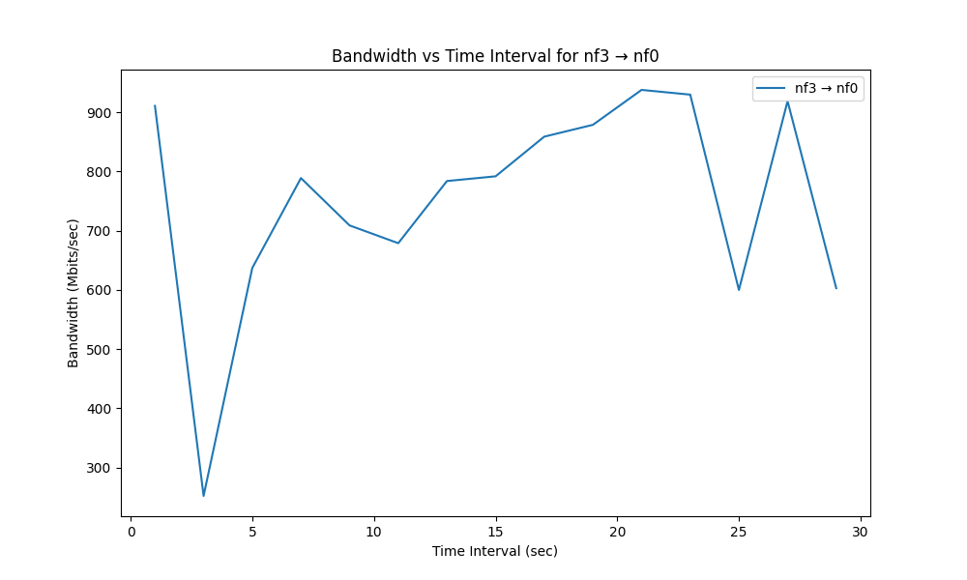

Fig.3.4 nf3->nf0

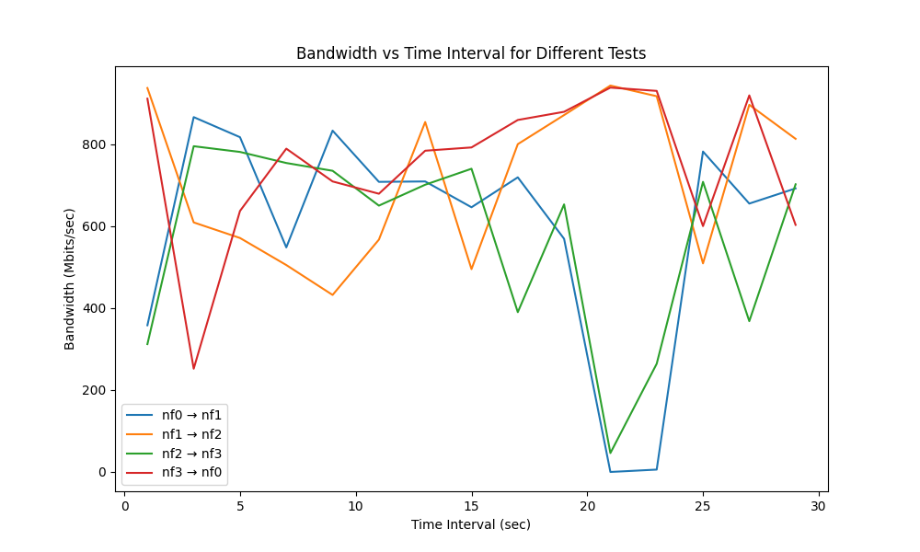

Fig.3.5 Different Tests Comparsion

From the figures 3.1-3.5 above, we can find that the bandwidth of all of the 4 tests fluctuates greatly over time. However, the fluctuation from nf1 to nf2 and from nf3 to nf0 is a little better than the other two tests.

Table 3.1 Average and Standard Deviation of Bandwidth between different Tests(NIC)

|  |  |  |
| --- | --- | --- |
| Test | Average Bandwidth(Mbits/sec) | Standard Deviation(Mbits/sec) |
| nf0->nf1 | 593.85 | 262.21 |
| nf1->nf2 | 714.60 | 183.34 |
| nf2->nf3 | 573.27 | 225.06 |
| nf3->nf0 | 752.07 | 176.40 |

According to the table 3.1 above, we can also find that the connection performance of nf1->nf2 and nf3->nf0 is much better than the other two ones from the perspectives of the average and standard deviation of bandwidth.

1. NetFPGA Hardware IP Router
2. Iperf tests for NetFPGA Router

After loading the reference router into the NetFPGA, following figures show the change of bandwidth.

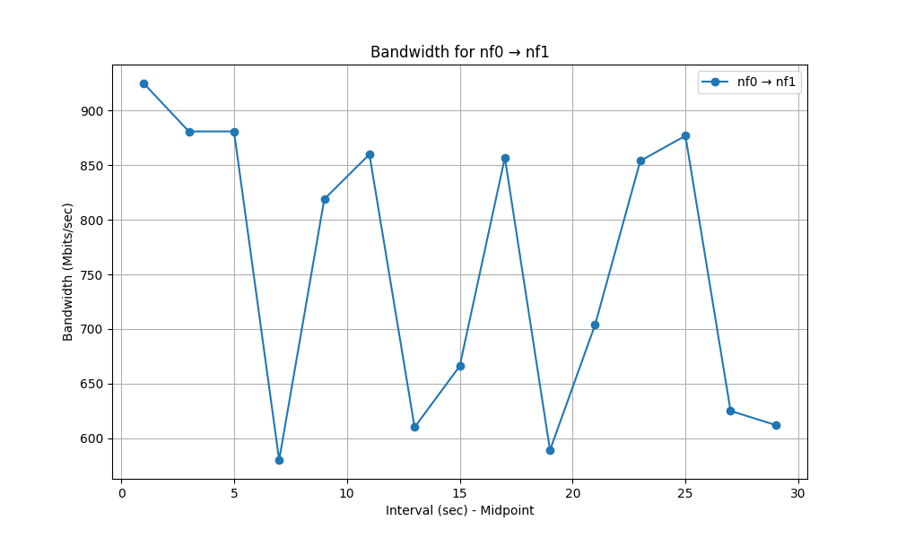

Fig.4.1.1 nf0->nf1

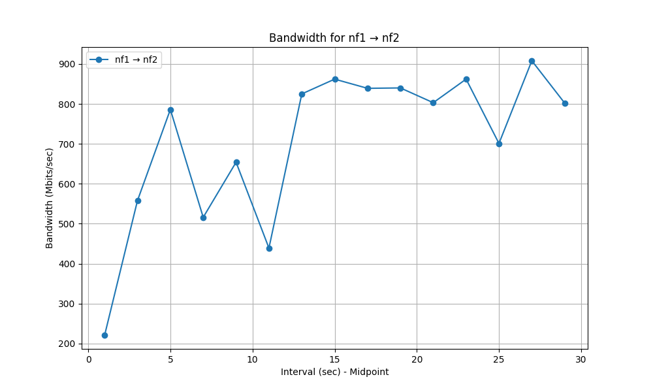

Fig.4.1.2 nf1->nf2

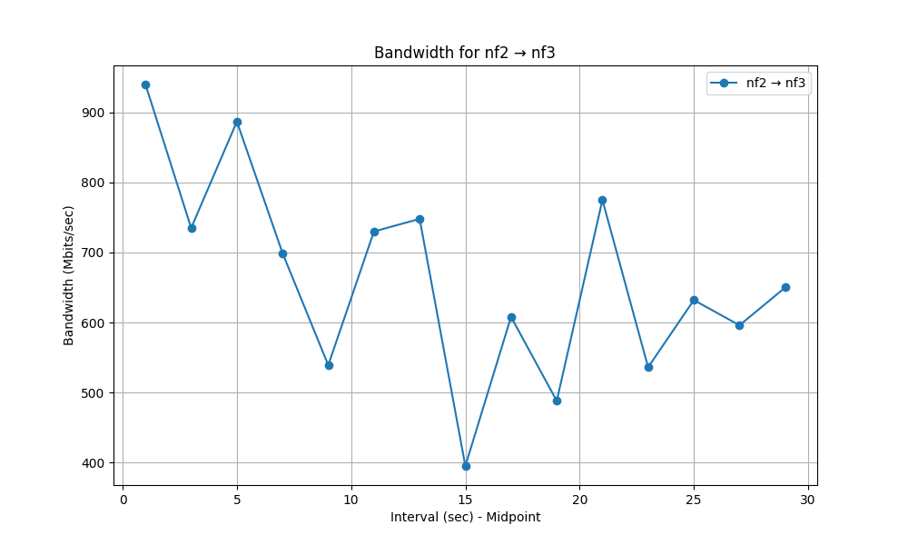

Fig.4.1.3 nf2->nf3

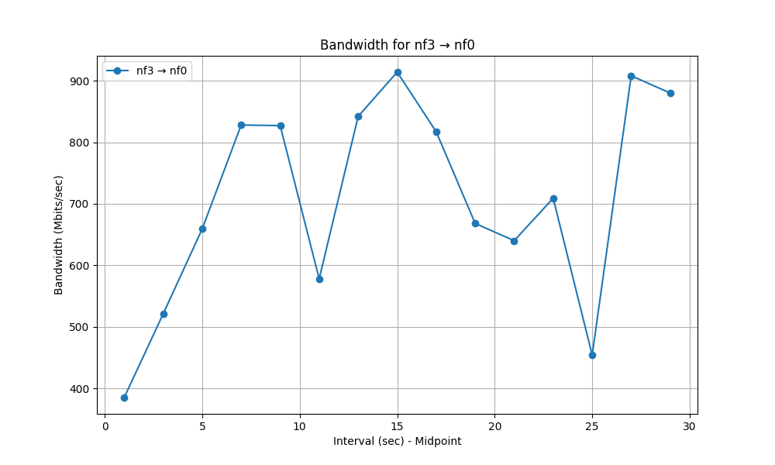

Fig.4.1.4 nf3->nf0

It looks like the same fluctuation trend as the NetFPGA being a network interface card, but let’s look at the average and standard deviation of bandwidth.

Table 4.1 Average and Standard Deviation of Bandwidth Comparison between Router and NIC

|  |  |  |  |  |
| --- | --- | --- | --- | --- |
| Test | Router_Average Bandwidth(Mbits/sec) | Router_Standard Deviation(Mbits/sec) | NIC_Average Bandwidth(Mbits/sec) | NIC_Standard Deviation(Mbits/sec) |
| nf0->nf1 | 756.00 | 121.94 | 593.85 | 262.21 |
| nf1->nf2 | 707.75 | 182.26 | 714.60 | 183.34 |
| nf2->nf3 | 663.88 | 136.98 | 573.27 | 225.06 |
| nf3->nf0 | 708.69 | 158.06 | 752.07 | 176.40 |

Average bandwidth of NetFPGA as Router across all tests: 709.25 Mbits/sec.

Average bandwidth of NetFPGA as NIC across all tests: 649.50 Mbits/sec.

From now on, we can know the bandwidth of NetFPGA as Router improves a lot compared with as NIC, since NetFPGA router can speed up IP forwarding and reduce CPU burden. Loading the routing table through rkd enables NetFPGA to know how to forward data packets.

1. Iperf test in UDP Mode for NetFPGA NIC

We did Iperf test in UDP mode for 5 times. The recorded bandwidth is as follows.

Table.4.2 Average Bandwidth for each Iperf Test

|  |  |
| --- | --- |
| Test Times | Average Bandwidth(Mbits/sec) |
| 1 | 181.87 |
| 2 | 140.77 |
| 3 | 182.65 |
| 4 | 172.00 |
| 5 | 221.25 |

Average bandwidth for 5 times tests: 179.71 Mbits/sec.

Using small packets stresses the system because it increases the number of packets per second that need to be processed, leading to higher CPU load, more interrupts, memory bottlenecks, and lower overall efficiency.

1. Iperf test in UDP Mode for NetFPGA Router

We did Iperf test in UDP mode for 5 times. The recorded bandwidth is as follows.

Table.4.2 Average Bandwidth for each Iperf Test

|  |  |
| --- | --- |
| Test Times | Average Bandwidth(Mbits/sec) |
| 1 | 182.17 |
| 2 | 209.25 |
| 3 | 243.50 |
| 4 | 236.25 |
| 5 | 231.25 |

Average bandwidth for 5 times tests: 220.48 Mbits/sec.