Chapter I. Infrared Technology

1.1 Infrared radiation and application
The human visual perception can be accomplished with a maximum of function during day lighting conditions. The range of visible spectrum is from 390 nm to 700 nm [1] approximately, which is corresponding to 430 THz – 770THz. The maximum sensitivity of the region is close to the peak wavelength of the sunlight at around 550 nm. On the contrast, the human can hardly perceive visible light during the night.
Infrared radiation, the energy of which is lower than that of red light in the spectrum, was first observed by William Herschel [2] during his research on a thermometer more than 200 years ago. The infrared range includes all electromagnetic radiation, which is longer than the visible, and shorter than millimeter waves. Table 1 shows the division of infrared radiation [3] which stands on the sensitivity limits of regular IR detectors.
Table 1. Division of infrared radiation [3]
Region (abbreviation) | Wavelength range (µm)
Near infrared (NIR) | 0.78 – 1
Short wavelength IR (SWIR) | 1 – 3
Medium wavelength IR (MWIR) | 3 – 6
Long wavelength IR (LWIR) | 6 – 15
Very long wavelength IR (VLWIR) | 15 - 1000

Infrared radiation has been widely developed in the fields of industry, science, medical diagnostic and military. The use of active near-infrared illumination for night vision permits the investigator to observe human or animals without being discovered. The photon rate in the infrared region is several times higher than in visible region about 500nm [3], which means more light in infrared region can be available than that in visible region at night. The night vision device converts the photons involved in ambient light into electrons, which are then amplified and converted back into visible light by a chemical and electrical process.
Thermal-infrared imaging has the different principle from the infrared light and night vision devices. It is generated by catching the infrared radiation emitted from the bodies and their surroundings with macro different surface temperatures, which determines the wavelength of the radiation. By taking advantage of it, infrared cameras can detect slight variations in the emission spectrum. Since it is a completely passive technique, it can be applied not just daytime but also night time. Within a scene, it can detect spots with different temperatures, or areas of various emissivities. Besides, thermal radiation can penetrate obstacles such as smoke, compared to visible radiation, since IR wavelength is respectively larger than the particles [4]. Figure 1 below shows the visible and infrared image of the same scene (Image source: https://en.wikipedia.org/wiki/Infrared). It compares two images, showing that a trash bag is transparent but glass (the man's spectacles) is opaque in the infrared.
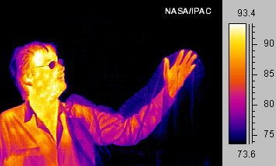
Figure 1. A visible image (top) and a thermal image (bottom)
Infrared images have various applications, especially in military applications. Multiple fields of view (FOV) can be obtained during operation, which means not only can they provide a broad, generic scrutiny mode but also a great magnification used to spot, recognize, or comprehensively gather intelligence. Moreover, infrared image can also be used in non-military fields, including fire alert, weather forecast, law enforcement, building constructions, and power line maintenance. It can also monitor physiological activities, such as cancer, fever and tumor in human beings.
In the early generation of thermal-infrared imaging system, focal plane array (FPA), the simplest scanning linear array, is applied to the scanner to generate an image. At present, the second-generation systems have developed with more detector elements on the focal plane, which can be configured in a 2-D array. Furthermore, CCDs (charge-coupled device) has being developed in the silicon addressing circuit. Nowadays, most common CCDs are sensitive in the near-infrared (NIR) region and middle wavelength infrared (MWIR) region.
Generally speaking, LWIR is a better choice for thermal imaging, considering its better sensitivity to the temperature of ambient surroundings. On the contrary, MWIR is preferred to objects with higher temperature. Additionally, MWIR detectors may operate in a relatively high temperature while LWIR detectors need cryogenic cooling (about 77K). Considering the typical weather conditions (winter haze), LWIR can be of higher performance in West Europe, North US, and Canada [3].

1.2 Infrared detectors
In the development of IR detector, several milestones are as follows [5] [6] [7]:
- the thermoelectric effect was found, and then the first thermocouple was verified by Seebeck in 1921,
- the first thermopile was composed of a series of thermocouples by Nobili in 1829 [8],
- the thermocouple design was reformed and bismuth and antimony were applied for it by Melloni in 1933 [9].
Two types of IR detectors can be classified based on the principles of IR light detection: thermal detectors and photo detectors. Fig. 1 [5] briefly shows the history of IR detectors’ development.
Fig. 2. History of the development of IR detectors [5]
In IR detector technology, interests has concentrated mostly on 3~5 µm and 8~ 14µm of radiation range. Longer wavelengths have been paid more and more attention in the recent years in many applications, especially in space area. Table 3 [10] gives the principle characteristics of some important infrared materials, such as Si, ZnS, and GaAs.
Table 2. Principal characteristics of some infrared materials [10]
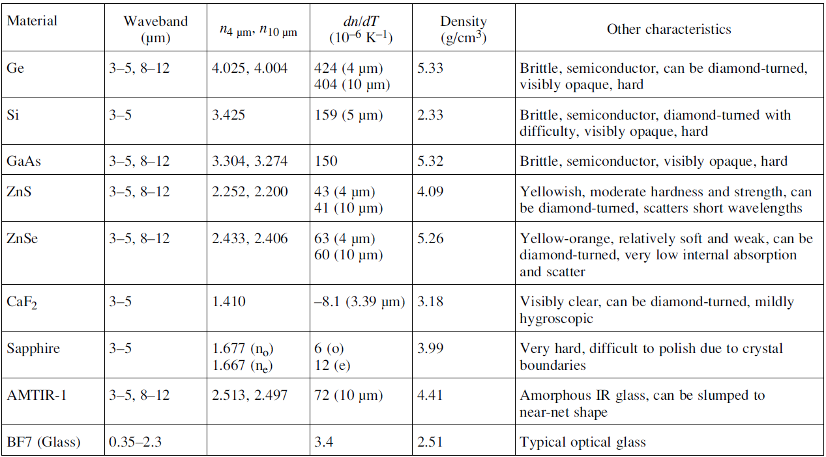

1.2.1 Thermal detector
Thermal detectors have an absorption layer to absorb the incident radiation and change light into heat to change the temperature of the material, which can be output as an electric signal. Thermal detectors have several types, such as thermopile detectors, bolometers, pyroelectric detectors, and diodes that change in voltage-current characteristics. These devices are independent of wavelength, and absorb photons thoroughly. The output signal is related to the radiant power instead of the spectral content, which leads thermal detectors have a wider bandwidth compared to photodetectors.
Thermal detectors have been in the greatest utility in the last century due to their cheap price and ease to use. However, they have very slow response (ms order) because their working principles. For example, pyroelectric detectors depend on the internal spontaneous polarization measurement, and bolometers depend on the electrical resistance change, which all work in the room temperature. Their slow response makes thermal detectors hardly to be used in real-time detection. Moreover, thermal detectors have rather low sensitivity compared to phtodetectors, which have been of wide popularity in commercial and military fields since the nineties in last century [5]. Thus, more worldwide efforts have been made to photodetectors.

1.2.2 Photodetectors
A photodetector is a light-sensing device. It takes advantage of materials’ conductivity, and changes it when light irradiates on them. Photoconductors convert light signals into electric signal, such as voltage or current, based on photo excited electron generation process. This is known as the photoelectric effect. Photos are absorbed on a surface of metal in vacuum and then electric-hole pairs are generated in the depletion region. Photodetectors exhibit a wavelength dependent selection, which means photodetectors response to a range of spectrum. They can offer a perfect signal-to-noise ratio and high sensitivity. By achieving these, photodetectors require to be cooled by cooling system. The energy of infrared radiation can be influenced by the dark current. By using cooling system, dark current can be suppressed.
Photodetectors can be sub-divided into different kinds based on the nature of interaction [5]. The most significant are: intrinsic detectors, extrinsic detectors, quantum well detectors, and quantum dot detectors.
1.2.2.1 Intrinsic photodetector
The principle of intrinsic photodetectors is the excitation of electrons from the valence band to the conduction band (interband transition) [11] as shown in Figure 3. The energy gap between the bands determines the long-wavelength response. Hg1-xCdxTe, Pb1-xSnxTe, and InAs1-xSbx are the commonly used intrinsic photodetectors.
Intrinsic photodetectors have been well developed in theoretical and experimental fields. They are easy bandgap tailoring, and can be realized as multicolored detectors. However, they are hard to be grown uniformly over large area, and the growth and processing costs are very high [5]. Besides, the sensitivity is limited by the noise in the detectors, like Johnson noise. Thus, the detectors require cooling system to reduce the temperature less than 80 K.
Fig. 3. Diagram of the principle of intrinsic photodetectors
1.2.2.2 Extrinsic photodetector
The sensitivity of extrinsic photodetectors is dependent on the doping of some certain substances into the host semiconductor. These certain substances establish discrete energy levels between the bands. Electrons are excited from these levels to either band. The response of extrinsic photodetectors is determined by the energy variations or the excitation energy between the levels and the bands. An example of this kind of photodetectors is impurity-doped Ge and Si. On one hand, it can response to the spectrum range of 1 to 120 µm [11], which is very wide and long. On the other hand, it demands extremely low temperature environment to operate, generates a lot of thermal energy and has low quantum efficiency.
1.2.2.3 Quantum well infrared photodetectors
The principle of quantum well infrared photodetectors is the usage of electronic intersubband transitions in barrier-separated quantum wells to absorb photos. Figure 4 shows the energy levels in a quantum well. All electrons in the same horizontal plane have the same transition energy, and they can move freely in the plane. The levels are vertical quantized quantum levels, and only photons with energies corresponding to the selected energy gaps can be detected. The depth of the well can be changed by using another layered material.
Epitaxial layers

40nm
4nm
40nm
A
B
A
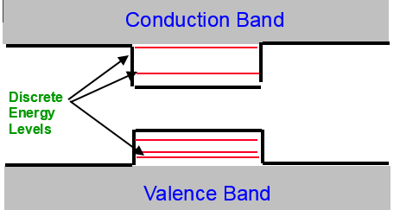
“Quantum well”
Fig. 4 Diagram of quantum well
The QWIP has good uniformity over large area, low auger recombination rate, high sensitivily, low cost, low power consumption and can control wavelength easily. While they still have low quantum efficiency. Among the drawbacks, the most critical is that they are not sensitive to normal incident light.
1.2.2.4 Quantum dots infrared photodetectors
Quantum dots (QDs) have low density of states and sharper eigenenergy, which are beneficial to operate certain optical devices, such as quantum dot lasers and quantum dot photodetectors. More interests have been focused on exploiting the usage of intersubband transitions in quantum dots for infrared photodetectors, especially in the range of long wavelength, since they can absorb normal incidence radiation benefitted from their intrinsic ability [12] [12, 13]. QDIPs make use of extrinsic detection scheme. In the scheme, electrons from confined states in the conduction band absorb the photon energy, which is less than the bandgap, because of intraband photoexcitation empowered by the 3-D quantum dots [14].
The self-assembled InAs/GaAs quantum dots on GaAs substrates are a typical QDIP. Figure 5 shows the InAs/GaAs QD conduction band diagram under flat-band conditions [14]. Electrons in the confined states will tunnel through the potential barriers to the continuum band when biased voltage is involved. The schematic diagram of InAs/GaAs QDIPs and the detection mechanism are shown in Figure 6 [14]. The characteristics of QDIPs will be discussed in the following paragraphs.
Fig. 5. Schematic diagram of generating photocurrent in the conduction band

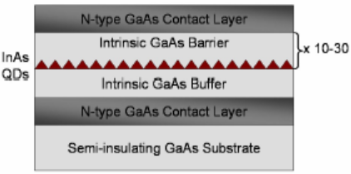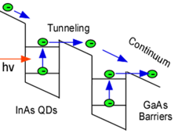

Sw
- (b)
Fig. 6 (a) Schematic diagram of InAs/GaAs QDIPs; (b) the detection mechanism of QDIPs.
One of the major advantages of QDIPs is that they can absorb normal incidence, which means the incident light normal to the wafer (the same direction with the growth direction) is supposed to make intraband absorption happen. The reason is that the normal incidence property prevents QDIPs from the fabrication work of a grating coupler, which is required in the standard QWIP imaging arrays [15, 16].
Compared to QWIPs, another advantage of QDIPs is the lower dark current [17]. The formula to calculate the normalized dark current density is as follows [18, 19]:
$$J_{dark}=G_{th}q= \frac{qδσt}{α_{0}n_{1}Fτ}\left(n_{2}+n_{b}\right) (1)$$
We assume:
$$α_{0}=5 × {10}^{4} {cm}^{-2}$$
$$V= 5.3 × {10}^{-19} {cm}^{-3}$$
$$δ=5 × {10}^{10} {cm}^{-2}$$
$$τ=1 ns$$
$$N_{d}=1 × {10}^{11} {cm}^{-2}$$
$t= \frac{1}{α_{0}}$ (t is the detector thickness)
In the literature, these parameters are representative for self-assembled InAs/GaAs quantum dots. Figure 7 shows the normalized dark current trend of different LWIR materials with the change of temperature [18]. From the figure, we can see that QDIPs can be operated in the temperature range of 60 to 120 K, while QWIP is better to work in the range of 40 to 80 K. At the same temperature, the normalized dark current for QDIP is much lower than the current of QWIP.
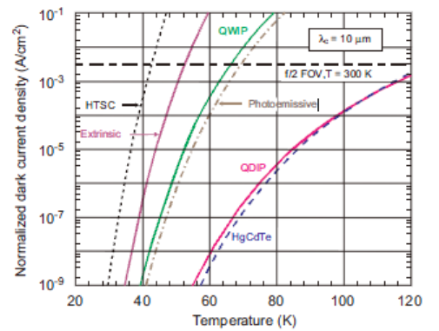
Fig. 7 The normalized dark current trend of different LWIR materials vs. the temperature
Due to the low carrier capture probability [19] and long excited electron lifetime τ_{life} [16], it is expected that QDIPs can have a high photoconductive gain. The following equation shows the relationship between photoconductive gain and electron lifetime [16]
$$g= \frac{τ_{life}}{τ_{trans}} (2)$$
where g is the photoconductive gain and τ_{trans} is the transit time across the device. The long excited electron lifetime can directly leads to a high photoconductive gain. As a photoconductor responsivity is given by [16]
$$R= \frac{e}{hν}ηg (3)$$
where ν is the photon frequency and η is the absorption efficiency. Thus, a high responsivity can be achieved by QDIPs.
Figure 8 [19] shows the relationship between the capture probability and biased voltage under different experimental temperatures of InAs QDIPs. Figure 9 [19] shows the relationship between the photoconductive gain and biased voltage under 77 K of InAs QDIPs.
Fig. 8. Carriers capture probability versus biased voltage at different temperatures. [19]
Fig. 9. Photoconductive gain versus biased voltage at 77K [19].
These two figures clearly show that at certain temperature, when the absolute value of biased voltage increases, the carrier capture probability decreases promptly which leads to the photoconductive gain increases accordingly swiftly [19].
As we discussed before, QDIPs have low dark current, which allows QDIPs work at higher operating temperatures and has higher detector sensitivity [16]. The operation temperature of 175 K can be achieved in a heterostructure, with which dark current can be minimized and responsivity can be maximized [20]. Besides, Lu [21] reported a longwave infrared InAs-InGaAs QDIP with a large photoresponsivity at the operating temperature of 190K.
However, it is a huge challenge to increase the responsivity of QDIPs, since it is required to grow a lot more dot layers in absence of generating dislocations. Therefore, the active QD absorption region is small. To improve responsivity, it is better for QDIPs to trap more light and improve the efficiency of light absorption. Thus, the technology of surface plasmon resonance was proposed and introduced [22, 23, 24] in the following chapter.

Chapter II. SURFACE PLASMON Polaritons AND ITS APPLICATION ON iNFRARED dETECTION

2.1 Introduction to surface plasmon polaritons (SPP)
Last century, Mie [25] and Ritchie [22] probed into surface plasmon polaritons first and found they are electro-magnetic waves that can propagate along the surface of a thin metal layer. These electro-magnetic waves are generated by the coherent electron oscillation at the surfaces of metal [22, 26]. Compared to free space emission, plasmonic structures can collect the emission and control the direction of the emission. With different plasmonic structures, different frequencies of the waves can be selectively excited. This is known as the excitation of Surface plasmon resonance (SPR).
Compared to the propagation constant of optical wave propagation in the dielectric, the propagation constant of surface plasmon wave (SPW) is often higher. Therefore, an incident optical wave cannot excite the SPW directly at a planar metal-dielectric interface. There are many ways to excite surface plasmon waves, and we will introduce several as below.

2.1.1 Prism Excitation
Surface plasmon resonance can be obtained by illuminating a thin metal film through a glass prism (using attenuated total reflection). The most common used thin film is gold, and typically the thickness of it is in nm scale. The reflected light from the film is at all

angles except a small range of them where the light is absorbed by the film. This absorption results from the resonant electron oscillations inspired in the thin metal film when the incident light illuminates. Figure 10 shows the schematics of the light-induced surface plasmons [27].
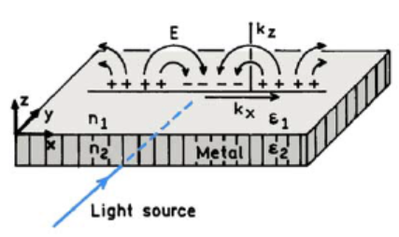
Fig. 10. Schematic diagram of the light-induced surface plasmons [27].
Resonance happens when the in-plane vector (k_{x}) of the incident light matches the surface plasmon wave vector (k_{spp}). The surface plasmon wave vector is determined by the incident wave vector in free space (k₀), the dielectric constant of metal in the function of wavelength (ε_{m}), and the dielctric constant of the dielectric (ε_{d}) [28, 29, 30].
$k_{spp}= k_{0}∙\sqrt{\frac{ε_{m}∙ε_{d}}{ε_{m}+ε_{d}}}$ (4)
$k_{0}= \frac{ω}{c}$ (5)
The dielectric constant of metal contains two parts: the real part (ε_{r}) and the imaginary part (ε_{im}).
$ε_{m}= ε_{r}+i∙ε_{im}$ (6)
The real part of the dielectric constant is usually negative on top of the plasmon frequency, and concerned with the metal conductivity and penetration depth of electric waves into the metal [27].
The calculation formula of in-plane vector (k_{x}) of the incident light is involved in the incident wave vector in free space (k₀), the dielectric constant of the air (ε_{air}), and the angle measured from the incident light to the normal (θ).
$k_{x}= k_{0}∙\sqrt{ε_{air}}∙\sin{θ}$(7)

Therefore, the resonant condition can be expressed as:
$\frac{ω}{c}∙\sqrt{ε_{air}}∙\sin{θ}= \frac{ω}{c}∙\sqrt{\frac{ε_{m}∙ε_{d}}{ε_{m}+ε_{d}}}$ (8)

2.1.2 Plasmonic resonance in grating configuration
SPW can also be obtained through the diffraction at the surface of diffraction gratings. In the grating configuration, surface plasmons are excited by a grating coupler. Let us suppose the grating constant is a, the incident light wave vector is given by
$k= \frac{ω}{c}∙\sqrt{ε_{air}}∙\sin{θ_{0}± \frac{2π}{a}}$ (9)
The resonance can be discovered at θ₀ as an intensity minimum of the reflected light. Resonance happens when the incident light wave vector (k) of the incident light matches the surface plasmon wave vector (k_{spp}). The resonant condition can be expressed as:
$\frac{ω}{c}∙\sqrt{ε_{air}}∙\sin{θ_{0} ± \frac{2π}{a}}= \frac{ω}{c}∙\sqrt{\frac{ε_{m}∙ε_{d}}{ε_{m}+ε_{d}}}$ (10)

2.1.3 Waveguide coupling
In a waveguide, the incident light can be guided. When entering the area with a thin metal layer, the light can evanescently penetrate through it. At the moment of the surface plasmon wave and the guided mode matching, the SPW can be excited at the outer interface of the metal [31]. Figure 11 shows the schematic diagram of a waveguide-based SPR system [31].
Fig. 11. The schematic diagram of a waveguide-based SPR system

2.1.4 Metallic two-dimensional subwavelength hole array (2DSHA) plasmonic structure
Besides the above structures that can excite the surface plasmon, metallic 2DSHA is one of the most attractive surface plasmonic structures in the recent studies due to its excitation advantages. First, it has a capacity of surface light trapping and concentrating light in especially small spaces [32]. This structure has a very thin metal layer with periodic holes, and can form an integrated small-scale device. Secondly, it has extraordinary optical transmission (EOT) effects and can be utilized in the quantum dot photodetector to obtain huge enhancement, which is dominantly because of the light focusing effect in the holes [32]. Figure 12 shows a schematic structure of the metallic 2DSHA array structure. From the figure, one can get the hole diameter is d, and the period for the structure is p. 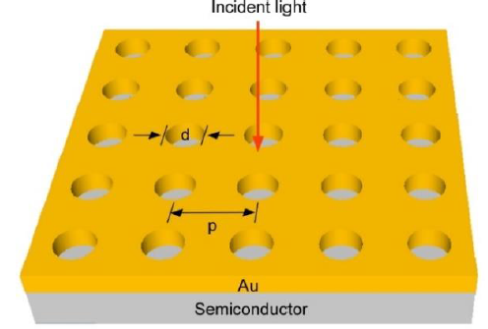
Fig. 12 Schematic diagram of the metallic 2DSHA array structure
Based on the momentum matching, the excitation condition of the 2DSHA plasmonic structure can be calculated in the following equation:
(11)
is the structure period. The resonance wavelength of the rectangle lattice can be expressed in the formula below:
(12)
From the above formula, it can be seen that the resonance wavelength can be altered by varying the parameters, such as the structure period, the metal material and the dielectric material.

2.2 Surface plasmonic structures on QDIPs

2.2.1 2DSHA plasmonic enhanced QDIPs
Due to the 2DSHA’s advantages, such as better compactness and convenience to work with any optic device surface, outstanding EOT and the extraordinary surface confinement tunable functionality, the 2DSHA structures are comprehensively reported in researchers’ studies. In 2010, Chang reported a surface plasmon enhancement on InAs QDIP [33]. In his work, he achieved a 130% absolute enhancement at the resonant wavelength (around 8.8µm) by integrating the 2DSHA structure with QDIPs [33]. In 2011, Vasinajindakaw reported a QDIP enhanced by Fano-type interference in a metallic 2DSHA. More than 100% enhancement of photodetectivity has been obtained at the Fano dip of the first order plasmonic mode [34]. Figure 13 shows the pictures of the QDIP with the metallic 2DSHAs [34].
Fig. 13(Color) Pictures of the QDIP with the metallic 2DSHAs. (a) Top view and (b) zoom-in view. The 2DSHA is a square lattice with the lattice constant a=2.6 µm. The diameter of the hole is d=1.3 µm. The thickness of the metal film is 30 nm.
In 2013, Gu reported a QDIP enhanced by a backside-configured 2DSHA surface plasmonic structure and over 40 times peak photocurrent enhancement obtained. Compared to the top-configured plasmonic structures, the backside-configured plasmonic structure could provide more efficient surface plasmonic excitation and then offered a higher enhancement [35].Figure 14 (a) shows the cross-structure of the backside-configured 2DSHA surface plasmonic structure on QDIP. One can get the IR incidence comes from the backside. (c) shows the microscopic image of the plasmonic structure on a QDIP, and (d) gives a close-up view of the 2DSHA structure.
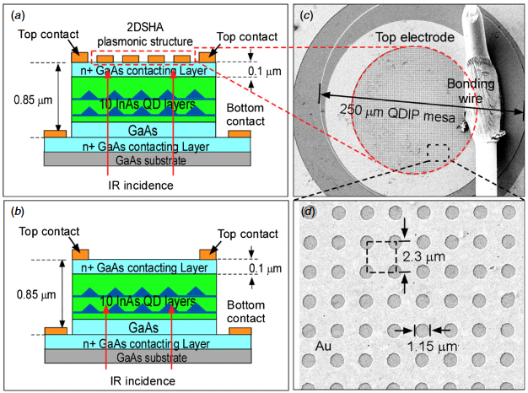
Fig. 14. (a) Cross-sectional structure of the backside-configured 2DSHA plasmonic structure on the QDIP. The IR incident illuminates from the substrate side; (b) Ref-QDIP without the plasmonic structure. (c) The 2DSHA plasmonic structure on the QDIP and (d) close-up view of the plasmonic structure. It is square lattices with period of 2.3µm and the hole-diameter of 1.15 µm. The thickness of the deposited Au film is 25nm [35].
Figure 15 shows the enhancement factors of the backside-configured and top-configured 2DSHA plasmonic structures. A more than 40 times peak enhancement factor is obtained by the backside-configured plasmonic structure. And also a wider enhancement spectral width (FWHM) is provided by the backside-configured plasmonic structure, compared with the FWHM provided by the top-configured plasmonic structure [35].
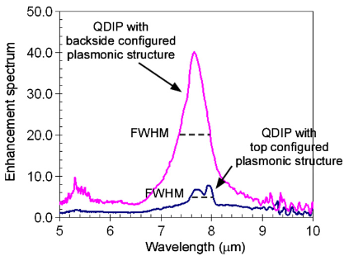
Fig. 15. Photocurrent enhancement ratio of the backside-configured and top-configured plasmonic structures. The backside-configured plasmonic structure shows larger photocurrent enhancement. An over 40 times peak photocurrent enhancement is obtained by the backside-configured plasmonic structure [35].
In 2016, Zhang analyzed how the quantum selection rules played a role in the enhancement of 2DSHA plasmonic structure on QDIPs. He designed a series of periods of the 2DSHA plasmonic structures on QDIPs to understand specific plasmonic enhancement of individual intersubband transitions [36]. The plasmon resonant peak wavelengths of different orders for variant periods of 2DSHA plasmonic structure are shown in figure 16 [36].
Fig. 16. Plasmonic resonant peaks λ_{sp} of different orders for various 2DSHA periods; (b) linear dependence of the resonant peak wavelength λ_{sp} with the period of different orders. [35]

2.2.2 Two dimensional metallic disc array (2DMDA) plasmonic enhanced QDIPs
2DMDA and 2DSHA are two complementary plasmonic structures that can excite surface plasmonic resonances. Both of them can provide enhancement on QDIPs. Compared to 2DSHA, the 2DMDA provide 10 times with broad band enhancement [37]. Figure 17 shows the microscope image of the reference QDIP, which has no plasmonic structures, the QDIP with metallic disc and hole arrays on the top of the surfaces. Besides, (d) shows the schematic cross-sectional view of the QDIP with the incident light coming from the backside. Finally, (e) and (f) presents the microscope images of the close-up view of the metallic disc and hole array [37].
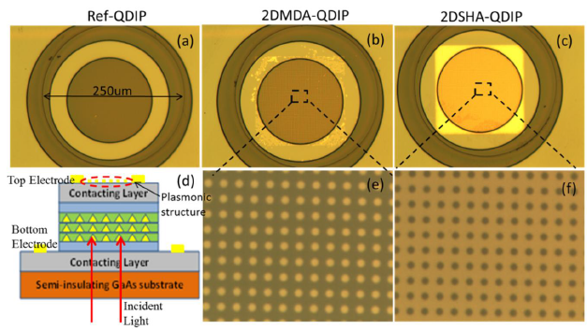
Fig. 17 Microscope images of QDIP with metallic disc and hole arrays and the close-up view of the different plasmonic structures. (a) Ref-QDIP without any plasmonic structures attached; (b) and (c) QDIP with metallic disc and hole arrays on the top of the surface, respectively; (d) presents the schematic cross-sectional view of the QDIP with backside illumination; (e) and (f) microscope images of the close-up view of the disc and hole array with period of 2.3um, disc/hole diameter of 1.15um, and gold film of 25nm [37].
Figure 18 shows the measured photocurrent spectrum of the QDIP with 2DSHA and 2DMDA plasmonic structures. From it, one can get both structures can induce strong enhancement on the QDIP compared to the reference QDIP, and the 2DSHA structure provides higher enhancement [37].

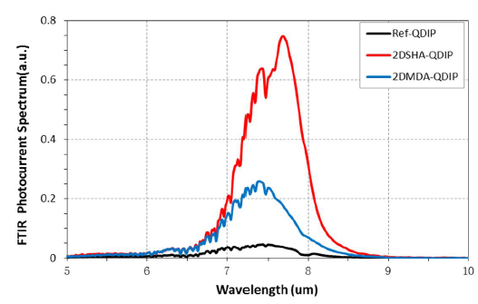
Fig. 18 The measured FTIR photocurrent spectrum of the QDIP with different plasmonic structures and the Ref-QDIP [37].

Chapter III. QDIP Growth and Device Fabrication Process

3.1 MBE Method for Sample Growth
Molecular beam epitaxy is a technique utilized for the growth of crystalline thin films in the atmosphere of ultrahigh vacuum. It can provide precise control of atomic layers, such as thickness, composition and morphology, through the control of the atomic beam fluxes. It has low growth rate of around 1 monolayer (lattice plane) per second, and can work in a low growth temperature. Besides, it can provide smooth growth surface with steps of atomic height and large flat terraces [38].
A schematic diagram of an MBE reactor is shown in figure 1 [38]. Typically, there are three vacuum sections in an MBE reactor. First, in the buffer section, the work of preparation and storage should be done. Then, in the load lock, people can load the samples into the growth chamber. The place for loading samples is a rotational magnetic holder, the process of which is named continual azimuthal rotation (CAR). Finally, cryopanels works with the vacuum system to guarantee the desired atmosphere. For example, the gases, such as CO₂ and H₂O, should be controlled around 10⁻¹¹ Torr [38]. Four essential steps can be summarized based on the most significant processes during MBE growth, which happen at the atomic level in the crystallization zone. First, the atoms or molecules are absorbed in the way of impinging on the substrate surface.
Secondly, the surface migrates and dissociated from the absorbed species. Thirdly, the
atoms merge into the crystal lattice at the place where adequately strong bonding happens. The place is often bordering on an extensive atom layer, which is the growing epitaxial crystal. Finally, the species may refuse to merge into the crystal lattice because of their thermal desorption [38].
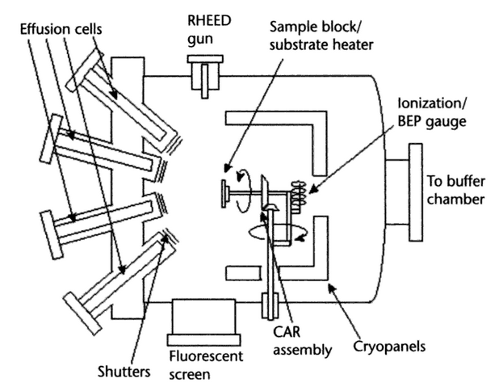
Fig. 1 The schematic diagram of an MBE system [38]
High-quality, defect-free QDs can be obtained by utilizing MBE technology. Besides, these QDs are of great size uniformity. This approach takes advantage of highly lattice-mismatched growth of In(Ga)As on GaAs. A few mono layers will be grown layer by layer, after which self-assembled QDs form. This phenomena happens since the strain is established during the epitaxial growth. The typical temperature for GaAs growth is approximate 620 °C [21]. While for QDs, the temperature is about 470 °C [21]. QDs can form by depositing a few monolayers (ML) of InAs on GaAs.
In our research group, the first step for growing a regular QDIP sample is to grow a highly doped contact layer on the substrate. Then a buffer layer forms to help work with the lattice mismatching problem. After that, quantum dots layers are grown with GaAs capping layers. Finally, a contact layer forms.
In my experiment, I used the QD sample of UML 668. The sample device is grown by a V80H MBE system. A 3000Å undoped GaAs buffer layer was first grown on the semi-insulating GaAs (100) substrate at the growth temperature of 580 °C. A 1500Å n+ doped GaAs bottom contact layer and a 1000 Å undoped GaAs buffer layer were then grown. The temperature was 580 ⁰C for both the GaAs contract layer and buffer layer growth. In the growth direction, the active region of QDIPs consisted of 10 periods of QD heterostructures. Each of these heterostructures consisted of 1nm In0.15Ga0.85As, 2 monolayers (ML) of InAs QDs and 30 ML of In_{0.15}Ga_{0.85}As capping layers. Then, 45nm GaAs spacer layers were grown between the QD layers. The 1nm In_{0.15}Ga_{0.85}As layer is applied to reduce the defects during the growth. The QD layers and In_{0.15}Ga_{0.85}As capping layers were grown at 460 ⁰C. After the growth of the 10 QD active layers, the substrate temperature was then increased to 580 °C.A 1000 nm top GaAs buffer layer was grown, followed by the n+ top contacting layer. Figure 2 shows the cross-section of sample UML668 MBE growth structure.
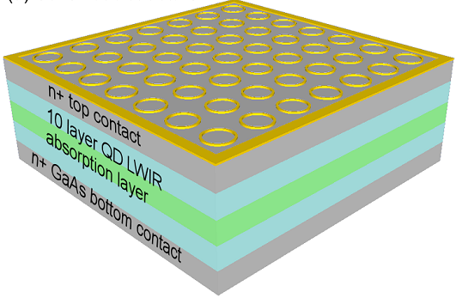
Fig. 2 Schematic structure of the circular ring POA enhanced LWIR QDIP. The circular POA structures are fabricated on top of the LWIR QDIP. The QDIP has 10 layers of InAs QDs for LWIR light absorption.

3.2 Fabrication of the device

3.2.1 Fabrication processes of QDIPs
After the MBE growth, the wafer was processed into circular mesas using standard photo-lithography and wet-etching procedures to form individual QDIPs. The fabrication processes of QDIPs are schematically shown in Figure 1.
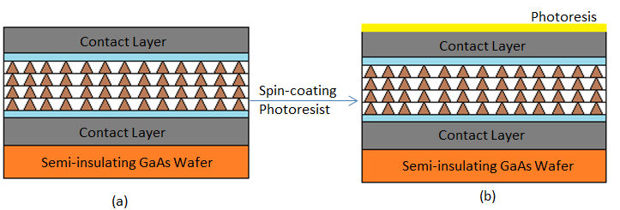
Photolithography
Patterning

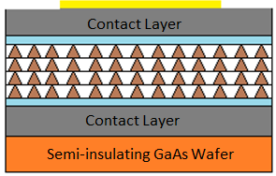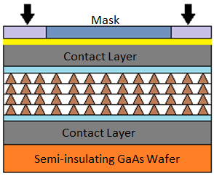
(c)
(d)
Develop with
MA-26
Wet etching

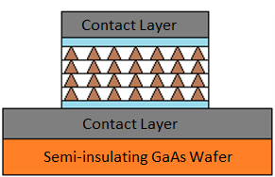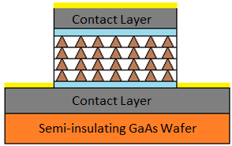
Spin-coating
Photoresist
(f)
(e)
Photolithography
Patterning with electrode mask

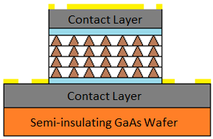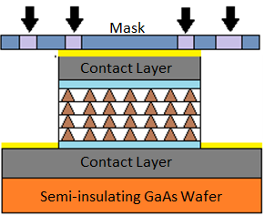
(g)
(h)
Develop with
MA-26
Metal Deposition

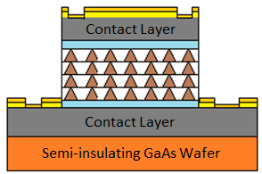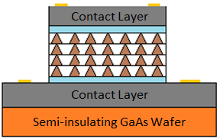
(j)
(i)
Lift-off and rapid thermal annealing

The above figure shows the flowchart of standard QDIP fabrication process. At the beginning, the sample was gently cleaned with acetone and then isopropanol in an ultrasonic cleaner around 2 minutes, respectively. Then it was spin-coated with a layer of photoresist on the top surface as shown in (b). After that, the sample was exposed in UV light with mask on top of it (as illustrated in (c)), which step is known as the photolithography process. In this step, the light passed through the open channel and dissolved the positive photoresist. The dark area on the mask blocked the light and the photoresist in the corresponding area on the sample was remaining after the development step by MA-26 (shown in (d)). Thus, the sample was patterned with certain structures. Next, the sample was wet-etched by piranha etch solution (2H₂SO₄ + 16H₂O₂ + 160H₂0) till the contact layer was reached. The etching depth was measured by a profilometer or an optical profiler. The QDIP mesas were formed as shown in (e). Then, the sample was spin-coated with photoresist again, applied with electrode mask on top of it, then exposed in the UV light and developed in MA-26 solution. The metal electrode pattern was formed on the sample in (h). Next, the standard E-beam metal deposition was performed: Ni, Ge, Au, Ni and Au layers were deposited on the top of mesas with thickness 50 Å, 170 Å, 330 Å, 150 Å, and 3000 Å, as shown in (i). Finally, lift-off was applied by dipping the sample in acetone. The top and bottom electrodes were formed at this time (shown in j). To obtain the ohmic contacts between the electrodes and the contact layers, rapid thermal annealing was applied on the metal layers.

3.2.2 Fabrication of SP structure
3.2.2.1 E-beam lithography
As a specialized technique, electron beam lithography can create ultra-small pattern by scanning an extremely concentrated high energy beam of accelerated electrons across a surface overlaid with a charge-sensitive film (also known as the e-beam resist film) and removing selected areas from the resist film to imprint the desired pattern [39]. It is a kind of lithography without utilizing physical mask-plates.
E-beam lithography can provide especially high resolution, almost to the atomic level, while the traditional photolithography can only obtain resolution in micron meter scale. Besides, it is very effective to offer the precise exposure and excellent geometrical controls. Moreover, it is flexible to cooperate with different materials and nearly unlimited number of patterns.
However, E-beam lithography takes much longer time to complete tasks, compared to optical lithography, since one of its characteristic is the long exposure time for the electron beam scan. Meantime, it is expensive and may cost people millions of dollars to purchase the tools. Furthermore, it requires frequently check and maintenance, which is complicated.
3.2.2.2 Fabrication of the surface plasmonic structure
In this work, the PMMA950 A2 was used as the electron beam resist. Before applying with the resist, the sample was first cleaned by wet solutions: dipped into acetone for 10 minutes, and then IPA for another 10 minutes. And then the sample was deoxidized and dehydrated in Oxygen plasma. In the E-beam lithography process, 30keV beam energy was provided. After dose test, the exposure dose was fixed at a certain time for the ring structure. It took about minutes for the whole area. Then the sample was developed in the solvent (MIBK: IPA = 1:3) for 20 seconds and then rinsed with IPA for 15 seconds. At last, metal deposition (50nm Au) was applied on the sample, and followed by lift-off.
The ring SP structure was aligned with the standard QDIPs, and fabricated. Figure 2 shows the schematic cross-section diagram of QDIPs before and SP fabrication.
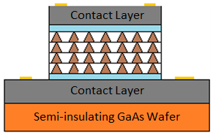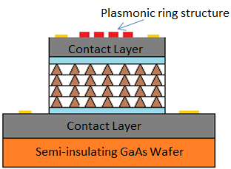
Fabrication of
SP structure
Fig. 2 Schematic cross-section diagram of QDIPs before and SP fabrication
Figure 3 presents the microscope image of the ring SP structure by E-beam lithography
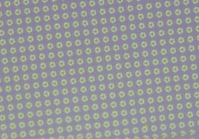
Fig. 3 Microscope image of the ring SP structure by E-beam lithography

REFERENCES
[1] Cecie Starr (2005). Biology: Concepts and Applications. Thomson Brooks/Cole. ISBN 0-534-46226-X.
[2] Herschel, W., Experiments on the Refrangibility of the Invisible Rays of the Sun. By William Herschel, LL. DFRS. Philosophical Transactions of the Royal Society of London, 1800. 90: p. 284-292.
[3] A. Rogalski, Infrared devices and techniques. OPTO-ELECTRONICS REVIEW 10(2), 111-136 (2002).
[4] R.D. Hudson, Infrared System Engineering, Wiley, New York, 1969.
[5] Antoni Rogalski, Infrared detectors: an overview, Infrared Physics & Technology 43 (2002) 187-210
[6] R.A. Smith, F.E. Jones, R.P. Chasmar, The Detection and Measurement of Infrared Radiation, Clarendon, Oxford, 1958.
[7] P.W. Kruse, L.D. McGlauchlin, R.B. McQuistan, Ele- ments of Infrared Technology, Wiley, New York, 1962.
[8] E.S. Barr, Historical survey of the early development of the infraredspectralregion,Am.J.Phys.28(1960)42–54.
[9] E.S.Barr,Theinfraredpioneers––II.MacedonioMelloni, InfraredPhys.2(1962)67–73.
[10] M.E. Couture, “Challenges in IR optics,” Proc. SPIE 4369,
649–661 (2001).
[11] Nathan Sclar, IEEE TRANSACTION ON ELECTRON DEVICES, VOL. ED-27, NO.1, JANUARY 1980
[12] D. Pan, Y. P. Zeng, M. Y. Kong, J. Wu, Y. Q. Zhu, H. Zhang, and J. M. Li, Electron. Lett. 32, 1726 ~1996
[13] J. C. Phillips, K. Kamath, and P. Bhattacharya, Appl. Phys. Lett. 72, 2020 (1998).
[14] A. D. Stiff-Roberts, Journal of Nanophotonics, Vol.3, 031607 (14 April 2009).
[15] S.D. Gunapala and S.V. Bandara, “Quantum well infrared photodetector focal plane arrays,” in Semiconductors and Semimetals, Vol. 62, pp. 197-–282, edited by H. C. Liu and F. Capasso, Academic Press, San Diego, 2000.
[16] H.C. LIU, Quantum dot infrared photodetector, OPTO-ELECTRONICS REVIEW 11(1), 1-5 (2003)
[17] V. Ryzhii, “The theory of quantum-dot infrared phototransistors”, Semicond. Sci. Technol. 11, 759–765 (1996).
[18] P. Martyniuk, A. Rogalski, Review Quantum-dot infrared photodetectors: Status and outlook. Progress in Quantum Electronics 32(2008) 89-120.
[19] Ye Z, Campbell J C, Chen Z, Kim E-T and Madhukar A 2003 Noise and photoconductive gain in InAs quantum-dot infrared photodetectors Appl. Phys. Lett. 83 1234–6
[20] Chakrabarti S, Stiff-Roberts A D, Bhattacharya P, Gunapala S, Bandara S, Rafol S B and Kennerly S W 2004 High-temperature operation of InAs-GaAs quantum-dot infrared photodetectors with large responsivity and detectivity IEEE Photonics Technol. Lett. 16 1361–3
[21] Lu, X., J. Vaillancourt, and M.J. Meisner. A voltage-tunable m ultiband quantum dot
infrared focal plane array with high photodetectivitv. in SPIE Defense and Security
Symposium. 2008: International Society for Optics and Photonics.
[22] Ritchie, R., Plasma losses by fast electrons in thin films. Physical Review, 1957.
106(5): p. 874.
[23] Ebbesen, T.W., et al.. Extraordinary' optical transmission through sub-wavelength hole
arrays. Nature, 1998. 391(6668): p. 667-669.
[24] Atwater, H.A. and A. Polman, Plasmonics for improved photovoltaic devices. Nature
materials, 2010. 9(3): p. 205-213.
[25] Mie G 1908 Beitr¨age zur Optik tr¨uber Medien, speziell kolloidaler Metall¨osungen Ann. Phys., Lpz. 330 377–445
[26] Ghaemi, H„ et al., Surface plasmons enhance optical transmission through subwavelength holes. Physical Review B, 1998. 58(11): p. 6779.
[27] Lakowicz J. R. Plasmonics in Biology and Plasmon-Controlled Fluorescence // Plasmonics Vol. 1, pp. 5-33 (2006).
[28] Raether H (1988) Surface Plasmons on Smooth and Rough Surfaces and onGratings. Springer-Verlag, New York, pp 136
[29] Raether H (1978) Surface plasma oscillations and their applications. In: Hass G, Francombe MH, Hoffman RW
(eds) Physics of Thin Films. Academic Press, New York, pp 145–261
[30] Forstmann F, Gerhardts RR (1986) Metal optics near the plasma frequency. Springer Tracts Mod Phys 109:132
[31] Jir'ı´ Homola, Sinclair S. Yee, Gu¨ nter Gauglitz, Surface plasmon resonance sensors: review, Sensors and Actuators B 54 (1999) 3–15
[32] Ebbesen T W, Lezec H J, Ghaemi H F, Thio T and Wolff P A 1998 Extraordinary optical transmission through
sub-wavelength hole arrays Nature 391 667–9
[33] C.-C. Chang, Y. D. Sharma, Y.-S. Kim et al., “A surface plasmon enhanced infrared photodetector based on InAs quantum dots,” Nano letters, 10(5), 1704-1709 (2010).
[34] P. Vasinajindakaw, J. Vaillancourt, G. Gu et al., “A Fano-type interference enhanced quantum dot infrared
photodetector,” Applied Physics Letters, 98(21), 211111-211111-3 (2011).
[35] G. Gu, J. Vaillancourt, P. Vasinajindakaw, and X. Lu, "Backside-configured surface plasmonic structure with over 40 times photocurrent enhancement," Semiconductor Science and Technology, vol. 28, p. 105005, 2013.
[36] Y. Zhang, J. Vaillancourt, G. Gu, W. Guo, and X. Lu, "Quantum selection rule dependent plasmonic enhancement in quantum dot infrared photodetectors," Journal of Applied Physics, vol. 119, p. 193103, 2016.
[37] G. Gu, and X. Lu, "Comaparison of two complementary surface plasmonic structures and their enhancement in infrared photodetectors," Proc. of SPIE Vol. 9070 907038 (2014).
[38] Todd D. Steiner. Semiconductor Nanostructures for Optoelectronic Applications. 2004.
[39] McCord, M.A. and M.J. Rooks. SPIE handbook of microlithography, micromachining and microfabrication, in SPIE, Bellingham. 2000.

