OPTIMAL VEHICLE CONTROL AT HIGHWAY RAMPS BASED ON CONNECTED VEHICLES AND AUTONOMOUS DRIVING

BY

HUIXING ZHANG

B.S. NORTH CHINA UNIVERSITY OF WATER RESOURCES

AND ELECTRIC POWER (2007)

SUBMITTED IN PARTIAL FULTILLMENT OF THE REQUIREMENTS

FOR THE DEGREE OF MASTER OF SCIENCE

DEPARTMENT OF ELECTRICAL AND COMPUTER ENGINEERING

UNIVERSITY OF MASSACHUSETTS LOWELL

**Signature of**

**Author:** **Date:**

**Signature of Thesis**

**Supervisor:**

**Name Typed: Yuanchang Xie**

**Signatures of Other Thesis Committee Members:**

**Committee Member Signature:**

**Name Typed: Tricia Chigan**

**Committee Member Signature:**

**Name Typed: Nathan Gartner**

**Committee Member Signature:**

**Name Typed:** **Nikunja K. Swain**

OPTIMAL VEHICLE CONTROL AT HIGHWAY RAMPS BASED ON CONNECTED VEHICLES AND AUTONOMOUS DRIVING

2012-2014

BY

HUIXING ZHANG

ABSTRACT OF A THESIS SUBMITTED TO THE FACULTY OF THE DEPARTMENT OF ELECTRICAL AND COMPUTER ENGINEERING

IN PARTIAL FULFILLMENT OF THE REQUIREMENTS

FOR THE DEGREE OF

MASTER OF SCIENCE

UNIVERSITY OF MASSACHUSETTS LOWELL

2014

Thesis Supervisor: Yuanchang Xie, Ph.D., P.E.

Assistant Professor, Department of Civil and Environmental Engineering

# ABSTRACT

Under connected vehicles and autonomous driving environment, vehicles are able to communicate and even collaborate with each other. This research developed an optimization-based model to optimally control highway and on-ramp vehicles simultaneously with the assumption that all vehicles are connected and controlled automatically. This control strategy was tested using VISSIM and the C2X module included in it. Some empirical ramp control strategies, including dynamic speed limit, gradual speed limit, and collaborative lane change, were first simulated under various traffic conditions to obtain some preliminary results. The results suggest that the two collaborative lane change strategies perform equivalently better in terms of average speed, average delay time, and throughput; while speed limit control strategies are less effective than lane-change strategies. The gradual speed limit control strategy and a benchmark case without considering any control strategies were further compared with the proposed optimization-based control model. The proposed optimization-based model is proved to perform well under different traffic conditions and its benefits become more significant as both the highway and ramp are not saturated. It is also concluded that the proposed optimization-based model can effectively coordinate all vehicles and improve safety.

# ACKNOWLEDGMENTS

First and foremost, I would like to express my sincere gratitude to my supervisors: Dr. Yuanchang Xie and Dr. Tricia Chigan, for providing me with their guidance, invaluable suggestions, constant encouragement and financial support throughout my master research work.

I would like to thank my committee members, Dr. Nathan Gartner, and Dr. Nikunja K. Swain from South Carolina State University, for your time and brilliant comments and suggestions.

I would like to thank the National Institute of Food and Agriculture (NIFA), United States Department of Agriculture (USDA), South Carolina State University, and the University of Massachusetts Lowell Office of the Vice Provost for financially supporting this work.

Furthermore, I am grateful to my office friends Tugba Arsava, Chen Chen, and Sushma Srinivas for generous help and assistance in various forms during my study.

Last but not least, I would like to express my special appreciation to my beloved wife, Lin Li, and my parents for their love and continued support throughout my days at school.

TABLE OF CONTENTS

ABSTRACT ii

ACKNOWLEDGMENTS iii

LIST OF TABLES vi

LIST OF ILLUSTRATIONS vii

CHAPTER 1: INTRODUCTION 1

1.1. MOTIVATION 1

1.2. PROBLEM DESCRIPTION 3

1.3. RESEARCH OBJECTIVES 5

1.4. THESIS OUTLINE 6

CHAPTER 2: LITERATURE REVIEW 7

2.1. TRAFFIC SIMULATION 8

2.2. TRAFFIC SIMULATION WITH RAMP METER 9

2.3. NETWORK SIMULATION 9

2.4. INTEGRATED SIMULATION 11

2.5. COLLABORATIVE MERGING BEHAVIORS 12

2.6. OPTIMAL VEHICLE CONTROL 14

2.7. DRIVER BEHAVIOR 19

CHAPTER 3: METHODOLOGY 21

3.1. PROBLEM FORMULATION 21

3.1.1. Problem Description 21

3.1.2. Problem Formulation 22

3.2. NONLINEAR CONSTRAINED OPTIMIZATION IN MATLAB 24

3.3. SET UP C++ PROJECT FOR USING MATLAB 26

3.3.1. Set up Environment Variables 26

3.3.2. Set up C++ Project 26

3.4. VISSIM MICROSCOPIC SIMULATION 27

3.5. SPECIFICATION OF THE PROBLEM FORMULATION 28

CHAPTER 4: MODEL ESTIMATION 33

4.1 MODEL IMPLEMENTATION 33

4.2 CASE STUDIES 34

4.2.1 Case 1: Four Vehicles without Initial Conflicts 34

4.2.2 Case 2: Four Vehicles with Initial Conflicts 36

4.2.3 Case 3: Twenty Vehicles with Initial Conflicts 41

4.3 CONCLUSION 46

CHAPTER 5: EXPERIMENT DESIGN AND IMPLEMENTATION 48

5.1 EMPIRICAL STUDY OF CVTECH-BASED RAMP CONTROL 49

5.1.1 Experimental Design 49

5.1.2 Selection of Parameter Values 51

5.1.3 VISSIM Simulation Output 52

5.2 OPTIMIZATION-BASED RAMP CONTROL 56

5.2.1 Experimental Design 56

5.2.2 Parameter Selection 58

5.2.3 VISSIM Simulation Output 62

CHAPTER 6: RESULTS AND CONCLUSION 63

6.1 RESULT OF CVTECH-BASED RAMP CONTROL 63

6.1.1 Average Delay Time Analysis 63

6.1.2 Average Speed Analysis 65

6.1.3 Traffic Throughput Analysis 66

6.1.4 Penetration Rate Analysis 67

6.2 OPTIMIZATION-BASED RAMP CONTROL RESULTS 70

6.2.1 Simulations and Observations 70

6.2.2 Average Delay Time 74

6.2.3 Average Speed 77

6.2.4 Traffic Throughput 78

6.3 CONCLUSIONS 80

CHAPTER 7: FUTRUE WORK 83

REFERENCES 84

BIOGRAPHICAL SKETCH OF AUTHOR 87

# LIST OF TABLES

Table 3-1 Notations used in the formulation 29

Table 4-1 Step-by-step accelerations for the 20-vehicle case 45

Table 4-2 Step-by-step velocities for the 20-vehicle case 46

Table 4-3 Step-by-step vehicle positions for the 20-vehicle case 47

Table 5-1 Average speeds for different highway vehicle inputs 61

Table 6-1 Recorded distances to merging point 72

Table 6-2 Minimum distance between vehicles 73

Table 6-3 Recorded acceleration obtained from VISSIM 73

Table 6-4 Suggested acceleration obtained from MATLAB 73

Table 6-5 Simulation results showing the average delay time for all vehicles 76

Table 6-6 Simulation results showing the average speed of all vehicles 78

Table 6-7 Simulation results showing the throughput 79

# LIST OF ILLUSTRATIONS

Figure 2-1 Simulation results for required merge acceleration vs. relative velocity 15

Figure 2-2 Distance of separation comparison of AFS and HoL with virtual vehicle 16

Figure 2-3 DTTI comparison of AFS and HoL with virtual vehicle 17

Figure 2-4 Relative distances between vehicles for field test 18

Figure 2-5 Velocity, acceleration and following distance profiles for studied scenarios 19

Figure 3-1 Integrated platform architecture 24

Figure 4-1 Merging model 33

Figure 4-2 Accelerations of the 4 vehicles 35

Figure 4-3 Velocities of the 4 vehicles 36

Figure 4-4 Distances of the 4 vehicles to the merging point 36

Figure 4-5 Accelerations of the 4 vehicles 37

Figure 4-6 Velocities of the 4 vehicles 38

Figure 4-7 Positions of the 4 vehicles 38

Figure 4-8 Accelerations of the 4 vehicles with the standard deviations of accelerations considered 39

Figure 4-9 Velocities of the 4 vehicles with the standard deviations of accelerations considered 40

Figure 4-10 Positions of the 4 vehicles with the standard deviations of accelerations considered 40

Figure 4-11 Accelerations of the 10 highway vehicles 42

Figure 4-12 Accelerations of the 10 ramp vehicles 42

Figure 4-13 Velocities of the 10 highway vehicles 43

Figure 4-14 Velocities of the 10 ramp vehicles 43

Figure 4-15 Distances of the 20 vehicles to the merging point 44

Figure 5-1 Highway on ramp model in this research 49

Figure 5-2 Desired speed distribution for car 53

Figure 5-3 Desired speed distribution for truck 53

Figure 5-4 Maximum acceleration distribution for car 54

Figure 5-5 Maximum deceleration distribution for car 54

Figure 5-6 Maximum acceleration distribution for truck 55

Figure 5-7 Maximum deceleration distribution for truck 55

Figure 5-8 Driving behavior parameter sets 56

Figure 5-9 Simplified optimization-based merging model 57

Figure 5-10 Driving behavior parameters in VISSIM 59

Figure 5-11 Desired speed distribution for car used in optimization model 60

Figure 5-12 Average speeds for different vehicle inputs 60

Figure 6-1 Average delay time comparison with different on-ramp traffic inputs 64

Figure 6-2 Average speed comparison with different on-ramp traffic inputs 65

Figure 6-3 Traffic throughput comparison with different on-ramp traffic inputs 66

Figure 6-4 Average delay time comparison with different penetration ratios 67

Figure 6-5 Average speed comparison with different penetration ratios 68

Figure 6-6 Traffic throughput comparison with different penetration ratios 69

Figure 6-7 VISSIM simulation result (Distance to merging point vs. Time) 71

Figure 6-8 VISSIM simulation result (Speed vs. Time) 71

Figure 6-9 VISSIM simulation result (Acceleration vs. Time) 72

Figure 6-10 Average delay time comparison 75

Figure 6-11 Average speed comparison 77

Figure 6-12 Throughput comparison 80

# CHAPTER 1: INTRODUCTION

## 1.1. MOTIVATION

According to a National Safety Council (NSC) report [1], there are about 3.8 million crash injuries every year that require medical attention in the United States. Vehicle crashes are considered as one of the most urgent problems that affect public health. Despite the safety problems caused by roadway traffic, new freeways and urban streets are still needed to mitigate congestion and improve traffic operations. Given the limited budget and the fact that infrastructure investment needs far exceed the available resources, an alternative and low-cost solution is to improve traffic operations through better managing existing traffic networks. A lot of studies have been conducted along this direction. Numerous intelligent traffic control and management methods have been proposed. Because of the high implementation costs and safety risks involved, few previous studies considered field tests to evaluate the developed methods. Most of them relied exclusively on various simulation tools for model evaluation and validation.

The above safety and mobility problems have been the focus of recent research on intelligent transportation systems (ITS). The Road Safety Action Programme [2] in Europe proposed a number of strategies to improve roadway safety from various perspectives. Their ultimate goal was to reduce the number of fatalities caused by vehicle crashes by 50% before 2010. Their strategies include encouraging drivers to follow traffic rules and to master defensive driving skills through training and strict enforcement

of traffic laws, improving road infrastructure conditions, and exploiting advanced active and passive roadway safety technologies.

The United States Federal Highway Administration (FHWA) also considers advancing safety and improving mobility as two of their six challenges with high priority [3]. To address these two challenges, they proposed to use Vehicle-to-Infrastructure (V2I) communication technologies to support systematic planning and management of roadway safety. Based on the V2I technologies and onboard safety devices, critical safety and operational information is exchanged among vehicles, drivers, and infrastructure. The V2I technologies and onboard safety devices are expected to significantly reduce vehicle crashes. In the meantime, the information exchange among drivers makes it possible for them to collaborate with each other and to enhance mobility at both local and network levels. At the local level, V2I applications combine the data received from surrounding vehicles and infrastructure to generate and provide warnings, instructions, and other useful information to drivers. Such information allows driver to behave collaboratively by making room for drivers on ramps or waiting to exit the highway. This can help to generate a safe and smooth traffic flow without (or with very few) abrupt decelerations and lane changes. At the network level, connected vehicles can receive real-time traffic information from other vehicles and roadside equipment. Based on which, they can dynamically revise their routes to avoid congested segments. These vehicles may also contribute their travel time information to improve traffic condition estimations and predictions.

Although the goals of the recent studies are quite broad, including increased traffic throughput, enhanced driving safety, and better driving experience; less research has been done on developing appropriate technologies to cooperatively control vehicles in merging zone that could result in more efficient use of highways. With that in mind, this paper focuses on improving traffic safety and mobility at the local level with the objective to improve the safety and traffic operations at highway on-ramps. Vehicle merging at on-ramps is a complicated and dangerous process which depends on the dynamic traffic conditions on both highways and ramps, courtesy of drivers on highways, etc. Due to capacity drop and frequent merging maneuvers, on-ramp areas typically have higher accident rates than other parts of highways. This trend is especially true for heavy vehicles because of their relatively low accelerations and high centers of gravity. Intuitively, the safety risk at on-ramps can be significantly reduced if highway and on-ramp vehicles can talk with each other and find a solution that maintains a safe distance between any two vehicles. Autonomous driving makes such collaborations more feasible, as autonomous vehicles can perform all the negotiations without the involvement of human drivers.

## 1.2. PROBLEM DESCRIPTION

Driving is a cooperative process and it consists of three levels of tasks [4]:

1). Navigation level. Traffic navigation is highly dependent on drivers’ familiarity with a traffic network and the availability of real-time information;

2). Guidance level. Vehicle’s movement is affected by road conditions and driving environment. Driving behavior is driven by goals such as following the road, maintaining a smooth speed, and keeping a safe distance from other vehicles.

3). Control level. Vehicle is directly operated by driver through steering, accelerating, braking, etc.

Different levels of driving tasks can be active at the same time. This is obvious when driving near intersections where strategic, tactical and operational levels need to be considered together. Many driver behavior models have been developed for various driving tasks. Among them, car-following and lane-changing models are two representatives. Car-following models assume that vehicles obey certain rules to follow vehicles in front of them and will react to the lead vehicle’s behavior properly. Free-flow condition is also considered when a vehicle is far away from the lead vehicle. Lane-changing models typically consist of two steps: the decision of lane change and the execution of lane change. Mandatory lane change is performed when a vehicle cannot stay in the current lane and discretionary lane change is used to achieve a better driving condition.

Most driver behavior models take the information of vehicles immediately in front of or next to the subject vehicle into consideration to make decisions for the next step. This in general is consistent with what is happening in the real world now. However, when vehicles are all connected and their precise locations, speeds, and accelerations information is shared among each other, more collaborative behaviors can be made possible. In particular, when all vehicles are controlled automatically, a central controller can be used to coordinate the movements of all vehicles to improve safety and efficiency. This is especially true for ramps and intersections. Such an idea may sound wild today. However, given the increasing pace of technological advances, it may very likely happen in the next two decades. Google is planning to build about 100 prototype vehicles [5] for autonomous driving and Google’s self-driving vehicles have traveled 700,000 autonomous miles by April, 2014. For the latest version of Google’s self-driving cars revealed in May 2014, there is no gas pedal, steering wheel, or brakes. Tesla also aims to build its own driverless cars based on Model S and they may be street ready by 2016 [6]. From a technological standpoint, it is generally believed that a vehicle can operate fully on its own without human intervention. This research is to access how connected vehicles and autonomous driving can improve traffic operations in on-ramp areas.

## 1.3. RESEARCH OBJECTIVES

The objective of this research is to model how drivers’ collaborative behaviors can improve traffic safety and efficiency in on-ramp areas. It is assumed that all vehicles are connected through Dedicated Short-Range Communications (DSRC). Once these vehicles are within an on-ramp area, they are controlled by a central controller. This central controller coordinates the trajectories of all vehicles and tries to maximize the overall traffic speed. In addition, this controller tries to maintain a safe distance between any two vehicles at the merging point.

In this thesis, a comprehensive framework is proposed for modeling vehicle accelerations. This framework is based on VISSIM [7] microscopic traffic simulation and the C2X module [8] included in VISSIM. It also includes an interface with MATLAB that allows users to utilize the optimization toolbox [9] in MATLAB. This framework is able to extract data such as position, velocity, and acceleration from VISSIM for vehicles entering a merging zone and to feed such data into a MATLAB optimization program. The optimization program coordinates the trajectories of all vehicles and generates optimal second-by-second acceleration/deceleration rates for each vehicle in the next decision interval, which is set to be 10 seconds long. The optimal acceleration/deceleration instructions are then sent back to VISSIM to control vehicles in the next interval. Vehicles are assumed to be automatically controlled and strictly follow the received instructions. In addition to the optimal control based on the connected and autonomous vehicles assumption, this research considers scenarios that all vehicles are connected but are controlled by individual human drivers. Human drivers are provided with suggested control strategies such as speed and lane choice. These scenarios are compared with the optimal control assuming all vehicles are controlled automatically.

## 1.4. THESIS OUTLINE

The rest of this thesis is organized as follows: Chapter 2 reviews documented research related to on-ramp merging, including studies on ramp metering and optimal speed control. Chapter 3 introduces the methodology developed in this thesis to achieve the optimal ramp control objectives. The proposed framework is described in detail and justified. Methods used for data analysis are also explained in this chapter. Chapter 4 provides 3 representative cases to validate the proposed optimization-based ramp control method. Chapter 5 evaluates the developed optimal ramp control method under various traffic conditions based on VISSIM simulation and compares it with other control scenarios assuming connected vehicles and human drivers. Chapter 6 presents the simulation results generated in Chapter 5. The results of different control scenarios are compared and discussed in detail. The entire study is summarized at the end of this Chapter. Chapter 7 provides recommendations for future research.

# CHAPTER 2: LITERATURE REVIEW

Traffic control has been studied for decades to prevent roadway from congestion so as to increase efficiency of current road system at a lower cost than the alternative of involving new road construction works. In 1970’s, system engineer and traffic engineer worked together to discuss and provide feasible solutions, such as ramp closure, ramp meter, and merging control, for ramp control [10], which is one of the most important parts of traffic control. Several models, containing car following risk index and/or lane change risk index, were then proposed to evaluate on ramp merge safety. Besides, the Programme for a European Traffic of Highest Efficiency and Unprecedented Safety (PROMETHEUS 1987-1995) project [11], which was the largest R&D project ever about autonomous car, attempted for the first time to realize a cooperative system prototype but failed owing to the lack of suitable communication technology. With the development of Global Positioning System (GPS) and wireless communication started in the beginning of this century, cooperative driving technology is expected to get a better chance and the first cooperative driving application is most likely to be released onto the market in 2014 or 2015. Many studies have been conducted with different simulation platforms, including traffic simulator, network simulator, and integrated simulator, and various traffic control strategies, which include ramp meter control and optimal vehicle control. In the rest of this chapter, these related papers are reviewed and summarized in detail.

## 2.1. TRAFFIC SIMULATION

Lots of traffic control studies are based on traffic simulation because it enables studying models which are too complicated for analytical or numerical treatment and is less expensive than field study. Traffic simulation is a mathematical modeling of transportation systems by building computer model and moving it dynamically to help predict, design and improve transportation systems [12]. It is considered started when Daniel L. Gerlough published his dissertation in 1955 [13]. By now, there are plenty of simulators that are able to simulate and analyze on ramp merging process, such as Aimsun, CORSIM, SimTraffic, VISSIM, PARAMICS, and SUMO. Different lane changing models at on-ramp are applied for those micro simulators. Aimsun uses *maximum waiting time* and *TimeDistanceonRamp* to determine when and how a vehicle on ramp merges into the main road [14]. While PTV VISSIM uses the parameter of *waiting time before diffusion*. The recommended waiting time for freeway and arterial links is 60s; vehicles are removed from network after that time and the result is saved in an error file [15]. In addition to this, some researches take the cooperative behavior of drivers into consideration. Hidas [16] developed a new lane change model and implemented it with ARTEMiS simulator. The lane change decision was depending on intended turning movement, end of lane, lane blockage, speed queue advantage, etc. Wang et al. [17] developed an explicit model for motorway traffic merging. In their model, authors took gap selection, acceleration and deceleration behavior, gap creation, and lane changing into account.

## 2.2. TRAFFIC SIMULATION WITH RAMP METER

Among traffic simulation studies and real world situations, ramp meter (RM) is widely exploited to avoid traffic congestion and improve driver safety by regulating the rate of automobiles entering highway. Different algorithms for ramp meter control have been developed by researchers recently, among which Demand-Capacity (D-C) and ALINEA are widely deployed and integrated into simulation model. Al-Obaedi and Yousif [18] developed a micro-simulation model for RM controlled merging. This model was applicable to general situations. Vehicles on main road may choose decelerating or changing to another lane to make space for vehicles on ramp. Different RM algorithms were tested and their results showed that ANCONA algorithm gave less travel time than ALINEA and D-C. Zhao et al. [19] set up a coordinated neural network controller with Dual Heuristic Programming (DHP) to optimize the location of ramp meters. This algorithm was tested with different cases and it was proved better than ALINEA algorithm.

## 2.3. NETWORK SIMULATION

With the development of communication technology, traffic control studies have entered a new stage. Vehicles equipped with internet access, usually a wireless local area network (WLAN), have been studied and are thought as promising. The wireless network enables vehicle to share information with other devices and/or vehicles. Many studies have been conducted to investigate the potential benefits that can be brought by connected vehicle technology.

Shagdar and Muhlethaler [20] developed a Media Access Control (MAC) model and a merging control algorithm to test the data exchange of Cooperative Awareness Message (CAM) and Decentralized Environmental Notification Message (DENM) based on IEEE 802.11p protocol. From the results of Packet Inter-Reception (PIR) and throughput, the authors believed that Cooperative Adaptive Cruise Control (CACC) system worked well with IEEE 802.11p system and Vehicle-to-Infrastructure (V2I) performed better than Vehicle-to-Vehicle (V2V) because the received information was more reliable.

VISSIM has been extended to include Car2X model, which means car communicates with an undefined end partner (with respect to a consistent representation, its technology will be referred as V2X), and users are able to access and/or set vehicles’ data. User-defined algorithm is also implementable to control drivers’ maneuver [7].

There are also some outstanding projects in Europe that push forward the V2X communication technology step by step. FleetNet-Internet on the Road [21], which ran from 2000 to 2003, provided a proof-of-concept for V2V communication. The successor project was Network on Wheels (NoW). It ran from 2004 to 2008, and used a dual network protocol stack to ensure functioning of road safety and infotainment. PReVENT [22], running from 2004 to 2008, developed an intelligent hazard warning system and integrated sensor and communication technology for the sake of safety at intersections. Co-operative Vehicle-Infrastructure System (CVIS) [23] ran from 2006 to 2010. It supported continuous and transparent communication for V2X. SAFESPOT [24] is another project that ran from 2006 to 2010. It further guaranteed the quality of V2X communication, including reliability, rapidity, security, and efficiency. It also developed a positioning system with high accuracy to enable advanced cooperative operations. COOPERS [22], running from 2006 to 2010, developed reliable communication architecture and had it tested on some busy highways in Germany, Italy, France, Austria, Netherlands, and Belgium. Secure Vehicular Communication (SeVeCom) [25] project, running from 2006 to 2008, was focused on protecting Car2X communication from security threats; thus key and identity management were first introduced in this communication architecture.

## 2.4. INTEGRATED SIMULATION

Integrated simulation combines the two different simulations mentioned previously. The mobility of vehicle nodes, which is simplified to traffic model, is simulated by traffic simulators, and the communication among vehicles is simulated by network simulators. Several integrated connected vehicle simulators that are free and currently in use by the research community are described below.

Traffic and Network Simulation Environment (TraNS) [26] is a GUI tool that links two simulators: SUMO (Simulation of Urban MObility) and NS2 (Network Simulator 2). TraNS is written in Java and C++ and works under Linux or Windows. It is known as the first open-source and most popular platform for application-centric Vehicular ad hoc network (VANET) simulation. TraNS is designed to enable exhaustive evaluation of VANET at network-centric level, as well as application-centric level, and make the simulation results in accordance with those obtained by real-world experiments.

CAVENET [27] simulator (Cellular Automaton based VEhicular NETwork simulator) is a lightweight simulator and it isolates mobility from protocol simulation. The mobility model is written in MATLAB to be more readable and extendable; and the protocol simulation may use any popular network simulators, such as NS2.

SWANS++ [28] (Scalable Wireless Ad hoc Network Simulator) is an extension of the network simulator SWANS with scenario visualization and a mobility model STRAW (STreetRAndom Waypoint) for vehicles’ movement in street scenarios. It is written in Java and runs over a standard Java virtual machine. The simulator is extended by AquaLab at Northwestern University to include runtime visualization, Distributed Speech Recognition (DSR), compatibility for NS2, and new mobility models. The main disadvantage of SWANS++ is that it does not provide feedback between the mobility and networking modules.

Vehicles in Network Simulation [29] (Veins) is a bidirectional coupled simulator that combines two state-of-the-art simulators: a mobility simulator SUMO with a network simulator OMNeT++. The network simulator can react to the behavior of mobility simulator [30], such as adding, deleting, and moving nodes according to the instructions from the mobility simulator. Veins is highly recommended for those protocol evaluations that network or radio effect cannot be overlooked, and for those evaluations where inter-vehicle communication may influence driver behavior.

## 2.5. COLLABORATIVE MERGING BEHAVIORS

More and more researchers have been focusing on intelligent vehicle and traffic control, advanced traveler information systems, and incident management [31]. Applying connected vehicle technology (CVtech) to ramp control is an important aspect of intelligent traffic control research and they are briefly reviewed in this section.

It is well known that work zone lane closures and lane reductions can significantly reduce freeway capacity. In light traffic conditions, drivers may merge easily to other lanes due to the existence of large gaps between vehicles. However, in heavy traffic conditions, it would be difficult for vehicles to change lanes and this may cause severe congestion and safety problems. The benefits of advanced warning systems on such situations have been discussed by a number of studies in the literature [32, 33].

To solve the abovementioned problem, Yang et al. [34] proposed a lane-based signal merge control system for freeway work zone operations. The basic idea was to use dynamic message signs designated for each freeway lane to regulate traffic flow on a lane basis to maximize section capacity and safety. These dynamic message signs display messages such as “Merge Here”, “Stay on Your lane”, and “Reduce Speed’. The proposed control system was evaluated using VISSIM simulation and calibrated with real-world work zone traffic data. Its performance was compared with those of conventional merge, static early merge and static late merge control systems under different traffic conditions. The new control system appeared to perform better in terms of average vehicle delay, average number of stops, and throughput under congested traffic conditions. Although the proposed idea is interesting, the authors did not provide much information on when each message should be activated. In addition, dynamic message signs are installed at fixed locations and are less flexible than on-board driving assistance systems in connected vehicles.

Harb et al. [35] conducted a similar study and compared the performance of three control strategies at a work zone with two-to-one lane closure. The three methods considered were simple dynamic lane merging system, dynamic early merging system, and dynamic late merging system. These control systems were again evaluated using VISSIM and the results show that the dynamic early merging system outperformed the other two in terms of throughput and travel time.

Different from [34, 35], Ge and Menendez [36]introduced CVTech into freeway work zone control for the first time. Instead of dynamic message signs, they used the C2X module in VISSIM to advise drivers to change lanes and adjust speeds according to the real-time traffic conditions. They found that control methods based on the CVTech generated better results than those static control systems.

Another interesting study was conducted by Schumacher et al. [37] for freeway control around lane-drop areas. The authors proposed a merging assistant application that implemented several variations of the dynamic lane merge strategies developed in [38]. In their research, AIMSUN microscopic traffic simulator was used. The authors also developed customized C++ programs to model V2V and V2I communications. These programs were integrated with the AIMSUN traffic simulator via an Application Programming Interface (API). The authors found that the proposed control strategies based on the CVTech significantly increased the capacity around freeway lane-drop areas and reduced travel time by up to 30% in dense traffic conditions.

## 2.6. OPTIMAL VEHICLE CONTROL

Vehicle to Infrastructure (V2I) communications have great potential to enhance roadway safety by providing surrounding vehicles’ information (e.g., speed, location, acceleration, and conflicts) to vehicle drivers. Such information exchanges allow drivers to collaborate with each other. As a result, traffic safety and operations can be both improved.

Optimal speed advising for automated merging at a highway on-ramp with connected vehicles has been studied by several researchers. Sivaraman and Trivedi [39] developed and evaluated a predictive driver assistance system in four main areas, which contained in-vehicle cooperation, vehicle-driver cooperation, Vehicles to Vehicles (V2V) cooperation, and V2I cooperation. They used Markov Chain Monte Carlo (MCMC) method, and assumed real-time control to simulate autonomous driving with predictive driver assistance system. Four scenarios, including merging vehicle with/without predictive driver assistance, merging vehicle with predictive driver assistance and communicating with other vehicles by V2V/V2I, were simulated and analyzed for one vehicle merging into highway traffic. The results are summarized as shown in Figure 2-1.

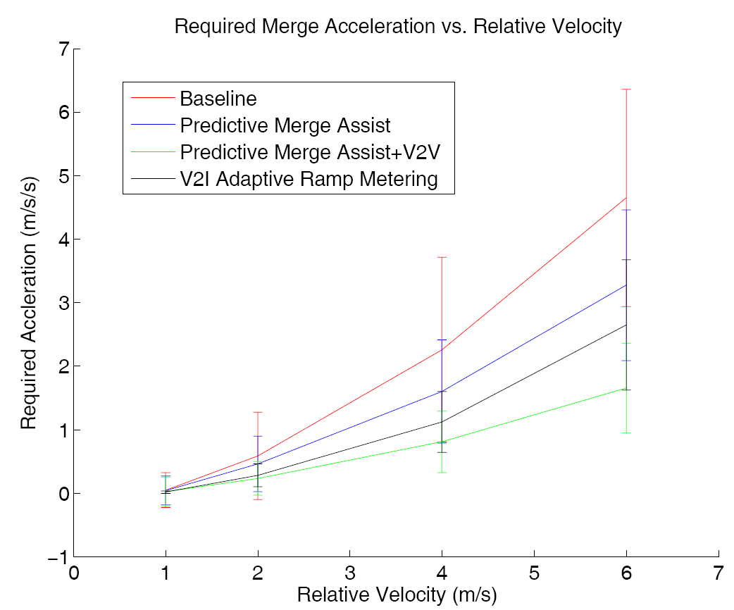

Figure 2-1 Simulation results for required merge acceleration vs. relative velocity

The red curve indicates the necessary acceleration for reference case; the blue curve represents the results for vehicles with predictive merge assistance; the lack curve shows the required acceleration for vehicles with predictive merge assistance and V2I communication; and the green curve represents the acceleration profile for vehicles with predictive merge assistance and V2V communication. Results show that active safety, which is quantitatively evaluated by a predefined near-collision scenario, is greatly enhanced when implementing predictive merge assistance, V2V, or V2I communications. The best result is generated from an integrated system which contains predictive driver assistance and V2V communication.

Shingde et al. [40] proposed and implemented two merge algorithms, named Head of the Lane (HoL), and All Feasible Sequences (AFS) for automated merge control. HoL considered the headmost vehicle of each road for competition and selected the winner based on minimizing the Driving-Time-To-Intersection (DTTI) of the two vehicles. The profile of winner vehicle would be broadcasted and the vehicle next to winner would be declared as a new HoL node. Different from HoL, AFS took all relevant vehicles within a snapshot into consideration and gave a centralized solution. Both algorithms were implemented in Java and were demonstrated by controlling the movement of some robots. The comparison of two proposed algorithms with virtual vehicle is shown in Figure 2-2.

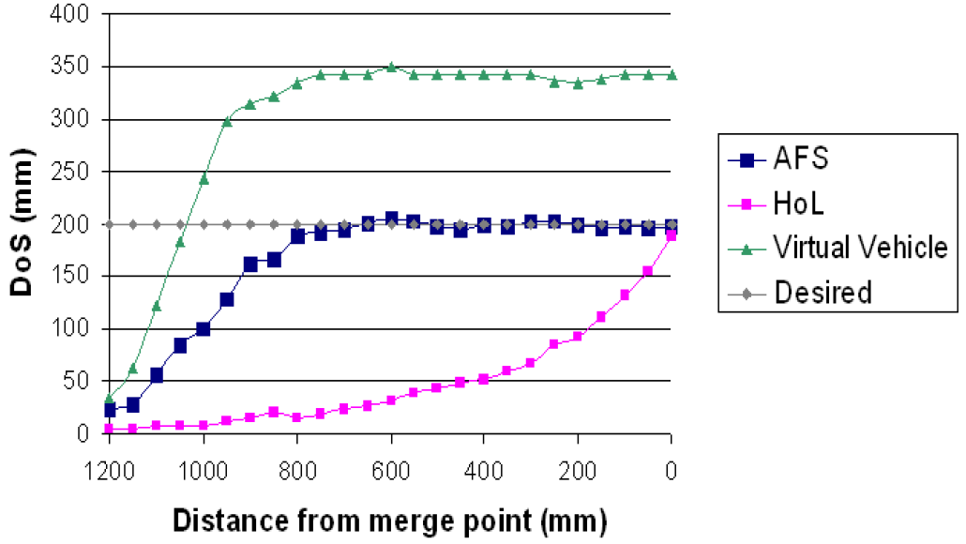

Figure 2-2 Distance of separation comparison of AFS and HoL with virtual vehicle

Figure 2-2 shows that inaccurate result is generated for the virtual vehicle based algorithm; vehicles maintain a distance around 350m at the merging point. Both AMC algorithms, HoL and AFS, under the same conditions, assure safety distance of 200mm for vehicles at merging point. While safety distance is established at different time; it starts at around 600 mm from the merge point for AFS algorithm; while for HoL algorithm, it establishes when vehicles have arrived at the merging point.

The comparison of average DTTI is shown in Figure 2-3. The number of merging vehicles is increased from one to four to study the impact of traffic volume.

It is observed from the graph that, compared to virtual vehicles, DTTI is decreased for both HoL and AFS algorithms, although HoL stopped working when vehicle generation rate is larger than one vehicle per second.

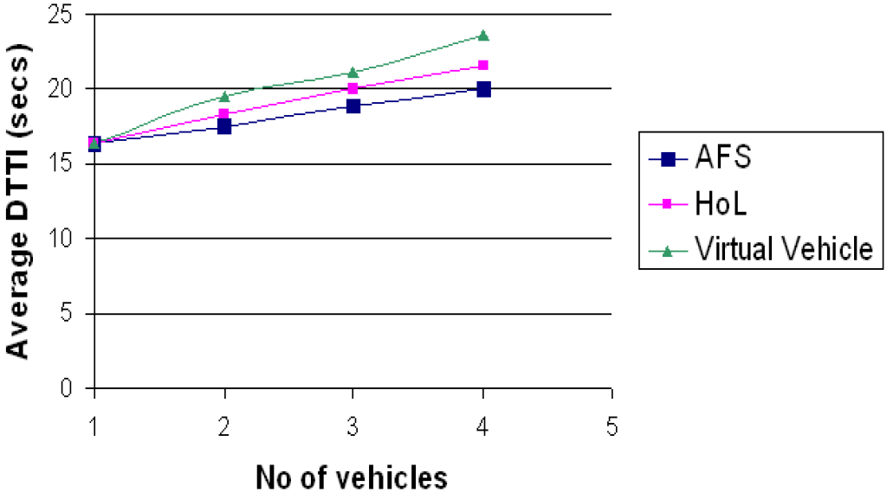

Figure 2-3 DTTI comparison of AFS and HoL with virtual vehicle

Milanés et al. [41] also developed a control algorithm to guide merging vehicles. The developed algorithm was tested by a simulator and was validated by three vehicles, one on minor road and the other two on major road, in a test field. In their study, the leading vehicle on highway was named Rocinante, the trailing vehicle was name Platero, and the merging vehicle was called Clavileño. The authors considered a merging scenario on congested traffic situations and the relative distances between vehicles is summarized as shown in Figure 2-4. The safety distance was set as 12m and was guaranteed at the end of merging process. Thus the authors claimed that their decision algorithm is capable of finding the optimum solution for merging vehicles.

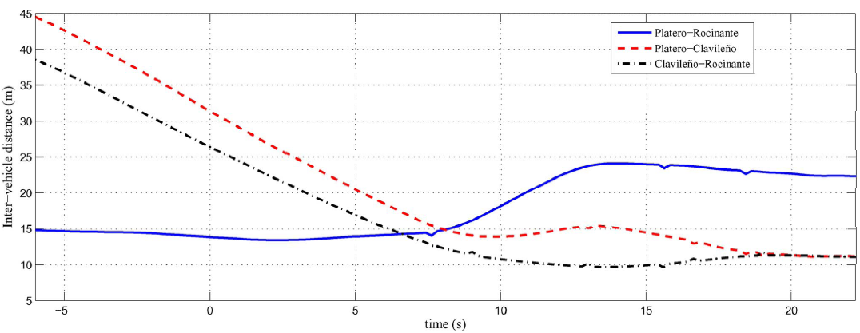

Figure 2-4 Relative distances between vehicles for field test

Cao et al. [42] proposed a nonlinear model predictive control (MPC) method for merging traffic. One vehicle on main road and one vehicle on minor road were considered in a two dimensional space. This merging issue was simplified as a nonlinear optimization problem and was solved by C/GMRES method to get the optimal moving patterns. Three different cases were evaluated in their study. Merging vehicle was deemed to merge to the front or behind of highway vehicle for case 1 and 2, respectively; in case 3, vehicles would collide with each other if maintaining initial speeds and accelerations. The merging maneuver in the simulation for each case is shown in Figure 2-5.

It can be seen from Figure 2-5 that, realistic and mild speed patterns are generated and their proposed method performs well for these three typical scenarios. The authors believe that merging maneuver of two vehicles can be conducted successfully with their proposed algorithm as long as the initial inputs are reasonable.

|  |  |
| --- | --- |
| (a) Variables for 2 vehicles in case 1 | (b) Variables for 2 vehicles in case 2 |
|  |  |
| (c) Variables for 2 vehicles in case 3 |  |
|  |  |

Figure 2-5 Velocity, acceleration and following distance profiles for studied scenarios

## 2.7. DRIVER BEHAVIOR

Another element needs to be taken into consideration for traffic control is driver behavior. People behave differently in merging process, and their behaviors lie on their cultural background and psychological quality. Some advanced traffic simulators include driving behavior model into them so that users can easily change some parameters to modify driver behavior. But it may not model some complicated conditions, such as merging, as there are always some drivers who are more aggressive than others.

Ge et al. [36] changed 3 of the 10 user-defined parameters related to driver behaviors in VISSIM for merge control at freeway work zone. They found that CC1 (headway time) and CC2 (longitudinal following threshold) had a strong impact on the throughput. Based on their result, it was recommended that employing early merge method for aggressive drivers and late-merge method for cautious drivers. Al-Kaisy and Hall [43] studied the importance of driver population factor on highway with a long distance work zone. The authors believed that driver population factor is critically important to highway capacity. The driver population factor was 0.93 (took commuter traffic as 1.0 for reference) for peak traffic in the afternoon, and 0.84 for weekends; which means there is more capacity reduction on weekends than on weekdays. Praveen K. Edara [44] did a comprehensive comparison for different parameters used in driver behavior model of VISSIM and provided recommended parameters for work zones using early merge method. The author also gave some truck characteristics for reference because the default parameters do not represent typical U.S. trucks.

These studies showed traffic safety improvement and traffic throughput enhancement. However, none of these studies looked at how to coordinate the movements of all vehicles in the ramp area simultaneously to achieve a global optimal control. In this paper, a nonlinear optimization model is developed for this purpose. The control objective is to maximize the speeds of all vehicles while maintaining a safe distance between any two of them.

# CHAPTER 3: METHODOLOGY

Numerical optimization technique is used in this thesis to determine the optimal accelerations for merging vehicles. With appropriate simplifications, ramp control can be abstracted as a mathematical programming problem and solved by selecting optimal accelerations for vehicles in the merging zone. The optimal accelerations, which are considered as decision variables in the mathematical program, depend on a series of constraints such as safety and comfort. The optimization objective is to maximize the overall traffic speed. While a lot of control algorithms consider minimizing delay and/or maximizing throughput as the objectives, the results of this study suggest that these objectives are implicitly related to maximizing the overall traffic speed.

## 3.1. PROBLEM FORMULATION

### 3.1.1. Problem Description

The objective of this research is to develop and implement an optimal control model for merging vehicles to improve the safety and traffic operations at highway on-ramps. This ramp control model aims to maximize the speeds of all merging vehicles while taking into consideration necessary safety and comfort constraints. This model is based on a strict assumption that all vehicles are connected via DSRC and controlled by computers. Once these vehicles are within the ramp area, they will turn the control over to a central traffic controller and strictly execute the instructions received from the central

controller. Since all vehicles are connected and can communicate with the controller, the central traffic (or ramp) controller has enough detailed information to develop an optimal control plan for these vehicles in the next decision interval. Such a control plan is expected to significantly improve the traffic operations at highway on-ramps.

### 3.1.2. Problem Formulation

To evaluate to what extent such a system (described in Section 3.1.1.) can improve traffic operations at highway on-ramps, an integrated and comprehensive framework is needed. In the following sections, how to develop this framework is described in detail.

First of all, a microscopic traffic simulator, VISSIM, is included in the framework to simulate the merging process at highway on-ramps. With the VISSIM simulator, the accelerations, speeds, positions of all vehicles in the merging zone can be precisely captured. This information is fed into an optimization module coded in MATLAB. The optimization module will take all the inputs and find the optimal control strategies for each vehicle in terms of speed and acceleration. These optimal strategies will be sent back to the VISSIM simulator for vehicle control. To facilitate the data exchange between MATLAB and VISSIM, A C++ application is developed. The optimization module written in MATLAB is encapsulated into a dynamic-link library and called by the C++ application. This C++ application is then compiled as an executable file to override the default driver behavior model in VISSIM. Figure 3-1 illustrates the proposed modeling framework.

1. Optimization formulation

The *fmincon* function in MATLAB is used as the basis to develop and solve the optimal ramp control problem. The formulated optimization problem takes the second-by-second vehicle accelerations as the decision variables. A 10-second decision interval is considered. In other words, each vehicle has 10 decision variables associate with it. After 10 seconds, vehicles should keep a constant speed until they pass the merging point. Once a vehicle passes the merging point, the driver can take over the control or let the on-board computer to continue to control the vehicle. The objective is to maximize each vehicle’s speeds over the entire 10-second interval. Different variations of the objective are also considered. For example, the standard deviation (SD) of accelerations for each vehicle can also be taken into account to avoid frequent switches between acceleration and deceleration and aggressive driving behaviors.

To ensure a safe and smooth ride to all drivers, some key parameters, such as maximum speed, minimum speed, maximum acceleration, maximum deceleration, and minimum distance between vehicles, need to be carefully defined. Also, an initial feasible solution is required as the starting point for *fmincon* to find the optimal solution.

1. Call MATLAB function from the C++ application

VISSIM provides a C++ interface to allow users to access vehicle information and control vehicle movements. There are several ways to integrate the above MATLAB code and the C++ interface. Among them, the simplest method is to generate C++ code directly from the MATLAB code. Unfortunately, the current version of *fmincon* in MATLAB does not support generating C++ code directly. Therefore, a second option is adopted, which uses the MATLAB compiler to generate a dynamic-link library (DLL), which can be more easily integrated into the VISSIM C++ interface.



Figure 3-6 Integrated platform architecture

1. VISSIM simulation

The optimized vehicle control parameters are sent back to VISSIM via the C++ interface. VISSIM follows these instructions to control the simulated vehicles until they pass the merging point. After that, the default driving behavior model in VISSIM will be reactivated to control vehicles from the merging point to the end of network.

## 3.2. NONLINEAR CONSTRAINED OPTIMIZATION IN MATLAB

MATLAB’s optimization toolbox provides tools for solving various optimization problems, including linear programming, mixed-integer linear programming, and nonlinear optimization. *fmincon* is one of the nonlinear optimization functions and is able to solve constrained nonlinear multivariable minimum problems [42]. It applies derivative-based searches and does not guarantee a global solution.

The syntax of *fmincon* can be written as:

where:

*fval* is the returned scalar value of objective function *fun* with value of *x*;

*exitflag* is an integer indicating the reason of algorithm termination;

*fun* is the objective function;

*x0* is the initial value of *x* for optimization;

*A* and *Aeq* are matrices, *A* is used for linear inequality constraints and *Aeq* for linear equality constraints;

*b* and *beq* are vectors corresponding to *A* and *Aeq*;

*c(x)* and *ceq(x)* are functions that return vectors;

*lb* and *ub* are lower and upper bounds of variable *x*;

*nonlcon* is used to define nonlinear inequalities *c(x)* or equalities *ceq*(x); and

*options* is used to set or change optimization algorithm.

If necessary, it is possible to pass extra parameters into objective function and nonlinear function.

Four algorithms, *interior-point, trust-region-reflective, sqp, and active-set,* are implemented in *fmincon* function. The *interior-point* is the default algorithm. It is able to handle large but sparse problems, or small but dense problems at a low memory cost. Also, it includes some special options for large-scale optimization problems. However, the solutions generated by the interior-point method may be less accurate comparing to other algorithms because the solutions are kept away from inequality constraint boundaries. The *sqp* is a medium-scale algorithm by creating all matrices needed and exploiting dense linear algebra. The *active-set* is a small to medium-scale algorithm and is able to use large steps to accelerate the calculation process for non-smooth constraints. The *trust-region-reflective* algorithm handles problems with either bounds or linear equality constraints, but not both. In this thesis, the active-set algorithm is used.

## 3.3. SET UP C++ PROJECT FOR USING MATLAB

To access the *fmincon* function in MATLAB, the following procedures need to be followed to connect the C++ interface with the MATLAB code, which is compiled as a DLL file.

### 3.3.1. Set up Environment Variables

To establish the connection between the C++ interface and the MATLAB code, the following Windows environment variables need to be set up. One needs to make sure that the search directories of MATLAB are correctly added to the Windows operating system’s PATH variables. The search directories include ‘%MATLAB_home%\bin’, ‘%MATLAB_home%\runtime\win32’, and ‘%MATLAB_home%\bin\win32’, where “%MATLAB_home%” represents the installation folder for the MATLAB program.

### 3.3.2. Set up C++ Project

Microsoft Visual Studio 2008 is used in this study. For setting up the C++ project, one needs to start Microsoft Visual Studio with Administrator privilege, start a C++ project, and make the following changes to the project properties:

1. Set the include directories (under Configuration Properties -> VC++ Directories) to ‘%MATLAB_home%\extern\include’.
2. Set the library directories (under Configuration Properties -> VC++ Directories) to ‘%MATLAB_home%\extern\lib\win32\microsoft’.
3. Add three basic MATLAB libraries: ‘libeng.lib’, ‘libmat.lib’, and ‘libmx.lib” to the Additional Dependencies setting (under Configuration Properties -> Custom Build Step).
4. Copy the dynamic-link library, library file, and header file generated by MATLAB compiler into the C++ project file folder. Include ‘mclmcr.h’, ‘mclcppclass.h’, and function header file in C++ application.

## 3.4. VISSIM MICROSCOPIC SIMULATION

A Car2X Module has been incorporated into VISSIM to enable the modeling of Vehicle-to-Vehicle and/or Vehicle-to-Infrastructure communications. Users can write either C++ programs or python scripts to access this Car2X module. With the help of the Car2X module, it is possible to access and/or set connected vehicles’ data at every simulation time step. Specifically, the following six functionalities are available in the Car2X module:

1. Send–relevance checking
2. Driving behavior modification
3. Sending messages
4. Receiving messages
5. Resend relevance checking
6. Resending message

The Car2X module defines conditions that vehicles will send arbitrary messages to other vehicles and how other vehicles react on these messages. As shown in Figure 3-1, the sent messages are handled by a communication component named VCOM included in Car2X. This VCOM component is designed to emulate WLAN communications between a vehicle and “X” (Here “X” can be another vehicle or a roadside equipment). It handles plain text messages and attaches necessary vehicle stamps (e.g., vehicle ID and vehicle type) with it. There are three popular communication methods implemented in VCOM: point to point, broadcast, and geocast. For the point to point method, receiver’s ID will be sent along with messages and only the sender and the intended receiver can communicate with each other. For the broadcast method, all vehicles within a particular zone can receive messages and respond accordingly. The geocast is a virtual communication method and users can specify a reception distance which may be longer than a typical reception distance. This method enables large-area traffic coordination without considering the technical detail of how to make it happen.

The resending condition is similar to the sending condition, but is not exactly the same. It always serves as a node of a multi-hop network for long-distance communications. It is not necessary to follow a fixed order to execute the above six actions. However, it is highly recommended that senders and re-senders send a whole block of data without being interrupted by actions such as receiving messages.

## 3.5. SPECIFICATION OF THE PROBLEM FORMULATION

In this research, the 32-bit VISSIM 5.40 is used together with Microsoft Visual Studio 2008 and MATLAB 2013a (32 bit) to establish the modeling framework. The library file C2X_APPLICATION.LIB included in VISSIM 5.40 should be updated because it only supports Microsoft Visual Studio 2005 [5]. Also, a Boost library (version 1.37.0) should be installed to enable communications between VISSIM and its Car2X module. Table 3-1 lists the notations used in the developed optimization model. The objective function, constraints, and decision variables are described in detail below.

Table 3-1 Notations used in the formulation

|  |  |
| --- | --- |
| **Notation** | **Description** |
|  | Lane identifier |
|  | Vehicle index |
|  | Time steps index |
| m | Total number of time steps |
|  | Total number of vehicles in lane *i* |
|  | *i*th lane |
|  | *j*th vehicle |
|  | *k*th time step |
|  | Acceleration of vehicle *j* in lane *i* at time *tk* |
|  | Velocity of vehicle *j* in lane *i* at time *tk* |
|  | Position of vehicle *j* in lane *i* at time *tk* |
|  | Distance of vehicle *j* in lane *i* at time *tk*  to the merging point |
|  | Speed limit |
|  | Minimum distance gap |
|  | Minimum acceleration |
|  | Maximum acceleration |
|  | Maximum difference between two consecutive steps |
|  | Standard deviation of acceleration for vehicle *j* in lane *i* |

**Objective Function:**

As discussed previously, the objective of the proposed optimal control model is to maximize the average speed of all vehicles over the next decision interval. This is equivalent to minimizing the following objective function in (1). Maximizing the average speed alone may lead to aggressive acceleration and deceleration activities. To prevent such activities from happening, a new objective function in (2) is proposed, which takes into account the standard deviations of each vehicle’s second-by-second accelerations in the next decision interval.

(1)

Or: (2)

**Constraints:**

A decision interval of 10 seconds is considered in this study. This interval is further divided into ten 1-second steps. At the beginning of each time step, each vehicle needs to make a control decision, which is reflected by its acceleration for the next second/time step (Since deceleration is simply for the acceleration to be negative, acceleration will be used hereinafter to represent both acceleration and deceleration in this thesis). It is also assumed that a vehicle will not change its acceleration in the next time step. Based on the above assumptions, the following constraints have been derived.

1) *Speed limit constraints*: Each vehicle maintains a nonnegative speed (*v*) that is no greater than the speed limit.

(3)

2) *Car-following constraints*: Once a vehicle *j* enters a pre-defined zone, it is not allowed to overtake any other vehicles and it has to keep a minimum distance *Gmin* from vehicle in front of it (i.e., veh *j-1*). For two consecutive vehicles *vehi,j-1* and *vehi,j* in *lanei*, the following constraints must be satisfied:

(4)

3) *Mutual exclusion constraints*: These constraints ensure that any pair of highway and ramp vehicles maintains a safe distance when one of them arrives at the merging point.

(5)

4) *Consecutive acceleration constraints*: These constraints limit the acceleration changes to prevent aggressive driving behaviors.

(6)

5) *Equality constraints*: The following constraints describe the relationships among speed, acceleration, and distance. Acceleration is the derivative of velocity with respect to time, and velocity is the derivative of distance traveled to time.

(7)

(8)

6) *Lower and upper bounds for accelerations*: each vehicle should maintain an acceleration that is no more that and no less that at each time step.

(9)

**System input:**

Based on the above constraints, the following values are needed as the input to the optimization model.

|  |  |
| --- | --- |
|  |  |
|  |  |
|  |  |
|  |  |
|  |  |
|  |  |
|  |  |

**System output:**

The system output includes the optimal accelerations for all vehicles at each time step.

# CHAPTER 4: MODEL ESTIMATION

## 4.1 MODEL IMPLEMENTATION

To demonstrate how the optimization-based control algorithm works and verify the effectiveness of the proposed model, three case studies were conducted which considered vehicles from both the highway and the ramp in a controlled environment. A 10-second optimization horizon was considered and each time step was 1 second. Three representative scenarios were considered in this study to test and validate the proposed model.

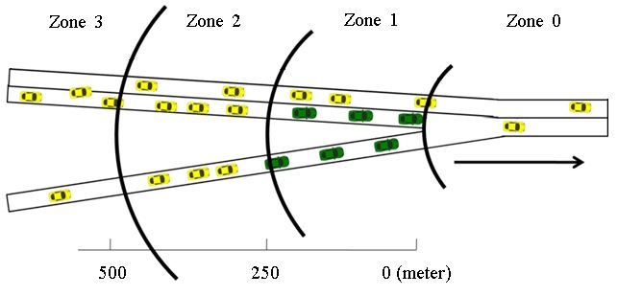

Figure 4-7 Merging model

As shown in Figure 4-1, the ramp area is divided into three zones. This study assumes that all necessary lane changes (by courteous drivers) are completed in Zone 3. Upon entering Zone 2, vehicles are in autonomous driving mode until they leave Zone 1. The detailed information of both highway and ramp vehicles in Zone 2 is used as the input to the optimization model; the accelerations of these vehicles for the next *m* time

steps are decision variables; the objective is to maximize the summation of all vehicles’ speeds in the next *m* time steps; and safety constraints are added to ensure that vehicles (on both highway and ramp) pass by the merging point (i.e., end of Zone 1) with space headways greater than a pre-specified value. In Zone 1, highway vehicles in the right lane are allowed to change to the left lane if needed. However, highway vehicles in the left lane are not allowed to change to the right lane. At the end of the simulation, all vehicles’ accelerations are set to zero.

## 4.2 CASE STUDIES

In all case studies conducted, the speed limit is set as 25m/s (about 60 mph) and the minimal speed is 0m/s. The maximum acceleration is 5m/s2 and the maximum deceleration rate is -5m/s2. Meanwhile, the acceleration difference between two consecutive steps is set as 2 m/s2 to ensure that the merging process is smooth and comfortable. Besides, the safety distance between vehicles is 15m.

### 4.2.1 Case 1: Four Vehicles without Initial Conflicts

Two highway vehicles and two ramp vehicles are considered in this case. If these vehicles maintain their initial speeds, there will be no potential conflicts among them when they pass the merging point. The system inputs are:

.

where, shows the initial (t=0) distances of the two vehicles in right-most lane of the highway to the merging point. Similarly, is for the two ramp vehicles, meaning the two ramp vehicles’ distances to the merging point are 500m and 485m, respectively. The initial distances allow all vehicles to finish adjusting their speeds and positions before reaching the merging point. The trajectories of these vehicles are optimized using the proposed model. The modeling results are summarized in Figures 4-2, 4-3 and 4-4, where H-1 and H-2 stand for the first and second highway vehicles and R-1 and R-2 denote the first and second ramp vehicles.

The results in Figures 4-2, 4-3 and 4-4 show that the acceleration, velocity, and safety distance constraints have all been satisfied. The four vehicles all reach the maximum possible speed when they pass the merging point. Also, the distance between any two vehicles is greater than the pre-specified safe distance at the end of the 10-second decision interval. This example suggests that the proposed method works well when there is no initial conflict among vehicles if these vehicles maintain their initial speeds.

Figure 4-8 Accelerations of the 4 vehicles

Figure 4-9 Velocities of the 4 vehicles

Figure 4-10 Distances of the 4 vehicles to the merging point

### 4.2.2 Case 2: Four Vehicles with Initial Conflicts

Again, two highway and two ramp vehicles are considered in this case. The initial positions, speeds, and accelerations are provided below. If these vehicles maintain their initial speeds, it is easy to see that they will run into each other at the merging point. In other words, these vehicles must adjust their accelerations/speeds in order to avoid potential collisions at the merging point.

.

Figures 4-5, 4-6, and 4-7 show the results of acceleration, velocity, and position profiles, respectively. As shown in Figure 4-5, to ensure vehicles can pass the merging point with safe space headways, both ramp and highway vehicles adjust their accelerations to make space for each other.

Figure 4-11 Accelerations of the 4 vehicles

Figure 4-12 Velocities of the 4 vehicles

Figure 4-13 Positions of the 4 vehicles

Figure 4-7 shows that at the end of the 10-second decision/optimization interval any two vehicles maintain a safe distance between them. This suggests that the proposed optimal control method is able to successfully optimize vehicle trajectories to avoid potential conflicts. The results in Figure 4-6 show that vehicles’ velocities fluctuate significantly, especially for the two ramp vehicles. The frequent accelerations and decelerations in Figure 4-6 may increase fuel consumption and cause discomfort to drivers. In order to address this issue, the standard deviations of vehicle accelerations in the 10-second interval are taken into consideration in the objective function. Figures 4-8, 4-9, and 4-10 show the acceleration, speed, and distance results based on the new objective function. It can be seen that, similar to the previous results, all vehicles reach the maximum velocity and maintain a safe distance between each other at the end of the 10-second interval. The optimized average velocities for both examples are 22.65 m/s. Different from the previous example, after adding the standard deviations in the objective function none of the 4 vehicles have a negative acceleration (i.e., deceleration). Also, the speed profiles of all vehicles in Figure 4-9 appear to be more reasonable and smooth.

Figure 4-14 Accelerations of the 4 vehicles with the standard deviations of accelerations considered

Figure 4-15 Velocities of the 4 vehicles with the standard deviations of accelerations considered

Figure 4-16 Positions of the 4 vehicles with the standard deviations of accelerations considered

### 4.2.3 Case 3: Twenty Vehicles with Initial Conflicts

Ten highway and ten ramp vehicles are considered in this case to test the developed model’s ability to coordinate a relatively large number of vehicles. The initial accelerations of all these vehicles are assumed to be zero, and vehicles initially are all traveling at 20m/s. Given the initial vehicle positions, some of the vehicles will collide with each other if they maintain the same speeds. For this case study, the standard deviations of accelerations are also taken into consideration. The inputs for this case study are summarized below:

By applying the optimal control model, the resultant acceleration, velocity and position profiles are shown in Figures 4-11 through 4-15. From Figures 4-11 and 4-12, it can be seen that both highway and ramp vehicles adjust their accelerations/decelerations to make space for each other. The validity of the proposed optimal control model is further illustrated in Figure 4-15, where vehicles in different lanes all keep a safe distance between each other at the end of optimization process. Figures 4-13 and 4-14 show that the first vehicle in each lane accelerates to the speed limit as soon as possible and keep this speed until the end; and the speeds of the remaining vehicles are constrained by vehicles in front them. At the end, most vehicles reach the maximum speed except for some vehicles at the end of each vehicle platoon. For vehicles with speeds less than the speed limit, increasing their speeds may violate the safety constraints and cause the distances between them to be less than the minimum safety distance.

Figure 4-17 Accelerations of the 10 highway vehicles

Figure 4-18 Accelerations of the 10 ramp vehicles

Figure 4-19 Velocities of the 10 highway vehicles

Figure 4-20 Velocities of the 10 ramp vehicles

Figure 4-21 Distances of the 20 vehicles to the merging point

Since there are many vehicles in this case study, it is a little difficult to discern the acceleration profiles of each vehicle and interpret them. To solve this problem and make sure all the constraints are satisfied, the detailed optimization model outputs at each time step are summarized in Tables 4-1, 4-2, and 4-3.

From Table 4-1, it is obvious that all the accelerations are between the upper bound (5m/s2) and lower bound (-5m/s2), and the maximum acceleration difference for two consecutive steps is 2m/s2. From the velocity data in Table 4-2, it is seen that all the velocities are between zero and 25m/s. Several vehicles at the end of each vehicle platoon have a very low speed in order to meet the safety distance constraint at the merging point. After passing the merging point, if these vehicles maintain their speeds, the distances between them and other lead vehicles will become keep increasing. This may have a negative effect on vehicles in the following platoons that are not included in the current optimization process. To address this issue for vehicles with speeds less than the speed limit at the end of the optimization process, it is necessary to use their speeds as a constraint for vehicles in Zone 2 during the following optimization process.

Table 4-1 Step-by-step accelerations for the 20-vehicle case

|  |  |  |  |  |  |  |  |  |  |  |  |
| --- | --- | --- | --- | --- | --- | --- | --- | --- | --- | --- | --- |
| **veh ID** | **Acceleration (m/s2)** | | | | | | | | | | |
|  | **t0** | **t1** | **t2** | **t3** | **t4** | **t5** | **t6** | **t7** | **t8** | **t9** | **t10** |
| **R-1** | 0 | -2.00 | -3.77 | -3.18 | -2.58 | -1.98 | -1.39 | -0.79 | -0.19 | 0.40 | 0.00 |
| **R-2** | 0 | -2.00 | -3.77 | -3.18 | -2.58 | -1.98 | -1.39 | -0.79 | -0.19 | 0.40 | 0.00 |
| **R-3** | 0 | -2.00 | -3.26 | -2.68 | -2.11 | -1.53 | -0.96 | -0.38 | 0.19 | 0.77 | 0.00 |
| **R-4** | 0 | -2.00 | -2.74 | -2.19 | -1.64 | -1.08 | -0.53 | 0.02 | 0.58 | 1.13 | 0.00 |
| **R-5** | 0 | -2.00 | -1.71 | -1.20 | -0.69 | -0.18 | 0.33 | 0.84 | 1.35 | 1.85 | 0.00 |
| **R-6** | 0 | -1.75 | -1.26 | -0.77 | -0.28 | 0.21 | 0.70 | 1.19 | 1.69 | 2.00 | 0.00 |
| **R-7** | 0 | -1.34 | -0.87 | -0.39 | 0.09 | 0.56 | 1.04 | 1.52 | 2.00 | 2.00 | 0.00 |
| **R-8** | 0 | -0.34 | -0.12 | 0.11 | 0.33 | 0.56 | 0.78 | 1.01 | 1.23 | 1.46 | 0.00 |
| **R-9** | 0 | 0.66 | 0.63 | 0.61 | 0.58 | 0.56 | 0.53 | 0.51 | 0.48 | 0.46 | 0.00 |
| **R-10** | 0 | 2.00 | 2.50 | 0.50 | 0.00 | 0.00 | 0.00 | 0.00 | 0.00 | 0.00 | 0.00 |
| **H-1** | 0 | -2.00 | -4.00 | -3.79 | -3.16 | -2.52 | -1.89 | -1.26 | -0.62 | 0.01 | 0.00 |
| **H-2** | 0 | -2.00 | -3.26 | -2.68 | -2.11 | -1.53 | -0.96 | -0.38 | 0.19 | 0.77 | 0.00 |
| **H-3** | 0 | -2.00 | -2.74 | -2.19 | -1.63 | -1.08 | -0.53 | 0.02 | 0.58 | 1.13 | 0.00 |
| **H-4** | 0 | -2.00 | -2.22 | -1.69 | -1.16 | -0.63 | -0.10 | 0.43 | 0.96 | 1.49 | 0.00 |
| **H-5** | 0 | -2.00 | -2.22 | -1.69 | -1.16 | -0.63 | -0.10 | 0.43 | 0.96 | 1.49 | 0.00 |
| **H-6** | 0 | -2.00 | -1.71 | -1.20 | -0.69 | -0.18 | 0.33 | 0.84 | 1.35 | 1.85 | 0.00 |
| **H-7** | 0 | -1.75 | -1.26 | -0.77 | -0.28 | 0.21 | 0.70 | 1.19 | 1.69 | 2.00 | 0.00 |
| **H-8** | 0 | -1.34 | -0.87 | -0.39 | 0.09 | 0.56 | 1.04 | 1.52 | 2.00 | 2.00 | 0.00 |
| **H-9** | 0 | -0.34 | -0.12 | 0.11 | 0.33 | 0.56 | 0.78 | 1.01 | 1.23 | 1.46 | 0.00 |
| **H-10** | 0 | 0.66 | 0.63 | 0.61 | 0.58 | 0.56 | 0.53 | 0.51 | 0.48 | 0.46 | 0.00 |

From the position data in Table 4-3, it can be seen that at each time step the distance between any two vehicles from the same lane is greater than the safety distance. At the end of the 10-second interval, the distance between any highway and ramp vehicles is also greater than the safety distance.

Also, it can be seen from Tables 4-2 and 4-3 that several vehicles do not reach the maximum speed at the end of this optimization process, which are vehicles R-1, R-2, R-3, R-4, R-5, H-1, H-2, H-3, H-4, H-5, and H-6. These vehicles are still in zone 2 (from 500m to 250m upstream of the merging point). Therefore, their trajectories can be further optimized in next optimization process.

Table 4-22 Step-by-step velocities for the 20-vehicle case

|  |  |  |  |  |  |  |  |  |  |  |  |
| --- | --- | --- | --- | --- | --- | --- | --- | --- | --- | --- | --- |
| **veh ID** | **Velocity (m/s)** | | | | | | | | | | |
| **t0** | **t1** | **t2** | **t3** | **t4** | **t5** | **t6** | **t7** | **t8** | **t9** | **t10** |
| **R-1** | 25.00 | 25.00 | 23.00 | 19.23 | 16.05 | 13.47 | 11.48 | 10.10 | 9.31 | 9.11 | 9.52 |
| **R-2** | 25.00 | 25.00 | 23.00 | 19.23 | 16.05 | 13.47 | 11.48 | 10.10 | 9.31 | 9.11 | 9.52 |
| **R-3** | 25.00 | 25.00 | 23.00 | 19.74 | 17.06 | 14.95 | 13.42 | 12.46 | 12.08 | 12.27 | 13.04 |
| **R-4** | 25.00 | 25.00 | 23.00 | 20.26 | 18.07 | 16.44 | 15.35 | 14.83 | 14.85 | 15.43 | 16.55 |
| **R-5** | 25.00 | 25.00 | 23.00 | 21.29 | 20.10 | 19.41 | 19.23 | 19.55 | 20.39 | 21.74 | 23.59 |
| **R-6** | 25.00 | 25.00 | 23.25 | 21.98 | 21.21 | 20.93 | 21.14 | 21.85 | 23.04 | 24.73 | 26.73 |
| **R-7** | 25.00 | 25.00 | 23.66 | 22.79 | 22.40 | 22.49 | 23.05 | 24.09 | 25.61 | 27.61 | 29.61 |
| **R-8** | 25.00 | 25.00 | 24.66 | 24.54 | 24.64 | 24.97 | 25.53 | 26.31 | 27.31 | 28.54 | 30.00 |
| **R-9** | 25.00 | 25.00 | 25.66 | 26.29 | 26.89 | 27.47 | 28.03 | 28.56 | 29.06 | 29.54 | 30.00 |
| **R-10** | 25.00 | 25.00 | 27.00 | 29.50 | 30.00 | 30.00 | 30.00 | 30.00 | 30.00 | 30.00 | 30.00 |
| **H-1** | 25.00 | 25.00 | 23.00 | 19.00 | 15.21 | 12.06 | 9.54 | 7.65 | 6.39 | 5.77 | 5.78 |
| **H-2** | 25.00 | 25.00 | 23.00 | 19.74 | 17.06 | 14.95 | 13.42 | 12.46 | 12.08 | 12.27 | 13.04 |
| **H-3** | 25.00 | 25.00 | 23.00 | 20.26 | 18.07 | 16.44 | 15.35 | 14.83 | 14.85 | 15.43 | 16.55 |
| **H-4** | 25.00 | 25.00 | 23.00 | 20.78 | 19.08 | 17.92 | 17.29 | 17.19 | 17.62 | 18.58 | 20.07 |
| **H-5** | 25.00 | 25.00 | 23.00 | 20.78 | 19.08 | 17.92 | 17.29 | 17.19 | 17.62 | 18.58 | 20.07 |
| **H-6** | 25.00 | 25.00 | 23.00 | 21.29 | 20.10 | 19.41 | 19.23 | 19.55 | 20.39 | 21.74 | 23.59 |
| **H-7** | 25.00 | 25.00 | 23.25 | 21.98 | 21.21 | 20.93 | 21.14 | 21.85 | 23.04 | 24.73 | 26.73 |
| **H-8** | 25.00 | 25.00 | 23.66 | 22.79 | 22.40 | 22.49 | 23.05 | 24.09 | 25.61 | 27.61 | 29.61 |
| **H-9** | 25.00 | 25.00 | 24.66 | 24.54 | 24.64 | 24.97 | 25.53 | 26.31 | 27.31 | 28.54 | 30.00 |
| **H-10** | 25.00 | 25.00 | 25.66 | 26.29 | 26.89 | 27.47 | 28.03 | 28.56 | 29.06 | 29.54 | 30.00 |

## 4.3 CONCLUSION

These case studies suggest that the proposed optimization method can generate safe and smooth acceleration patterns for each vehicle no matter whether there are initial conflicts among them or not. In all three cases, highway and ramp vehicles merge safely at the merging point with sufficient distances between any two vehicles. Although the distance headways between vehicles vary with time, they tend to be equalized and are all greater than a minimum value at the end of optimization process. These vehicles will then maintain the optimized distance headways until they pass the merging point.

Table 4-23 Step-by-step vehicle positions for the 20-vehicle case

|  |  |  |  |  |  |  |  |  |  |  |  |
| --- | --- | --- | --- | --- | --- | --- | --- | --- | --- | --- | --- |
| **veh ID** | **Distance to merging point (m)** | | | | | | | | | | |
|  | **t0** | **t1** | **t2** | **t3** | **t4** | **t5** | **t6** | **t7** | **t8** | **t9** | **t10** |
| R-1 | 600.0 | 575.0 | 551.0 | 529.9 | 512.2 | 497.5 | 485.0 | 474.2 | 464.5 | 455.3 | 446.0 |
| R-2 | 585.0 | 560.0 | 536.0 | 514.9 | 497.2 | 482.5 | 470.0 | 459.2 | 449.5 | 440.3 | 431.0 |
| R-3 | 570.0 | 545.0 | 521.0 | 499.6 | 481.2 | 465.2 | 451.0 | 438.1 | 425.8 | 413.7 | 401.0 |
| R-4 | 555.0 | 530.0 | 506.0 | 484.4 | 465.2 | 448.0 | 432.1 | 417.0 | 402.1 | 387.0 | 371.0 |
| R-5 | 540.0 | 515.0 | 491.0 | 468.9 | 448.2 | 428.4 | 409.1 | 389.7 | 369.7 | 348.7 | 326.0 |
| R-6 | 525.0 | 500.0 | 475.9 | 453.3 | 431.7 | 410.6 | 389.6 | 368.1 | 345.6 | 321.7 | 296.0 |
| R-7 | 510.0 | 485.0 | 460.7 | 437.4 | 414.9 | 392.4 | 369.6 | 346.1 | 321.2 | 294.6 | 266.0 |
| R-8 | 495.0 | 470.0 | 445.2 | 420.6 | 396.0 | 371.2 | 345.9 | 320.0 | 293.2 | 265.3 | 236.0 |
| R-9 | 480.0 | 455.0 | 429.7 | 403.7 | 377.1 | 349.9 | 322.2 | 293.9 | 265.1 | 235.8 | 206.0 |
| R-10 | 465.0 | 440.0 | 414.0 | 385.8 | 356.0 | 326.0 | 296.0 | 266.0 | 236.0 | 206.0 | 176.0 |
| H-1 | 600.0 | 575.0 | 551.0 | 530.0 | 512.9 | 499.3 | 488.5 | 479.9 | 472.9 | 466.8 | 461.0 |
| H-2 | 585.0 | 560.0 | 536.0 | 514.6 | 496.2 | 480.2 | 466.0 | 453.1 | 440.8 | 428.7 | 416.0 |
| H-3 | 570.0 | 545.0 | 521.0 | 499.4 | 480.2 | 463.0 | 447.1 | 432.0 | 417.1 | 402.0 | 386.0 |
| H-4 | 555.0 | 530.0 | 506.0 | 484.1 | 464.2 | 445.7 | 428.1 | 410.8 | 393.4 | 375.3 | 356.0 |
| H-5 | 540.0 | 515.0 | 491.0 | 469.1 | 449.2 | 430.7 | 413.1 | 395.8 | 378.4 | 360.3 | 341.0 |
| H-6 | 525.0 | 500.0 | 476.0 | 453.9 | 433.2 | 413.4 | 394.1 | 374.7 | 354.7 | 333.7 | 311.0 |
| H-7 | 510.0 | 485.0 | 460.9 | 438.3 | 416.7 | 395.6 | 374.6 | 353.1 | 330.6 | 306.7 | 281.0 |
| H-8 | 495.0 | 470.0 | 445.7 | 422.4 | 399.9 | 377.4 | 354.6 | 331.1 | 306.2 | 279.6 | 251.0 |
| H-9 | 480.0 | 455.0 | 430.2 | 405.6 | 381.0 | 356.2 | 330.9 | 305.0 | 278.2 | 250.3 | 221.0 |
| H-10 | 465.0 | 440.0 | 414.7 | 388.7 | 362.1 | 334.9 | 307.2 | 278.9 | 250.1 | 220.8 | 191.0 |

# CHAPTER 5: EXPERIMENT DESIGN AND IMPLEMENTATION

Due to frequent lane-changing and merging maneuvers, highway ramp areas often suffer from traffic congestion and safety problems. Under connected vehicle environment, vehicles are able to exchange precise location, speed, and acceleration information and collaborate with each other. Also, accurate traffic information (e.g., traffic density or level of service) in ramp areas can be shared with upstream drivers in a timely fashion so that proactive actions can be taken. For example, upstream drivers can either slow down or shift to left lanes to make room for vehicles on the ramp if there is an anticipated conflict. Intuitively, incorporating the connected vehicle technologies (CVtech) into highway ramp control can potentially improve traffic operations and safety. However, this hypothesis has never been tested based on our extensive literature review. In light of this gap in existing knowledge, this research aims to investigate the various collaborative merging scenarios at highway ramps enabled by the CVtech. VISSIM is a popular microscopic simulation tool trusted by many traffic engineers and researchers. It includes a C2X module which allows analysts to model V2V and V2I communications. VISSIM also provides several APIs, through which users can customize the simulation program by changing vehicles’ behaviors, such as their speeds and accelerations. Based on this information, various strategies, including dynamic speed limit, gradual speed limit, and collaborative lane change, are simulated in VISSIM using

the C2X module. These scenarios are then compared with the base scenario that does not consider any V2V or V2I communications.

## 5.1 EMPIRICAL STUDY OF CVTECH-BASED RAMP CONTROL

### 5.1.1 Experimental Design

In this study, CVtech is applied to highway ramp control to study the collaborative merging behaviors. Five different ramp control cases are considered. These five cases are applied to a typical highway on ramp. To thoroughly compare the performance of these ramp control cases, various levels of traffic demand are simulated using PTV VISSIM. The five control cases, highway on-ramp, and the various demand scenarios are detailed in the rest of this section.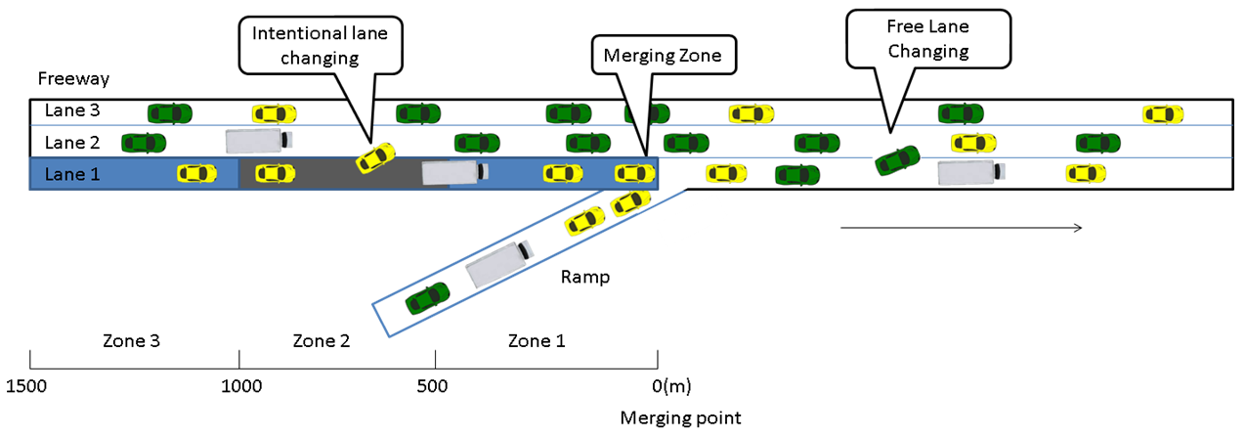

Figure 5-24 Highway on ramp model in this research

To compare the five control cases, a typical highway on-ramp shown in Figure 5.1 is considered. The length of the highway segment under investigation is 3000 meters, and the ramp connects to the highway approximately in its middle, which is called the merging point as shown in Figure 5.1. A merging zone is defined as the area in lane 1 that is within 100 meters upstream of the merging point. This merging zone is where vehicles from the on-ramp join the highway. Under the connected vehicle environment, highway vehicles will be informed of the traffic conditions in the merging zone and on the ramp. Based on such information, these highway vehicles (especially those in Lane 1) may slow down, accelerate, or shift to left lanes to allow vehicles from the ramp to join the highway. They may also choose to do nothing. To model such behaviors, three reaction zones, Zone1, Zone 2, and Zone 3, are considered in this research. As shown in Figure 5.1, Zones 1, 2, and 3 are [0, 500), [500, 1000), and [1000, 1500) meters upstream of the merging point, respectively. Five different cases are studied in this thesis and are described in detail as follows.

* Case 0: This ramp control case does not consider any communications among vehicles. It is introduced as a benchmark case (i.e., do nothing case) to be compared against other cases that are based on the connected vehicle technology. In Case 0, vehicles on both the highway and on-ramp simply follow the default lane-changing and gap-acceptance models included in VISSIM.
* Case 1: If the speed of any vehicle in the merging zone is less than 60km/h, upstream highway vehicles in Zones 1 and 2 of Lane 1 will be advised to reduce their speeds to 65km/h to allow on-ramp traffic to safely merge onto the highway. By asking highway vehicles to reduce their speeds, previously unacceptable gaps now may be considered safe and this may create more gaps for on-ramp traffic. In this case, vehicles in Lane 1 may choose to change to Lane 2 or Lane 3 to avoid the congested merging zone according to the lane-changing model implemented in VISSIM. However, they are not required to do so as opposed to the following three cases.
* Case 2: If the average vehicle speed in the merging zone is less than 60km/h, upstream highway vehicles in Zone 1 of Lane 1 are suggested to change to Lane 2 and stay in Lane 2 until they pass the merging point. In this way, more gaps can be created in Lane 1 in the merging zone.
* Case 3: If the average vehicle speed in the merging zone is less than 60km/h, upstream highway vehicles in Zone 1 of Lane 1 are informed to change to Lane 2 or Lane 3. Similar to Case 2, these vehicles, once change lanes, are not allowed to go back to Lane 1 until they pass the merging point.
* Case 4: If the average vehicle speed in the merging zone is less than 60km/h, upstream highway vehicles in Lane 1 will be asked to reduce their speeds to 75km/h in Zone 3, 70km/h in Zone 2, and 65km/h in Zone 1. This gradual-speed-limit strategy is introduced to allow highway vehicles longer distance to adjust their speeds. Unlike in Cases 2 and 3, highway vehicles in Case 4 are not required to change to Lanes 2 or 3. They choose lanes based on the default lane-changing models included in VISSIM.

To compare the proposed five ramp control cases, three measures of effectiveness (MOEs) are adopted, which are average delay time per vehicle, average speed, and traffic throughput (i.e., number of vehicles that have left the network).

### 5.1.2 Selection of Parameter Values

To better compare ramp operations under various traffic control strategies, three levels of traffic demand (i.e., low, medium, high) are considered for the highway, which are 4000veh/h, 4500veh/h, and 5000veh/h. Similarly, the on-ramp traffic flow rate is assumed to be 500veh/h, 1000veh/h, and 1500veh/h. The percentage of heavy vehicle is set to 2% of the total traffic for both on-ramp and highway. In total, there are 9 different combinations of traffic demand. Another important factor is the penetration rate (PR) of connected vehicles, which is the fraction of vehicles equipped with communication devices. In this study, the PR is set to 100%, 80%, 60%, 40% and 20% to investigate its impact on highway on-ramp traffic operations.

As discussed before, VISSIM is used in this research to simulate what may happen under the five ramp control cases as defined below. The desired speed for car is 90km/h. Its actual free-flow vehicle speeds vary between 85km/h to 120km/h and the desired speed distribution is shown in Figure 5-2. The desired speed for heavy vehicles is 80km/h for all cases. As shown in Figure 5-3, during the simulation, the speeds of heavy vehicles under the free-flow condition vary between 75km/h and 110km/h. The acceleration and deceleration for car and heavy vehicle are also strictly confined and their distributions can be found in Figures 5-4, 5-5, 5-6, and 5-7. In all simulations conducted, the Wiedemann 99 car-following model and free lane selection behavior, as shown in Figure 5-8, are adopted. For other parameters in VISSIM, default values are used.

### 5.1.3 VISSIM Simulation Output

For the empirical study, three measures of effectiveness (MOEs) collected, which are average delay time, average speed, and traffic throughput. Each scenario is simulated for 3600 seconds. The simulation resolution is 10 time steps per simulation second and the maximum simulation speed is used. Each scenario is simulated ten times by using 10 different random seeds and the average MOE values are used for further analysis.

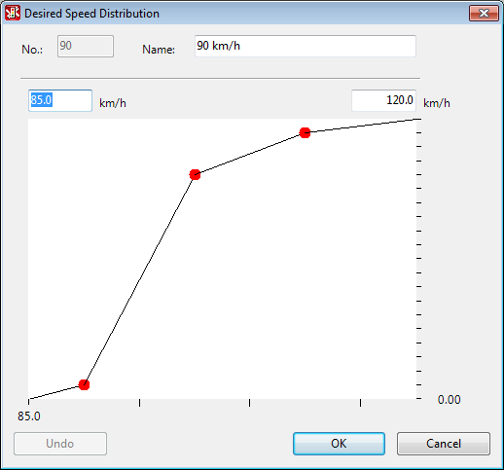

Figure 5-25 Desired speed distribution for car

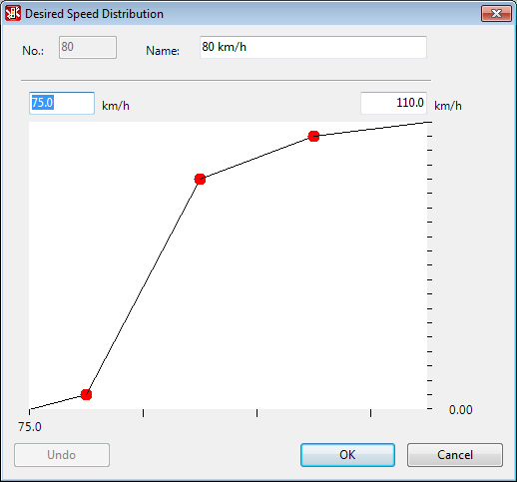

Figure 5-26 Desired speed distribution for truck

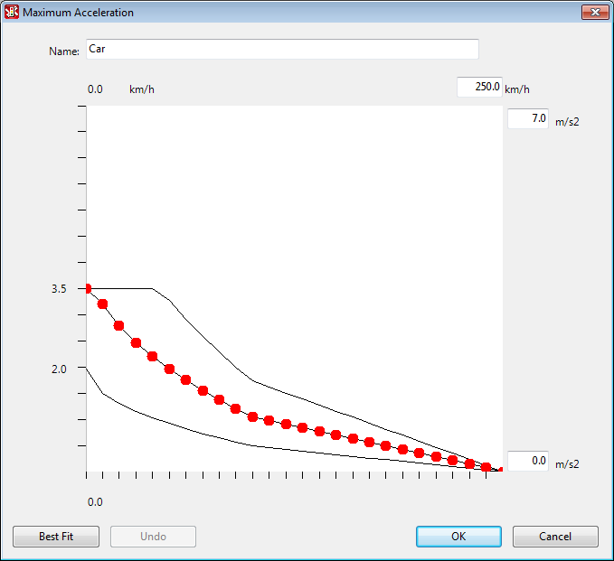

Figure 5-27 Maximum acceleration distribution for car

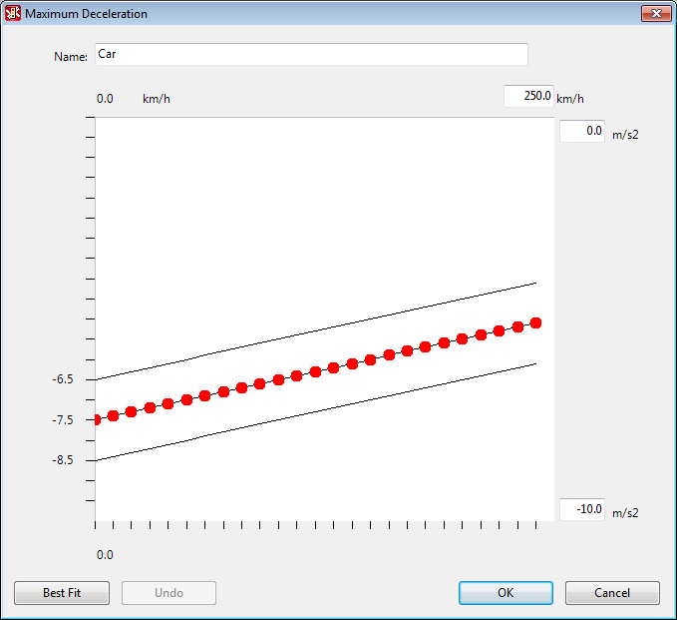

Figure 5-28 Maximum deceleration distribution for car

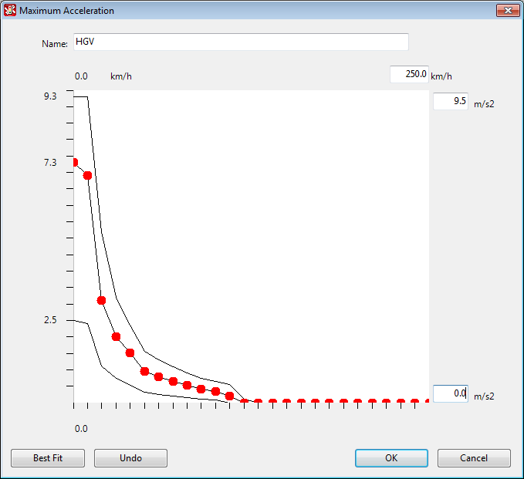

Figure 5-29 Maximum acceleration distribution for truck

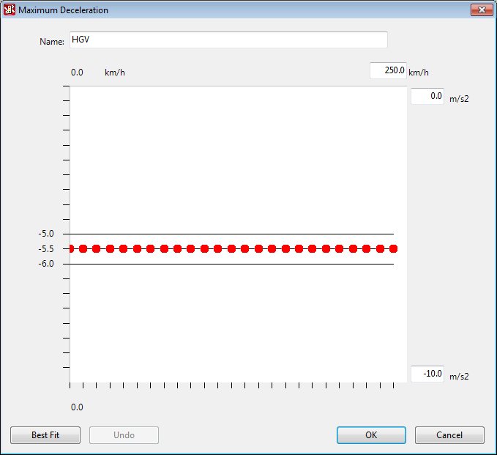

Figure 5-30 Maximum deceleration distribution for truck

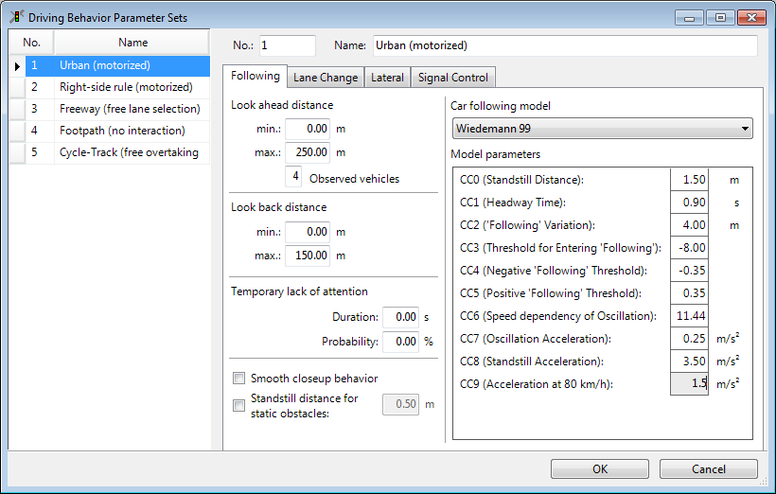

Figure 5-31 Driving behavior parameter sets

## 5.2 OPTIMIZATION-BASED RAMP CONTROL

### 5.2.1 Experimental Design

This subsection describes the experimental design of the optimization-based merge in VISSIM. All vehicles are assumed to be equipped with V2I technology and are controlled automatically when they enter the ramp area.

The model used in this study is similar to the one shown in Figure 4-1. As shown in Figure 5-9, the main difference is that only one lane is considered for the highway. The network is divided into four zones, and this study assumes that all necessary lane changes (by courteous drivers) for vehicles on highway are completed in Zone B-3. Upon entering Zone B-2, all vehicles are in autonomous driving mode until they leave Zone B-1. Zone B-3 is more than 500m upstream from the merging point; Zone B-2 is between 500m to 250m upstream from the merging point and Zone B-1 is within 250m upstream from the merging point. The detailed information of both highway and ramp vehicles in Zone B-2 is used as the input to the optimization model. With this zone definition and the speed limit setting, vehicles with the maximum speed will not be able to pass the merging point at the end of the 10-second optimization interval. As discussed before, the accelerations of these vehicles for the next *m* time steps are decision variables; the objective is to maximize the summation of all vehicles’ speeds in the next *m* time steps; and safety constraints are added to ensure that vehicles (on both highway and ramp) pass by the merging point (i.e., end of Zone B-1) with space headways greater than a pre-specified value. At the end of the *mth* interval, all vehicles’ accelerations are set to some values that can allow them to maintain the distances to their lead vehicles.

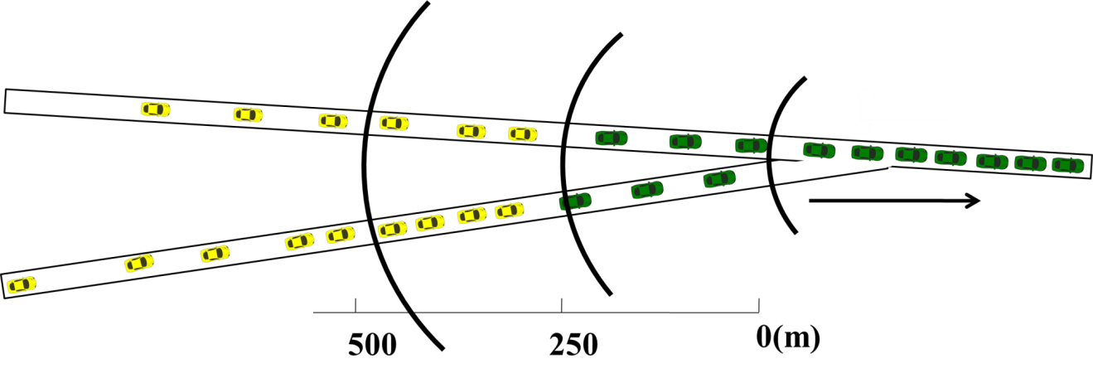

Zone B-3

Zone B-2

Zone B-1

Zone B-0

Figure 5-32 Simplified optimization-based merging model

The proposed model implemented utilizing VISSIM and its Car2X module is used in this section. Two other cases, a benchmark case and a reducing speed strategy, are chosen for comparison. Those three cases are described in detail as follows:

* Case B-0: Similar to Case 0 described in subsection 5.1.1, Case B-0 is introduced as a benchmark. It does not consider any communication between vehicles and simply rely on human drivers to control the vehicles.
* Case B-1: If the speed of any vehicle in Zone B-0 is less than 45km/h, upstream highway vehicles will be asked to reduce their speeds to 50km/h when they are in Zone B-1 and 70km/h when they are in Zone B-2 to avoid aggravating the traffic jam in Zone 0.
* Case B-2: Vehicles’ information will be collected every ten seconds if they are in Zone B-2. The information is sent to MATLAB for optimization and the optimized accelerations for each vehicle in the following ten time steps will be sent back to related vehicles. Vehicles will precisely execute these commands.

### 5.2.2 Parameter Selection

There are 10 different parameters in Wiedemann 99 model that can be modified by users. Standstill distance (CC0), Headway time (CC1), ‘Following’ variation (CC2), Threshold for entering ‘Following’ (CC3), Following’ thresholds (CC4/CC5), Speed dependency of oscillation (CC6), Oscillation acceleration (CC7), Standstill acceleration (CC8), and Acceleration at 80km/h (CC9). The safety distance (*dx_safe*) is defined as *dx_safe* = CC0 + CC1•*v*, where *v* is the current speed. CC2 is the safety distance oscillation, thus the real safety distance is between *dx_safe* and *dx_safe* + CC2. CC3 is used to determine the start time of deceleration process. CC4 and CC5 are speed difference between leading vehicle and following vehicle, while CC4 restricts the negative difference and CC5 restricts positive difference. CC6 is used for speed dependency. A value of 0 means a vehicle’s speed oscillation is independent of its distance to the leading vehicle. CC7 is the oscillation acceleration that vehicles use to reach the desired speed. CC8 is the desired acceleration when a vehicle starts to move. CC9 is the desired acceleration for vehicles traveling at 80km/h.

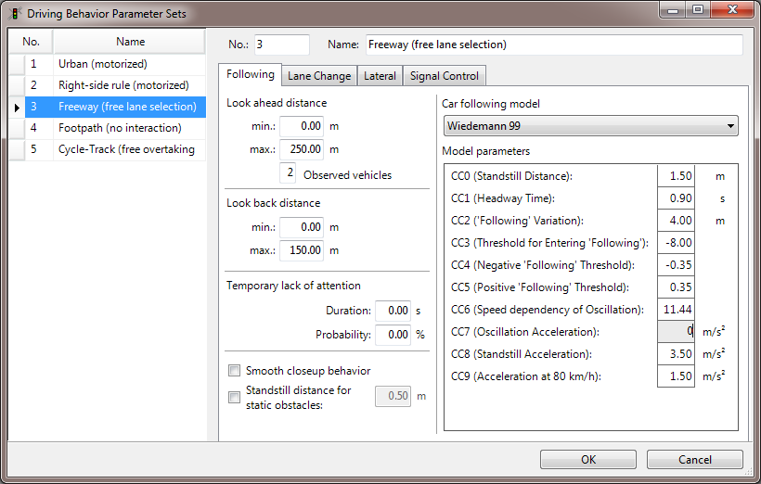

Figure 5-33 Driving behavior parameters in VISSIM

In this section, a safety distance of 15m is required for all vehicles in the optimization process. In order to precisely control accelerations during simulation, the oscillation acceleration is set to 0m/s2. The standstill acceleration is set to 2m/s2 to ensure consistency with the maximum acceleration difference constraint implemented in our proposed model. The detailed parameter setting used in this study is shown in Figure 5-10.

To determine suitable traffic inputs for highway and ramp, a series of vehicle inputs is tested using the traffic network in Figure 5-9 in VISSIM with ten different random seeds from 10 to 19. The desired speed for all autonomous vehicles is 90km/h and the speed distribution is shown in Figure 5-11. The average traffic speeds for the highway under different traffic inputs are collected and plotted in Figure 5-12.

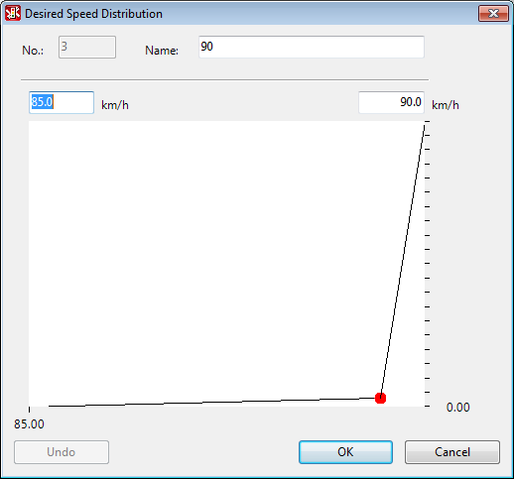

Figure 5-34 Desired speed distribution for car used in optimization model



Figure 5-35 Average speeds for different vehicle inputs

The vehicle input for highway varies from 1200veh/h to 1900veh/h, and the vehicle input for ramp is set to zero for all scenarios in Figure 5-12. Thus the average speeds in Figure 5-12 are only affected by the traffic conditions and not by the merging process. From Figure 5-12, it can be seen that the average speed decreases with the increase of vehicle input. The detailed average speeds for each case are listed in Table 5-1.

Table 5-36 Average speeds for different highway vehicle inputs

|  |  |  |
| --- | --- | --- |
| **Highway input**  **(Veh/h)** | **Ramp input**  **(Veh/h)** | **Average speed**  **(km/h)** |
| 1200 | 0 | 89.5878 |
| 1300 | 0 | 81.5857 |
| 1400 | 0 | 78.1186 |
| 1500 | 0 | 67.6437 |
| 1600 | 0 | 71.6997 |
| 1700 | 0 | 38.0828 |
| 1800 | 0 | 28.5907 |
| 1900 | 0 | 6.4638 |

It can be seen that at the traffic input of 1200veh/h, vehicles run freely and the average speed is close to the speed limit. When the traffic input is 1900veh/h, the freeway is highly congested. Thus, three levels of traffic demand are considered for the highway, which are 800veh/h, 1000veh/h, and 1200veh/h. Similarly, the on-ramp traffic flow rate is assumed to be 300veh/h, 500veh/h, and 700veh/h. Heavy vehicle is not considered for both on-ramp and highway for this network to simplify the optimization process. In total, there are 9 different combinations of traffic demand. The desired speed for cars is 90km/h and the maximum acceleration and deceleration for cars are both set to 5m/s2. For this network, each simulation run represents 3600-second of ramp operations in the real world and takes about 4 minutes on a regular i-7 desktop computer with 8 GB memory.

### 5.2.3 VISSIM Simulation Output

Similar to the empirical study in Section 5.1, three types of MOEs are considered, which are average delay time, average speed, and traffic throughput. Again, each simulation run is for 3600 seconds of ramp operations in the real world. The simulation resolution is set to 1 time step per simulation second using the maximum simulation speed. Each case is simulated ten times by using 10 different random seeds, which are 2, 6, 7, 8, 14, 16, 19, 20, 21, and 22. Those random seeds ensure that the generated vehicles have a headway greater than 15 meters when they enter Zone B-2. The average MOEs for the ten simulations are collected for further analysis in Chapter 6.

# CHAPTER 6: RESULTS AND CONCLUSION

In this chapter, the VISSIM simulation results from the empirical study and the optimization-based ramp control study are summarized and discussed. Section 6.1 presents the results from the empirical study. The results of the optimization-based ramp control model are discussed in Section 6.2.

## 6.1 RESULT OF CVTECH-BASED RAMP CONTROL

In this secction, the five ramp control strategies are compared based on VISSIM simulation under various traffic demand scenarios, covering both heavily congested and light traffic conditions. In addition, the control performances under different CVTech penetration rates are evaluated. In subsections 6.1.1 through 6.1.3, the simulation results assuming 100% CVTech penetration rate are described and compared. The results considering different CVTech penetration rates are discussed in subsection 6.1.4.

### 6.1.1 Average Delay Time Analysis

Figure 6-1 shows the average delay time results grouped by on-ramp traffic flow. Specifically, Figure 6-1 (a) shows the average delay time results for all three scenarios (i.e., highway traffic being 4000veh/h, 4500veh/h, and 5000veh/h) with the on-ramp traffic flow being 500veh/h. Figures 6-1 (b) and (c) are for scenarios with the on-ramp traffic being 1000veh/h and 1500veh/h, respectively. As the results in Figures 6-1 (a) and (b) suggest, when the on-ramp traffic flow is low, there is no significant difference

among the five control cases in terms of average delay time. As shown in Figure 6-1 (c), Case 2 (8.80s/veh) and Case 3 (8.78s/veh) (see definitions of different cases in Section 5.1.1.) have significantly smaller average delay times for high on-ramp traffic flow (i.e., 1500veh/h). However, under the same circumstance Cases 1 and 4 perform even worse than Case 0. Since both Cases 1 and 4 advise highway vehicles to reduce their speeds, this seems to suggest that speed-reduction strategies are less effective than lane-change strategies (i.e., Cases 2 and 3).

|  |  |
| --- | --- |
|  |  |
| (a) Low on-ramp vehicle inputs | (b) Medium on-ramp vehicle inputs |
|  |  |
| (c) High on-ramp vehicle inputs |  |
|  |  |

Figure 6-37 Average delay time comparison with different on-ramp traffic inputs

### 6.1.2 Average Speed Analysis

|  |  |
| --- | --- |
| (a) Low on-ramp vehicle inputs | (b) Medium on-ramp vehicle inputs |
|  |  |
|  |  |
| (c) High on-ramp vehicle inputs |  |
|  |  |

Figure 6-38 Average speed comparison with different on-ramp traffic inputs

Similar to Figure 6-1, Figure 6-2 shows the average speed results grouped by on-ramp traffic flow. For low to medium on-ramp traffic flow rates, the five control strategies perform approximately the same irrespective of the highway traffic conditions. When the on-ramp traffic flow is 1500veh/h, the average speed drops significantly except for Cases 2 and 3. Again, Cases 1 and 4 underperform Case 0. For Cases2 and 3, the average speeds are both 89.6km/h, while for Cases 1 and 4, the average speeds are 72.5km/h and 72.2 km/h, respectively.

### 6.1.3 Traffic Throughput Analysis

|  |  |
| --- | --- |
| (a) Low on-ramp vehicle inputs | (b) Medium on-ramp vehicle inputs |
|  |  |
| (c) High on-ramp vehicle inputs |  |

Figure 6-39 Traffic throughput comparison with different on-ramp traffic inputs

Throughput is another important MOE to characterize highway ramp operations. As shown in Figure 6-3, Cases 2 and 3 perform much better than the remaining control strategies. In the worst scenario, after 3600 seconds of simulation Case 0 has 310 vehicles left inside in the network and 239 vehicles have not been loaded onto the ramp due to congestion (i.e., the queue spills back to the beginning of the on-ramp). The situation gets much better for the remaining four cases considering CVTech. For them, there is no queue spillback and all vehicles have been loaded onto the network. For both Cases 2 and 3, only 238 vehicles (compared to 310 + 239 vehicles in Case 0) are left inside the network when the simulation ends at 3600 seconds.

### 6.1.4 Penetration Rate Analysis

|  |  |
| --- | --- |
| (a) Low on-ramp vehicle inputs | (b) Medium on-ramp vehicle inputs |
|  |  |
| (c) High on-ramp vehicle inputs |  |

Figure 6-40 Average delay time comparison with different penetration ratios

Among the five ramp control strategies investigated, Case 3 appears to be the best based on the above analysis. Thus, Case 3 is selected to further investigate the impact of CVTech penetration rates. As shown in Figure 6-4, the average delay time for Case 3 becomes smaller when the penetration rate increases. This trend is more obvious when the on-ramp traffic flow is 1500veh/h as shown in Figure 6-4 (c). It can be seen that when the highway traffic flow is 5000veh/h, the average delay time is 30.22, 25.17, 11.47, 9.49, and 8.78seconds when the penetration rate is 20%, 40%, 60%, 80%, and 100%, respectively.

|  |  |
| --- | --- |
|  |  |
| (a) Low on-ramp vehicle inputs | (b) Medium on-ramp vehicle inputs |
|  |  |
|  |  |
| (c) High on-ramp vehicle inputs |  |

Figure 6-41 Average speed comparison with different penetration ratios

The data in Figure 6-5 also shows a consistent trend, showing that the average speed becomes larger for higher CVTech penetration rates. For ramp traffic to be 1500veh/h, it is found that when the penetration rate is greater than 60%, the resultant average speeds are very close to each other; if the penetration rate is reduced to be less than or equal to 40%, there will be a significant drop in average speed.

|  |  |
| --- | --- |
| (a) Low on-ramp vehicle inputs | (b) Medium on-ramp vehicle inputs |
|  |  |
| (c) High on-ramp vehicle inputs |  |
|  |  |

Figure 6-42 Traffic throughput comparison with different penetration ratios

The throughput results in Figure 6-6 also follow this trend. Such a phenomenon is interesting and deserves further investigations. This suggests that there may exist a cost-effective penetration rate, which allows Case 3 and other CVTech based control strategies to perform as effectively as when the penetration rate is 100%.

## 6.2 OPTIMIZATION-BASED RAMP CONTROL RESULTS

In this section, the VISSIM simulation results of three cases with nine different traffic demand combinations are summarized and discussed to evaluate the proposed optimization model.

### 6.2.1 Simulations and Observations

This subsection provides the detailed outputs of a ramp control case to validate the the correctness of the developed simulaton platform. In this case, the highway and ramp vehicle inputs are set to 1000veh/h and 500veh/h, respectively. A random seed of 19 is used to run the simulation. The VISSIM simulation data between 30s to 40s is recorded and compared with the vehicle trajectories generated directly by the optimal control algorithm coded in MATLAB.

At 30s, there are seven vehicles in Zone B-2. Three of them, Veh-H-12, Veh-H-13, and Veh-H-14 are on the highway and the other four vehicles, Veh-R-15, Veh-R-16, Veh-R-17, and Veh-R-18, are on the ramp. These vehicles’ distances to the merging point, speeds, and accelerations versus time are plotted in Figures 6-7, 6-8 and 6-9, respectively. In these figures, vehicles on the highway are represented using dotted lines and vehicles on the ramp are plotted as solid lines. From Figures 6-8 and 6-9, it is apparent that these vehicles meet all the speed and acceleration constraints.

Figure 6-43 VISSIM simulation result (Distance to merging point vs. Time)

Figure 6-44 VISSIM simulation result (Speed vs. Time)

Figure 6-45 VISSIM simulation result (Acceleration vs. Time)

To have a clearly understanding of the merging process, detailed data for time-varying distances to the merging point is summarized in Table 6-1. The minimum following distances between vehicles in the same lane and the minimum mutual exclusive distances between vehicles from different lanes are calculated and shown in Table 6-2.

Table 6-46 Recorded distances to merging point

|  |  |  |  |  |  |  |  |
| --- | --- | --- | --- | --- | --- | --- | --- |
| **Time (s)** | **Distance to merging point (m)** | | | | | | |
| **Veh-H-12** | **Veh-H-13** | **Veh-H-14** | **Veh-R-15** | **Veh-R-16** | **Veh-R-17** | **Veh-R-18** |
| **30** | 287.46 | 383.36 | 407.10 | 403.01 | 426.66 | 453.20 | 489.77 |
| **31** | 262.57 | 358.48 | 382.15 | 378.10 | 401.73 | 429.57 | 464.86 |
| **32** | 237.57 | 333.48 | 357.58 | 353.10 | 376.73 | 404.57 | 439.86 |
| **33** | 212.57 | 308.48 | 333.30 | 328.10 | 351.73 | 379.57 | 414.86 |
| **34** | 187.57 | 283.48 | 309.19 | 303.10 | 326.73 | 354.57 | 389.86 |
| **35** | 162.57 | 258.48 | 285.18 | 278.10 | 301.73 | 329.57 | 364.86 |
| **36** | 137.57 | 233.48 | 261.17 | 253.10 | 276.73 | 304.57 | 339.86 |
| **37** | 112.57 | 208.48 | 237.05 | 228.10 | 251.73 | 279.57 | 314.86 |
| **38** | 87.57 | 183.48 | 212.73 | 203.10 | 226.73 | 254.57 | 289.86 |
| **39** | 62.57 | 158.48 | 188.12 | 178.10 | 201.73 | 229.57 | 264.86 |
| **40** | 37.57 | 133.48 | 163.12 | 153.10 | 176.73 | 204.57 | 239.86 |

Table 6-47 Minimum distance between vehicles

|  |  |  |
| --- | --- | --- |
| **Time**  **(s)** | **Minimum following distance(m)** | **Minimum mutual**  **exclusive distance(m)** |
| **30** | 23.75 | 4.09 |
| **31** | 23.68 | 4.05 |
| **32** | 24.11 | 4.48 |
| **33** | 24.82 | 5.20 |
| **34** | 25.72 | 6.09 |
| **35** | 26.70 | 7.08 |
| **36** | 27.69 | 8.07 |
| **37** | 28.57 | 8.95 |
| **38** | 29.25 | 9.63 |
| **39** | 29.64 | 10.02 |
| **40** | 29.64 | 10.02 |

Table 6-48 Recorded acceleration obtained from VISSIM

|  |  |  |  |  |  |  |  |
| --- | --- | --- | --- | --- | --- | --- | --- |
| **Time (s)** | **Veh-H-12** | **Veh-H-13** | **Veh-H-14** | **Veh-R-15** | **Veh-R-16** | **Veh-R-17** | **Veh-R-18** |
| **30** | - | - | - | - | - | - | - |
| **31** | 0 | 0 | 0 | 0 | 0 | 0 | 0 |
| **32** | 0.1054 | 0.1223 | -0.3782 | 0.0914 | 0.0701 | 1.3757 | 0.0917 |
| **33** | 0 | 0 | -0.2823 | 0 | 0 | 0 | 0 |
| **34** | 0 | 0 | -0.1862 | 0 | 0 | 0 | 0 |
| **35** | 0 | 0 | -0.0903 | 0 | 0 | 0 | 0 |
| **36** | 0 | 0 | 0.0057 | 0 | 0 | 0 | 0 |
| **37** | 0 | 0 | 0.1018 | 0 | 0 | 0 | 0 |
| **38** | 0 | 0 | 0.1977 | 0 | 0 | 0 | 0 |
| **39** | 0 | 0 | 0.2937 | 0 | 0 | 0 | 0 |
| **40** | 0 | 0 | 0.3897 | 0 | 0 | 0 | 0 |

Table 6-49 Suggested acceleration obtained from MATLAB

|  |  |  |  |  |  |  |  |
| --- | --- | --- | --- | --- | --- | --- | --- |
| **Time(s)** | **Veh-H-12** | **Veh-H-13** | **Veh-H-14** | **Veh-R-15** | **Veh-R-16** | **Veh-R-17** | **Veh-R-18** |
| **30** | - | - | - | - | - | - | - |
| **31** | 0.1053 | 0.1223 | -0.3782 | 0.0913 | 0.0700 | 1.3756 | 0.0917 |
| **32** | -4.4E-35 | 0 | -0.2822 | -1.6E-18 | 0 | -2.9E-17 | 0 |
| **33** | 0 | 0 | -0.1862 | -6E-18 | -9.9E-32 | 4.2E-18 | 2.3E-18 |
| **34** | 0 | 0 | -0.0902 | -2.8E-18 | 9.8E-32 | 8.0E-17 | 1.1E-19 |
| **35** | -4.1E-32 | -4.1E-32 | 0.0057 | -1E-17 | -8.4E-18 | 1.0E-16 | 5.8E-18 |
| **36** | 9.8E-32 | 0 | 0.1017 | -8.5E-18 | -7.9E-18 | -8.3E-17 | 4.8E-18 |
| **37** | 0 | 0 | 0.1977 | 8.1E-19 | 8.5E-18 | 3.0E-17 | -8.2E-33 |
| **38** | -3.9E-31 | 0 | 0.2937 | -6.8E-17 | 1.0E-18 | -1.2E-17 | -5.5E-17 |
| **39** | 4.9E-32 | -3.9E-31 | 0.3897 | 6.2E-17 | -7.3E-18 | 6.3E-17 | 1.0E-16 |
| **40** | 0 | 0 | 0 | 1.3E-35 | 0 | 0 | 0 |

From Table 6-2, it is obvious that all vehicles abide strictly by the safety distance rule/constraint. At 30s, the minimum mutual exclusive distance is between veh-H-14 and veh-R-15 and is 4.09m, which means at least one of them should change its driving pattern to avoid collision at the merging point. As a result of the optimal control, the minimum mutual exclusive distance changes gradually as time goes by. It reaches 10.02m at the end of the optimization process, which is larger than a pre-specified safety distance of 10m.

Table 6-3 shows the accelerations recorded during the simulation. The acceleration values in each time interval are recorded at the end (i.e., the acceleration of 0.1054 for veh-H-12 at 32s means the acceleration from 31s to 32s is 0.1054m/s2). Table 6-4 shows the suggested accelerations calculated by the MATLAB code. The suggested accelerations are given at the start of each time step (i.e., the acceleration of 0.1053 for veh-H-12 at 31s means the suggested acceleration from 31s to 32s is 0.1053 m/s2).

By comparing Tables 6-3 and 6-4, it is shown that VISSIM strictly follows the suggested accelerations in every time step. The maximum difference between the suggested and executed accelerations is 0.0001 at 32s for veh-H-14. Such a minor difference is acceptable and does not affect the accuracy of the optimization control model implementation.

### 6.2.2 Average Delay Time

The average delay time results, grouped by on-ramp traffic flow, are shown in Figure 6-10 and Table 6-5. Figure 6-10 (a) shows the average delay time results for all three scenarios (i.e., highway traffic being 800veh/h, 1000veh/h, and 1200veh/h) with the on-ramp traffic flow of 300veh/h. Figures 6-10 (b) and (c) are for scenarios with the on-ramp traffic input of 500veh/h and 800veh/h, respectively.

|  |  |
| --- | --- |
| (a) Low on-ramp vehicle inputs | (b) Medium on-ramp vehicle inputs |
|  |  |
| (c) High on-ramp vehicle inputs |  |
|  |  |

Figure 6-50 Average delay time comparison

As indicated in Figure 6-10 (a), the on-ramp traffic is 300veh/h. When highway and on-ramp traffic flows are both low (800veh/h for highway and 300veh/h for ramp), there is no apparent difference among three cases (See section 5.2.1 for case definitions) in terms of average delay time. With the increase of highway traffic input, Case B-0 significantly outperforms Case B-1. This suggests that reducing the highway traffic speed is unnecessary for light ramp traffic. The results in Figure 6-10(b) (ramp traffic = 500 veh/h) indicate that Case B-1 performs significantly better than Case B-0 for almost all scenarios except when the highway traffic flow is 1,200 veh/h. This is probably because when the highway traffic is low to medium, it is possible to create additional safe gaps for merging ramp vehicles by reducing the speeds of highway vehicles. However, it is impossible to do so when the highway traffic is heavy. The results in Figure 6-10 (c) show the same trend as in Figure 6-10 (b). For all traffic flow scenarios considered in this study, Case B-2 performs the best and its delay time is almost negligible.

Table 6-51 Simulation results showing the average delay time for all vehicles

|  |  |  |  |  |
| --- | --- | --- | --- | --- |
| **Ramp input=300**  **veh/h** | **Highway input**  **(veh/h)** | **Delay time(s)** | | |
| **Case B-0** | **Case B-1** | **Case B-2** |
| 800 | 2.5 | 2.9 | 0.0 |
| 1000 | 4.4 | 5.7 | 0.0 |
| 1200 | 13.5 | 24.2 | 0.0 |
| **Ramp input=500**  **veh/h** | **Highway input**  **(veh/h)** | **Delay time(s)** | | |
| **Case B-0** | **Case B-1** | **Case B-2** |
| 800 | 11.2 | 6.7 | 0.0 |
| 1000 | 62.9 | 28.5 | 0.0 |
| 1200 | 167.1 | 187.90 | 0.0 |
| **Ramp input=700**  **veh/h** | **Highway input**  **(veh/h)** | **Delay time(s)** | | |
| **Case B-0** | **Case B-1** | **Case B-2** |
| 800 | 103.2 | 53.5 | 0.0 |
| 1000 | 210.7 | 185.5 | 0.0 |
| 1200 | 234.8 | 261.6 | 0.1 |

### 6.2.3 Average Speed

|  |  |
| --- | --- |
| (a) Low on-ramp vehicle inputs | (b) Medium on-ramp vehicle inputs |
|  |  |
| (c) High on-ramp vehicle inputs |  |
|  |  |

Figure 6-52 Average speed comparison

Figure 6-11 and Table 6-6 show the average speed results grouped by on-ramp traffic flow. The average speed has an opposite trend as shown in the average delay time results. For low highway and on-ramp traffic, the average speeds for all three cases are close to each other. The average speeds for Cases B-0 and B-1 decrease significantly when either the highway or the ramp traffic increases to the medium or high level.

For all traffic scenarios considered, Case B-2 performs very well and its average speeds are barely affected by the varying traffic flows. On the contrary, the average speeds of both Cases B-0 and B-1 are significantly reduced by the heavy traffic flows of both ramp and highway. For high ramp and low highway flows, Case B-1 significantly outperforms Case B-0. In this case, reducing the speeds of highway vehicles can help to create additional safe gaps for ramp vehicles to merge onto the highway. The overall network average speed thus is increased. However, for low ramp (300 veh/h) or heavy highway (1,200 veh/h) traffic flows, Case B-0 consistently performs better than Case B-1. This suggests that the gradual speed limit strategy should take into consideration both ramp and highway traffic conditions.

Table 6-53 Simulation results showing the average speed of all vehicles

|  |  |  |  |  |
| --- | --- | --- | --- | --- |
| **Ramp input=300**  **veh/h** | **Highway input**  **(veh/h)** | **Speed(km/h)** | | |
| **Case B-0** | **Case B-1** | **Case B-2** |
| 800 | 84.8 | 84.1 | 89.4 |
| 1000 | 81.6 | 79.5 | 89.4 |
| 1200 | 69.3 | 61.3 | 89.4 |
| **Ramp input=500**  **veh/h** | **Highway input**  **(veh/h)** | **Speed(km/h)** | | |
| **Case B-0** | **Case B-1** | **Case B-2** |
| 800 | 72.4 | 76.1 | 89.4 |
| 1000 | 39.0 | 52.8 | 89.4 |
| 1200 | 19.1 | 17.4 | 89.4 |
| **Ramp input=700**  **veh/h** | **Highway input**  **(veh/h)** | **Speed(km/h)** | | |
| **Case B-0** | **Case B-1** | **Case B-2** |
| 800 | 27.8 | 42.4 | 89.4 |
| 1000 | 15.6 | 17.4 | 89.4 |
| 1200 | 14.2 | 12.9 | 89.1 |

### 6.2.4 Traffic Throughput

As shown in Figure 6-12 and Table 6-7, Cases B-2 performs very well for all traffic input combinations studied, and it is much better than the other two control strategies. The traffic throughput results are consistent with the average delay time and average speed results. When the ramp traffic flow is low (300 veh/h), there is no major difference among the three cases. As the ramp or highway traffic flow increases, the differences among the three cases become more significant. In general, Case B-2 performs the best and it allows all vehicles to clear the network for all scenarios. Case B-1 performs better than Case B-0 when the ramp traffic is heavy and the highway traffic flow is low. Again, Case B-0 outperforms Case B-1 when the highway traffic flow is high and the ramp flow is low.

Table 6-54 Simulation results showing the throughput

|  |  |  |  |  |
| --- | --- | --- | --- | --- |
| **Ramp input=300**  **veh/h** | **Highway input**  **(veh/h)** | **Throughput(veh/h)** | | |
| **Case B-0** | **Case B-1** | **Case B-2** |
| 800 | 1085 | 1085 | 1085 |
| 1000 | 1282 | 1282 | 1283 |
| 1200 | 1479 | 1473 | 1481 |
| **Ramp input=500**  **veh/h** | **Highway input**  **(veh/h)** | **Throughput(veh/h)** | | |
| **Case B-0** | **Case B-1** | **Case B-2** |
| 800 | 1280 | 1281 | 1282 |
| 1000 | 1437 | 1466 | 1480 |
| 1200 | 1528 | 1493 | 1678 |
| **Ramp input=700**  **veh/h** | **Highway input**  **(veh/h)** | **Throughput(veh/h)** | | |
| **Case B-0** | **Case B-1** | **Case B-2** |
| 800 | 1404 | 1463 | 1480 |
| 1000 | 1444 | 1488 | 1679 |
| 1200 | 1534 | 1486 | 1877 |

|  |  |
| --- | --- |
| (a) Low on-ramp vehicle inputs | (b) Medium on-ramp vehicle inputs |
|  |  |
| (c)High on-ramp vehicle inputs |  |
|  |  |

Figure 6-55 Throughput comparison

## 6.3 CONCLUSIONS

This chapter presents and discusses the results of two studies. The first empirical study evaluates four traffic control strategies based on the connected vehicle technology (CVTech) to improve highway operations around on-ramp merging areas, including dynamic speed limit, gradual speed limit, and collaborative lane change. These control strategies are compared with a base case that does not consider any V2I or V2V communications. VISSIM simulations are used to compare the five control cases based on a simple highway on-ramp under various traffic flow conditions and CVTech penetration rates. The Car2X module in VISSIM is used to model the communications among highway and on-ramp vehicles. It is found that the two collaborative lane change strategies are more effective than the base case and the dynamic and gradual speed limit control methods in terms of average delay time, average speed, and throughput. The dynamic and gradual speed limit control methods even underperform the base case, which is a little surprising. A possible explanation is that lowering the speed limit alone does not necessarily create more acceptable gaps for the ramp traffic. Another reason may be that for some vehicles traveling in that lane, if they maintain their speeds until the merging point, their trajectories may not conflict with any vehicles from the ramp. However, the dynamic and gradual speed limit methods require them to slow down, which negatively affects the three MOEs considered in this research.

Both collaborative lane change strategies performed equivalently well. The only difference between them is that in Case 2, vehicles in Lane 1 are advised to change to Lane 2 only, while in Case 3, vehicles are advised to change to both Lanes 2 and 3. This probably explains why the performance difference between these two cases is negligible. The advantages brought by Cases 2 and 3 become more significant as both the ramp and highway get congested, suggesting that the CVTech-based ramp control methods better suit saturated and oversaturated traffic conditions. Another interesting finding is that Case 3 performs approximately equally well when the CVTech penetration rate is 60%, 80%, and 100%. It would be interesting to conduct future studies to find the most cost-effective CVTech penetration rates.

The second study evaluates the proposed optimization-based ramp control model. An example is provided in Section 6.2.1 to prove the correctness of the proposed model and the developed VISSIM simulation platform. Following this example, nine combinations of traffic inputs covering different traffic conditions are used to evaluate the performance of proposed optimization-based control model based on average delay time, average speed, and traffic throughput.  In all the scenarios considered in this study, the proposed model performs the best in terms of all three MOEs. The improvements of the proposed model are very significant, except when both the ramp and highway traffic inputs are low.

# CHAPTER 7: FUTRUE WORK

This thesis proposes an optimal ramp control algorithm and an integrated framework for highway on-ramp control. The proposed algorithm and the modeling framework are evaluated extensively under various traffic conditions. Although the results are very promising, this research by no means is perfect. For future research, the following areas can be further explored or improved:

1. The optimal control model can be further extended to consider lane changes in the merging zone. Vehicles in the right-most lane of a highway might change to other lanes to avoid potential conflicts with vehicles from the on-ramp.
2. Vehicles on the highway should have a higher priority than vehicles from the on-ramp, in order to maintain a safe and smooth flow on the highway. How to set the priority is an interesting topic and should be carefully examined.
3. Geometric characteristics of roadways have a significant impact on the merging process in ramp areas. For example, lane width and curves may potentially affect the speeds of vehicles. Besides, acceleration lanes are commonly seen on highways. With acceleration lanes, ramp vehicles can choose to merge onto the highway at multiple points. These factors can be taken into account in the model in future studies.

# REFERENCES

|  |  |
| --- | --- |
| [1] | National Safety Council, "NSC," 2014. [Online]. Available: http://www.nsc.org/Pages/National-Safety-Council-Estimates-Traffic-Deaths-Down-Three-Percent-in-2013-.aspx. [Accessed 11 June 2014]. |
| [2] | EUROPA, "Road safety," 2010. [Online]. Available: http://europa.eu/legislation_summaries/internal_market/single_market_for_goods/motor_vehicles/technical_implications_road_safety/l24257_en.htm. [Accessed 11 June 2014]. |
| [3] | H. Lunenfeld, G. J. Alexander and T. J. Post, A users' guide to positive guidance, Washington, D.C.: U.S. Federal Highway Administration, Office of Traffic Operations, 1981. |
| [4] | Google, "Official blog," Google, [Online]. Available: http://googleblog.blogspot.com/2014/05/just-press-go-designing-self-driving.html. [Accessed June 2014]. |
| [5] | Networkworld, [Online]. Available: http://www.networkworld.com/article/2170054/data-center/elon-musk--tesla-s-driverless-car-will-be-street-ready-in-three-years.html. [Accessed June 2014]. |
| [6] | PTV, *PTV VISSIM 5.40 Users Manual,* 2012. |
| [7] | VISSIM, "VISSIM 5.40-00 - Car2X Interface Manual," PTV, Karlsruhe, 2012. |
| [8] | MathWorks, "Optimization Toolbox," MathWorks, [Online]. Available: http://www.mathworks.com/products/optimization/?s_cid=sol_des_sub2_relprod1_optimization_toolbox. [Accessed 01 June 2014]. |
| [9] | D. Bushnell, "A merging control system for the urban freeway," *IEEE Transactions on Vehicular Technology,* Vols. VT-19, no. 1, pp. 107-120, 2 1970. |
| [10] | PROMETHEUS, "PROMETHEUS," EUREKA, 1987. [Online]. Available: http://www.eurekanetwork.org/project/-/id/45. [Accessed 01 June 2014]. |
| [11] | D. R. Drew, Traffic flow theory and control, New York: McGraw-Hill, 1968. |
| [12] | H. Kallberg, *Traffic simulation,* Espoo: Helsinki University of Technology, 1971. |
| [13] | Aimsun, "Aimsun overview," Aimsun, 2005. [Online]. Available: http://www.aimsun.com/aimsun_overview_hccmeeting.pdf. [Accessed June 2014]. |
| [14] | Oregon Department of Transportation, "Protocol for VISSIM Simulation," 2011. |
| [15] | P. Hidas, "Modelling vehicle interactions in microscopic simulation of merging and weaving," *Transportation Research Part C,* vol. 13, no. 1, pp. 37-62, 2005. |
| [16] | J. Wang, R. Liu and F. Montgomery, "A simulation model of motorway merging behaviour," in *16th International Symposium on Transportation and Traffic Theory*, College Park, 2005. |
| [17] | J. Al-Obaedi and S. Yousif, "Microsimulation Model for Motorway Merges With Ramp-Metering Controls," *IEEE Transactions on Intelligent Transportation Systems,* vol. 13, no. 1, pp. 296 - 306, 2012. |
| [18] | D. Zhao, X. Bai, F. Wang, J. Xu and W. Yu, "DHP Method for Ramp Metering of Freeway Traffic," *Intelligent Transportation Systems, IEEE Transactions on,* vol. 12, no. 4, pp. 990-999, 2011. |
| [19] | O. S. a. P. Muhlethaler, "Study on Merging Control Supported by IEEE 802.11p Systems for Highway Environments," in *Wireless Days (WD), 2013 IFIP*, Valencia, 2013. |
| [20] | Fleetnet, "Fleetnet," fleetnet, 2003. [Online]. Available: http://www.ibr.cs.tu-bs.de/projects/fleetnet/. [Accessed 01 June 2014]. |
| [21] | L. Long, A. Festag, R. Baldessari and W. Zhang, "Car-2-X Communication in Europe," in *Vehicular Networks: From Theory to Practice*, Chapman and Hall/CRC, 2009, pp. 4-5. |
| [22] | Cvis, "Cvis," ERTICO, 2010. [Online]. Available: http://www.cvisproject.org/. [Accessed 01 June 2014]. |
| [23] | Safespot, "Safespot," University of Stuttgart, 2010. [Online]. Available: http://www.safespot-eu.org/. [Accessed 01 June 2014]. |
| [24] | SeVeCom, "SeVeCom," SEVECOM, 2008. [Online]. Available: http://www.sevecom.org/. [Accessed 01 June 2014]. |
| [25] | M. Piorkowski, M. Raya, A. Lugo, P. Papadimitratos, M. Grossglauser and J. Hubaux, "TraNS: Realistic Joint Traffic and Network Simulator for VANETs," *ACM SIGMOBILE Mobile Computing and Communications Review,* pp. 31-33, 2008. |
| [26] | G. De Marco, M. Tadauchi and L. Barolli, "CAVENET: Description and analysis of a toolbox for vehicular networks simulation," in *Parallel and Distributed Systems*, Hsinchu, 2007. |
| [27] | SWANS++, "SWANS++," 09 04 2007. [Online]. Available: http://www.aqualab.cs.northwestern.edu/projects/143-swans-extensions-to-the-scalable-wireless-ad-hoc-network-simulator. [Accessed 05 June 2013]. |
| [28] | C. Sommer, R. German and F. Dressler, "Bidirectionally Coupled Network and Road Traffic Simulation for Improved IVC Analysis," *Mobile Computing, IEEE Transactions on,* vol. 10, no. 1, pp. 3-15, 2010. |
| [29] | Veins, "Veins," 2013. [Online]. Available: http://veins.car2x.org/features/. [Accessed 03 June 2013]. |
| [30] | S. Srinivas, Y. Xie, T. Arsava and C. Tricia, "Review of Advances in Connected Vehicle Research," in *Working paper*, 2013. |
| [31] | M. Mirshahi, J. Obenberger, C. A. Fuhs, C. E. Howard and R. A. Krammes, "Active Traffic Management: The Next Step in Congestion Management," in *International Technology Scanning Program. Report.*, 2007. |
| [32] | F. Middelham, "Dynamic Traffic Management," *Directorate-General of Public Works and Water Management, AVV Transport Research Centre, Presentation to PCM Scan Team,* June 2006. |
| [33] | N. Yang, G. Chang and K. Kang, "Simulation-Based Study on a Lane-Based Signal System for Merge Control at Freeway Work Zones," *Journal of Transportation Engineering ASCE,* pp. 3-12, January 2009. |
| [34] | R. Harb, E. Radwan and V. V. Dixit, "Comparing Three Lane Merging Schemes for Short-Term Work Zones: A Simulation Study," *ISRN Civil Engineering,* 2012. |
| [35] | Q. Ge and M. Menendez, "A Simulation Study of the Car-to-X Communication Based Merge Traffic Control in Freeway Work Zone," *Institute for Transport Planning and Systems (IVT),* 2012. |
| [36] | H. Schumacher, C. Priemer and E. N. Slottke, "A Simulation Study of Traffic Efficiency Improvement Based on Car-to-X Communication.," *the sixth ACM international workshop on VehiculAr InterNETworking,* pp. 13-22, 25 Sep. 2009. |
| [37] | P. T. McCoy and G. Pesti, "Dynamic late merge controlconcept for work zones on rural interstate highways," *Transportation Research Board 80th Annual Meeting,* 2001. |
| [38] | S. Sivaraman and M. M. Trivedi, "Towards Cooperative, Predictive Driver Assistance," *16th International IEEE Annual Conference on Intelligent Transportation Systems,* pp. 1719-1924, 6-9 Oct. 2013. |
| [39] | V. Shingde, G. Raravi, A. Gudhe, P. Goyal and K. Ramamritham, "Merge-by-Wire: Algorithms and System Support," in *2008 Real-Time Systems Symposium*, 2008. |
| [40] | V. Milanes, J. Godoy, J. Villagra and J. Perez, "Automated On-Ramp Merging System for Congested Traffic Situations," *IEEE TRANSACTIONS ON INTELLIGENT TRANSPORTATION SYSTEMS,* pp. 500-508, June 2011. |
| [41] | W. Cao, M. Mukai, T. Kawabe, H. Nishira and N. Fujiki, "Automotive longitudinal speed pattern generation with acceleration constraints aiming at mild merging using model predictive control method," in *Control Conference (ASCC), 2013 9th Asian*, Istanbul, 2013. |
| [42] | A. Al-Kaisy and F. Hall, "Examination of Effect of Driver Population at," *In Transportation Research Record: Journal of,* pp. 35-42, 2001. |
| [43] | I. Chatterjee, "Replication of Freeway Work Zone Capacity Values in a Microscopic Simulation Model," Master thesis, 2008. |
| [44] | MATLAB, "Fmincon," 2014. [Online]. Available: http://www.mathworks.com/help/optim/ug/fmincon.html?s_tid=doc_12b. [Accessed 15 June 2014]. |

# BIOGRAPHICAL SKETCH OF AUTHOR

Huixing is currently pursuing his Master’s degree in the Department of Computer and Electrical Engineering at the University of Massachusetts Lowell under the guidance of Professors Yuanchang Xie and Tricia Chigan. He received his Bachelor’s degree in Dynamic Engineering from North China University of Water Resources and Electric power. His current research is focused on Intelligent Transportation Systems.