Seq2Geno
An integrated tool for microbial sequence analyses, aiming to allow biologists to focus on interpreting the results and assist bioinformaticians to ensure method reproducibility
Tzu-Hao Kuo
Department of Computational Biology of Infection Research
Helmholtz Centre for Infection Research
Inhoffenstraße 7
38124 Braunschweig

This work is licensed under a Creative Commons Attribution 4.0 International License.

Options

Graphical user interface

A new project without a yaml file
In the menu bar, File includes the options to read or save files. As we move down, there are long horizontal fields. We haven't yet had a yaml file so just skipping the first. We can set the log file name seq2geno_test.log in the second field. The third field for output format is set as none, with which the output folder won't be packed into a zip after the analyses are done.

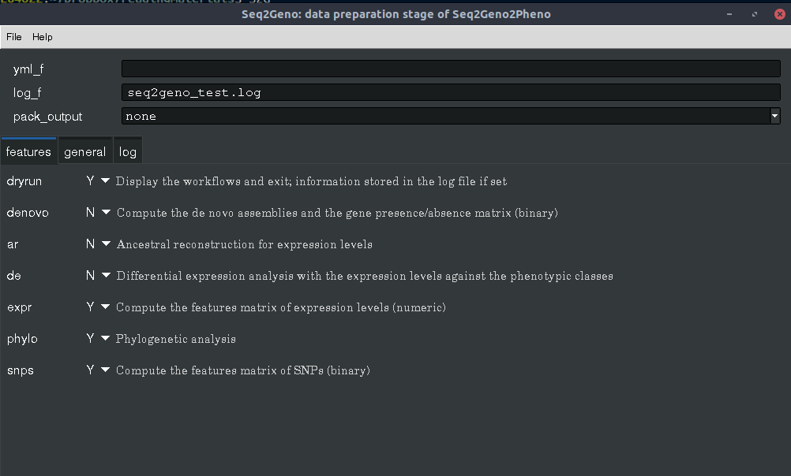

In the features page, opt Y to include the analyses (details in the previous chapter). In this tutorial, we include snps, expr, phylo, as well as dryrun to have a preview.
Then, we will be determining the input data in the general page. If the working directory (set in wd) is new, make sure that old_config is N; otherwise, the package won't find the required configuration files.

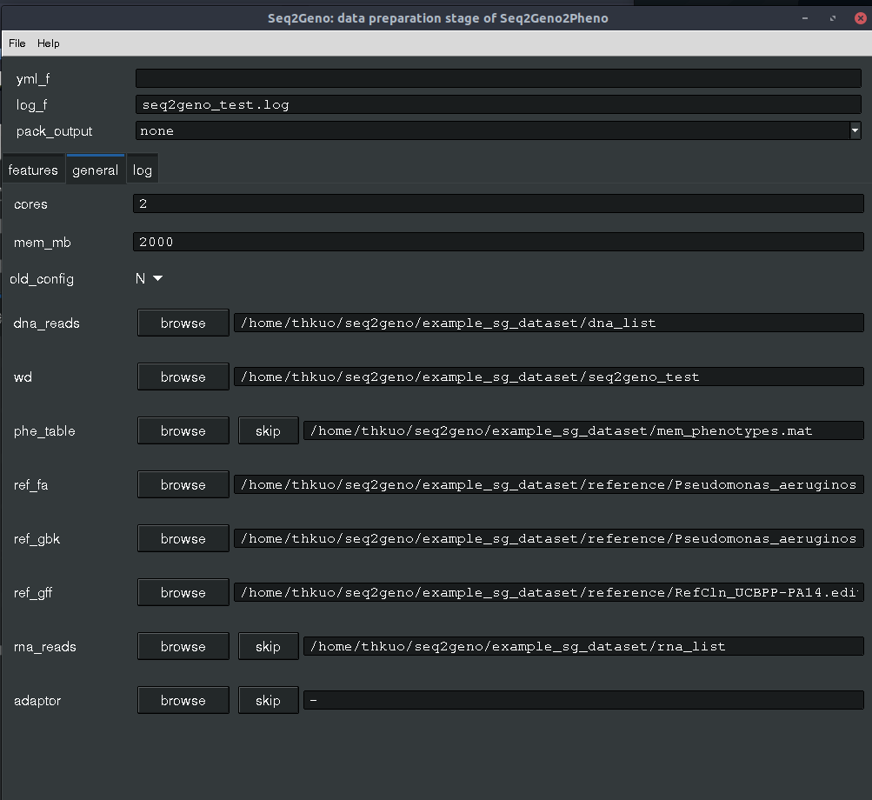

After everything is set, move to the menu bar and click Run. A window will pop out to allow you to save the settings are start running. Because we have opted dryrun, the processes won't start and Seq2Geno will only write the working plan in the log file seq2geno_test.log. Click Load log and select the log file, and then click log to view the information.
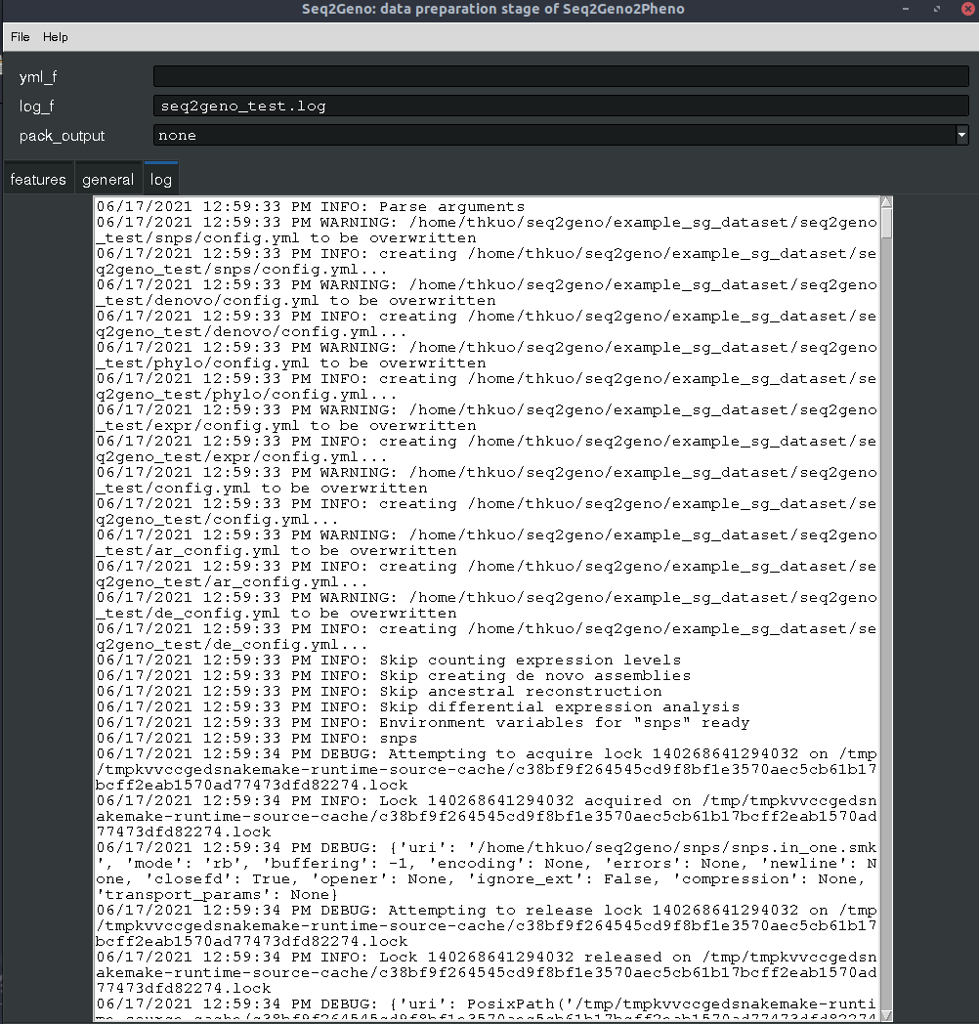

If the settings and analyses plans look fine, go changing the other log filename such as seq2geno_real.log. Then, go to features and set N for dryrun. Finally, we are about to start the analyses: go clicking File and then Run to launch the analyses. You can view the status by loading the log file like mentioned above or using any your preferred text viewer/editor.

A new project with a yaml file
If you want to start by editting a pre-determined or shared settings, go to the menu bar and click File and Load yaml to import the old settings. You can review or edit the settings like mentioned in the previous section. Otherwise, just run it by clicking File > Run.

Add analyses to an old project
It is possible to add some more analyses after one is done without rerunning the others. For instance, we want to compute de novo assemblies and gene presence/absence table after the above analyses were finished. First, load the old yaml using File > Load yaml. Then, repeat the above: setting another log file in log_f, opt Y for denovo and then go to File > Run.

Add more samples to an old project
Adding samples are also possible without recomputing everything. Given an old project, there should already be a list of DNA-seq reads set in dna_list. Add the new samples into the list, set another log file in log_f, and then Run the analyses again. You could also use dryrun to ensure what and how many new analyses will be launched.

