In this project, I implemented the user login function, adjusted the UI page scale, and the page background to light or dark and Restart alarm function, and successfully implemented the creation of a simple desktop reminder application that reminds the user to take a 20 second break every 20 minutes. The application should be able to be hidden in the taskbar and pop up and make a sound when reminding the user.

In the demo I recorded I set it to 5 seconds in order to test the sound of an alert.

We can change the time of the restart countdown here

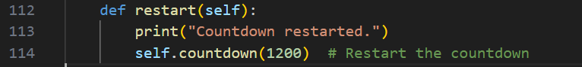

The reason why I didn't start the countdown automatically when running is because I want to show the function of the restart button more clearly, if you want to start the countdown automatically when I run, you can add a self.countdown(1200) after setting up the layout design of the main program in front of you to realize that the countdown will start automatically when you run.

Such as add”self.countdown(1200)” in Line 91

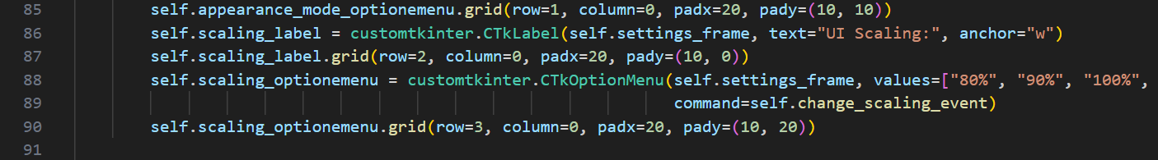

Because the design of such a UI interface is not very difficult, so I additionally added a login system, although in the code I wrote you no matter what happens to the act of pointing the login button can enter the next interface, if you want to verify that the user and password is correct, I think you need to connect to the database and then compared.

These are my short statements, I am very keen to join your team and look forward to improving my skills. Have a great weekend:)