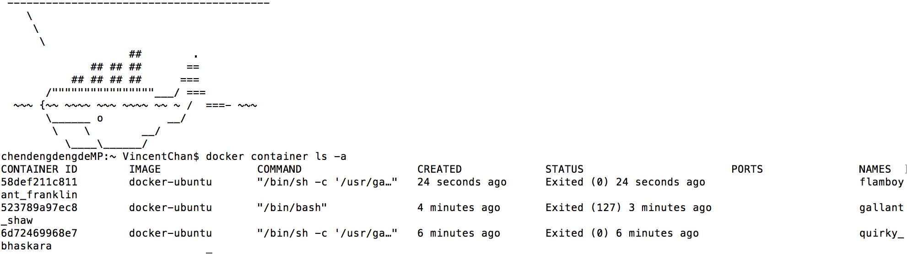

Figure.1 Build Ubuntu Docker image

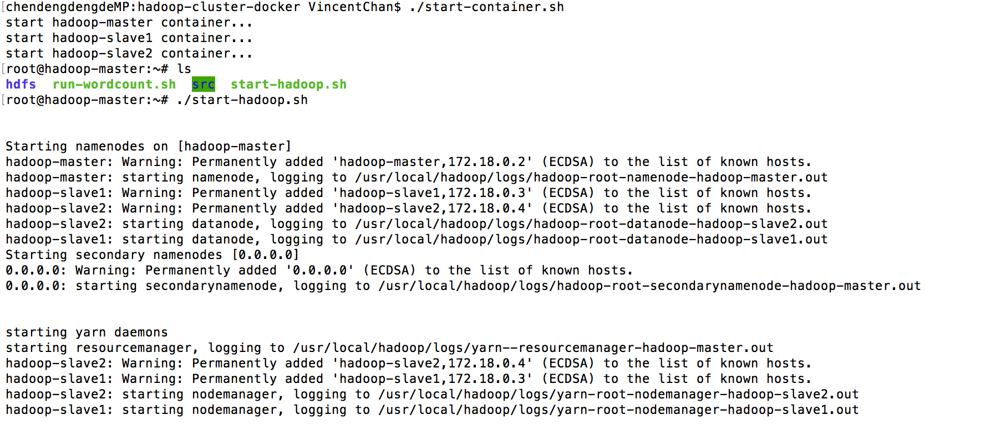

Figure. 2 Build Hadoop Docker image

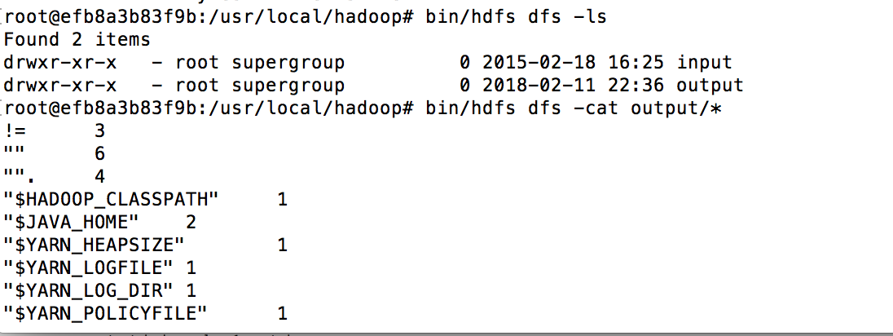

Figure. 3 The result of wordcount