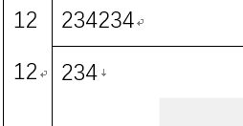
$f\left(x\right)=a_{0}+\sum_{n=1}^{∞}{\left(a_{n}\cos{\frac{nπx}{L}}+b_{n}\sin{\frac{nπx}{L}}\right)}$
121²12₁2
1212$f\left(x\right)=a_{0}+\sum_{n=1}^{∞}{\left(a_{n}\cos{\frac{nπx}{L}}+b_{n}\sin{\frac{nπx}{L}}\right)}$ | 234234 | 34
234
122222222222222222222222222222222222222222222222222222222222222221212121212122112

