菜单栏View→Tool Windows→Maven Projects就可以调右侧出maven栏

1.

<project xmlns="http://maven.apache.org/POM/4.0.0" xmlns:xsi="http://www.w3.org/2001/XMLSchema-instance"

xsi:schemaLocation="http://maven.apache.org/POM/4.0.0 http://maven.apache.org/maven-v4_0_0.xsd">

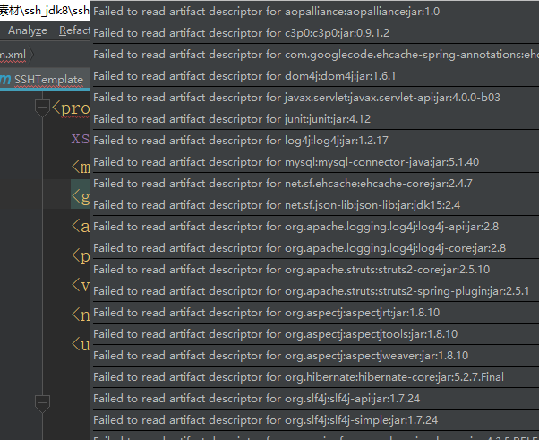

解决

File -> Settings -> Build, Execution, Deployments -> Build Tools -> Maven

勾选Always update snapshots check box

