**Hazel Bunning**

bunninghazel@gmail.com

**CAS-ADS – M1 Project**

**Evidence of Potential Honey Adulteration (2009-2022): a comparison of export and import data with honey quantity and pricing data**

**6 October 2024**

# Abstract

This project examines potential honey adulteration from 2009 to 2022 by analyzing export, import, and quantity of beehive data from the FAO and WITS databases. Focusing on the 8 following countries: Argentina, Brazil, Canada, Mexico, China, India, Viet Nam, and Ukraine, this analysis compares honey export volumes and prices with production capacities and Switzerland's import data. Findings reveal discrepancies, particularly in Ukraine, where honey imports exceed production capabilities, raising concerns about adulteration. Similar trends in Argentina, Viet Nam, and India suggest possible fraud, while Canada shows irregular pricing patterns. Although this analysis cannot confirm adulteration, it highlights key areas of concern, underscoring the need for stricter purity testing, traceability, and regulatory oversight in the global honey trade.

# Table of Contents

Abstract 0

Table of Contents 1

1 Project Objectives 2

2 Methods 2

3 Data 3

4 Metadata 6

5 Data Quality 7

6 Data Flow 7

8 Documentation 7

9 Risks 8

11 Conclusions 8

Acknowledgements 8

Statement 9

Appendix 10

References and Bibliography 19

# 1 Project Objectives

Honey adulteration, which involves mixing honey with cheaper substances like sugar syrup to increase volume, has become a significant issue in the global food industry, particularly in recent decades. Professor Norberto Garcia (2016) highlighted a concerning trend from 2007 to 2014 where certain countries appeared to be exporting more honey than could realistically be produced by their available beehive populations [1]. This suggests that a portion of the honey being exported and labeled as "pure" may be adulterated or counterfeit.

The objective of this project is to conduct a preliminary study to determine whether there could be fraud in the importation and/or exportation of natural honey to Switzerland by identifying patterns of honey adulteration through the analysis of export data from the Food and Agriculture Organization of the United Nations (FAO) [2] and import data from World Integrated Trade Solution (WITS) database, spanning from 2009 to 2022 [3]. This project will focus on 4 countries from the Americas, namely Argentina, Mexico, Brazil and Canada and 4 from the Eastern hemisphere, namely China, India, Viet Nam and Ukraine.

Additionally, with regard to the CAS ADS final project, this preliminary study will help determine whether these analyses would be feasible and worthwhile to conduct in more depth.

# 2 Methods

The project will be conducted using Google Colab as the primary platform, with Python as the programming language. Data will be handled using XLSX and CSV files, and libraries such as Pandas, Numpy and OS will be used for processing and analysis. Visualization will be performed using Matplotlib's pyplot module to generate charts and graphs.

1. Data Collection:

* Extract honey export data (in Kg) and corresponding prices ($ per Kg) from the FAOSTAT database for the period 1988-2022
* Collect data on the number of beehives for each country from FAOSTAT database for the period 1988-2022
* Extract honey import data (in Kg) from the WITS database for the period 1988-2022.

2. Data Analysis

* Trend Analysis: Identify countries with significant changes in honey export, import to Switzerland and beehive volumes over time.
* Export Analysis: Compare honey export data to determine if there is more outgoing honey than is being produced by the country.
* Switzerland Import Analysis: Compare Switzerland's honey import data from different countries to determine if there is more incoming honey from any country than would be expected based on each country’s honey production.
* Compare export trends and pricing data between two clusters of countries (those suspected of exporting adulterated honey vs. those not suspected).

3. Visualization:

* Use time series plots to illustrate trends in honey exports and prices over time.
* Generate comparative line charts and scatter plots to visualize discrepancies.
* Create a report highlighting key findings, with recommendations for monitoring potential food fraud.

The expected outcome is to identify countries exhibiting suspicious honey export trends which could be evidence of a potential of adulteration. Furthermore, the analysis offers insights into Switzerland's honey import patterns, highlighting their implications for detecting and preventing food fraud.

# 3 Data

There are 4 datasets used for the purpose of this project. The first five rows of the relevant columns from each dataset are shown below.

Table : Import Quantities of Natural Honey to Switzerland (2009–2022) by Country

|  |  |  |  |  |  |  |
| --- | --- | --- | --- | --- | --- | --- |
| Reporter | TradeFlow | Partner | Product Description | Year | Quantity | Quantity Unit |
| Switzerland | Import | Mexico | Natural honey | 2009 | 3051020.0 | Kg |
| Switzerland | Import | Argentina | Natural honey | 2009 | 463528.0 | Kg |
| Switzerland | Import | China | Natural honey | 2009 | 78888.0 | Kg |
| Switzerland | Import | Brazil | Natural honey | 2009 | 74060.0 | Kg |
| Switzerland | Import | Canada | Natural honey | 2009 | 47860.0 | Kg |
| …. |  |  |  |  |  |  |

This dataset was generated by first downloading data in XLSX format from the WITS website for the years 2009 to 2022. The data was then converted to CSV format, and the 15 individual CSV files were merged into a single file. The final dataset contains 88 rows with 5 missing values for Canada, 4 for Ukraine, 4 for India and 11 for Viet Nam.

Table : Export price of natural honey per kg for chosen countries from 2009 to 2022

|  |  |  |  |  |  |
| --- | --- | --- | --- | --- | --- |
| Area | Element | Item | Year | Unit | Value |
| Argentina | Export Value | Natural honey | 2009 | 1000 USD | 160291 |
| Argentina | Export Value | Natural honey | 2010 | 1000 USD | 173426 |
| Argentina | Export Value | Natural honey | 2011 | 1000 USD | 223448 |
| Argentina | Export Value | Natural honey | 2012 | 1000 USD | 215147 |
| Argentina | Export Value | Natural honey | 2013 | 1000 USD | 212637 |
| … |  |  |  |  |  |

This dataset was downloaded from FAOSTAT in CSV format. The dataset contains 112 rows with no missing values. During analysis the unit was converted to 1 USD

Table : Natural honey export quantity per country from 2009 to 2022

|  |  |  |  |  |  |
| --- | --- | --- | --- | --- | --- |
| Area | Element | Item | Year | Unit | Value |
| Argentina | Export Quantity | Natural honey | 2009 | t | 57969.0 |
| Argentina | Export Quantity | Natural honey | 2010 | t | 57317.0 |
| Argentina | Export Quantity | Natural honey | 2011 | t | 72356.0 |
| Argentina | Export Quantity | Natural honey | 2012 | t | 75135.0 |
| Argentina | Export Quantity | Natural honey | 2013 | t | 65180.0 |
| … |  |  |  |  |  |

This dataset was downloaded from FAOSTAT in CSV format. The dataset contains 112 rows with no missing values. During analysis the units were converted to kg.

Table : Number of beehives per country from 2009 to 2022

|  |  |  |  |  |
| --- | --- | --- | --- | --- |
| Area | Item | Year | Unit | Value |
| Argentina | Bees | 2009 | No | 2970000 |
| Argentina | Bees | 2010 | No | 2970000 |
| Argentina | Bees | 2011 | No | 2970000 |
| Argentina | Bees | 2012 | No | 2970000 |
| Argentina | Bees | 2013 | No | 3000000 |
| … |  |  |  |  |

This dataset was downloaded from FAOSTAT in CSV format. The dataset contains 112 rows with no missing values.

The quantity of honey produced in this analysis is based on the FAO's (2020) approximation that a single beehive can produce 20 kg of honey annually [4]. Therefore, Total Honey Production (kg) = Number of beehives * 20.

Graphs 1 through 8 in the Appendix illustrate the trends in honey production quantities (kg) compared to the export quantities (kg) from 2009 to 2022 for Argentina, Brazil, Canada, Mexico, China, Ukraine, India, and Viet Nam, respectively. These graphs reveal that Argentina, Brazil, Canada, and Mexico exhibit volatile export trends, often with exports surpassing actual production levels. Such a phenomenon could be attributed to several factors, including honey adulteration, re-exporting imported honey, exporting stored reserves, or potential discrepancies in data reporting. Notably, these irregularities are more pronounced in countries like Ukraine and Viet Nam, where significant export volumes are reported despite comparatively low production. This raises strong concerns about the integrity of the global honey market and underscores the need for more stringent purity testing, traceability protocols, and international standards to prevent fraud and maintain consumer trust.

In contrast, China and India display more consistent trends of growth in both honey production and exports, with their export volumes remaining below their respective production levels. While these patterns do not explicitly eliminate the possibility of honey adulteration in these countries, the issue of quantity discrepancy is less apparent.

To further investigate these dynamics, a comparison was made between the normalized export quantities and the normalized price per kilogram (as shown in Graphs 9 through 16 in the Appendix). This comparison reveals a pattern in countries such as Argentina, Ukraine, India, and Viet Nam, where rising honey export volumes are coupled with falling prices per kilogram. This trend is consistent with economic principles where an increase in supply typically exerts downward pressure on price. Therefore, the initial suspicion regarding honey adulteration in Argentina, Ukraine, and Viet Nam remains plausible, but this supply-price relationship does not strengthen this suspicion. In addition, there is still no indication that India might be involved in honey adulteration.

Conversely, Canada shows the opposite trend, a decrease in exports alongside rising prices, which is unusual and strengthens the concerns from the first analysis. This could suggest scarcity or increased demand for high-quality honey, but it could also indicate potential irregularities that require deeper scrutiny.

Graphs 17 through 24 in the Appendix show honey production quantities (kg) compared to the import quantities into Switzerland (kg) from 2009 to 2022 for Argentina, Brazil, Canada, Mexico, China, Ukraine, India, and Viet Nam, respectively. Typically, one would expect each country’s honey production to exceed its exports to any single destination, such as Switzerland, as countries tend to distribute honey across multiple markets. However, in Ukraine, the amount of honey imported into Switzerland notably exceeds its domestic production. This discrepancy, as observed earlier in the export trends, could again be attributed to honey adulteration, re-exportation of honey, exporting from reserves, or misreporting of production data. It would be important to see if chemical methods of detecting honey fraud (spectroscopic, chromatographic, and electrochemical methods ) corroborate these findings [5], that Switzerland may be importing a lot of adulterated honey from Ukraine.

In conclusion, while the overall analysis reveals clear trends in honey production, export volumes, and price movements, it also exposes a range of potential irregularities and red flags in the global honey market. The findings particularly point to countries such as Ukraine and to some extent, Canada. Ukraine appears to be of particular concern to Switzerland, as the quantity of natural honey imported from Ukraine seems to exceed the amount that the country can realistically produce. These concerns emphasize the urgent need for enhanced global regulatory measures, including stricter purity testing, better traceability, and improved oversight of international honey trade practices.

# 4 Metadata

The quantity and price of export of natural honey, as well as the quantity of beehives are available as open source on the FAO website and the quantity of imports to Switzerland is available as open source on the WITS website. All of these data cover the time period analysed, 2009 to 2022.

# 5 Data Quality

After collecting, cleaning and processing the data, in order to achieve the quality requirements by having complete and precise yearly export and import data, as well as yearly beehive counts for all countries from 2009 to 2022, all missing values are eliminated. While the overall data size is sufficient for analysis, some of the reported values are unusually low, potentially indicating incomplete or inaccurate data entries. This could introduce bias into the results, especially when analyzing trends over time or conducting anomaly detection.

# 6 Data Flow

The below data flow model illustrates the different steps of this project:

Figure : data flow diagram

# 8 Documentation

Google colab is being used with Python code, in which comments are being made regarding the aim of each line, for reproducibility purposes.

# 9 Risks

The primary risks are related to the reliability of the available data, including the potential for reporting errors or inaccuracies in annotation. Additionally, there is a risk of oversimplifying the issue, which could lead to a flawed or insufficient analysis of the data. This analysis is not able to confirm honey adulteration however it is able to raise red flags and identify areas of concern.

# 11 Conclusions

The analysis highlights significant irregularities and potential red flags in the global honey market, particularly concerning countries like Ukraine and to some extent Canada. The volume of honey imported from Ukraine into Switzerland appears to exceed the country’s actual production capacity, raising strong suspicions of adulteration. Similar concerns, although less pronounced, are evident in export patterns from Argentina, Viet Nam, and India, where discrepancies between production and export volumes suggest the need for further investigation.

While this study cannot definitively confirm honey adulteration, it clearly identifies trends that warrant deeper investigation. Enhanced regulatory measures, such as stricter purity testing, improved traceability protocols, and more transparent trade practices, are essential to preserve the integrity of the international honey trade. Addressing these concerns will help maintain consumer trust and ensure that the global honey market remains free from fraudulent practices. Further laboratory testing and trade verifications would be crucial next steps in confirming the suspicions raised by this analysis.

# Acknowledgements

I would like to acknowledge the use of ChatGPT, an AI language model developed by OpenAI, in helping me with text and Python code generation, language refinement and clarity.

# Statement

The following part is mandatory and must be signed by the author or authors.

„Ich erkläre hiermit, dass ich diese Arbeit selbstständig verfasst und keine anderen als die angegebenen Quellen benutzt habe. Alle Stellen, die wörtlich oder sinngemäss aus Quellen entnommen wurden, habe ich als solche gekennzeichnet. Mir ist bekannt, dass andernfalls die Arbeit als nicht erfüllt bewertet wird und dass die Universitätsleitung bzw. der Senat zum Entzug des aufgrund dieser Arbeit verliehenen Abschlusses bzw. Titels berechtigt ist. Für die Zwecke der Begutachtung und der Überprüfung der Einhaltung der Selbstständigkeitserklärung bzw. der Reglemente betreffend Plagiate erteile ich der Universität Bern das Recht, die dazu erforderlichen Personendaten zu bearbeiten und Nutzungshandlungen vorzunehmen, insbesondere die schriftliche Arbeit zu vervielfältigen und dauerhaft in einer Datenbank zu speichern sowie diese zur Überprüfung von Arbeiten Dritter zu verwenden oder hierzu zur Verfügung zu stellen.“

Date: 06.10.24 Signature(s):



# Appendix

According to Garcia (2016), China, Ukraine, India, and Viet Nam (in red) are known for honey adulteration, while Argentina, Brazil, Canada, and Mexico (in blue) have a reputation for exporting pure honey [1]. This distinction is reflected in the colour coding in the graphs below.

Graph : Argentina’s natural honey export quantity compared production quantity from 2009 to 2022

Graph 2: Brazil’s natural honey export quantity compared production quantity from 2009 to 2022

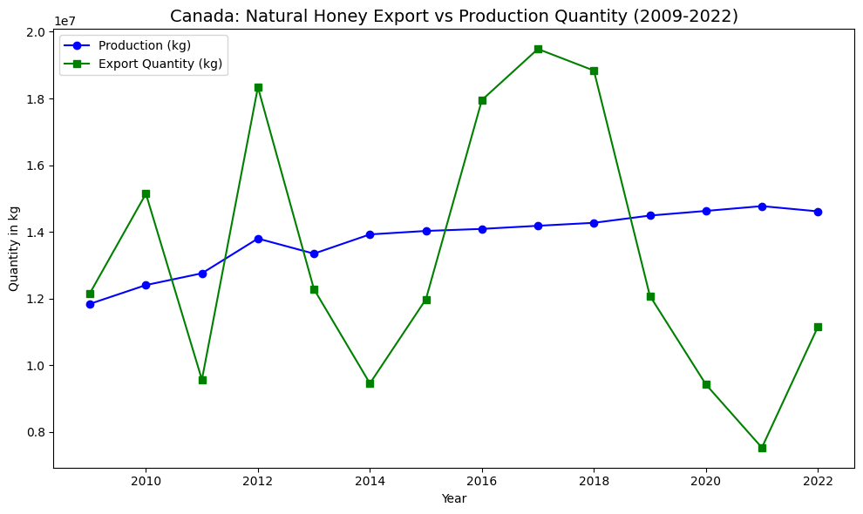

Graph : Canada’s natural honey export quantity compared production quantity from 2009 to 2022

Graph : Mexico’s natural honey export quantity compared production quantity from 2009 to 2022

Graph : China’s natural honey export quantity compared production quantity from 2009 to 2022

Graph : Ukraine’s natural honey export quantity compared production quantity from 2009 to 2022

Graph : India’s natural honey export quantity compared production quantity from 2009 to 2022

Graph : Viet Nam’s natural honey export quantity compared production quantity from 2009 to 2022

Graph : Argentina’s natural honey import quantity to Switzerland compared to production quantity (2009-2022)

Graph : Brazil’s natural honey import quantity to Switzerland compared to production quantity (2009-2022)

Graph : Canada’s natural honey import quantity to Switzerland compared to production quantity (2009-2022)

Graph : Mexico’s natural honey import quantity to Switzerland compared to production quantity (2009-2022)

Graph : China’s natural honey import quantity to Switzerland compared to production quantity (2009-2022)

Graph : Ukraine’s natural honey import quantity to Switzerland compared to production quantity (2009-2022)

Graph : India’s natural honey import quantity to Switzerland compared to production quantity (2009-2022)

Graph : Viet Nam’s natural honey import quantity to Switzerland compared to production quantity (2009-2022)

Graph : Argentina’s natural honey export quantity in relation to the price of honey per kg from 2009 to 2022

Graph : Brazil’s natural honey export quantity in relation to the price of honey per kg from 2009 to 2022

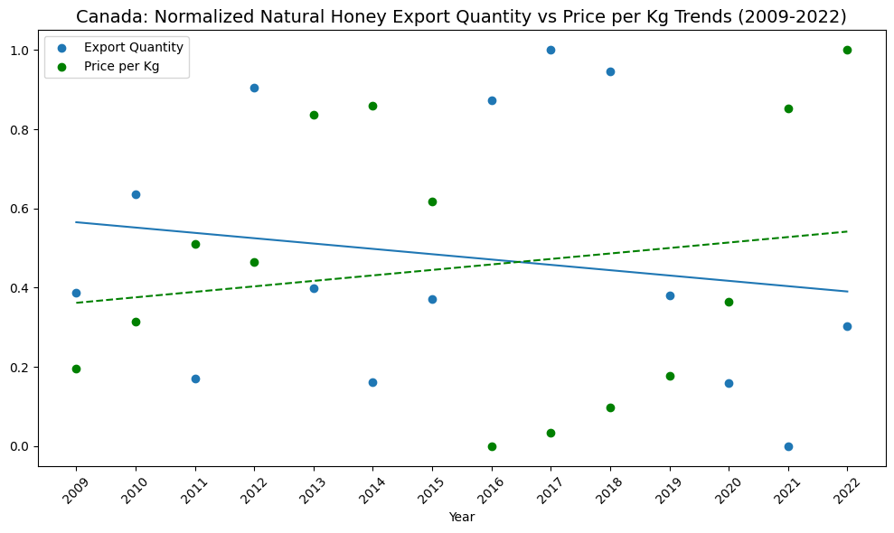

Graph : Canada’s natural honey export quantity in relation to the price of honey per kg from 2009 to 2022

Graph : Mexico’s natural honey export quantity in relation to the price of honey per kg from 2009 to 2022

Graph : China’s natural honey export quantity in relation to the price of honey per kg from 2009 to 2022

Graph : Ukraine’s natural honey export quantity in relation to the price of honey per kg from 2009 to 2022

Graph : India’s natural honey export quantity in relation to the price of honey per kg from 2009 to 2022

Graph : Viet Nam’s natural honey export quantity in relation to the price of honey per kg from 2009 to 2022

# References and Bibliography

[1] García, N. "A Study of the Causes of Falling Honey Prices in the International Market." *American Bee Journal*, vol. 156, no. 212, 2016, pp. 877-882. Available at: <https://calgarybeekeepers.com/wp-content/uploads/2018/12/study_causes_falling_honey_prices_international_market.pdf> (Accessed: 05 October 2024).

[2] FAO. "FAOSTAT: Crops and Livestock Products Database." Available at: <https://www.fao.org/faostat/en/#data/QCL> (Accessed: 05 October 2024).

[3] Switzerland Natural Honey Imports by Country (2023). Data. Available at: <https://wits.worldbank.org/trade/comtrade/en/country/CHE/year/2023/tradeflow/Imports/partner/ALL/product/040900> (Accessed: 05 September 2024).

[4] FAO. "Quelques faits intéressants sur les abeilles." CA4657FR/1/04.20, 2020. Available at: FAOSTAT, 2017. (Accessed: 01 October 2024).

[5] Weisz, N., Serban, A., Szanto, Z., & Alebic-Kolbah, T. "Analytical Challenges and Recent Advances in the Authentication of Natural Honeys." *Journal of AOAC International*, vol. 100, no. 4, 2017, pp. 827-841. <https://doi.org/10.5740/jaoacint.16-0340> (Accessed: 05 October 2024).

[6] Awram, Peter. "The History of Honey Fraud." *True Honey Buzz*, British Columbia, 2020. Available at: <https://www.apiservices.biz/documents/articles-en/history_honey_fraud.pdf> (Accessed: 05 September 2024).