

Modern Power Electronics Technology

Experiment Report

**Name 林智铭**

**Teacher 魏春**

**Class 卓越工程2402班**

**College** **信息工程学院**

January 17, 2025

CONTENTS

# 1 Modeling and simulation of three-phase voltage source PWM inverter

## 1.1 Derivation of SPWM model

SPWM (Sinusoidal Pulse Width Modulation) is a technique used to control the output voltage of an inverter by modulating the pulse width of the switching elements, as shown in Fig.1-1.

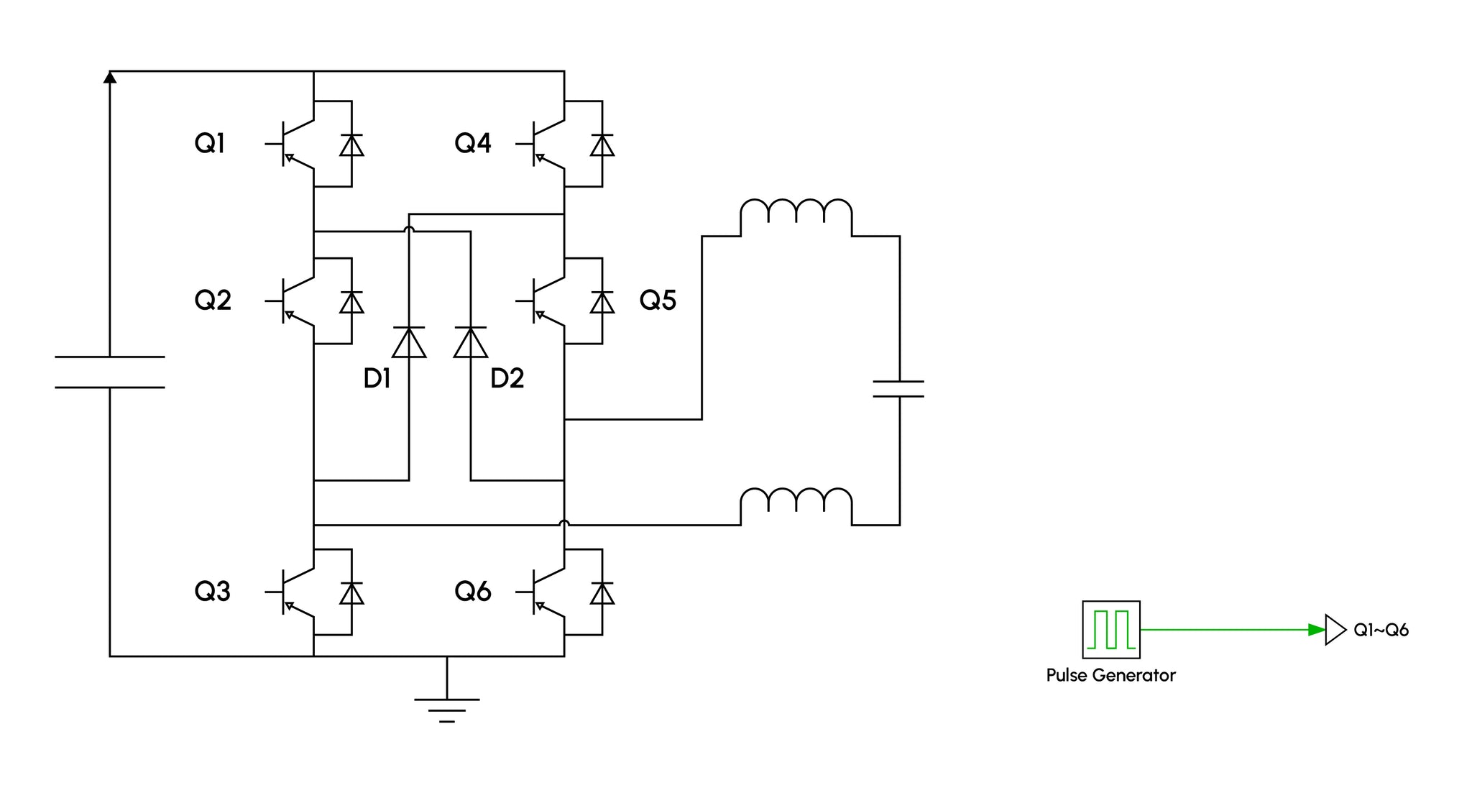

Fig.1-1 SPWM Inverter

When the inverter operates in continuous conduction mode, a switching cycle can be divided into multiple segments, each corresponding to a different phase angle of the reference sine wave. In each segment, the switching elements are controlled to generate a series of pulses with varying widths. For simplicity, consider a single-phase SPWM inverter.

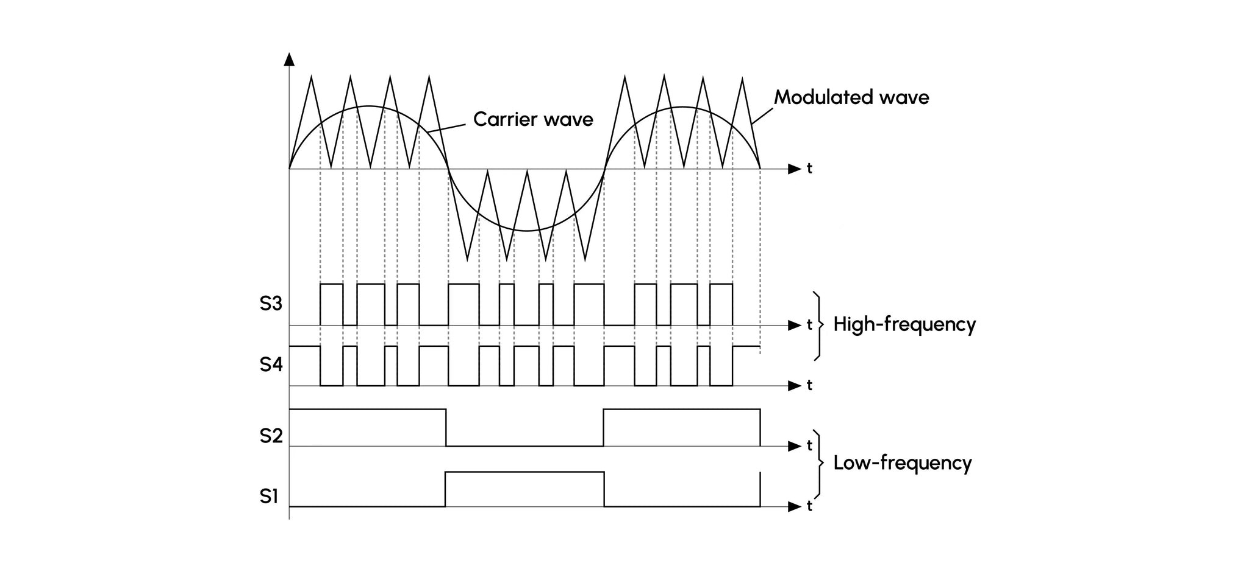

Fig.1-2 SPWM Inverter

### 1.1.1 Formulation Derivation of Large Signal Model

When the converter operates at state 1, the voltage between the inductors is



The current through the capacitor is



When the converter operates at state 2, the voltage between the inductors is



The current through the capacitor is



So the average inductance voltage in one switching cycle is



If the input voltage and the output voltage are continuous and vary very little during a switching cycle, the following approximation can be obtained





So



Since



That



Similarly





### 1.1.2 Formulation derivation of small signal model

If the input voltage and duty cycle are slightly perturbed near the DC operating point, i.e





Which will cause small perturbations of each state quantity and input current in the Buck converter, i.e







By substituting these formulas into the large signal model, the state space average equation after perturbation can be obtained



If the perturbation is small



Then the second-order AC term can be ignored and can be simplified as



Similarly





## 1.2 Simulation of Buck converter in CCM mode

MATLAB /Simulink is used to simulate Buck small-signal AC model. The circuit static operating points are selected as follows: output voltage V=200V, input voltage Vg =20V, control duty cycle D=0.5, inductor L=500uH, capacitor C=47uF, load resistance R=100, Rg=300,inductor current I=4A.The Buck simulation model is shown in Fig.1-4.

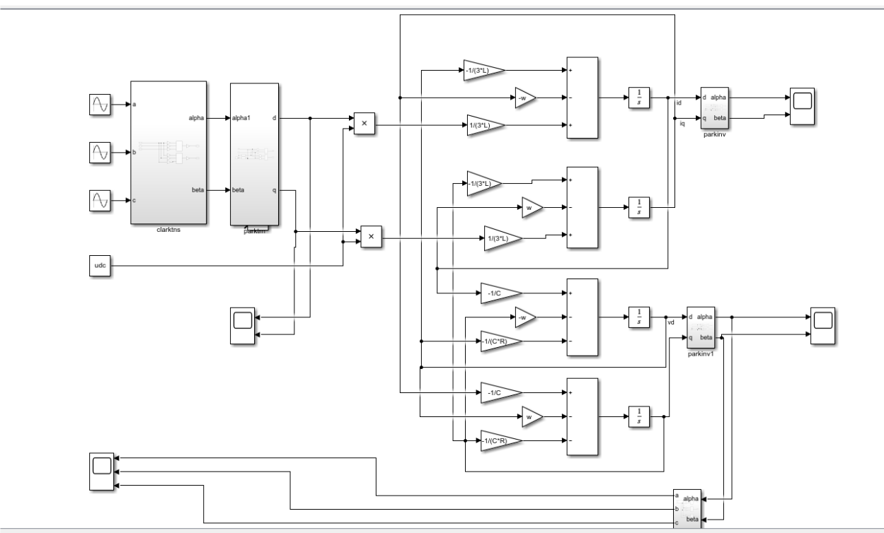

Fig.1-4 CCM small-signal AC model simulation diagram of Buck circuit

The small-signal AC model simulates the influence of small disturbance on the steady state of the system. When the duty cycle D has a pulse disturbance of 0.02, the output voltage disturbance is V=-15V and the inductance current disturbance is I =5A. The simulation results are shown in Fig.1-5(a). When the duty cycle D has a pulse disturbance of -0.05, the output voltage disturbance is V=40V, and the inductance current disturbance is I =-12A. The simulation results are shown in

Fig.1-5(b).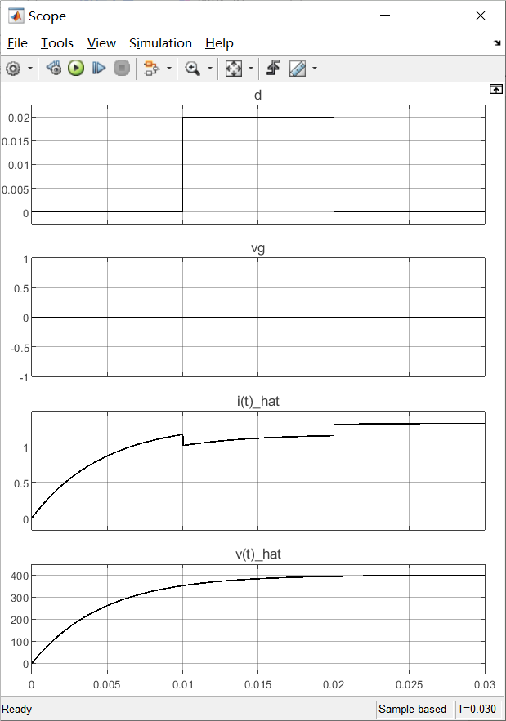 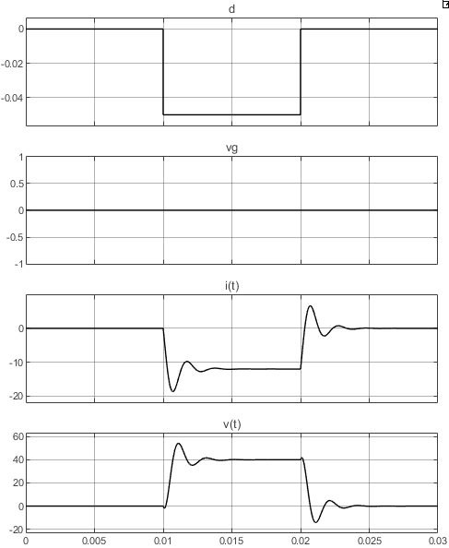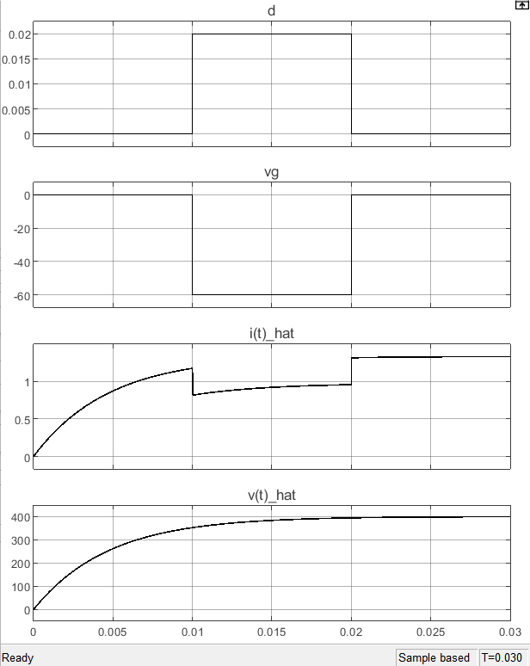

(a) Duty cycle increases by 0.02 (b) Duty cycle Decreases by 0.05

Fig.1-5 Simulation results when the duty cycle is disturbed

When the input voltage increases by 20V, the output voltage perturbation is V=-20V and the inductance current perturbation is I =4A. The simulation results are shown in Fig.1-6 (a). When the input voltage is reduced by 60V, the output voltage perturbation is V=60V and the inductance current perturbation is I=-12A. The simulation results are shown in Fig.1-6 (b).

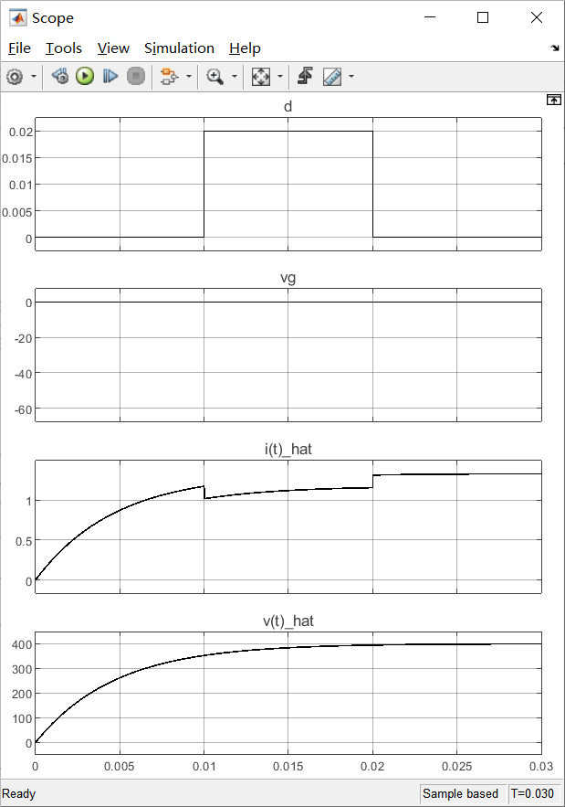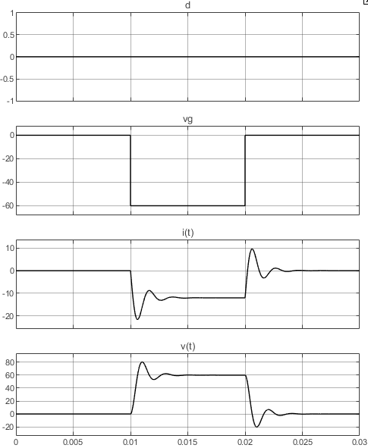

(a) Input voltage increases by 20V (b) Input voltage Decreases by 60V

Fig.1-5 Simulation results when the input voltage is disturbed

## 1.3 Summary

The small-signal model of the SPWM inverter linearizes a specific steady-state operating point of the inverter, allowing for the analysis of the system's response to small disturbances. This model retains only the disturbance component of the inverter's electrical quantities, thereby excluding the steady-state component and switching ripple. In this experiment, the small-signal model of the SPWM inverter is simulated, and the operational results of the SPWM inverter's small-signal model under various perturbations are simulated. Additionally, the linearization characteristics of the small-signal model are verified, providing insights into the stability and performance of the SPWM inverter under different operating conditions.