Final Project Report

Description
The dataset we investigate contains all the Airbnb listings in Austin. We are interested in solving the following problems: how to determine the optimal listing price range when a property owner decides to list their place on Airbnb? And what are the determinants that mostly influence the listing price on Airbnb?
Importance of the Problem
The sharing economy is one of the fastest-growing business trends in history. Airbnb has become a pioneer of this emerging business and is dedicated to offering outstanding lodging, homestays, and tourism experiences. More people are looking for becoming hosts and listing their places on Airbnb to earn some extra money. However, most of them are facing the same problem when they start listing: how much do they need to charge the guest to maximize the hosts’ profit? Are they supposed to set the price higher to earn more or make it lower to attract more guests? The primary reason we choose this problem is that we want to help the hosts to identify the optimal listing price range, so their places will be booked by more guests while the hosts are earning more than they expect. From a broader perspective, solving this problem could also help the guests or the tourists to pay the most reasonable price when they are looking for places to stay that meet their requirements. If both hosts and guests have pleasant experiences using Airbnb and are satisfied with what they earn and what they pay for, it is likely that more people will start using the platform since they can get a broader choice of traveling now. The economy might experience higher growth in terms of more hosts’ places are being posted and rented and promoting the local tourism industry. More people will benefit from utilizing idle spaces and spending less on trip costs.
Exploratory Analysis
First, we plot all the listings’ price. In Figure 1, we found that most listings’ prices are under $1,500. Then we ranked all the listing prices from low to high and divided them into three different groups: first 70% of all the prices, 70% - 85%, and above 85%. Figure 2 shows that the numerical price range corresponding to each group are $0 - $300, $300 - $500, and $500- $10,000. We conclude that about 70% of the listings have listing prices lower than $300 per night.
According to the Airbnb website, Superhosts are experienced hosts who provide shining examples for other hosts, and extraordinary experiences for their guests. We are curious about whether listings posted by Superhosts have higher prices. We selected all the 1740 listings that are posted by Superhosts and fit them into the price range mentioned in the previous slide. In Figure 3, we can see that most of these listings fall into the range of $0 - $300. We conclude that even for Superhosts, most of them do not charge higher prices. Maybe what makes them distinguished from normal hosts are better services or better room settings.
We labeled the price range of $0 - $300, $300 - $500, and $500 - $10,000, as low, medium, and high price listings, respectively. Additionally, since listings with review scores higher than 99 are deemed to be superior, we chose 99 as a cutoff to distinguish between high review score and low review score. Then we compare the percentage of high review score listings and the percentage low score listings within each price range. From the result shown in Figure 5, we found that as the listing prices get higher, the percentage for high review score within that price range also gets higher. A potential reason might be that for places with higher listing prices, they have better amenities or provide better services. Another reason might be that high listing price places tend to have larger sizes so they are capable of accommodating more guests at a time. Taking all these into account, it is easier for the guests to gain memorable experiences, so they are more likely to leave better ratings.
Finally, we would like to see what amenities are the most common among all the listings. We counted the occurrence of different amenities and the results are shown in Figure 7. The top 8 most common amenities are air conditioning, heating, kitchen, internet, parking, smoke detector, washer, essentials. These amenities might be important to the guests.
Solution and Insights
(a) Features:
Originally, we have up to 95 different features that are potentially useful. But since we aim to construct a model that has “price” as the response, we kept 14 most relevant features in figure 8 Features Table.

(b) Choice of classifiers:
Since we have plenty of features that we want to use in the Airbnb dataset, it is not a good idea to use KNN because it is very hard to find training data points close to point along every feature.
Additionally, we know that some of the useful variables are potentially correlated with each other. For example, “host_is_super_host” must be highly correlated with the variable “review_scores_rating”. Naive Bayers will make mistakes in our case.
Therefore, we decided to try the logistic regression model that can deal with the correlated features better than Naive Bayers. We would also try to fit Decision Tree, Bagging, Boosting, Random Forest models since the Tree models make fewer assumptions about the data and they are easy to interpret.
(c) Summary of the results obtained
For our logistic model, firstly, we constructed our regression model with the features mentioned in (a). The response is whether the listings’ price is lower than $300 (negative class) or higher than $300 (positive class). We chose $300 as the watershed because 70% of all the listings in Austin have price lower than $300. Then, using the formula, we trained our model in the training set, and fit the model in the test set, we have obtained the following result in Figure 9 Feature Coefficients Chart and Figure 10 Accuracy Table for Logistic Model.
Generally speaking, we get pretty good accuracy for both the training and testing dataset with our logistic model.
For our Tree Models, initially, we constructed our formula with the features mentioned in (a) and responses of three listings price ranges: $0-$200, $200-$400, and $400 above, because we think split into more price bins could provide better estimates when determining listings’ price using our model. Next, we utilized our formula to train our tree model using the training set, and fit the model using the test set. Also by using the Figure 13 Decision Tree Depth to Figure 19 Tree Model vs Accuracy, we have obtained the best result in Figure 11 Accuracy Table for Tree Models and Figure 12 Most Important Variable Chart.
And among all the tree models, the random forest is the best one.
(d) Analysis of the result
From Figure 9 Feature Coefficients Chart, we can observe that the most important features in the logistic model are the negative coefficients list: “host_has_profile_pic”,”cancellation_policy”,”host_is_superhost”; Positive coefficients list: ”amenities”,”is_location_exact”, “bedrooms”, ”bathrooms”. And the rest of the features are kind of useless in our case.
There are several interesting findings worth mentioning. Among all the important variables, it is surprising to see “host_has_profile_pic” will shift the resulting price towards the “0” dummy, which represents that the housing price is below $300. It might be due to the fact that it is not “host_has_profile_pic” caused the low price of housing, it could actually be the opposite: most of the low price Airbnb would have “host_has_profile_pic” so that people are willing to believe these Airbnb are safe to live. The same logic applies features including ”cancellation_policy”,“host_is_superhost”.
For the positive coefficients list, we were expecting to see these features since we assumed there should be positive correlations between them and our response ”price”.
However, we did not expect that review_score_ratings has super small coefficients. It might be due to the fact that people tend to choose places based on the pictures and the price rather than the review_score_ratings.
For the tree models, since the random forest model has the highest est accuracy among all the tree models, we will specifically talk about that below. Based on Figure 12 Visualizing Important Features Chart, the top four most important features are “Review_scores_rating”, ”number_of_reviews”, ”amenities”, and ”instant_bookable”. The useless ones are “bathrooms”, ”host_identity_verified”, ”bedrooms”, ”beds”.
It is really interesting to see that our tree models provide a very different perspective comparing to the logistic model above. The two models treat each other’s features in the opposite way.
The explanation for that might be, for the logistic model, it only provides the features with its coefficients. But in statistics, it is also very important to check the importance of the features before using them. Otherwise, even the features have high absolute value of coefficients, they might not contribute to accurately predicting the model response. Therefore, our logistic models provide good estimates of the coefficients, and our random forest model provides good importance rank.
Furthermore, our random forest model enables the new hosts who are preparing to post a new listing on Airbnb to estimate the appropriate price range. Depending on what they entered for the variables, the model can predict what price range (low price($0 - $200), middle price($200 - $400), and high price(>$400)) should be selected.
Appendix

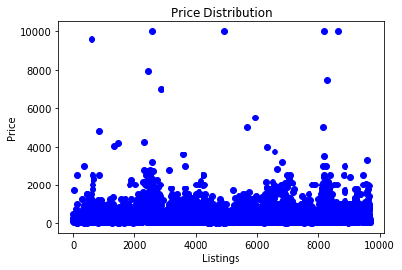
Figure 1 Price Distribution

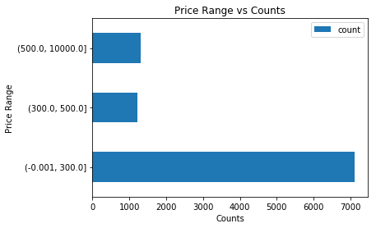
Figure 2 Price Range vs Counts

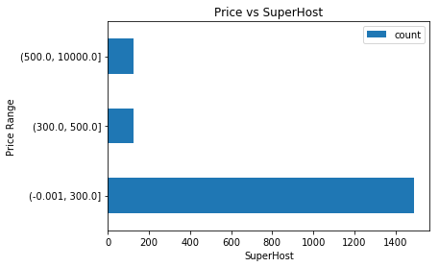

Figure 3 Price vs SuperHost

Price Range | % | count
0~300 | 85% | 1492
300~500 | 7% | 122
500~ | 8% | 126

Figure 4 Price Range and % change Table

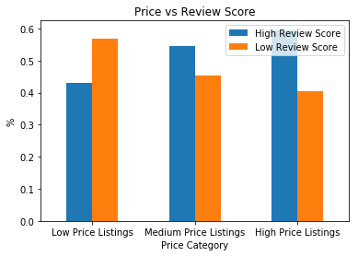
Figure 5 Price vs Review Score

Price Listing | Review Score | count
Low | Low | 56.8%
 | High | 43.2%
Medium | Low | 45.3%
 | High | 54.7%
High | Low | 40.5%
 | High | 59.5%

Figure 6 Price vs Review Score Table
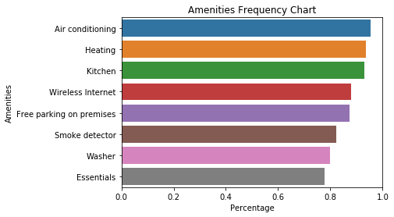
Figure 7 Amenities Frequency Chart

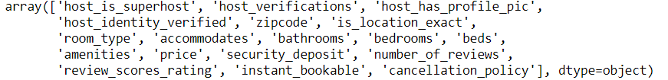
Figure 8 Features Table
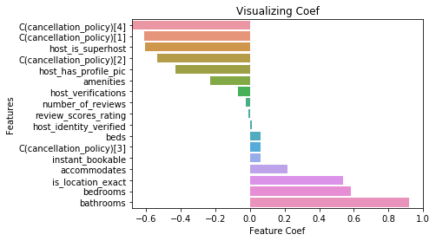
Figure 9 Feature Coefficients Chart
Dataset | Accuracy
Training | 0.869
Testing | 0.877
Baseline | 0.794

Figure 10 Accuracy Table for Logistic Model

Model | Train Accuracy | Test Accuracy | Max_Depth | Num Trees
Decision Tree | 0.783 | 0.777 | 5 | N/A
Bagging | 0.778 | 0.782 | 2 | N/A
Random Forest | 0.791 | 0.786 | 5 | 210
Boosting | 0.790 | 0.778 | 1 | 120

Figure 11 Accuracy Table for Tree Models
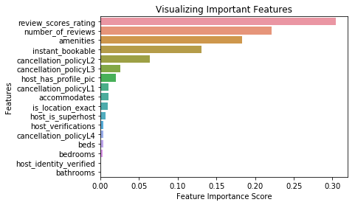
Figure 12 Visualizing Important Features Chart
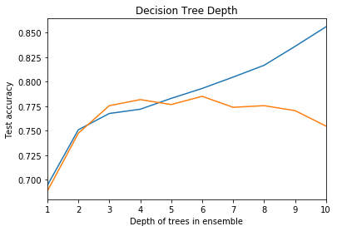
Figure 13 Decision Tree Depth
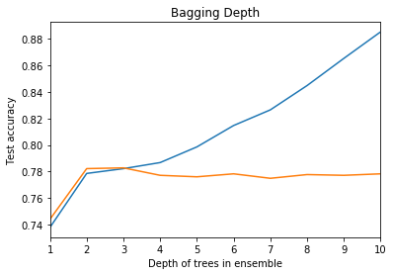
Figure 14 Bagging Depth

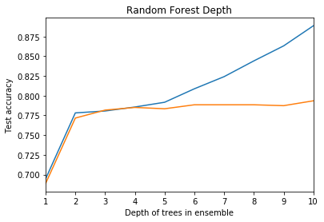
Figure 15 Random Forest Depth
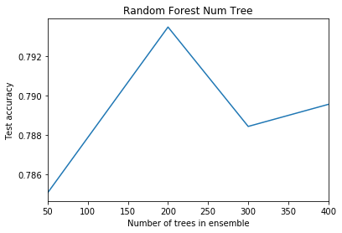
Figure 16 Random Forest Num Tree

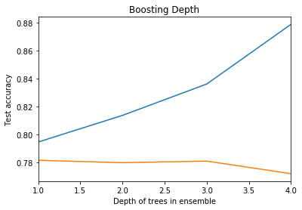
Figure 17 Boosting Num Tree
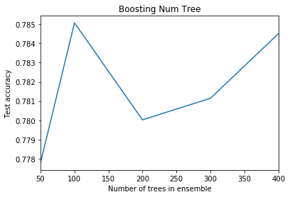
Figure 18 Boosting Num Tree
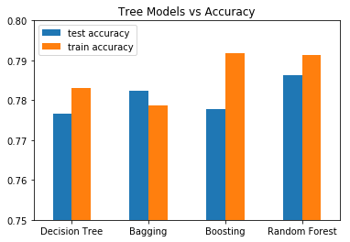
Figure 19 Tree Model vs Accuracy

