Spark Streaming Optimization

一. Condition One(Video Spark)
1. Version and Context
Spark version is 1.6.1 and Kafka Receiver mode
2. the optimization for Streaming
2.1 basic principle
the count of Receiver is larger than the count of instances.
The count of Receiver * the threads count == the partitions of kafka
the partition numbers is equal to the biggest count of the Events
2.2 the Items for optimization
Item | principle
Window size | The average times of processing time for batch count
Partition numbers | The max events count or half of the max events
Receiver count | The Receiver count is twice count of instances
Threads count | The total partitions of kafka divide the Receiver count

Eg:
1) the selection for window size(6s is the best selection mode)
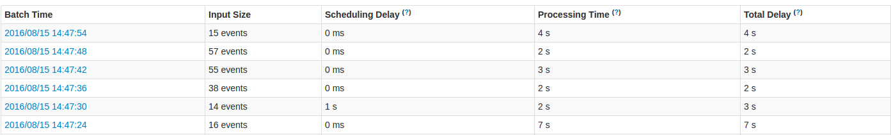
2) the partitions for the repartitions(120 partition number is the best selection mode)

