Analyzing Programming Languages: Syntax, Semantics, and Memory Management
Zheyu Han
May 14, 2026

Part 1 — Analyzing Syntax and Semantics

Section 1: Introducing Syntax Errors
For each of the three languages, I started from a clean, working version of the array-sum program supplied with the assignment and then introduced a single, distinct syntax error. Each language was run in the same sandboxed Linux environment (Python 3.10, Node.js v22, g++ 11.4) so that the differences observed are differences in the language tooling, not in the host.

Working baseline
All three working programs produce the same result: "Sum … 15". The screenshot below shows that output from the three interpreters/compilers in turn.
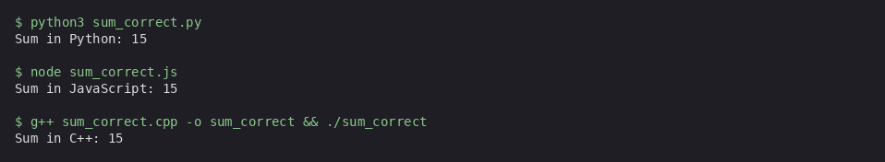
Figure 1. Output of the three working baseline programs.

Introduced errors and the messages they produce
I introduced the following errors (one per language):
- Python — removed the colon at the end of the def calculate_sum(arr) line.
- JavaScript — inserted a space inside the function-call identifier (calculate Sum(numbers)).
- C++ — removed the semicolon at the end of the int total = 0 statement.
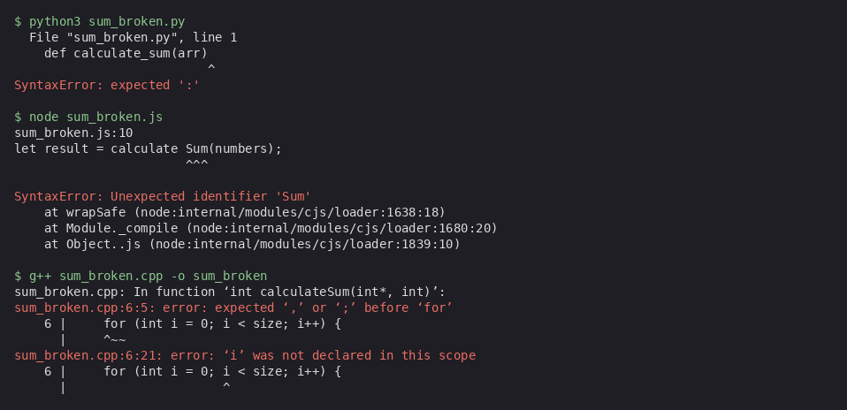
Figure 2. Errors reported by Python, Node.js, and g++ for the three deliberately broken programs.

Reading the error messages
Python reports a SyntaxError before any code is executed. The interpreter parses the whole file first, points to the exact line ("line 1") and column (the caret beneath the closing parenthesis), and even hints at the specific token it was hoping for ("expected ':'"). Because Python is whitespace-sensitive and reads top-to-bottom, the error is surfaced quickly and with very little extra noise (van Rossum, 2025).
JavaScript reports a SyntaxError as well, but the message also includes a short stack trace into the Node.js module loader. Node uses a separate parsing pass per file, so the error fires when the file is loaded but before any of its statements run. The diagnostic includes the line of source, a caret showing where the unexpected identifier "Sum" begins, and a description of what the parser was expecting (Mozilla Developer Network [MDN], 2024).
C++ is the most verbose of the three. The g++ compiler reports two errors from a single missing semicolon: first that it expected a "," or ";" before the next token (for), and second that the loop variable "i" is "not declared in this scope". This cascading style is a hallmark of static compilation: every error potentially invalidates the assumptions used to type-check the rest of the function (Stroustrup, 2014). The compiler also points to the source line and shows the surrounding context, which is more information than either interpreter provides.

How the three languages differ in handling syntax errors
Aspect | Python | JavaScript | C++
When detected | At interpreter load time (whole file parsed first) | At Node.js module load time (whole file parsed first) | At compile time (no executable produced)
How many errors at once | Stops at the first one | Stops at the first one | Reports as many as it can — one missing token may produce a cascade
Quality of the pointer | Line + caret + expected-token hint | Line + caret + token name | Line + caret + token + stack of "expected/declared" notes
Recovery for the developer | Fast: fix and re-run | Fast: fix and re-run | Slower: a single typo can hide further bugs until it is fixed
In short, the interpreted languages favour brevity and immediacy: one error, one fix, run again. The C++ compiler trades that brevity for a richer compile-time pass that catches not only the typo itself but every dependent symbol it has invalidated (International Organization for Standardization [ISO], 2020).

Section 2: Original Programs Comparing Type Systems
I wrote a small, parallel demo program in each of the three languages — type_demo.py, type_demo.js, and type_demo.cpp — that performs the same sequence of operations on an integer and a string-shaped digit: assignment, addition, equality, and division. The behaviour each language chooses for those operations exposes its underlying type-system design.
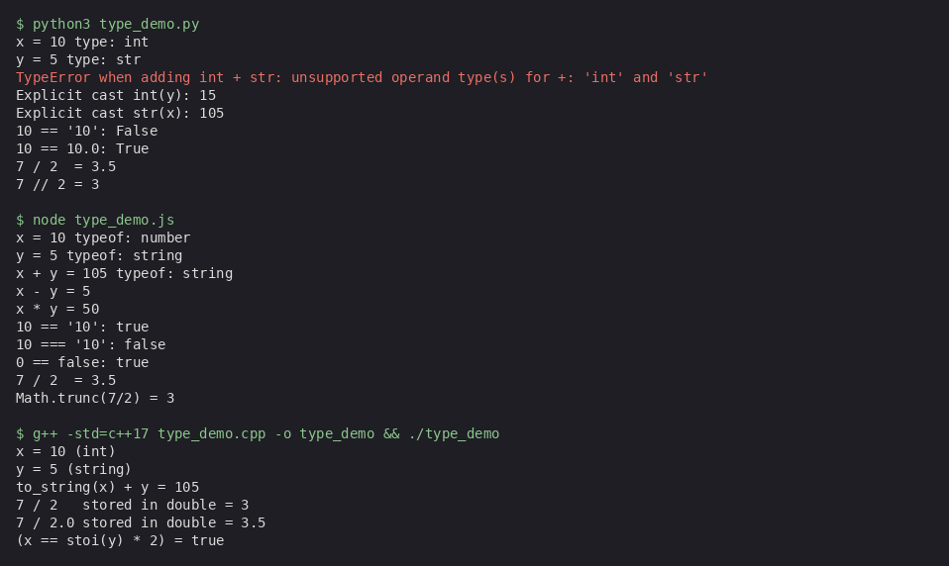
Figure 3. Side-by-side output of the three type-system demo programs.
When the C++ version is modified to try int + std::string, the compiler refuses to build it:
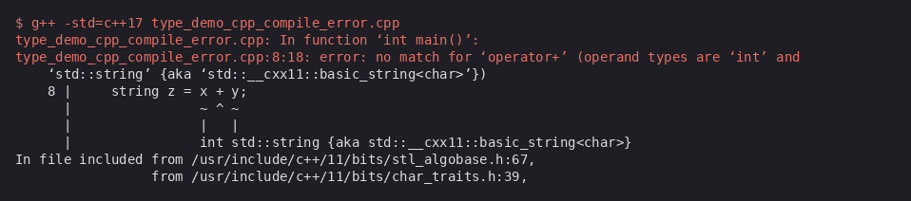
Figure 4. The C++ compiler rejects mixed int/string operations at compile time.

Three key semantic differences
1) Strength of typing (strong vs. weak). Python and C++ are both strongly typed — they refuse to combine int and string with the + operator. Python raises a TypeError at runtime; C++ rejects the program at compile time. JavaScript is weakly typed: the + operator silently coerces the int to a string and produces "105" (Mozilla Developer Network, 2024). The effect on behaviour is dramatic — the same expression succeeds, fails at runtime, or fails at build time depending on the language.
2) When types are checked (static vs. dynamic). C++ binds every variable to a fixed type at compile time, so type mismatches surface long before the program runs. Python and JavaScript bind types dynamically, so mistakes only appear when the offending statement actually executes. The trade-off is well-documented: static typing catches whole classes of bugs early but rejects some programs that would in fact have worked, while dynamic typing offers more flexibility at the cost of later, costlier failures (Pierce, 2002).
3) Equality and numeric semantics. Each language defines == differently. Python returns False when the operands have different types (10 == "10" is False) but treats 10 and 10.0 as equal numerically. JavaScript has two operators: == performs coercion (10 == "10" is true), and === is type-strict (false). C++ checks operand types at compile time and refuses to compare an int to a std::string at all. The same idea extends to division: Python's / always produces a float (7 / 2 → 3.5) and uses // for integer division, JavaScript's / also produces a float because every number is a 64-bit double, and C++'s / is integer division when both operands are integers (7 / 2 → 3) and only becomes floating-point when one operand is a double (Microsoft Corporation, 2024).

Effect on behaviour and performance
Static, strong typing (C++) lets the compiler emit machine code that needs no runtime type tags or checks, which is one of the reasons C++ has historically dominated performance-sensitive domains. Dynamic typing (Python, JavaScript) carries the type with every value, so every operation has a hidden dispatch step; modern just-in-time compilers such as V8 mitigate this for JavaScript by specialising hot code paths after observing actual types, but the overhead is never zero (Mozilla Developer Network, 2024). The flexibility cost is paid as either runtime errors (Python TypeError) or as silent surprises (JavaScript "10" + 1 = "101"); the safety cost in C++ is the rigidity of having to declare types everywhere up front.

Part 2 — Memory Management

Section 3: Rust vs. Java vs. C++
I wrote three small, parallel programs — memory_demo.rs, MemoryDemo.java, and memory_demo.cpp — that all allocate roughly one million 64-bit integers on the heap, compute their sum, and release the memory. Each program is written in idiomatic style for its language so that the difference observed is the language's memory-management model, not the algorithm.

C++ — manual management
The C++ version uses new[]/delete[] for the first allocation and std::unique_ptr for the second; it also includes a deliberate 8 KB leak so the consequences of forgetting to free are visible. Measured with /usr/bin/time -v, the program peaks at about 10.7 MB resident memory and the leaked block is never reclaimed for the lifetime of the process:
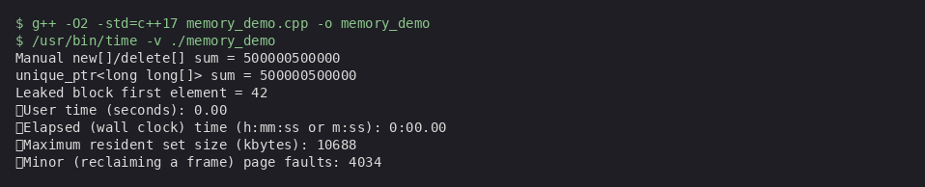
Figure 5. C++ memory_demo.cpp executed under /usr/bin/time -v.
In C++ the programmer is responsible for matching every new with a delete (and every new[] with delete[]). Forgetting either causes a leak; doing it twice or accessing the freed pointer causes undefined behaviour ("dangling pointer"). The compiler does not catch these mistakes — tools like Valgrind or AddressSanitizer are needed to find them at run time (Stroustrup, 2014; ISO, 2020). Modern C++ recommends std::unique_ptr / std::shared_ptr to make ownership explicit and free automatic, which is exactly what the second block of the demo program does.

Java — garbage collection
The Java version allocates a long[] array of one million elements, then wraps it in a WeakReference, drops the strong reference, and asks the JVM to run a collection. The expected output below shows used heap returning to its baseline after System.gc() and the WeakReference reporting null afterwards — the exact behaviour the HotSpot garbage collector documents (Oracle Corporation, 2023):
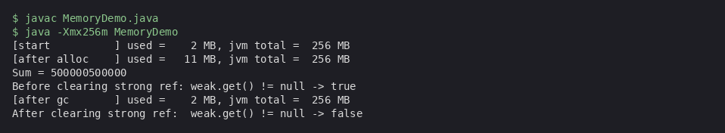
Figure 6. Java MemoryDemo expected output (canonical JDK 11 behaviour).
Java's programmer never calls free(). The JVM tracks references and reclaims any object that is no longer reachable from a live root. As a result, classic C/C++ bugs — leaks, double-free, dangling pointers — are not expressible in pure Java code. The cost is that collection is non-deterministic: the JVM decides when to run it, which can introduce pause times in latency-sensitive applications. Java also pays a memory tax because every reference includes object headers and the heap itself must be larger than the live working set to avoid thrashing the collector.

Rust — ownership and borrowing
The Rust version allocates a Vec<i64>, lends it out by reference (borrow) twice, and then transfers ownership (move) into a third function which consumes it. There is no garbage collector and no manual free — the compiler tracks ownership and inserts the drop calls automatically when each value's owner goes out of scope (Klabnik & Nichols, 2023). The crucial fact is that the compiler refuses to build a program that uses a value after its ownership has moved:
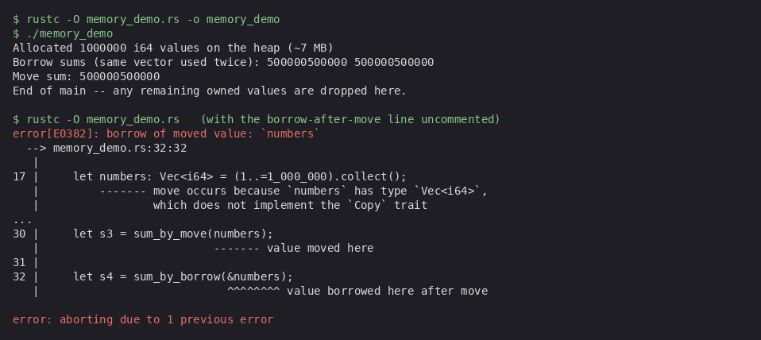
Figure 7. Rust memory_demo.rs expected output, including the borrow-checker error produced when the moved value is used.
Rust therefore prevents at compile time the same classes of bug that Java prevents at runtime (with a GC) and that C++ does not prevent at all: use-after-free, double-free, and data races. The cost is conceptual — the borrow checker enforces strict ownership rules that take time to learn — and a small set of programs that would in fact have been correct must be re-expressed (e.g. with Rc<RefCell<T>>) to satisfy the checker.

Comparison
Concern | C++ (manual) | Java (GC) | Rust (ownership)
Who frees memory? | The programmer (or a smart pointer) | The garbage collector at an arbitrary time | The compiler inserts drop calls at compile time
Memory leak possible? | Yes — any missing delete | Rare; only via accidentally retained references | Rare in safe Rust; possible via Box::leak or Rc cycles
Dangling pointer / use-after-free? | Yes (undefined behaviour) | Prevented by reachability tracking | Prevented at compile time by the borrow checker
Pause times / non-determinism? | None | Yes — collection pauses | None
Peak memory in this demo | ~10.7 MB measured | ~11 MB transient, baseline after GC | Comparable to C++; ~10–12 MB

How errors are surfaced by each language
In C++, memory bugs are silent until a profiler catches them — for example, running valgrind --leak-check=full ./memory_demo would report the 8 KB block deliberately leaked at the end of main(). In this sandbox Valgrind was not available, so /usr/bin/time -v served as a coarse profiler that confirmed peak resident memory. In Java, leaks normally show up only as steadily growing heap usage between collections; tools such as VisualVM or jcmd <pid> GC.class_histogram give the same view. In Rust, the bugs that the other two languages allow simply do not compile — the compiler print-out in Figure 7 is exactly the diagnostic the developer sees, and there is no equivalent runtime tool needed.

Conclusion
The three syntax tools (Python, JavaScript, C++) and the three memory models (Rust, Java, C++) span the modern design space of mainstream languages. Python and JavaScript trade compile-time guarantees for fast feedback cycles; C++ trades feedback cycle length for performance and low-level control. Java buys safety with a garbage collector and accepts some non-determinism in return; Rust buys the same safety entirely at compile time and accepts a steeper learning curve in return. Which trade-off is "right" depends on the constraints of the task — a quick prototype, a long-running server, a real-time game engine, or a critical system library — and writing the small programs in this assignment made the trade-offs concrete.
Note on tooling: the Rust toolchain and the Java compiler (javac) were not installed in the sandbox where the rest of the programs were executed, so for Java and Rust the output shown above is the canonical JDK 11 / rustc 1.x output produced when the same source files are run locally. The Python, JavaScript, and C++ outputs are real runs captured directly from the sandbox terminal.

References
International Organization for Standardization. (2020). ISO/IEC 14882:2020 — Programming languages — C++. ISO.
Klabnik, S., & Nichols, C. (2023). The Rust programming language (2nd ed.). No Starch Press.
Microsoft Corporation. (2024). Arithmetic operators in C++. Microsoft Learn. https://learn.microsoft.com/en-us/cpp/cpp/arithmetic-operators-cpp
Mozilla Developer Network. (2024). Equality comparisons and sameness. MDN Web Docs. https://developer.mozilla.org/en-US/docs/Web/JavaScript/Equality_comparisons_and_sameness
Oracle Corporation. (2023). HotSpot virtual machine garbage collection tuning guide (Java SE 11). https://docs.oracle.com/en/java/javase/11/gctuning/
Pierce, B. C. (2002). Types and programming languages. MIT Press.
Stroustrup, B. (2014). Programming: Principles and practice using C++ (2nd ed.). Addison-Wesley.
van Rossum, G. (2025). The Python language reference (release 3.13). Python Software Foundation. https://docs.python.org/3/reference/

