Ride Sharing System: An OOP Comparison in C++ and Smalltalk
Zheyu Han
June 10, 2026
GitHub repository: https://github.com/hzy-stack/MSCS-632-M30

1. Overview
This assignment implements a small ride-sharing system in two object-oriented languages — C++ and Smalltalk — to compare how each language expresses the three core principles of object-oriented programming: encapsulation, inheritance, and polymorphism. Both implementations share the same class structure (Ride, StandardRide, PremiumRide, Driver, Rider) so the language-specific differences stand out without being confounded by design changes.

2. How Each OOP Principle Is Used

Encapsulation
C++. Each class hides its data members behind access specifiers. Ride keeps rideID, pickupLocation, dropoffLocation, and distance as protected so derived classes can read them, while Driver and Rider declare assignedRides and requestedRides as private std::vector<std::shared_ptr<Ride>> members. Callers can only modify those collections through addRide() and requestRide(); they cannot reach in and mutate the list directly. This is the classic compile-time enforcement that C++ provides (Stroustrup, 2014).
Smalltalk. In Smalltalk all instance variables are private by default — there is no public or protected keyword. The only way to read or write rideID, assignedRides, etc. is to send an accessor message defined inside the class (e.g. rideID, addRide:). The implementations of those messages live in the class itself, so encapsulation is structural, not just a convention: an outside object literally has no syntax to peek inside (Goldberg & Robson, 1989).

Inheritance
C++. StandardRide and PremiumRide are declared with class StandardRide : public Ride and class PremiumRide : public Ride. They inherit the data members and the rideDetails() method from Ride and add their own override of fare() and rideType(). The base class declares fare() and rideType() as pure virtual (= 0), which makes Ride an abstract class that cannot itself be instantiated.
Smalltalk. The same hierarchy is built with Ride subclass: #StandardRide and Ride subclass: #PremiumRide. The base Ride defines fare and rideType to return self subclassResponsibility — Smalltalk's idiomatic equivalent of an abstract method that raises an error if the subclass forgets to implement it. The shared rideDetails behaviour is inherited verbatim from Ride and re-used by both subclasses without any further code.

Polymorphism
C++. main() puts the four rides into a std::vector<std::shared_ptr<Ride>> and iterates with for (const auto& ride : allRides) ride->rideDetails(). Because rideDetails() and fare() are virtual, the call resolves through the v-table to the correct subclass method at run time. The compiler statically sees only Ride*, but the program prints the right "Standard" or "Premium" details for each element.
Smalltalk. Polymorphism is the default in Smalltalk because every method call is dynamic message passing. The script puts the rides in an OrderedCollection and writes allRides do: [ :ride | ride rideDetails ]. The receiver decides at run time which fare and rideType method to execute. There is no special "virtual" keyword because every method already behaves that way (Black et al., 2010).

3. Sample Output
Both programs print the same headings ("All rides", "Driver report", "Rider report") and produce the same fares, demonstrating that the two implementations are behaviourally equivalent and that the polymorphic dispatch picks the right fare() method for each subclass in both languages.
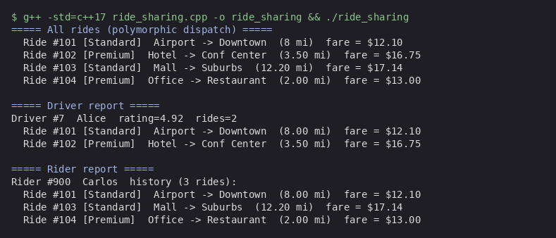
Figure 1. C++ output (./ride_sharing).
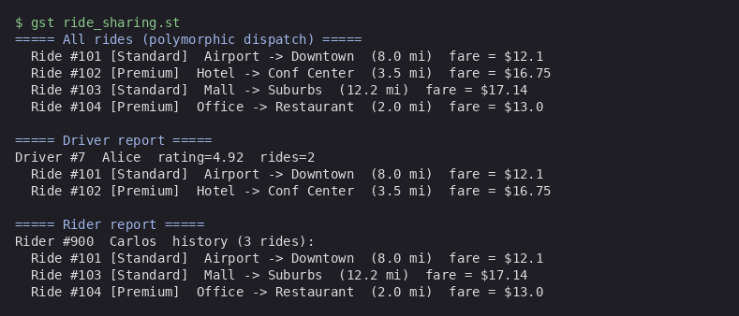
Figure 2. Smalltalk expected output (gst ride_sharing.st, canonical GNU Smalltalk behaviour).

4. Conclusion
Both languages support the three OOP principles cleanly, but with very different ergonomics. C++ uses compile-time keywords (private, virtual, override) to enforce structure, and the compiler catches mistakes before the program runs. Smalltalk leaves almost everything to run time: instance variables are inherently private, every method is virtual, and the language relies on conventions like subclassResponsibility for things C++ enforces statically. The result is roughly the same class hierarchy in both languages, with Smalltalk's implementation being more compact and dynamic and C++'s being more verbose but statically checked.

References
Black, A. P., Ducasse, S., Nierstrasz, O., Pollet, D., Cassou, D., & Denker, M. (2010). Pharo by example. Square Bracket Associates.
Goldberg, A., & Robson, D. (1989). Smalltalk-80: The language. Addison-Wesley.
Stroustrup, B. (2014). Programming: Principles and practice using C++ (2nd ed.). Addison-Wesley.

Appendix: Source-Code Screenshots
Full source files are also available in the GitHub repository linked on the cover page.
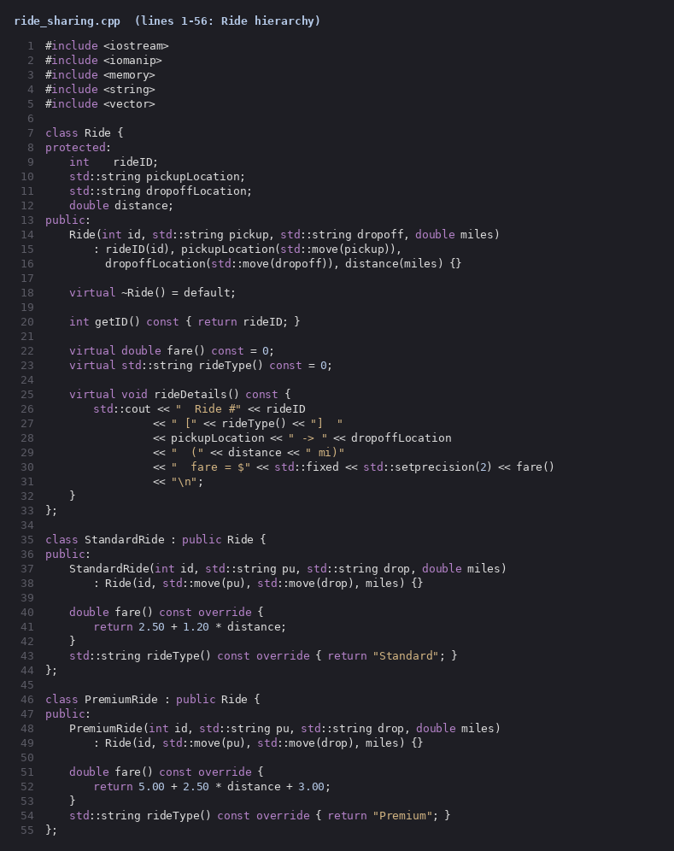
Figure 3. C++ source — Ride, StandardRide, PremiumRide.
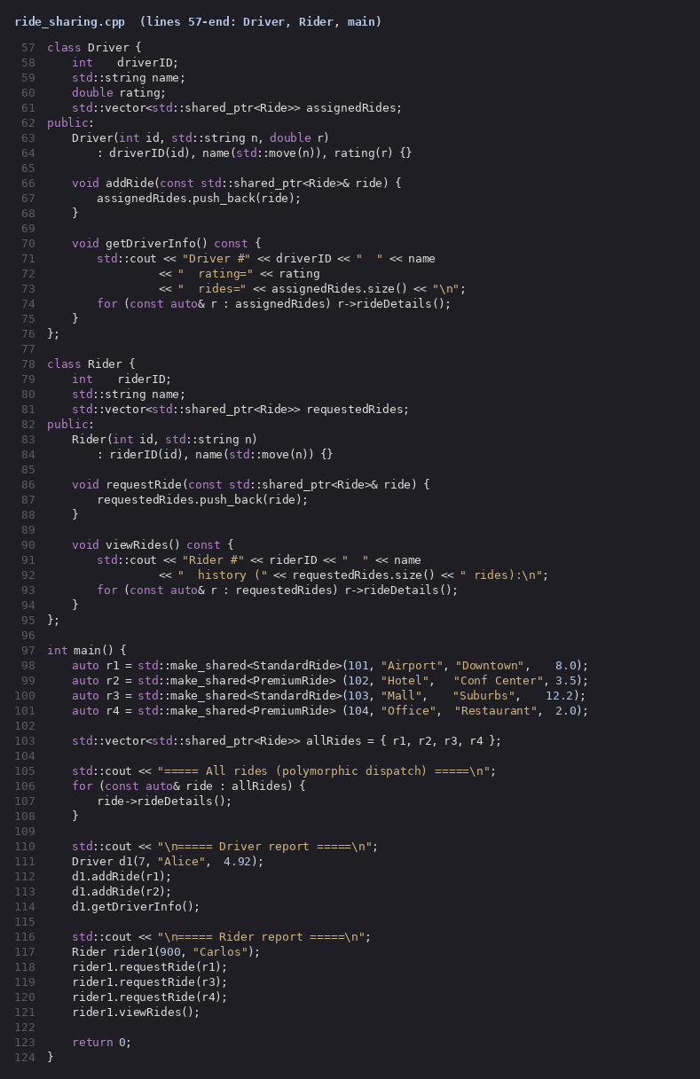
Figure 4. C++ source — Driver, Rider, and main() polymorphism demo.
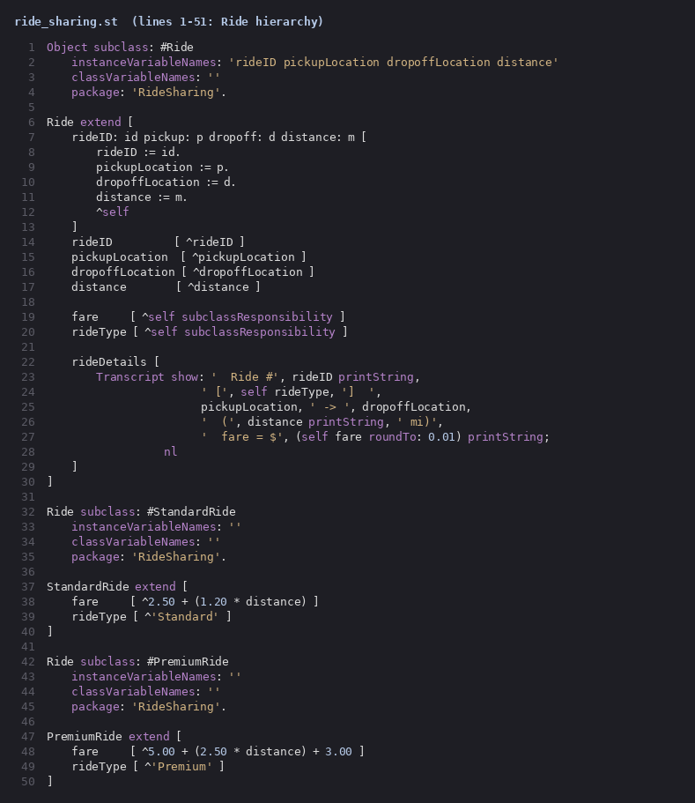
Figure 5. Smalltalk source — Ride hierarchy with subclassResponsibility.
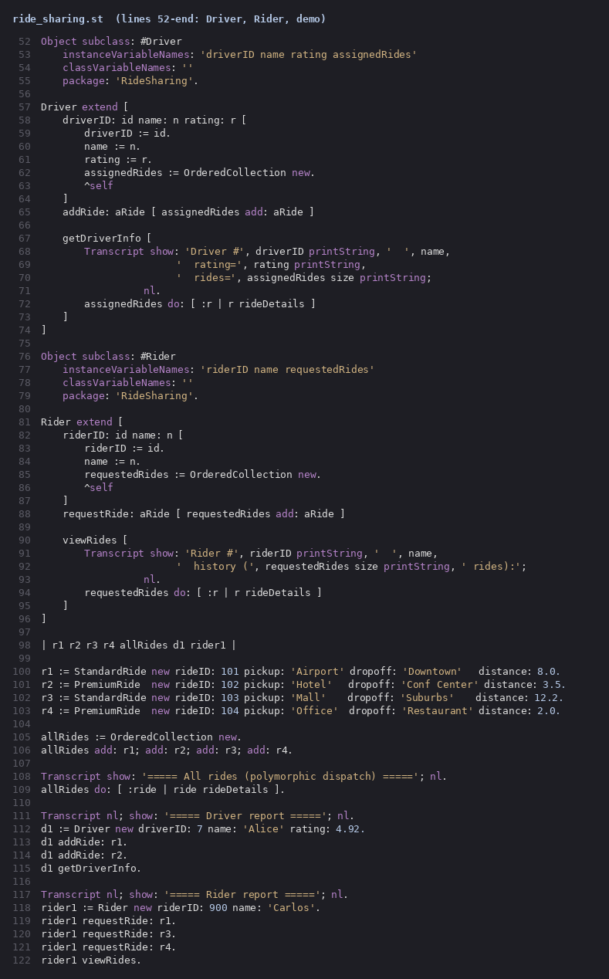
Figure 6. Smalltalk source — Driver, Rider, and polymorphic demo block.

