Designing a Multi-Threaded Data Processing System in Java and Go

Zheyu Han
University of the Cumberlands
MSCS-632-M30
June 21, 2026

Designing a Multi-Threaded Data Processing System in Java and Go
Designing a Multi-threaded data processing system in Java and Go. Concurrent programs improve throughput by performing independent tasks at the same time, however, they also result in race conditions, deadlocks and resource leaks (Goetz et al., 2006). We have presented in this paper a multi-threaded data processing system which is implemented once in Java and once in Go, so that we can compare the concurrency and exception handling in both languages. In both cases a pool of workers fetches tasks from a shared queue, simulating the computation time and writing the results to a shared collection that is saved to a file.
Concurrency Techniques
Java
The Java implementation is based on shared memory, where several threads work on common objects that need to be protected in advance. The shared queue TaskQueue provides access to addTask() and getTask() methods whose bodies are protected by a ReentrantLock. The Condition variable enables the getTask() to be executed efficiently if the queue is empty, rather than busy-waiting, where a producer declares a condition after every insertion (Goetz et al., 2006). Worker threads are not created directly, but rather are submitted to a fixed-size ExecutorService (Oracle, 2023) to reuse a pool of threads and make the whole process easier. The shared results list is serialized with a block that is synchronized so that extra threads can't corrupt it. Safe termination is achieved by a “poison pill”: one sentinel task per worker gets inserted into the queue, so that at some point every worker gets a stop signal and the main thread calls shutdown() and waits for termination to join all threads.
The following output demonstrates the Java workers processing 20 tasks concurrently, with thread-safe queue access and poison-pill termination.
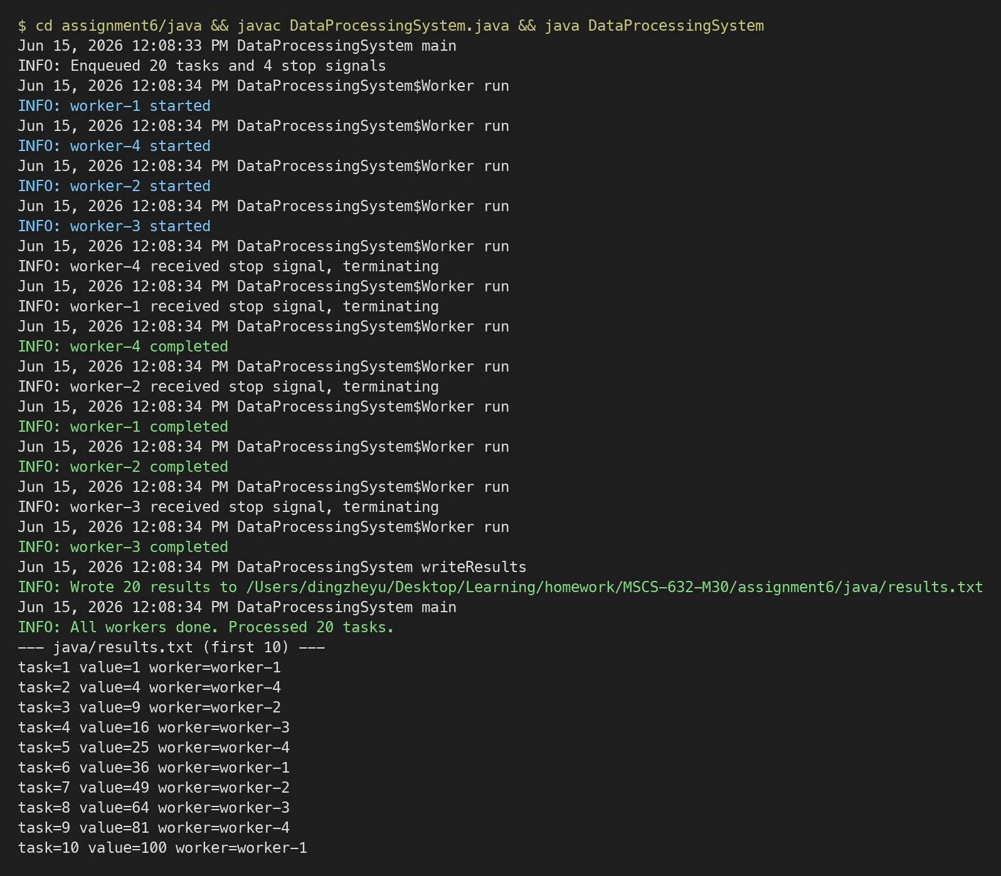
Go
The Go implementation follows the communicating sequential processes model, epitomized by the phrase: “do not communicate by sharing memory; instead, share memory by communicating” (Donovan & Kernighan, 2015). Rather than locking a shared structure, tasks go through a buffered channel, which is concurrency-safe, so addTask and getTask are channel send and receive operations. Each worker is a goroutine, a lightweight runtime-scheduled function, which starts with the go keyword and returns results in a second channel that is drained by the main goroutine. Termination is signaled by closing the tasks channel: each worker's range loop ends automatically when the channel is empty. A sync.WaitGroup keeps track of the active workers and a small goroutine closes the results channel once wg.Wait() is finished, which ends the collector loop without any risk of deadlock (The Go Authors, 2023).
The following output shows the Go workers processing tasks through channels, with goroutine-based concurrency and channel-close termination.
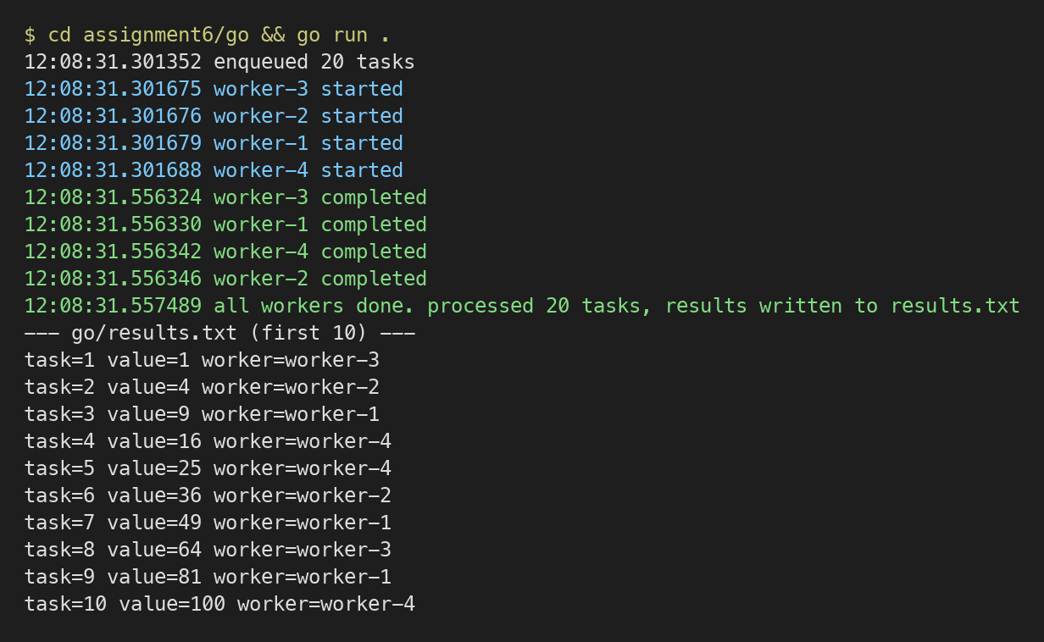
Exception and Error Handling
Java
Java signals failures with exceptions. When blocking calls like getTask() and Thread.sleep() throw InterruptedException, each worker catches it, re-asserts the interrupt flag with Thread.currentThread().interrupt(), and exits gracefully so the pool can shut down cleanly. The file output is encapsulated in a try-with-resources statement that keeps the BufferedWriter closed even if there is an IOException, and that is caught and logged at the SEVERE level instead of crashing the program. A wide catch for RuntimeException shields all the workers from unexpected faults so that a bad task can't bring down the whole pool.
The following source code shows the Java implementation, highlighting the ReentrantLock-based TaskQueue, Worker exception handling, and ExecutorService lifecycle management.
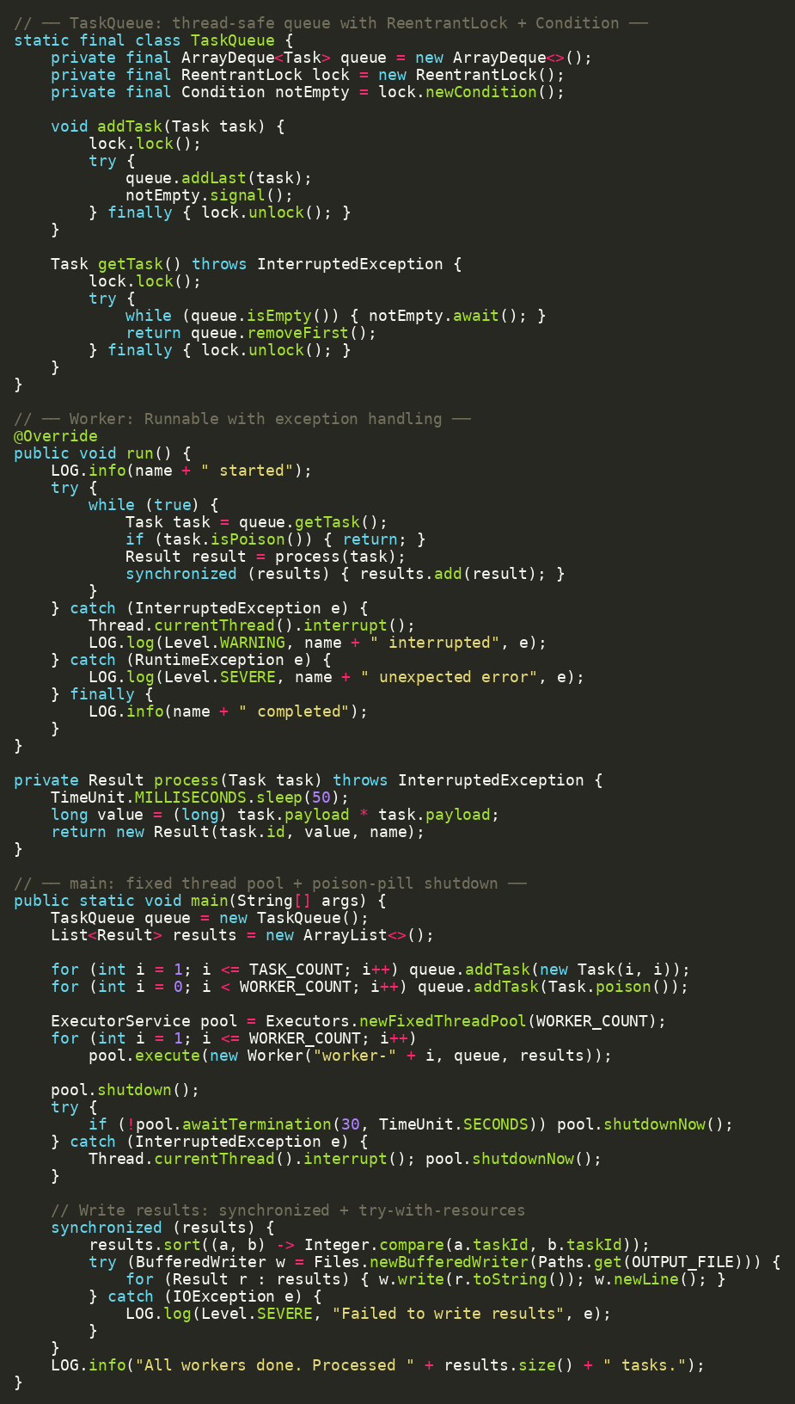
Go
Go treats errors as ordinary return values that the caller must inspect. The process function returns a (Result, error) pair, and the worker checks the error after every call, logging it and moving on to the next task instead of aborting. The writeResults function returns an error that is wrapped with fmt.Errorf and the %w verb to preserve context, and it uses a deferred call to close the file; that deferred function also captures the close error so a failed flush is never lost silently. In main, a fatal write error is reported with log.Fatalf. The defer statement is Go’s idiom for guaranteed resource cleanup, playing a role similar to try-with-resources in Java.
The following source code shows the Go implementation, highlighting the channel-based worker goroutines, error-return pattern, and defer-based resource cleanup.

Github repo: https://github.com/hzy-stack/MSCS-632-M30.
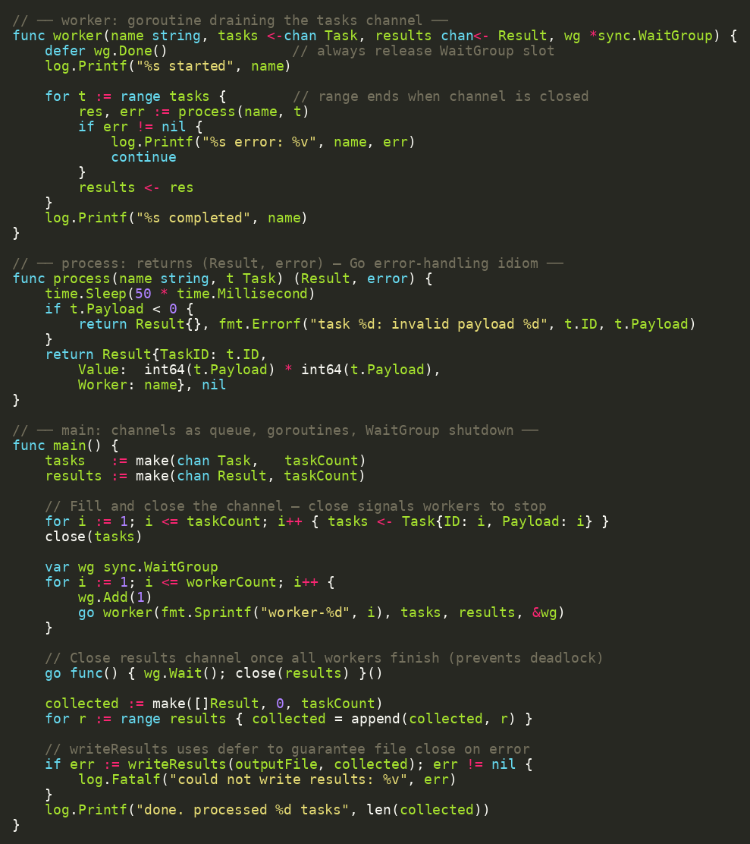
Comparing the Two Concurrency Models
The two implementations illustrate fundamentally different philosophies. Java exposes operating-system threads and relies on explicit synchronization primitives—locks, condition variables, and synchronized blocks—to coordinate access to shared state. This model is powerful, but it places the burden of correctness on the programmer, who must prevent both race conditions and lock-ordering deadlocks. Go instead encourages structuring a program around channels, so that ownership of data passes from one goroutine to another and explicit locking is rarely required. Goroutines are also far cheaper than threads: the runtime multiplexes thousands of them onto a small number of operating-system threads, whereas Java threads map one-to-one to operating-system threads and are pooled through executors to limit overhead (Donovan & Kernighan, 2015).
The languages also differ in error handling. Java’s checked exceptions force the programmer to acknowledge failures such as InterruptedException and IOException through try-catch blocks, and exceptions propagate up the call stack automatically. Go makes failure explicit and local: every call that can fail returns an error that must be handled at the call site, and defer ensures resources are released on the way out. Both approaches satisfy the assignment’s requirements—no deadlocks, no missed or duplicated work, and a clean shutdown—but Java emphasizes disciplined control over shared memory, whereas Go emphasizes safe communication between independent processes.
Conclusion
Implementing the same data processing system in Java and Go showed how each language’s concurrency model shapes program design. Java’s lock-based, shared-memory approach with executors and exceptions produced a robust solution at the cost of explicit synchronization, while Go’s channel-based, message-passing approach with goroutines and explicit error values produced a concise solution with minimal locking. Familiarity with both models lets a developer choose the most appropriate tool for a given concurrent workload.
References
Donovan, A. A. A., & Kernighan, B. W. (2015). The Go programming language. Addison-Wesley Professional.
Goetz, B., Peierls, T., Bloch, J., Bowbeer, J., Holmes, D., & Lea, D. (2006). Java concurrency in practice. Addison-Wesley Professional.
Oracle. (2023). Concurrency (The Java™ tutorials). https://docs.oracle.com/javase/tutorial/essential/concurrency/
The Go Authors. (2023). Effective Go. https://go.dev/doc/effective_go

