Assignment 4: Implementing Control Structures
MSCS-632-M30 — Zheyu Han

Overview
This assignment implements an employee shift scheduler in two contrasting languages — Python (dynamically typed, interpreted) and Java (statically typed, compiled). Both programs schedule ten employees across morning, afternoon, and evening shifts for a Monday–Sunday week, using the same hard-coded inputs and the same random seed so their outputs are directly comparable.

Languages Chosen
- Python 3 — dynamic typing, dictionaries, list comprehensions.
- Java 17 — static typing, generic collections (LinkedHashMap / ArrayList), explicit type declarations.

Scheduling Rules Enforced
- No employee works more than one shift per day.
- No employee works more than five days per week.
- Each shift requires at least two employees per day; if preferences fall short, additional staff are randomly drawn from employees who have not yet hit their 5-day cap.
- If an employee's preferred shift is full, the scheduler tries another shift on the same day, then the preferred shift on the next day.

Control Structures Demonstrated
Both programs exercise conditional branching (preference vs. conflict resolution), nested loops over days and shifts, helper functions, and a randomized fallback loop that runs until every shift meets the minimum-staffing requirement. The Python version uses a list comprehension to filter candidate employees, while the Java version uses an explicit for-loop with a guard clause — a clear stylistic contrast between the two languages.

GitHub Repository
Source code is available at: https://github.com/hzy-stack/MSCS-632-M30
Assignment 4 source files live under the assignment4/ folder: python/scheduler.py and java/Scheduler.java.

How to Run

Python
cd assignment4/python
python3 scheduler.py

Java
cd assignment4/java
javac Scheduler.java
java Scheduler

Final Schedule Output
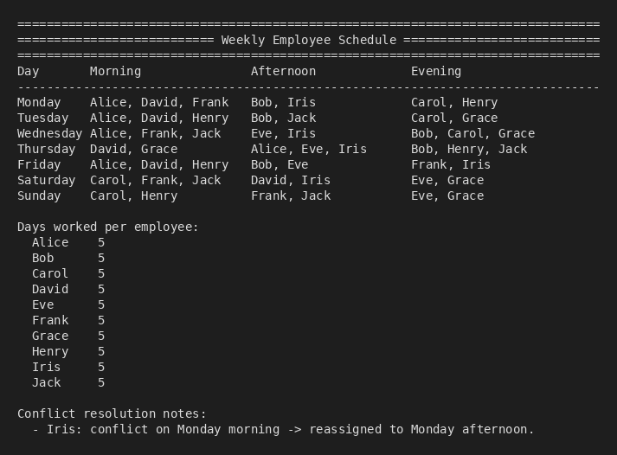

Notes
MAX_PER_SHIFT is set to 3 to intentionally force a conflict in the sample input so that the conflict-resolution branch is exercised: Iris's preferred Monday morning shift is full and she is reassigned to Monday afternoon, which is captured in the program's "Conflict resolution notes" section at the bottom of the output.

