SPRINT 1 VALIDATION REPORT
Restaurant Table Reservation Management System

1. Purpose and scope
During Sprint 1, we focused on getting the basic table reservation process working from start to finish. We ran the application locally, made bookings through the website, checked how the API responded to conflicts, and looked at the saved records in MongoDB. This report summarizes what we tested, along with screenshots from the checks. Staff login, reservation changes and cancellations are planned for later work and were not part of this review.

2. Team responsibilities
Member | Role | Validation contribution
Jean Mesmer Allou | Business Analyst / Project Manager | Reviewed the booking flow against our requirements, carried out local checks and collected screenshots for this report
Hongzhi Yu (Tom) | Developer Lead | Developed the application and booking logic and maintained the implementation
Patel Adarsh Vijaybhai | Quality Assurance | Responsible for QA test cases, tracking issues and follow-up testing
These results come from the local checks and test output available at the time of writing. They should not be taken to mean that Patel independently repeated every test.

3. Environment and readiness
Check | Observed result
Application | React/Vite at localhost:5173; Express API at localhost:4000
Database | Local MongoDB; restaurant_reservations database viewed in Compass
API health | GET /api/health returned ok: true with America/Toronto timezone
Automated tests | Vitest: 11 test files passed, 62 tests passed
Static checks | TypeScript typecheck completed without reported errors
Build | Vite production client build completed successfully

4. Functional test results
ID | Scenario | Observed result | Status
S1-F01 | Create 2-guest reservation at 14:30 | T1 assigned, 14:30–16:00; reference RZ65T2A9 | PASS
S1-F02 | Repeat same date/time for 2 guests | T2 assigned, not occupied T1; reference RVSDQTCU | PASS
S1-F03 | Create 6-guest reservation at 16:00 | T5 assigned, 16:00–17:30; reference R99B93TD | PASS
S1-F04 | Repeat same date/time for 6 guests | T6 assigned, not occupied T5; reference RNMHAU32 | PASS
S1-F05 | Attempt third 6-guest reservation at 16:00 | 16:00 disabled; overlapping starts 15:00–17:00 disabled | PASS
S1-API01 | Direct POST bypassing frontend for 6 guests at 16:00 | HTTP 409, error code BOOKING_CONFLICT | PASS
S1-DB01 | Inspect tableSlots records | 12 records shown for 4 confirmed bookings (3 slots each) | PASS
S1-DB02 | Inspect MongoDB compound index | tableId_1_slotStart_1 marked UNIQUE, COMPOUND, READY | PASS

5. Acceptance assessment
The booking flow behaved as expected in the cases we tried. When one table was already taken, the system selected another suitable table. When no suitable table remained, the relevant times were unavailable in the interface. We also sent a booking request directly to the API and received a conflict response. MongoDB showed the index used to protect table and time-slot combinations. The automated concurrency tests passed, although we did not separately run a manual test with two requests sent at exactly the same moment.

6. Screenshot evidence — booking allocation
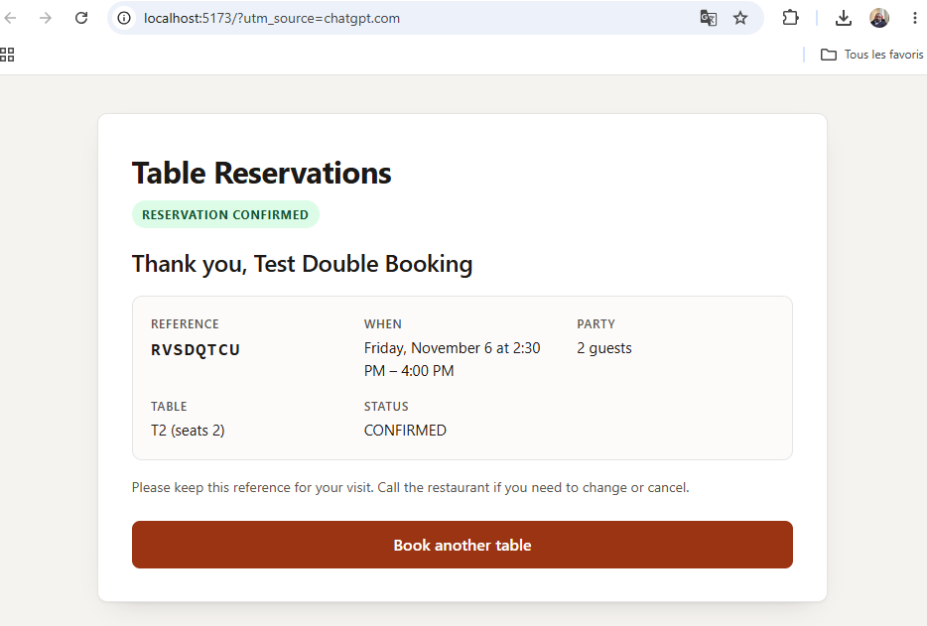
E01 — Second 2-guest reservation assigned to T2 at 14:30–16:00, avoiding occupied T1.
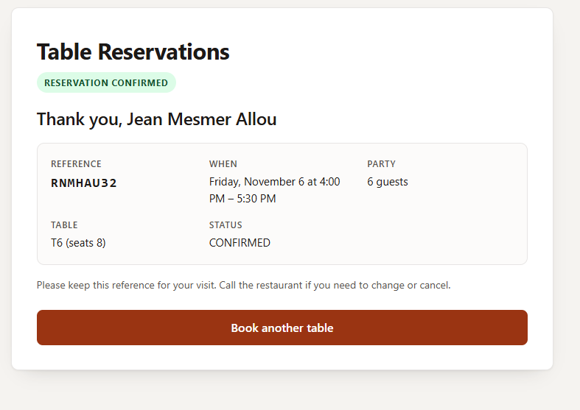
E02 — Second 6-guest reservation assigned to T6 at 16:00–17:30, avoiding occupied T5.

7. Screenshot evidence — conflict handling
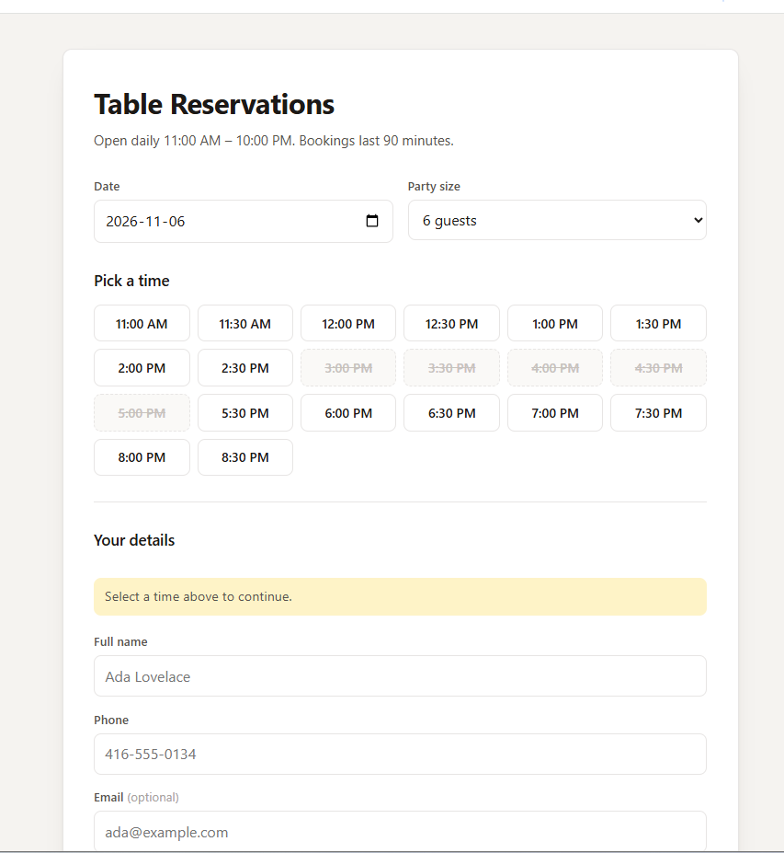
E03 — UI disables 15:00–17:00 start times for 6 guests because their 90-minute windows overlap fully booked tables.
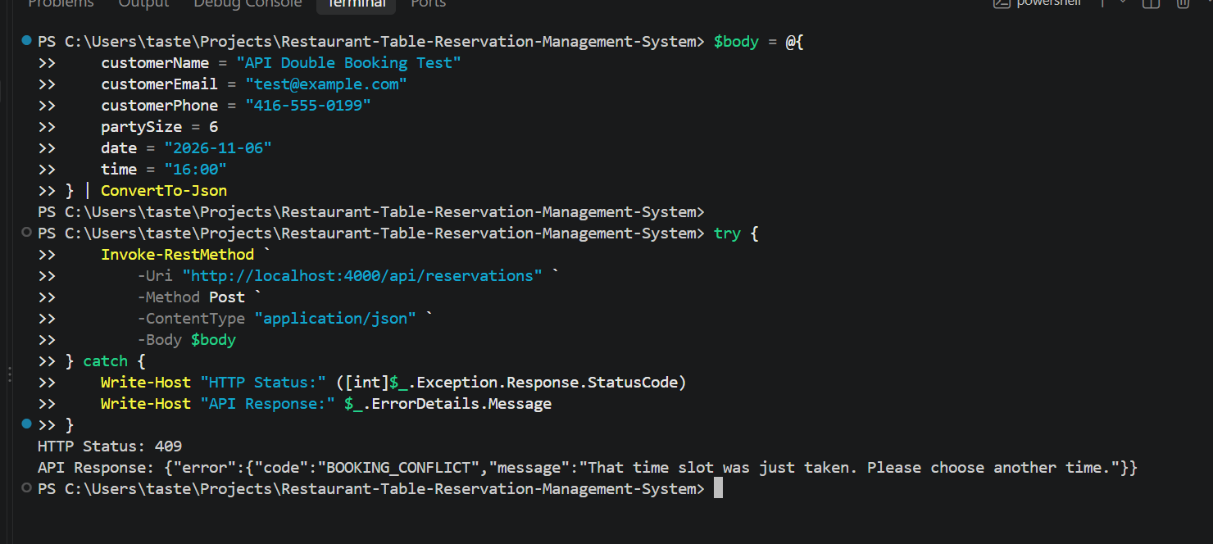
E04 — Direct API POST returns HTTP 409 and BOOKING_CONFLICT.

8. Screenshot evidence — database integrity
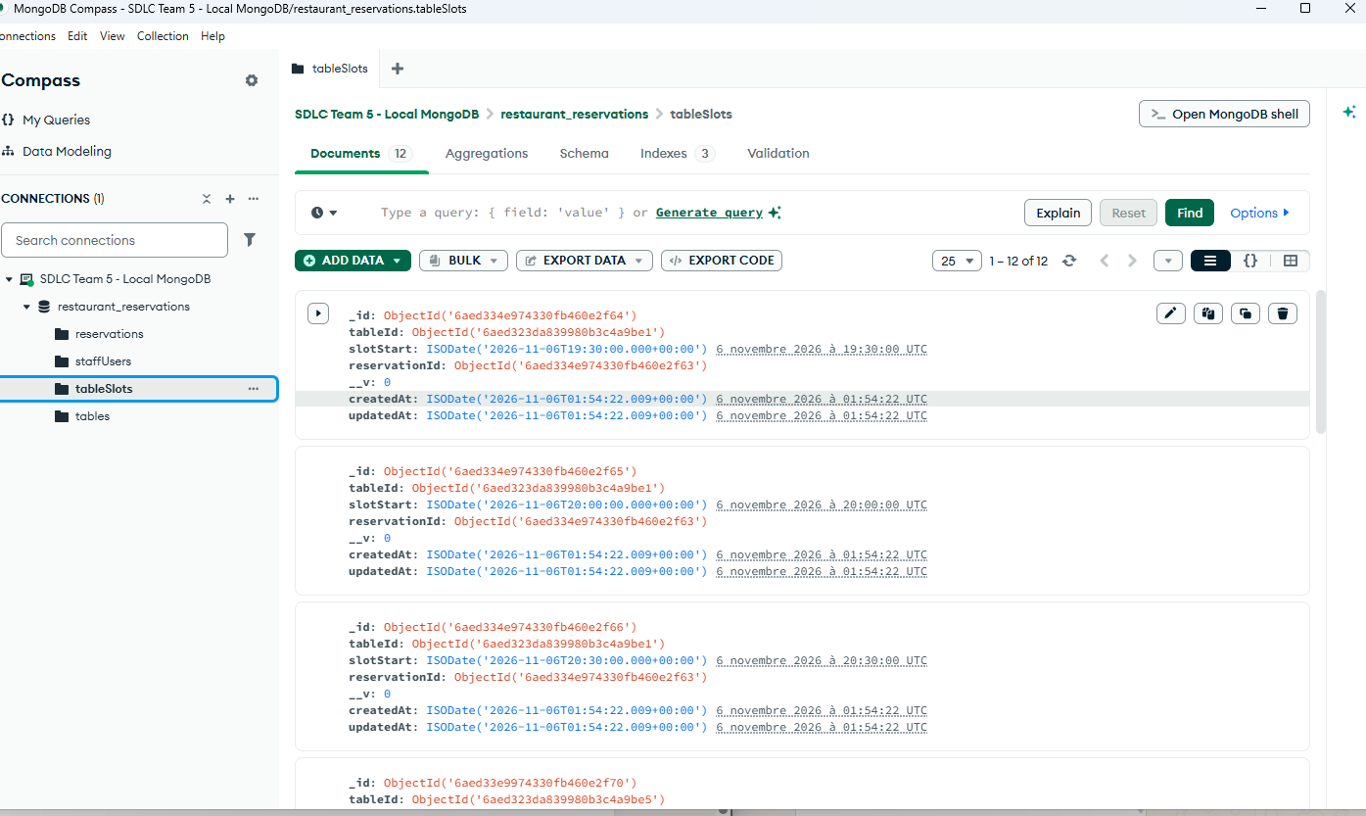
E05 — MongoDB Compass tableSlots collection shows 12 records and tableId, slotStart, reservationId fields.
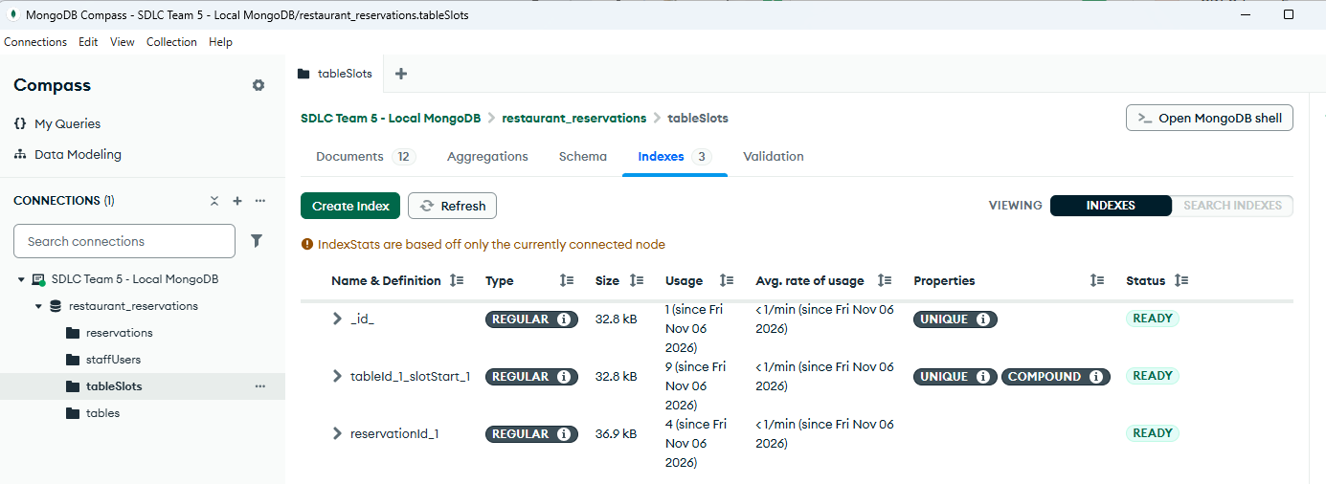
E06 — MongoDB Compass index tableId_1_slotStart_1 has UNIQUE and COMPOUND properties, status READY.

9. Database control explanation
We checked the tableSlots collection in MongoDB Compass. Each 90-minute booking uses three 30-minute slots. The database has a unique compound index on tableId and slotStart, so the same table cannot have two records for the same slot. This is an important safeguard because it works at the database level, not just in the booking screen. The screenshots confirm that the index exists; the more complex concurrency and recovery cases are covered by the automated tests rather than by these screenshots alone.

10. Automated verification evidence
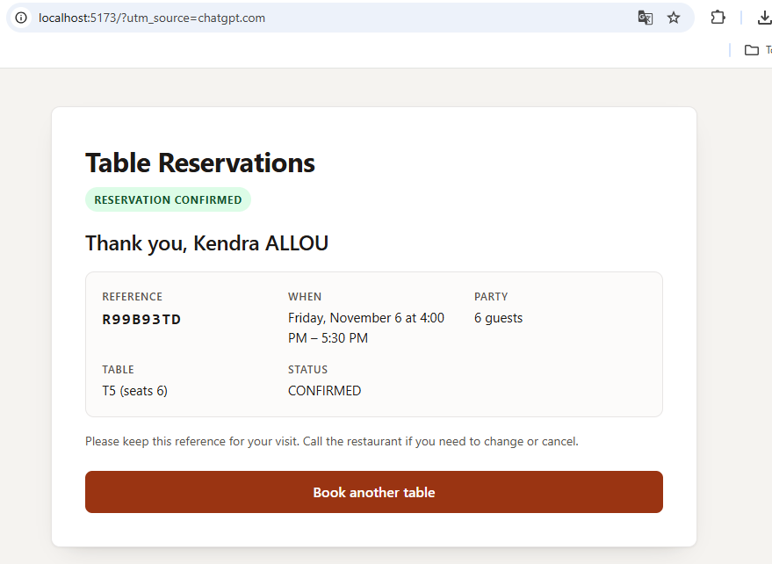
E07 — VS Code terminal: Vitest execution with 11 passed test files and 62 passed tests.
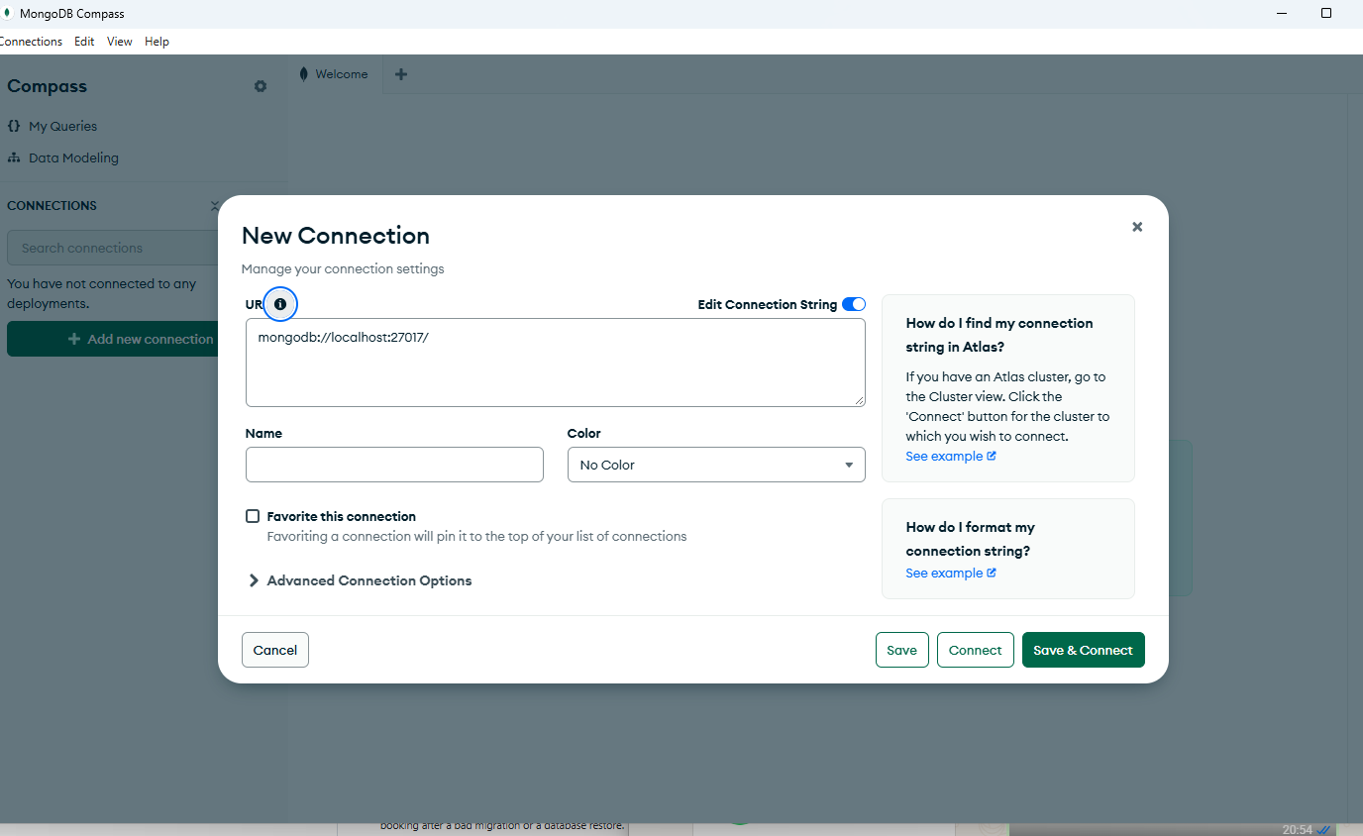
E08 — VS Code terminal: TypeScript checks and successful Vite client build.

11. Limitations and next steps
- Run an additional test with simultaneous booking requests and keep the server logs as evidence.
- Ask Patel to review the database indexes and booking references against the PRD and acceptance criteria.
- Check edge cases such as invalid details, dates in the past, opening and closing times, and daylight-saving changes. Test slot release once cancellation is implemented.
- Record any issues found in the team’s defect tracker. Keep staff features listed as future work.

12. Validation conclusion
Based on the checks we completed, the Sprint 1 booking prototype is working for the scenarios covered in this report. We successfully created reservations, saw bookings saved in MongoDB, and confirmed that a conflicting API request returned HTTP 409. The database index was present and ready, and all 62 automated tests passed. This gives us a good basis to move forward, while leaving the remaining edge cases and independent QA review clearly identified.

