* CREATE DATABASE sql_study
* USE sql_study

CREATE TABLE ss_student

(s_no CHAR(9) PRIMARY KEY,

s_name CHAR(20) UNIQUE,

s_sex CHAR(2),

s_age SMALLINT,

s_dept CHAR(20)

);

CREATE TABLE ss_course

(c_no CHAR(4) PRIMARY KEY,

c_name CHAR(40),

c_pno CHAR(4), /*先修课*/

c_credit SMALLINT,

CONSTRAINT fk_c_pno FOREIGN KEY (c_pno) REFERENCES ss_course(c_no)

);

ALTER TABLE ss_course DROP FOREIGN KEY fk_c_pno;

ALTER TABLE ss_course ADD CONSTRAINT fk_c_pno FOREIGN KEY (c_pno) REFERENCES ss_course(c_no);

CREATE TABLE ss_sc

(s_no CHAR(9),

c_no CHAR(4),

sc_grade SMALLINT,

CONSTRAINT Fk_s_no FOREIGN KEY (s_no) REFERENCES ss_student(s_no),

CONSTRAINT Fk_c_no FOREIGN KEY (c_no) REFERENCES ss_course(c_no)

);

ALTER TABLE ss_sc Add PRIMARY KEY(s_no,c_no);

* -- ----------------------------

-- Records of ss_course

-- ----------------------------

INSERT INTO `ss_course` VALUES ('c1', 'c1', null, '1');

INSERT INTO `ss_course` VALUES ('c2', 'c2', 'c1', '2');

INSERT INTO `ss_course` VALUES ('c3', 'c3', 'c2', '3');

-- ----------------------------

-- Records of ss_sc

-- ----------------------------

INSERT INTO `ss_sc` VALUES ('s1', 'c1', '1');

INSERT INTO `ss_sc` VALUES ('s1', 'c2', '2');

INSERT INTO `ss_sc` VALUES ('s1', 'c3', '3');

INSERT INTO `ss_sc` VALUES ('s3', 'c2', '2');

INSERT INTO `ss_sc` VALUES ('s4', 'c1', '3');

INSERT INTO `ss_sc` VALUES ('s4', 'c3', '1');

INSERT INTO `ss_sc` VALUES ('s5', 'c1', '2');

-- ----------------------------

-- Records of ss_student

-- ----------------------------

INSERT INTO `ss_student` VALUES ('s1', 's1', 'm', '18', '1');

INSERT INTO `ss_student` VALUES ('s2', 's2', 'w', '19', '2');

INSERT INTO `ss_student` VALUES ('s3', 's3', 'w', '20', '3');

INSERT INTO `ss_student` VALUES ('s4', 's4', 'w', '19', '4');

INSERT INTO `ss_student` VALUES ('s5', 's5', 'm', '21', '5');

* SELECT s_no, COUNT(c_no) FROM ss_sc GROUP BY s_no HAVING COUNT(c_no) >= 2;

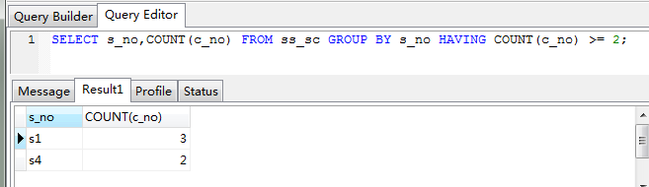

* SELECT * FROM ss_student as s LEFT JOIN ss_sc as s1 ON s.s_no = s1.s_no WHERE s.s_age > 18;

