automated meeting room booking system

TEAM 1- WFS 2

Mentor

DR.Rajesh UPADHYAY

October 12, 2020

Contents

INTRODUCTION 2

KEY FUNCTIONALITIES 2

SYSTEM REQUIREMENTS 2

SYSTEM FLOW 2

USE CASE DIAGRAM 4

CLASS DIAGRAM 5

ENTITY-RELATIONSHIP DIAGRAM 6

CONTEXT DIAGRAM 7

DATA FLOW DIAGRAM 8

# Introduction

The Automated Meeting Room Booking system automates the procedure of booking a meeting room in an organisation. Employees can search and book a meeting room and schedule meetings based on their requirements.

# Key Functionalities

* Login page (Users-Manager, Admin, Member)
* Import Users(Upload file to add new users in XML format)
* Home Page for Users
* Create Meetings (Admin)
* Organize Meetings(Manager)
* View scheduled meetings (Member)
* Security (Hashed passwords and restricting unauthorised Login)
* Logging (Visible last logs for Users and uncaught Exceptions )
* Transactions
* Automatic Session timeout after 240 seconds of inactivity

# System Requirements

* Tomcat Server (9.0.x)
* Derby Database
* Any internet browser(Recommended: IE, Google Chrome, Mozilla Firefox)
* JDK (1.8)
* Spring Tool Suite 4
* JAR files necessary for XML Import User  
   commons-fileupload-1.3.jar  
   commons-io-2.2.jar

# System flow

* The entry point of the program is the Home Page which consists of details of available meeting rooms, option to import users, and a login page.
* Based on the category of the user who logs in, the login page directs them to either an *Admin Home Page*, *Manager Home Page* or *Member Home Page*.
* Admin Home Page

The screen allows admins to create and manage meeting rooms

The page displays:

1. Admin information: User ID, Name, Email, Phone Number, Role, last logged-in.
2. A list of meeting rooms created by that Admin.
3. A link to **Create Room**.
4. A link to **Edit Room.**

* Manager Home Page

The screen allows a manager to view meetings and book a meeting room. The page displays

1. Manager information: User ID, Name, Email, Phone Number, credits, Role, last logged-in.
2. List of scheduled meetings by the logged-in Manager.
   1. List of items display the Meeting Name, Meeting Room, Start Date and Start Time, End Time and Meeting Type
3. Link to Organize Meeting

* Member Home Page

The screen is displayed when a member logs in.

1. It displays the details of all meetings scheduled for the logged-in member.
2. Member information: User ID, Name, Email, Phone Number, Role, last logged-in.

* The system uses Derby database to store data.
* Layered architecture along with an Object Oriented approach has been implemented throughout the system.

# USE CASE Diagram

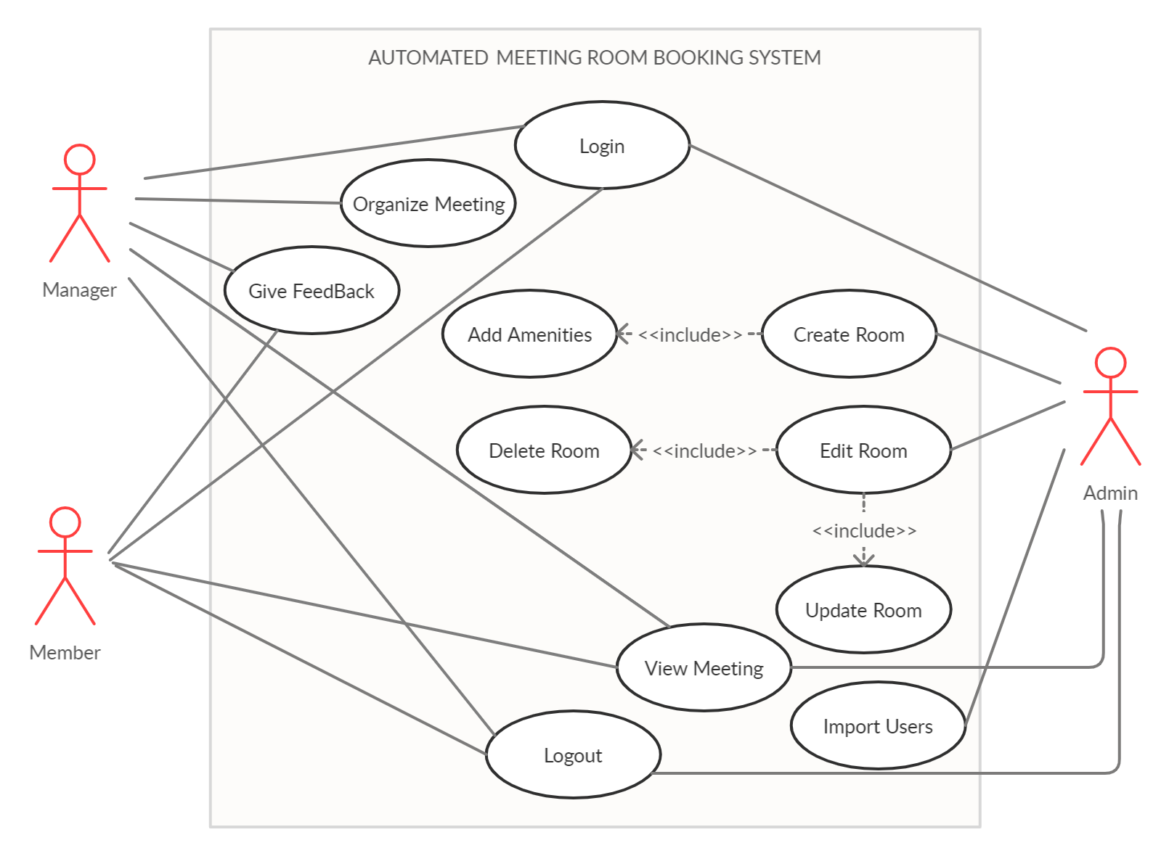

# CLASS DIAGRAM

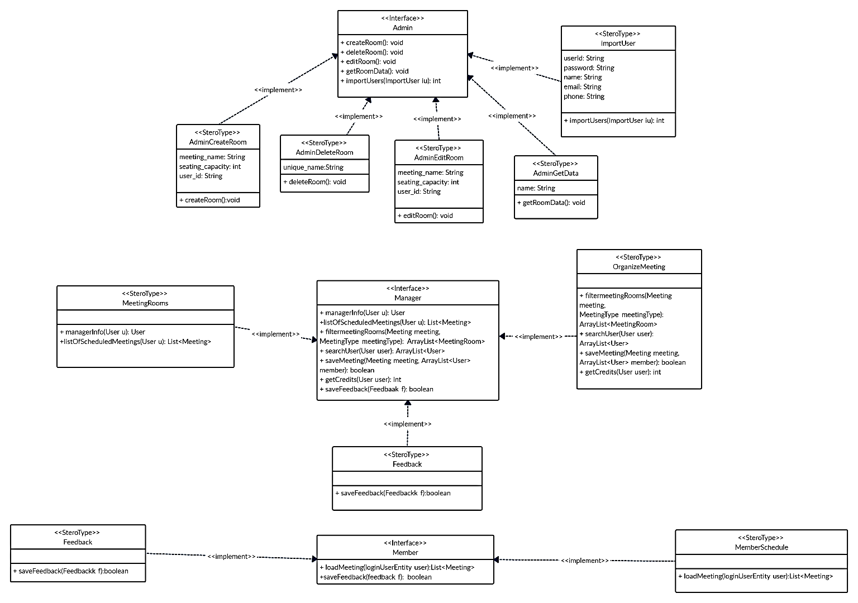

# ENTITY-RELATIONSHIP Diagram

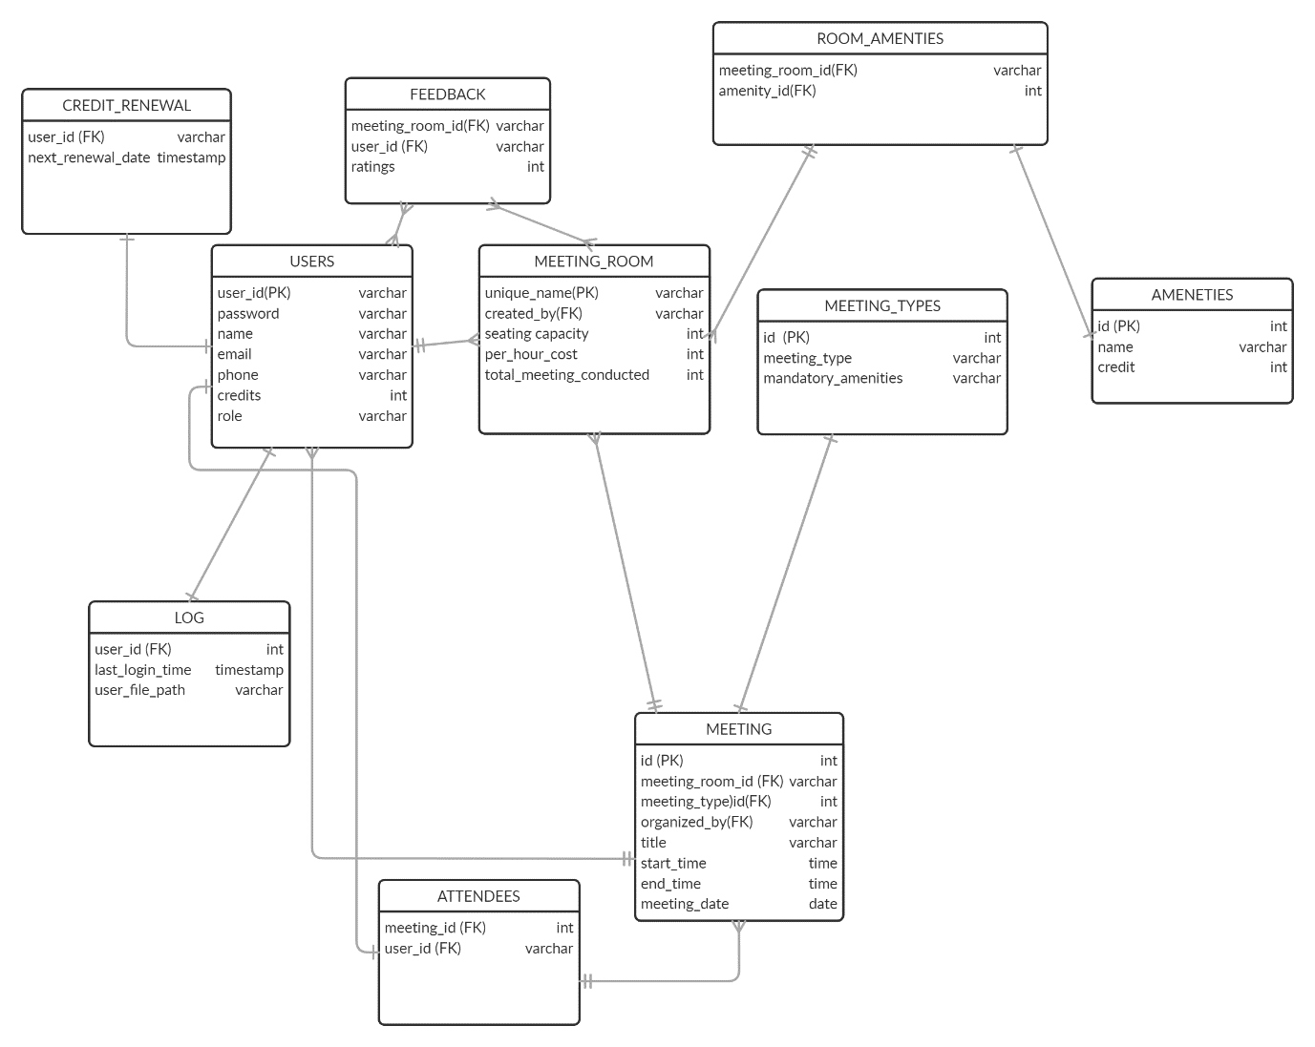

# CONTEXT DIAGRAM

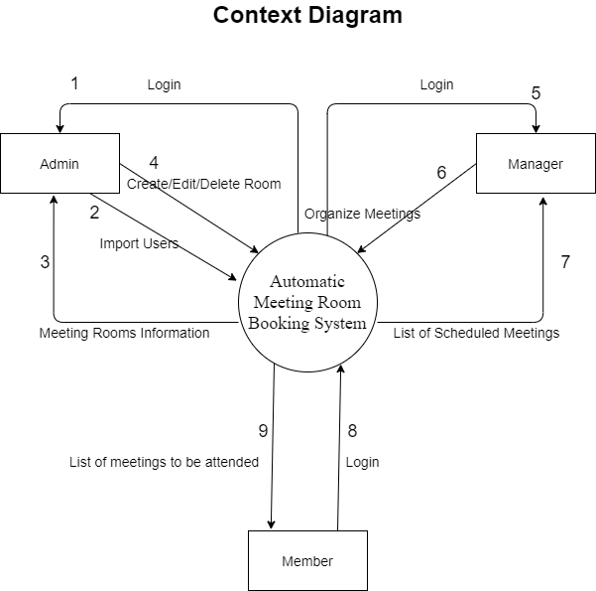

# DATA FLOW DIAGRAM

