
书名：天蓝色的彼岸
Title: The Great Blue Yonder
介绍：哈里的生命结束在了童年的意外上——因为和姐姐吵架而出走，结果被卡车撞死，灵魂去往了天堂。就像孩子在生活中那样，哈里在天堂也是单纯，疑惑而天真的。在对自己所处的迷惑和失落中他遇到了因为未完成的遗愿而徘徊的孩童幽灵阿瑟，借由他的启发，回到自己所住的地方，完成了最后的生活——最后一次体验和感受人的日常和环境，表达对身边人的爱和善意，最终回到天堂，走向天蓝色的彼岸，消逝在这个世界。唯美治愈的文风讲述着关于生命，愿望，善和爱的故事，从一个孩子的角度，体验日常的可贵和风中的幸福。
Introduction: Harry's life ended in a childhood accident - he ran away because of a quarry with his sister and ended up getting hit by a truck. As a result, his soul went to heaven. Like a child in life, Harry is simple, doubtful and innocent. In his confusion and loss of where he is he meets Arthur, the ghost of a child who wanders for thousands of years because of his unfulfilled last wish, and through his inspiration, Harry returns to the place where he lives and fulfills his last day of life - experiencing and feeling human routines for the last time, expressing love to those around him, and eventually returning to heaven, fading into this world at the Great Blue Younder. The beautiful and healing style of writing tells a story about life, wishes, goodness and love, from a child's point of view, experiencing the preciousness of everyday life and the happiness in the wind.
推荐理由：也许你会迷茫于未来，可能在各种压力下感到彷徨，不如用一段简单真诚的故事，说服自己在湖畔温和的风里感受一下生命，重新获得生活的美感。文风清新唯美，也许能在急促而看上去乱七八糟的日常中提供一个小小的港湾，也愿更多生命的美好被看见。
Recommendation: Maybe you are lost in the thought of future, may feel lost under all kinds of pressure, then why not use a simple and sincere story to convince yourself to feel life in the gentle wind beside the lake and regain the beauty of life? With the style of writing fresh and graceful, perhaps it can provide you a harbor in the rush and seemingly chaotic daily life, and may the beauty of more life be seen.


书名：荒原狼
Title: Der Steppenwolf
介绍：黑塞中期的代表作，探讨现代社会对人性的分裂，精神疾病的发生对人格的摧残和启示对现代人的拯救作用。主人公哈勒尔在信仰缺失的现代社会被挤压而绝望、分裂，一本偶然读到的《评荒原狼》使他产生了莫大的共鸣，认为自己就是人狼性质并存的荒原狼，孤独地生存在黑暗绝望的社会里。他的疯狂，荒唐，绝望和善恶交织的形象被作者通过心理变化和行为的无端分析解剖，描述了“荒原狼”这样的人的同时，也对社会作出了反思。
Introduction: Hesse's mid-career masterpiece, explores modern society's harm to human nature, the occurrence of mental illnesses that destroy the personality and the saving effect of revelation on modern man. The protagonist, Harrell, is squeezed and stressed and despaired and desperate in the modern society with lack of faith. A book he reads by chance, “Review of the Steppenwolf”, resonates with him greatly, and he thinks that he is the steppenwolf, who are human and wolves in nature at the same time, and he survives alone in the dark and despairing society, or rather, the forest of endless darkness. His craze, absurd, desperate and good and sins are analyzed and dissected by the author through psychological changes and behavioral analysis, describing the “Wasteland Wolf” such a person, but also reflecting on the society.
推荐理由：如果你也在审视、定义自己的时候产生了迷惑，或者感到社会中的孤独，荒原狼毫不掩饰的自白也许会给你启发。尽管所处的社会环境并不相同，人性却亘古不变。也许你能从荒原狼的迷茫中找到自己的解药，用自己所期待的方式面对世界。
Recommendation: If you too are confused when examining and defining yourself, or feel alone in society, the Steppenwolf's unabashed confession may inspire you. Despite the fact that the social environment is totally different, the complexity of human nature has never changed. Perhaps you can find your own antidote from the Wasteland Wolf's confusion, and face the world in the way you expect yourself to be.

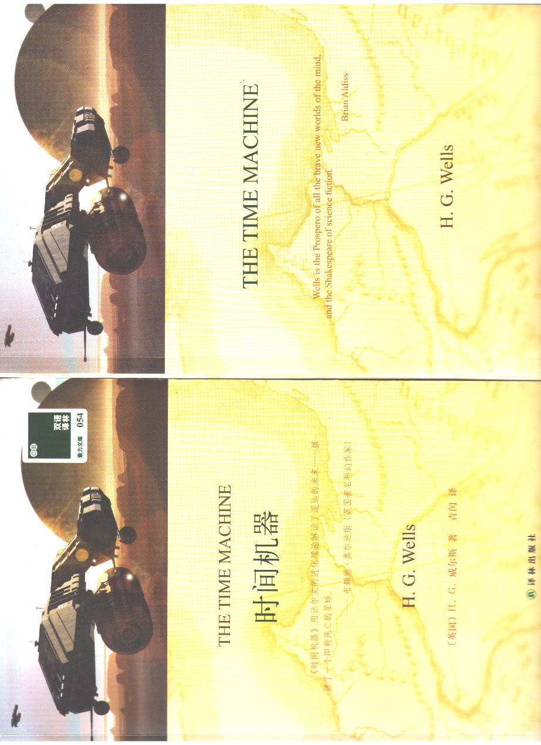
书名：时间机器
Title: The Time Machine
介绍：经典的穿越类型科幻小说，以细腻的描写和缜密逻辑著称。相比于多数科幻介绍的科技世界，时间机器最高深的科技却只是时间机器本身，与其说它想象的是技术意义上的未来，不如说这是一部思考人类社会结构走向的小说。阶层分化走向的是灭亡，而处在一个开始使用和部分依赖人工智能的现实中，时间机器也提出了对理想社会的质问。
Introduction: A classic crossover genre science fiction novel, known for its subtle descriptions and meticulous logic. In contrast to the technological world that most sci-fi introduces, The Time Machine's most profound technology is nevertheless just the time machine itself, and rather than imagining the future in a technological sense, this is a novel that contemplates the direction of social structure. Class divisions lead to extinction, and with us in a reality that is beginning to use and partially rely on artificial intelligence, Time Machine also raises questions about the ideal society.
推荐理由：曾经被作为批判阶级分化的书目被大力推崇，但时间机器不仅仅是对西方世界的批判。未来理想世界本身存在的争议性，以及劳动和原则的保留问题，在这本书中都被提出并值得处于数据时代的我们探讨。本书篇幅不大，休闲时刻随手翻开，也不失为一个不错的选择。
Recommendation: Once promoted as a critique of class divisions, Time Machine is more than just a critique of the Western world. The controversial nature of the ideal world of the future itself, as well as the question of the preservation of labor and principles, are all raised in this book, and worth exploring for us in the age of data. The book is small enough that it is not a bad choice to turn to in a casual moment, but you may also reflect on the story while approaching your engineering or academic career.

