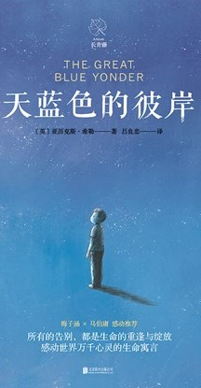
书名：天蓝色的彼岸
Title: The Great Blue Yonder
介绍：哈里的生命结束在了童年的意外上——因为和姐姐吵架而出走，结果被卡车撞死，灵魂去往了天堂。就像孩子在生活中那样，哈里在天堂也是单纯，疑惑而天真的。在对自己所处的迷惑和失落中他遇到了因为未完成的遗愿而徘徊的孩童幽灵阿瑟，借由他的启发，回到自己所住的地方，完成了最后的生活——最后一次体验和感受人的日常和环境，表达对身边人的爱和善意，最终回到天堂，走向天蓝色的彼岸，消逝在这个世界。唯美治愈的文风讲述着关于生命，愿望，善和爱的故事，从一个孩子的角度，体验日常的可贵和风中的幸福。
Introduction: Harry's life ended in a childhood accident - he ran away because of a quarry with his sister and ended up getting hit by a truck. As a result, his soul went to heaven. Like a child in life, Harry is simple, doubtful and innocent. In his confusion and loss of where he is he meets Arthur, the ghost of a child who wanders for thousands of years because of his unfulfilled last wish, and through his inspiration, Harry returns to the place where he lives and fulfills his last day of life - experiencing and feeling human routines for the last time, expressing love to those around him, and eventually returning to heaven, fading into this world at the Great Blue Younder. The beautiful and healing style of writing tells a story about life, wishes, goodness and love, from a child's point of view, experiencing the preciousness of everyday life and the happiness in the wind.
推荐理由：也许你会迷茫于未来，可能在各种压力下感到彷徨，不如用一段简单真诚的故事，说服自己在湖畔温和的风里感受一下生命，重新获得生活的美感。文风清新唯美，也许能在急促而看上去乱七八糟的日常中提供一个小小的港湾，也愿更多生命的美好被看见。
Recommendation: Maybe you are lost in the thought of future, may feel lost under all kinds of pressure, then why not use a simple and sincere story to convince yourself to feel life in the gentle wind beside the lake and regain the beauty of life? With the style of writing fresh and graceful, perhaps it can provide you a harbor in the rush and seemingly chaotic daily life, and may the beauty of more life be seen.

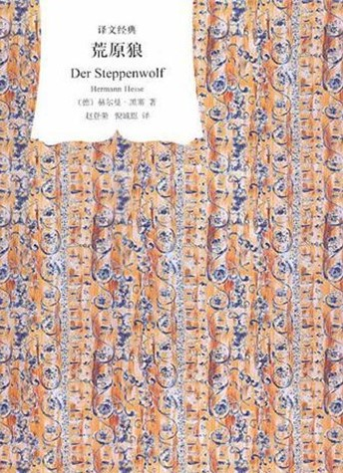
书名：荒原狼
Title: Der Steppenwolf
介绍：黑塞中期的代表作，探讨现代社会对人性的分裂，精神疾病的发生对人格的摧残和启示对现代人的拯救作用。主人公哈勒尔在信仰缺失的现代社会被挤压而绝望、分裂，一本偶然读到的《评荒原狼》使他产生了莫大的共鸣，认为自己就是人狼性质并存的荒原狼，孤独地生存在黑暗绝望的社会里。他的疯狂，荒唐，绝望和善恶交织的形象被作者通过心理变化和行为的无端分析解剖，描述了“荒原狼”这样的人的同时，也对社会作出了反思。
Introduction: Hesse's mid-career masterpiece, explores modern society's harm to human nature, the occurrence of mental illnesses that destroy the personality and the saving effect of revelation on modern man. The protagonist, Harrell, is squeezed and stressed and despaired and desperate in the modern society with lack of faith. A book he reads by chance, “Review of the Steppenwolf”, resonates with him greatly, and he thinks that he is the steppenwolf, who are human and wolves in nature at the same time, and he survives alone in the dark and despairing society, or rather, the forest of endless darkness. His craze, absurd, desperate and good and sins are analyzed and dissected by the author through psychological changes and behavioral analysis, describing the “Wasteland Wolf” such a person, but also reflecting on the society.
推荐理由：如果你也在审视、定义自己的时候产生了迷惑，或者感到社会中的孤独，荒原狼毫不掩饰的自白也许会给你启发。尽管所处的社会环境并不相同，人性却亘古不变。也许你能从荒原狼的迷茫中找到自己的解药，用自己所期待的方式面对世界。
Recommendation: If you too are confused when examining and defining yourself, or feel alone in society, the Steppenwolf's unabashed confession may inspire you. Despite the fact that the social environment is totally different, the complexity of human nature has never changed. Perhaps you can find your own antidote from the Wasteland Wolf's confusion, and face the world in the way you expect yourself to be.

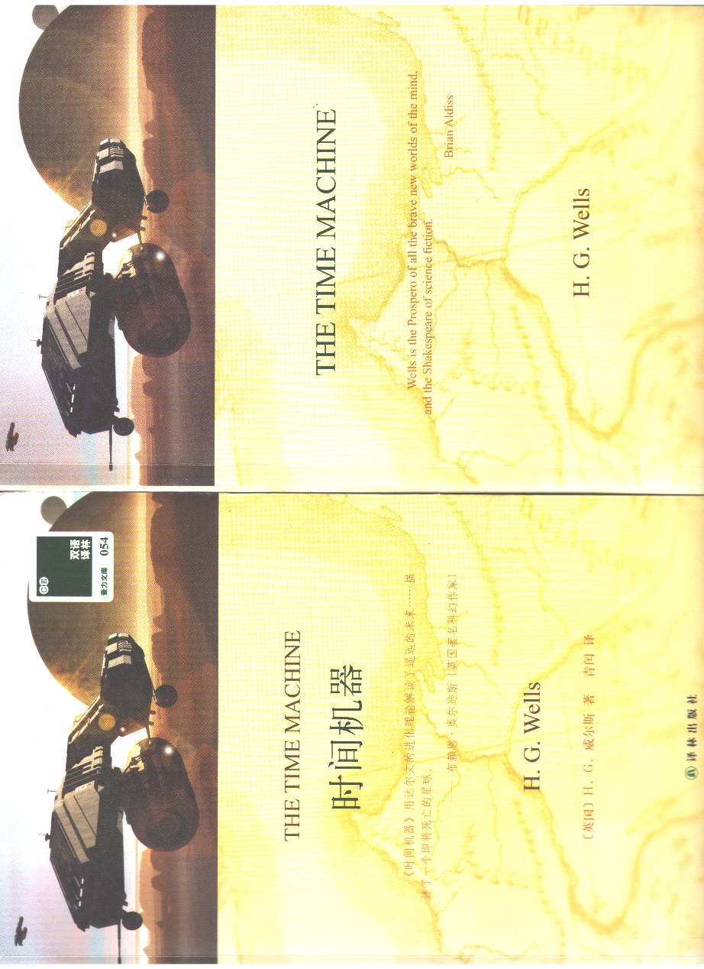
书名：时间机器
Title: The Time Machine
介绍：经典的穿越类型科幻小说，以细腻的描写和缜密逻辑著称。相比于多数科幻介绍的科技世界，时间机器最高深的科技却只是时间机器本身，与其说它想象的是技术意义上的未来，不如说这是一部思考人类社会结构走向的小说。阶层分化走向的是灭亡，而处在一个开始使用和部分依赖人工智能的现实中，时间机器也提出了对理想社会的质问。
Introduction: A classic crossover genre science fiction novel, known for its subtle descriptions and meticulous logic. In contrast to the technological world that most sci-fi introduces, The Time Machine's most profound technology is nevertheless just the time machine itself, and rather than imagining the future in a technological sense, this is a novel that contemplates the direction of social structure. Class divisions lead to extinction, and with us in a reality that is beginning to use and partially rely on artificial intelligence, Time Machine also raises questions about the ideal society.
推荐理由：曾经被作为批判阶级分化的书目被大力推崇，但时间机器不仅仅是对西方世界的批判。未来理想世界本身存在的争议性，以及劳动和原则的保留问题，在这本书中都被提出并值得处于数据时代的我们探讨。本书篇幅不大，休闲时刻随手翻开，也不失为一个不错的选择。
Recommendation: Once promoted as a critique of class divisions, Time Machine is more than just a critique of the Western world. The controversial nature of the ideal world of the future itself, as well as the question of the preservation of labor and principles, are all raised in this book, and worth exploring for us in the age of data. The book is small enough that it is not a bad choice to turn to in a casual moment, but you may also reflect on the story while approaching your engineering or academic career.

《雪国》Snow Country川端康成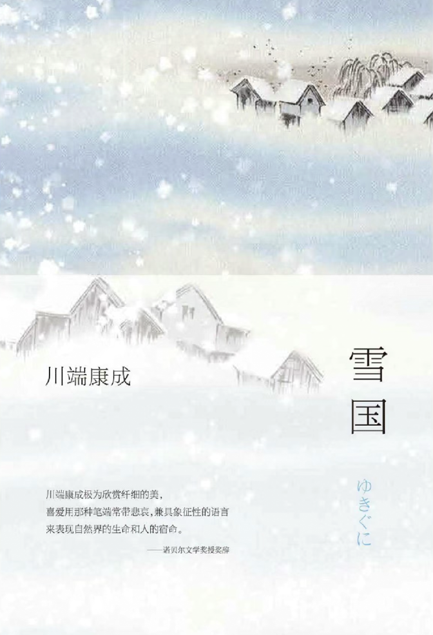
内容简介
《雪国》是日本诺贝尔文学奖得主川端康成的经典之作，描绘了一个关于爱、孤独与自然的动人故事。故事围绕东京男人岛村与艺妓小雪之间的复杂关系展开。岛村在一个被雪覆盖的温泉小镇上邂逅小雪，二人之间的情感交织着吸引与隔阂，反映了人类内心深处的孤独。
"Snow Country" is a classic work by Nobel Prize-winning Japanese author Yasunari Kawabata, telling a poignant tale of love, loneliness, and nature. The story centers on Shimamura, a man from Tokyo, and his complex relationship with the geisha Yoko. Their encounter in a snow-covered hot spring town intertwines attraction and distance, reflecting the deep solitude of the human heart.

推荐理由：
川端康成的文字简洁而富有诗意，巧妙地将雪国的自然景观与角色的内心世界结合在一起。雪不仅是背景，更是角色情感的隐喻，象征着纯洁与无奈。小说通过细腻的情感描写，让读者深刻感受到爱与生命的脆弱。

推荐这本书不仅因为它的美丽语言和深邃思想，更因为它对人性和文化的深刻探讨。小雪作为传统文化的象征，与现代的岛村形成鲜明对比，展现了时代的变迁和人类关系的复杂性。

如果你对日本文学感兴趣，或想体验一种独特的情感与自然交融的美，《雪国》无疑是一本不可错过的经典。它将带你进入一个充满诗意的世界，让你在每一页中感受到那份独特的情感与美丽。

Kawabata's prose is both concise and poetic, seamlessly blending the stunning landscapes of the snow country with the inner worlds of the characters. Snow serves not only as a backdrop but also as a metaphor for their emotions, symbolizing purity and helplessness. Through delicate emotional portrayals, readers can deeply feel the fragility of love and life.

This book is recommended not only for its beautiful language and profound thoughts but also for its exploration of human nature and culture. Yoko, as a symbol of traditional culture, contrasts sharply with modern Shimamura, showcasing the complexities of changing times and human relationships.

If you're interested in Japanese literature or wish to experience the unique beauty of emotion intertwined with nature, "Snow Country" is a classic you shouldn't miss. It will immerse you in a poetic world, allowing you to feel that unique blend of emotion and beauty on every page.

《人生海海》Life is a Journey麦家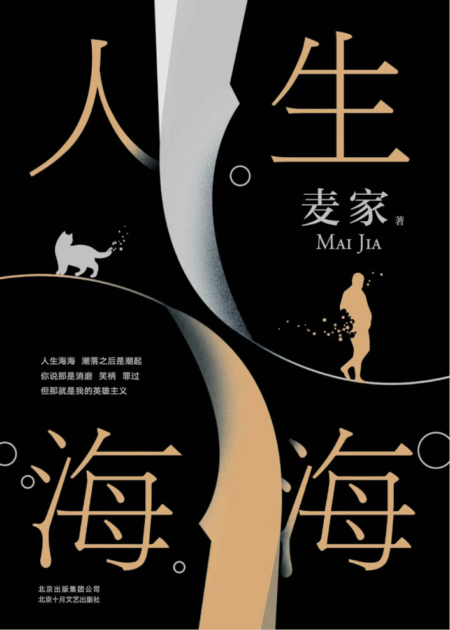
内容简介
《人生海海》是中国当代作家麦家的长篇小说，这部作品标志着他创作风格的转变，从谍战题材转向了对故乡和童年的深情回顾。小说通过一个少年的视角，讲述了村里传奇人物“上校”在时代浪潮中起伏的一生，展现了个体与历史的复杂交织。
“Life is a Sea” is a long novel by the contemporary Chinese writer Mai Jia, marking a shift in his creative style from spy-themed works to a reflection on his hometown and childhood. Through the perspective of a young boy, the novel tells the story of a legendary figure known as “the Captain” in the village, whose life is filled with ups and downs amidst the tides of time, showcasing the complex interplay between the individual and history.
推荐理由
“人生海海”这个闽南语词汇被用来比喻人生的宽广与复杂多变，它告诉我们，尽管生活中会有起起落落，但人们应该勇敢地活下去。麦家通过这部作品，传达了一种即使在绝望中也要寻找希望，即使在艰苦中也要坚守道德的人生态度。
小说的叙述方式温柔而充满悲悯，它不仅仅是对一个人物的描写，更是对一个时代的反思。麦家在书中探讨了父子关系、故乡情怀以及命运的无常，这些都是他个人成长经历的反映。他用“温柔的书写”来表达对乡村的理想化呈现，以及对父亲的复杂情感。
《人生海海》是一部深刻探讨人生、历史和人性的作品，它鼓励我们在人生的大海中，无论遇到什么风浪，都要有勇气继续航行，寻找属于自己的方向。这部作品是对生活的深刻洞察，也是对人性的温暖拥抱。

In this novel, the Minnan dialect term “life is a sea” is used to describe the vastness and complexity of life, reminding us that despite the ups and downs, we should live bravely. Through this work, Mai Jia conveys a life attitude of seeking hope even in despair.
The narrative style of the novel is gentle and full of compassion, making it more than just a character portrayal but also a reflection on an era. Mai Jia explores themes of relationships between father and son, hometown sentiments, and the impermanence of fate in the book, all of which are reflections of his personal growth experiences. He uses “gentle writing” to express an idealized representation of the countryside and complex feelings towards his father.
In summary, “Life is a Sea” is a profound exploration of life, history, and human nature, encouraging us to navigate the sea of life with courage, regardless of the winds and waves we encounter, in search of our own direction. This work is an insightful look into life and a warm embrace of humanity.

《第二性》Le Deuxième Sexe波伏娃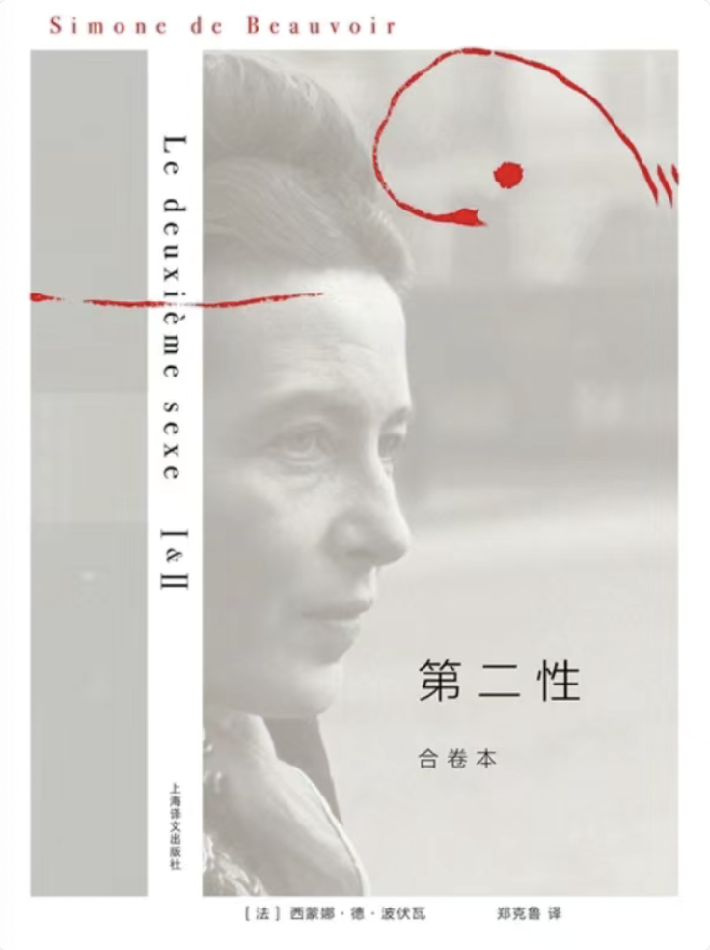
内容简介
《第二性》是法国思想家西蒙娜·德·波伏娃的杰作，这部作品被认为是女性主义运动的“圣经”。在这部社会学著作中，波伏娃以哲学、历史、文学、生物学、古代神话和风俗为背景，深入探讨了从原始社会到现代社会中女性的地位、处境和权利，以及性别差异如何影响女性个体的发展。
《第二性》分为I、II两卷：I从生物学、精神分析学、历史和女性神话在文学中的体现等方面来分析女性的处境；II从存在主义的哲学理论出发，研究女人在出生、青春期、恋爱、结婚、生育到衰老各个阶段，以及在农妇、女工、妓女、明星或知识分子等各个阶层中的真实处境，探讨女性独立可能的出路。” 波伏娃提出了女性获得经济独立的必要性，并强调只有女性经济地位变化才能带来精神的、社会的、文化的等等后果，只有当女性对自身的意识发生根本的改变，才有可能真正实现男女平等。

“The Second Sex” is a groundbreaking work by French philosopher and writer Simone de Beauvoir, considered one of the foundational texts of feminist theory. In this sociological treatise, Beauvoir explores the historical and social realities of women’s conditions, status, and rights from primitive societies to modern times, against a backdrop of philosophy, history, literature, biology, ancient myths, and customs. The work is divided into two volumes: Volume I analyzes the situation of women from perspectives of biology, psychoanalysis, history, and the representation of women in literature; Volume II, grounded in existentialist philosophy, examines the real situations of women across various stages of life—birth, adolescence, love, marriage, motherhood, and old age—as well as in different social strata, from peasants to workers, prostitutes, stars, or intellectuals, discussing possible ways for women’s independence.
推荐理由
在英语中，这部作品名为 “The Second Sex”，它不仅在法国，而且在全球范围内都产生了深远的影响。波伏娃的洞察力和对女性境况的深刻分析，使得《第二性》成为了女性主义理论的基石之一。她勇敢地挑战了传统观念，提出了女性不是天生的，而是被社会构建的观点，这一观点至今仍对性别研究和女性主义讨论产生着深远的影响。
《第二性》被誉为‘有史以来讨论女性的最健全、最理智、最充满智慧的一本书’”，甚至被尊为西方妇女的“圣经”。波伏娃由此被称为第二波女性主义运动的“精神母亲”。 这部作品的出版，不仅在法国引起轩然大波，也在全球范围内引发了对女性角色和地位的重新思考。
Beauvoir argues for the necessity of women’s economic independence and emphasizes that only changes in women’s economic status can bring about spiritual, social, and cultural consequences. She asserts that true gender equality can only be achieved when there is a fundamental change in women’s consciousness. “The Second Sex” has been hailed as “the most sound, rational, and wise book ever written about women,” and Beauvoir is regarded as the “spiritual mother” of the second wave of the feminist movement. The publication of this work has sparked a rethinking of women’s roles and status not only in France but around the world.

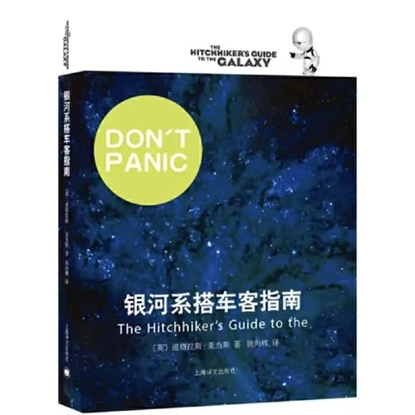
《银河系搭车客指南The Hitchhiker’s Guide to the Galaxy》

一本极其轻松的科幻作品，能够让生理与心理状态均不好的人读进脑、笑出声。
A science fiction extremely relaxed to read. Reading it brings laughter even to someone with physiological and psychological problem.

突如其来的寂静笼罩了地球。这事实上比噪音更加可怕。有一会儿，什么也没有发生。

巨大的飞船一动不动地挂在空中，覆盖了地球上的每个国家。

在黯然退场之前，地球首先被改造成了最终极的声音重放器件，这是有史以来建造过的最伟大的播音系统。但伴之而来的不是演奏会，不是音乐，没有开场号曲，而仅仅是一条简短的信息。

“地球人，请注意了。”一个声音说，这声音堪称完美，仿佛来自四声道系统，完美得无懈可击，失真度低得能让勇敢的男人洒下眼泪。

“这里是银河超空间规划委员会。诸位无疑已经知道，银河系边远地区的开发规划要求建造一条穿过贵恒星系的超空间快速通道，令人遗憾的是，贵行星属于计划中预定毁灭的星球之一。毁灭过程将在略少于贵地球时间两分钟后开始。谢谢合作。”Sudden silence enveloped the earth. This was actually more terrifying than noise. For a moment, nothing happened.
The huge spaceship hung motionless in the air, covering every country on Earth.
Before fading away, the Earth was first transformed into the ultimate sound reproduction device, the greatest broadcasting system ever built. But instead of a concert, no music, no opening fanfare, there was only a brief message.
"Attention, Earthlings," a voice said, a voice that was perfect in every way, as if it came from a four-channel system, flawless and distortion-free enough to make even the bravest of men shed a tear.
"This is the Galactic Hyper-Space Planning Commission. You are no doubt aware that the development plan for the outskirts of the Galaxy requires the construction of a hyper-space expressway through your star system. Unfortunately, your planet is one of the designated planets for destruction as part of this plan. The destruction process will begin in slightly less than two minutes of your Earth time. Thank you for your cooperation."


《我的名字叫红My Name is Red》

一桩谋杀案，但死的不只是人——还有一整代人的文化。
A murder with death of not only people, but also culture.

《我的名字叫红》是土耳其作家奥尔罕·帕穆克创作的长篇小说，首次出版于1998年。
该小说讲述16世纪末，离家12年的青年黑终于回到他的故乡——伊斯坦布尔，迎接他归来的除了爱情，还有接踵而来的谋杀案。 [1]一位细密的画家失踪了，奉命为苏丹绘制抄本的长者也惨遭杀害。苏丹要求在三天内查出结果，而线索，藏在图画某处。作品以巧妙的后现代叙事，用一件发生在伊斯兰世界的谋杀案件作为故事主轴，以貌似侦探小说的结构性线索展开故事，实则是在讲述一段古老的奥斯曼艺术史的往事，由冲突、痛苦、共存三个不同的层面入手，借古喻今，探讨生命与艺术的存在意义及信仰的冲突，呈现给读者的是关于“文明冲突”的理性思考以及关于全球化语境中人类文明发展趋势的历史性解读。
《我的名字叫红》获得欧洲发现奖、美国外国小说独立奖、法国文学奖、意大利格林扎纳·卡佛文学奖和都柏林文学奖在内的欧洲三大文学奖项。"My Name is Red" is a novel written by Orhan Pamuk, a Turkish author, which was first published in 1998.
The novel tells the story of Red, a young man who has been away from home for 12 years, returning to his hometown of Istanbul. Besides love, he is greeted by a series of murder cases. A miniaturist has gone missing, and an elderly man who was ordered to create a manuscript for the sultan was brutally murdered. The sultan demands that the case be solved within three days, and the clues are hidden somewhere in the paintings. The novel uses a clever postmodern narrative to tell a murder story that seems to be a detective novel, but it is actually a story about an old tale of Ottoman art history. It begins with the conflict, pain, and coexistence from three different levels, and uses the past to reflect the present, exploring the meaning of life and art, as well as the conflicts between beliefs. It presents a rational reflection on "civilization clash" and a historical interpretation of the trend of human civilization in the context of globalization.
"My Name is Red" has won three major European literary awards, including the European Union Prize for Literature, the Independent Foreign Fiction Prize, and the Prix du Meilleur Livre Etranger.
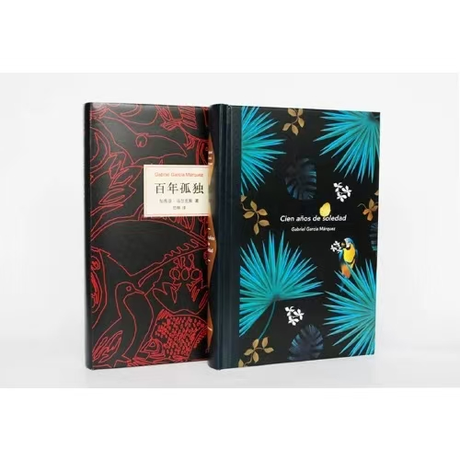
《百年孤独One Hundred Years of Solitude》

完全的混乱，彻底的人声鼎沸。可孤独就在其中。
The lonliness or solitude from chaos and crowd.

《百年孤独》，是哥伦比亚作家加西亚·马尔克斯创作的长篇小说，是其代表作，也是拉丁美洲魔幻现实主义文学的代表作，被誉为“再现拉丁美洲历史社会图景的鸿篇巨著”。
故事讲述马孔多小镇和布恩地亚家族的兴衰变化与传奇故事，记录了家族命运与百年历史，是重复地叙述相同而荒唐的命运，是拉美国家几百年命运的缩影，独具意味地隐喻着人类“文明”史的建立、发展与终结，在荒凉失落与荒唐可笑中诠释宿命式的轮回。家族中人物名字是相同或相近的，预示着他们拥有殊途同归的孤独命运。《百年孤独》以布恩地亚被捆在树上为开端，以他被蚂蚁吃掉为结束，通过细腻丰富的笔触、大胆自由的想象、魔幻的叙事艺术，讲述布恩地亚家族命运与历史，刻画人物孤独的灵魂与自我救赎，进而体现出个人、家族及全人类的悲悯与孤独情怀，让人们重新思考时代发展与人性变化。"
One Hundred Years of Solitude" is a novel written by Colombian writer Gabriel Garcia Marquez, which is his masterpiece and also a representative work of Latin American magical realism literature. It is praised as "a monumental epic that vividly depicts the historical and social landscape of Latin America."
The story tells the rise and fall of the town of Macondo and the legendary stories of the Buendia family, recording the fate of the family and the century-long history, repeating the same absurd fate, and being a microcosm of the fate of Latin American countries for hundreds of years, metaphorically implying the establishment, development, and demise of human "civilization" history, and interpreting the cyclical fate in a desolate and ridiculous manner. The names of the characters in the family are the same or similar, indicating that they have the same destiny of solitude. "One Hundred Years of Solitude" begins with Buendia being tied to a tree and ends with him being eaten by ants, telling the story of the fate and history of the Buendia family through delicate and rich writing, bold and free imagination, and magical narrative art, depicting the lonely souls and self-redemption of the characters, and ultimately reflecting the compassion and loneliness of individuals, families, and all humanity, which makes people rethink the development of the times and the changes in human nature.

《月亮与六便士》
“满地都是六便士，他却抬头看见了月亮。”还未读过这本书，我却被这句话吸引了，我并不理解它的意思，只是觉得其中蕴含着深意。读过书后，我明白了六便士和月亮代表的就是生活和理想。在现实生活中，安逸的生活可能是很多人会做的选择;可要放弃一切寻求梦想的时候，我们就会发现这不仅需要强大的毅力作为后盾，还要有放弃安逸生活的勇气。这本书用一个故事引发了人们对逃离世俗社会寻找心灵家园这一话题的思考。简单的故事却给了人庞大的思考空间。
“It was full of sixpence, but he looked up and saw the moon.” Before I had read the book, I was fascinated by this quote, I didn't really understand what it meant, I just thought it held a deep meaning. After reading the book, I realized that sixpence and the moon represent life and ideals. In real life, a comfortable life may be a choice that many people will make; but when we have to give up everything to seek our dreams, we will realize that it not only requires strong perseverance as a backing, but also the courage to give up a comfortable life. This book uses a story to trigger people's thoughts on the topic of escaping from the secular society to find a spiritual home. The simple story gives huge room for thought.

荐书理由：你是愿意以月亮为枕，还是愿意以六便士为枕呢?当下的我们，大多数人对名声充满渴求，对利益充满向往，更希望名利兼得，而大部分人却还是过着平淡无奇的生活。当然，也不排除某些人突然醍醐灌顶，去追真正喜欢的有意义的生活。

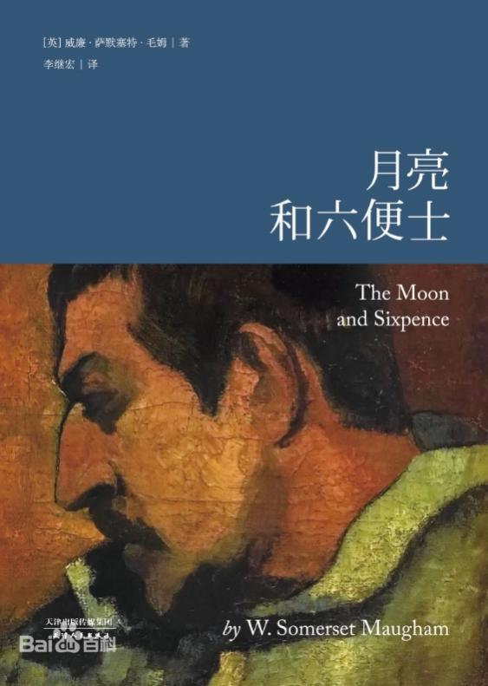
《我们仨》
“在遇到你之前我没有想过结婚，但在遇到你之后我结婚没有想过和别人。”正是因为钱钟书先生的这句话，我才有了看这本书的冲动，《我们仨》是杨绛先生的一佳作。主要讲述了杨绛，她的丈夫钱钟书和其女瑗的一些往事，可以算是一篇回忆录。读这本书时，心里会有一股暖流划过，这书，就如同绿茶一般，温温润润，但又给人一种强烈的感觉。我喜欢这本书，不仅是因为它的情节，更是因为这里面包含的爱。
“I didn't think about marriage before I met you, but after I met you I married without thinking about being with someone else.” It is because of Mr. Qian Zhongshu's words that I got the urge to read this book, “The Three of Us” is a masterpiece of Mr. Yang Jiang. It is mainly about some past events of Yang Jiang, her husband Qian Zhongshu and his daughter Won, which can be regarded as a memoir. When reading this book, a warm current will pass through my heart. This book, just like green tea, is warm and moist, but gives people a strong feeling. I like this book, not only because of its plot, but also because of the love it contains.

荐书理由
这本温暖而感人至深的作品，让我们重新思考家的意义，感悟亲情的珍贵。无论是在忙碌的现代生活中寻求心灵的慰藉，还是在人生的旅途中寻找方向，这本书都带给了我们深刻的启迪和感动。

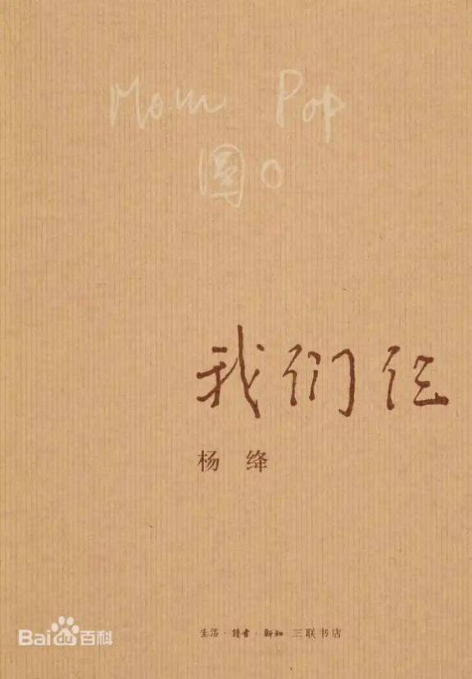
《苏东坡传》
林语堂为我们讲述了一个不一样的苏东坡，一个与世人眼中不同的苏东坡，一个政绩卓著、爱民如子、文韬武略兼备的苏东坡，一个虽累遭打击而乐观情怀不变的苏东坡。
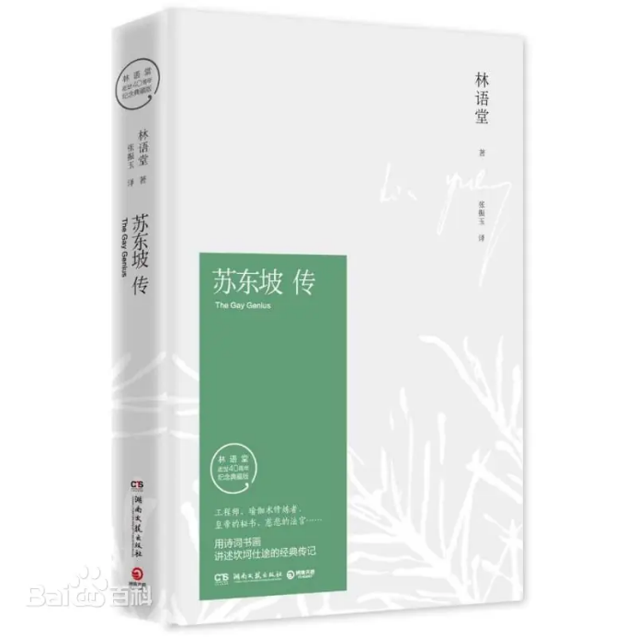
Lin Yutang tells us a different Su Dongpo, a different Su Dongpo in the eyes of the world, a Su Dongpo with outstanding political achievements, a love for the people like a son, and a combination of literary and military strategies, a Su Dongpo who is optimistic and unchanged despite repeated blows.
荐书理由：此书带你走进苏东坡的内心世界，感受那份穿越千年的心灵喜悦和思想快乐。

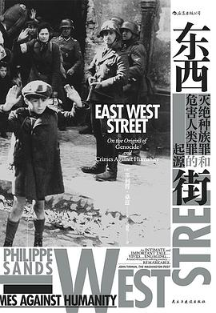《东西街》
《东西街》是菲利普·桑兹所著的一部杰作，结合了历史、法律和个人叙述的元素。这本书通过作者对他祖辈在二战期间的经历追溯，揭示了“种族灭绝”和“反人类罪”这两个法律概念的起源，带领读者穿越欧洲历史的复杂性与悲剧。桑兹以其深厚的法律背景和敏锐的笔触，既为我们呈现了法律的发展历程，也展示了历史中的个人命运。这本书不仅是对法治的反思，更是对人性的探讨，令人深思，感人至深。
推荐理由： 桑兹不仅讲述了他家族的故事，还将其与世界历史大背景中的关键法律事件紧密相连。无论你对历史、法律或个人故事感兴趣，《东西街》都值得一读。

"East West Street" by Philippe Sands is a masterful blend of history, law, and personal narrative. Tracing his grandparents' experiences during World War II, Sands uncovers the origins of the legal concepts of "genocide" and "crimes against humanity," leading readers through the complexities and tragedies of European history. With his deep legal expertise and sharp storytelling, Sands not only sheds light on the evolution of these legal terms but also brings the personal fates behind history into vivid focus. This book is both a reflection on the rule of law and an exploration of the human condition, deeply thought-provoking and moving.
Why Read It: Sands intertwines his family history with pivotal legal moments in world history, making this book essential reading for anyone interested in history, law, or personal stories.

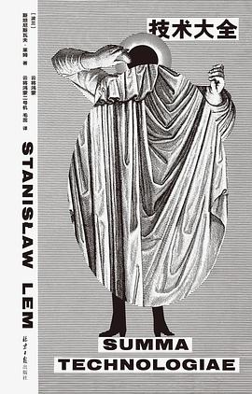
《技术大全》
斯坦尼斯瓦夫·莱姆的《技术大全》（Summa Technologiae）是一本前瞻性极强的科技哲学著作，探讨了技术与人类演化的复杂关系。莱姆通过类比生物进化与技术进化，提出了技术不仅仅是工具，而是一种对自然世界的超越。这本书并不仅是关于未来技术的预测，还深入分析了技术对人类、社会和认知的深远影响。例如，莱姆早在几十年前就预见到了虚拟现实的到来，思考了信息爆炸、人工智能和技术可能带来的伦理挑战​。
通过这本书，莱姆质疑了人类中心论，指出生物进化是无计划、无序的，技术进化可能将人类带入一个更加不确定的未来。这种思辨不仅探讨了技术如何改变世界，也触及到艺术、文化和人类生存的本质问题​。

Recommendation:
Stanisław Lem's “Summa Technologiae” is a highly forward-thinking work of technological philosophy that explores the complex relationship between technology and human evolution. Lem draws parallels between biological evolution and technological progress, suggesting that technology is not merely a tool, but a form of transcendence over the natural world. The book is not just a series of predictions about future technologies but offers a deep analysis of how technology impacts humanity, society, and cognition. For example, decades ahead of his time, Lem predicted the emergence of virtual reality and discussed the ethical challenges posed by information overload, artificial intelligence, and other technological phenomena.
Through this work, Lem challenges anthropocentrism, arguing that biological evolution is unplanned and chaotic, and that technological evolution might lead humanity into an even more uncertain future. His philosophical reflections go beyond how technology shapes the world, touching on the essence of art, culture, and the human condition.
Why Read It: "Summa Technologiae" combines rich sci-fi imagination with deep philosophical inquiry. Lem’s exceptional talent brings these elements together, prompting readers to reflect on the impact of technology on society, making it a must-read masterpiece.

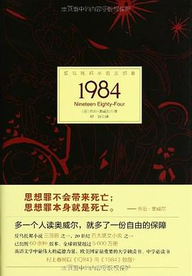
《1984》
乔治·奥威尔的《1984》通过其惊人的预见性和紧张的叙事，揭示了极权主义对个人自由的无情压制。它不仅是一部文学杰作，也是对我们时代的深刻警示，提醒我们警惕任何对思想自由和隐私权的侵犯。这本书让读者反思：在技术进步和社会变革的背景下，我们该如何守护人类的自由与尊严。

Recommendation: George Orwell's 1984 is a chilling portrayal of a totalitarian regime where individual freedom is obliterated by constant surveillance and thought control. Through the protagonist Winston Smith, Orwell vividly explores the dangers of unchecked state power and the manipulation of language to control minds. The novel’s striking foresight remains eerily relevant today, making it a must-read for anyone concerned with privacy and freedom in the modern age.

《局外人》
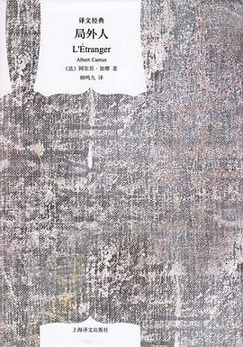
简介：阿尔贝·加缪的成名作，存在主义文学的代表作，对荒谬的绝佳呈现和回应。默尔索所在的世界是荒诞不经的，而他在荒诞世界中所遵循的内心理性，或许可以对正在探索可能性的我们作出启发。

Albert Camus' extraordinary thought, a masterpiece of existentialist literature, an excellent presentation of and response to the absurd world. The world in which Meursault lives is absurd, and the inner rationality he follows may serve as an inspiration to us who are exploring the possibilities of life.

推荐语
默尔索生长在他所不关心的世界里，世界似乎也对他漠不关心；人们看到罪行和联系，而它们是否真实存在并不触动任何人。《局外人》也被理解为《外乡人》，深刻探讨了荒谬的本质，而默尔索临终的宣泄也可以成为我们思考的对象。
Meursault grew up in a world he didn't care about, and the world seemed indifferent to him; one sees crimes and connections, and whether they are real or not doesn't touch anyone. The Outsider, also understood as Outlander, deeply explores the nature of absurdity, and Meursault's dying catharsis can be an object of contemplation.

《丁丁历险记》
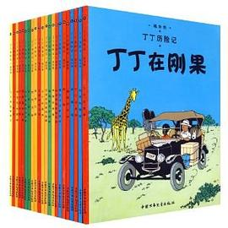
简介：《丁丁历险记》是一套由比利时著名艺术家埃尔热创作的漫画。故事的主角是一位年轻的记者丁丁（Tintin），他和他的小狗米卢（Snowy）一起环游世界，解开谜团，识破阴谋，维护正义。《丁丁历险记》不仅是一部冒险故事，更是一部教育作品——其传递了反战、和平和人道主义的思想。出版一百多年来，《丁丁历险记》在全球以110多种语言出版，销量2.7亿册，多次被改编为电影与动画作品，是一部跨越百年的经典佳作。
"The Adventures of Tintin" is a beloved comic series by Belgian artist Hergé, telling the stories of the globe-trotting journalist Tintin and his dog Snowy. With over 2.3 billion copies sold and widely adapted into films and animation, it's celebrated for its detailed art, captivating stories, and educational value.
推荐语：尽管《丁丁历险记》是一部漫画作品而非纯文学作品，其在世界漫画史上举足轻重的地位、跨越百年的巨大影响力、庞大的读者群体都使其不凡。书籍展览应该兼容并包一切形式的书籍，更不必说这样一部世界级的作品。丁丁和米卢向你问好！阿道克请你喝威士忌！

《燕食记》
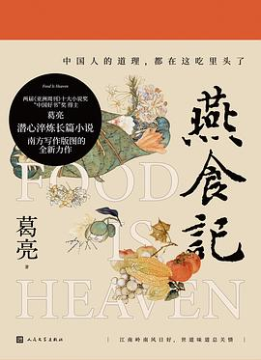
简介：独属于岭南的一段食物史，也是一段悲欢的历史，在食宴与味蕾的碰撞中流淌过的一段民国与抗日战争时期的血泪史。静思之，我们读到了小人物的无奈，大人物的悲情，时代与个人的碰撞，新潮与旧势的对决…葛亮的文字总是娓娓道来，在俗世清欢中道出往事的韵味，一本岭南书，半生燕食记。你要静静品读，感受文字如流水般流经内心的感觉。
A food history that is unique to the Lingnan region is also a history of joys and sorrows, a history of blood and tears during the Republic of China and the Anti-Japanese War periods, flowing through the collision of feasts and taste buds. Reflecting on it, we read the helplessness of ordinary people, the tragic fate of important figures, the collision between times and individuals, and the confrontation between new trends and old customs. Ge Liang's words always flow smoothly, conveying the flavor of the past in the everyday joys of life. A Lingnan book, half a lifetime of food memories. You should read it slowly and savor the feeling of words flowing through your heart like a stream.
推荐理由：葛亮是我最喜欢的作家，他的书真的很值得一读，再忙也要有自己的俗世清欢！

《原子习惯 建立好习惯 打破坏习惯》
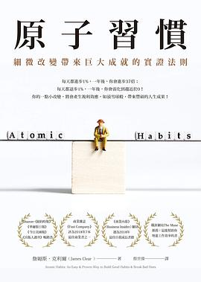
简介：《原子习惯》由詹姆斯·克利尔（James Clear）所著，强调了微小、逐渐变化的力量可以在时间中产生显著的改善。克利尔引入了原子习惯的概念——微小的行为积累成更大的成功。他概述了习惯形成的四个步骤：线索、渴望、反应和奖励。关键策略包括关注身份变化、打破坏习惯，以及使好习惯明显且吸引人。这本书鼓励读者关注1%的改进，显示出持续的小行动在长时间内会带来显著的结果。
"Atomic Habits" by James Clear emphasizes the power of small, incremental changes to create significant improvements over time. Clear introduces the concept of atomic habits—tiny behaviors that compound into larger successes. He outlines a four-step framework for habit formation: cue, craving, response, and reward. Key strategies include focusing on identity change, breaking bad habits, and making good habits obvious and attractive. The book encourages readers to focus on 1% improvements, showing that consistent, small actions lead to remarkable results in the long run.
推荐理由：This book serves as a self-help guide for individuals looking to establish positive habits and eliminate negative ones.

