
书名：天蓝色的彼岸
Title: The Great Blue Yonder
介绍：哈里的生命结束在了童年的意外上——因为和姐姐吵架而出走，结果被卡车撞死，灵魂去往了天堂。就像孩子在生活中那样，哈里在天堂也是单纯，疑惑而天真的。在对自己所处的迷惑和失落中他遇到了因为未完成的遗愿而徘徊的孩童幽灵阿瑟，借由他的启发，回到自己所住的地方，完成了最后的生活——最后一次体验和感受人的日常和环境，表达对身边人的爱和善意，最终回到天堂，走向天蓝色的彼岸，消逝在这个世界。唯美治愈的文风讲述着关于生命，愿望，善和爱的故事，从一个孩子的角度，体验日常的可贵和风中的幸福。
Recommendation: Harry's life ended in a childhood accident - he ran away because of a quarry with his sister and ended up getting hit by a truck. As a result, his soul went to heaven. Like a child in life, Harry is simple, doubtful and innocent. In his confusion and loss of where he is he meets Arthur, the ghost of a child who wanders for thousands of years because of his unfulfilled last wish, and through his inspiration, Harry returns to the place where he lives and fulfills his last day of life - experiencing and feeling human routines for the last time, expressing love to those around him, and eventually returning to heaven, fading into this world at the Great Blue Younder. The beautiful and healing style of writing tells a story about life, wishes, goodness and love, from a child's point of view, experiencing the preciousness of everyday life and the happiness in the wind.


书名：荒原狼
Title: Der Steppenwolf
介绍：黑塞中期的代表作，探讨现代社会对人性的分裂，精神疾病的发生对人格的摧残和启示对现代人的拯救作用。主人公哈勒尔在信仰缺失的现代社会被挤压而绝望、分裂，一本偶然读到的《评荒原狼》使他产生了莫大的共鸣，认为自己就是人狼性质并存的荒原狼，孤独地生存在黑暗绝望的社会里。他的疯狂，荒唐，绝望和善恶交织的形象被作者通过心理变化和行为的无端分析解剖，描述了“荒原狼”这样的人的同时，也对社会作出了反思。
Recommendation: Hesse's mid-career masterpiece, explores modern society's harm to human nature, the occurrence of mental illnesses that destroy the personality and the saving effect of revelation on modern man. The protagonist, Harrell, is squeezed and stressed and despaired and desperate in the modern society with lack of faith. A book he reads by chance, “Review of the Steppenwolf”, resonates with him greatly, and he thinks that he is the steppenwolf, who are human and wolves in nature at the same time, and he survives alone in the dark and despairing society, or rather, the forest of endless darkness. His craze, absurd, desperate and good and sins are analyzed and dissected by the author through psychological changes and behavioral analysis, describing the “Wasteland Wolf” such a person, but also reflecting on the society.

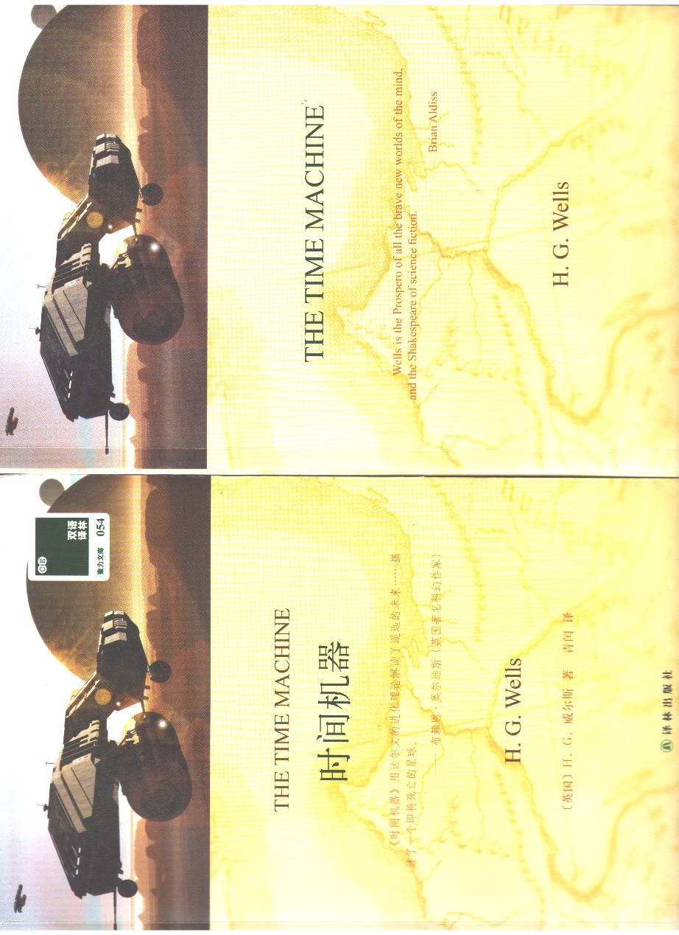
书名：时间机器
Title: The Time Machine
介绍：经典的穿越类型科幻小说，以细腻的描写和缜密逻辑著称。相比于多数科幻介绍的科技世界，时间机器最高深的科技却只是时间机器本身，与其说它想象的是技术意义上的未来，不如说这是一部思考人类社会结构走向的小说。阶层分化走向的是灭亡，而处在一个开始使用和部分依赖人工智能的现实中，时间机器也提出了对理想社会的质问。
Recommendation: A classic crossover genre science fiction novel, known for its subtle descriptions and meticulous logic. In contrast to the technological world that most sci-fi introduces, The Time Machine's most profound technology is nevertheless just the time machine itself, and rather than imagining the future in a technological sense, this is a novel that contemplates the direction of social structure. Class divisions lead to extinction, and with us in a reality that is beginning to use and partially rely on artificial intelligence, Time Machine also raises questions about the ideal society.

