《月亮与六便士》
“满地都是六便士，他却抬头看见了月亮。”还未读过这本书，我却被这句话吸引了，我并不理解它的意思，只是觉得其中蕴含着深意。读过书后，我明白了六便士和月亮代表的就是生活和理想。在现实生活中，安逸的生活可能是很多人会做的选择;可要放弃一切寻求梦想的时候，我们就会发现这不仅需要强大的毅力作为后盾，还要有放弃安逸生活的勇气。这本书用一个故事引发了人们对逃离世俗社会寻找心灵家园这一话题的思考。简单的故事却给了人庞大的思考空间。
“It was full of sixpence, but he looked up and saw the moon.” Before I had read the book, I was fascinated by this quote, I didn't really understand what it meant, I just thought it held a deep meaning. After reading the book, I realized that sixpence and the moon represent life and ideals. In real life, a comfortable life may be a choice that many people will make; but when we have to give up everything to seek our dreams, we will realize that it not only requires strong perseverance as a backing, but also the courage to give up a comfortable life. This book uses a story to trigger people's thoughts on the topic of escaping from the secular society to find a spiritual home. The simple story gives huge room for thought.

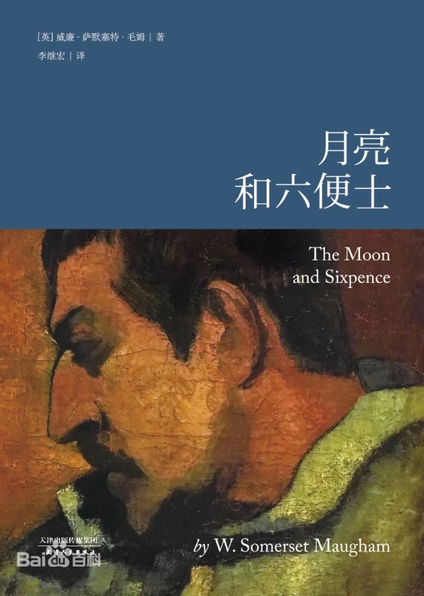
《我们仨》
“在遇到你之前我没有想过结婚，但在遇到你之后我结婚没有想过和别人。”正是因为钱钟书先生的这句话，我才有了看这本书的冲动，《我们仨》是杨绛先生的一佳作。主要讲述了杨绛，她的丈夫钱钟书和其女瑗的一些往事，可以算是一篇回忆录。读这本书时，心里会有一股暖流划过，这书，就如同绿茶一般，温温润润，但又给人一种强烈的感觉。我喜欢这本书，不仅是因为它的情节，更是因为这里面包含的爱。
“I didn't think about marriage before I met you, but after I met you I married without thinking about being with someone else.” It is because of Mr. Qian Zhongshu's words that I got the urge to read this book, “The Three of Us” is a masterpiece of Mr. Yang Jiang. It is mainly about some past events of Yang Jiang, her husband Qian Zhongshu and his daughter Won, which can be regarded as a memoir. When reading this book, a warm current will pass through my heart. This book, just like green tea, is warm and moist, but gives people a strong feeling. I like this book, not only because of its plot, but also because of the love it contains.
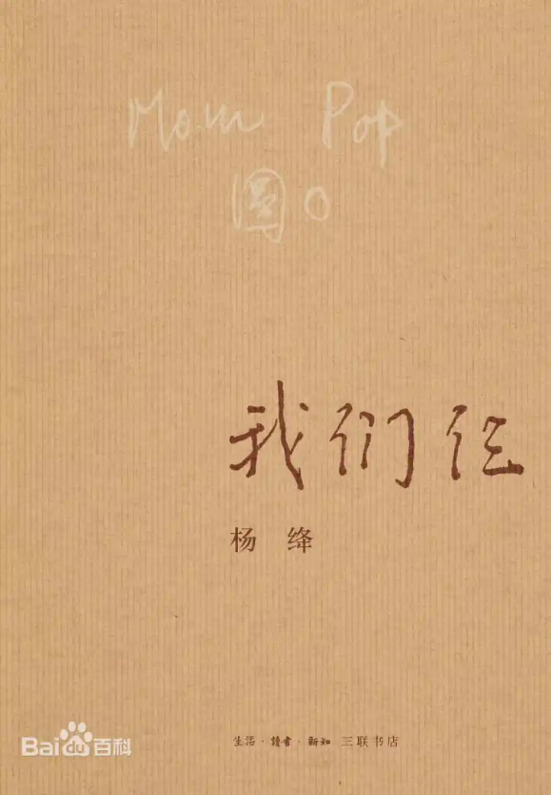
《苏东坡传》
林语堂为我们讲述了一个不一样的苏东坡，一个与世人眼中不同的苏东坡，一个政绩卓著、爱民如子、文韬武略兼备的苏东坡，一个虽累遭打击而乐观情怀不变的苏东坡。
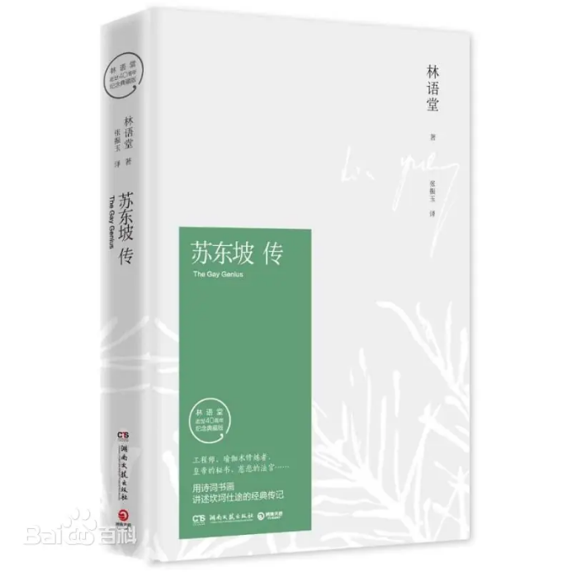
Lin Yutang tells us a different Su Dongpo, a different Su Dongpo in the eyes of the world, a Su Dongpo with outstanding political achievements, a love for the people like a son, and a combination of literary and military strategies, a Su Dongpo who is optimistic and unchanged despite repeated blows.

