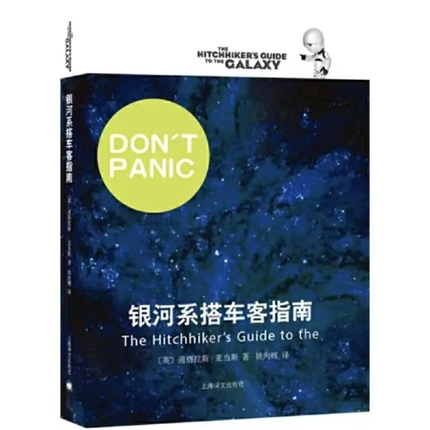
《银河系搭车客指南The Hitchhiker’s Guide to the Galaxy》

一本极其轻松的科幻作品，能够让生理与心理状态均不好的人读进脑、笑出声。
A science fiction extremely relaxed to read. Reading it brings laughter even to someone with physiological and psychological problem.


《我的名字叫红My Name is Red》

一桩谋杀案，但死的不只是人——还有一整代人的文化。
A murder with death of not only people, but also culture.
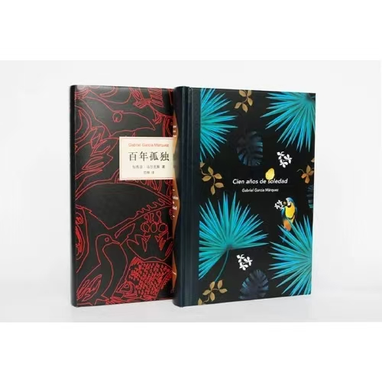
《百年孤独One Hundred Years of Solitude》

完全的混乱，彻底的人声鼎沸。可孤独就在其中。
The lonliness or solitude from chaos and crowd.

