《雪国》Snow Country川端康成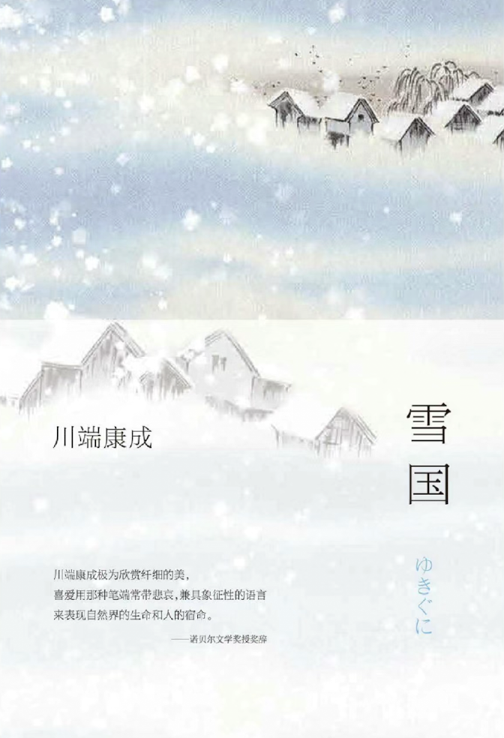
《雪国》是日本诺贝尔文学奖得主川端康成的经典之作，描绘了一个关于爱、孤独与自然的动人故事。故事围绕东京男人岛村与艺妓小雪之间的复杂关系展开。岛村在一个被雪覆盖的温泉小镇上邂逅小雪，二人之间的情感交织着吸引与隔阂，反映了人类内心深处的孤独。

川端康成的文字简洁而富有诗意，巧妙地将雪国的自然景观与角色的内心世界结合在一起。雪不仅是背景，更是角色情感的隐喻，象征着纯洁与无奈。小说通过细腻的情感描写，让读者深刻感受到爱与生命的脆弱。

推荐这本书不仅因为它的美丽语言和深邃思想，更因为它对人性和文化的深刻探讨。小雪作为传统文化的象征，与现代的岛村形成鲜明对比，展现了时代的变迁和人类关系的复杂性。

如果你对日本文学感兴趣，或想体验一种独特的情感与自然交融的美，《雪国》无疑是一本不可错过的经典。它将带你进入一个充满诗意的世界，让你在每一页中感受到那份独特的情感与美丽。

"Snow Country" is a classic work by Nobel Prize-winning Japanese author Yasunari Kawabata, telling a poignant tale of love, loneliness, and nature. The story centers on Shimamura, a man from Tokyo, and his complex relationship with the geisha Yoko. Their encounter in a snow-covered hot spring town intertwines attraction and distance, reflecting the deep solitude of the human heart.

Kawabata's prose is both concise and poetic, seamlessly blending the stunning landscapes of the snow country with the inner worlds of the characters. Snow serves not only as a backdrop but also as a metaphor for their emotions, symbolizing purity and helplessness. Through delicate emotional portrayals, readers can deeply feel the fragility of love and life.

This book is recommended not only for its beautiful language and profound thoughts but also for its exploration of human nature and culture. Yoko, as a symbol of traditional culture, contrasts sharply with modern Shimamura, showcasing the complexities of changing times and human relationships.

If you're interested in Japanese literature or wish to experience the unique beauty of emotion intertwined with nature, "Snow Country" is a classic you shouldn't miss. It will immerse you in a poetic world, allowing you to feel that unique blend of emotion and beauty on every page.

《人生海海》Life is a Journey麦家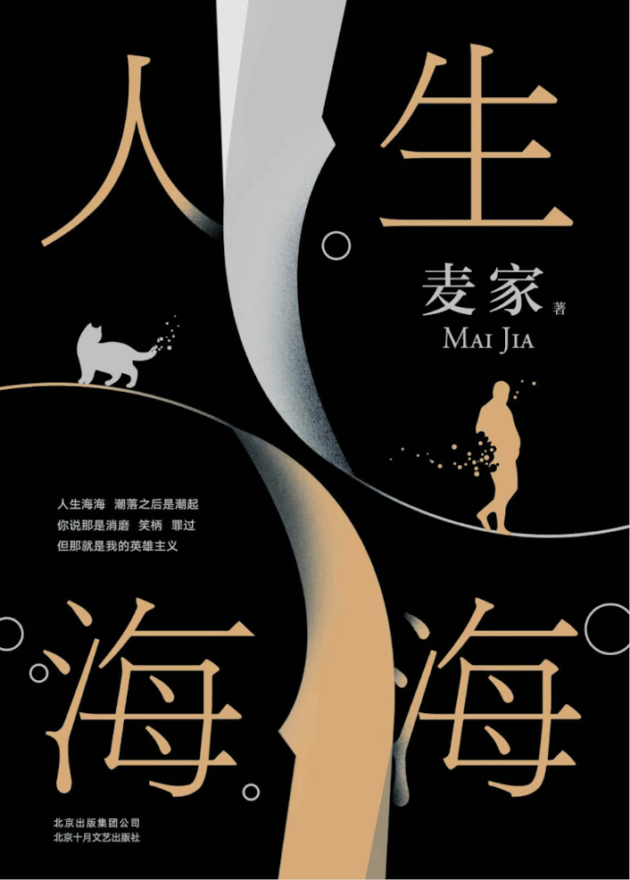《人生海海》是中国当代作家麦家的长篇小说，这部作品标志着他创作风格的转变，从谍战题材转向了对故乡和童年的深情回顾。小说通过一个少年的视角，讲述了村里传奇人物“上校”在时代浪潮中起伏的一生，展现了个体与历史的复杂交织。
“人生海海”这个闽南语词汇被用来比喻人生的宽广与复杂多变，它告诉我们，尽管生活中会有起起落落，但人们应该勇敢地活下去。麦家通过这部作品，传达了一种即使在绝望中也要寻找希望，即使在艰苦中也要坚守道德的人生态度。
小说的叙述方式温柔而充满悲悯，它不仅仅是对一个人物的描写，更是对一个时代的反思。麦家在书中探讨了父子关系、故乡情怀以及命运的无常，这些都是他个人成长经历的反映。他用“温柔的书写”来表达对乡村的理想化呈现，以及对父亲的复杂情感。
《人生海海》是一部深刻探讨人生、历史和人性的作品，它鼓励我们在人生的大海中，无论遇到什么风浪，都要有勇气继续航行，寻找属于自己的方向。这部作品是对生活的深刻洞察，也是对人性的温暖拥抱。

“Life is a Sea” is a long novel by the contemporary Chinese writer Mai Jia, marking a shift in his creative style from spy-themed works to a reflection on his hometown and childhood. Through the perspective of a young boy, the novel tells the story of a legendary figure known as “the Captain” in the village, whose life is filled with ups and downs amidst the tides of time, showcasing the complex interplay between the individual and history.
In this novel, the Minnan dialect term “life is a sea” is used to describe the vastness and complexity of life, reminding us that despite the ups and downs, we should live bravely. Through this work, Mai Jia conveys a life attitude of seeking hope even in despair.
The narrative style of the novel is gentle and full of compassion, making it more than just a character portrayal but also a reflection on an era. Mai Jia explores themes of relationships between father and son, hometown sentiments, and the impermanence of fate in the book, all of which are reflections of his personal growth experiences. He uses “gentle writing” to express an idealized representation of the countryside and complex feelings towards his father.
In summary, “Life is a Sea” is a profound exploration of life, history, and human nature, encouraging us to navigate the sea of life with courage, regardless of the winds and waves we encounter, in search of our own direction. This work is an insightful look into life and a warm embrace of humanity.

《第二性》Le Deuxième Sexe波伏娃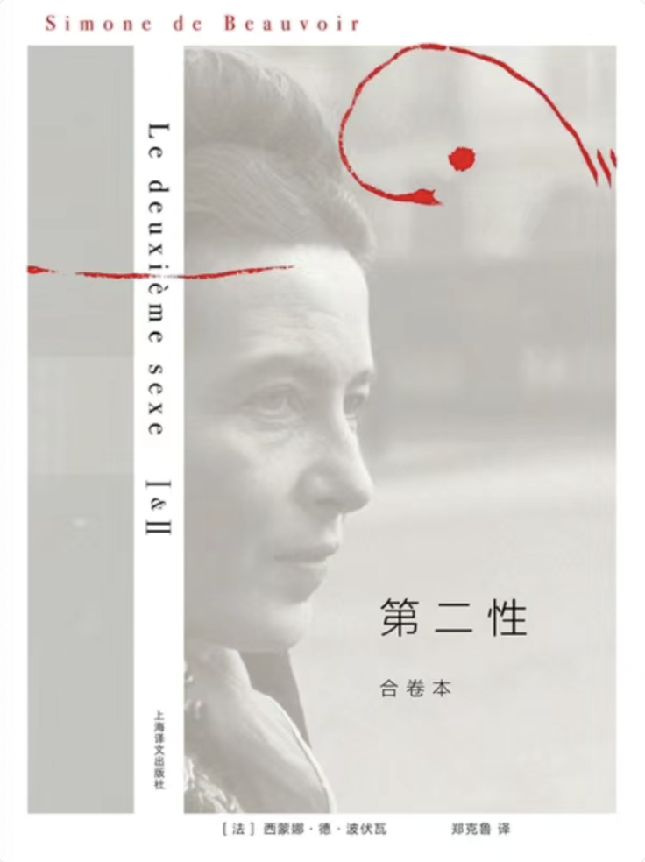《第二性》是法国思想家西蒙娜·德·波伏娃的杰作，这部作品被认为是女性主义运动的“圣经”。在这部社会学著作中，波伏娃以哲学、历史、文学、生物学、古代神话和风俗为背景，深入探讨了从原始社会到现代社会中女性的地位、处境和权利，以及性别差异如何影响女性个体的发展。
《第二性》分为I、II两卷：I从生物学、精神分析学、历史和女性神话在文学中的体现等方面来分析女性的处境；II从存在主义的哲学理论出发，研究女人在出生、青春期、恋爱、结婚、生育到衰老各个阶段，以及在农妇、女工、妓女、明星或知识分子等各个阶层中的真实处境，探讨女性独立可能的出路。” 波伏娃提出了女性获得经济独立的必要性，并强调只有女性经济地位变化才能带来精神的、社会的、文化的等等后果，只有当女性对自身的意识发生根本的改变，才有可能真正实现男女平等。
在英语中，这部作品被翻译为 “The Second Sex”，它不仅在法国，而且在全球范围内都产生了深远的影响。波伏娃的洞察力和对女性境况的深刻分析，使得《第二性》成为了女性主义理论的基石之一。她勇敢地挑战了传统观念，提出了女性不是天生的，而是被社会构建的观点，这一观点至今仍对性别研究和女性主义讨论产生着深远的影响。
《第二性》被誉为‘有史以来讨论女性的最健全、最理智、最充满智慧的一本书’”，甚至被尊为西方妇女的“圣经”。波伏娃由此被称为第二波女性主义运动的“精神母亲”。 这部作品的出版，不仅在法国引起轩然大波，也在全球范围内引发了对女性角色和地位的重新思考。
“The Second Sex” is a groundbreaking work by French philosopher and writer Simone de Beauvoir, considered one of the foundational texts of feminist theory. In this sociological treatise, Beauvoir explores the historical and social realities of women’s conditions, status, and rights from primitive societies to modern times, against a backdrop of philosophy, history, literature, biology, ancient myths, and customs. The work is divided into two volumes: Volume I analyzes the situation of women from perspectives of biology, psychoanalysis, history, and the representation of women in literature; Volume II, grounded in existentialist philosophy, examines the real situations of women across various stages of life—birth, adolescence, love, marriage, motherhood, and old age—as well as in different social strata, from peasants to workers, prostitutes, stars, or intellectuals, discussing possible ways for women’s independence.
Beauvoir argues for the necessity of women’s economic independence and emphasizes that only changes in women’s economic status can bring about spiritual, social, and cultural consequences. She asserts that true gender equality can only be achieved when there is a fundamental change in women’s consciousness. “The Second Sex” has been hailed as “the most sound, rational, and wise book ever written about women,” and Beauvoir is regarded as the “spiritual mother” of the second wave of the feminist movement. The publication of this work has sparked a rethinking of women’s roles and status not only in France but around the world.

