ASEN 1022 Instron Test Procedure

Procedure:

1. Confirm that the Instron machine and onboard PC have power.
2. Confirm the following settings for initial configuration:

Universal Testing Machine: one green light on the front

Instron machine control panel: a green POWER light, a red FRAME STANDBY light, and a red TEST STOPPED light.

1. Confirm ±50 KN Load Cell is installed in the Instron machine #1 or #2 that you plan to use. And the flat grip faces of S16 (16 teeth/inch) and 0 – 0.25 inch range are installed in both top and bottom of machine.

1. Confirm that the yellow limit blocks with the **black knobs** on the left hand side of the machine are set so that the clamps will not run into each other or the top of the machine. These are on the left side of the machine.
2. Obtain the extensometer from the course assistant and do not install it without his or her supervision. The extensometers are very expensive (~$1200) and critical to the success of this lab experiment. An image of the extensometer is shown in Figure 1.

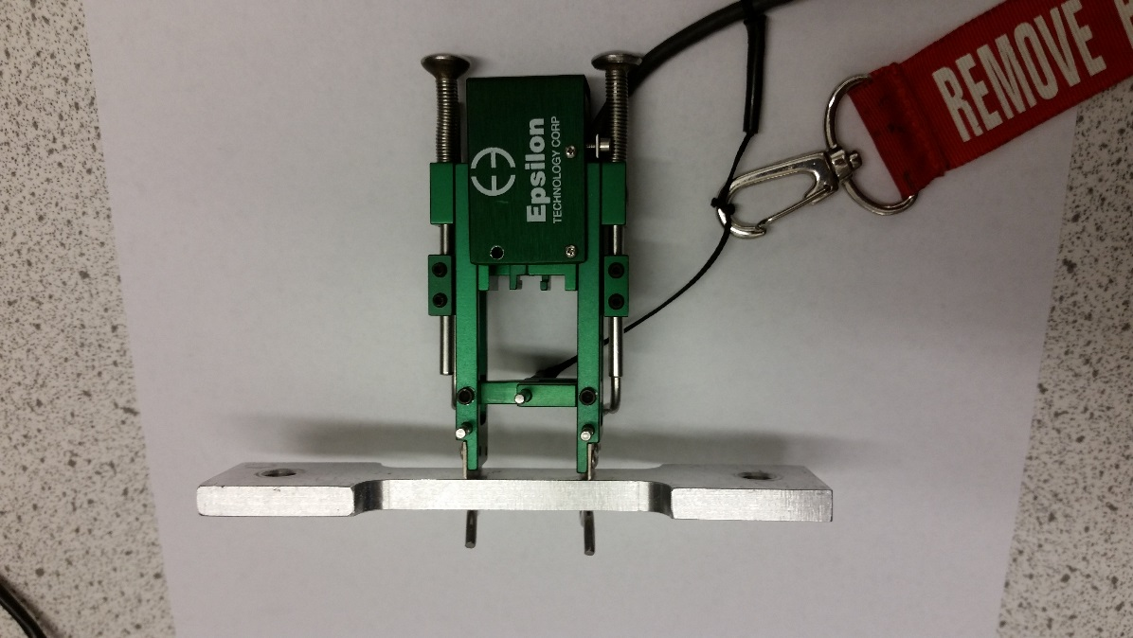

**Knife edges**

**Wire forms**

**Sample**

**Spring-loaded plungers**

**Zero Pin**

Figure 1. Epsilon Extensometer 3542 with aluminum test sample.

1. Connect the matching (#1 or #2) extensometer to the Instron Machine (#1 or #2) **BEFORE** the next step when you will run the LabVIEW VI or the sensor will not be recognized by the software. Using the matched extensometer will use the proper preset calibration file for the extensometer/machine set.
2. Open the ASEN 1022 class folder and select the “Instron Extensometer 2008.vi” from the list displayed. Once the VI has loaded, set the “units” button to inches, pound force and the “control quantity” to the position control. Press the run (right arrow) button to start the VI. The Instron machine control panel should now show a green POWER light, a green FRAME READY light, and a red TEST STOPPED light.

**If an error message occurs when the run button is pressed, try restarting the lab station PC. If errors persist, ask ITLL staff for assistance.**

1. Suggested settings of the machine are:
   1. Test speed: 0.0005 in / s
   2. Test end point: 0.5 in
   3. Time between samples: 1s
   4. Break Detect enabled
2. Prepare the machine for installation of the test specimen. This is done by moving the crosshead up/down using the “JOG UP/JOG DOWN” buttons on the machine control panel until the grips are about **2.5 in** apart to allow the specimen to fit into both clamps. Use the “FINE POSITION” knob to make very small movements as needed and later in 13.
3. Record the material type and measure the cross sectional area of the narrow testing portion that will be tested to failure.
4. Back on the Instron machine, the V-clamps need to be adjusted so they are open enough to fit the specimen without damaging it. The V-clamps are tightened using the rotating knob directly above or below the clamp. Be sure to notice the tighten “T” and loosen “L” directions on the knob.
5. Ensure that the zero pin has been placed in the extensometer. Refer back to Figure 1 for where the zero pin is located.
6. Attach the extensometer to the sample. Refer again to **Figure 1** above. Depress the two spring-loaded plungers at one end of the extensometer so that the wire forms at the other end expand to fit the specimen. Place the wire forms around the sample and release the springs. Make sure that the knife edges are flat against the sample and are aligned, centered and perpendicular to the edge. This ensures good data and that the extensometer will not fall off the specimen when it breaks.
7. 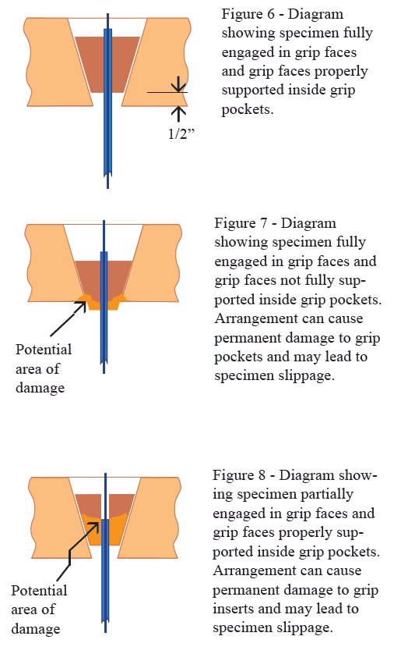Install the specimen (with extensometer attached) into the **bottom** clamp only so that the entire dog-bone tab is lined up with the grip faces. Use the “Fine Position” knob to make fine adjustments. Make sure the specimen is aligned correctly before tightening the clamp into position. See Figures 6-8 from [Ref 1]. **Secure bottom clamps only** by using the rotating knob directly below the clamp.

**GOOD**

1. Line up the specimen in the **top** clamp but **DO NOT SECURE**. **Do not tighten the upper grip yet!** Note: The clamp will move up/down slightly when it is tightened or loosened. (If the grips were tightened at this point this would impart a real measurable force on the specimen, and the sensors must be zeroed before that occurs.) See page 8 of the reference pdf: ADMET_Materials_Testing_Guide_July_2013
2. On the Instron machine control panel, push the “Reset GL” button. This button resets the initial position or origin of the machine for safety purposes. You should see the value of the extension, at the top right of the LabVIEW screen, go to zero and the green light next to the “At GL” button should now be lit.
3. **REMOVE THE ZERO PIN!** Pull out the pin in the center of extensometer and let it hang safely away from the specimen while still attached by the string.

**BAD**

1. Return to the LabVIEW software. Zero all the sensors by clicking the large yellow button labeled “Initialize Values” in the VI. Enter zero for all sensors and press OK. Notice, we zero FIRST then tighten the top grip next.
2. NOW you can tighten the upper grip by turning handles as labeled on the grip. Hand tight is sufficient since the grips are self-tightening. Notice: tightening the top grip imparted a significant REAL load (typically 80 lb-200 lbs) on the specimen that must be measured and not removed. Otherwise our ultimate stress will be calculated too low if we zero before tightening.
3. Shut the door of the Instron Machine.
4. SEAT THE GRIPS: Using the control pad on the machine, manually apply a small additional force of ~150 lbs MORE than the 80-200 lb initial load. This will mechanically “seat” the specimen and allow the grips to securely tighten onto the specimen. Move the crosshead using the FINE POSITION adjustment on the machine control panel. Run the force up to an ADDITIONAL force change of 150 lbs and then back down to zero (as displayed in the VI). Repeat this operation 1-2 more times to establish a solid, reliable initial condition. Once seated, use the FINE POSITION adjustment to move the crosshead so the force is as close to zero as possible for the start of the test.

**Note: There is a manual stop on the control panel box, as well as an emergency stop on the bottom of the machine for EMERGENCY STOP SITUATIONS ONLY! Be careful not to activate this button accidentally with your knee.**

1. On the software, select the ‘Break Detect’ enabled button. This will protect the machine and extensometer by stopping the movement when the force drops suddenly by 50%.
2. If you want to clear the chart from a previous test, put a check in the “Clear data” box. Press the “Start Test” button in the VI to start the test. The VI will now control the Instron machine and run the tensile test up the target endpoint of displacement. The Instron machine control panel should now show a green POWER light, a green FRAME READY light, and a green TEST IN PROGRESS light.
3. Note observations during the test in your lab notebook. It’s a good idea to take pictures and video of the test setup and during the test.
4. Once the specimen breaks, the machine should stop automatically and the “TEST STOPPED” light will show red. Double check that the machine is no longer moving so that the extensometer is not pulled apart past its mechanical stops - causing damage.
5. When you are satisfied with the data, **press the “Save Data” button to save your results! Do not forget** this step; unlike other VIs this one does not automatically save the data while it is running.
6. For safety ensure the force reading is low, < 5 lbs, before removing your specimen.
7. Remove extensometer first so it does not fall and get damaged.
8. Then loosen grips to remove sample.
9. Return to step 9 to test another sample, or choose “STOP VI” when you are finished with all samples.
10. Close out of the Instron Software by right clicking on the gray area next to the stop sign and click Exit.

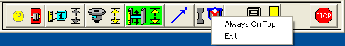

1. Log out of the computer. DO NOT shutdown the computer.
2. Leave the Instron and Universal Testing Machine powered. They must remain powered to keep Instron’s onboard battery charged or software and communication failures occur.
3. **Note: The first column in your data file is Crosshead Position (inches), which is how much the machine moved. You will not use this column 1. The second column is load (lbs) from the load cell. You will use this column, divided by cross sectional area A to get stress (). The third column is Extensometer position (inches), which is how much your material stretched (L). You will use this column to get  L/ L, where L is the initial gauge length. If you used English units the gauge length of the extensometer is 1 inch. So the third column divided by 1 inch, is a direct measure of your strain () if you used English units.**

References

**MATERIAL TESTING GUIDE**

**In-text:**1

**Your Bibliography:**1 "Material Testing Guide" Available: <http://cdn2.hubspot.net/hub/70514/file-236488676-pdf/ADMET_Materials_Testing_Guide_July_2013.pdf>