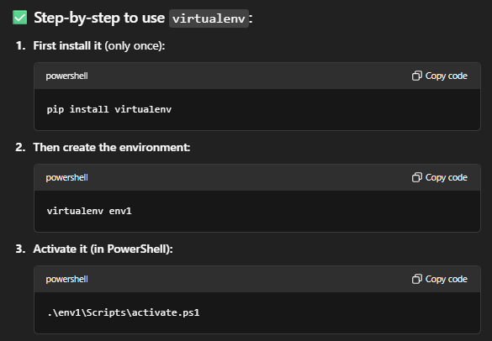

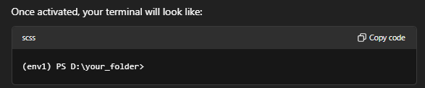

---🡪 install packages you require 🡪

|  |  |
| --- | --- |
| Commands | Use |
| pip index versions <package_name>  ex - pip index versions pandas | Lists all available versions |
| pip install <package_name>=<version>  ex - pip install pandas=2.1.4 | Installs particular version |
| pip freeze  ex –  numpy==1.23.5  flask==2.1.2 | It **lists all Python packages currently installed** in your active environment, along with their exact versions. |
| pip freeze > requirements.txt | This will save all installed packages and their versions into a file named requirements.txt in your current folder. |
| pip install -r requirements.txt | This command run on other environment , will install all same packages with same version |

When work is complete ---you should deactivate it

