**Basic CE Voltage Divider Setup**

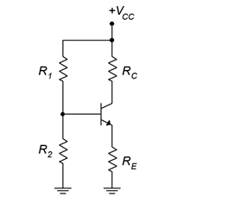

**E**

**C**

**B**

**⚙️ Main Components:**

* **Vcc**: DC supply voltage
* **Rc**: Collector resistor
* **Re**: Emitter resistor
* **R1 & R2**: Base voltage divider resistors
* **Q**: NPN transistor (we’ll assume silicon, so VBE≈0.7 v)

Using voltage divider

