Formula | Explanation
FET basics | FET is a 3 terminal device which uses electric field to control the flow of current through the device  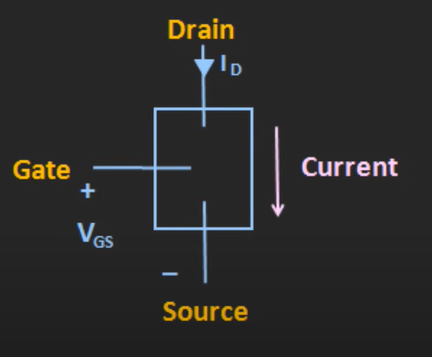  - Current flows from drain to source  - And is controlled by voltage across gate and source  - Voltage changes the electric field in the device and in turns controls the current flowing from drain to source  - So, in FET , by controlling the electric field we can control the current  - Thus, FET is called as the field effect transistor and also called as voltage-controlled device  - Contrary to the BJTs – which are current controlled devices  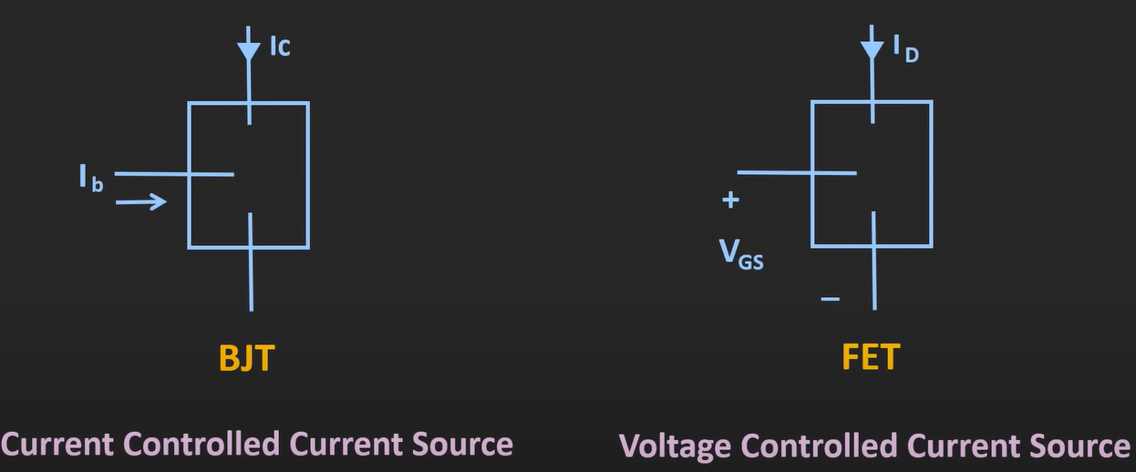    BJT vs FET  - FETs are voltage controlled – BJTs are current controlled  - Input Impedance of FET is very high (in M$Ω$ ) – BJTs as per config(CE, CC , CB have different types of input impedance)  - FETs are smaller in size compared to BJTs  - FET consumes less power compared to BJTs – hence used in low power applications  Types of FET  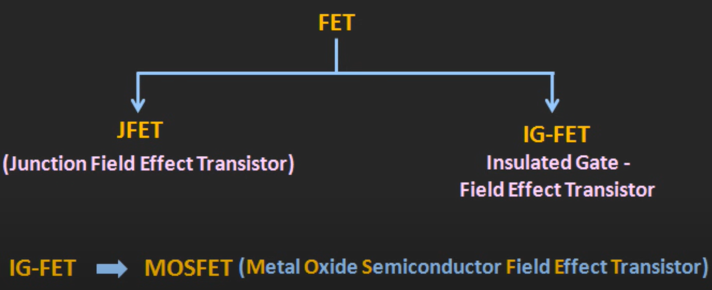  - JFET (junction field effect transistor)  - IG-FET (insulated Gate-field effect transistor) [mosfet is of type IG-FET]  More details on FET construction  - FET is a 3-terminal device (drain , Gate , source) – [note : actually four : substrate/body is also there – in VLSI - FET to function – we need to bias it]  - Path through which charge carrier flows known as channel  - Based on doping of these channels – they are called n-channel / p-channel  Note : JFETs are not that used so we will focus on IG-FETs  IG-FET construction  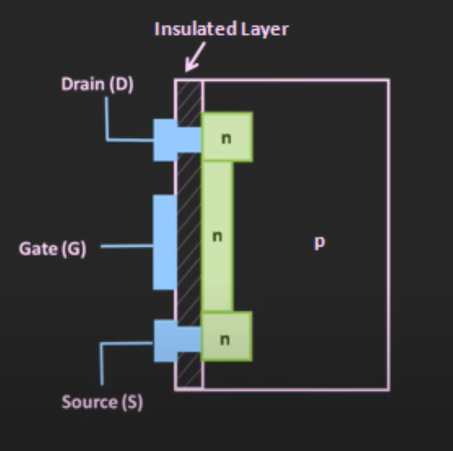  - The channel here is N-type , drain and source is also of N type  - The substrate or body here is of P-type  - The insulated layer is formed using the oxide of semiconductor  - In IG-FET , gate terminal is isolated from the channel  - Most common type of IG-FET is MOSFET  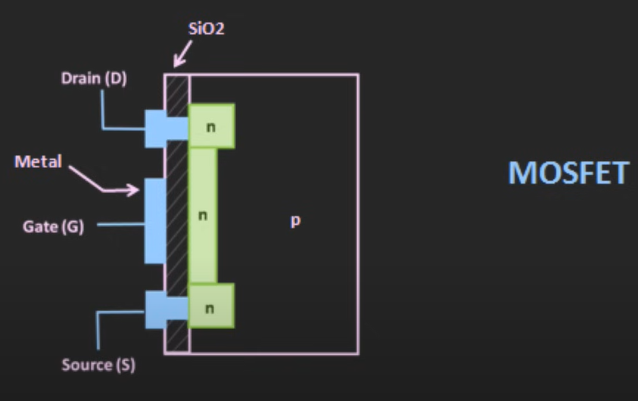  - In MOSFET , gate is made up of metal  - Insulation layer is made of silicon dioxide (${SiO}_{2}$)  - MOSFET can be further classified as  - Depletion type (when we apply voltage at gate terminal and if the quantity of charge carrier in the channel gets depleted – it is called as depletion type of mosfet)  - Enhancement type (when we apply voltage at gate terminal and if the quantity of charge carrier in the channel gets enhanced – it is called as enhancement type of mosfet)  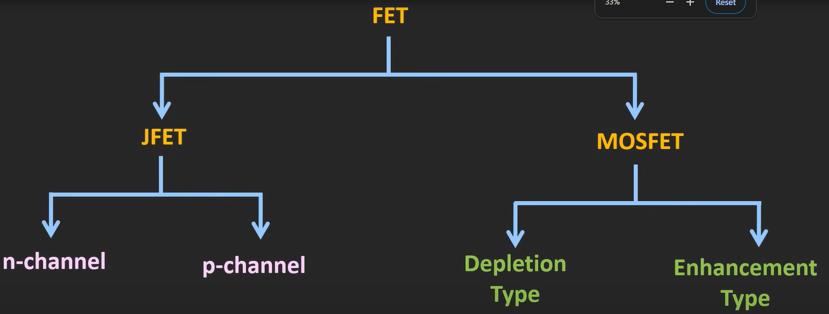  Depletion Type MOSFET  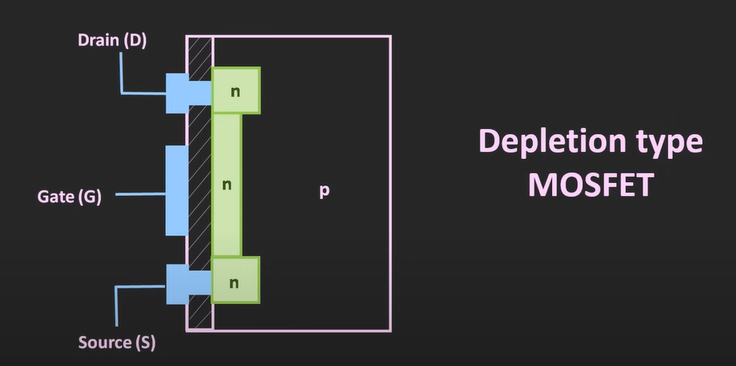  Enhancement Type MOSFET  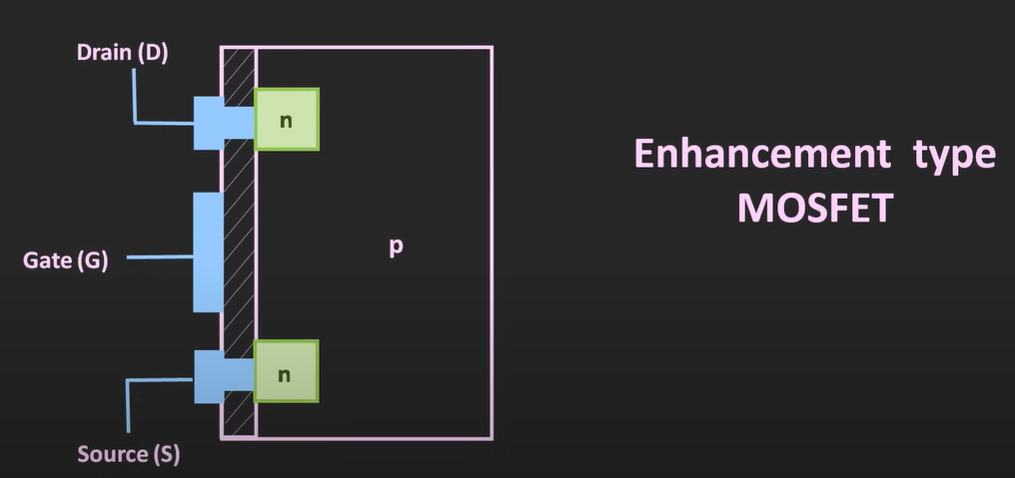  Further classification  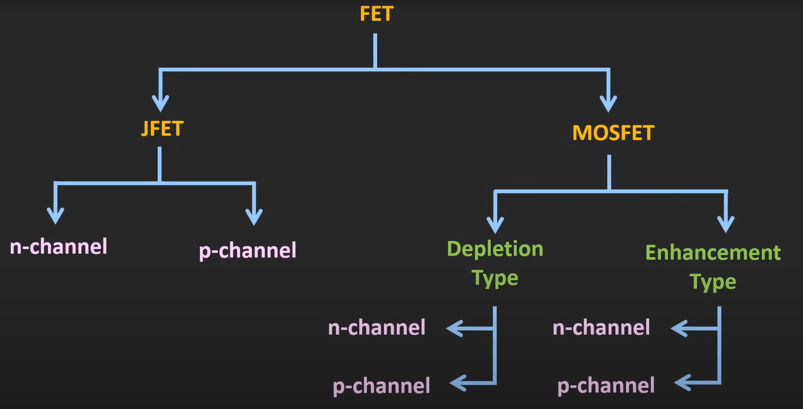
Depletion type MOSFET | N – CHANNEL DEPLETION MOSFET Construction 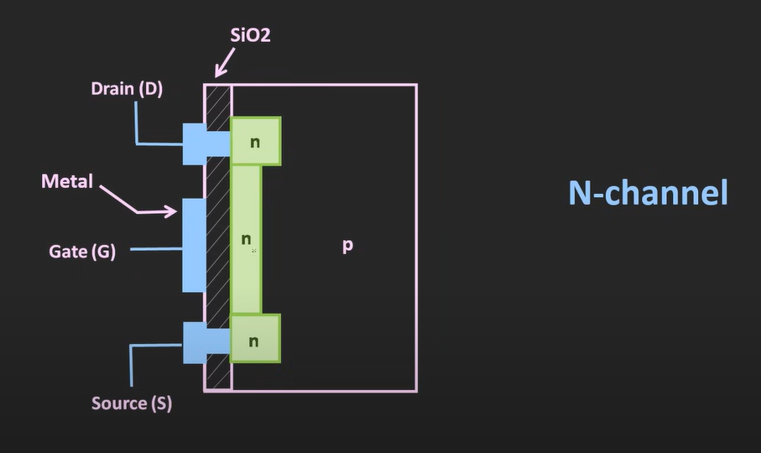 - Channel : n-type material - Substrate : p-type material - Through metallic terminals – drain and source are connected to the n channel - Gate terminal is isolated from the channel using SiO2 layer - Gate doesn’t have any direct contact with the n-channel – so no flow of current in gate terminal - Thus gate (input) is considered as high impedance 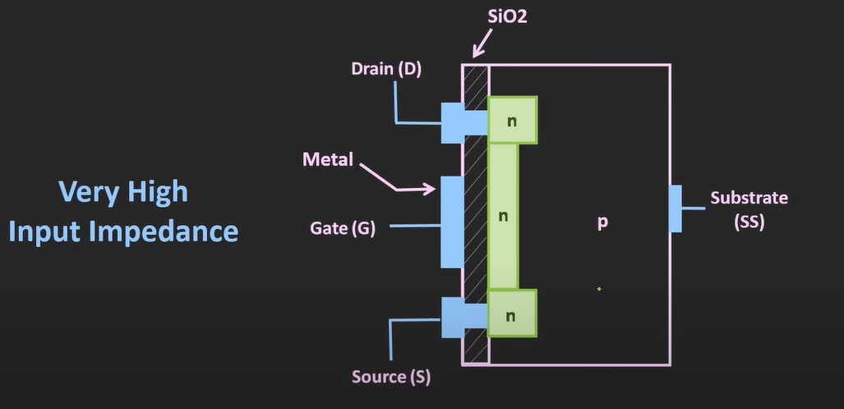 - Thus, these FETs are used where min power is required Working of depletion type of MOSFET When $V_{GS} is 0$ 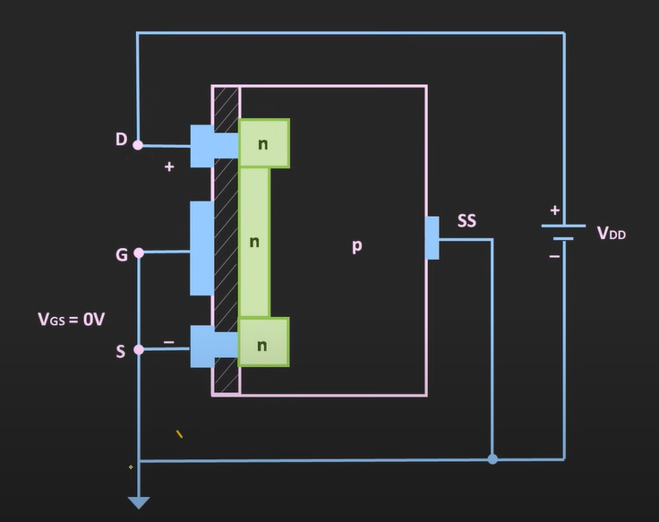 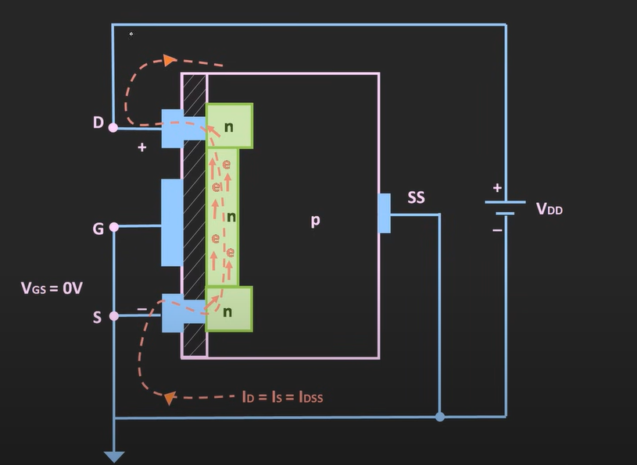 - Current follows this path (using electrons) : -ve side of battery source n-channel drain +ve side of battery - As we increase Vds , the flowing current increases - If we keep on increasing the Vds voltage – there comes a certain point where all electrons will be moving from Source to Drain and we observe constant current in n- channel afterwards - Conventional current flows from Drain to source Depletion type mosfet output/drain characteristics 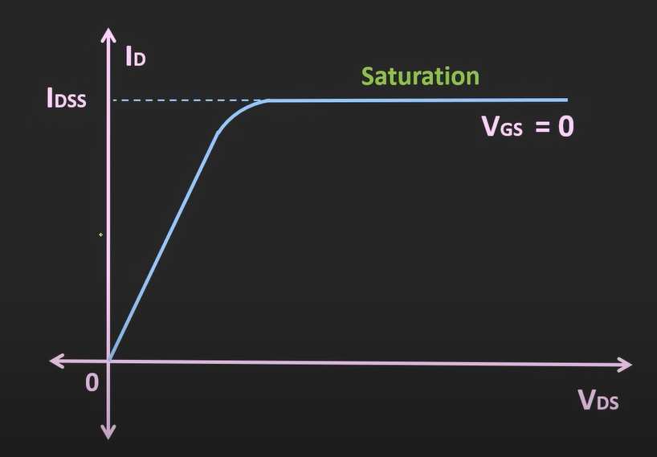 - As we increase the supply voltage $V_{DS}$ – the current $I_{DSS}$ will increase , but after certain voltage it becomes constant - The value current when $V_{GS}=0 ,$ is called $I_{DSS} (current from drain to source in saturation)$ When $V_{GS} is-ve$ 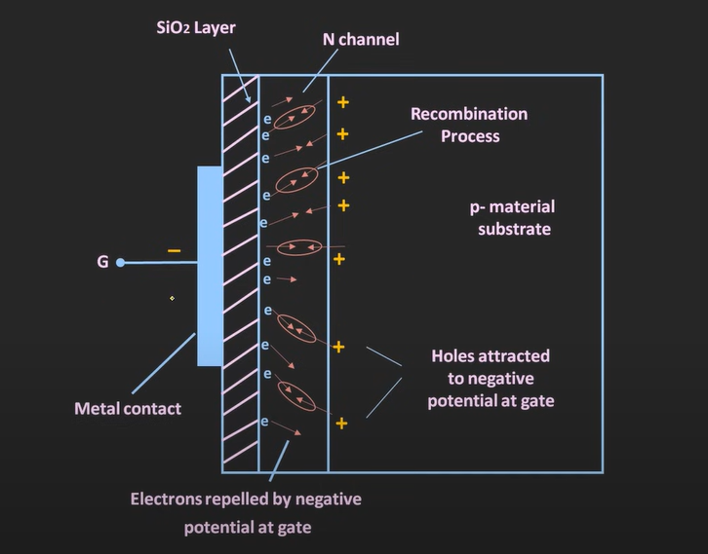 - The -ve charge at gate terminal pushes the electrons from channel to substrate (where holes exist) - There they recombine (reducing the electrons in channel) - In turn reducing the charge carriers - Effectively reducing the flow of electrons i.e. flow of current 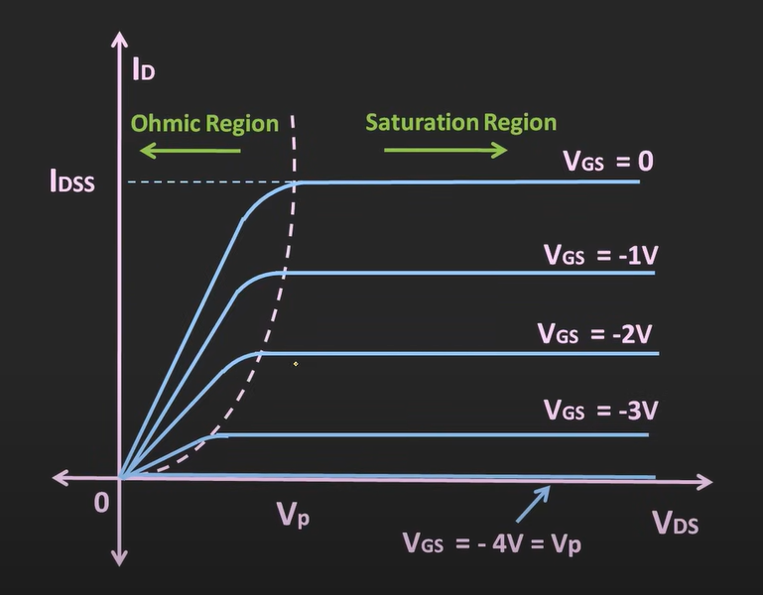 - Here u can see , when Vgs is becoming more negative the drain current reducing - And at one voltage the current becomes 0 (here showed as -4v) (also known as Vp = pinch off voltage) When $V_{GS} is+ve$ 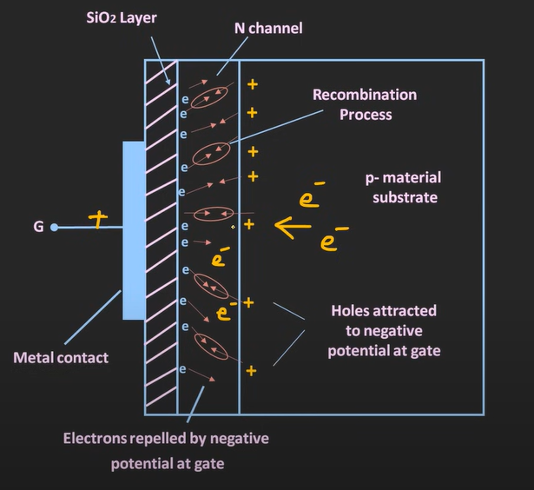 - Here , when gate terminal is +ve , even the minority carriers in substrate (electrons) gets attracted towards the gate terminal - And enters into the channel (making more electrons available in channel) - This effectively increases available carriers in turn increasing the flow of current 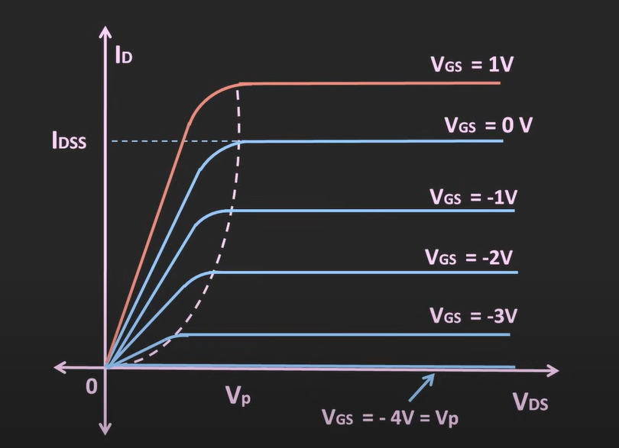 TRANSFER CHARECTERISTICS OF N- type DEPLETION TYPE MOSFFET Transfer characteristic defines the relation between input and output (for fixed value of Vds) 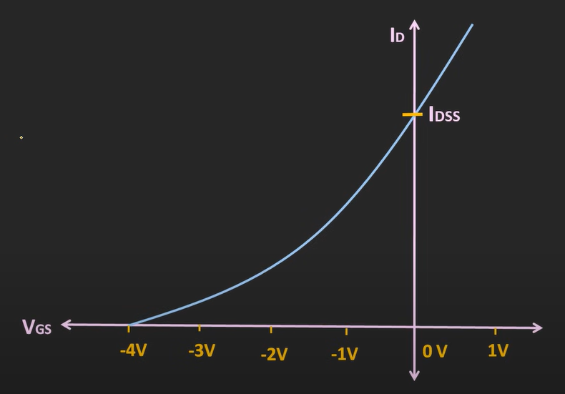 - For fixed value of $V_{DS}$ relationship between $V_{GS}$ (input) and $I_{d}$ - As the $V_{GS}$ becomes more positive $I_{d}$ increases 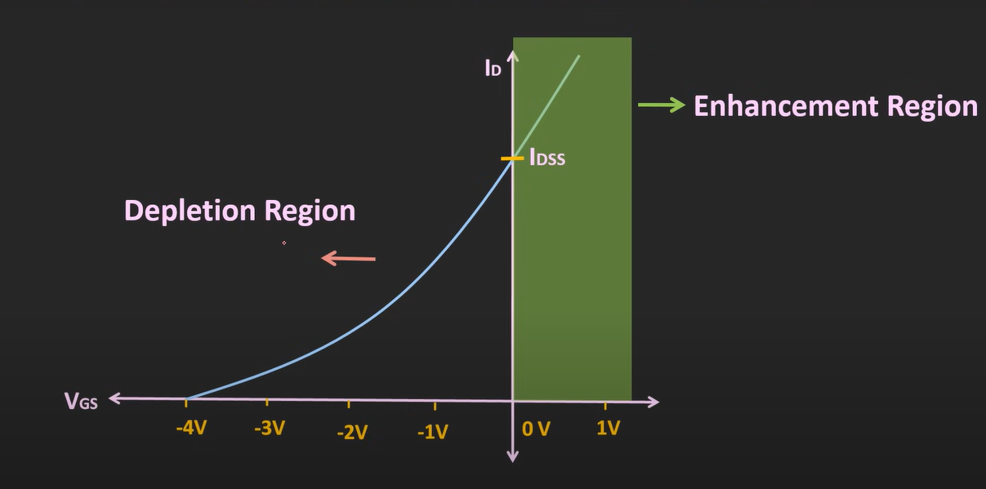 - Where $V_{GS}$ is negative known as depletion region - Where $V_{GS}$ is positive known as enhancement region $I_{D}= I_{DSS} {( 1- \frac{V_{GS}}{V_{p}} )}^{2}$ [for both NMOS and PMOS] P – CHANNEL DEPLETION MOSFET Construction 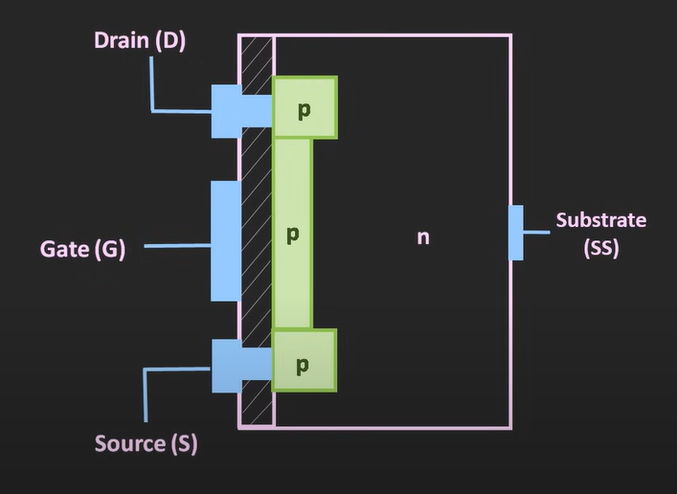 Working of depletion type of MOSFET 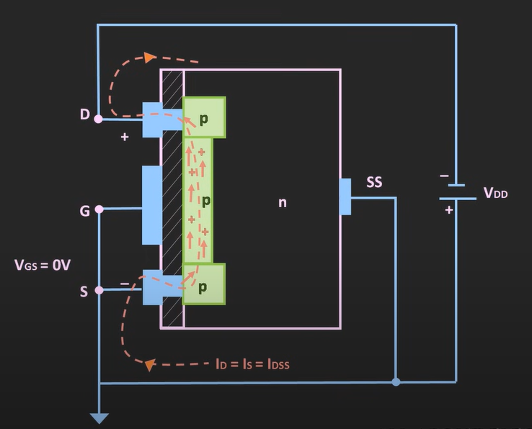 - Flow of holes (due to attraction at -ve terminal of Vds) When $V_{GS} is-ve$ - Minority carriers from substrate(holes) gets attracted towards p channel - Effectively increasing holes in p-channel - In turn increasing current from holes When $V_{GS} is+ve$ - Holes of channel repel (due to gate being positive) and moves toward substrate and electron from substrate move towards channel due to attraction for positive gate terminal - In turn holes and electrons get recombine - Effectively reducing carriers in channel - Thus, reducing the current 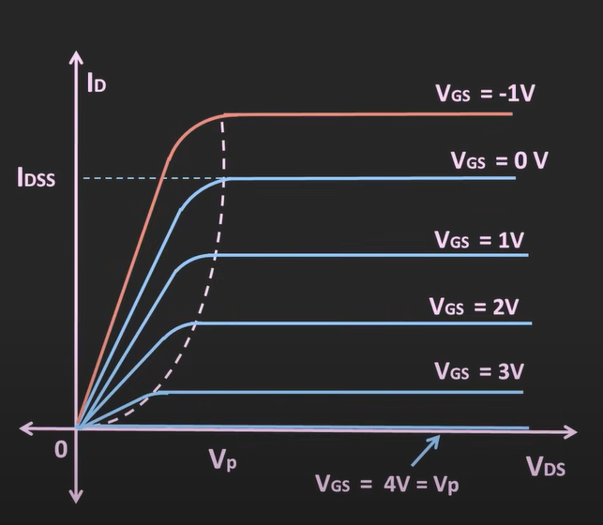 [here , note : $V_{DS}$ is negative here – but for ease shown on positive axis] (as when $V_{DS}$ is negative – current increases) TRANSFER CHARECTERISTICS OF P- type DEPLETION TYPE MOSFFET 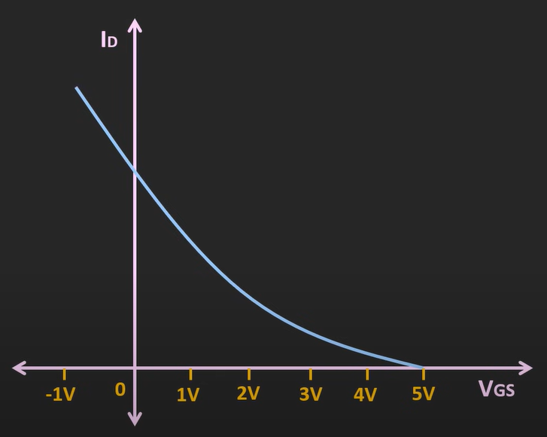  Electronic symbol of N-channel and P-channel depletion type mosfet  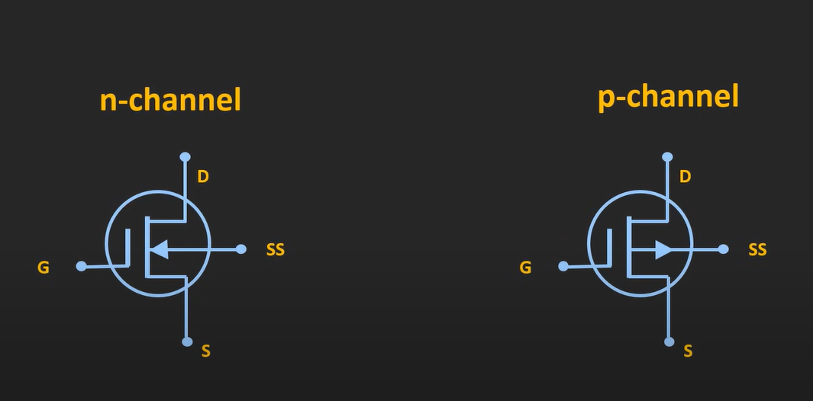  - When substrate pin terminal is available  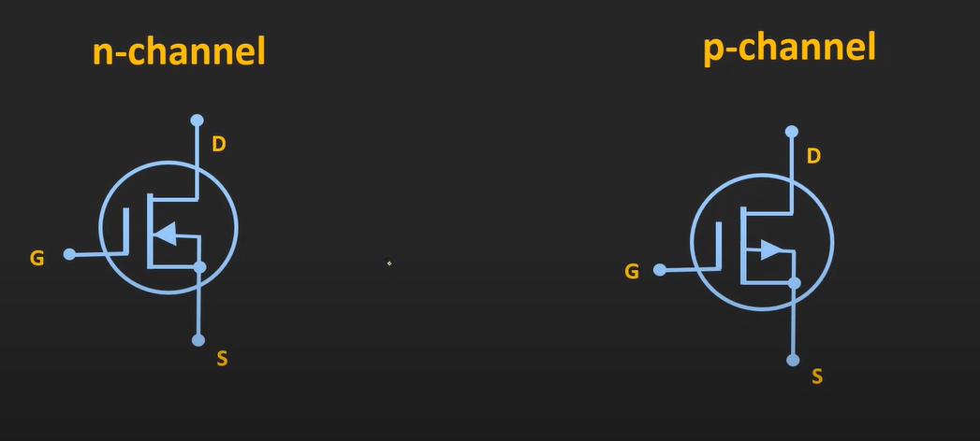  - When substrate terminal is not available as pin
Enhancement type MOSFET | Note : before learning this : review Depletion type mosfet  N – CHANNEL ENHANCEMENT MOSFET Construction 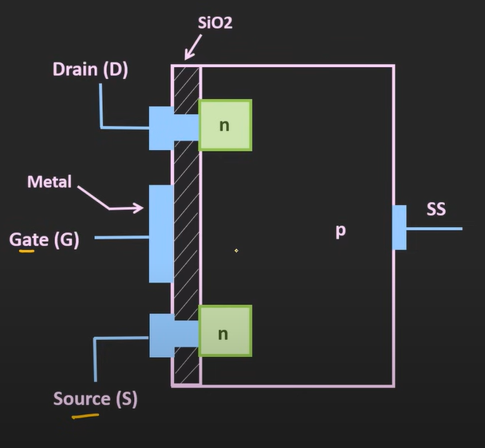 - Here when controlled voltage is applied to Gate and source,a channel type layer starts to form near gate terminal Working When $V_{GS} is 0$ 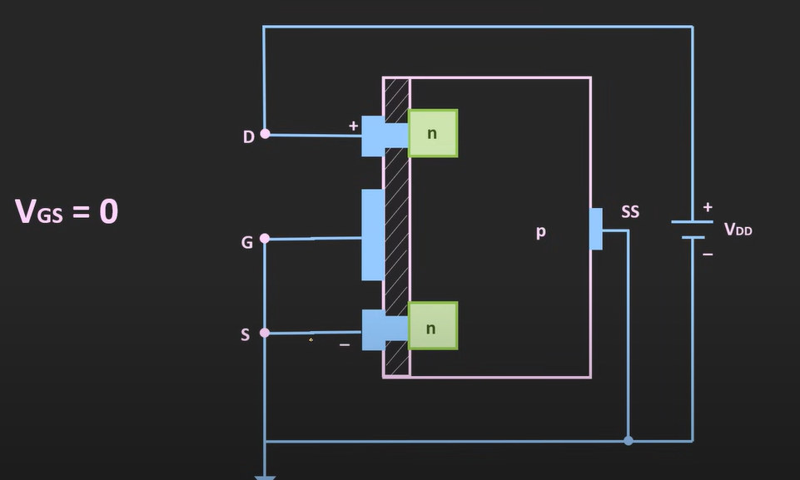 - There is no channel – hence no current flow - Mosfet is OFF when $V_{GS}$ = 0 When $V_{GS} is+ve$ 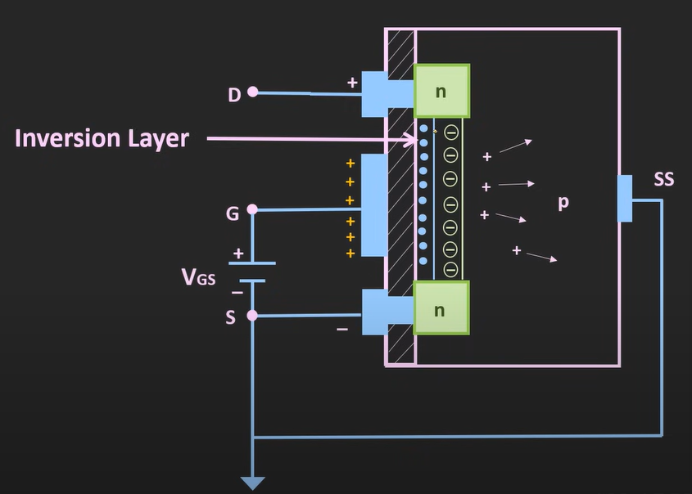 - When $V_{GS}$is positive, minority carriers (electrons) from substrate are attracted towards gate and form a layer (that is called inversion layer) - When we apply $V_{DS}$ current starts flowing from inv. layer - Value of $V_{GS}$ at which inversion layer starts to form is known as threshold voltage ($V_{th})$ - When $V_{GS}$ is below threshold voltage $V_{T}$ current doesn’t flow as there is no inversion layer) - As the $V_{GS}$ increases beyond $V_{T}$ – the inversion layer becomes more thick - When we apply voltage $V_{DS}$ 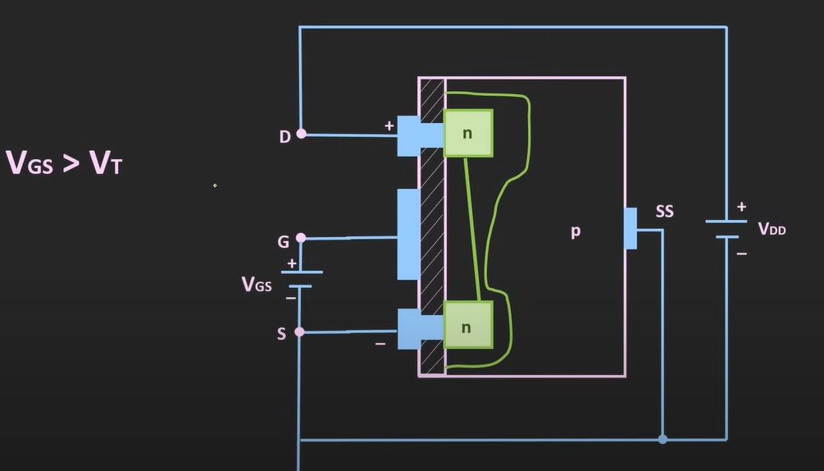 - We can observe that the width of the channel has reduced on the drain side - Because– 1. Channel formation - In an NMOS, applying VGS>Vth ​ creates an inversion layer (n-channel) from source → drain. - This channel is controlled by the gate voltage. 2. Apply Vds​ - When you apply a drain-to-source voltage, current flows. - But the voltage along the channel is not the same everywhere: - At source end, channel potential ≈ 0 (ground). - At drain end, channel potential ≈ Vds 3. Effective gate voltage along the channel Gate voltage relative to channel at any point = 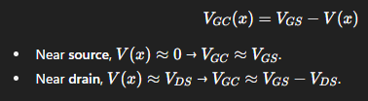 4. Pinch-off condition - The channel exists only if Vgc​>Vth​. - At the drain end, when Vds​ becomes so large that: Vgs – Vds = Vth the inversion layer vanishes right at the drain. - This is the pinch-off point. - As we keep increasing the voltage $V_{DS}$ at one particular voltage pinch off condition will occur - Voltage $V_{DS}$ at which pinch off condition occurs is considered as $V_{DS (saturation)}= V_{GS}- V_{T}$ 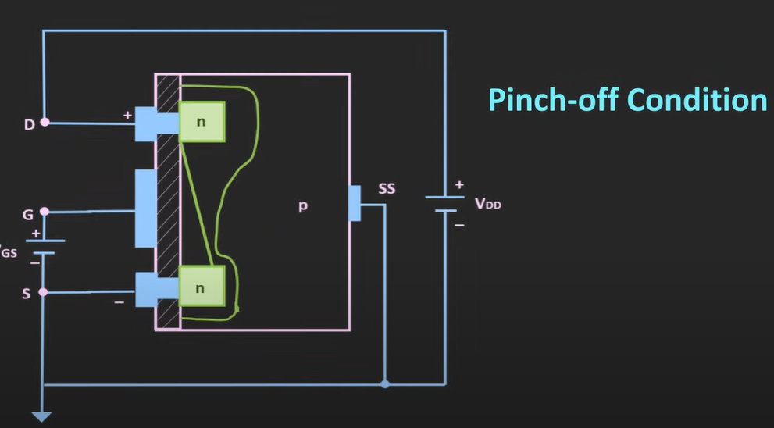 - If we keep on increasing $V_{DS}$ beyond saturation , the layer will become as shown in image 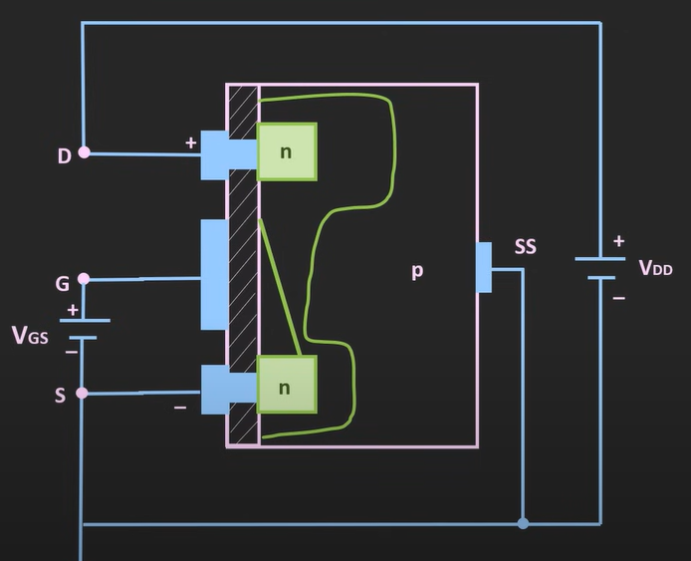 - But even if there is no layer on drain side , current still flows and same as $I_{D(sat)}$ because , the force of voltage will make electrons jump across the gap - Means for $V_{DS }$voltage > $V_{DS (saturation)}$ –> current $I_{D(sat)}$ remains same 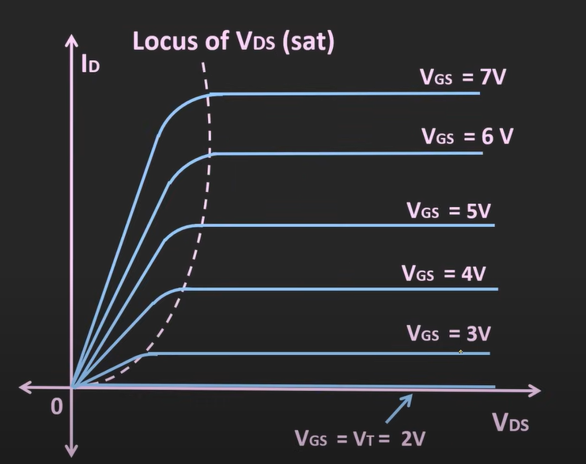 - Here u can see , as we increase Vds current becomes same for a particular value of Vgs - Also, if we increase Vgs (the pull of carriers at Gate terminal increases , the inversion layer increases) allowing more current to flow 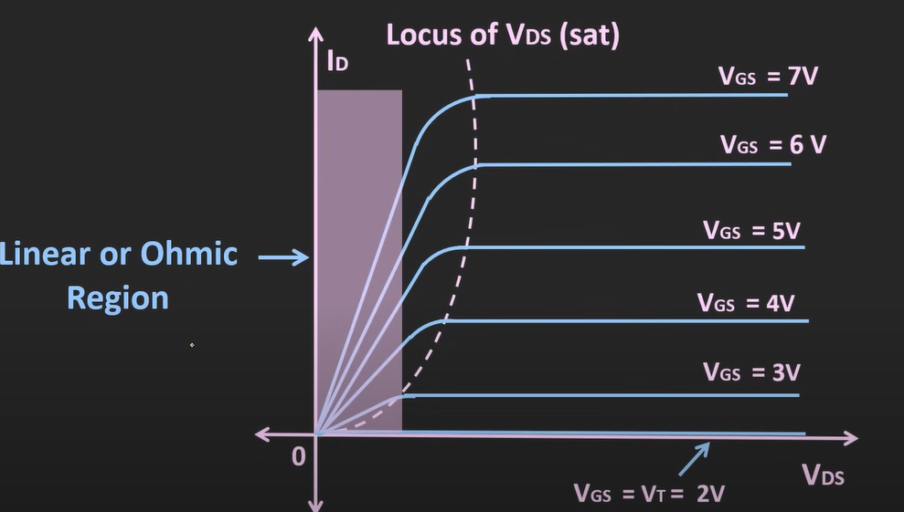 - This region is called as linear or ohmic region - In this region mosfet acts as voltage-controlled resistor (for the fixed value of Vds , if we change the value of Vgs – the width of layer will change in turn resulting in change in current - When - Vds < Vgs – Vt - Vgs > Vt - That time mosfet is in ohmic region or can be said to act like voltage-controlled resistor Cutoff region 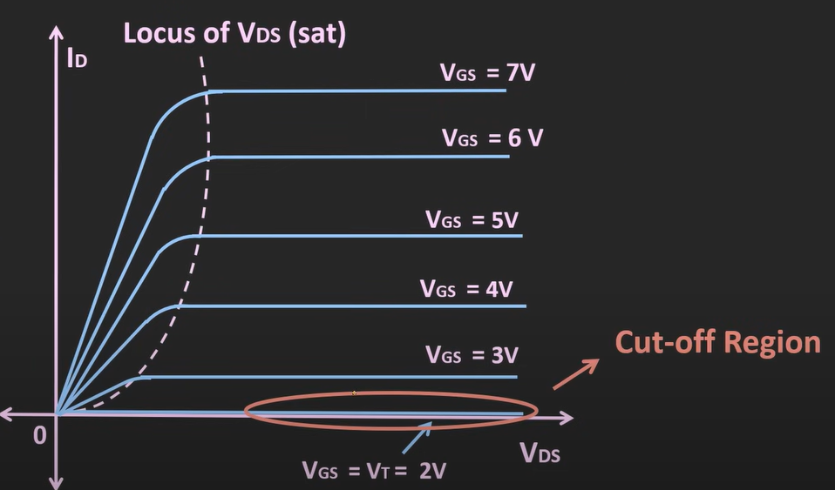 - When Vgs < Vt – the current through the mosfet is 0 - Mosfet is off Saturation region 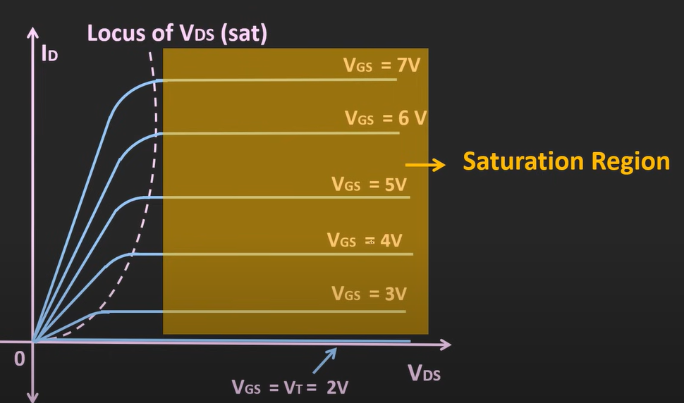 - When Vds >= Vgs – Vt , mosfet is said to be operating in saturation region Transfer characteristics This shows the relation between output(Id) and Input (Vgs) (at const Vds) 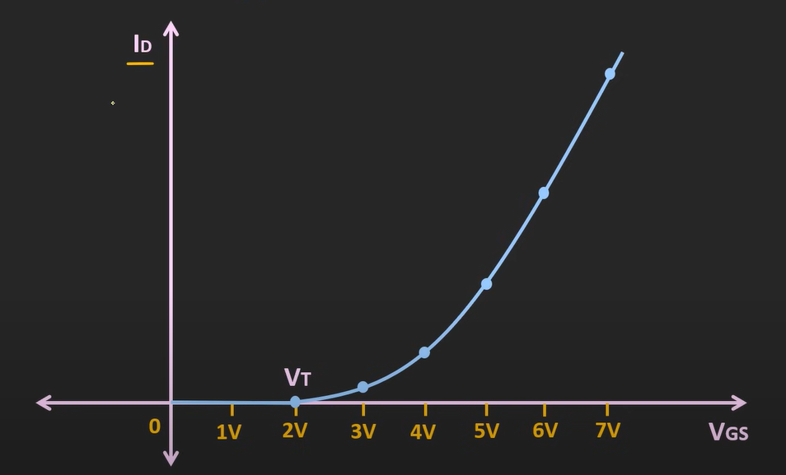 - Here u can see, up to threshold volt , drain current is 0. - Because of No inversion layer available $I_{D}= K {( V_{GS}- V_{T})}^{2}$ (k depends on the physical parameter of MOSFET) [valid for both PMOS and NMOS] P – CHANNEL ENHANCEMENT MOSFET Construction 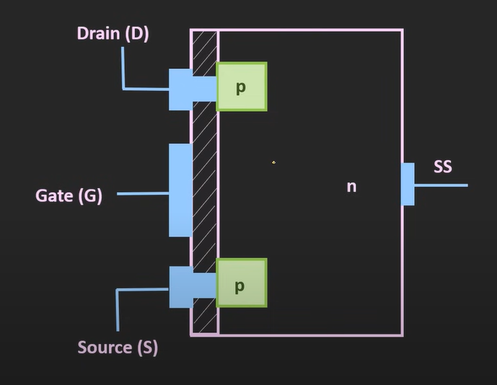 Working When $V_{GS} is-ve$ 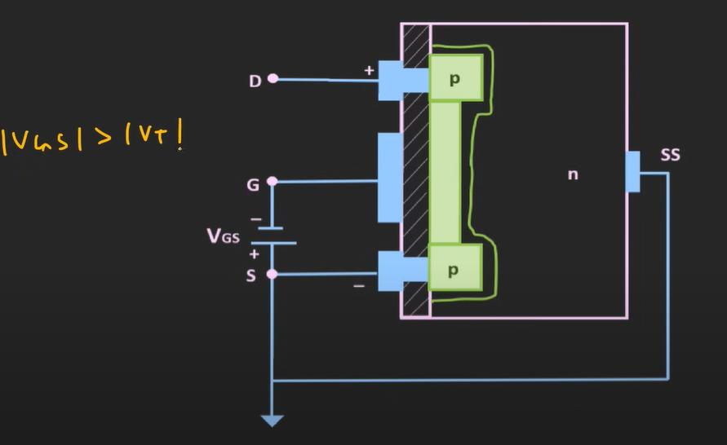 - Minority carriers from substrate (holes) gets attracted towards gate terminal (the layer starts to form when | Vgs | > |Vt| 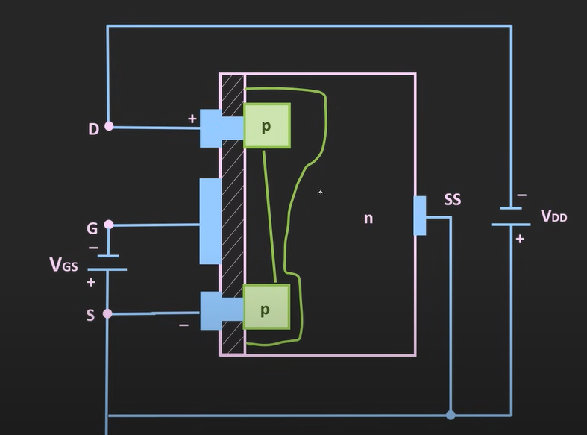 - Pinch off condition will occur when |Vds | = |Vgs| - |Vt| 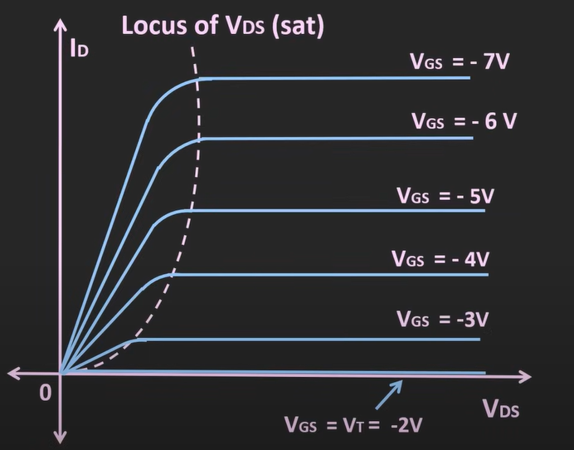 Note : Vds is negative in values (just the axis is shown this way for ease) Transfer characteristics 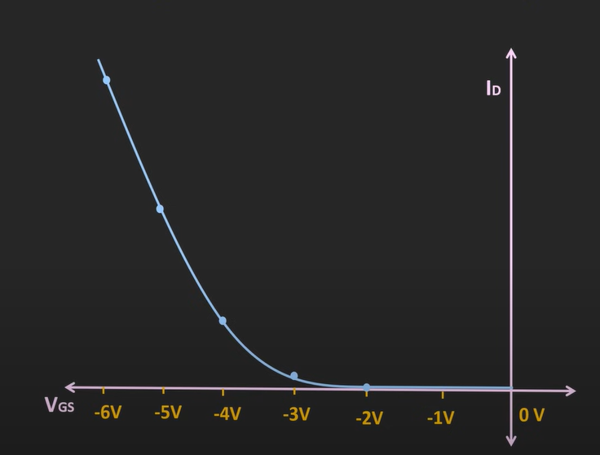  Electronic symbols  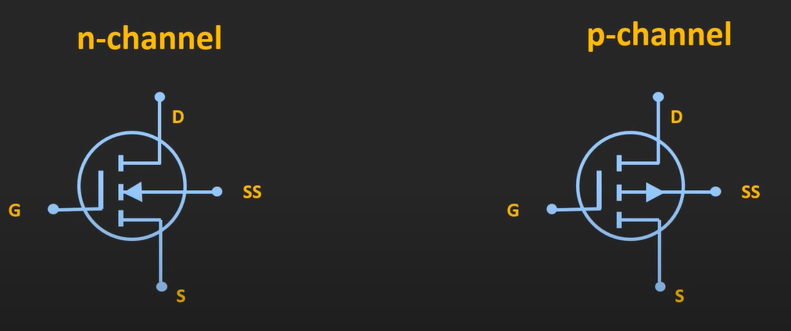  - When substrate pin is given  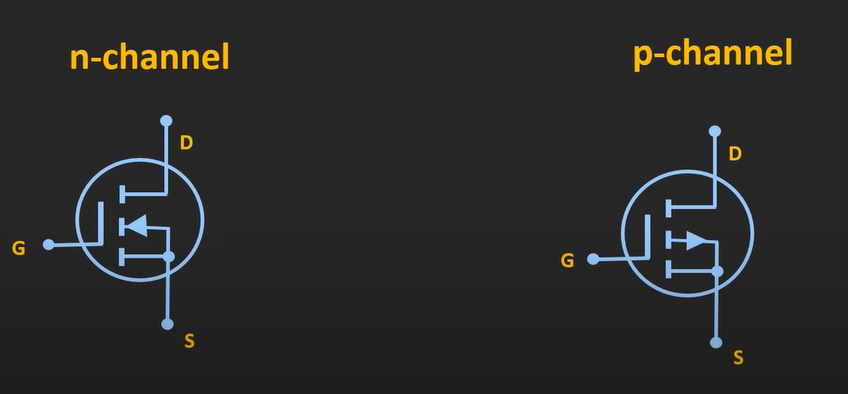  - When the substrate is connected to the source terminal internally
A MOSFET has 4 terminals:  Gate, Source, Drain, Body.  Why is the body usually shorted to the source in circuits? | ✅ Answer  - The body (substrate) forms a pn-junction with the source and drain.  - If the body is left floating or at a different potential than the source → that junction could become forward biased, leading to unwanted current leakage.  - By shorting Body = Source, the Source–Body junction is always at zero bias → so no unwanted current flows.  - It also removes the body effect (where threshold voltage changes with body-to-source voltage).  👉 That’s why in most circuits, MOSFET is treated as a 3-terminal device (G, D, S).  why in some cases ss is connected to source and not drain (ss forms PN junction with both drain and source then why connected with source??)  - The bulk/body (SS) forms p–n junctions with both source and drain.  - If left floating, either junction can forward bias, causing leakage or latch-up.  - To avoid that, we fix the bulk to a reference potential so that at least one junction (with source) is always reverse biased.  👉 In practice:  - For NMOS, bulk = p-type → tied to ground (0 V), same as source.  - For PMOS, bulk = n-type → tied to VDD, same as source.  Why source, not drain?  Because the source is the reference terminal (where carriers enter). By tying bulk to source, the body–source diode is never forward biased. The drain voltage can then swing higher/lower without accidentally turning that diode on.  ✅ In short: Bulk is tied to source so that the body–source junction stays reverse biased and the MOSFET operates properly.
Body effect (a.k.a substrate bias effect)  (for enhancement type mosfet ) | $V_{th}$(threshold voltage) :  - In Enhancement type mosfet (there doesn’t exist a channel between drain and source)  - When we apply gate volt (it attracts carriers from substrate(body) and makes a channel  - At some gate voltage $V_{GS }$the channel is formed that much , that It can now start conducting (means when $V_{DS }$is applied – it allows carriers to flow through it) (that $V_{GS }$is called $V_{th}$)  - After $V_{GS }$ crosses the $V_{th}$ voltage – current starts flowing from drain to source (considering $V_{DS }$is available)  Effect : body effect can change $V_{th }$(threshold voltage) to shift and also allow leakage currents  Note : MOSFET has 2 PN junction  - Drain – substrate/body/bulk  - Source – substrate/body/bulk  For N- type mosfet  - Drain(n-type) – body(p-type)  - source(n-type) – body(p-type)  For P- type mosfet  - Drain(p-type) – body(n-type)  - source(p-type) – body(n-type)  - when substrate/body left unbiased(not connected / floating) (Leakage currents) -  - [for P-type] drain or source being more positive than the floating volt of substrate can cause forward biased PN junction  - [for N-type] floating volt of substrate being more positive than the drain/source can cause forward biased PN junction  - Making current to flow (carriers to move) (called as leakages)  - So, to avoid leakages substrate should not be left floating  - when substrate/body left unbiased(not connected / floating) (How $V_{th }$ is affected) -  - Normally: Body/substrate/bulk = Source (so there’s no voltage between them $V_{SB}= 0$. Easy case → Vth is constant.  - But now when substrate is left floating  - For P type material (PMOS)(substrate is of n-type) : substrate is at higher potential than source/drain (makes reverse biased PN junction at source-ss and drain-ss)  - In turn making depletion region under the gate wider (substrate bias increases the depletion charge under the channel. To balance that extra depletion charge, Gate must supply more field → i.e., higher |Vgs| to keep inversion layer maintained.  - So now, the Gate must apply extra -ve voltage to overcome this depletion (for PMOS)  - For N type material (substrate is of p-type) : : substrate is at lower potential than source/drain (makes reverse biased PN junction at source-ss and drain-ss)  - In turn making depletion region under the gate (substrate bias increases the depletion charge under the channel. To balance that extra depletion charge, Gate must supply more field → i.e., higher |Vgs| to keep inversion layer maintained.  - So now, the Gate must apply extra +ve voltage to overcome this depletion  - This is how $V_{th}$ gets changed  - So ,  - pMOS : Body more positive wrt Source : |Vth| ↑ (needs stronger negative gate)  - nMOS : Body more negative wrt Source : Vth ↑ (needs stronger positive gate)  Body Effect Summary  - Two effects of substrate (body) bias:  - Leakage currents → if body is floating, its potential may drift, causing body–source or body–drain PN junctions to become forward biased → unwanted current leaks.  - Threshold shift (Body Effect) → if body–source PN junction is more reverse biased, depletion region widens → Gate must apply extra voltage to invert → Vth increases (for nMOS → more +ve, for pMOS → more –ve).  That’s why in VLSI, the substrate (bulk) must always be correctly biased, otherwise even tiny mismatches cause large leakage and unreliable switching.
Body tied to source in VLSI to avoid body effect? | • In discrete MOSFETs → yes, body is tied to source internally.  • In VLSI/IC design → not always. For large-scale circuits, all NMOS bodies are tied to ground (Vss) and all PMOS bodies are tied to Vdd. This way, body diodes are oriented correctly. That means the source isn’t always equal to body → so body effect is real in ICs.
MOSFET as switch | MOSFETs are more power efficient than BJTs  In ON condition mosfet’s Drain to source terminal acts as resistor of very little value. For high power application – it is generally in milliohms  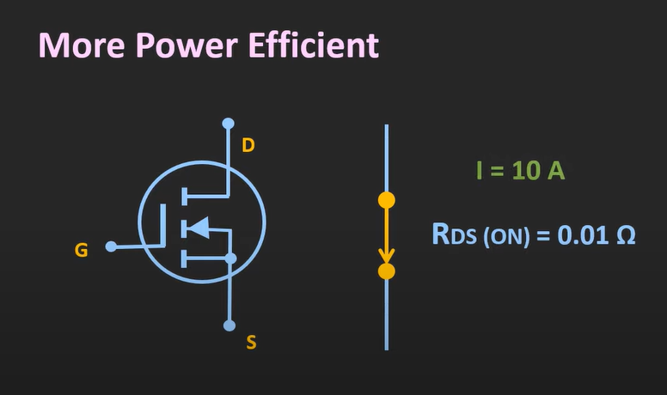  - There are basically two types of losses to be considered when dealing with MOSFET or BJT as switch  - Conduction loss  - Switching loss  - Here from the above image conduction loss can be calculated as  - $P=I^{2}*R$ = 100 * 0.01 = 1 watt  - But when we are talking about continuous application where switching is frequent – switching loss shall be considered  - MOSFET has switching loss lower compared to BJT  - So, at high freq , high switching application MOSFET is preferred over BJT  - Mosfet are more thermally stable than BJTs  - MOSFET has positive temp Coeff. – means when temp rises , resistance rises and in turn decreasing drain current , which will also gradually reduce temp  - BJT has negative temp Coeff. – means when temp rises , collector current Ic also rises , which will also gradually increase temp (so temp management is very crucial in BJTs  MOSFET are of two types  - Depletion type (Normally ON : because when there is 0v at gate terminal (still the conduction can happen) [when the pinch off happens they are in the off condition] [ because of these characteristics they are not preferred as switch]  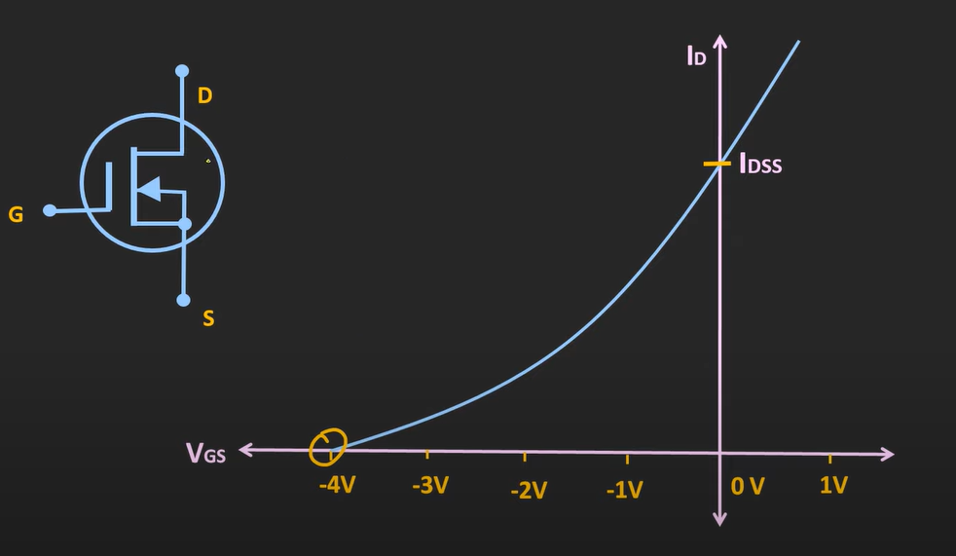  - Enhancement type  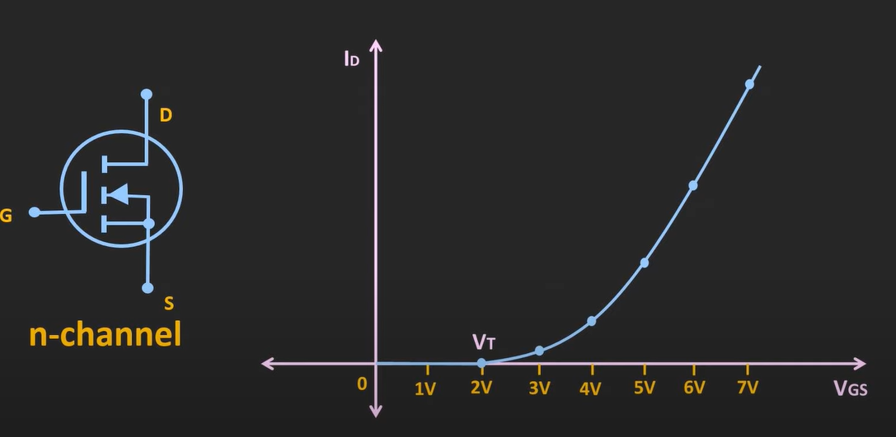  - These mosfet starts conducting when the Vgs > Vth  - When Vgs < Vth – drain current Id is almost 0 - it will remain in OFF condition’  - So, they are Normally OFF devices  - Thus, they are more preferrable for using them as a switch  - When Enhancement mosfet operated as a switch they are operated in linear/ohmic region and cutoff region  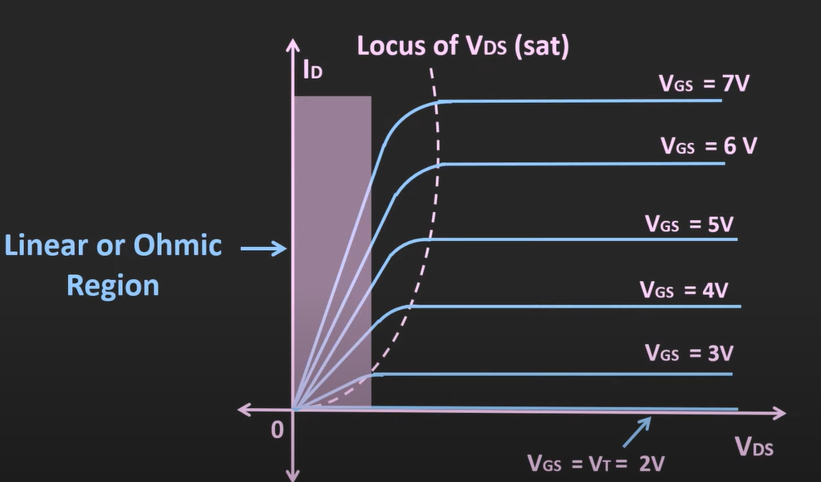  - In cutoff region (when Vgs < Vth) : current is 0 (acts as open circuit)  - In linear/ohmic region (when Vds < Vgs – Vth) : acts as a resistor ($R_{DS (on)}$) (resistance of MOSFET in ON condition)  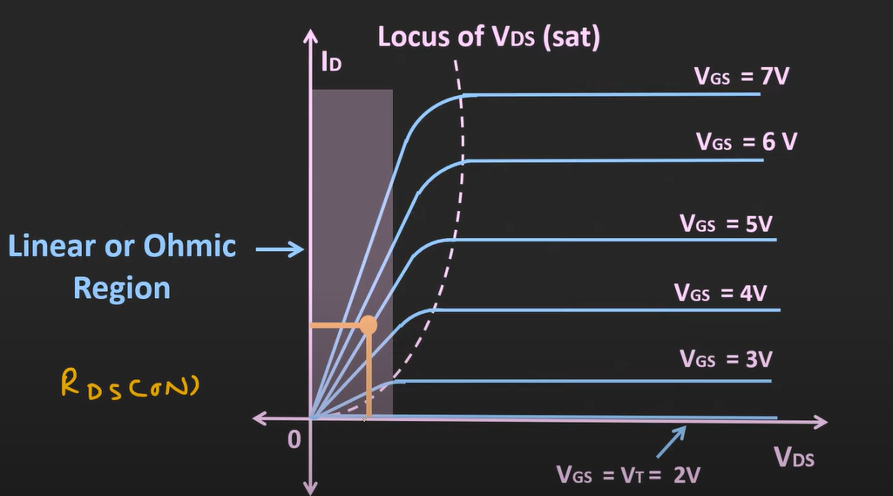  - Here the slope is considered as $R_{DS (on)}$ = $\frac{V_{DS}}{I_{D}}$  - here as the Vgs increases -> $R_{DS (on)}$ reduces  - $R_{DS (on)}$ is one of the imp parameters for mosfet  - $R_{DS (on)}$ is should be as low as possible (to reduce conduction losses)  Basic circuit of N-type MOSFET as a switch  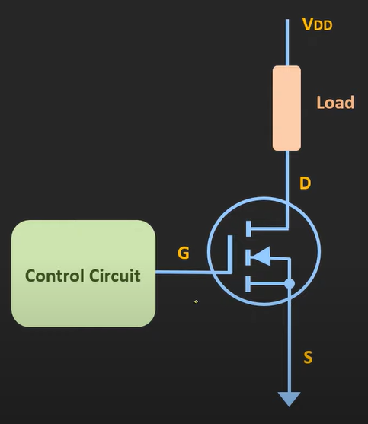  - Here load is connected between supply(Vdd) and the drain terminal  - And the control circuit (input) is connected between the gate and source terminal  - The input can be given directly by microcontroller or a driver circuit  When Vgs < Vth (MOSFET will act as an open ckt)  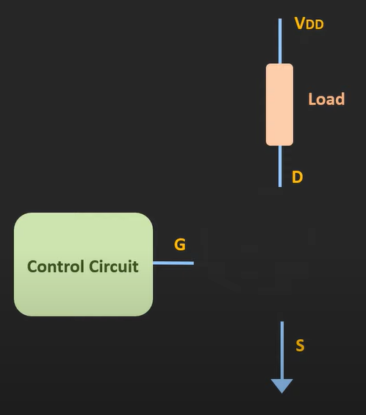  - No current flows through the load  - Operates in cutoff region  - When Id is 0 (due to Vgs<Vth) --> the Vds = Vdd (Vdd appears at drain terminal and source is kept at gnd)  When Vgs > Vth (mosfet will act like a closed switch)  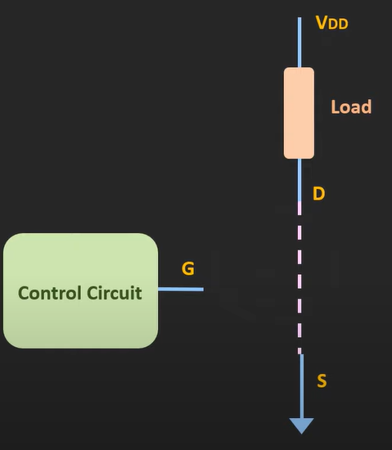  - Current will flow through the load  - Operate in linear/ohmic region  - By selecting a proper supply volt we can ensure that this operates in the linear region  Example :  - Consider Vds =bias volt between drain and source = 0  - Rd = load resistance  - Id = Vdd / Rd  [when threshold voltage of a mosfet is around 2-3v – microcontrollers can be used to drive mosfet]  Load line  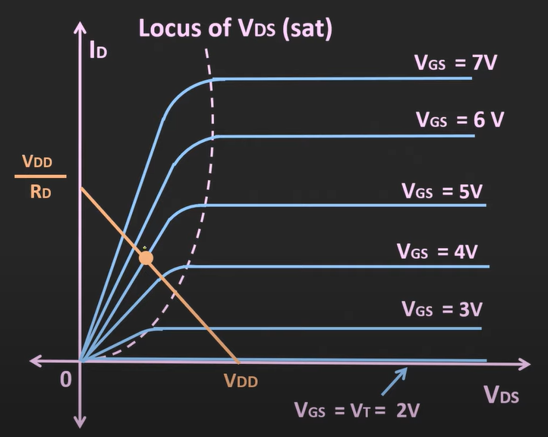  For the extreme two cases – when Vds = Vdd (due to Id being 0 in the cutoff region) and Vds=0 (due to Id considered as Vdd/Rd)  The line connecting to this two extreme point is called as load line  Which will give us the operating point  For example : if we are operating the mosfet at Vgs = 5v and the intersection point should fall such a way that the mosfet operates in linear/ohmic region  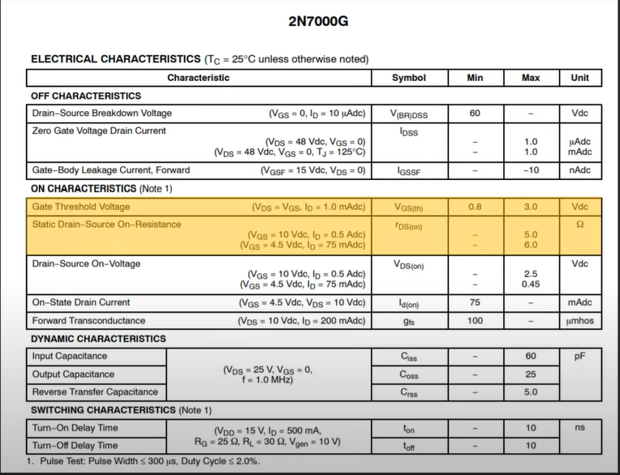  Datasheet of mosfet (2N7000G) and some imp parameters  - Gate threshold voltage (Vgs(th)) – 0.8 to 3.0v (that means it can be operated using the microcontroller)  - Rd(on) (resistor) : for some optimum condition Rd(on) is 5 or 6 ohms  - Id (max) : 200mA  Example:  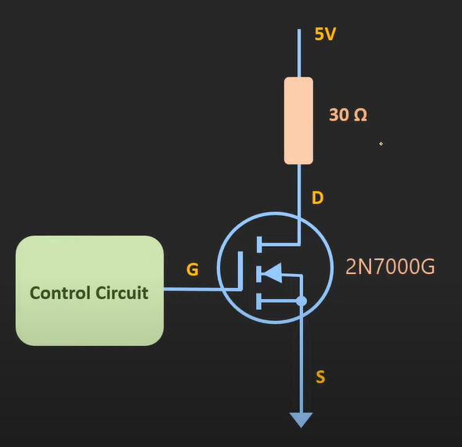  - Vdd = 5v  - Rd = 30 ohms  - Id(on) = Vdd / Rd = 166mA  Load line  - Point on X axis = Vdd = 5  - Point on the Y axis = Vdd/Rd = 166mA  So load line will be (5,0.170) for Vgs = 5v  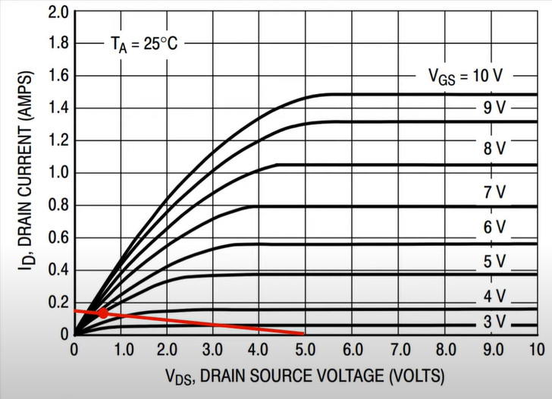  Notes  - Here we have directly applied control voltage to gate terminal (but that is not a proper way to do it)  - A series resistance should be there (Rg)  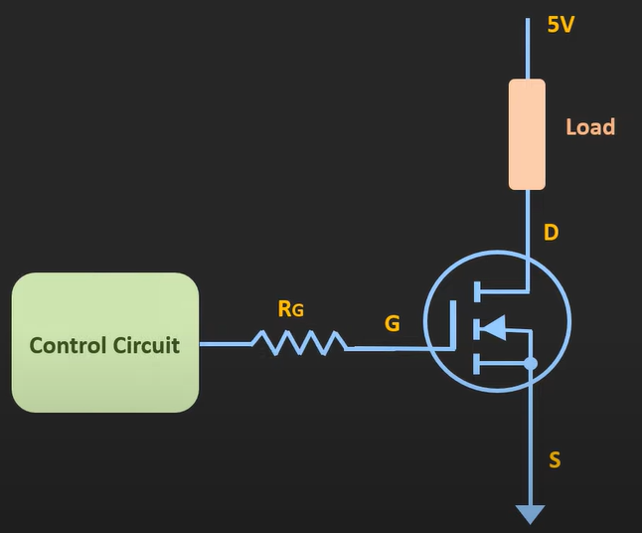  - Why ?? :  - The gate of the mosfet offers very high input resistance at the low frequencies  - That means the gate terminal hardly draws any current from the control circuit  - When we apply input (when Rg is not present) – it could draw very large current in case of the transients (when control circuit could not supply that much of current which could lead damaging the circuit) because the equivalent ckt of gate to source terminal is a capacitor (so when transient appears the capacitor tries to charge suddenly in turn leading to drawing more current and damaging the source – thus to avoid large currents – we use resistor (Rg)  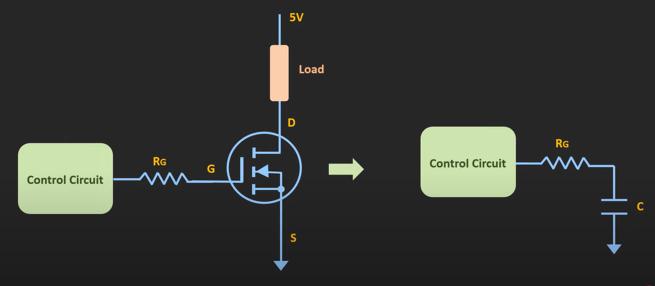  - Example : if the control ckt is a microcontroller and the max current it can supply from a GPIO is 5v , 20mA –the resistor should be at least Rg = 250 ohm (this will ensure that max current flowing out of microcontroller is 20mA max  - Apart from the series resistor a pull-down resistor is also required at gate terminal  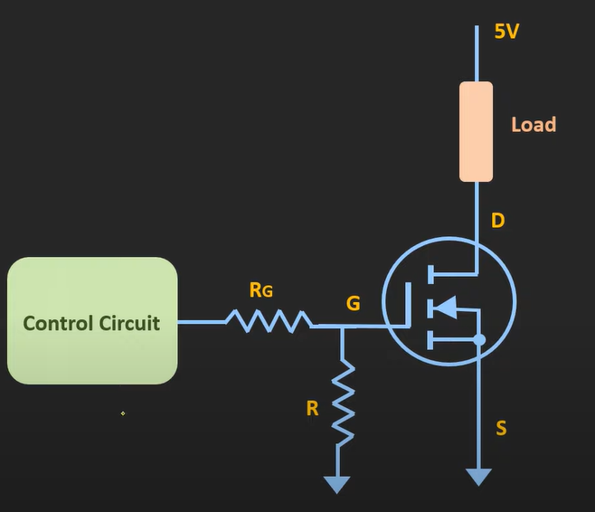  - This pull-down resistor ensures that when input is floating/undefined – MOSFET is at logic level 0 (the default state)  P-type MOSFET as a switch  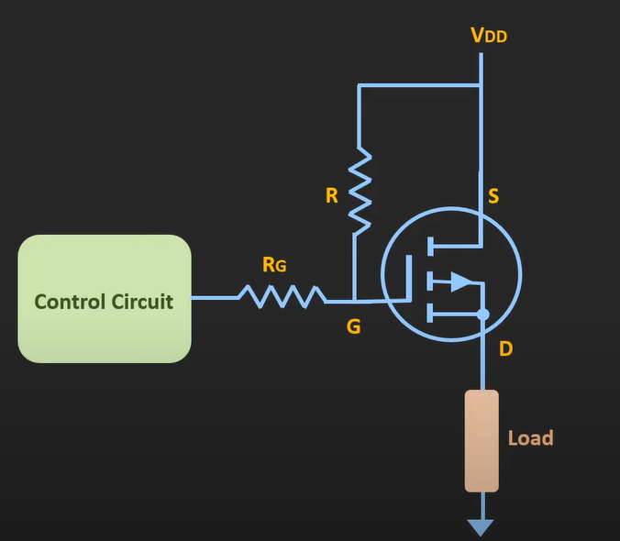  - The Rg is same as explained in N-type  - Here there is another resistor – which is a pull -up resistor – when the input is floating/un-defined it pulls MOSFET up to Vdd  - Here when control circuit is providing logic high – at that time gate volt and source volt is same thus – Vgs = 0 (keeps mosfet in cutoff)  - When control circuit is providing logic low – at that time gate is at lower potential than source making Vgs -ve (keeping mosfet on)  General Things  - When we use mosfet with anything that doesn’t require frequent switching or can be said that has low freq – at that time when mosfet id connected (takes sometime after switching happens)  - But for continuous switching application – or say high freq application – we need to consider few other parameters  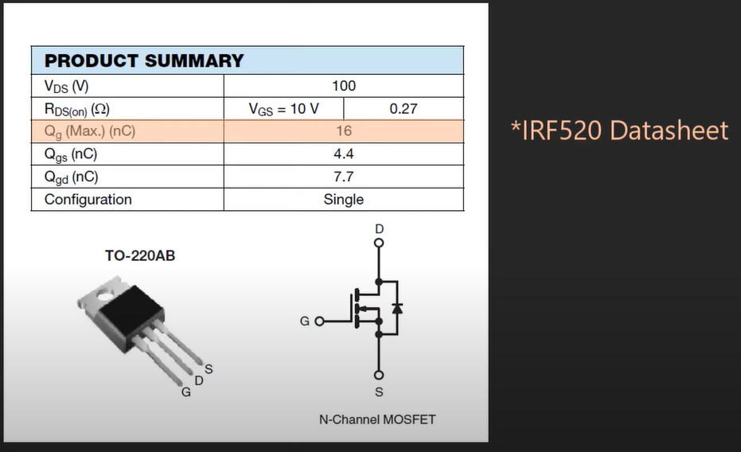  - Qg(max) [ total gate charge ] – unit : nC (nano Coulomb) this total gate charge is the charge which needs to be injected into the terminal to completely turn on the mosfet  General/rough formula to calculate time to reach a particular Charge using current  Q = I * T  Example :  - Current which a control circuit can source(example : microcontroller can source 20mA max on GPIO pin)  - I = 20mA  - Q = charge required = 20 nC  - T = 20nC / 20mA  - T = 1 micro second  - So, for this type of ckt where microcontroller is connected to gate and is operating it (this is what time taken to turn it on  - Even if the sourcing capacity of control circuit increase – let’s say control ckt can source 1 Amp – then the time taken for MOSFET to turn on in this ckt is 20nS  - Thus, we should use a good driver IC which can source good amount of current hence , MOSFET can turn on faster (also for fast switching application Qg should also be less)  - Fast switching of mosfet in turn makes the switching loss of mosfet less  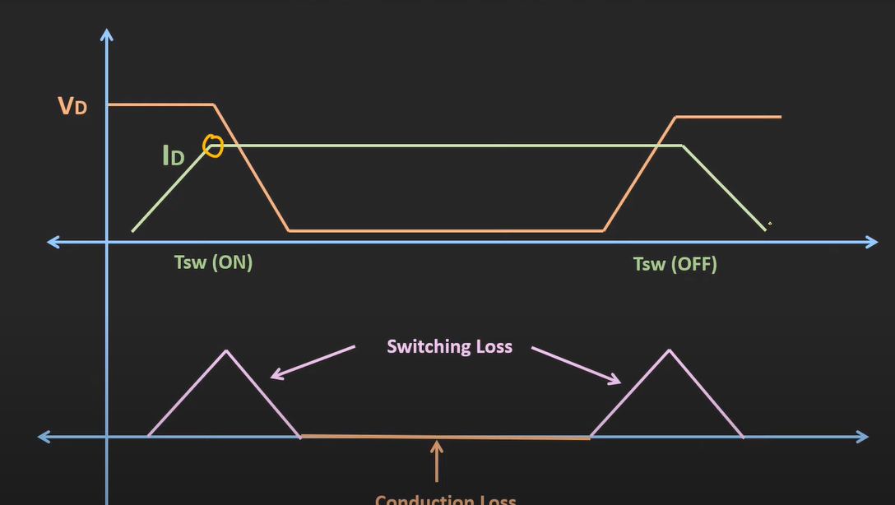  - Here 1st graph is of Vds vs. Id  - When the MOSFET is turned on (for N-type : gate becomes positive or can say is at logic high)  - After sometime drain current starts to flow (as in enhancement sometime is taken to form the inversion layer) - at that time the Vd starts to decrease  - And the middle portion when mosfet is ON  - Again, when MOSFET is turned off : the current start to decrease and voltage Vd starts to increase  - So, at the time of switching loss takes place  - And in the time of mosfet being on – conduction loss takes place  - Which is showed in the second graph  - So, when faster switching is there – the switching losses reduces  [Gate capacitance charging/discharging → This is switching loss, dominant at high frequencies.]
MOSFET as a switch Question | 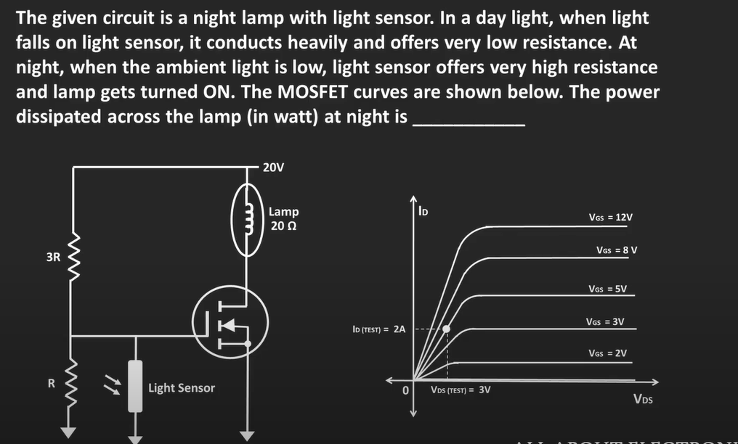  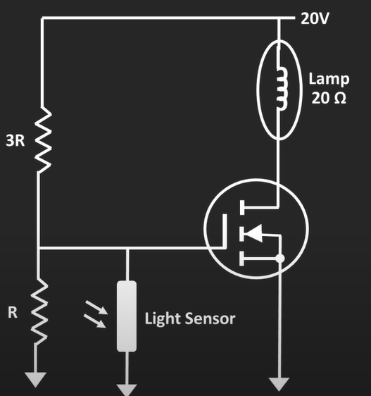  - In morning light sensor conducts heavily providing very low resistance (can be considered as short) (at morning the gate is at gnd and source is also at gnd – making Vgs = 0 (cutoff region)) [mosfet will act as open ckt and no current will flow through lamp)  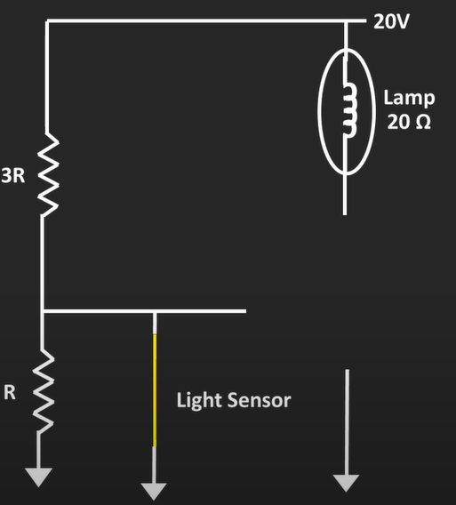  - At night light sensor conducts very low providing high resistance (can be considered as open) [ the voltage at gate will be decided by voltage divider] [making mosfet ON – current will flow through lamp]  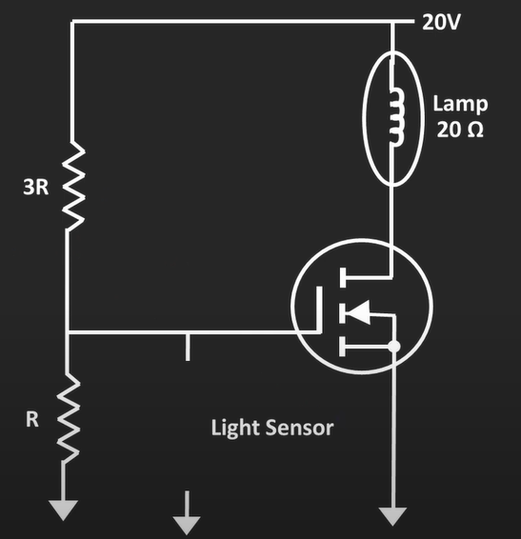  $$V_{g}= \frac{R}{R+3R}*20v =5v$$  - Vgs = 5v – 0v = 5v  - When mosfet is on – it provides some resistance [ $R_{DS(on)}$]  - From the mosfet curve ,  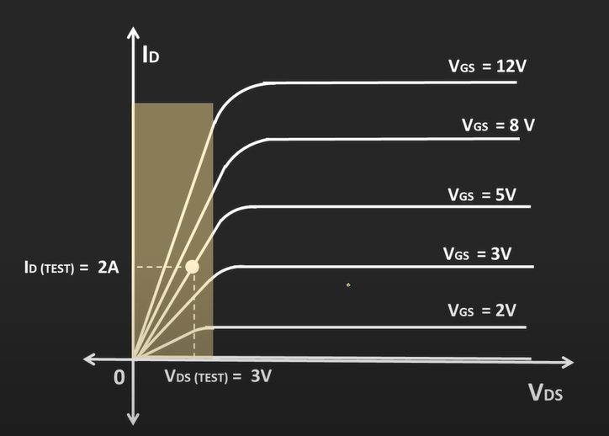  - Here when Vgs = 5v , Id = 2A and Vds = 3v (from this we can find $R_{DS(on)}$ )  - $R_{DS(on)}$ = $\frac{3}{2}$ = 1.5 ohm  - Equivalent ckt now,  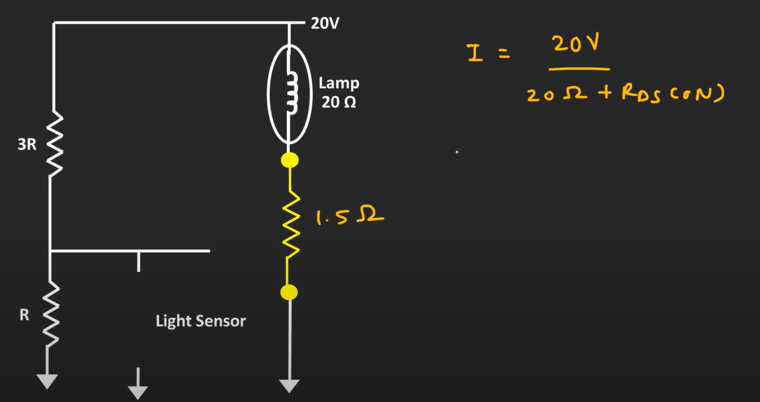  - From ohm’s law I = V/R  - I = 20 / 21.5 = 0.93Amp  - P = $I^{2}R$ = 0.8649 * 20 = 17.29 Watt
NMOS & PMOS | 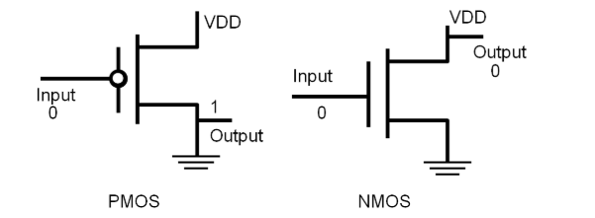  S  G  D  D  S  G  Basics  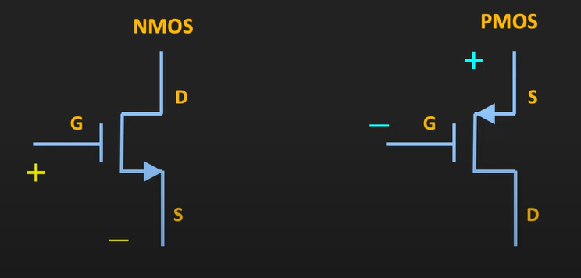  - When MOSFETs are used as logic gates , they are used as a switch  - Here in NMOS controlled volt is applied between Gate and source ( $V_{GS}$) ( G +ve and S -ve)  - Here in PMOS controlled volt is applied between Gate and source ( $V_{GS}$) ( G -ve and S +ve)  In case of NMOS  - When Vgs < Vth (it is called as cutoff region operation – can be called as switch off )  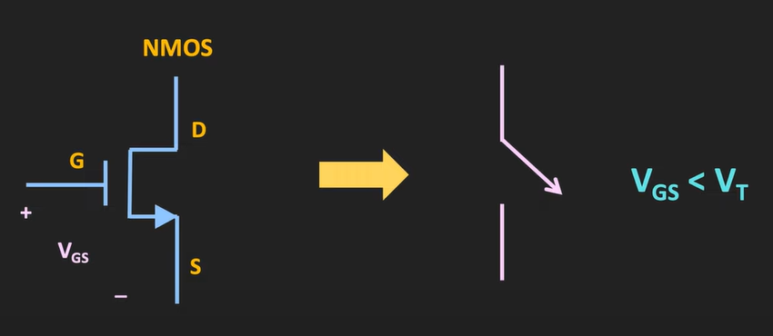  - When Vgs > Vth and Vds <= Vgs - Vth (it is called as linear/ohmic region operation – can be called as switch ON )  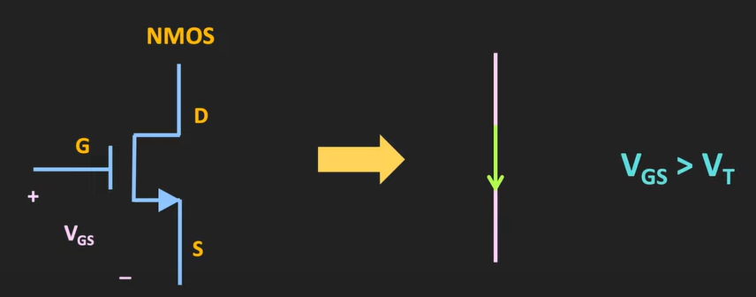  In case of PMOS  - When Vgs > Vth (it is called as cutoff region operation – can be called as switch off ) (example : Vgs = -1 and Vth = -2)  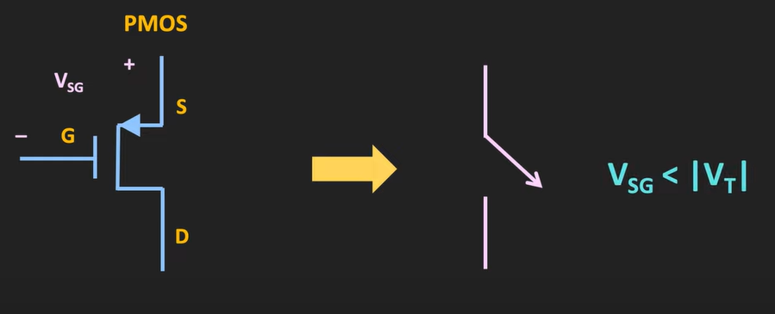  - When Vgs < Vth and Vds > Vgs - Vth (it is called as linear/ohmic region operation – can be called as switch ON ) (example : Vgs = -3 and Vth = -2)  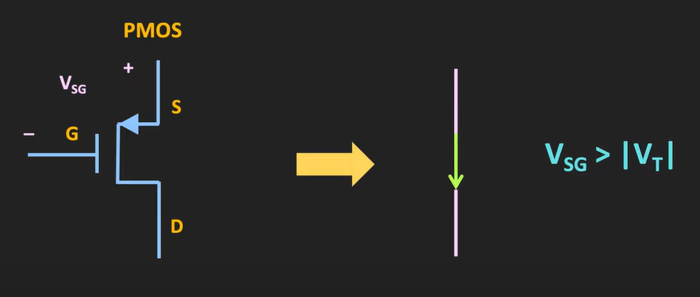  This way NMOS and PMOS can be used to design the logic gates  NMOS / PMOS have two uses  - As inverter  - As pass transistor(older version) – As transmission gate (updated version)  1) As Inverter  - Concept: An inverter produces the opposite logic level at the output (input 0 → output 1, input 1 → output 0).  - NMOS-only inverter:  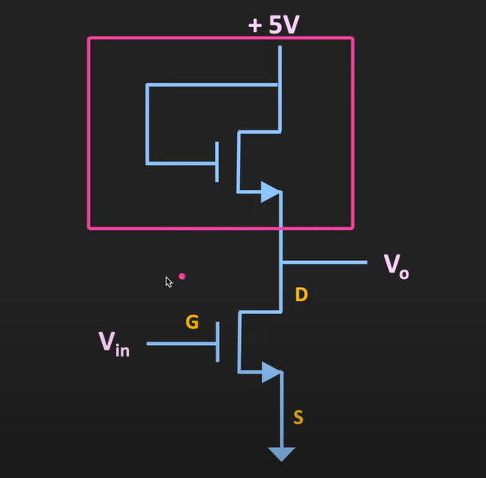  - Uses one NMOS as the pull-down device and another NMOS (in “always ON” mode) as the load (as active load).  - When input = 1 → pull-down NMOS ON → output = 0 (strong).  - When input = 0 → pull-down NMOS OFF → load pulls output up to VDD, but only up to VDD − Vth (weak logic 1).  - Limitation → degraded logic high, static power dissipation due to always on active load NMOS device  - PMOS-only inverter:  - Uses one PMOS as the pull-up device and another PMOS (always ON) as the load(as active load).  - When input = 0 → pull-up PMOS ON → output = VDD (strong).  - When input = 1 → pull-up PMOS OFF → load pulls output down toward GND, but only down to Vth above GND (weak logic 0).  - Limitation → degraded logic low, static power dissipation due to always on active load PMOS device  - CMOS inverter (NMOS + PMOS):  - NMOS used for pull-down, PMOS for pull-up.  - Provides full rail-to-rail swing (0 to VDD) and zero static power (except during switching).  - This is the standard in modern digital ICs.  2) As Pass Transistor  - Concept: A MOSFET can be used like a controlled switch to pass logic signals between nodes. (consider as a joint – passes same signal as input )  - NMOS pass transistor:  - Passes logic ‘0’ strongly.  - Passes logic ‘1’ weakly (stops at VDD − Vth).  - Limitation → degraded logic high.  - PMOS pass transistor:  - Passes logic ‘1’ strongly.  - Passes logic ‘0’ weakly (stops at Vth above GND).  - Limitation → degraded logic low.  - Transmission Gate (NMOS || PMOS = in parallel): (updated version of pass transistor)  - NMOS and PMOS combined → compensates for each other’s weakness.  - Passes both logic ‘0’ and ‘1’ strongly (full rail-to-rail).  - Widely used in multiplexers, latches, and flip-flops.  Basic design of the NMOS inverter  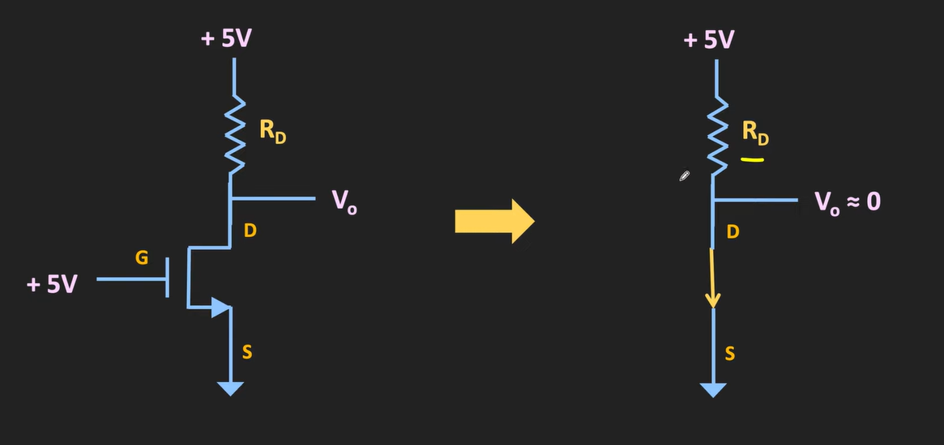  - When input is logic 1 (Vgs > Vth)– NMOS acts as short ckt – making Vout = 0v (the NMOS provides 0 resistance ideally but practically this resistance is called Rd(on) resistance and it is in ohm [note : Rd resistance is in Kilo ohms]  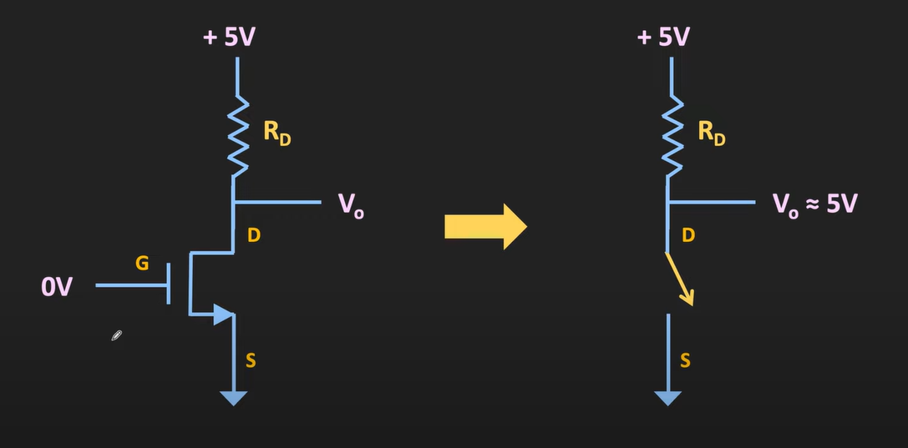  - When the input is 0 volt (logic 0) (Vgs < Vth) – NMOS will act as an open switch – providing infinite resistance – Vout = Vdd (as no current flows – no drop across Rd)  This way NMOS works as an inverter  Input output  1 (logic level 1) 0  0 (logic level 0) 1  - But here when standalone NMOS is used – then we can have this much of large Rd (in kiloohms) – but in ICs it is difficult to fabricate resistors with high values  - In IC instead of resistor – mosfet is used as an active load    - Here two NMOS are connected (upper NMOS is active load (active device-needs external power to operate) (used instead of resistor))  - In this case gate terminal is at logic 1 – making mosfet on all the time – making Rd(on) act as Rd in this case [ note : we need to update upper NMOS’s W/L ratio in order to get resistance( Rd(on) ) in Kilo Ohms]  NMOS INVERTER WITH ACTIVE LOAD  When input is logic level high When input is logic level low  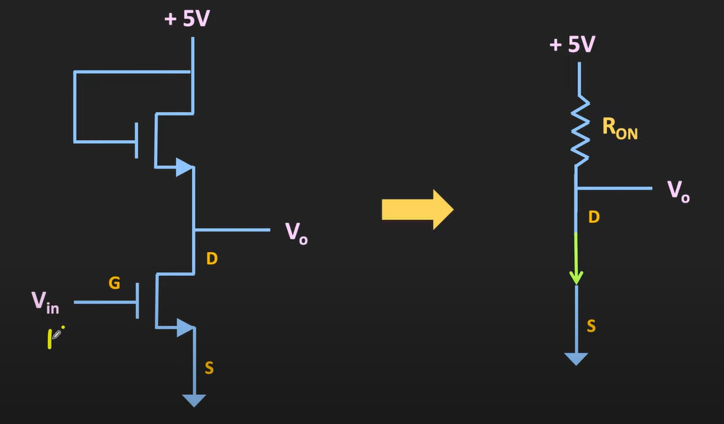 Vout $≈$ 0 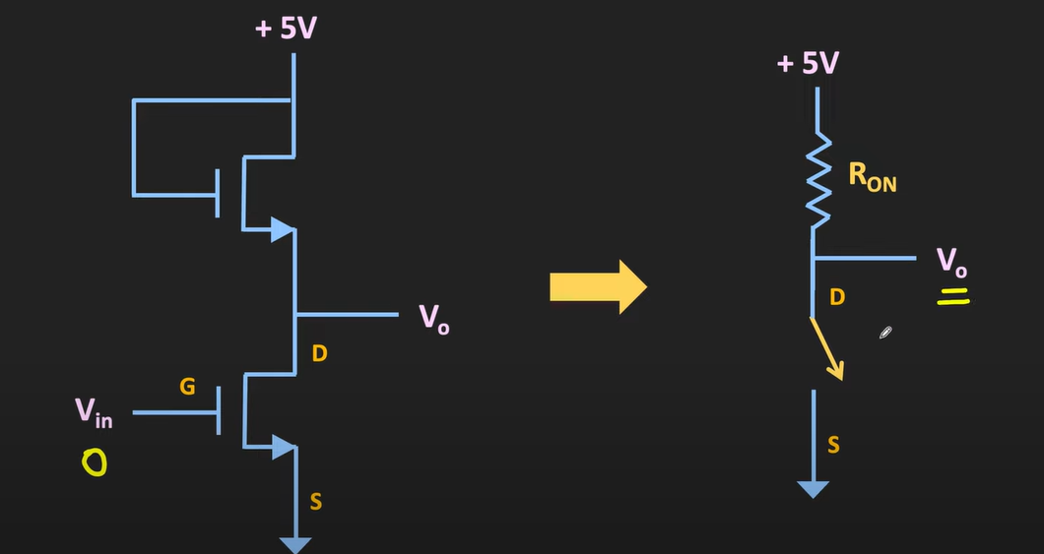 Vout $≈$ 5v  The issue with these designs is – static power dissipation across MOSFETs  - When logic 1 is input : the lower NMOS will act as a close switch – current will start to flow from 5v to GND – so there will be power dissipation across both the MOSFETs  - Example : if a clock signal is applied as input (continuously changing from 1 to 0 ) – the half of the cycle of a pulse we will experience static loss  - When only NMOS or PMOS is used as building block of IC – there is large power dissipation causing major power loss  Other issue with this design is – NMOS passes weak logic ‘1’ and PMOS passes weak logic ‘0’  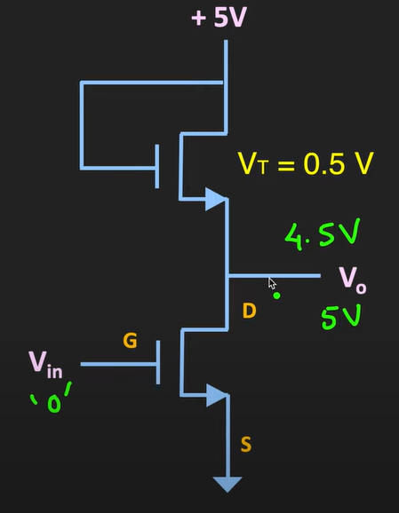  - When input is at logic 0 : output should be Vdd – but instead It is Vdd – Vth  - So, if Vth = 0.5v – then output for input = logic level 0 will be 5 – 0.5 = 4.5v  - So, it is said that NMOS passes weak logic ‘1’  - When input is at logic 1 : the NMOS(lower) is in ON condition – Vout = 0 (Vout is pulled down to gnd)  NMOS and PMOS as Inverter (basically CMOS as inverter)  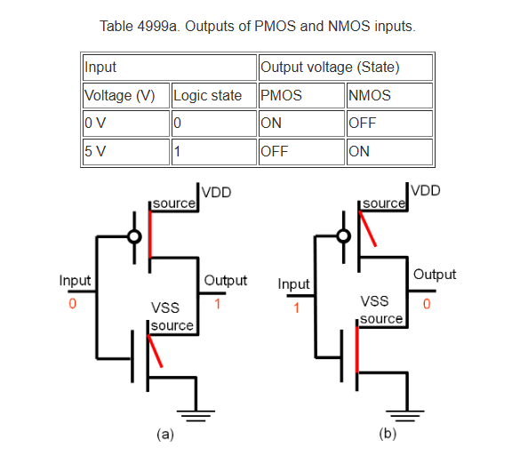  Basic design of the PMOS as pass transistor (this explanation is unclear – to understand properly chat with ChatGPT)  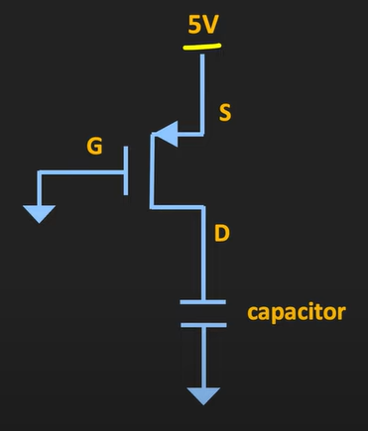  [ capacitor is basically – capacitance caused by fanout = capacitance caused by various device connected at output ]  - Here if Gate is connected to gnd -> Vgs = -5v  - Let’s say this PMOS have threshold volt of -0.5v  - Then this condition is Vgs < Vth is PMOS on condition  - PMOS will act as a close switch – making capacitor charge up to 5v – making 5v available at Vout  - So PMOS passes strong logic 1  - PMOS passes weak logic 0  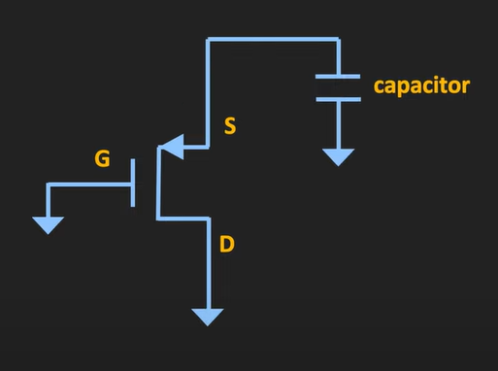  - Assume initial voltage across cap is 3v  - When gate is at gnd – Vgs = -3v which is Vgs < Vth (making it on)  - The PMOS will act as a close switch  - Capacitor will start draining (making current flow from source to drain)  - But as soon as the capacitor volt become Vgs = Vth (PMOS will turn off acting as an open ckt)  - Volt at source terminal cannot go below the threshold volt  - Example – the Vth of this PMOS is 0.5v – volt at source terminal cannot go below 0.5v (means PMOS passes weak logic 0)  - That means whenever we want to pull down volt to 0 – it is not preferrable to use PMOS (PMOS is not preferrable in the pull-down network)
CMOS basics and logic gates | There are multiple logic gates  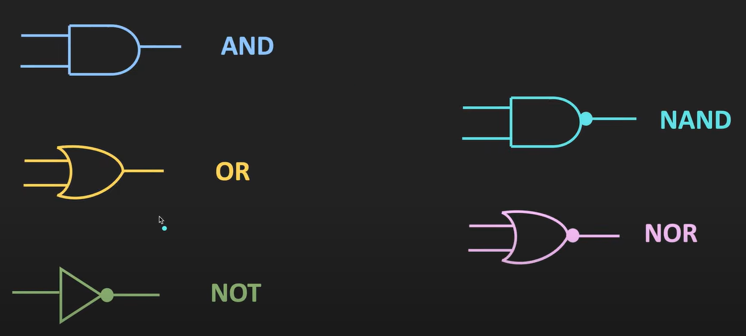  Main Characteristics of logic gate  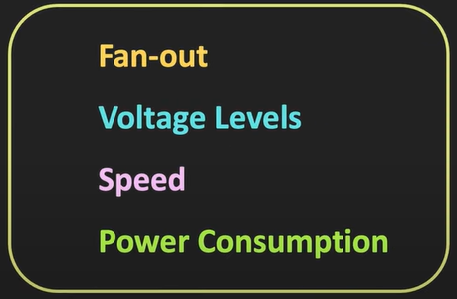  Technologies used to design logic gates  - RTL  - DTL  - TTL  - ECL  - CMOS  1. RTL – Resistor-Transistor Logic (obsolete)  - Components: Resistors + BJTs.  - First practical logic family (1960s).  - Resistor provides input logic combining, transistor does switching.  - Very simple but: slow, power-hungry, low noise margin.  2. DTL – Diode-Transistor Logic (obsolete)  - Components: Diodes + BJTs.  - Diodes used for input “AND/OR” function, transistor for amplification/inversion.  - Better than RTL, but still slow.  3. TTL – Transistor-Transistor Logic  - Components: Only BJTs (no resistors/diodes for logic part).  - One transistor can perform multiple functions (input combining + switching).  - Became very popular in the 1970s–80s → 7400-series ICs.  - Faster and more reliable than RTL/DTL, but consumes more power.  4. ECL – Emitter-Coupled Logic  - Components: BJTs, but instead of switching fully ON/OFF, they operate in active region.  - This avoids transistor saturation → gives very high speed (used in supercomputers, telecom).  - Downside → huge power consumption.  5. CMOS – Complementary MOS  - Components: NMOS + PMOS.  - Revolutionized digital logic → low power, high-speed, high-density integration.  - No static power loss (ideally).  - Became dominant in the 1980s and still rules today (your phone, laptop, ICs are all CMOS).  👉 In short, the flow is:  RTL → DTL → TTL → ECL → CMOS  Each step was about improving speed, power, noise immunity, and scalability..  CMOS – Complementary Metal Oxide Semiconductor  CMOS uses the complementary pair of NMOS and PMOS  CMOS logic Gates  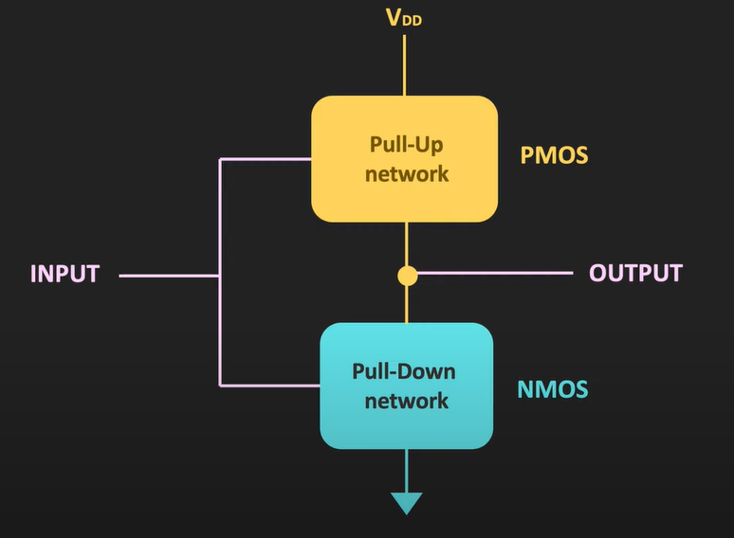  - cmos uses complementary pair of PMOS and NMOS – PMOS are used as pull up networks and NMOS are used as pull-down network. Because of that the static power consumption of CMOS logic gates/ckts are very low compared to the logic gates/ckts made up of only NMOS or PMOS only  - CMOS gates /ckts have higher noise margin compared to the gates/ckts build by only PMOS or only NMOS  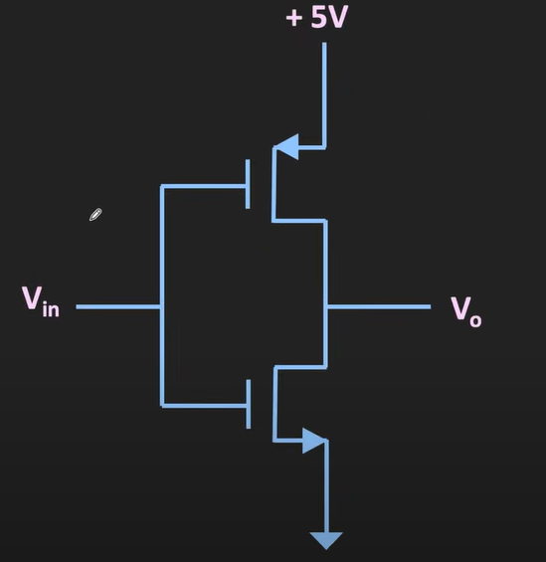  - In CMOS – PMOS (pull up network) and NMOS(pull down network) are used  - Because of this configuration we will get full volt swing as op – in other words – we will get higher noise margin  - Because of this config there is no static power consumption : the power consumption in the circuit when there is no change in the inputs and output (when there is no activity in the ckt)  Noise Margin in Digital Logic - Definition : Noise margin is the tolerance of a digital circuit to unwanted noise/voltage fluctuations without causing logic errors.  It tells you: “How much extra room do I have before a 0 is misread as a 1, or a 1 misread as a 0?”  🔹 The Key Voltage Levels [Every logic family defines four important voltage levels]:  - VOH (Output High Voltage) → minimum guaranteed output for logic ‘1’.  - VOL (Output Low Voltage) → maximum guaranteed output for logic ‘0’.  - VIH (Input High Voltage) → minimum voltage recognized as logic ‘1’.  - VIL (Input Low Voltage) → maximum voltage recognized as logic ‘0’.  🔹 Noise Margin Formulas  - Noise Margin High (NMH) = VOH − VIH  → Tells how much noise can be tolerated on a logic ‘1’.  - Noise Margin Low (NML) = VIL − VOL  → Tells how much noise can be tolerated on a logic ‘0’.  Both NMH and NML should be positive for reliable operation.  🔹 Example (for CMOS 5V logic)  - VOH ≈ 4.9V, VOL ≈ 0.1V  - VIH ≈ 3.5V, VIL ≈ 1.5V  Then:  - NMH = 4.9 − 3.5 = 1.4V  - NML = 1.5 − 0.1 = 1.4V  So the circuit can tolerate up to ±1.4V noise without errors.  ✅ In short:  Noise Margin = the safety buffer that ensures noisy signals are still interpreted correctly as 0 or 1.    NMOS  PMOS  D  D  G  G  S  S  Working of CMOS  Case 1 : when input is logic 0  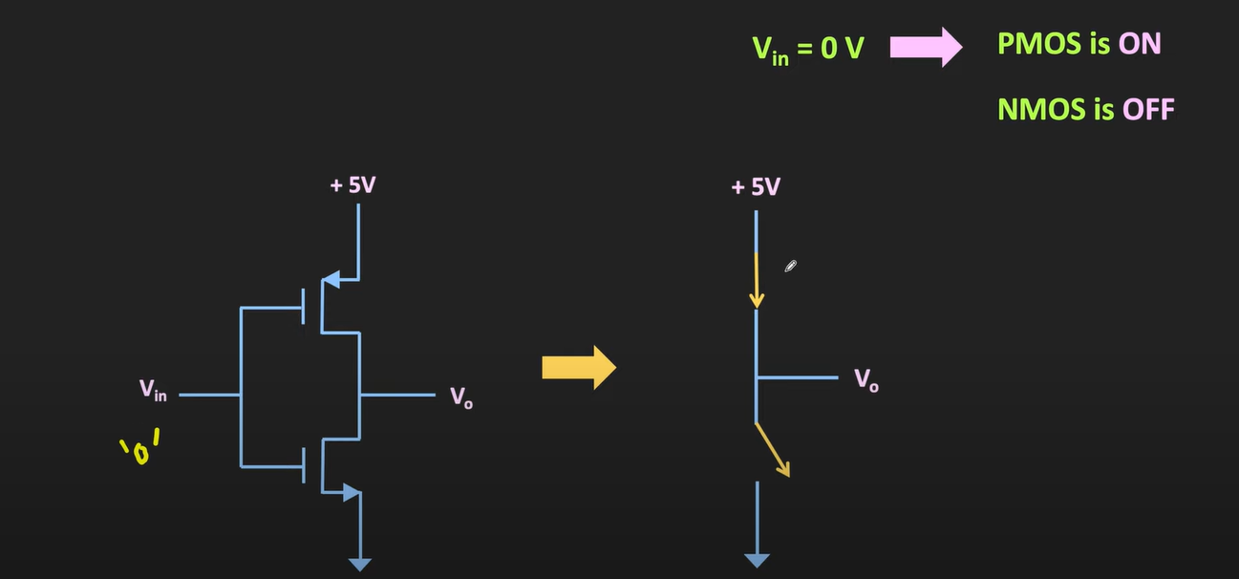  - For PMOS : Vg = 0v and Vs = 5v Vgs = -5v [ON] (acts as short ckt)  - For NMOS : Vg = 0v and Vs = 0v Vgs = 0v [OFF] (acts as open ckt)  - Vout = 5v ( moreover , PMOS passes the strong logic ‘1’ hence output will be very close to 5v)  Case 2 : when input is logic 1  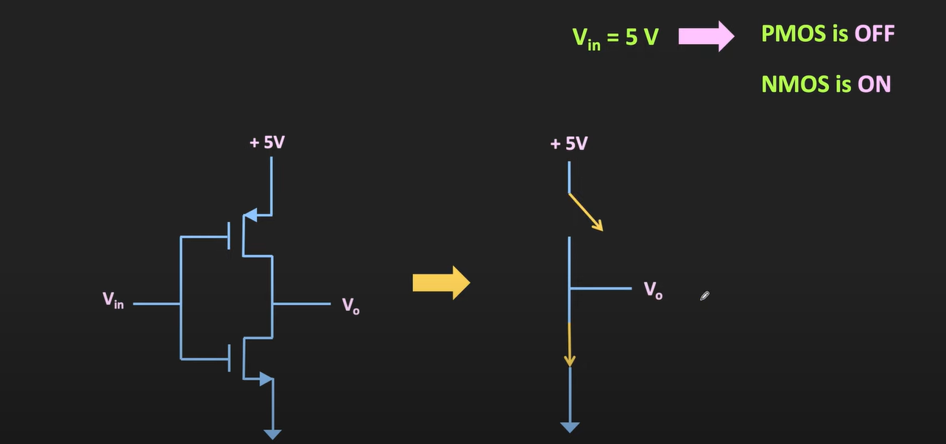  - For PMOS : Vg = 5v and Vs = 5v Vgs = 0v [OFF] (acts as open ckt)  - For NMOS : Vg = 5v and Vs = 0v Vgs = 5v [ON] (acts as close ckt)  - Vout = 0v ( moreover , NMOS passes the strong logic ‘0’ hence output will be very close to 0v)  Note : In CMOS – any one logic gate remains on -thus in any case there is no direct path from supply volt to gnd (thus static power consumption of this CMOS inverter is negligible)  - CMOS gates have very low power consumption  - And provide very high noise margin
LOGIC GATES USING CMOS | Alternate symbol for PMOS and NMOS  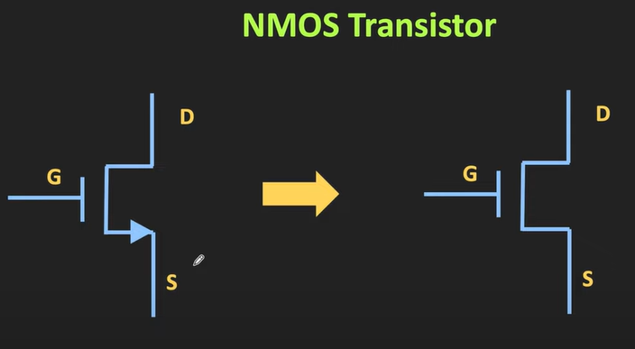 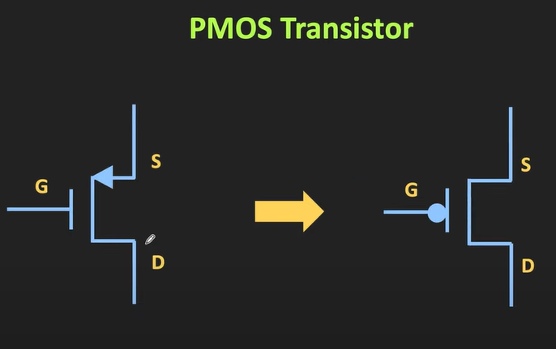  Note  - In NMOS – when AND operation is there (2 NMOS in series)  - In NMOS – when OR operation is there (2 NMOS in parallel)  - In PMOS – when AND operation is there (2 PMOS are in parallel)  - In PMOS – when OR operation is there (2 PMOS are in series)  CMOS Inverter / NOT gate  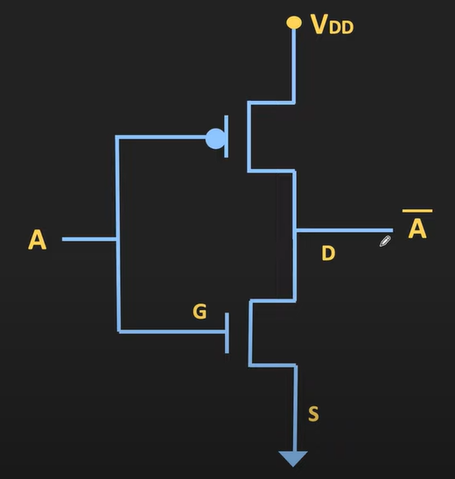  NAND Gate  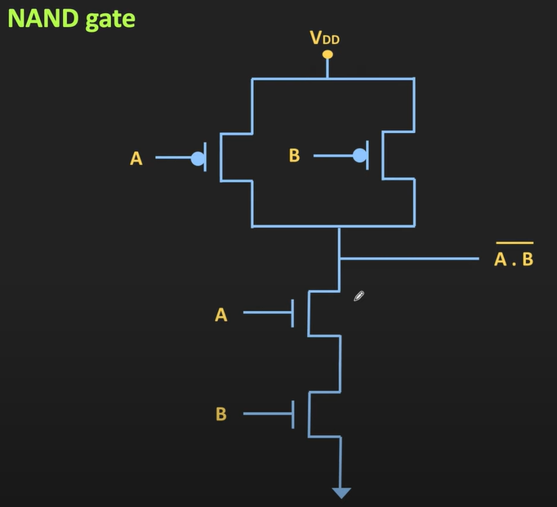  Truth table  A B Y  0 0 1  0 1 1  1 0 1  1 1 0  Explanation  Case 1: A=0 , B=0 Y = 1  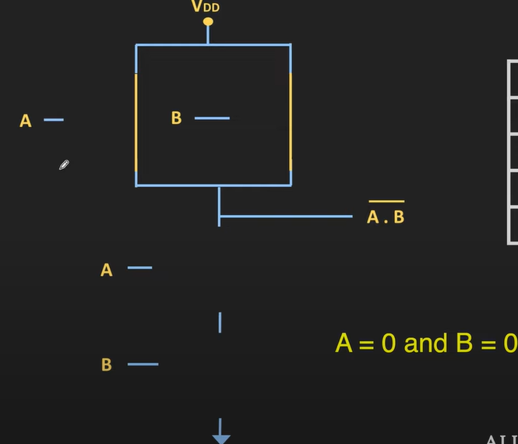  - PMOS Network :  - A =0 , B=0 (PMOS) both ON Vout = 5v  - NMOS Network  - B=0 Vgs = 0v OFF (makes path open)  - Op = 5v  Case 2: A=0 , B=1 Y = 1  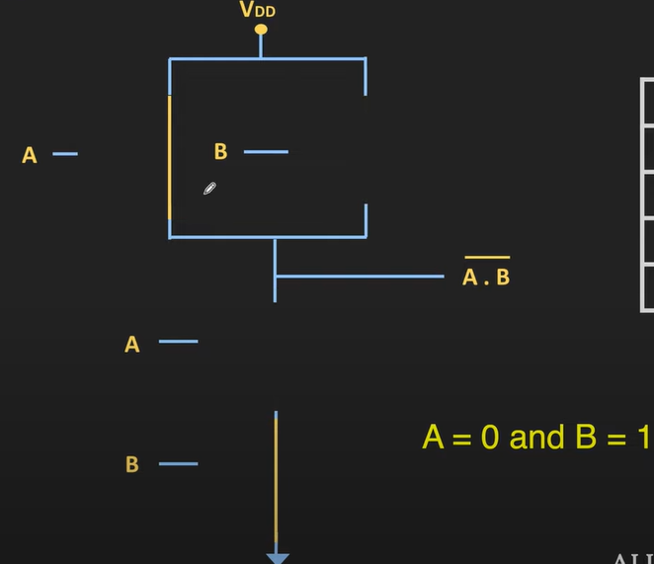  - PMOS Network :  - A =0 (ON) Vgs = -5v  - B=1 (OFF) Vgs = 0v  - NMOS Network  - B=1 Vgs = 5v ON (makes close path)  - A=0 Vgs = 0v OFF (makes path open)  - Op = 5v  Case 3: A=1 , B=0 Y = 1  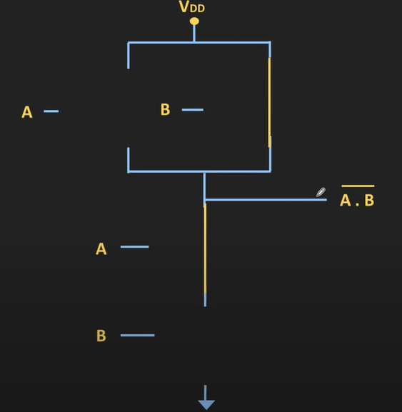  - PMOS Network :  - A =1 (OFF) Vgs = 0v  - B=0 (ON) Vgs = -5v  - NMOS Network  - B=0 Vgs = 0v OFF (makes open path)  - A=1 Vgs = 5v ON (makes close open)  - Op = 5v  Case 4: A=1 , B=1 Y = 0  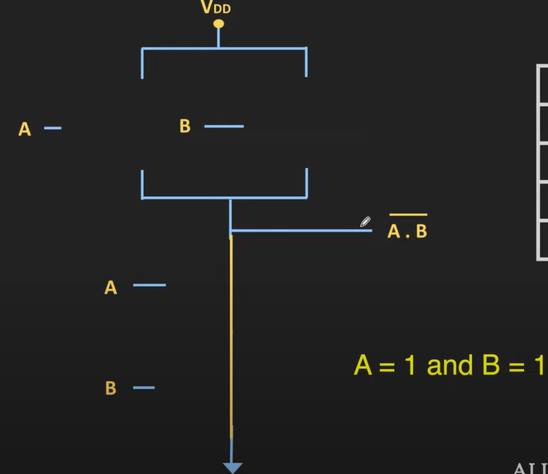  - PMOS Network :  - A =1 (OFF) Vgs = 0v (makes open path)  - B=1 (OFF) Vgs = 0v (makes open path)  - NMOS Network  - B=1 Vgs = 5v ON (makes close path)  - A=1 Vgs = 5v ON (makes close open)  - Op = 0v  3 input NAND Gate  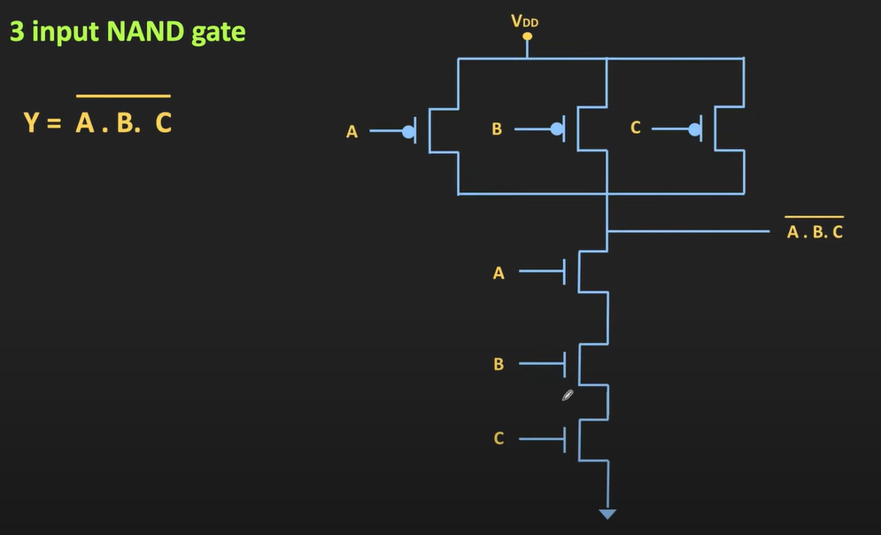  NOR GATE  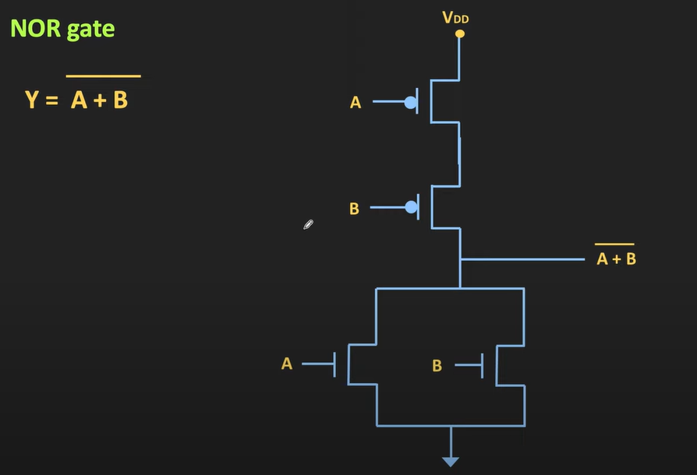  Truth table  A B Y  0 0 1  0 1 0  1 0 0  1 1 0  Case 1 : A=0,B=0 Y =1  - PMOS : A = ON  - PMOS : B = ON  - NMOS : A = OFF  - NMOS : B = OFF  - Op : 5v  Case 2 : A=0,B=1 Y =0  - PMOS : A = ON  - PMOS : B = OFF  - NMOS : A = OFF  - NMOS : B = ON  - Op : 0v  Case 3 : A=1,B=0 Y =0  - PMOS : A = OFF  - PMOS : B = ON  - NMOS : A = ON  - NMOS : B = OFF  - Op : 0v  Case 4 : A=1,B=1 Y =0  - PMOS : A = OFF  - PMOS : B = OFF  - NMOS : A = ON  - NMOS : B = ON  - Op : 0v  OR Gate  OR Gate = NOR + NOT  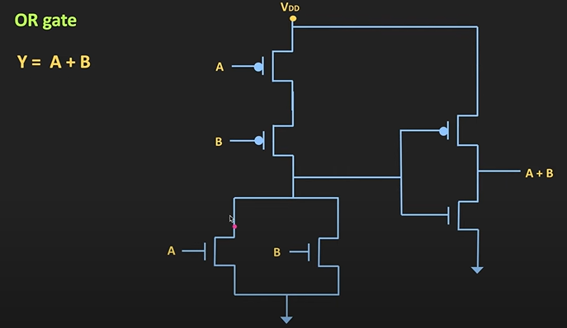  Truth table  A B Y  0 0 0  0 1 1  1 0 1  1 1 1  AND Gate  AND Gate = NAND + NOT  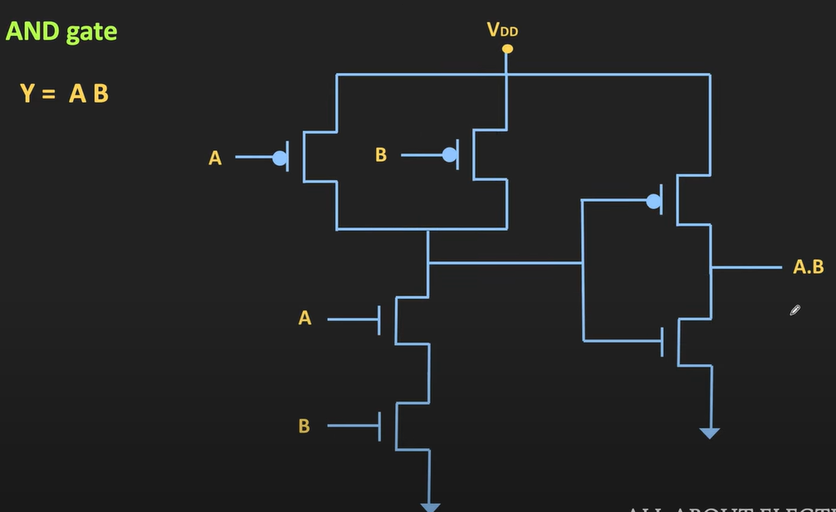  Truth table  A B Y  0 0 0  0 1 0  1 0 0  1 1 1  XOR Gate  XOR Gate = A.B’ + A’.B = (A.B + A’B’)’  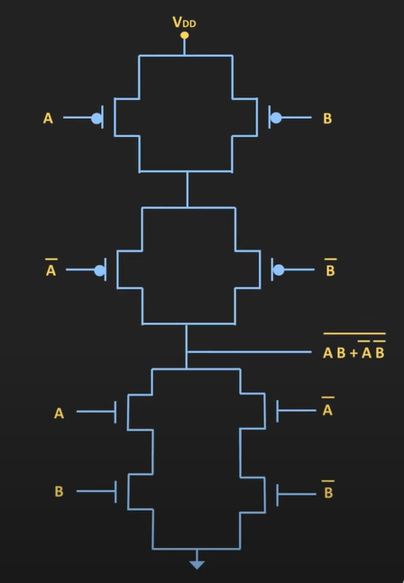  Truth table  A B Y  0 0 0  0 1 1  1 0 1  1 1 0  XNOR Gate  XNOR Gate = (A.B’ + A’.B)’  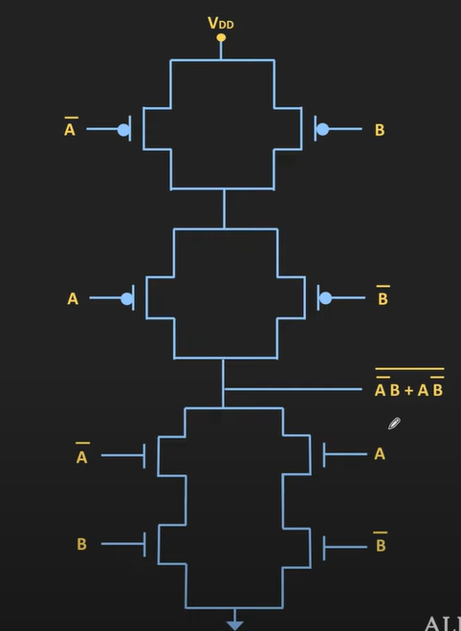  Truth table  A B Y  0 0 1  0 1 0  1 0 0  1 1 1
Power Consumption in CMOS Logic gates | Static power consumption : In CMOS – any one logic gate side remains oFF -thus in any case there is no direct path from supply volt to gnd (thus static power consumption of CMOS gates are negligible)  [but in reality, due to some leakage current through transistor/transistors there exist some small amount of static power consumption ]  Dynamic power consumption : the power consumption in CMOS logic gate is mainly due to dynamic power consumption  - Power loss due to load capacitance- due to fanouts of gate  - Power loss in rise and fall time  Load Capacitance & Rise fall time losses :  Till now ,we have assumed that output of logic gates is not connected anywhere – but practically output of the logic gate will get connected to other logic gates  Example :  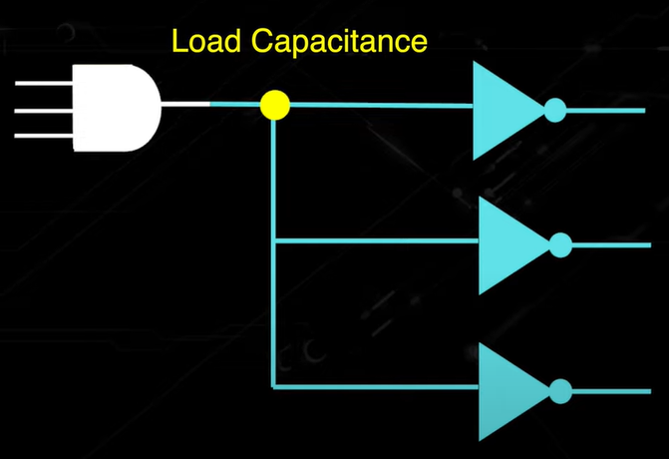  - Because of that there will be some load capacitance  - i.e. when we connect op of the logic gate to inputs of some other logic gates there will be some load capacitance at the input of the other logic gates  - basically, gate capacitance of all the gates will act as load capacitor for previous stage (that is our gate for which we are measuring load capacitance)  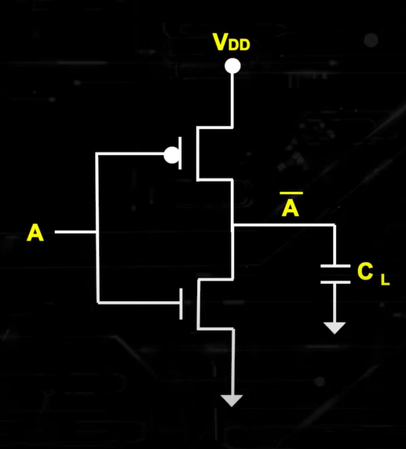  - as shown above – the load capacitance will not allow op to rise or fall immediately  - during the charging and discharging of the capacitance – there will be some dynamic power loss  - meaning whenever output changes from logic 0 to 1 or 1 to 0 – there will be dynamic power dissipation  - moreover , due to the finite rise time and fall time of output – there will be period when both NMOS and PMOS becomes on – making path between supply and gnd (so current will flow ) – because of that there will be power dissipation in CMOS  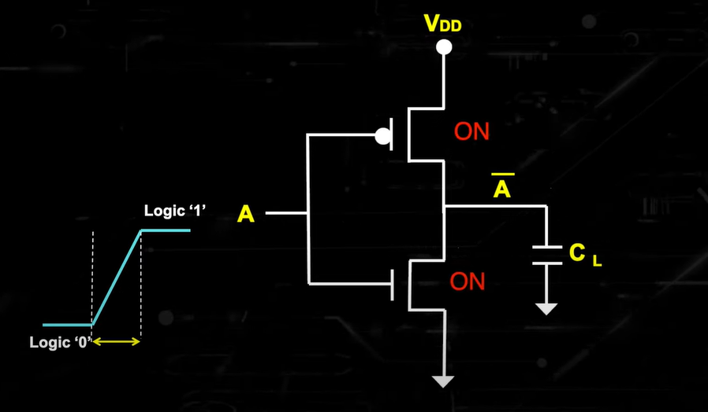  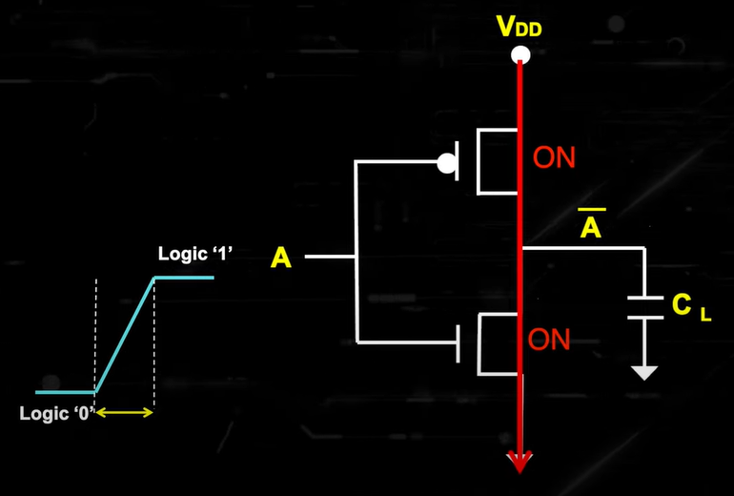  - but even after this – the power consumed by CMOS is very low compared to power consumed by other logic families – that is the biggest advantage of CMOS ckt
PMOS and NMOS ss pin connection | Here’s why your video is telling you to connect them that way:  - NMOS bulk (substrate) → must be tied to the lowest potential in the circuit, usually ground (0V).  - Reason: The NMOS body is typically p-type, and tying it to ground prevents unwanted forward-biasing of the body-diode between source and bulk.  - PMOS bulk (substrate) → must be tied to the highest potential in the circuit, usually VDD (5V in your case).  - Reason: The PMOS body is typically n-type, and tying it to VDD prevents the parasitic diode from conducting between source and bulk.  ⚡ If you don’t connect the bulk pins properly, the parasitic diodes can forward bias when the transistor switches, messing up your inverter behavior.  So the rule of thumb for CMOS logic in LTspice (and real silicon):  - NMOS bulk → GND  - PMOS bulk → VDD
CMOS Imp points | CMOS can be used as or in  - CMOS inverter → the most basic CMOS circuit, forms the basis of logic gates.  - Transmission gate → a bidirectional switch using NMOS + PMOS in parallel.  - Pass transistor logic → using NMOS or PMOS as switches to pass logic levels.  - All logic gates (NAND, NOR, XOR, etc.)  - Flip-flops & latches  - Memory cells (SRAM, DRAM)  - Analog circuits (op-amps, ADC/DAC, comparators)  - VLSI systems (microprocessors, SoCs, etc.)  VTC (voltage Transfer characteristics)  Transfer characteristics mean relation between input and output  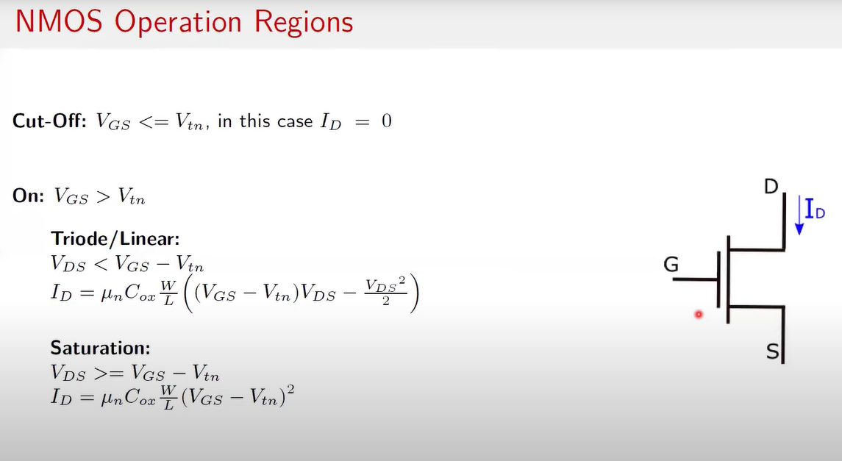  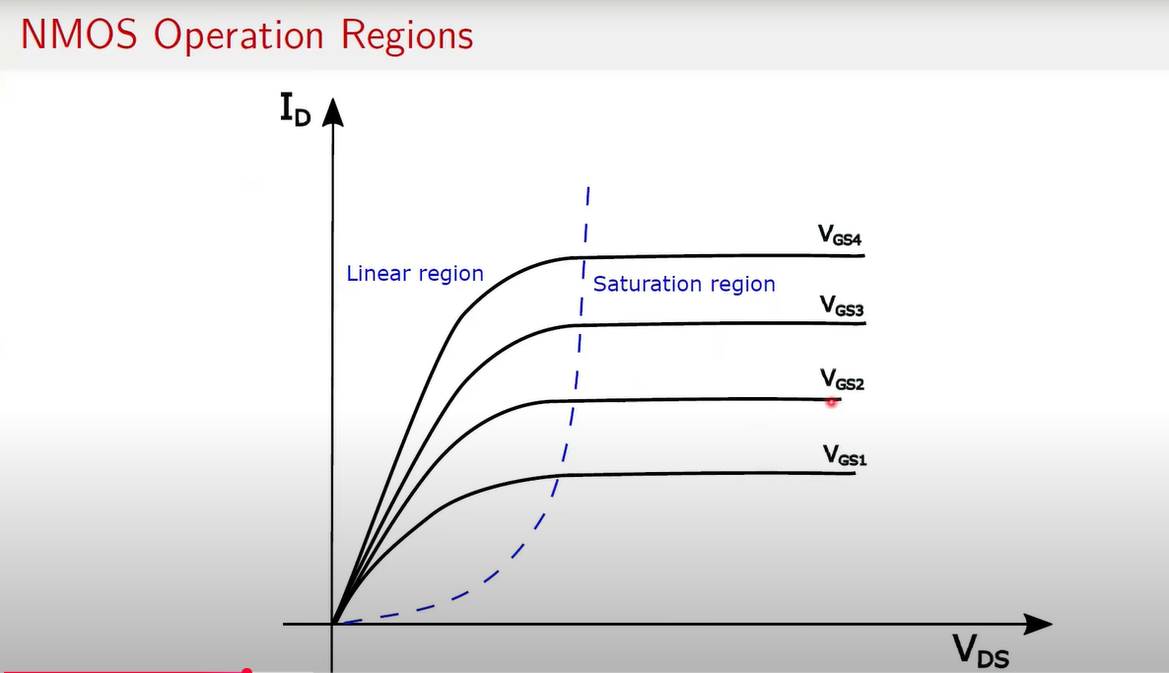  - Things to note  - In linear/ohmic region $I_{D}$ increases linearly with Vds (considering Vgs const)  - In saturation region $I_{D}$ is independent of Vds (and is only dependent on Vgs)  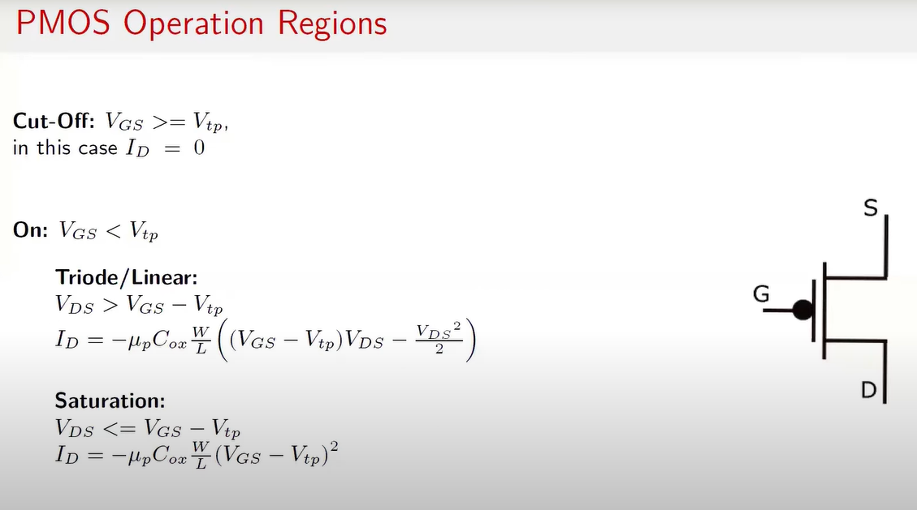  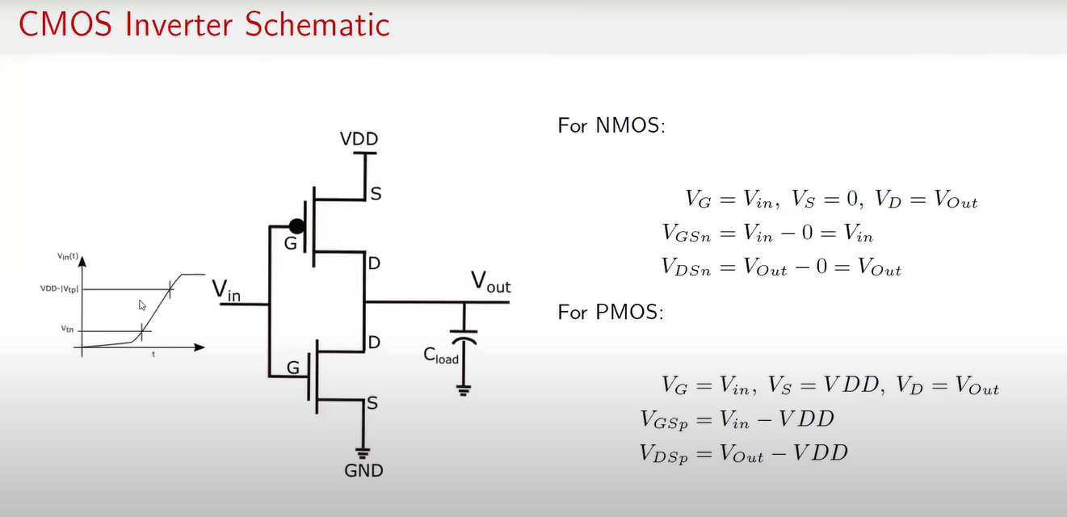  - Things to Note  - Threshold volt of NMOS -> is +ve  - Threshold volt of PMOS -> is -ve  NMOS (Different Biasing Voltages)  $V_{thn}$ (threshold volt) +ve +ve  $V_{GSn}$ (gate-source volt) $$V_{G}- V_{S} = V_{in}-0$$ $$V_{in}$$  $V_{DSn}$ (drain – source volt) $$V_{D}- V_{S} = V_{out}-0$$ $$V_{out}$$  PMOS (Different Biasing Voltages)  $V_{thp}$ (threshold volt) -ve -ve  $V_{GSp}$ (gate-source volt) $$V_{G}- V_{S} = V_{in}- V_{DD}$$ $$V_{in} - V_{DD}$$  $V_{DSp}$ (drain – source volt) $$V_{D}- V_{S} = V_{out}-V_{DD}$$ $$V_{out}- V_{DD}$$  NMOS operating regions  $V_{GSn}<$ $V_{thn}$ Cutoff region  $V_{GSn}≥$ $V_{thn}$ Linear or saturation region  - $V_{DSn}<$ $V_{GSn}- V_{thn}$ Linear region  - $V_{DSn}≥$ $V_{GSn}- V_{thn}$ saturation region  PMOS operating regions  $V_{GSp}>$ $V_{thp}$ Cutoff region  $V_{GSp}≤$ $V_{thp}$ Linear or saturation region  - $V_{DSp}>$ $V_{GSp}- V_{thp}$ Linear region  - $V_{DSp}≤$ $V_{GSp}- V_{thp}$ saturation region  Before plotting the characteristic curve – understand few Important volt points (for x axis)  - $V_{thp}$ (it is -ve)  - $0$ v  - $V_{thn} (it is+ve)$  - $\frac{V_{DD}}{2}$  - $V_{DD}$ + $V_{thp}$  - $V_{DD}$  understand few Important volt points (for Y axis)  - $V_{DD}$  - $\frac{V_{DD}}{2}$  - 0 v  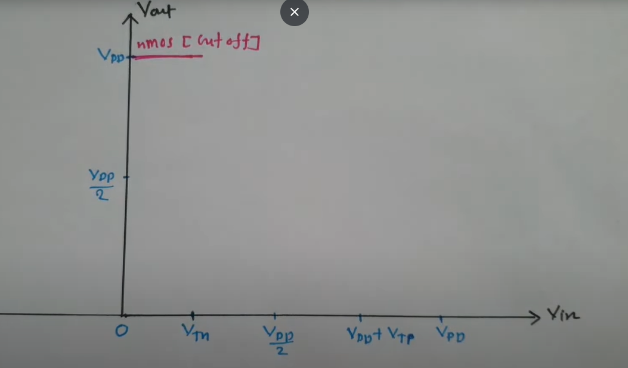  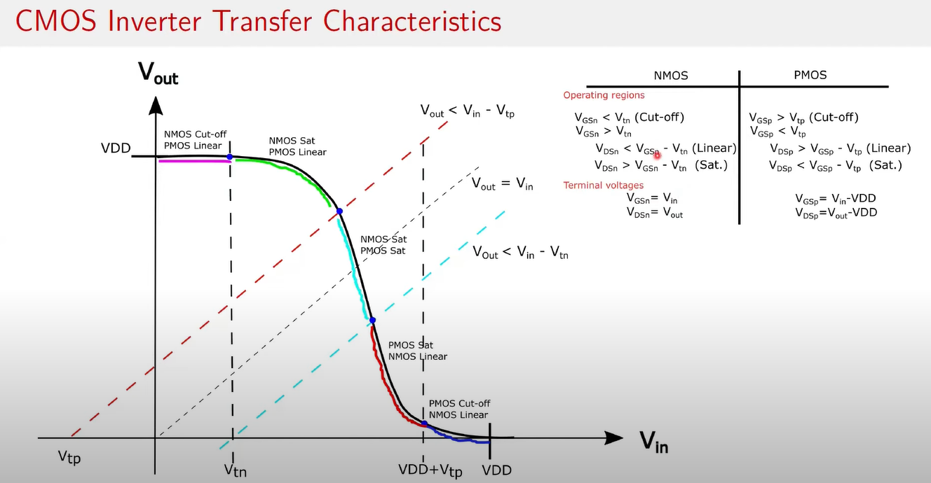  NOTES:  - Vtp = Threshold volt of PMOS  - Vtn = Threshold volt of NMOS  - The graph is called VTC (voltage transfer characteristics of CMOS)  - Note : when PMOS and NMOS both in saturation region – CMOS has very high static dissipation  - For (0 <= $V_{in}$ <= $V_{thn}$)  - Region of NMOS  - $V_{GSn}$ < $V_{thn}$ means cutoff region  - Region of PMOS  - $V_{GSp}=$ $V_{in} - V_{DD}$ = 0 - $V_{DD}$ = -$V_{DD}$  - $V_{DSp}= V_{out}- V_{DD}= V_{DD}- V_{DD}=0$  - Here , $V_{DSp}$> $V_{GSp}$ (meaning $V_{DSp}$> $V_{GSp}- V_{thp}$) (meaning in linear region)  - For ( $V_{thn}$ <= $V_{in}$ <= $\frac{{ V}_{DD}}{2}$)  - Region of NMOS  - $V_{GSn}$ = $V_{in}={ V}_{thn}$  - $V_{DSn}= V_{out}=$ $V_{DD}$  - So here , $V_{DSn}> V_{GSn}-V_{thn}$ (meaning NMOS is in saturation region) (also $V_{GSn}= V_{thn}$ )  - Region of PMOS  - $V_{GSp}=$ $V_{in} - V_{DD}$ = $V_{thn}$ - $V_{DD}$ (this will be -ve)  - $V_{DSp}= V_{out}- V_{DD}= V_{DD}- V_{DD}=0$  - So here, $V_{DSp}$> $V_{GSp}-V_{thp}$ (meaning PMOS is in linear region)  - Example  - $V_{thn}=0.5v$ , $V_{DD}=5v$, $V_{thp}= -0.5v$  - $V_{GSp}=V_{thn}$ - $V_{DD}= -4.5v$  - $V_{GSp}-V_{thp}$ = -4.5 – (-0.5) = -4v  - So here $V_{DSp}$> $V_{GSp}-V_{thp}$ (meaning PMOS is in linear region)  - For ( $\frac{{ V}_{DD}}{2}$ <= $V_{in}$ <= ${(V}_{DD}+V_{thp}) )$  - Region of NMOS  - $V_{GSn}$ = $V_{in}=\frac{{ V}_{DD}}{2}$  - $V_{DSn}= V_{out}=$ somewhere between $V_{DD}$ and 0 (consider $\frac{{ V}_{DD}}{2}$ )  - So here , $V_{DSn}> V_{GSn}-V_{thn}$ (meaning NMOS is in saturation region)  - Region of PMOS  - $V_{GSp}=$ $V_{in} - V_{DD}$ =$\frac{{ V}_{DD}}{2}$ - $V_{DD}$ = $- \frac{{ V}_{DD}}{2}$  - $V_{DSp}= V_{out}- V_{DD}= \frac{{ V}_{DD}}{2}- V_{DD}=- \frac{{ V}_{DD}}{2}$  - So here, $V_{DSp}<$ $V_{GSp}-V_{thp}$ (meaning PMOS is in saturation region) ($V_{thp} is-ve)$  - For (${(V}_{DD}+V_{thp})$ <= $V_{in}$ <= ${ V}_{DD}$ )  - Region of NMOS  - $V_{GSn}$ = $V_{in}={ V}_{DD}$  - $V_{DSn}= V_{out}=$ 0v  - So here , $V_{DSn}< V_{GSn}-V_{thn}$ (meaning NMOS is in linear region) (also $V_{GSn}> V_{thn}$ )  - Region of PMOS  - $V_{GSp}=$ $V_{in} - V_{DD}$ = $V_{DD}$ - $V_{DD}$ = 0  - $V_{DSp}= V_{out}- V_{DD}= 0- V_{DD}=-V_{DD}$  - So here, $V_{GSp}$> $V_{thp}$ (meaning PMOS is in cutoff region)  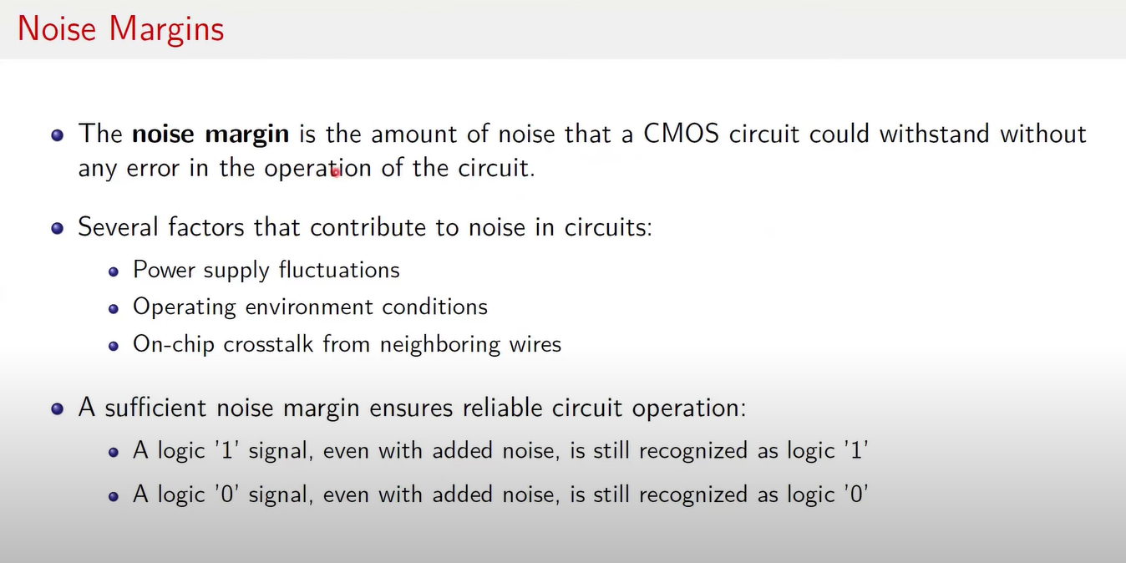  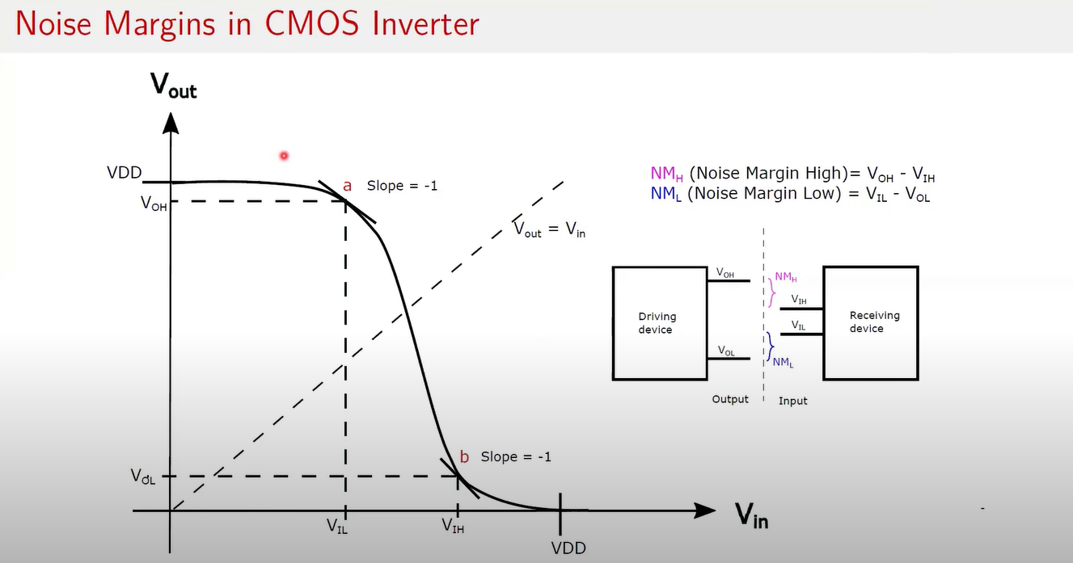  Another Important Insight  Effect of relative strength and sizing of the PMOS and NMOS devices on the overall behaviour of the CMOS inverter  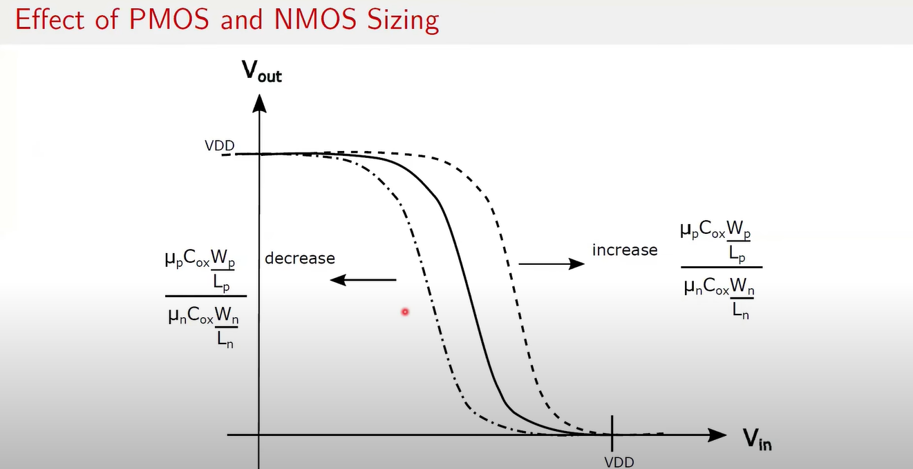  $μ_{p or }μ_{n }=$ effective mobilities of PMOS and NMOS  $C_{ox}$ = gate oxide capacitance per unit area  $W_{p or }W_{n }$= gate width of PMOS and NMOS  $L_{p or }L_{n }$= gate length of PMOS and NMOS  - When the ratio increases -> curve shifts to the right (because PMOS is stronger than NMOS – and PMOS pulls output to Vdd a bit longer)) meaning CMOS inverter remains at Vdd(or logic high) for longer time  - When the ratio decreases -> curve shifts to the left (because NMOS is stronger than PMOS – and NMOS pulls output to gnd much faster)) transitioning from high to low more quickly  - Therefore, sizing of PMOS and NMOS is very crucial and directly impacts the characteristics of the CMOS inverter (such as the rise and fall of the output voltage)
CMOS as transmission gate | Solid state switch : A semiconductor-based ON/OFF control device (like a MOSFET or transistor).  - Called “solid-state” because all conduction and switching occur within the solid semiconductor, not by mechanical or vacuum action.  The type of solid-state switch which allows for a signal or data transfer in both directions is called a Transmission Gate, or TG.  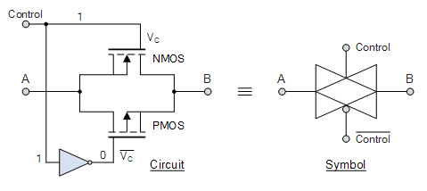  Two MOS transistors are connected back-to-back in parallel with an inverter used between the gate of the NMOS and PMOS to provide the two complementary control voltages. When the input control signal, V_{C} is LOW, both the NMOS and PMOS transistors are cut-off and the switch is open. When V_{C} is high, both devices are biased into conduction and the switch is closed.  Thus, the transmission gate acts as a “closed” switch when V_{C} (control voltage)= 1, while the gate acts as an “open” switch when V_{C} (control voltage)= 0 operating as a voltage-controlled switch. The bubble of the symbol indicating the gate of the PMOS FET.  Transmission Gate Boolean Expression  As with traditional logic gates, we can define the operation of a transmission gate using both a truth table and Boolean expression as follows.  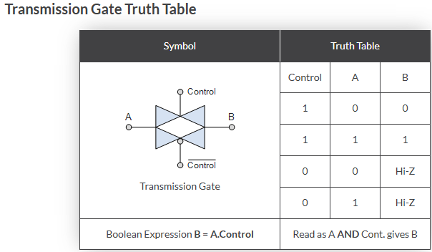  We can see from the above truth table, that the output at B relies not only the logic level of the input A, but also on the logic level present on the control input. Thus, the logic level value of B is defined as both ( A ‘AND’ Control )giving us the boolean expression for a transmission gate of:  B = A.Control
Rise time ($t_{r})$ (general terms) | 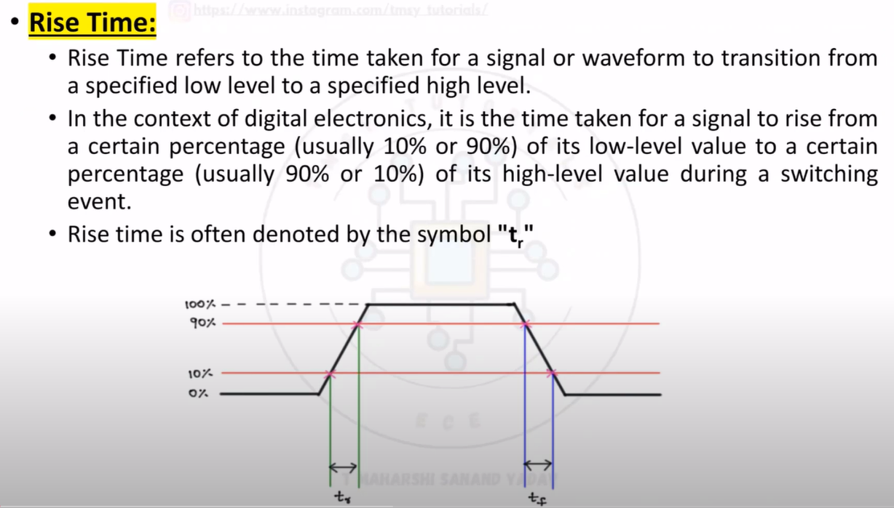  - Time taken by the signal to reach from 10% to 90%
Fall time ($t_{f})$ (general terms) | 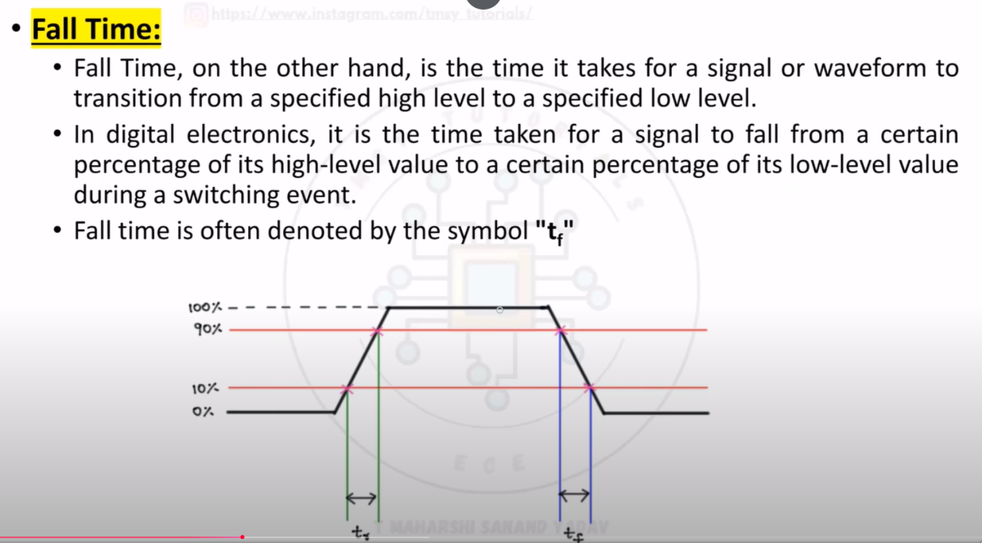  - Time taken by the signal to reach from 90% to 10%
Propagation delay or delay time ($t_{p})$ ($t_{d})$ (general terms) | 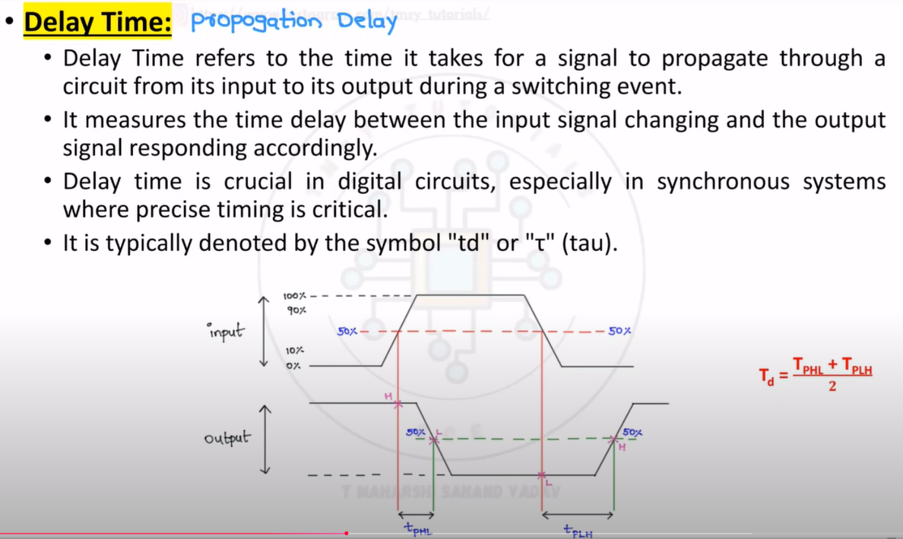  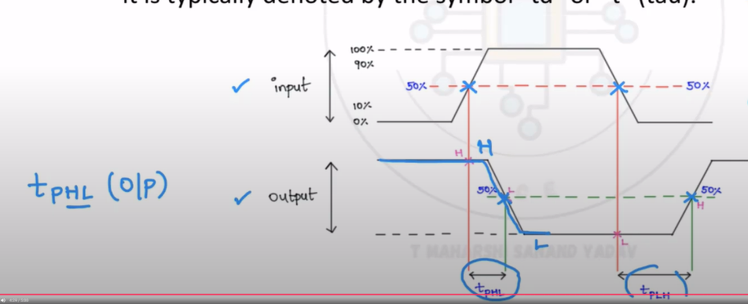  Propagation delay : delay in observing the response when input changes  $$t_{p}= \frac{t_{pHL}+ t_{pLH}}{2}$$  - there are two sub parameters of propagation delay - $t_{pHL}$ & $t_{pLH}$ (measured in output waveform context)  - $t_{pHL}$ – time duration when output’s High to low transition happens (for input transition (any transition high to low or low to high) (measured when input transition is at 50% and output’s transition is at 50%) [shown in above graph]  - $t_{pLH}$ – time duration when output’s low to high transition happens (for input transition (any transition high to low or low to high) (measured when input transition is at 50% and output’s transition is at 50%) [shown in above graph]  Example : consider an inverter gate  At 0 ns input transitioned from 5v to gnd At 12ns output transitioned from gnd to 5v (so it can be said that prop delay is of 12 ns(measured at 50% or input transition and 50% at output transition) [ this timing is referred as $t_{pLH}$ – because op transitioned from low to high)
Rise and Fall time (In context with CMOS inverter) | 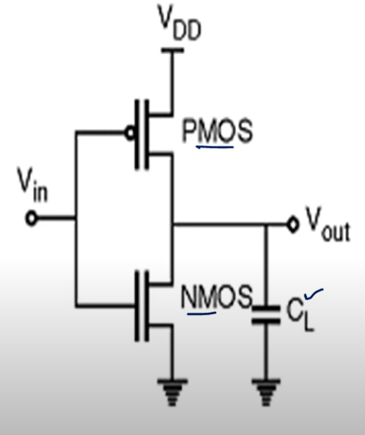  - Here when the input is 0 – PMOS is on and is conducting (bringing output = Vdd) (so the path is Vdd -> PMOS -> Vout & CL -> gnd)  - Load Capacitor $( C_{L} )$ ( this is basically representation of gate capacitance due to fanout-or u can say gate capacitance of gates connected to the output) charges  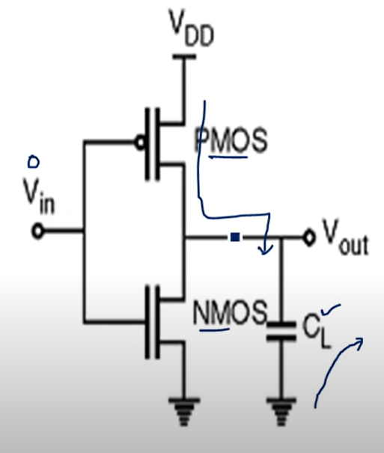  - Now when the input is 1 – NMOS is on and is conducting (bringing output = GND) (so the path is CL -> Vout -> NMOS -> gnd  - Load Capacitor $( C_{L} )$ ( this is basically representation of gate capacitance due to fanout-or u can say gate capacitance of gates connected to the output) discharges  Basically  - Input = logic low PMOS ON - $C_{L}$ charges  - Input = logic High NMOS ON - $C_{L}$ discharges  Rise Time (tr)  - Happens when output goes from 0 → Vdd.  - In a CMOS inverter, this is when PMOS conducts (charging the output node through Rp).  - $t_{r}$ depends on: PMOS resistance (Ron_p), load capacitance (CL), Vdd.  $$t_{r} ≈ 2.2* R_{P}* C_{L}$$  [ Note : 2.2$τ$ = 90% of charge on charging curve of capacitor – thus 2.2 used]  Fall Time ($t_{f}$)  - Happens when output goes from Vdd → 0.  - In CMOS inverter, NMOS conducts (discharging CL through Rn).  - $t_{f}$ depends on: NMOS resistance (Ron_n), load capacitance (CL).  $$t_{f} ≈2.2* R_{N}* C_{L}$$  Note: If PMOS ≠ NMOS strength → tr ≠ tf → rise–fall skew.
Propagation Delay of CMOS inverter | Refer “ Propagation delay or delay time ($t_{p})$ ($t_{d})$ (general terms) ” first  Then Refer “Rise and Fall time (In context with CMOS inverter) “  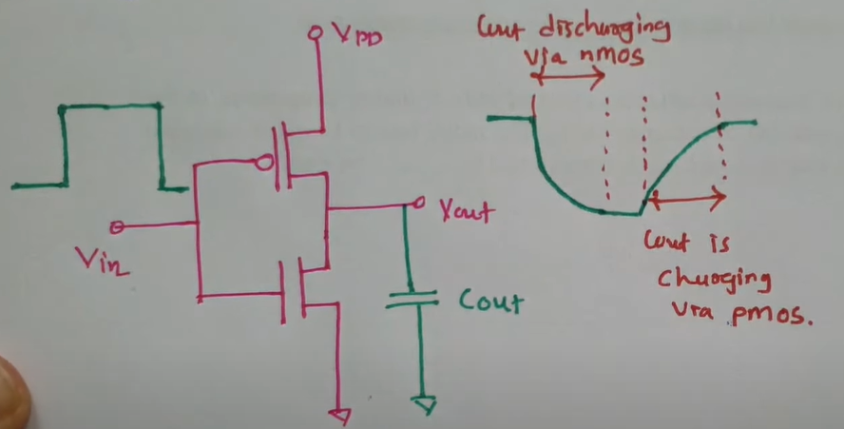  - In CMOS inverter propagation delay is observed due to charging and discharging of Load capacitor ($C_{L})$  - When input is transitioning from low -> high output goes high -> low [NMOS is on] [capacitor discharges via NMOS]  - When input is transitioning from high -> low output goes low -> high [PMOS is on] [capacitor charges via PMOS]  - The graph which is observed at the output is shown in the image  Note : Propagation delay creates some issues and because of that , it limits the freq of operation of integrated ckt  How to minimize the propagation delay ?  - by decreasing load capacitance  - by increasing width of the MOS transistor , known as gate sizing (refer section 1)  - by providing full voltage swing as input, that is input low = gnd and input high = Vdd (refer section 2)  Measuring Propagation delay  $t_{pHL}= \frac{C_{L}* ∆V_{HL}}{I_{avg(HL)}}= \frac{C_{L}*(V_{OH} - V_{50\%}) }{I_{avg(HL)}}=0.69* R_{on(N)}*C_{L}$  - $R_{on(N)}= \frac{12.5}{{( \frac{W}{L} )}_{n}}$  $t_{pLH}= \frac{C_{L}* ∆V_{LH}}{I_{avg(HL)}}= \frac{C_{L}*( V_{50\% }- V_{OL}) }{I_{avg(LH)}}= =0.69* R_{on(P)}*C_{L}$  - $R_{on(P)}= \frac{30}{{( \frac{W}{L} )}_{p}}$  Avg propagation delay  $$t_{p}= \frac{t_{pHL}+ t_{pLH}}{2}$$  Note : Propagation delay creates some issues and because of that , it limits the freq of operation of integrated ckt  Max freq of operation = $f_{max}= \frac{1}{2* t_{p} }$ [we cannot use IC beyond this freq] (refer section 3)  SECTION 1 : GATE SIZING  - Each MOS transistor has an on-resistance:  $$R_{on}∝ \frac{1}{W/L}$$  - Wider gate (bigger W) → lower resistance → stronger drive → charges/discharges $C_{L}$ faster.  - So, increasing W reduces tpHL, tpLH, tr, tf.  But:  - Wider gate → larger input capacitance (Cgs, Cgd) → when this gate drives other gates, it increases the load for the previous stage.  - So sizing is always a trade-off: make gates wide enough to switch fast, but not so wide that they load down the previous stage too much.  3️⃣ Practical Example  Suppose:  - $R_{on(P)}= \frac{30}{{( \frac{W}{L} )}_{p}}$  - $R_{on(N)}= \frac{12.5}{{( \frac{W}{L} )}_{n}}$  - If you double W/L, resistance halves → tp halves (roughly).  - But also, input capacitance doubles → so previous stage tp doubles.  That’s why in VLSI gate sizing is a design art:  - Critical path gates (where delay matters most) are upsized.  - Non-critical gates are left small to save power/area.  4️⃣ Summary of Gate Sizing Effect  - Increase W → ↓ R_on → ↓ delay of that stage.  - But ↑ W → ↑ input capacitance → ↑ load on previous stage.  - Optimal gate sizing = balance between drive strength and loading.  SECTION 2 :  1️⃣ Full Voltage Swing & Its Effect  - Full swing input = logic “0” = 0 V (GND), logic “1” = Vdd.  - Why it matters: The MOSFET turns on more strongly when the gate–source voltage (Vgs) is fully high (for NMOS) or fully low (for PMOS).  - Effect on propagation delay:  - If input doesn’t reach full Vdd → MOSFET doesn’t fully turn on → higher R_on → slower charging/discharging of the load capacitor (CL).  - Result: tₚ increases.  2️⃣ Example  - Suppose Vdd = 5 V.  - Ideal input swings from 0 → 5 V → NMOS fully enhanced when Vin = 5 V.  - If input only swings 0 → 3 V → NMOS partially enhanced → less current → slower output transition.  Practical Rule  - To minimize propagation delay: drive CMOS inputs with full rail-to-rail voltage (0 → Vdd).  - This is why CMOS outputs are usually directly connected to CMOS inputs (they are rail-to-rail).  it’s just MOSFET physics: stronger gate voltage → lower R_on → faster switching → smaller tₚ → higher f_max.  SECTION 3  1️⃣ What tₚ really means for a clocked circuit  - tₚ (propagation delay) = time it takes for a signal to propagate through a gate (input change → output change).  - In a clocked sequential circuit, the output of one gate must settle before the next clock edge triggers the next stage.  - If the clock is too fast, the signal doesn’t settle in time → wrong logic values → circuit fails.  2️⃣ How fₘₐₓ comes from tₚ  - Consider a simple inverter chain being toggled by a clock.  - One full clock period must accommodate:  - Signal propagation through the logic → tₚ  - Signal stabilization (if sequential circuits) → usually included in setup time  - In the simplest toggle circuit, the output must go HIGH → LOW → HIGH in one period.  - The time for one complete transition (rise + fall) ≈ 2 × tₚ.  $$T_{min}=2* t_{p}$$  $$f_{max}=\frac{1}{T_{min}}= \frac{1}{2* t_{p} }$$  3️⃣ Intuition  - If tₚ = 1 ns → 1 full rise-fall takes 2 ns → maximum toggling frequency = 0.5 GHz.  - Faster IC = smaller tₚ (smaller CL, larger W/L, stronger drive).  - This is why propagation delay directly limits how fast an IC can operate.
Skew in CMOS | 🔹 What is Skew in CMOS Inverters?  - Rise time (tr) ≠ Fall time (tf) in many cases, because PMOS mobility < NMOS mobility.  - This mismatch creates asymmetric propagation delays → TpLH ≠ TpHL.  - Skew is simply the imbalance between the two.  🔹 Why it’s important  - Balanced design: If skew is high, your output waveform is not symmetrical → signal integrity issues.  - Power & speed trade-off: Balancing skew sometimes needs bigger PMOS → more area & power.  - In complex logic: Uncontrolled skew accumulates → can cause timing errors in sequential circuits.  🔹 What to focus on  - Definition: Skew = TpHL / TpLH (or vice versa).  - Cause: mobility difference (µn ≈ 2–3 × µp). [NMOS mobility is 2-3 times PMOS mobility]  - Fix: Wp > Wn (usually Wp ≈ 2–3 × Wn for balanced delays). [width channel in PMOS is kept greater than NMOS]  - Impact: influences propagation delay, power, and frequency of operation.  1️⃣ Influence on Propagation Delay  - Recall:  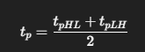  - If skew is high (say TpHL ≫ TpLH):  - The slower transition dominates.  - Even if one edge is fast, the overall propagation delay is limited by the slower edge.  - So skew directly increases average tp, degrading circuit speed.  - Balanced skew (TpHL ≈ TpLH) ensures both edges contribute equally → minimum average delay.  2️⃣ Influence on Power  - Dynamic power:  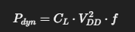  depends on frequency and load capacitor(fanout capacitor) charging/discharging.  - If skew is large:  - One transition (say rising edge) takes longer → larger short-circuit current window (when both NMOS & PMOS conduct together).  - More short-circuit power.  - So unbalanced skew = more wasted energy per transition.  short-circuit current  • In an ideal CMOS inverter:  - When Vin = 0 → PMOS ON, NMOS OFF → clean Vout = VDD.  - When Vin = VDD → NMOS ON, PMOS OFF → clean Vout = 0.  - No direct path between VDD and GND.  • But in real operation:  - Input doesn’t switch instantly → it has a finite rise/fall time.  - During the middle of the transition (Vin ≈ VDD/2):  - Both PMOS and NMOS are partially ON at the same time.  - This creates a direct current path from VDD → NMOS → GND  3️⃣ Influence on Frequency  - Maximum frequency:  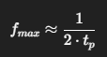  - If skew increases tp, then fmax drops.  - Example:  - Symmetric case: TpHL = 40 ps, TpLH = 40 ps → tp = 40 ps → fmax ≈ 12.5 GHz.  - Skewed case: TpHL = 80 ps, TpLH = 20 ps → tp = 50 ps → fmax ≈ 10 GHz.  - So even though one edge is fast, the circuit can only run as fast as the average → speed penalty.  ✅ Summary in 1 line:  Skew slows propagation delay, wastes dynamic power (short-circuit loss), and reduces max operating frequency.

