Topic | Details
What does a voltage regulator do? | Link : https://youtu.be/AX5SqSJu6R4?si=6lO8gsnXo1aeNSzp  - What is an unregulated power supply  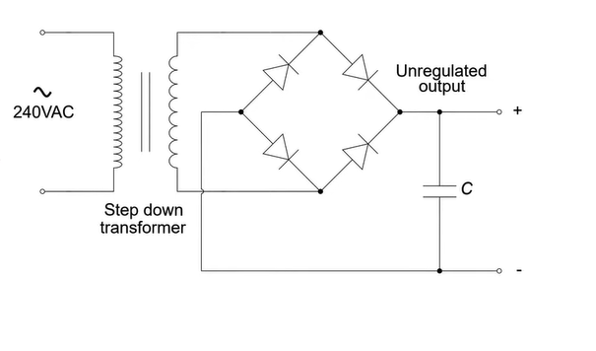  - This section is called unregulated power supply  - Here the output DC is almost stable  - There are several factors that affects output DC volt (makes it change)  - If the load changes – the DC volt also changes (example : if low resistance value load is connected – the volt output will be low as the volt drop there is very low)  - If the input AC volt changes (or you can say line volt changes)  - Temperature – it changes the current flowing through the diodes  - A VOLTAGE REGULATOR corrects all 3 problems  - Independent of the load current ($I_{L}$) [ independent of the load ]  - Independent of the AC line volt  - Independent of temperature  - 2 types of voltage regulator  - Shunt regulators / parallel regulators  - Series regulators  - SHUNT Regulators/parallel regulator (controls current flow)  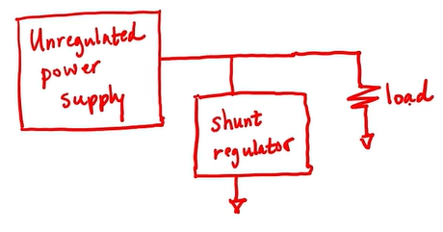  - Shunt regulator is connected in parallel with load  - Shunt regulator reduces the volt appearing at the load (it doesn’t posses the ability to increase volt – so thus unregulated power supply output should be in such a way that it always is high and if required shunt regulator can lower it down  - This regulator does so by providing lower resistance path to pass more current through it (lowering current at load)  - series Regulators (controls voltage drop)  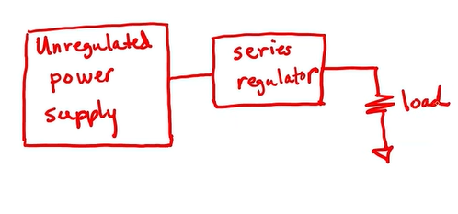  - series regulator controls the voltage drop across itself  - if it senses the volt at load is decreased – then it lowers its voltage drop (that in turn increases voltage available at load  - if it senses the volt at load is increases – then it Highers its voltage drops (that in turn decreases voltage available at load]  ⚡ Types of Voltage Regulators  There are two broad categories:  ➤ 1️⃣ Linear Regulators  - Easy to use  - Low noise, very stable output  - Poor efficiency (excess energy is converted to heat)  Examples:  - Series regulators  - 78xx family (e.g. 7805 gives +5V)  - Low Dropout Regulators (LDOs)  Power loss = (Vin − Vout) × $I_{load}$  So if Vin >> Vout → Too much heat!  ➤ 2️⃣ Switching Regulators  - High efficiency (80–95%+)  - Slightly complex, more ripple/noise  - Uses inductors + switching transistors  Subtypes:  - Buck converter → Step-down  - Boost converter → Step-up  - Buck-Boost converter → Can do both  - Flyback/Forward → Used in SMPS

SHUNT Regulators/parallel regulator (controls current flow) | Link : https://www.youtube.com/watch?v=5vec422YMik&list=PLXb3r5ny8_1VGu4f8FoKp4ZkdEyd8CF1a&index=2  Zener diode shunt regulator  Normal diode  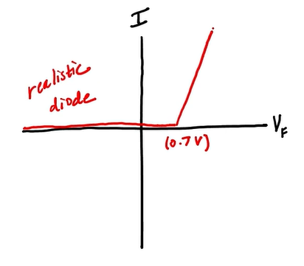  Zener diode  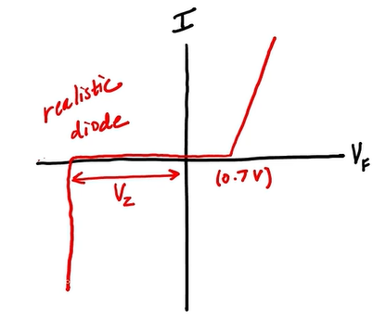  Zener diode equivalent circuit  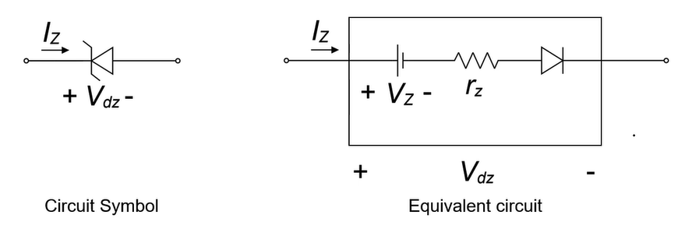  Zener shunt regulator :  - as we discussed in the prev section (shunt regulator is parallel to load )  - shunt regulator controls the current through it – that is how they change the voltage of load\  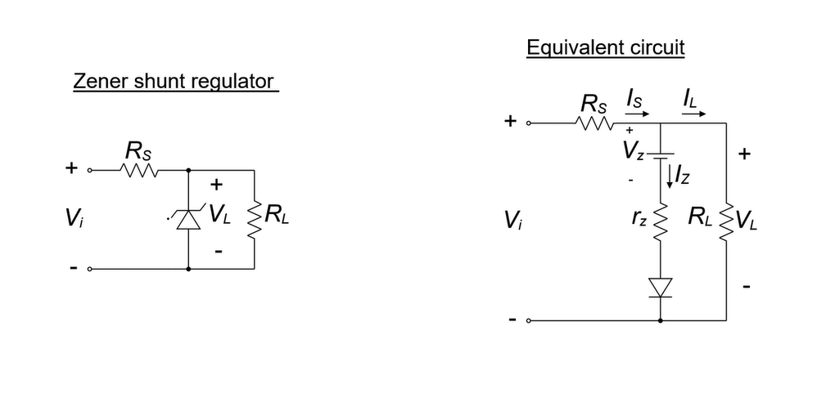  - voltage across load is same as zener voltage(zener breakdown voltage) [ $V_{Z}=V_{L}$ ]  - this zener volt regulator is not very efficient – ex. if the voltage source is high and the regulated volt we need is low ($R_{Z}$ & $R_{S} )$ dissipates power in terms of heat in order to bring the volt down  [ for more details – you can visit diode section of the learning]  Shortcomings of shunt regulators  - series resistance might have to absorb a lot of current in order to achieve the op voltage  - zener diode might need to carry lot of current in order to maintain the op voltage
Line and Load regulation | Link : https://www.youtube.com/watch?v=eADfk2EN1MA&list=PLXb3r5ny8_1VGu4f8FoKp4ZkdEyd8CF1a&index=3  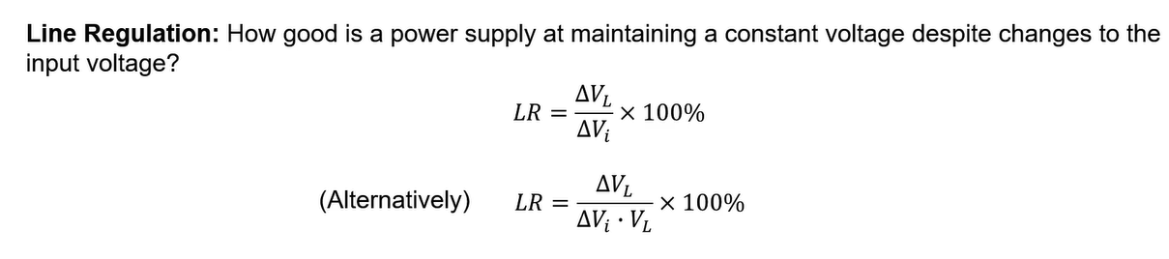  - $V_{L}$ = Load volt  - $V_{i}$ = input volt (line volt / AC volt)  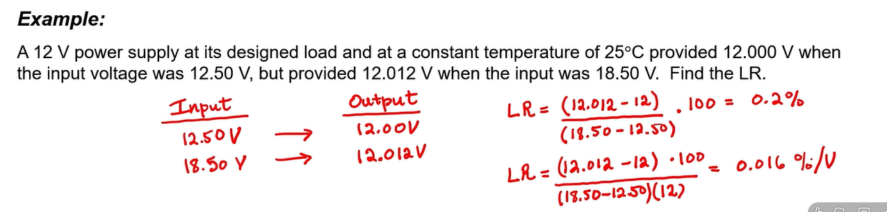  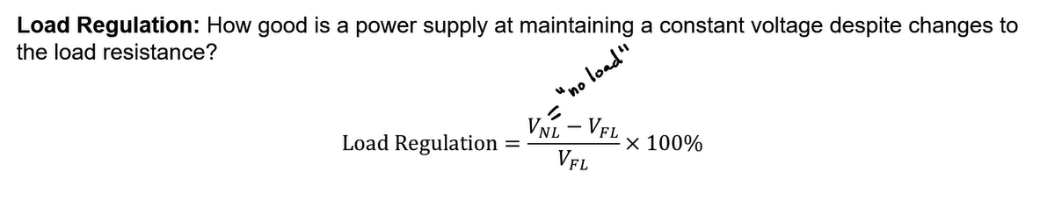  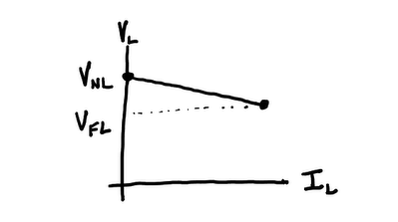  - Here when current is 0 (meaning no load condition – the ${V_{out }= V}_{NL}=no load volt$ ) ( here u can also consider no load = infinite resistance (which makes op volt appear full))  - Even when the load changes and current changes – ideal regulator should have no change in volt appearing across load  - Here when the load is max (current is seem to be decreasing ) and the output appears is called ${V_{out }= V}_{FL}=full load volt$ ) ( here u can also consider full load = lowest resistance or the min resistance (which makes op volt appear little less than${ V}_{NL}$))  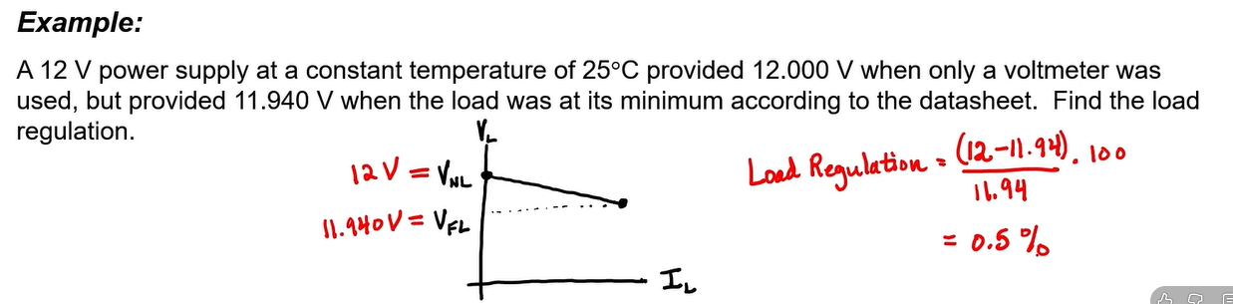

Series voltage regulators | Link : https://www.youtube.com/watch?v=J8obBcHviaY&list=PLXb3r5ny8_1VGu4f8FoKp4ZkdEyd8CF1a&index=4  Shortcomings of shunt regulators which we need to overcome in series regulators  - series resistance might have to absorb a lot of current in order to achieve the op voltage  - zener diode might need to carry lot of current in order to maintain the op voltage  Basic series voltage regulator  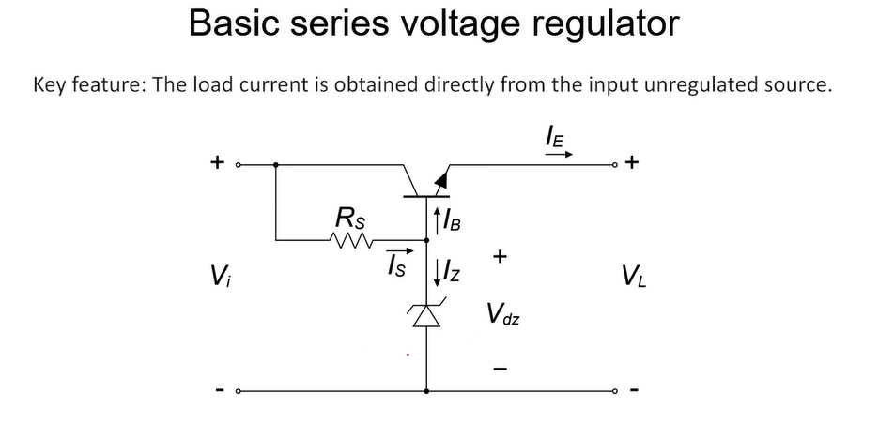  - here – the zener diode breakdown volt or zener volt is what creates the reference voltage/output volt  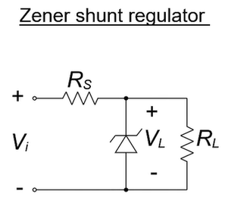  - same as zener shunt regulator where it was the output voltage  - voltage at base is fixed by zener diode (which is Zener’s breakdown volt) + also for silicon diode in active region the base emitter junction drop is +0.7v (so the op volt $V_{out}= V_{z}-0.7$  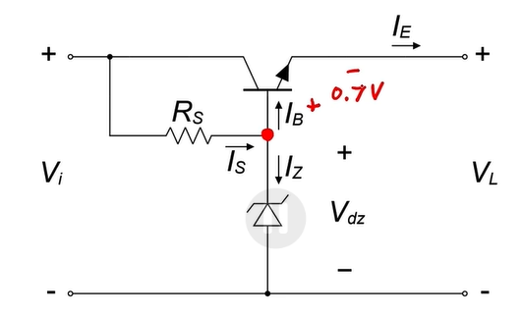  - in series regulator the current passes through series resistance ($R_{s}$) – but here current passes through transistor (which is the key feature)  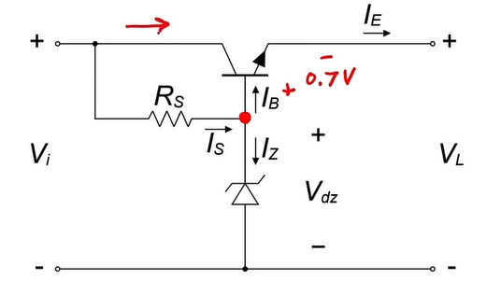  - in series regulators very short value of current flows through series resistor ($R_{s}$) but in shunt regulator entire current needs to be passed through series resistor ($R_{s}$) [ so this regulator is more efficient and doesn’t burn up much power as a shunt regulator ]  - also keep in mind that we have base current that goes to transistor  - Here major factors we shall look upto  - $I_{E} (emitter current)$ is basically our load current  - And all transistor has some $β$ (current gain)  - Which means to connect a load consuming X value of current – we need to ensure our $I_{B}$ is such a way that it can fulfil $I_{E}$  - Shortcomings of simple series regulator  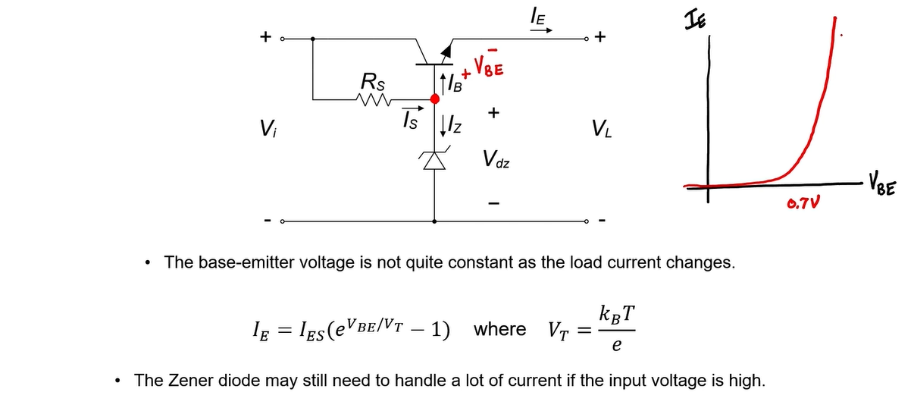  - A simple series regulator uses zener diode to provide reference voltage for output and the output is considered as zener volt – BE junction volt (=0.7v) but that isn’t true (it is not const ) current shows different exponential trend (till 0.7v it is 0 and after 0.7v it increases exponentially (making Vbe change)- which in turn leading to change in load volt  - Zener diode might need to pass lot of current if the Input volt is high compared to output volt
Series voltage regulator with negative feedback | Link : https://www.youtube.com/watch?v=3n-jcCPBfWI&list=PLXb3r5ny8_1VGu4f8FoKp4ZkdEyd8CF1a&index=5  Issue with the basic series regulator    Series regulator with negative feedback  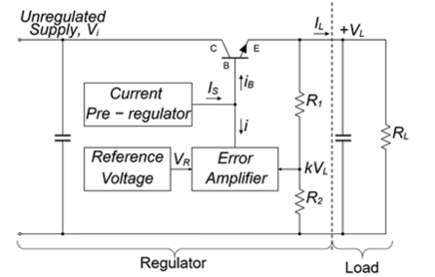  - A key element in this ckt is – Error amplifier : it is basically a comparator and compares the output we actually have with the output we want (which uses reference voltage (which can be provided by zener diode)) – we will compare the reference volt to a fraction of load volt (provided via volt divider)  - If the voltages are same – nothing to change  - But if there is any difference in the voltage – this gets amplified little bit and provides a corrective current that adjusts base emitter voltage accordingly  - R1 and R2 forms the voltage divider and we don’t want it drawing large current – so R1 and R2 are kept high  - K is the volt divider ration K = $\frac{R_{2}}{R_{2}+ R_{1}}$  - Also, other thing to keep in mind - we don’t want transistor to saturate ( $V_{CE}$ ) – which is basically difference of input and output voltages ($V_{CE}$ > 2v) – so there must be minimum 2 v difference between input and output [ example : if we want 10v as op , we must have >12v input ]  Implementation of the circuit  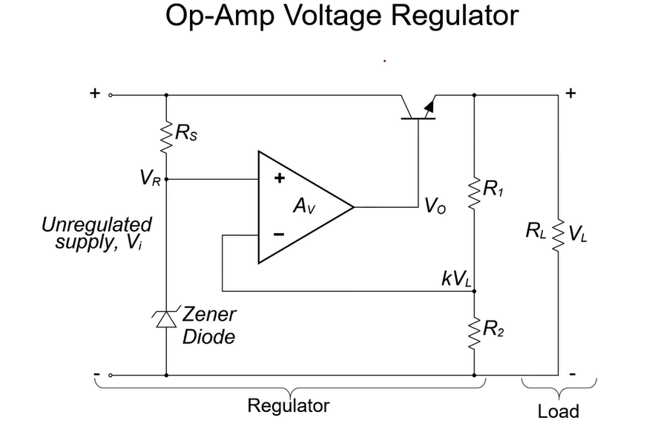  - $V_{R}$ = reference volt generated by zener diode (zener operates in the breakdown region and provides reference volt)  - The op-Amp is acting as a comparator (also on the same time due to virtual short concept -it tries to match the potential at both of its input (opAmp forces $V_{R}$ = K $V_{L}$ )  - K = $\frac{R_{2}}{R_{2}+ R_{1}}$  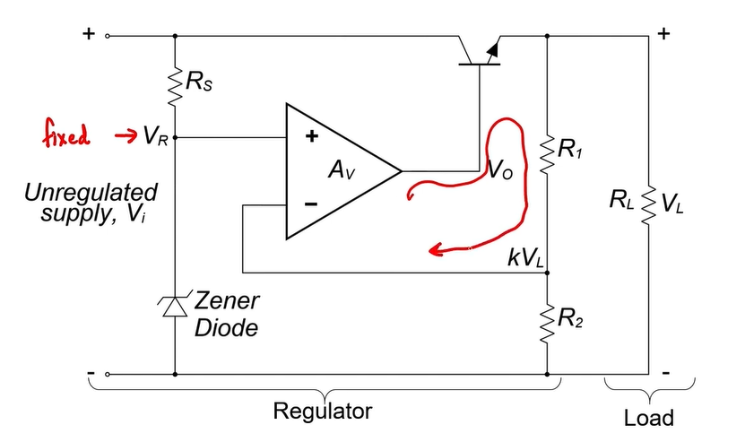  - Here, opAmp forms negative feedback (as shown in the image) – this then acts like feedback  - Case 1 : Load voltage is too high  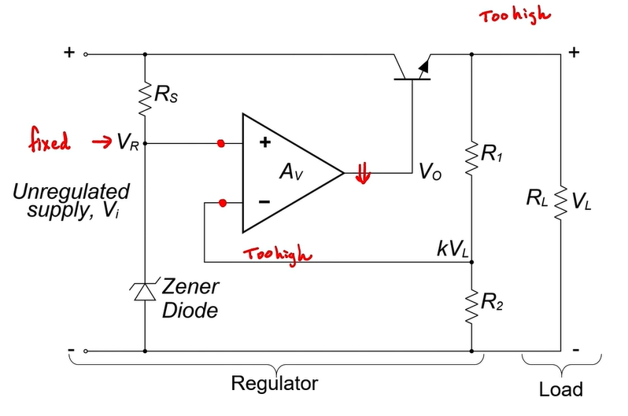  - If load volt/op volt is high , it makes the volt divider op to be high and the opAmp output lowers down – which eventually makes the output volt/load volt lower (so this feedback loop serves the issue)  - Case 2 : Load voltage is too Low  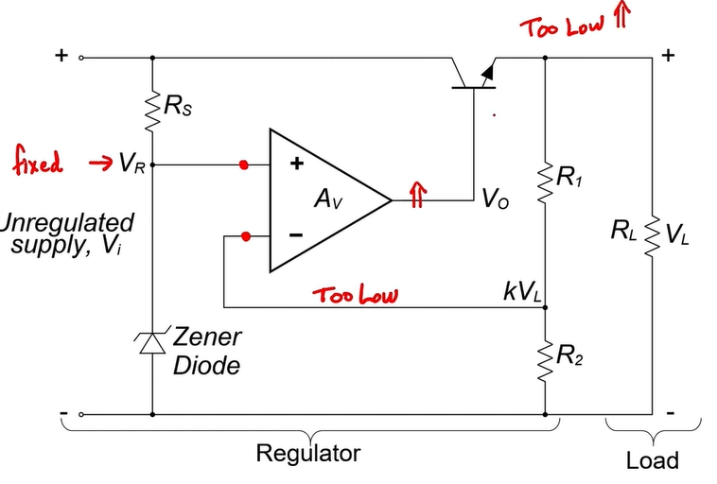  - If load volt/op volt is low , it makes the volt divider op to be low and the opAmp output increases – which eventually makes the output volt/load volt to increase (so this feedback loop serves the issue)  - Only 2 things to consider when designing this – the resistor should not be too low and also there shall be not high current passing through the zener  So adding op-Amp and negative feedback solves the issues we noticed with basic series regulator
Examples | Shunt regulator  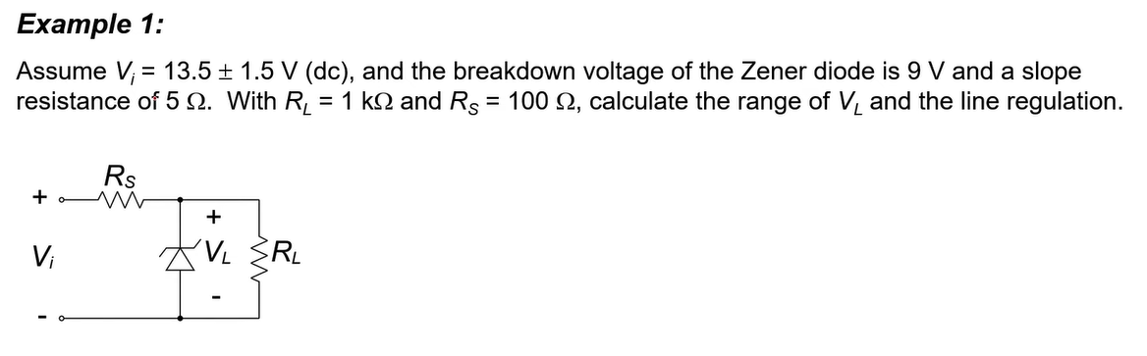  - Identified things from problem statement  - $V_{i}$ range $V_{i}$ = 13.5 ± 1.5 12v and 15v  - $R_{s}$ = 100 ohm  - $R_{z}$ = 5 ohms  - $R_{L}$ = 1000 ohms  - $V_{z}$ = 9v  - Find  - Range of $V_{L}$  - Line regulation  - Redrawing the ckt  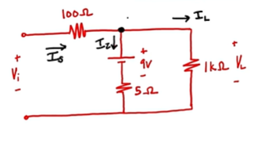  - Here the 9v is shown as battery but it is not – it represents 9v drop due to zener  - We need to find relation between input and output (to find the range of load voltage)  - $I_{s}= I_{L}+ I_{z}$  - $\frac{V_{i}- V_{L}}{100}=\frac{V_{L}- 9}{5}+ \frac{V_{L}}{100}$  - $V_{L}=\frac{10 V_{i }- 1800}{211}$  - Putting $V_{i}$ range 12v and 15v  - $V_{L}=9.100 v$ (for 12v)  - $V_{L}=9.242 v$ (for 15v)  - Line regulation (LR)  - $LR =\frac{{∆ V}_{L}}{∆ V_{i}}$ $\frac{9.242-9.100}{15-12} *100\%$  - $LR=4.7\%$

