Topic | Description / Explanation
Op-Amp | What an Op-Amp does  - An op-amp (operational amplifier) is basically a high-gain voltage amplifier.  - It takes the difference between two input voltages (non-inverting + and inverting – terminals) and multiplies it by a large gain.  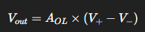  where $A_{OL}$​ is the open-loop gain (very large, ~10⁵ to 10⁶).  - Because the gain is huge, in practice we add feedback (feeding part of output back to input) to control and stabilize the behaviour.  - With feedback, op-amps can perform many linear and non-linear operations.  1. Linear Operation of Op-Amp  - Meaning: The op-amp is used in a mode where the output is a linear function of the input (within the limits of supply voltage).  - Condition: Achieved when the op-amp is used with negative feedback (which stabilizes and keeps the output proportional to the input).  - Examples:  - Inverting amplifier  - Non-inverting amplifier  - Voltage follower (buffer)  - Integrator  - Differentiator  👉 In these circuits, the op-amp acts as an amplifier, maintaining linearity between input and output.  2. Non-Linear Operation of Op-Amp  - Meaning: The op-amp is used in a mode where the output is not directly proportional to the input; instead, it behaves according to the circuit design (often digital-like switching or nonlinear shaping).  - Condition: Achieved when the op-amp is used without negative feedback or in circuits designed for non-linear tasks.  - Examples:  - Comparator (output jumps between +Vsat and –Vsat depending on input)  - Schmitt trigger (adds hysteresis for noise immunity)  - Clipping and clamping circuits  - Precision rectifier  👉 In these circuits, the op-amp is more like a switch or decision-making element rather than an amplifier.  ✨ Simple way to remember:  - Linear op-amp → “Amplifier role” (output ∝ input).  - Non-linear op-amp → “Decision-making role” (output jumps, shapes, or modifies input in a non-linear way).  🔹 Key Features  - Very high input impedance (doesn’t load the source).  - Very low output impedance (can drive loads easily).  - Extremely high gain.  - Behaviour shaped by external resistors/circuits (super flexible).  🔹 Main Applications  Op-amps are like the “Swiss army knife” of analog electronics. Some classic uses are:  - Signal Amplification  - Inverting amplifier → output is negative and scaled version of input.  - Non-inverting amplifier → output is positive and scaled.  - Math Operations (hence "operational")  - Adder (summing amplifier) → adds multiple signals.  - Subtractor → finds difference between signals.  - Integrator → performs mathematical integration (used in filters, waveform generation).  - Differentiator → outputs slope of the input (edge detection, signal processing).  - Filters  - Active low-pass, high-pass, band-pass filters.  - Comparators  - Compare two voltages and output logic high/low (though comparators are specialized ICs now).  - Oscillators & Waveform Generators  - Sine, square, triangular wave generation.  - Signal Conditioning  - Removing noise, scaling signals (e.g., from sensors before ADC).  - Control Systems  - PID controllers, voltage regulators, analog computing.  👉 So, in short:  An op-amp is a versatile building block that, with feedback and a few resistors/capacitors, can do almost anything in analog electronics—amplify, filter, add, subtract, integrate, differentiate, compare, and generate signals.  It is ‘AB de Villiers’ of Electronics
OP-Amp basics | It is basically an amplifier  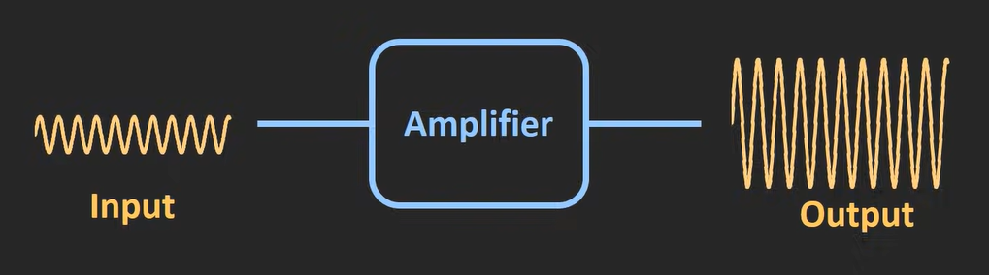  Symbol  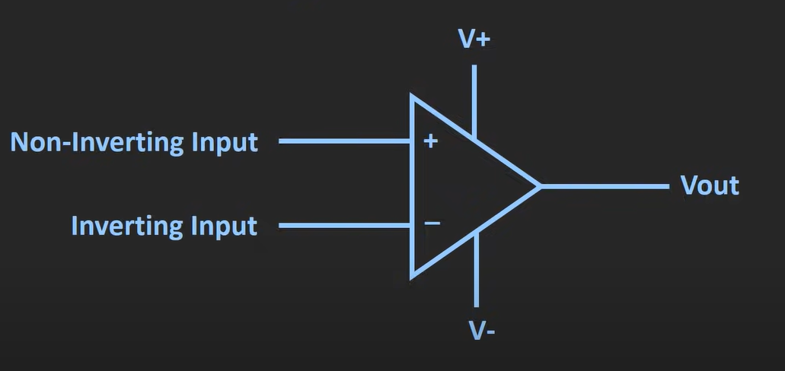  - opAmp is basically a differential amplifier (read ref-1)  - if gain of this op-Amp is considered A and volt at terminal (+) is $V_{1}$ and volt at terminal (-) is $V_{2}$ – then $V_{out}=A ( V_{1}- V_{2})$  - so, if we gnd one terminal – then $V_{out}=A* V_{1}$ considering $V_{2}$ = gnd  - Here A=gain (which is open loop gain as no feedback is being given here)  - Example  - If sine wave is given at non-inverting side and inverting side is grounded -> $V_{out}$ will be amplified version of input ($V_{out}=A* V_{1}$)  - If sine wave is given at inverting side and non-inverting side is grounded -> $V_{out}$ will be amplified + inverted version of input ($V_{out}=-A* V_{2}$) [ output is 180 ֯ out of phase from input]  - If we apply $V_{d}$ as input -> we will get -> $V_{out}=A* V_{d}$  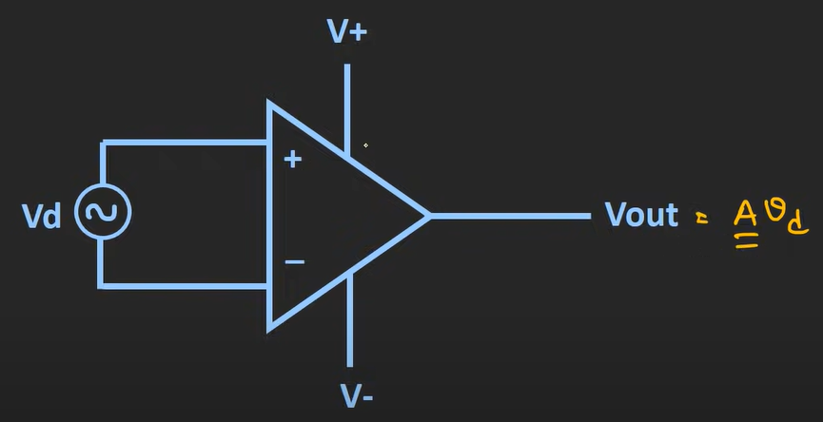  - Output of the opAmp is restricted by the biasing voltages ($V_{+}$ and $V_{-}$)  - Example :  - if open loop gain of op-Amp is ${10}^{5}$ then  - input = 1mv output = 100v (but things like this doesn’t happen – output gets restricted at $V_{+}$ and $V_{-}$  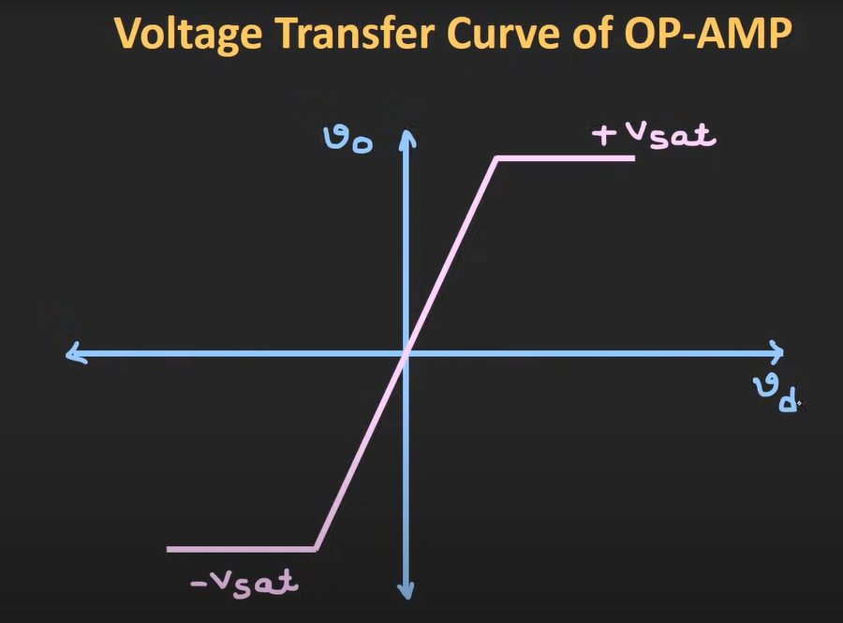  - $V_{o}$ is output voltage  - $V_{d}$ is differential volt (input)  - $V_{+sat}$ < $V_{+}$ (example: if biasing is ±15 then $V_{+sat} ≈14v$and $V_{-sat}≈-14v)$  - $V_{-sat}$ > $V_{-}$(example: if biasing is ±15 then $V_{+sat} ≈14v$and $V_{-sat}≈-14v)$  - The slope of this graph is Open loop gain  - Here , when the input goes beyond a certain value – output volt is saturated ( at $V_{+sat}$ or $V_{-sat}$ )  - Open loop configuration provides high gain – this config is useful when we are using it as comparator (for low input – output becomes saturated)  - opAmp have large number of applications because of its various characteristics (such as : comparator , active filter , oscillators, waveform converter , ADC , DAC,etc)  Characteristics of OpAmp  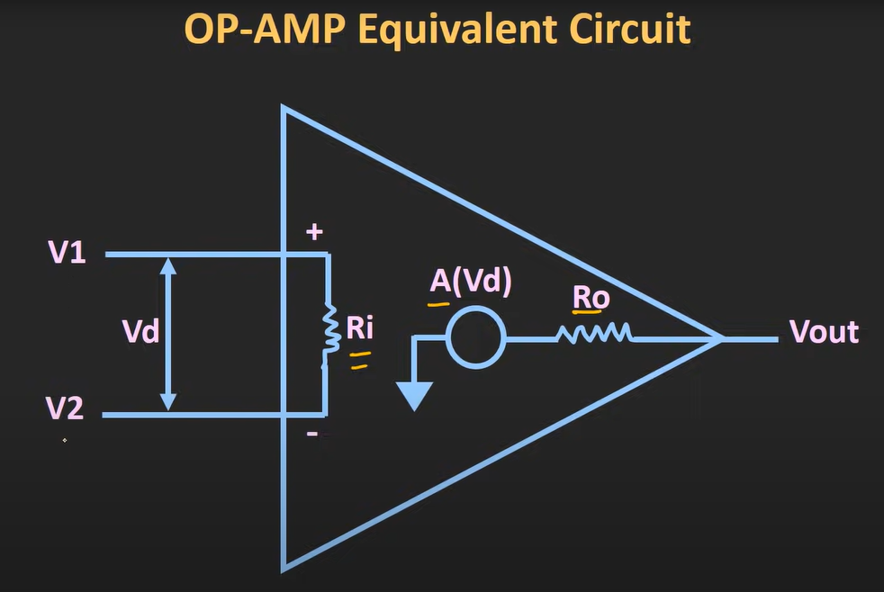  - $V_{d}$ is differential volt (input)  - $R_{i}$ is input impedance  - $R_{o}$ is output impedance  - $AV_{d}$ [ A=open loop gain , $V_{d}$ is the diff voltage]  IDEAL OPAMP CHARACTERISTICS  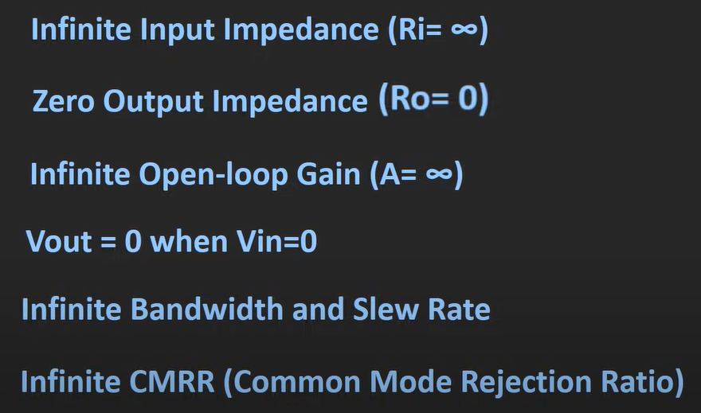  - $R_{i}= ∞$ (Because whatever is applied at the input terminal – gets directly applied to opAmp (meaning $R_{i}= ∞=open ckt$ making entire input is available to opAmp  - $R_{O}= 0=short ckt$ (Because whatever op opAmp generate should be available to Load without any drop)  - Bandwidth = $∞$ (opAmp should amplify all signal freq)  - A = $∞$ (gain of the opAmp )  - When both the inputs are 0 – output should be 0  - Slew rate = $∞$ (Slew rate is the maximum rate of change of the op-amp’s output voltage per unit time.)  - $SL= \frac{dV_{out}}{dt}$ (unit : $V/{μs}$ )  - So ideally – slew rate should be infinite because it is considered that any change in output voltage should happen instantaneously meaning in 0 sec ( anything divided by 0 is infinite)  - CMRR = $∞$ (common mode rejection ratio) [CMRR tells us how well an op-amp can reject common-mode signals (signals that are present at both inputs simultaneously) compared to differential signals (the actual useful input).  - $CMRR= \frac{A_{d}}{A_{cm}}$ = $∞$  - Where:  - $A_{d}$ = Differential gain (gain for (V+) – (V−) )  - $A_{cm}$ = Common-mode gain (gain for signals common to both inputs)  - Here $A_{cm}$ should be 0 (that is gain provided for same signal should be 0 – rejection of common signal should be so accurate that there is no gain of common signal (it should not appear at the output)) [ so anything divided by 0 is infinite]  characteristics Ideal Op-Amp Practical Op-Amp  $$R_{i}$$ $$∞$$ MΩ to G$Ω$  $$R_{O}$$ $$∞$$ Few Ω  $$A_{OL}$$ $$∞$$ $${10}^{5} to {10}^{6}$$  Vout when Vin=0 0 Few mV (which is called offset volt)  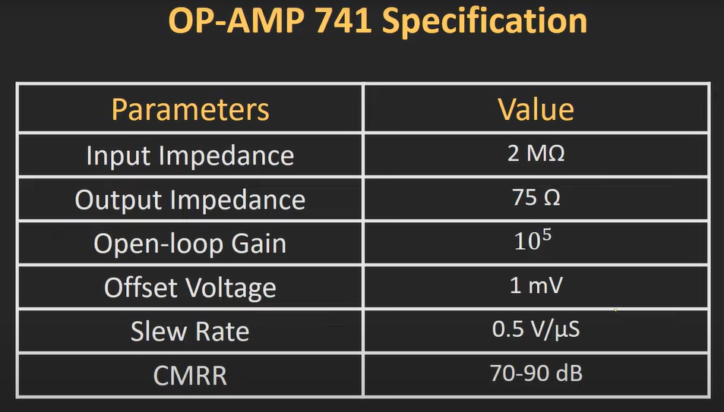  - Different op-Amps are optimised for different stuff (some has high slew rate , some has high gain, low offset volt, etc) (based on the application one should decide the critical para and choose the op-Amp IC accordingly)  Differential Amplifier (ref-1)  Definition : A differential amplifier is a circuit that amplifies the difference between two input voltages while rejecting any voltage that is common to both inputs.  Mathematically:  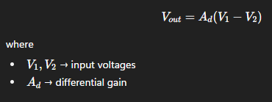  Key Features  - Amplifies only the difference between inputs (helps remove noise that is common to both signals).  - Rejects common-mode signals (like interference or power line hum) → This property is called Common Mode Rejection.  - Measured by CMRR (Common-Mode Rejection Ratio).  - It’s the basic building block of an op-amp itself — inside every op-amp, the input stage is a differential amplifier.  Circuit  A simple version can be built using an op-amp:  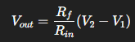  (with proper resistor selection for balance).  Applications  - As the input stage of op-amps.  - Sensor signal conditioning (since sensors often produce small differential signals with common noise).  - Instrumentation amplifiers (precise measurement circuits use a combination of differential amplifiers).  - Audio systems → to eliminate hum/buzz from long cables.  ✨ In short:  A differential amplifier is a circuit that says — “I don’t care about what is common in the two inputs, I only amplify their difference.”
Inverting and Non-inverting Op-Amp and concept of virtual ground + OP-Amp as volt follower/buffer | 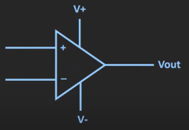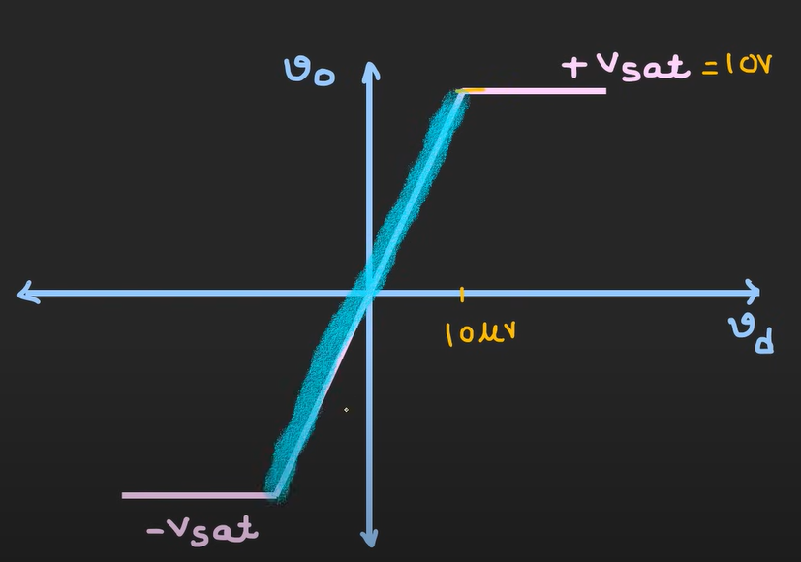  - Example :  - If open loop gain of this op-Amp is ${10}^{6}$  - and saturation volt is ±10v  - Then for mere input of 10uV (the output saturates)  - So, if you want to opAmp setting to work as amplifier one must use it in its linear region (highlighted area)  - But when we are using this op-Amp open loop setting linear range is very small  - So, in order to increase the linear region / operational region of opAmp as amplifier we need to control the gain of the op-Amp  - We can do so by applying the feedback from op to ip side  - There are two ways to provide feedback(fraction of output is provided as feedback) (op to non-inverting terminal) and (op to inverting terminal  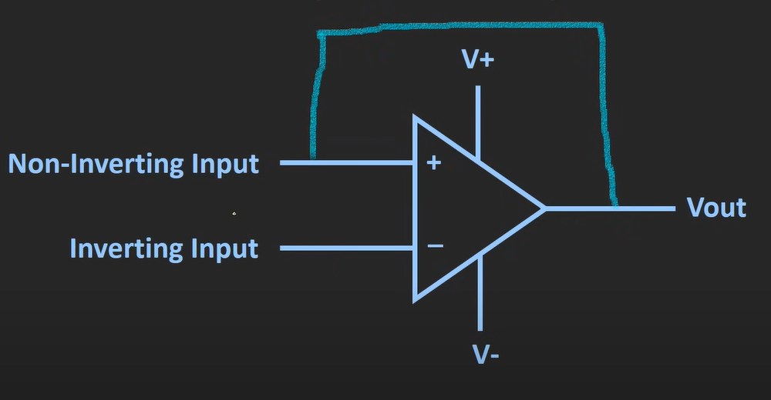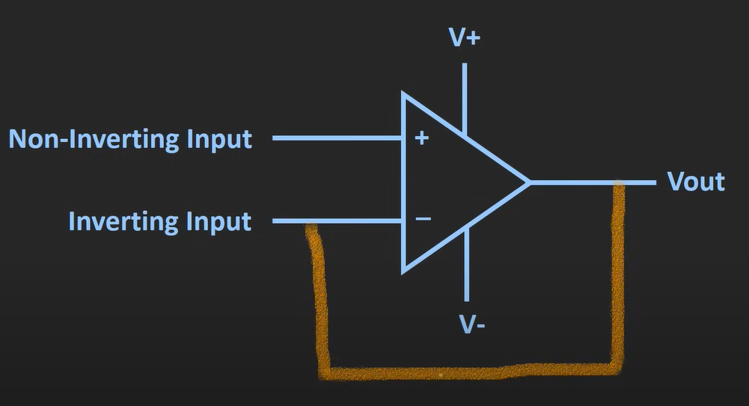  - When feedback is given to non-inverting terminal it is called as ‘positive feedback’ [positive feedback leads the system to instability]  - When feedback is given to inverting terminal, it is called as ‘negative feedback’  • Negative feedback reduces distortion, stabilizes gain, and increases bandwidth & linearity.  • Minor extra: it also increases input impedance and reduces output impedance, which is a nice bonus.  - There are 3 ways to provide input in negative feedback op-Amp setting  - Config 1 : input is provided to inverting terminal (-) and non-inverting terminal(+) is grounded (inverting Amplifier)  - Config 2 : input is provided to non-inverting terminal (+) and inverting terminal(-) is grounded (non-inverting Amplifier)  - Config 3 : input is provided to both inverting terminal (-) and non-inverting terminal(+)  Virtual Ground  - Virtual ground is applicable when we are providing negative feedback to the op-Amp  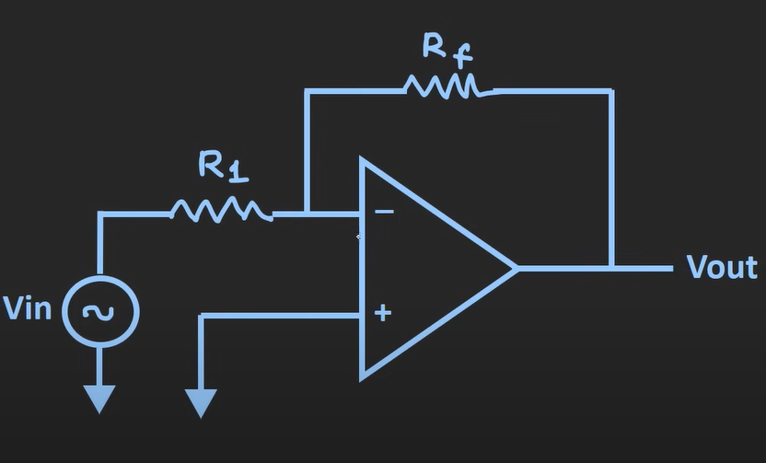  - Example:  - Here -> open loop gain = $A_{OL}= {10}^{6}$  - We know that $V_{out}= A_{OL} ( V_{d} )$ [ note : $V_{d}=V_{1}- V_{2} ]$  - We have to operate op-Amp such that , that it works in linear region or u can say its output is always within saturation voltages  - The saturation volt ($V_{sat})$= 10v  - $V_{out}= A_{OL} ( V_{d} )$  - $10= {10}^{6}$ * $V_{d}$  - $V_{d}=$ 10uV  - $V_{d}=V_{1}- V_{2}$  - Thus , $V_{1}- V_{2}=10uV$  - But this 10uV is small hence we can assume $V_{1}- V_{2} ≈0v$  - Thus , $V_{1}= V_{2}$ or $V_{+}= V_{-}$  - Means inverting and non-inverting terminal are at the same potential or you can say the inverting and non-inverting terminal are virtually short  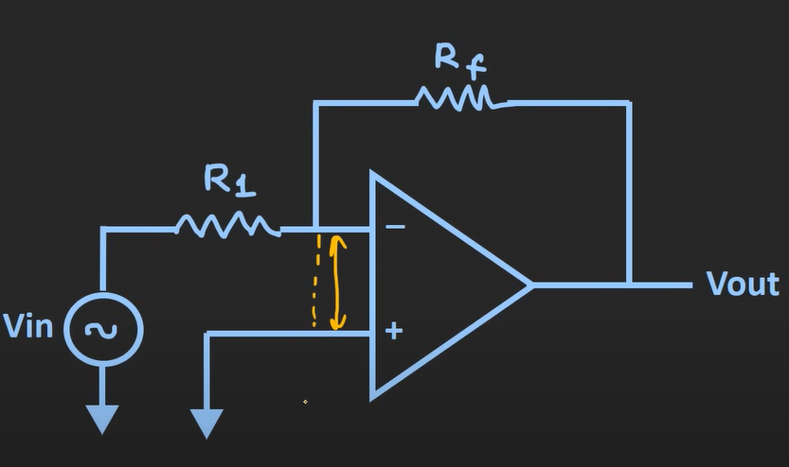  - Here + terminal is grounded (- terminal is not grounded – still they will appear as grounded – meaning they are said to be virtually grounded)  - $V_{+}= V_{-} =0v$  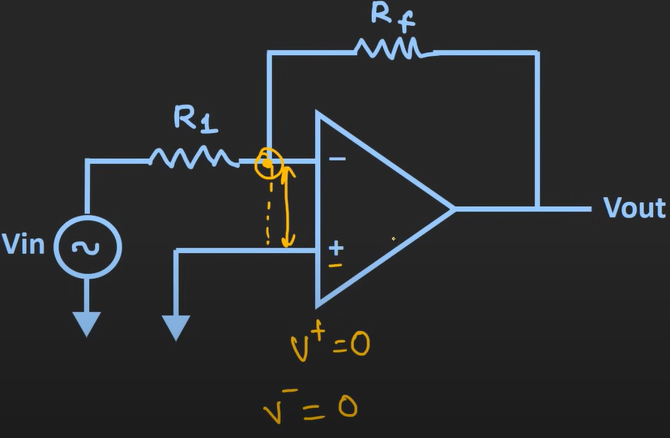  - Here the feedback will ensure that difference between highlighted point and + terminal difference is negligible / very small / zero  - So, the feedback ensures both the terminal are at same potential or have negligible difference  - The concept of considering both the input at same potential is considered as virtual gnd  Config 1: [ inverting Op-Amp config ] input is provided to inverting terminal (-) and non-inverting terminal(+) is grounded  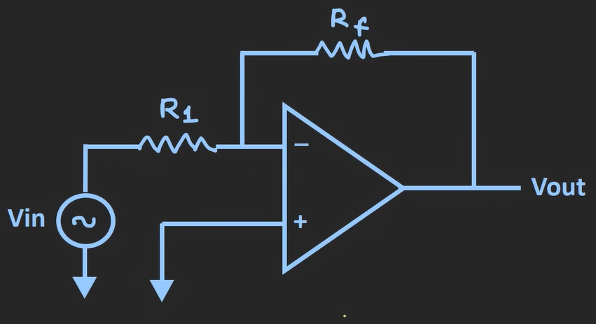  - Relation between input and output  - Let’s identify currents in the loop  - $I_{1}$ = current from $V_{in}$to X  - $I_{x}$ = current from $X$to OpAmp inverting terminal  - $I_{f}$ = current from $X$to $V_{out}$  - Applying KCL  - $I_{1}$ = $I_{x}+ I_{f}$  - $I_{x}=0$(for ideal OpAmp input resistance is considered infinite (open ckt) )  - Thus , $I_{1}$ = $I_{f}$  - $I_{1}$ = $I_{f}$ $\frac{V_{in}- V_{x}}{R_{1}}$ = $\frac{V_{x} - V_{out}}{R_{f}}$  - Here , $V_{x}=0$ (due to virtual gnd concept)  - $\frac{ V_{out}}{V_{in}}= A_{CL}= - \frac{R_{f}}{R_{1}}$ (This is closed loop gain)  - $A_{CL}= - \frac{R_{f}}{R_{1}}$ (close loop gain for inverting amplifier) [ -ve sign indicates 180 degrees out of phase from input ]  Config 2: [ NON-inverting Op-Amp config ] input is provided to non-inverting terminal (+) and inverting terminal(-) is grounded  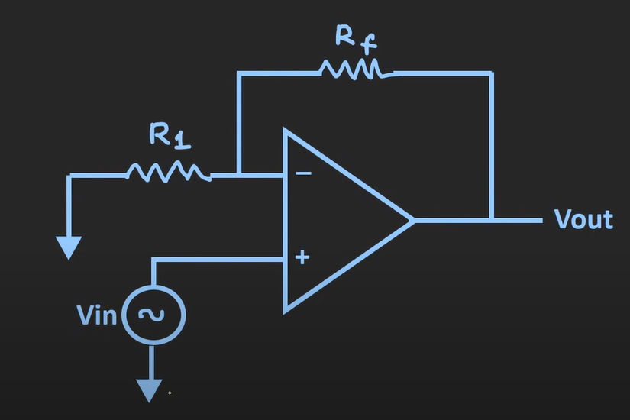  Redrawing the above ckt  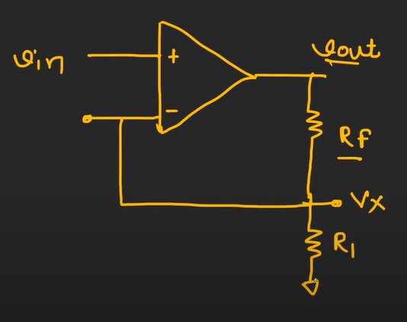  - Close loop gain of non-inverting amplifier= $A_{CL}= \frac{ V_{out}}{V_{in}} =\left(1+ \frac{R_{f}}{R_{1}} \right)$ (output and input will have same phase)  - Example :  - If I provide Vin = 1v DC and $A_{CL}=3$output will be 3v dc  - If I provide Vin = 1v AC sine wave and $A_{CL}=3$output will be of 3v amplitude sine wave  We can control gain in both Inverting Amplifier and non-Inverting amplifier (hence what are the advantages of non-inverting over inverting opAmp)  Non-inverting OpAmp Inverting OpAmp  Output in phase with input Output 180 ֯ degree out of phase with input  $Z_{in}=input impedance ≅∞$ (doesn’t load Prev stage) $Z_{in}=input impedance= R_{1}$(if R1 is high = input impedance is high and if R1 is low = input impedance is low) (might load Prev stage depending on the R1)  Op-Amp as buffer / Op-Amp as voltage follower (special case of non-inverting amplifier)    This is a ckt of non-inverting opAmp (if we consider $R_{f}$ = 0 ohm and $R_{1}= ∞$ ohm) – this acts as buffer/voltage follower (the ckt would look like this)  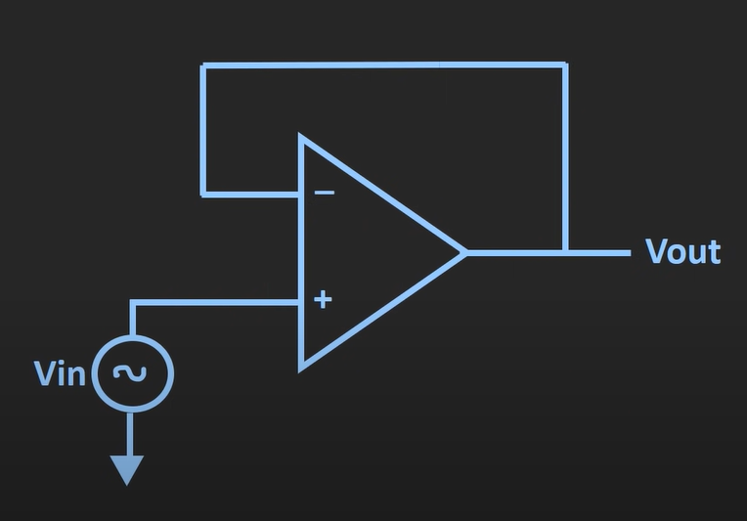  - Gain of a buffer/voltage follower is 1  - Non-inverting amplifier close loop gain is $A_{CL}= \left(1+ \frac{R_{f}}{R_{1}} \right)$  - $R_{f}$ = 0 , $R_{1}= ∞$  - Updating the equation of $A_{CL}$, we get $A_{CL}=1$ (close loop gain of buffer/voltage follower)  - other way of proving it  - voltage appearing at non-inverting terminal is Vout  - due to virtual short concept voltage at both the inverting and non-inverting end is same  - thus , Vin = Vout ( note $Z_{in}= ∞$ (input impedance of this ckt is $∞$)  - this ckt is used as buffer/isolator ckt (as it provides high input impedance and low op impedance)  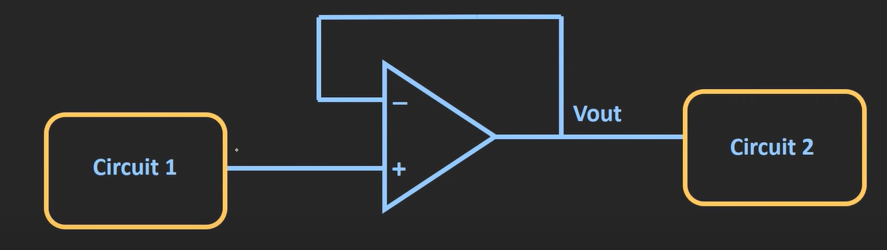  Config 3: [Differential Op-Amp config ] input is provided between non-inverting terminal (+) and inverting terminal(-)
Inverting Summing Amplifier | A summing amplifier basically adds up all the input voltages (with some scaling factor decided by resistors).  - If it’s the inverting summing amplifier → output is the negative (inverted) sum.  - If it’s the non-inverting summing amplifier → output is the positive (non-inverted) sum.  👉 So yes — it’s just an adder circuit using an op-amp.  Inverting Amplifier as summing Amplifier/adder  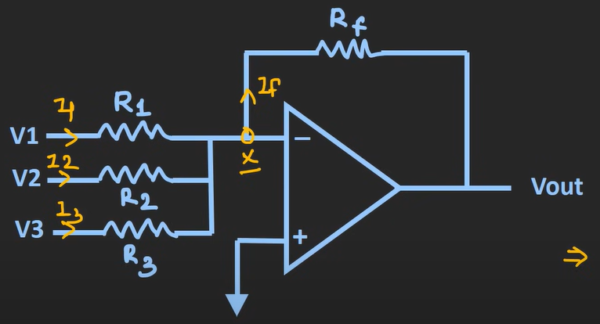  - Applying KCL $I_{1}+ I_{2}+ I_{3}= I_{f}$  - $\frac{V_{1}-0}{R_{1}}+ \frac{V_{2}-0}{R_{2}}+ \frac{V_{3}-0}{R_{3}}= \frac{0-V_{out}}{R_{f}}$ ( Here $V_{x}=0$ (due to virtual short/gnd concept))  - $V_{out}= -[ \frac{R_{f}}{R_{1}} V_{1} + \frac{R_{f}}{R_{2}} V_{2}+ \frac{R_{f}}{R_{3}} V_{3} ]$ (-ve sign indicates 180 ֯ phase shift)  Case 1: If $R_{1}= R_{2}= R_{3 }=R$ then $V_{out}= - \frac{R_{f}}{R} [ V_{1} + V_{2}+ V_{3} ]$  Case 2: If $R_{f}= R$ and $R_{1}= R_{2}= R_{3 }=R$ then $V_{out}= -[V_{1} + V_{2}+ V_{3}]$ (this is the case we achieve for this inverting amplifier to work as summing Amplifier/adder)  Inverting Amplifier as Scaler    - Read “Inverting Amplifier as summing Amplifier/adder” first  Case 3: If $R_{1}≠ R_{2}≠ R_{3 }$and $\frac{R_{f}}{R_{1}}=A$ , $\frac{R_{f}}{R_{2}}=B$ , $\frac{R_{f}}{R_{3}}=C$ then $V_{out}= -[{AV}_{1} + {BV}_{2}+ {CV}_{3}]$ (the input is scaled using this)  Inverting Amplifier as Average    Case 4: If $R_{1}= R_{2}= R_{3 }=R$ and the value of R = total number of inputs (in our case it is 3) and $R_{f}=1$  - Or the ratio $\frac{R_{f}}{R}=\frac{1}{number of inputs}$ (in our case 1/3)  - Then $V_{out}= - \frac{R_{f}}{R} [ V_{1} + V_{2}+ V_{3} ]$ $= - \frac{1}{3}[ V_{1} + V_{2}+ V_{3} ]$  - In general, for n number of inputs $V_{out}= - \frac{1}{n}\left[ V_{1} + V_{2}+ V_{3}+…+ V_{n}\right]$ (this is average of all input available as output)  Notes :  -Summing amplifier cannot have N number of input (it should take care of power dissipation as well as the total current that can be supplied by the opAmp (here $I_{1}+ I_{2}+ I_{3 }+…+ I_{n }= I_{f}$ (the Value of $I_{f}$ shall not exceed limits described by op-Amp)  - all voltage sources are isolated from each other (so if we consider V1 (the impedance seen by it is R1 only not the other)  - the output of summing amplifier or any inverting amplifier is 180 degrees out of phase (or say -ve) so to bring it back to original state we use another inverting amplifier with unity gain ( Vout = - Rf/R1 (Vin)) – here keeping Rf=R1 we can achieve unity gain  Summing Amplifier Use :  - As adder , average , scaler : Inverting Summing Amplifier can be used for summing , scaling and averaging  - As Audio signal mixer : adds two AC volt  - As DC offset provider : Also, it can be used to provide DC offset to the input signals (example : provide DC component)  - 👉 Problem: Many signals (like audio, sensor output, AC waveforms) are centered around 0V. But some circuits (like ADCs or amplifiers running on single supply 0–5V) cannot handle negative voltages.  👉 Solution: Add a DC bias (offset) so the whole waveform is shifted up.  - How it works  - One input of summing amplifier = AC signal (e.g., audio).  - Another input = constant DC voltage (from a reference source).  - The summing amplifier adds them together.  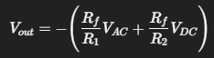  - Result: An AC signal riding on a DC level (shifted waveform).  - Example :  - Audio signal ±1V (centered at 0V).  - Add +2.5V DC.  - Output becomes a waveform centered at +2.5V, so it’s always positive and safe for a 0–5V ADC.  - As DAC : Digital inputs (binary bits) can be turned into analog voltage using weighted summing.  - How it works  - Each digital bit (D0, D1, D2, …) controls a switch that applies either Vref​ (logic 1) or 0 (logic 0).  - Each bit is connected to the op-amp summing amplifier through a resistor chosen to give the correct binary weight.  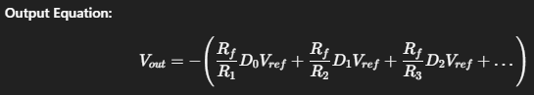  - If R1=R , R2=2R , R3=4R, etc → each input contributes a binary weight (1, 1/2, 1/4, …).  - This is basically a weighted-resistor DAC.  - Example : For 3-bit input (D2 D1 D0):  - Input = 101 (binary 5).  - Output voltage = proportional to (1∗Vref + 0∗Vref/2 + 1∗Vref/4)  - = 1.25Vref​ (scaled and inverted).
NON- Inverting Summing Amplifier | Read Inverting Summing amplifier first (prev section)  [Non-inverting summing amplifier is not that useful]  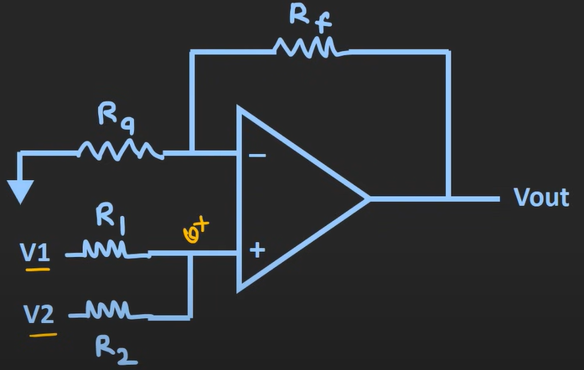  As per non-inverting amplifier $V_{out} =\left(1+ \frac{R_{f}}{R_{a}} \right) V^{+}$  - Now let’s identify $V^{+}$ using superposition theorem  - Consider only one source (here considering V1 as source and V2 as gnd) (if more than 2 inputs are there- consider 1 as source and consider remaining connected to gnd (meaning parallel to each other))  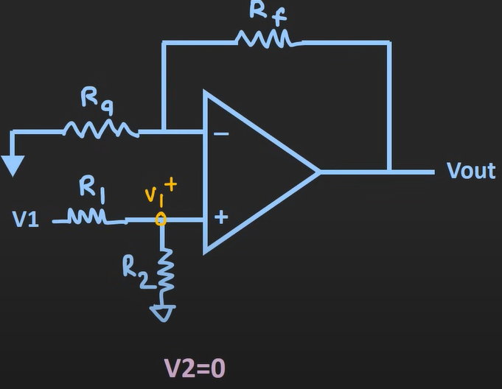  - ${V_{1}}^{+}= \frac{R_{2}}{R_{1}+ R_{2}} V_{1}$ (using volt divider)  - Now consider other source (here considering V2 as source and V1 as gnd)  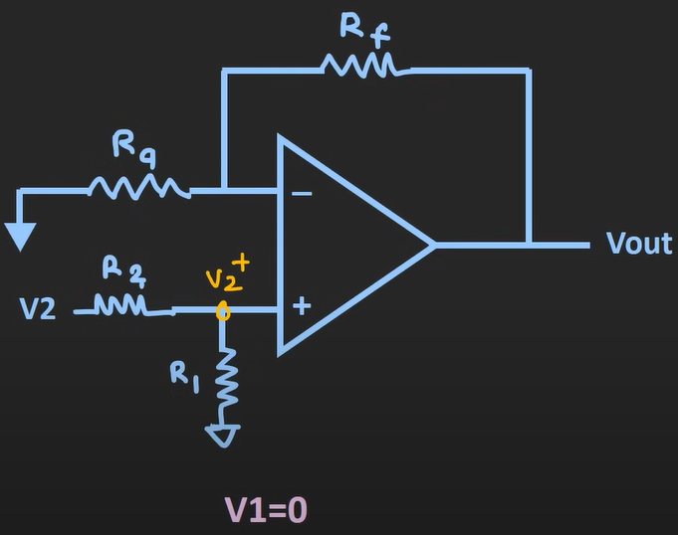  - ${V_{2}}^{+}= \frac{R_{1}}{R_{1}+ R_{2}} V_{2}$ (using volt divider)  - $V^{+}= {V_{1}}^{+}+ {V_{2}}^{+}$  - $V_{out} =\left(1+ \frac{R_{f}}{R_{a}} \right) V^{+}=\left(1+ \frac{R_{f}}{R_{a}} \right)[ \frac{R_{2}}{R_{1}+ R_{2}} V_{1}+ \frac{R_{1}}{R_{1}+ R_{2}} V_{2} ]$  Case 1: R1 = R2 = R  $$V_{out}= \left(1+ \frac{R_{f}}{R_{a}} \right) ( \frac{V_{1}+V_{2} }{2} )$$  Case 2: R1 = R2 = R and Rf = Ra  $$V_{out}= V_{1}+ V_{2}$$  Note : other voltage source’s series resistance plays a crucial part in the calculation of effective voltages while we are considering superposition theorem – hence they are not isolated) – basically all voltages play a crucial role for the effective volt that appears at the input (thus they are not isolated)  Inverting summing Amplifiers are more preferred over it due to non- inverting summing amplifiers being more complex
Op-Amp as differential amplifier or subtractor | 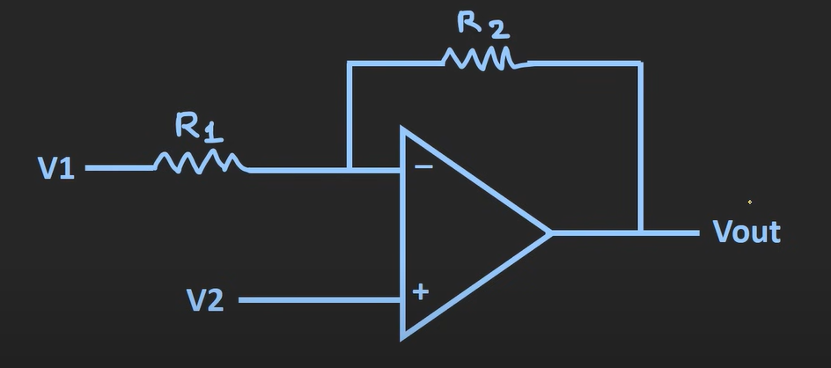  Now applying superposition theorem and considering V1=0 and V2=0 sequentially  - When V2 =0 (it is basically inverting amplifier) $V_{o1} =\left(- \frac{R_{2}}{R_{1}} \right) V_{1}$  - When V1=0 (it is basically non-inverting amplifier) $V_{o2} =\left(1+ \frac{R_{2}}{R_{1}} \right) V_{2}$  - So, when both are present $V_{out}= V_{o1}+ V_{o2}$  - $V_{out}= V_{o1}+ V_{o2} = \left(- \frac{R_{2}}{R_{1}} \right) V_{1} + \left(1+ \frac{R_{2}}{R_{1}} \right) V_{2}$  - Here , to achieve something like this $V_{out}=k*(V_{2}- V_{1})$  - We need to make something common between $V_{o1} \& V_{o2}$ lets consider we want common factor to be $\frac{R_{2}}{R_{1}}$  - To make 2nd term $\left(1+ \frac{R_{2}}{R_{1}} \right)=\left( \frac{R_{1}+ R_{2}}{R_{1}} \right)to \frac{R_{2}}{R_{1}}$ what we need to do – we need to multiply $\left( \frac{R_{1}+ R_{2}}{R_{1}} \right)$ with $\left( \frac{ R_{2}}{R_{1}+ R_{2}} \right)$  - How can we achieve that  - By making config like this at input  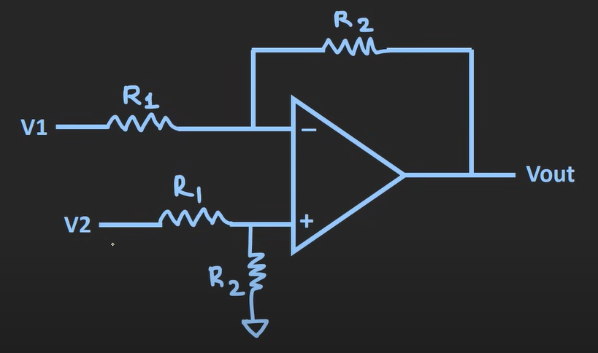  - Now the effective volt at non-inverting terminal is (using volt divider) $V_{2eff}= \left( \frac{ R_{2}}{R_{1}+ R_{2}} \right)V_{2}$  - So now $V_{out}= V_{o1}+ V_{o2} = \left(- \frac{R_{2}}{R_{1}} \right) V_{1} + \left(1+ \frac{R_{2}}{R_{1}} \right) V_{2} = \left(- \frac{R_{2}}{R_{1}} \right) V_{1} + \left(1+ \frac{R_{2}}{R_{1}} \right) \left( \frac{ R_{2}}{R_{1}+ R_{2}} \right)$ $V_{2}$  - Gives us $V_{out}= \left(- \frac{R_{2}}{R_{1}} \right) V_{1}+\left( \frac{R_{2}}{R_{1}} \right)V_{2}$  - Considering $\left( \frac{R_{2}}{R_{1}} \right)=k$  - Then $V_{out}= {k*(V}_{2}- V_{1})$  - Thus, using this config we can use op-Amp as differential amplifier (or subtractor)  Use case of differential amplifier  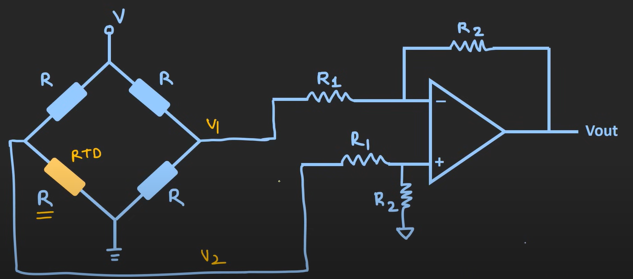  - Consider a RTD is connected to diff. amplifier  - When the RTD is at 0 temp (this bridge is balanced) but when the temp changes (the value of highlighted R changes)  - Making $V_{1} \& V_{2}$ different (thus at op – we get amplified version of volt difference at output) – which then can be feed to any circuitry to control the temp of room or as per our need(any measuring device, etc)  - But major factor here is the input impedance (here input impedance of diff amplifier is $Z_{in}=2 R_{1}$ (which is low and will load the prev circuit) hence to avoid it (buffer/volt follower ckt is used at both the end)  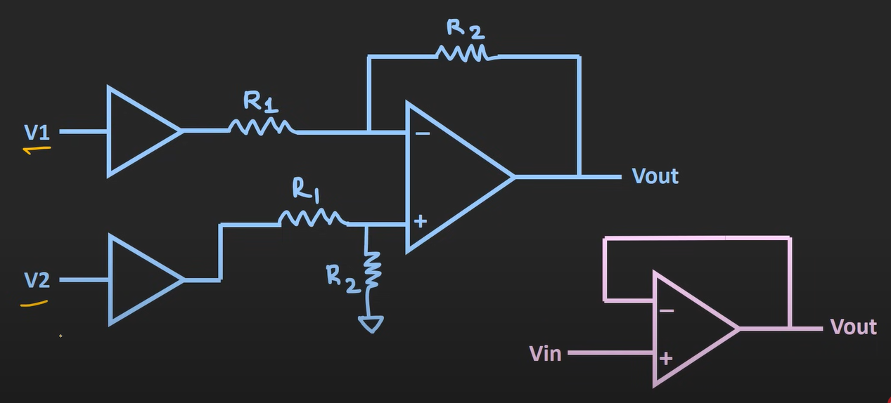  - This will do the impedance matching thing as buffer has high input impedance and low op impedance  - But practically instrument amplifier(basically it is a high gain , high input impedance diff amplifier) is used when dealing with sensor and all (but this can also be used)  Example 1 : find the op volt  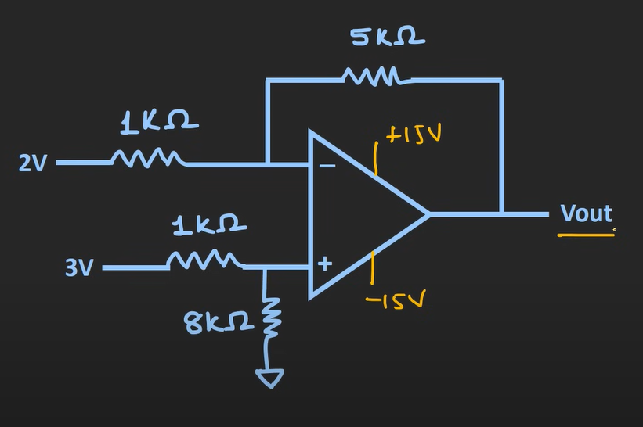  - Here let’s calculate using superposition theorem  - Consider v1 only and v2=0v  - $V_{o1} =\left(- \frac{R_{2}}{R_{1}} \right) V_{1}$ = - 5 * 2v = -10v  - Consider v1=0v only and v2  - using volt divider : V2eff = $\frac{8}{8+1} V_{2}$ = $\frac{8}{9} V_{2}$  - Now $V_{o2}= \left(1+ \frac{R_{2}}{R_{1}} \right) V_{2eff}=\left(1+\frac{5}{1}\right)*\left(\frac{8}{9} V_{2}\right) =6*3* \frac{8}{9} =16v$  - Vout = $V_{o1}+ V_{o2}= -10+16=6v$  - Vout = 6v  [ Note : here, if the output was beyond the biasing volt (i.e. $±$15v – then the output would have saturated at biasing volt]  Example 2 : find the op volt  [ Note : here u can use case 2(of non-inverting summing amplifier) for considering eff volt at non-inverting terminal and case 2(of inverting summing amplifier) for inverting terminal – this would have been easier method – but as u know I choose the path less travelled] [ to find V1out and v2out]  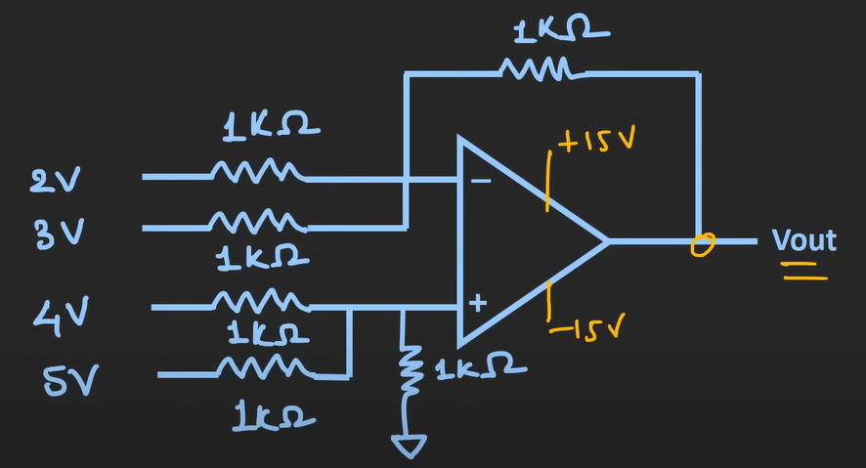  - let’s apply superposition theorem (first consider non-inverted terminal as 0v and then consider inverted terminal as 0v)  - considering non-inverting terminal to be at gnd(0v)  - using the explanation of inverting summing amplifier [ here R1 = 1k , R2 = 1k and Rf = 1k – thus case 2]  - Vout1 = -[V1 + V2] = -5v  - Considering inverting terminal to be at gnd(0v)  - Considering the explanation of non-inverting summing amplifier  - Let’s calculate eff volt at non-inverting terminal (using superposition theorem)  - Consider V1(4v) and other 2 as gnd (and in parallel)  - Using volt divider : V1eff = $\frac{R_{2}}{R_{1}+ R_{2}} V_{1}= \frac{1/2}{1 + 1/2 } 4v = \frac{1}{3}$ *4v  - Consider V2(5v) and other 2 as gnd (and in parallel)  - Using volt divider : V2eff = $\frac{R_{2}}{R_{1}+ R_{2}} V_{2}= \frac{1/2}{1 + 1/2 } 5v = \frac{1}{3}$ *5v  - For 3rd (V3=0) so V3eff = 0v  - Now Veff = V1eff + V2eff + V3eff = $\frac{1}{3}$ *4v + $\frac{1}{3}$ *5v + 0v = 3v  - Vout2 = $\left(1+ \frac{R_{f}}{R_{a}} \right)$ Veff = ( 1 + $\frac{1}{1/2}$ ) * 3 = 9v  - Vout = Vout1 + Vout2 = -5 + 9 = 4v
Op-Amp as Integrator | An integrator is a circuit that gives an output proportional to the time integral of the input signal.  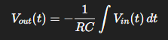  Practical Roles  - Signal Processing  - Converts a square wave input into a triangular wave output.  - Smooths signals (like an averaging effect).  - Analog Computers / Control Systems  - Used in solving differential equations (like position from velocity, velocity from acceleration).  - Waveform Generation  - Key block in triangle wave & ramp wave generators.  - Filters  - Acts like a low-pass filter, suppressing high-frequency noise.  In short:  The integrator’s role is to accumulate input over time, turning sharp/fast changes into smoother outputs.  Ckt of integrator  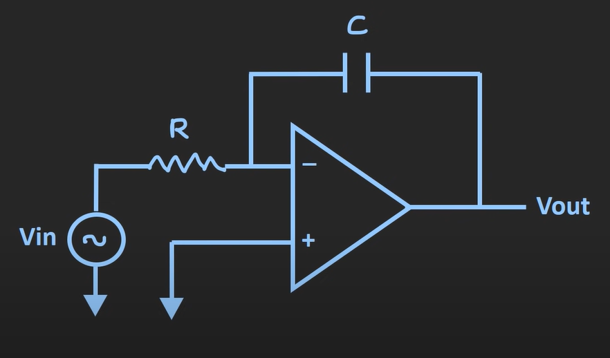  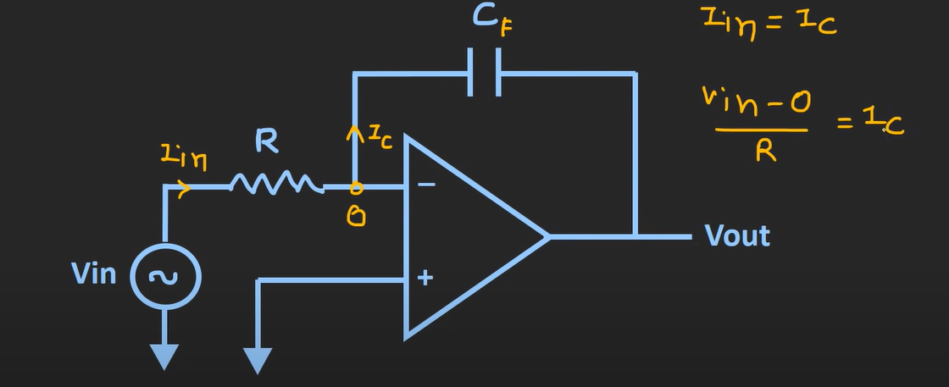  - Here applying KCL (considering virtual ground due to non-inverting terminal being gnd)  - $I_{in}= I_{C}$  - $\frac{V_{in}-0}{R}=I_{C}$  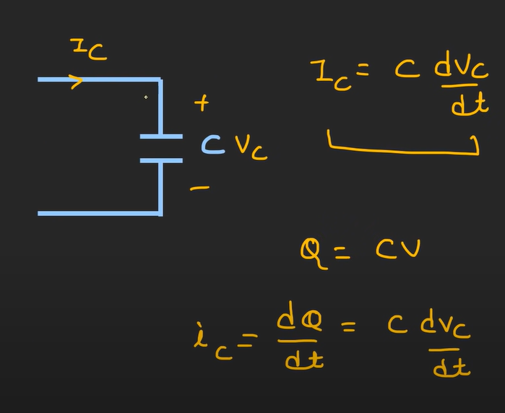  - Here , Q = CV taking derivation : rate of change of charge = current = $I_{C}= \frac{dQ}{dt}=C\frac{dV_{c}}{dt}$ [ $V_{c}$ = voltage across capacitor] [ considering capacitance is not changing ]  - $\frac{V_{in}-0}{R}= C\frac{dV_{c}}{dt}$  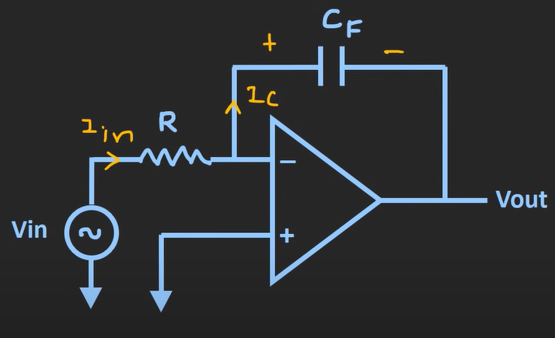  - $\frac{V_{in}}{R}= C_{F}\frac{dV_{c}}{dt}$  - $\frac{V_{in}}{R}= C_{F}\frac{d [ 0- V_{out}]}{dt}$  - $\frac{dV_{out}}{dt}= - \frac{1}{RC_{F}} V_{in}(t)$  - If we apply integration at both the sides , we would get  - $V_{out}(t)$ = $- \frac{1}{RC_{F}}\int{V_{in}\left(t\right) dt}$ (can be considered as Vout accumulated over time) (considering initial Vout is 0v)  - If initial Vout is not 0v then $V_{out}(t)$ = $- \frac{1}{RC_{F}}\int{V_{in}\left(t\right) dt}+ V_{out}\left(0^{+}\right)$ ($V_{out}\left(0^{+}\right)=$output component before we start the integration)  - This shows output voltage is the integration of input voltage (using this integrator we can integrate any input signal)  - $RC_{F}$ represents the integration time of integrator  Example of signals :  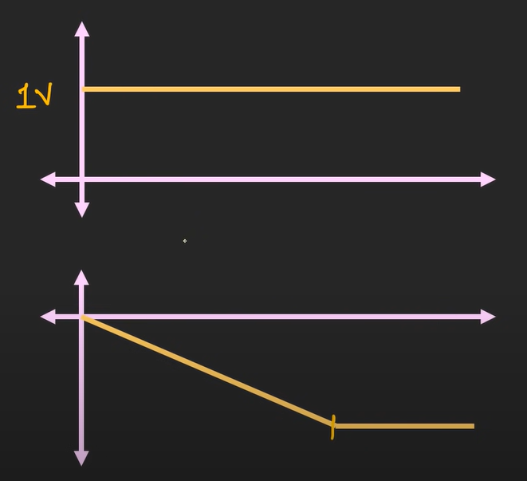  - Here DC signal turns into signal shown in above image  - It increases in negative side and reaches the saturation volt  - The rate at which the op reaches the saturation point depends upon the value of R and $C_{F}$ (by changing the value of these two parameters we can change the slope of the signal)  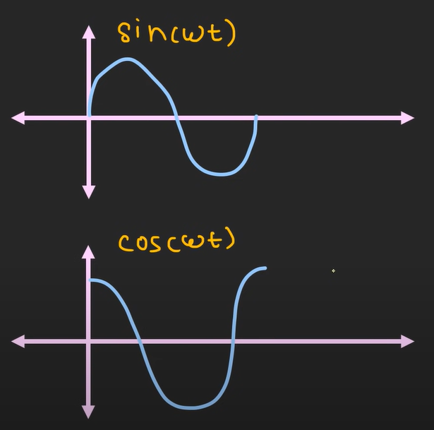  - If we provide sin($ω$t) output will be cos($ω$t)  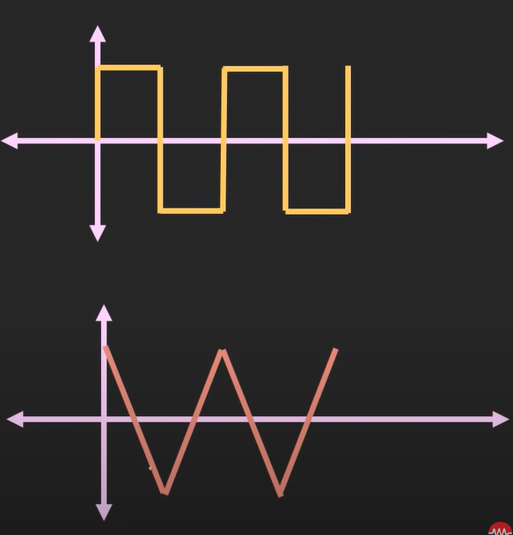  - If we provide square wave as input, we will get triangular wave in op  [Note : amplitude of the output signal will depend upon R and $C_{F}$ ]  Limitation of simple integrator ckt and how we can overcome them  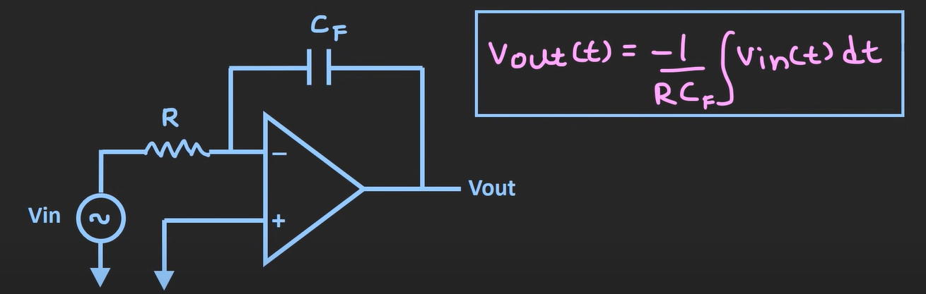  - In real life if you use this integrator, we may not get expected results due to some limitations (compared to the theoretical results)  - Output volt in terms of resistance (R) and reactance ($X_{C}$) (saturation and distortion due to freq and input offset volt)  - $X_{C}= \frac{1}{2πfC}$  - $V_{out}= - \frac{X_{C}}{R} V_{in}$  - $A_{v}=close loop gain= \frac{1}{2πfCR}$  - For low freq – gain of the op-Amp will be very high (for example DC signal (freq=0) – gain will be infinite – theoratically but practically it will be limited by open loop gain of op-Amp (${10}^{5} to {10}^{6})$  - Understanding it : for dc signal or low freq signal capacitor will act like open ckt – (and the op-Amp configuration will be of no feedback – thus making this close loop configuration as open loop when freq is 0 or very low)  - Thus, making output saturated  - As the freq increases – reactance reduces – making output amplification to reduce  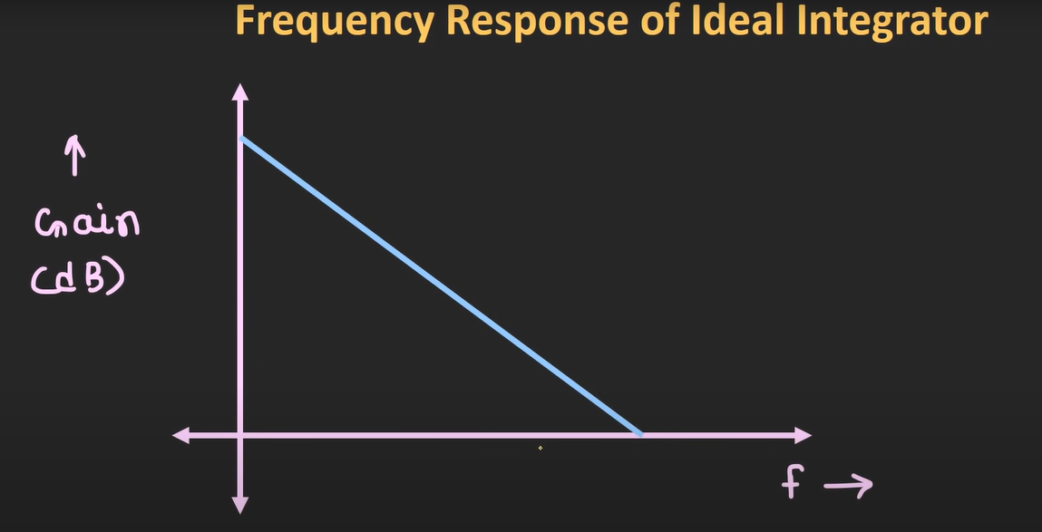  - Freq response of ideal integrator  - Here we can see when the input freq is 0Hz (the gain will be open loop gain = ${10}^{5} to {10}^{6}=100 dB$  - As the freq increases the gain reduces  - Note : even if we use mid-range freq , it is quite possible that the output we get will be distorted or saturated (because of the offset-volt of op-Amp)  - Example : if the input offset voltage is in mV (it will eventually get integrated by the ckt) making output saturate  - We can avoid this problem by introducing feedback resistor in parallel with the capacitor  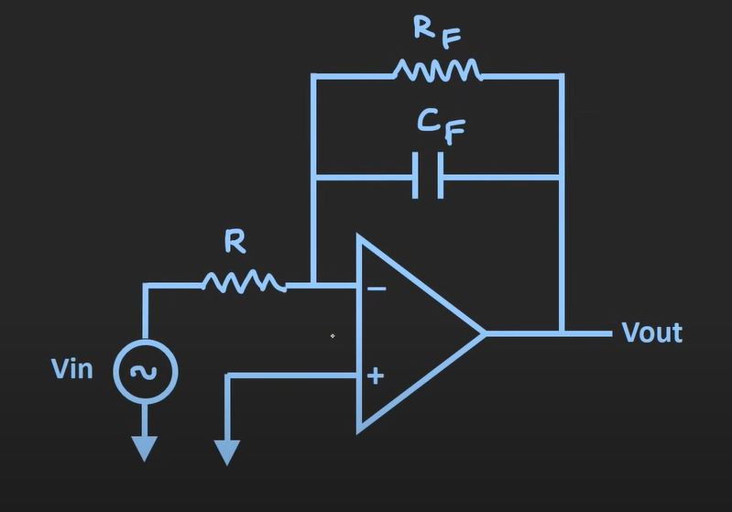  - At low freq (capacitor will act as open ckt – but resistor will act as feedback and make the ckt inverting amplifier – thus making gain = $A_{CL}= - \frac{R_{f}}{R_{1}}$ (saving output signal being saturated) (so input offset voltage present at input terminals will get multiplied by this gain) (this way we can avoid saturation issue of output volt)  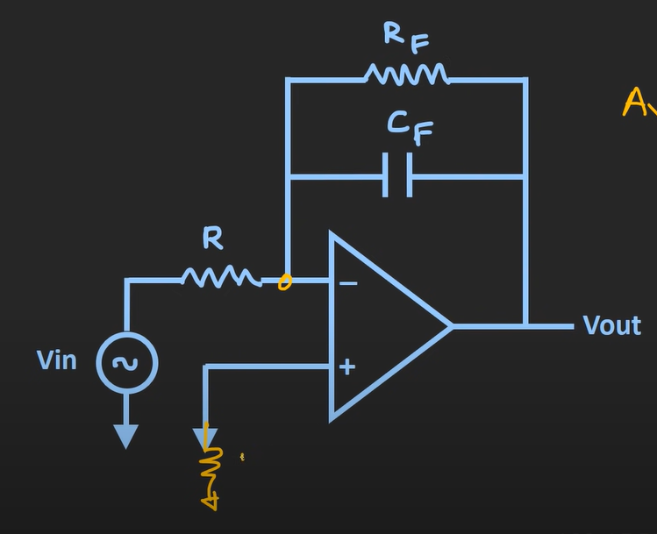  - Resistor at non-inverting end is also used to avoid the effect of bias current  - So now due to addition of this parallel feedback resistor , freq response of this integrator ckt changes (highlighted with yellow – blue one is the old response before parallel feedback resistor))  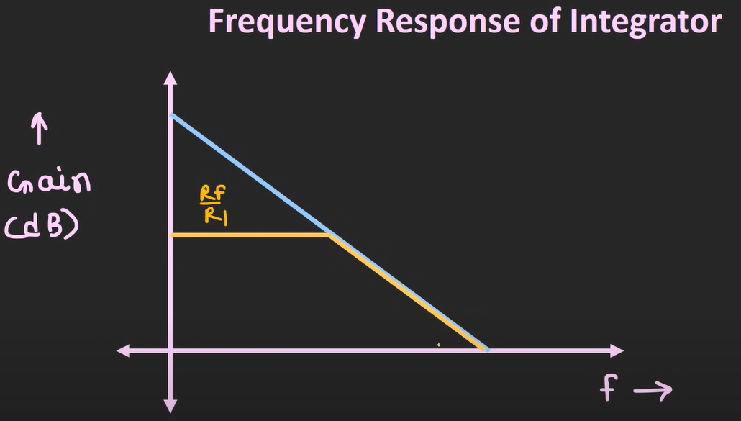  - till some low freq – the gain is const ( $- \frac{R_{f}}{R_{1}}$ ) and if we go beyond this freq – we will see reduction in the gain  - response of this integrator is similar to a low pass filter  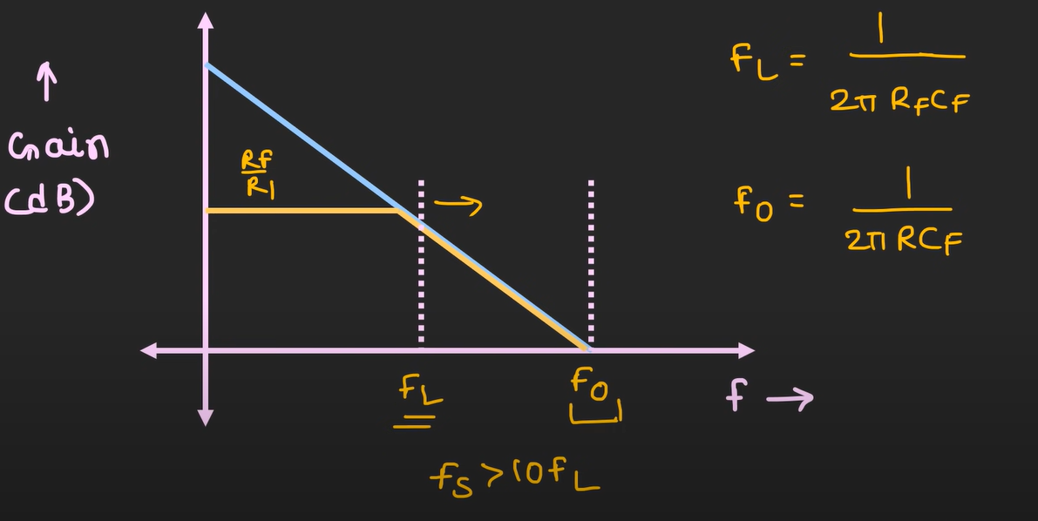  - $F_{L}= \frac{1}{2π R_{F} C_{F}}$ (Cutoff freq – above this freq this ckt acts as an integrator till $F_{0} )$ (this is 3dB freq) (gain is const in this -$\frac{R_{f}}{R_{1}}$ )  - $F_{0}= \frac{1}{2π R C_{F}}$ (zero dB freq- beyond this point integrator works but distorts/attenuates the signal)  - For the freq till $F_{L}$ – this ckt will act as a Low pass filter or as an inverting amplifier  - For proper operation of this ckt as integrator $F_{s} (signal freq)>10*F_{L}$  Example: 1  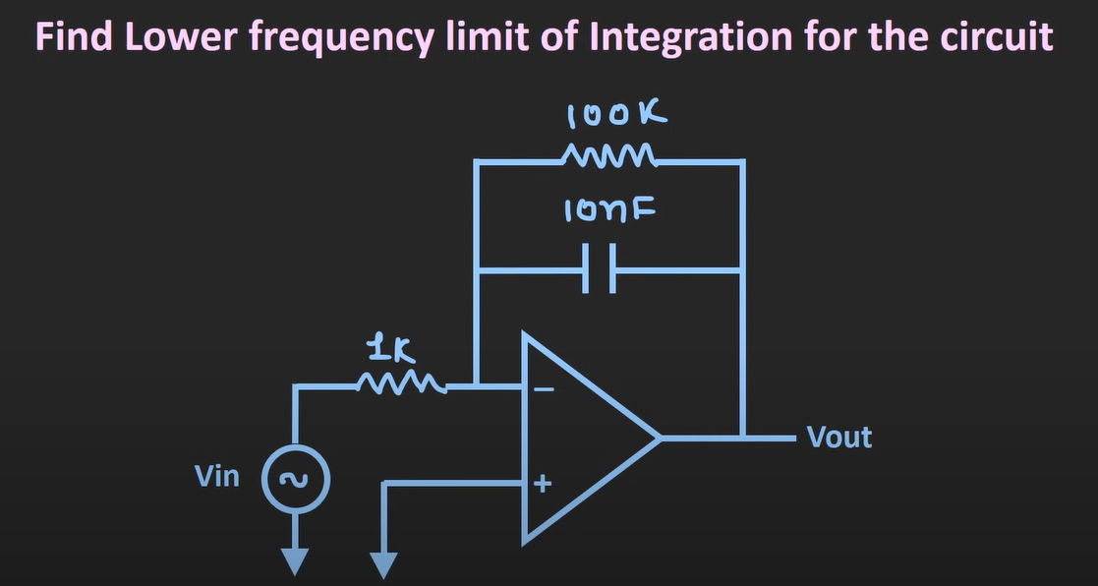  - Lower freq of integrator = cutoff freq = $F_{L}= \frac{1}{2π R_{F} C_{F}}= \frac{1}{2*π*100k*10nF }=159Hz$  - Ideal value of freq where integrator works perfect = 10* $F_{L}$ = 1.59 KHz  Example : 2  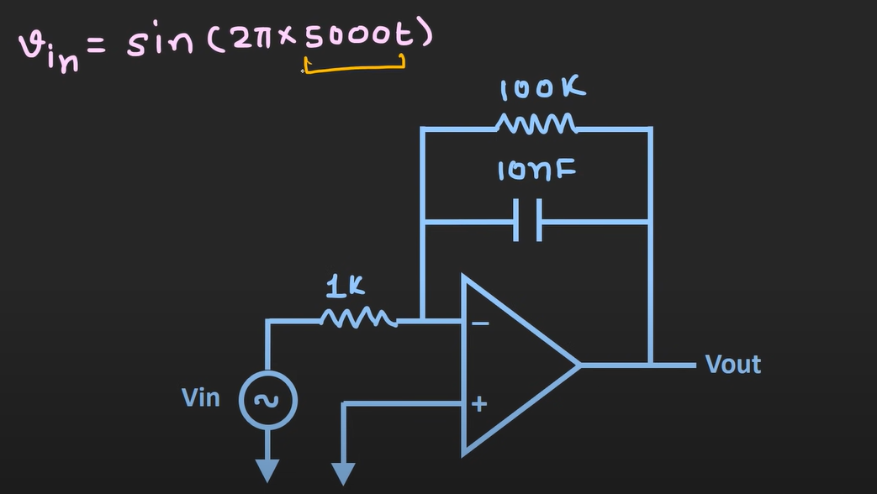  - cutoff freq = $F_{L}=159Hz$  - signal freq for proper integration $F_{s}$= 10* $F_{L}$ = 1.59 KHz  - Here the signal freq is 5KHz (this signal will get properly integrated)  - $V_{out}(t)$ = $- \frac{1}{RC_{F}}\int{V_{in}\left(t\right) dt}$ = $- \frac{1}{1k* 10nF}\int{sin⁡(2π*5000t) dt}$  - $V_{out}\left(t\right)=- \frac{1}{1k* 10nF}\int{\sin\left(2π*5000t\right) dt} = \frac{{10}^{5}}{2π* 5000} \cos\left(2π*5000t\right) =3.18 cos\left(2π*5000t\right)$  Integration formulas  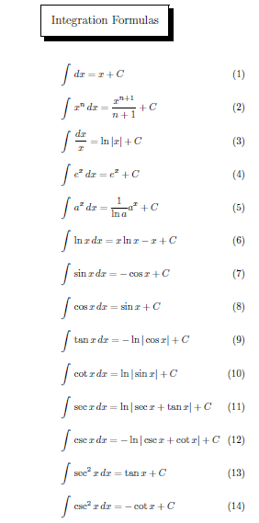  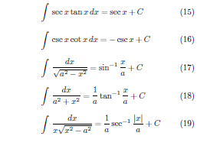  Example : 3 : find output voltage  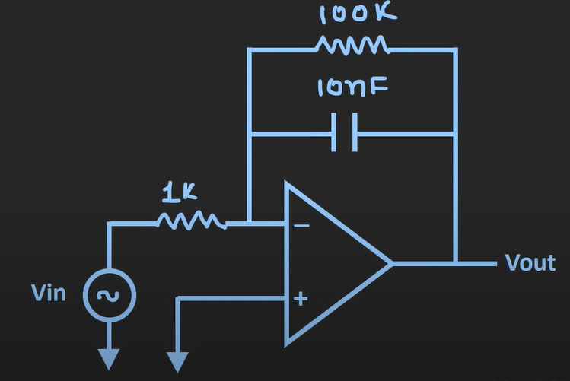  Input signal : square wave  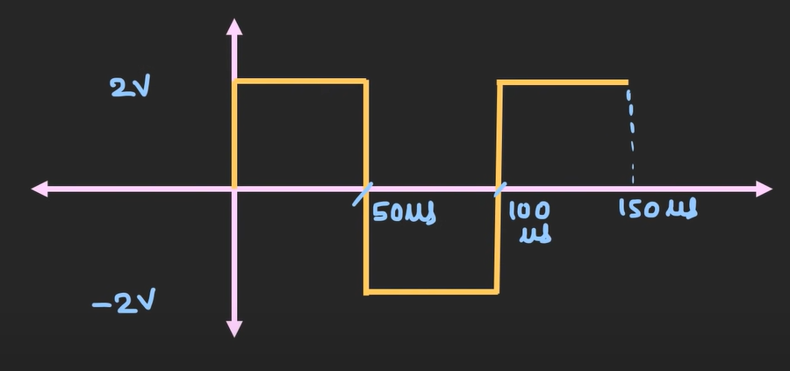  $V_{out}(t)$ = $- \frac{1}{RC_{F}}\int{V_{in}\left(t\right) dt}$  - Here T(time period) = 100us  - Freq = 10kHz  - R = 1k  - $C_{F}$ = 10nF  - From the prev examples $F_{L}=159Hz$ which is smaller than the $F_{s}$(signal freq) (thus integrator will work fine)  - Different input segments  - V1(t) 0 to 50us 2v  - V2(t) 50 to 100us -2v  For the 1st segment : V1(t) 0 to 50us 2v  $V_{out}(t)$ = $- \frac{1}{RC_{F}}\int{V_{in}\left(t\right) dt}$ = - ${10}^{5} \int_{0}^{50}{2 dt}$ = - ${- 10}^{5}*50 * {10}^{-6}*2= -10v$  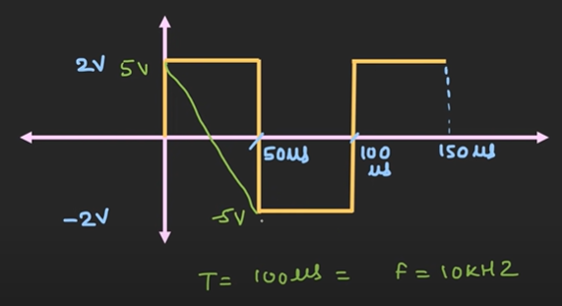  - Output swing is 10v ( from 5v to -5v)  For the 2nd segment : V1(t) 50 to 100us 2v  ${ V}_{out}(t)$ = $- \frac{1}{RC_{F}}\int{V_{in}\left(t\right) dt}$ = - ${10}^{5} \int_{0}^{50}{-2 dt}$ = - ${- 10}^{5}*(100-50)* {10}^{-6} *-2= 10v$  - Output swing is 10v ( from -5v to 5v)  Example 4: find output voltage  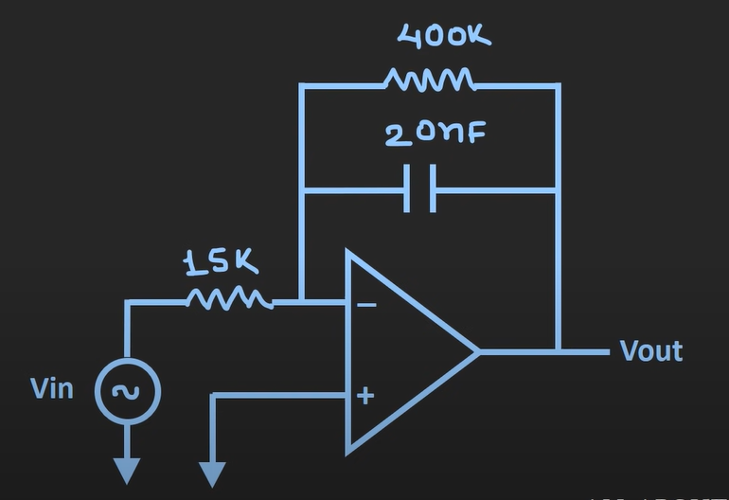  Input signal :  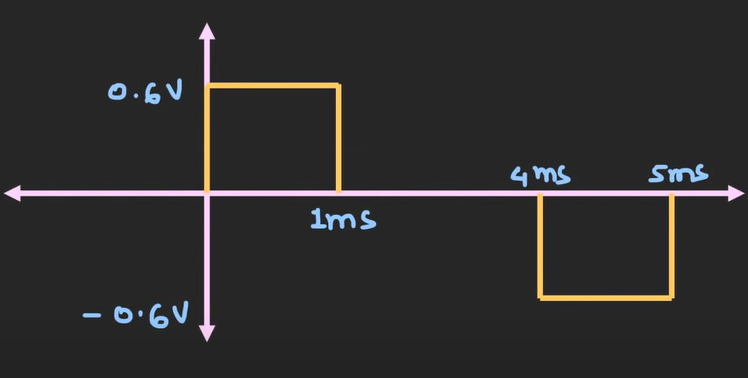  T = 5 ms  F = 200 Hz  R = 15k  Rf = 400k  Cf = 20nF  Check weather it will work as integrator or not  - $F_{L}= \frac{1}{2π R_{F} C_{F}}= \frac{1}{2*π*400k*20nF } ≅20 Hz$  - $F_{o}= \frac{1}{2π R C_{F}}$ = $\frac{1}{2*π*15k*20nF } ≅530 Hz$ (zero dB freq)  - $F=200Hz$ which is in the perfect operating freq for integrator as it is 10x the $F_{L}$  - There will be 3 subsections  - Section 1 : 0 to 1 ms : 0.6v  - Section 2 : 1ms to 4ms : 0v  - Section 3 : 4 ms to 5ms : -0.6v  Section 1 :  $V_{out}(t)$ = $- \frac{1}{RC_{F}}\int{V_{in}\left(t\right) dt}$ + $V_{out}\left(0^{+}\right)$ = $- \frac{1}{15k*20nF} \int_{0ms}^{1ms}{0.6v dt}$ = $- 2000*\left(1-0\right)*{10}^{-3}=-2v [ 0v to-2v]$  Section 2 :  $V_{out}(t)$ = $- \frac{1}{RC_{F}}\int{V_{in}\left(t\right) dt}$ + $V_{out}\left(0^{+}\right)$ = 0v $[ -2v to-2v]$  Section 3 :  $V_{out}(t)$ = $- \frac{1}{RC_{F}}\int{V_{in}\left(t\right) dt}$ + $V_{out}\left(0^{+}\right)$ = $- \frac{1}{15k*20nF} \int_{4ms}^{5ms}{-0.6v dt}$ =$2000*\left(5-4\right)*{10}^{-3}$ = 2v $[ -2v to 0v]$  Output waveform  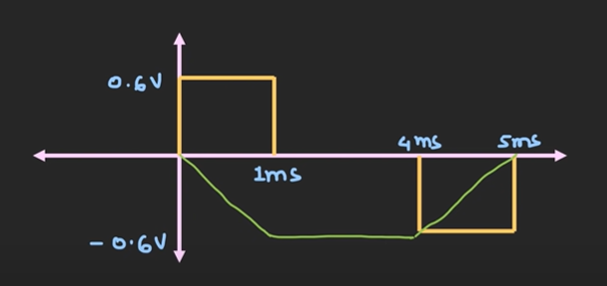 [signal is varying from 0v to -2v -2v to -2v -2v to 0]
Op-Amp as differentiator | 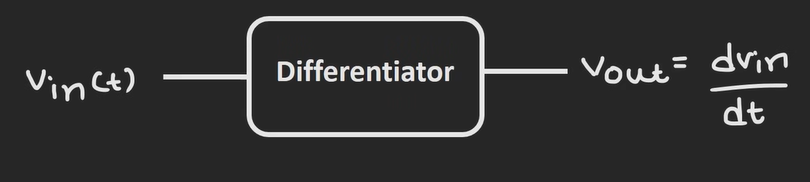  Op-Amp Differentiator  A differentiator is a circuit that produces an output voltage proportional to the rate of change (derivative) of the input voltage:  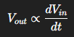  - If input is a ramp, output is a constant  - If input is sinusoidal, output is cosine scaled by frequency  - Useful for: edge detection, waveform shaping, high-pass filtering.  - Sensitive to high-frequency noise; often a small resistor is added at the input to stabilize.  Basically, using differentiator, we get rate at which input is changing  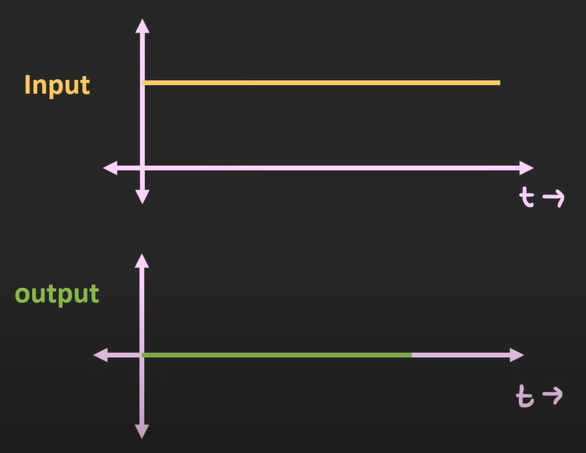  - Suppose we provide dc signal to differentiator (it will output 0v as signal)  - The rate at which input is changing here is 0 (because input is not changing hence its rate of change is 0)  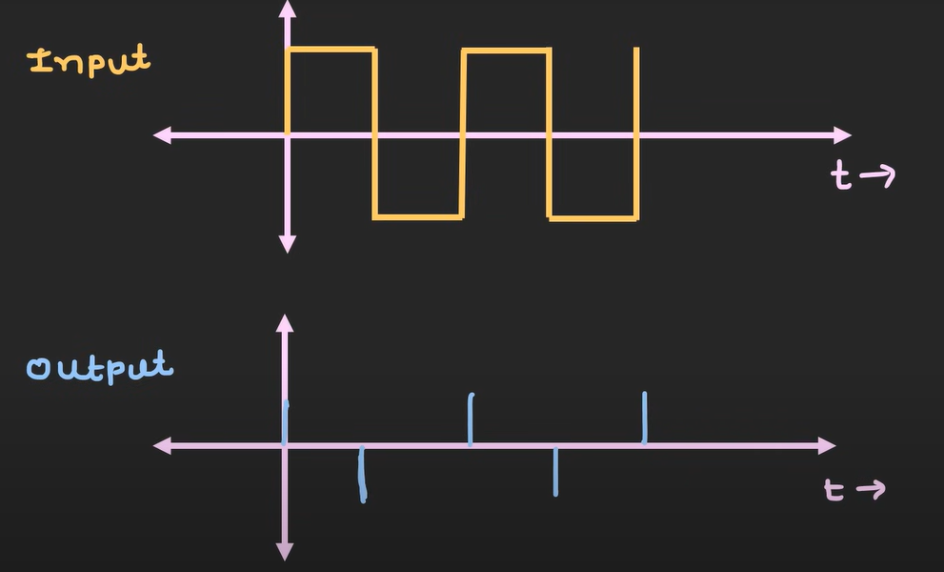  - We can use differentiator for edge detection purpose  Differentiator ckt  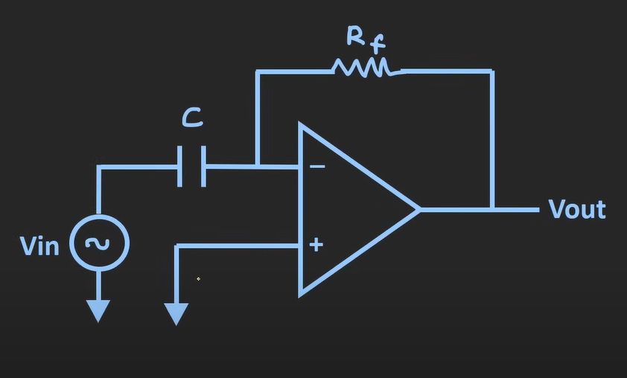  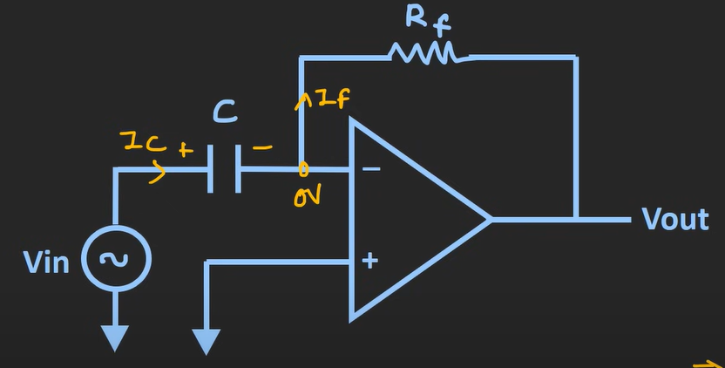  - Applying KCL $I_{c}= I_{f}$  - $C\frac{dV_{c}}{dt}= \frac{{0- V}_{out}}{R_{f}}$  - $C\frac{dV_{in}}{dt}= \frac{{- V}_{out}}{R_{f}}$  - $V_{out}={- R}_{f}*C*\frac{dV_{in}}{dt}$ [this shows output is the differentiation of the input]  Example  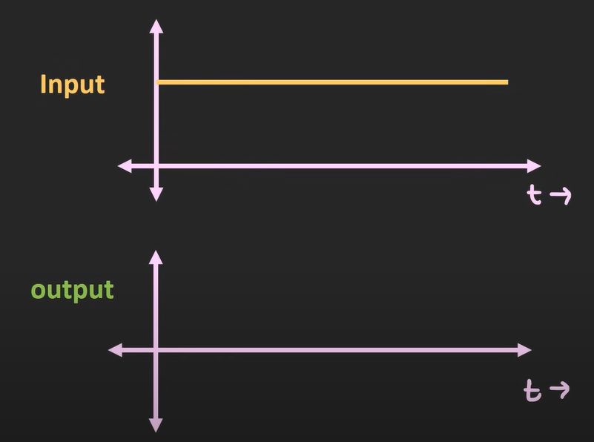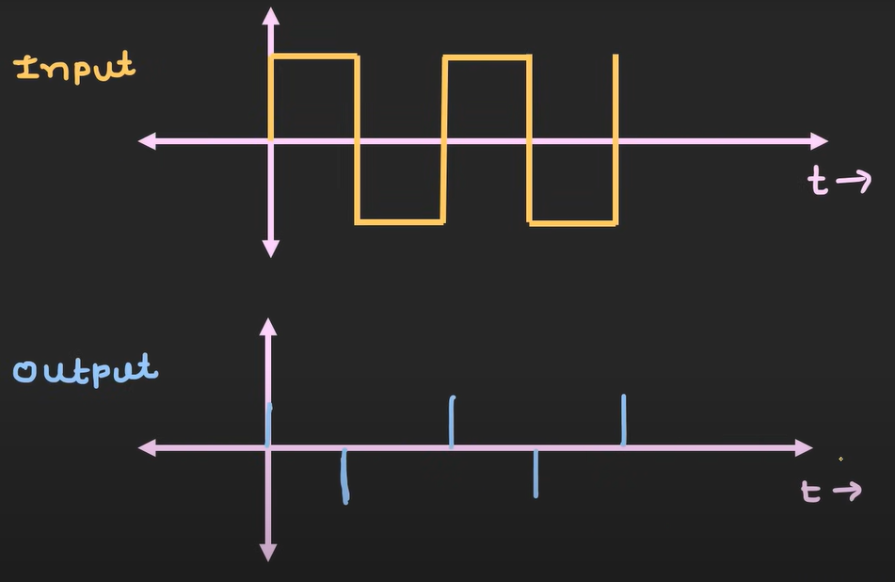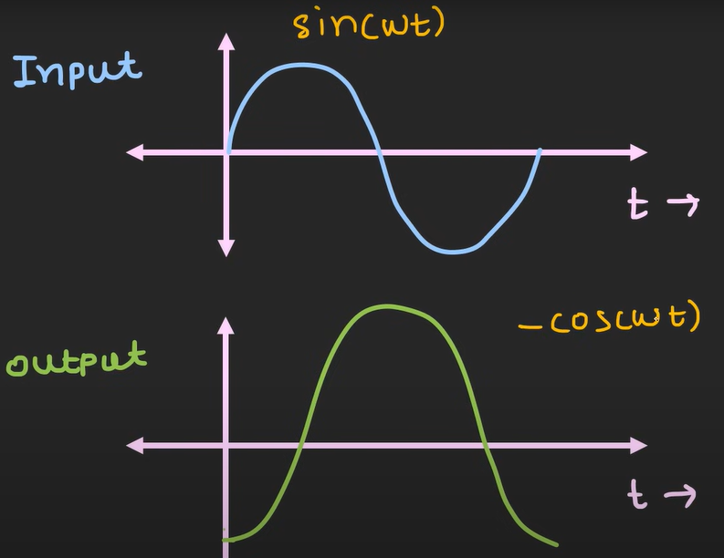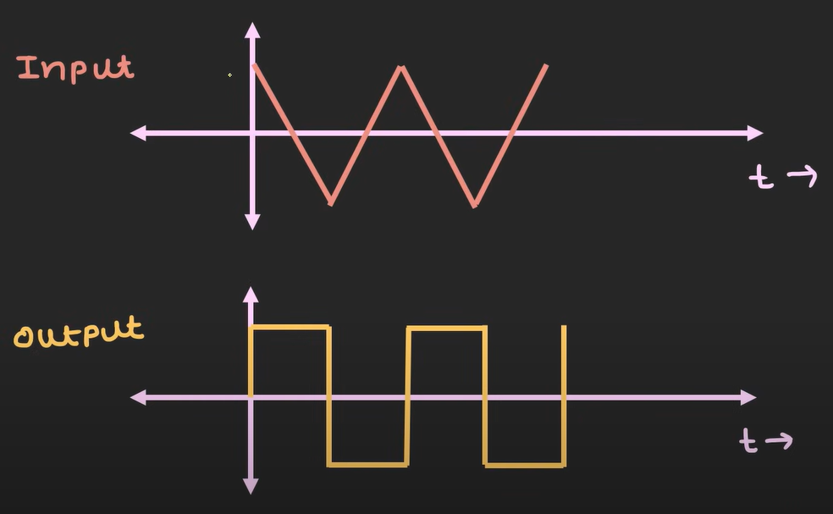  Limitation of differentiator  - Considering Resistance and reactance ( differentiator is sensitive to high freq noise (high freq noise gets more gain))  - $\frac{V_{out}}{V_{in}}=A\left(gain\right)= -2π*CfR_{F}$ (gain is directly proportional to freq)  - $| \frac{V_{out}}{V_{in}}|= {2πR}_{F}fC$  - Freq response of differentiator  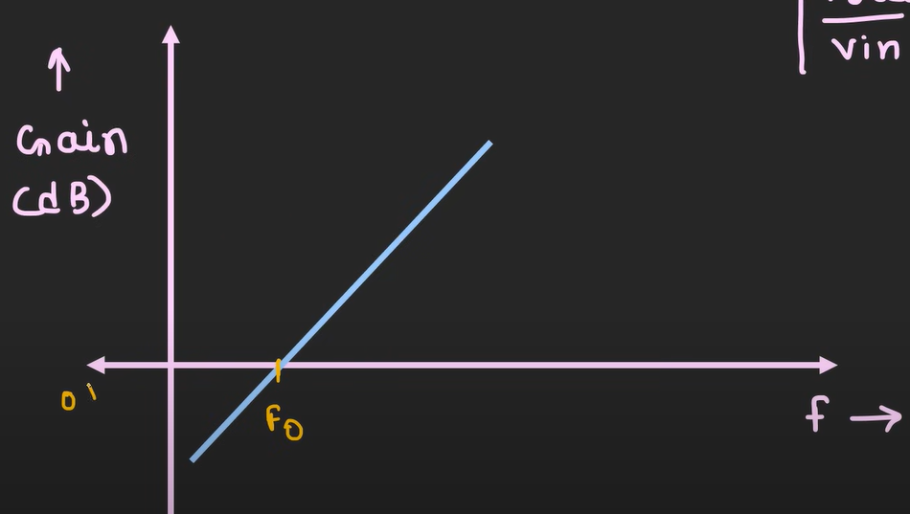  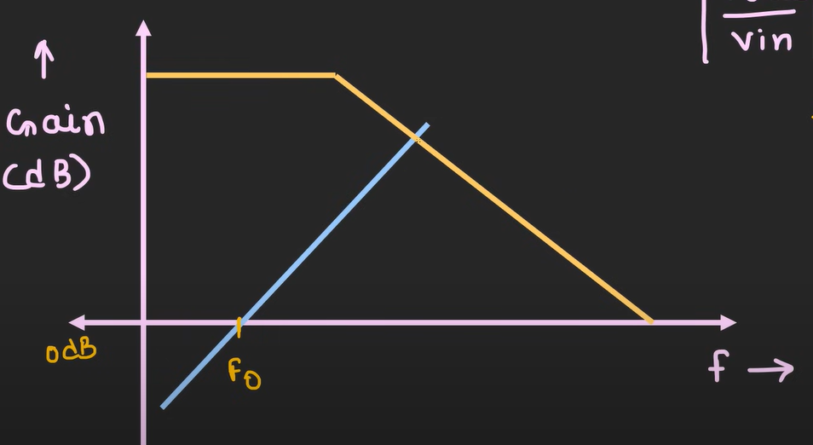  - Here you can see  - Blue graph : graph of differentiator  - Yellow graph : op-Amp open loop response  - As the freq increases the gain is also increases (but it is limited by open loop gain = 10^5 or 10^6)  - The max gain differentiator can achieve is the intersection point  - $f_{0}$ = 0 dB freq ($f_{0}= \frac{1}{2π R_{F}C}$ )  - Here one can observe that there is no gain when the input is 0 (freq is 0) – so for DC signals no gain and no input offset compared to as seen in integrator  - But for any high freq component or say noise (it will get amplified)  - This is the simple differentiator response  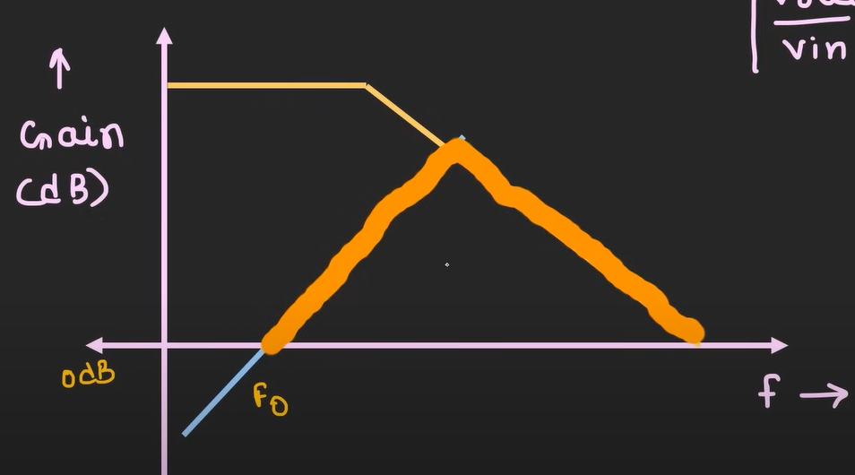  - Input impedance of differentiator  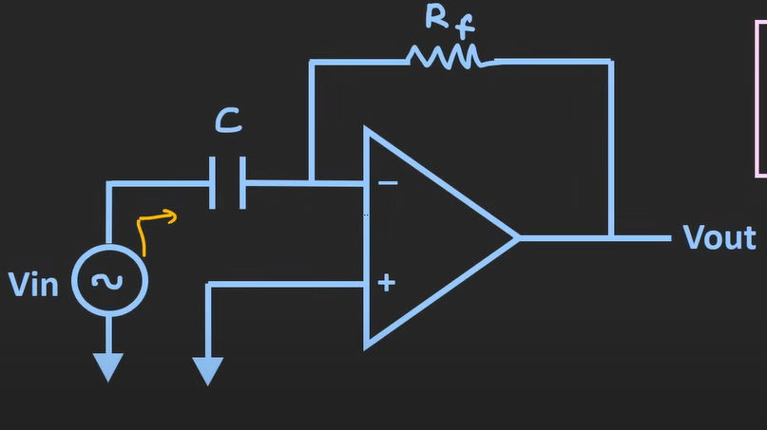  - Input impedance as seen at differentiator depends on the reactance of capacitor $X_{c}$ (and $X_{c}=\frac{1}{2πfc}$ ) changes with freq (so for high freq input – input impedance ($Z_{in}= X_{c} )$ is low ----- and for low freq – input impedance is very high)  So, there are two limitations  - As the input freq will increase – the input impedance will decrease ($Z_{in}= X_{c} )$  - This simple differentiator is very sensitive to noise (as high freq noise gets high gain)  How to avoid this problem (by adding a series resistor)  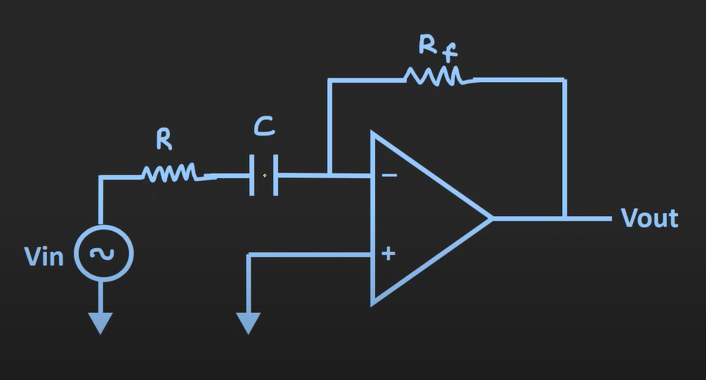  - High input freq – low input Impedance issue  - Here $Z_{in}= \sqrt{R^{2}+ {X_{C}}^{2}}$ ------- so $Z_{in}>R$ ($Z_{in}$always > R)  - high freq noise gets high gain issue  - Here for high freq gain will be A = $-\frac{R_{F}}{R}$ (restricting it)  - Also, if we introduce feedback capacitor, we get more stability at higher freq (circuit of a practical differentiator)  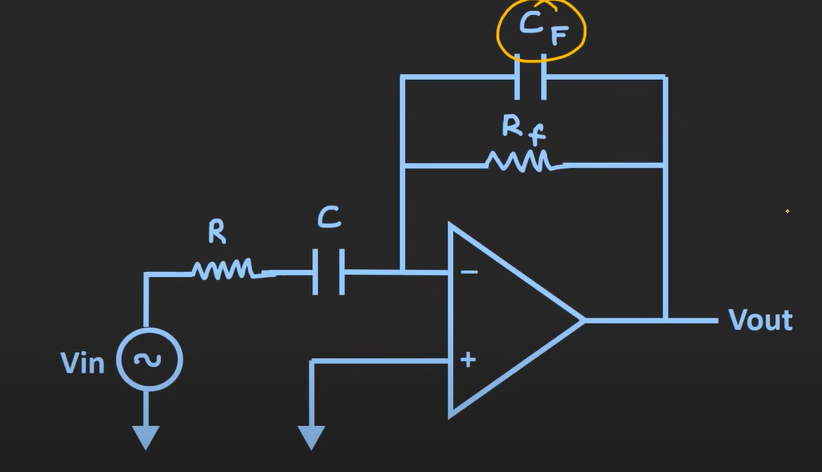  - Here there forms a two low pass filter ( R & C) and ($R_{F}$ and $C_{F}$)  - Thus, we will have two cutoff freq  - $f_{L1}= \frac{1}{2π RC}$ (cutoff freq due to R & C)  - $f_{L2}= \frac{1}{2π R_{F}C_{F}}$ (cutoff freq due to $R_{F}$ &$C_{F}$)  - Let’s assume $f_{L2}> f_{L1}$  - Response of this practical differentiator  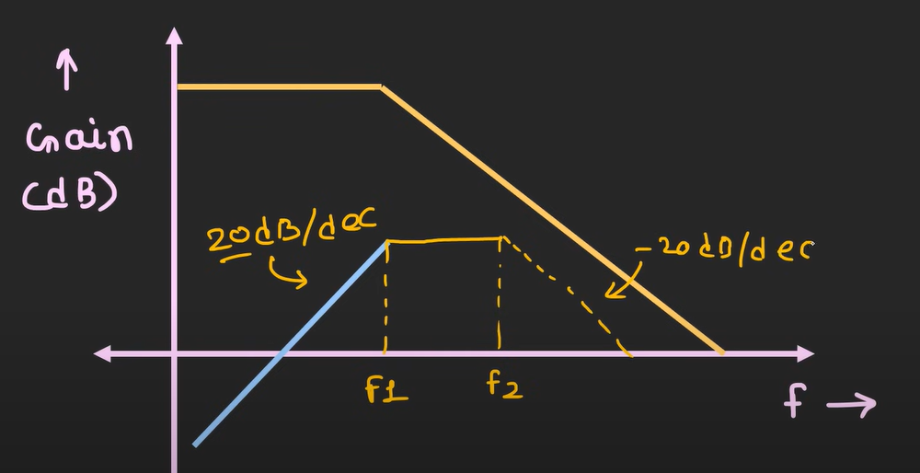  - Let’s assume $f_{L2}= f_{L1}$  - Response of this practical differentiator  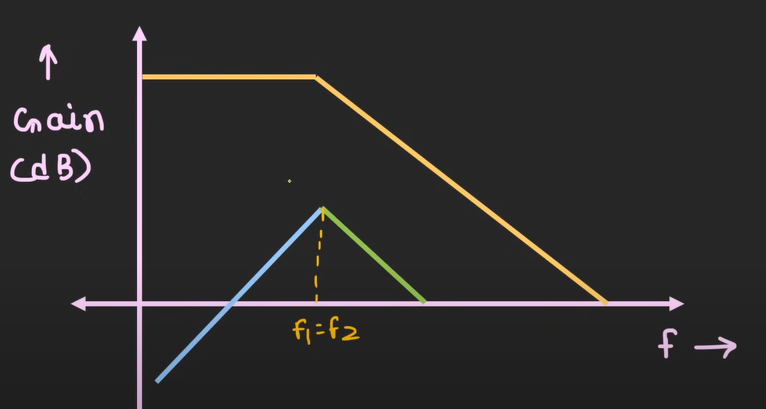  - To operate this spec as differentiator one should use freq which is $f_{0}< f_{s}<\left(f_{L2}= f_{L1}\right)$ or $f_{0}< f_{s}<\left(f_{L2} or f_{L1}-whichever is less\right)$  - For proper differentiation $f_{s} \left(signal freq\right)= \frac{f_{L1}}{10}$  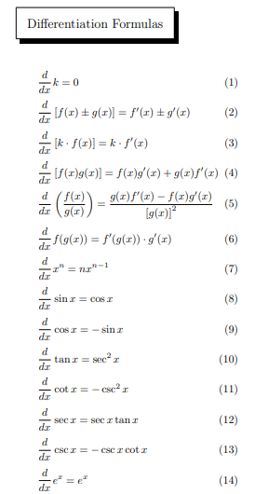  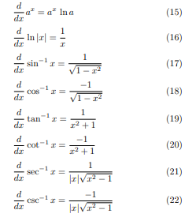  Example :  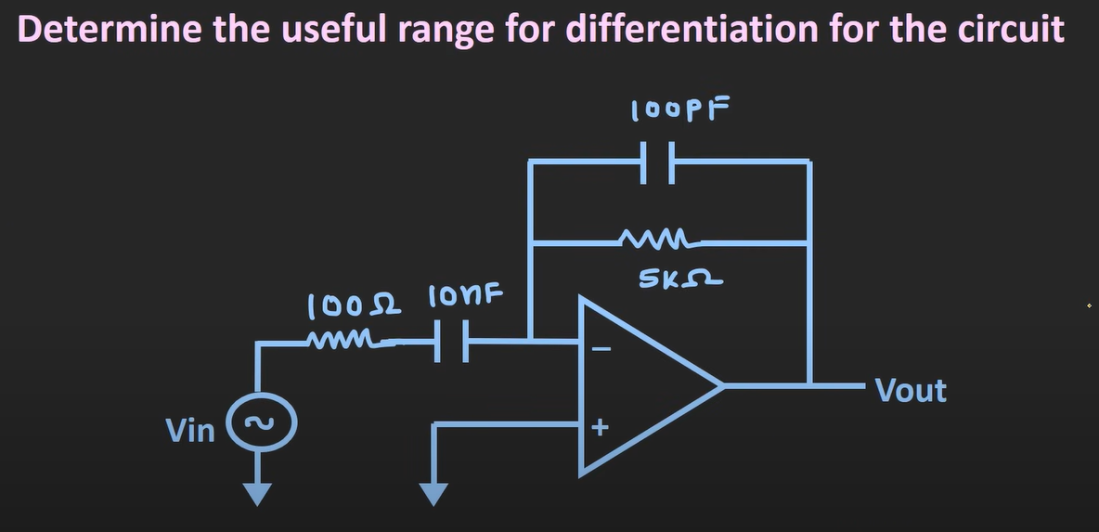  Here  - R = 100 ohm  - C = 10 nF  - Cf = 100pF  - Rf = 5k ohm  - $f_{L1}= \frac{1}{2π RC}$ = $\frac{1}{2π*100*10nF}=159235 Hz$ = 159 KHz  - $f_{L2}= \frac{1}{2π R_{F}C_{F}}$ = $\frac{1}{2π*5000*100pF}=318471 Hz$ = 318 KHz  - $f_{0}= \frac{1}{2π R_{F}C}$ = $\frac{1}{2π*5000*10nF}=3184 Hz$ = 3 KHz  - Useful range $f_{0}< f_{s}<\left(f_{L2} or f_{L1}-whichever is less\right)$  - Useful range $3 KHz < f_{s} < 159 KHz$  - for proper differentiation $f_{s}=\frac{f_{1}}{10}=\frac{159kHz}{10}=15.9 KHz$  Example : 2 (same ckt as example 1)  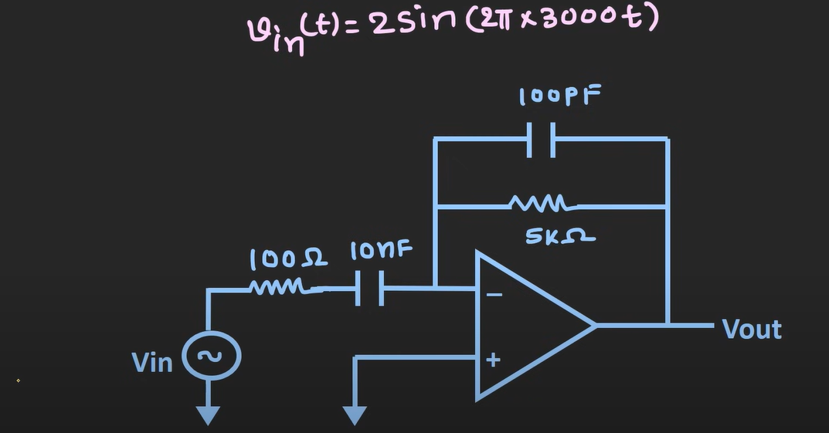  Input signal : $V_{in}\left(t\right)=2\sin{(2π*3000t}$)  $V_{out}={- R}_{f}*C*\frac{dV_{in}}{dt}$ - 5000 * 10nF * $\frac{d V_{in}\left(t\right)}{dt}$ - ${10}^{-4}*2 π*3000*\cos\left(2π*3000t\right)$ = -1.885$\cos\left(2π*3000t\right)$  $$V_{out}= -1.88\cos\left(2π*3000t\right)$$  Example : 3 (same ckt as example 2)  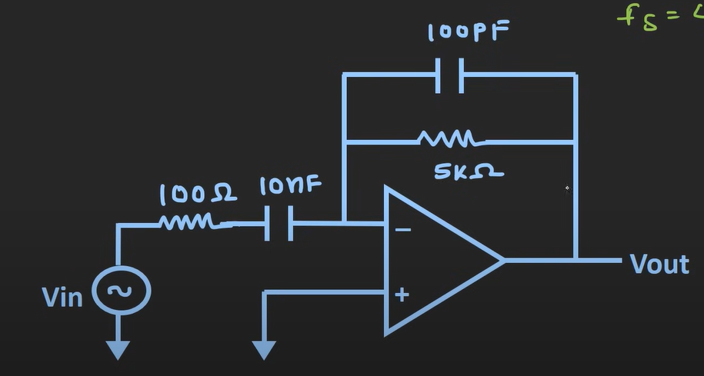  Input signal :  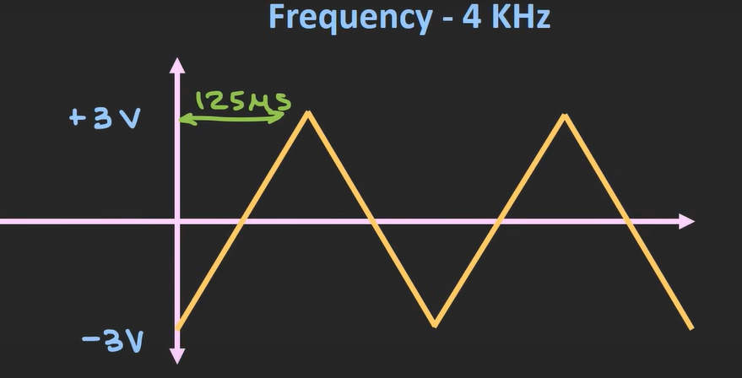  - from the signal we can identify that  - T = $\frac{1}{4000}=250 µs$  - Thus, half period = 125 $µs$  - In 125us input is varying from -3v to 3v  - Thus, the slope = $\frac{6v}{125 µs }=48000 volt per\sec{(v/s)}$ [this is also called rate of change of signal ]  - $V_{out}={- R}_{f}*C*\frac{dV_{in}}{dt}$ = $- 5000*10*{10}^{-9}*\left(48000\right)= -2.4v$  - And for another half the signal is opposite to that what we have in 1st half (thus, Vout = 2.4v)  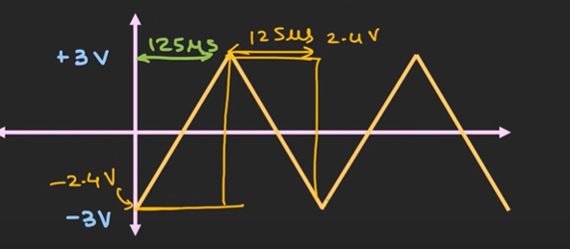  - So, this way – triangular signal is converted to square wave
Comparator | Short explanation of an Op-Amp as a Comparator 👇  ⚙️ Concept  An op-amp comparator compares two input voltages and tells which one is higher.  - The non-inverting terminal (+) gets one voltage.  - The inverting terminal (–) gets another voltage.  - The output switches between the maximum positive and maximum negative voltage (near the op-amp’s supply rails).  ⚡ Working Principle  - If $V_{+}>V_{-}$→ Output saturates high (≈ +$V_{sat})$  - If $V_{+}<V_{-}$→ Output saturates low (≈ -$V_{sat})$  So, the op-amp acts like a binary switch — either high or low, depending on which input is larger.  📊 Example  Suppose an op-amp is powered by ±12 V (biasing volt).  Condition Result  $$V_{+}=3V, V_{-}=2V$$ Output ≈ +12 V  $$V_{+}=1V, V_{-}=4V$$ Output ≈ –12 V  🧩 Applications  - Zero-crossing detector  - Level detector  - Over-voltage or under-voltage protection circuits  - Converting analog signals to digital (logic) signals  💡 Note  A comparator is different from an amplifier —it doesn’t amplify linearly, it just switches between two states.  - If $V_{+}>V_{-}$→ Output saturates high (≈ +$V_{sat})$ [non-inverting amplifier]  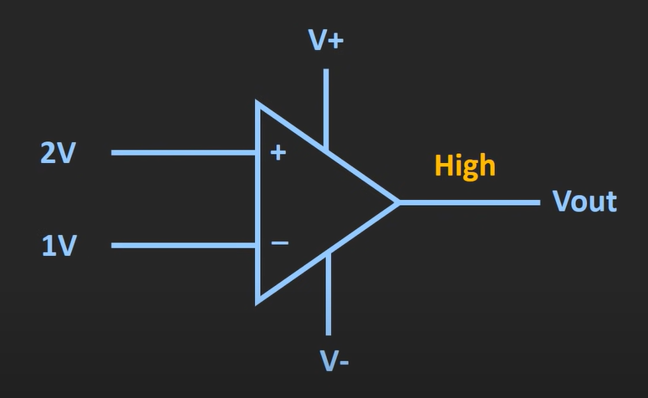  - If $V_{+}<V_{-}$→ Output saturates low (≈ -$V_{sat})$ [inverting amplifier]  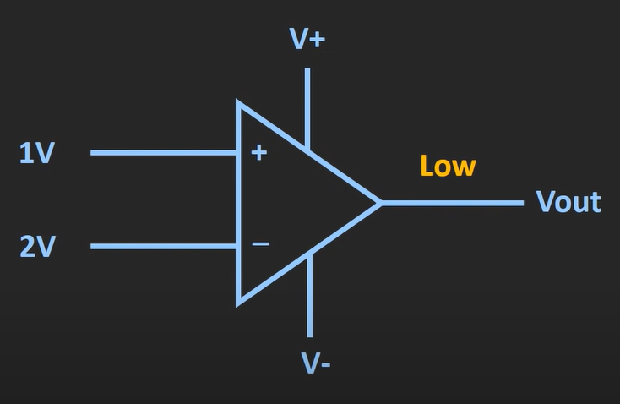  - Basically, comparator is nothing but Op-Amp in open loop configuration  - $V_{out}= A_{OL}V_{d}$  How this works  - Open-loop config of op-Amp is used  - It takes the difference of the input – multiplies it with open-loop gain – output saturates  - Example (if biasing volt is $±12v$)  - If the non-inverting terminal has higher volt (difference is positive) (output saturates to +ve bias volt = 12v)  - If the inverting terminal has higher volt (difference is negative) (output saturates to -ve bias volt = -12v)  Example: of non-inverting amplifier  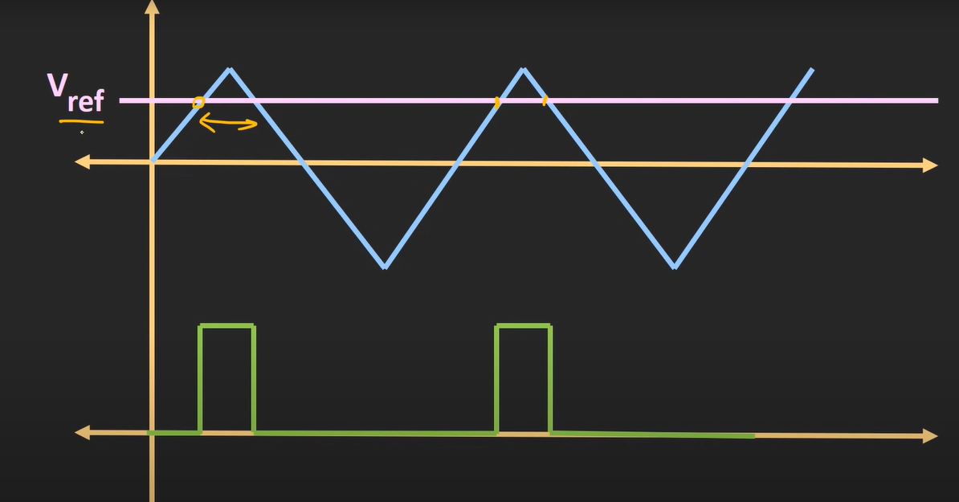  - Here triangular wave is shown (which is provided to the non-inverting terminal)  - And ref signal is provided to inverting terminal  - When the $V_{+}>V_{-}$ output saturates to +Vsat  - When the $V_{+}<V_{-}$ output saturates to -Vsat  - Here output swing will be +Vsat to -Vsat (not as shown in image)  Window Comparator  Output should remain high or low for specific band of input (they are called as window comparator  That means output will be high/low when the volt is withing specific limits of voltages  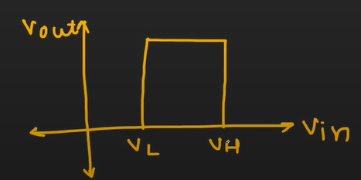  - $V_{L}$ is known as lower threshold volt  - $V_{H}$ is known as higher threshold volt  Ckt of window comparator (acts as a wired AND connection)  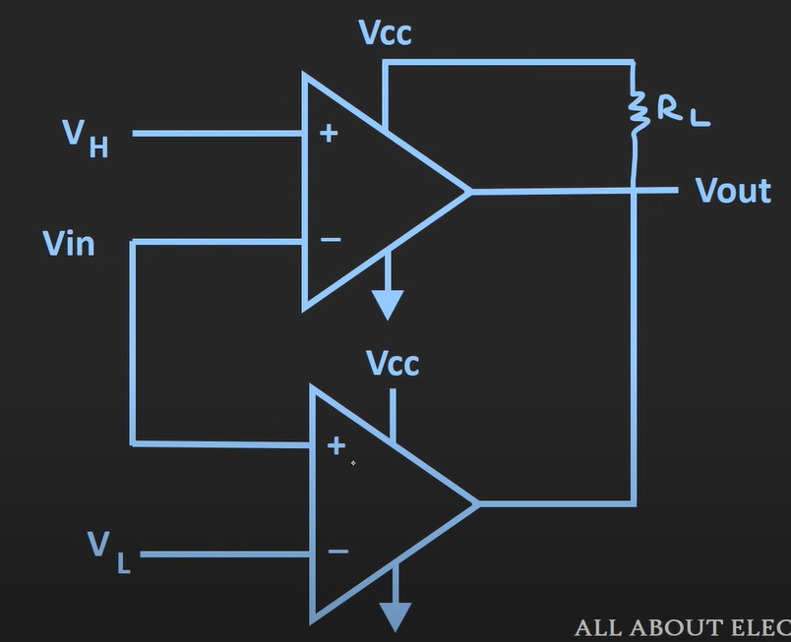  - If any of the comparator input is low output will be low  - If both the input is high output will be high  - When $V_{in}$ < $V_{L}$ 2nd comparator op will be low 1st comparator will be high value overall op = low  - When $V_{in}$ > $V_{L}$ and $V_{in}$ < $V_{H}$ 1st and 2nd comparator output will be high overall op = high  - When $V_{in}$ > $V_{H}$ 2nd comparator op will be High 1st comparator will be low value overall op = low  condition 1st comparator 2nd comparator final op (AND operation)  $V_{in}$ < $V_{L}$ high Low Low  $V_{in}$ > $V_{L}$ and $V_{in}$ < $V_{H}$ High High High  $V_{in}$ > $V_{H}$ low high Low  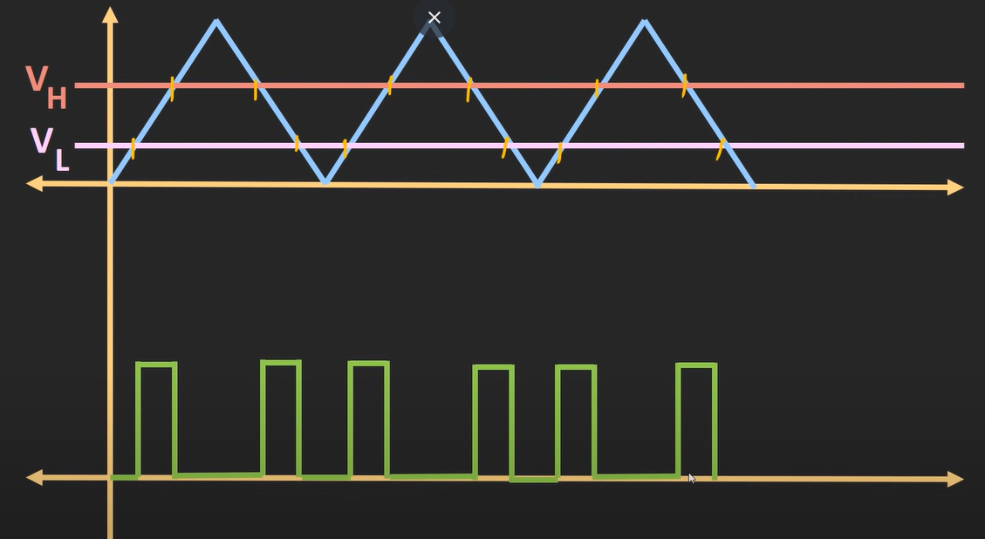  Effect of noise  - Without noise  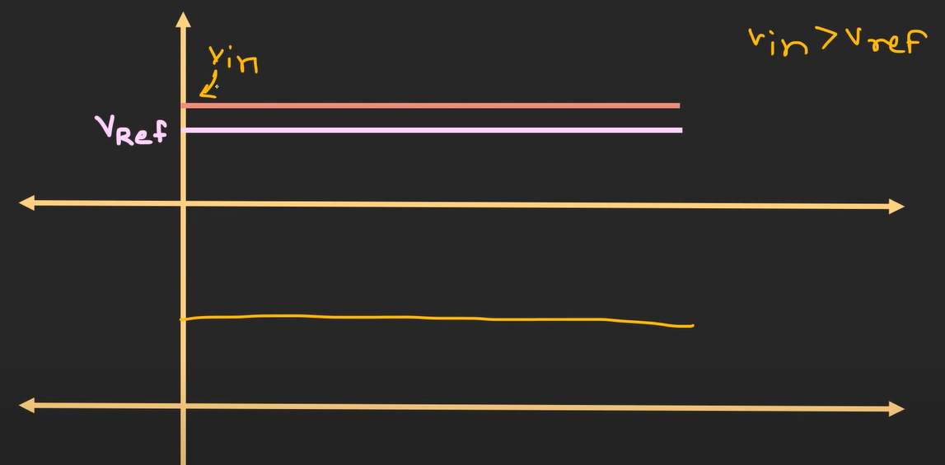  - With noise  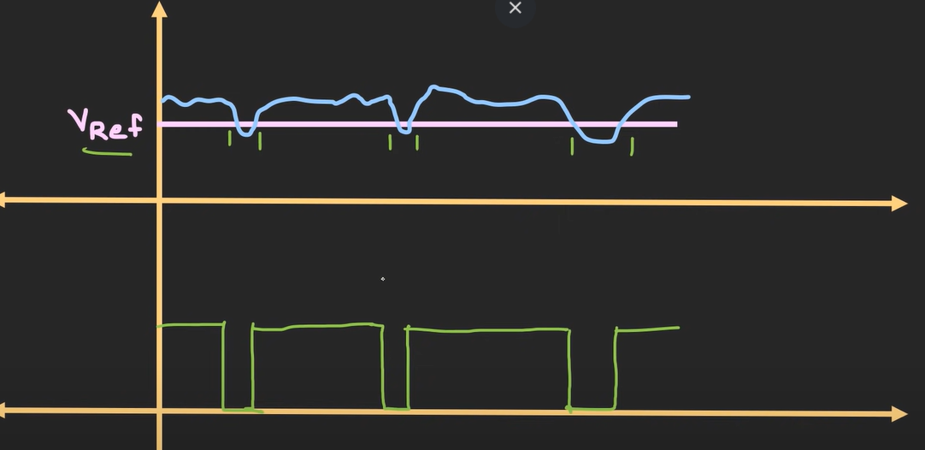  This shows comparator is not immune to external noise  To avoid this problem comparators are used with hysteresis – positive feedback is provided to the ckt (which is known as Schmitt trigger ckt)  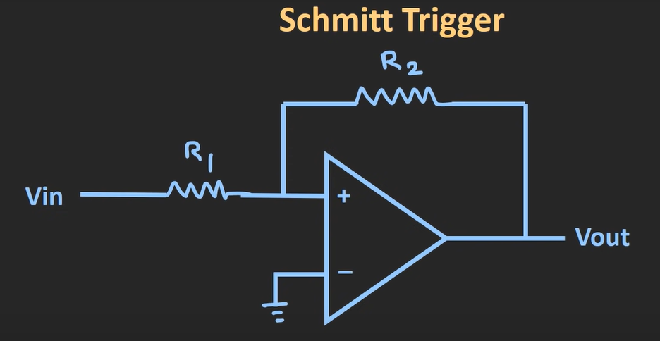  - By providing the positive feedback – we can increase noise immunity of the ckt  Hysteresis  Basic Idea  Hysteresis means the comparator has two different threshold voltages —  one for switching ON and another for switching OFF.  👉 In simple words:  The output does not change state at exactly the same input voltage when going up and when coming down.  📉 Why?  Without hysteresis, if your input signal is slowly varying or has noise,  the comparator output can rapidly toggle ON/OFF many times near the threshold — creating unwanted flicker or instability.  Hysteresis adds a small intentional gap between the “turn ON” and “turn OFF” points → making the circuit stable.  💡 Example  Let’s say:  - Upper threshold (V<sub>TH</sub>) = 3 V  - Lower threshold (V<sub>TL</sub>) = 2 V  Now:  - When input rises and crosses 3 V, output → HIGH.  - When input falls and goes below 2 V, output → LOW.  Between 2 V and 3 V, the output remains stable — it doesn’t toggle even if small noise is present.  📊 So:  Input direction Condition Output  Increasing V<sub>in</sub> > V<sub>TH</sub> HIGH  Decreasing V<sub>in</sub> < V<sub>TL</sub> LOW  That gap between V<sub>TH</sub> and V<sub>TL</sub> = Hysteresis width.  ⚡ Where It’s Used  - Schmitt trigger circuits  - Sensor signal conditioning  - Noise immunity  - Switch de-bouncing  🎯 In one line:  Hysteresis = the intentional difference between the rising and falling threshold voltages, added to prevent output chatter due to noise.
Schmitt trigger | This simple open-loop config of op-Amp as comparator wasn’t immune to noise. This kind of problem can be avoided if used schmitt trigger  - Schmitt trigger is nothing but a comparator with hysteresis  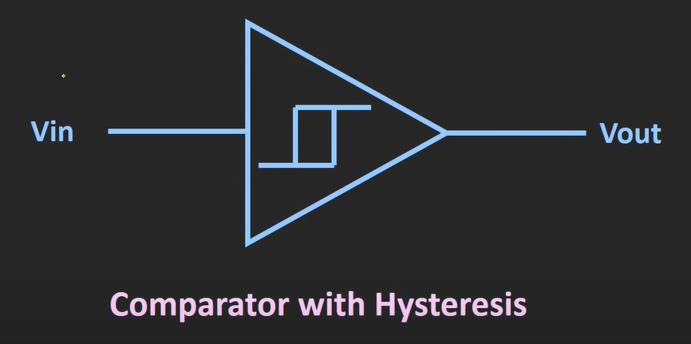  - It has two threshold voltages  - Upper threshold volt : low to high  - Lower threshold volt : high to low  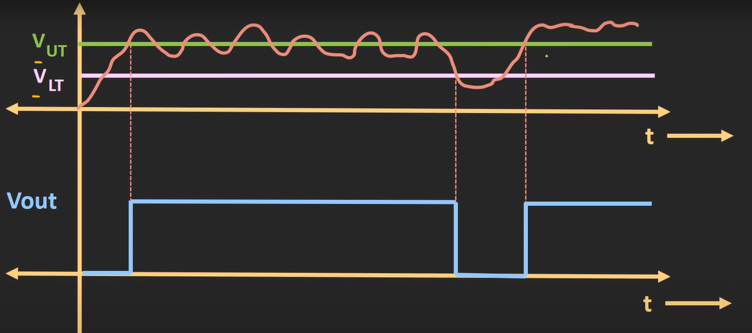  - Here input is considered high when the input crosses $V_{UTH}$ and remains high till it crosses $V_{LTH}$  - Here input is considered low when the input crosses $V_{LTH}$ and remains low till it crosses $V_{UTH}$  - So, for high to be considered as high (when it crosses $V_{UTH}$ and till it doesn’t cross $V_{LTH}$)  - So, for low to be considered as low (when it crosses $V_{LTH}$ and till it doesn’t cross $V_{UTH}$)  - Schmitt trigger provides immunity in the range of $V_{UTH}$ and $V_{LTH}$  - so, this hysteresis volt defines noise immunity of the given schmitt trigger  - so, there are basically 4 deciding paras in schmitt trigger (high and low volt) (higher threshold and lower threshold volt)  Schmitt trigger transfer characteristics (hysteresis curve) (for non-inverting schmitt trigger)  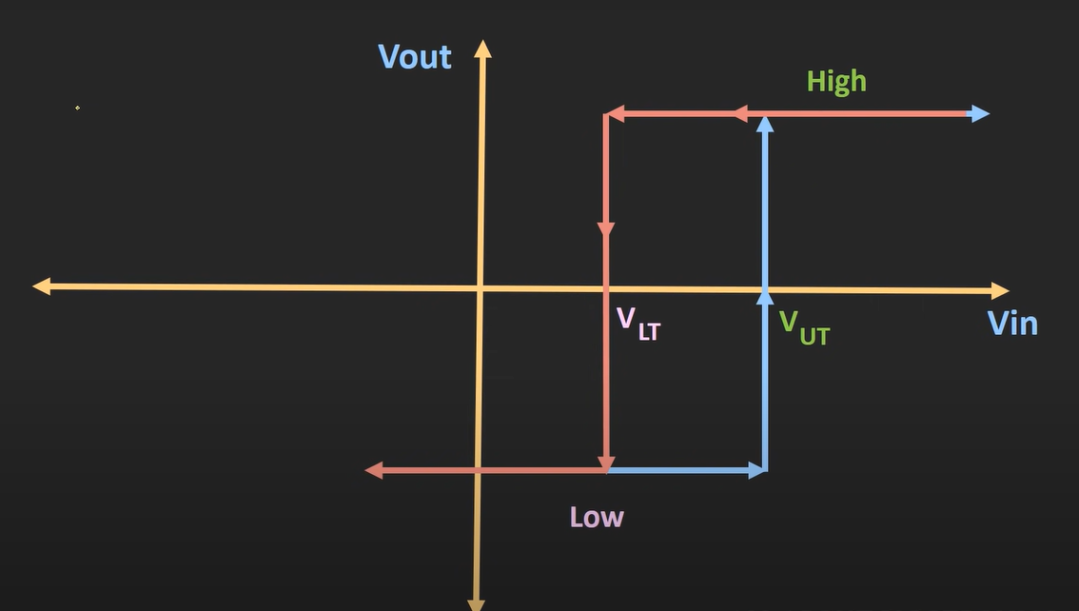  If $V_{H}$ and $V_{L}$ are equal and opposite in polarity then hysteresis curve shifts in the middle  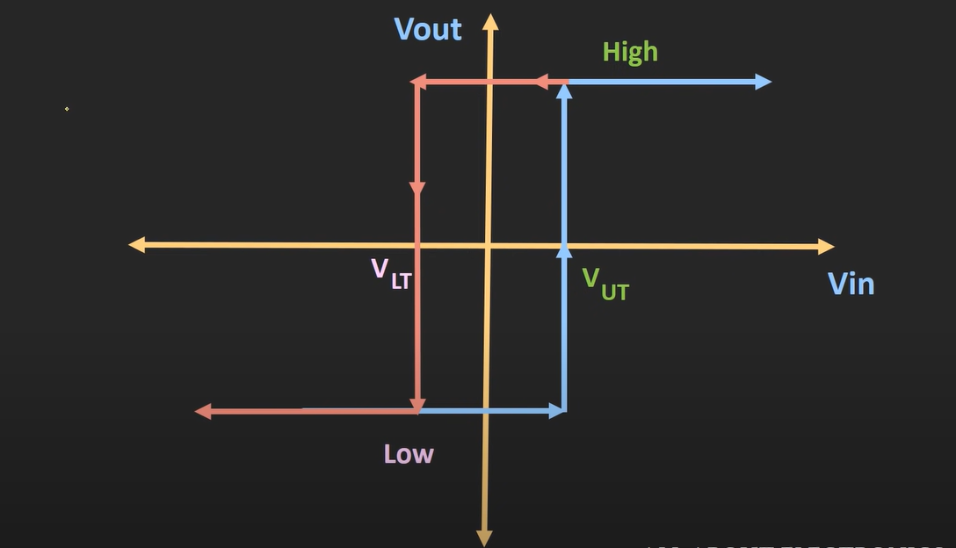  Schmitt trigger transfer characteristics (hysteresis curve) (for inverting schmitt trigger)  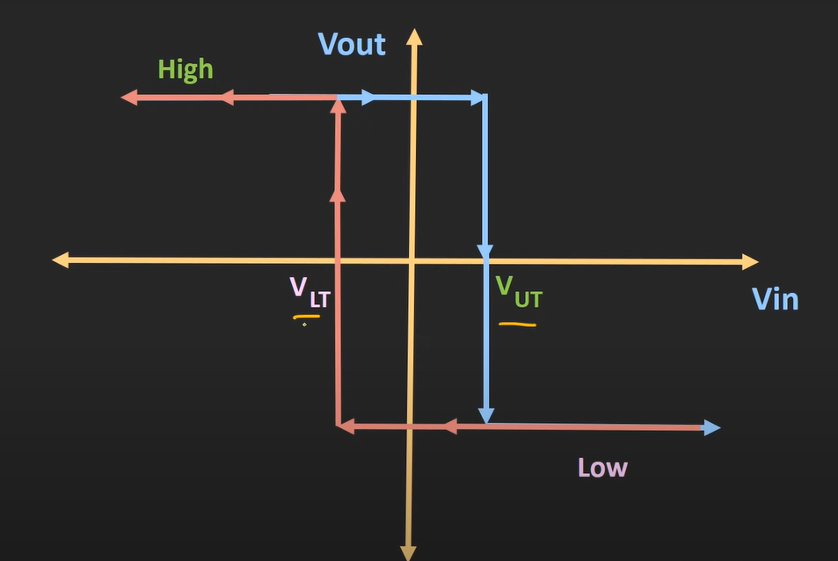  Symbols  Inverting schmitt trigger 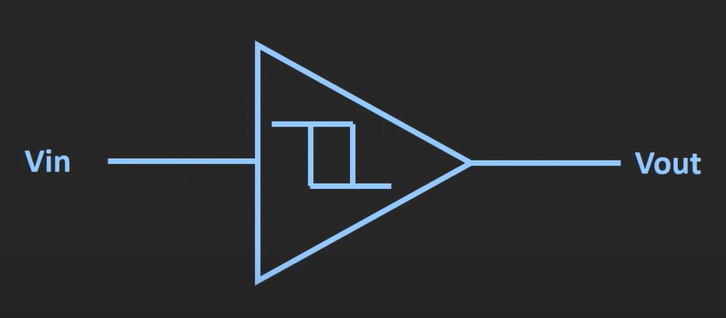 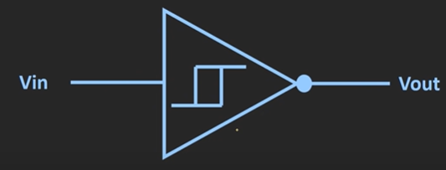 Non-inverting schmitt trigger 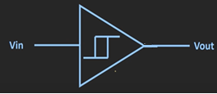  - schmitt triggers can be designed using op-Amps and transistors  Inverting schmitt trigger  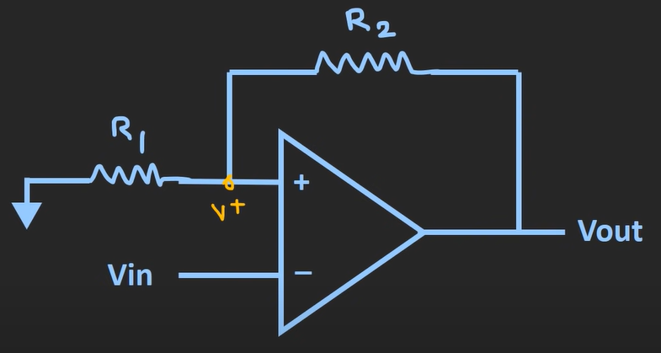  - here  - when $V_{in}> V_{+}$ op is low  - when $V_{in}< V_{+}$ op is High  - Applying KCL  - $\frac{V^{+}- 0}{R_{1}}+ \frac{V^{+}- V_{out}}{R_{2}}$ = 0  - $V^{+}= \frac{R_{1}}{R_{1}+ R_{2}} V_{out}$  - Case 1: considering $V_{out}=high$ and calling $V^{+} as V_{1}$ [$V_{in}> V_{+}$ op is low]  - $V_{1}=V_{UT} = \frac{R_{1}}{R_{1}+ R_{2}} V_{H}$ (upper threshold volt)  - Case 2: considering $V_{out}=low$ and calling $V^{+} as V_{2}$ [ $V_{in}< V_{+}$ op is High]  - $V_{2}= V_{LT}= \frac{R_{1}}{R_{1}+ R_{2}} V_{L}$ (lower threshold volt)  - Hysteresis : $V_{UT}-V_{LT}$ (defines the noise immunity of schmitt trigger)  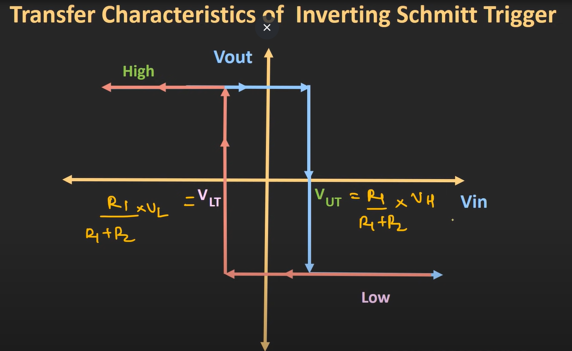  Example : $V_{H}=12v$ , $V_{L}=-12v$ , $R_{1}= R_{2}=R$  - Hysteresis = 6 – (- 6) = 12v  Note : we can shift transfer curve to the right or to the left by providing external reference voltage as an input  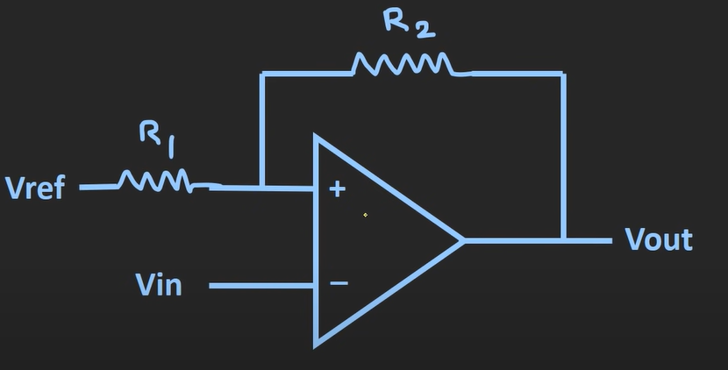  NON-inverting schmitt trigger  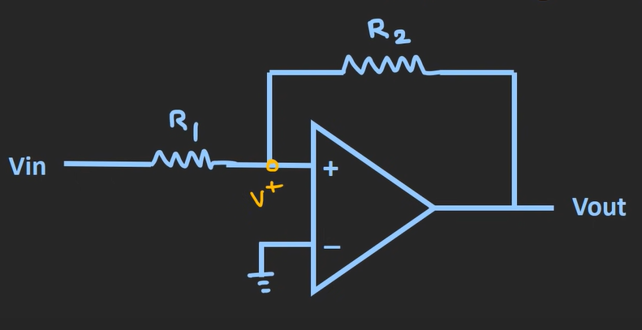  - here  - when $V_{+}>0$ op is high  - when $V_{+}<0$ op is Low  - After applying KCL  - $V_{+}= \frac{R_{2}}{R_{1}+ R_{2}} V_{in} + \frac{R_{1}}{R_{1}+ R_{2}} V_{out}$  - Case 1: considering $V_{out}=LOW$ and calling $V^{+} as V_{1}$ [$V_{+}> 0$ op is High]  - $V_{+}= \frac{R_{2}}{R_{1}+ R_{2}} V_{in} + \frac{R_{1}}{R_{1}+ R_{2}} V_{out}$  - $V_{1}= \frac{R_{2}}{R_{1}+ R_{2}} V_{in} + \frac{R_{1}}{R_{1}+ R_{2}} V_{L}$  - $V_{UT}= -\frac{R_{1}}{ R_{2}} V_{L}$  - Case 2: considering $V_{out}=High$ and calling $V^{+} as V_{2}$ [$V_{+}< 0$ op is Low]  - $V_{+}= \frac{R_{2}}{R_{1}+ R_{2}} V_{in} + \frac{R_{1}}{R_{1}+ R_{2}} V_{out}$  - $V_{2}= \frac{R_{2}}{R_{1}+ R_{2}} V_{in} + \frac{R_{1}}{R_{1}+ R_{2}} V_{H}$  - $V_{LT}= -\frac{R_{1}}{ R_{2}} V_{L}$  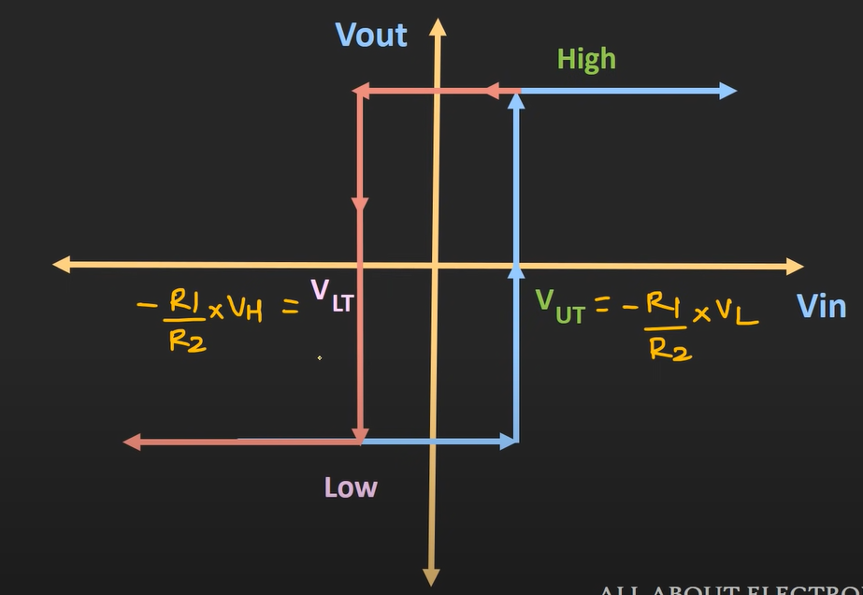  Note : we can shift transfer curve to the right or to the left by providing external reference voltage as an input  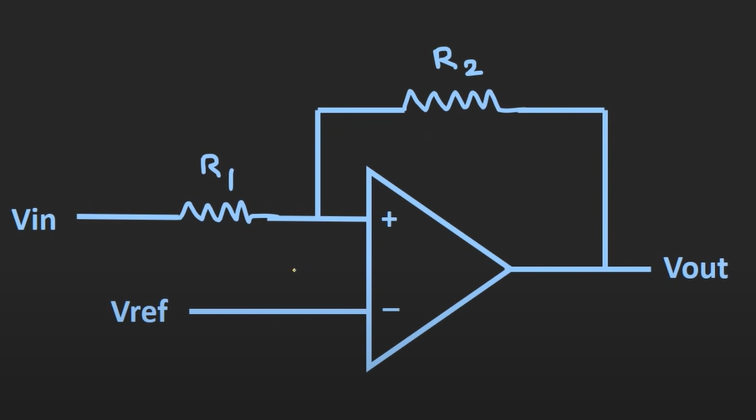  Uses of schmitt trigger: (schmitt trigger is basically updated version of comparator – provides noise immunity)  - As a level comparator  - As an analog to digital converter  - As a wave shaping ckt (sine wave /triangular wave can be converted into square wave)  - Oscillator  - Multivibrator

