Learning Path
Level 0: Oscillator Fundamentals (MUST-KNOW)

Goal: Understand what an oscillator is and why it oscillates.
Topics
- What is an oscillator?
- Oscillator vs amplifier
- Need for oscillators in systems
- Positive feedback concept
- Barkhausen Criterion
  - Loop gain condition |Aβ| = 1
  - Phase condition = 0° / 360°
- Why oscillations start (noise)
- Why oscillations stabilize (non-linearity)
👉 Learn via:
Conceptual explanations + block diagrams

Level 1: RC Oscillators (Low-Frequency)

Goal: Understand oscillators built using resistors & capacitors.
Topics
- RC phase-shift oscillator
  - Why 3 RC sections?
  - 180° phase shift from RC + 180° from amplifier
- Wien bridge oscillator
  - Frequency of oscillation
  - Condition for oscillation
  - Automatic amplitude control (lamp / diode idea)
- Frequency equations (important)
- Advantages & limitations of RC oscillators
👉 Learn via:
Circuit diagrams + phasor reasoning + simple math

Level 2: LC Oscillators (High-Frequency)

Goal: Learn oscillators used at RF / MHz ranges.
Topics
- Why RC fails at high frequency
- LC resonance concept
- Tank circuit (energy exchange between L & C)
- Hartley oscillator
- Colpitts oscillator
- Frequency of oscillation
- Feedback mechanism in LC oscillators
👉 Learn via:
Energy flow explanation + resonance concept

Level 3: Crystal Oscillators (Stability Focus)

Goal: Understand why crystals are used for accurate clocks.
Topics
- Piezoelectric effect
- Quartz crystal equivalent circuit
- Series vs parallel resonance
- Why crystal oscillators are ultra-stable
- Typical frequencies (kHz–MHz)
- Use in MCUs, CPUs, SoCs
👉 Learn via:
Equivalent circuit + intuition (not fabrication)

Level 4: Oscillators in VLSI / IC Context (AWARENESS)
Goal: Connect oscillators to digital IC design.
Topics
- Ring oscillators
  - Inverter delay based oscillation
- Relationship between delay, frequency & VDD
- PVT (Process, Voltage, Temperature) variation
- Why ring oscillators are used in:
  - On-chip clocking
  - Silicon characterization
  - Aging monitors
- Difference between crystal clock & ring oscillator clock
👉 Learn via:
Logic diagrams + timing intuition

General

Level vs Expectation Summary

Level | Needed for FE VLSI | Depth
Level 0 | ✅ Mandatory | Strong
Level 1 | ✅ Mandatory | Moderate
Level 2 | ✅ Mandatory | Moderate
Level 3 | 🟡 Useful | Conceptual

Completion Criteria
You’ll be oscillator-ready when you can:
- Explain Barkhausen clearly
- Explain why RC/LC/crystal are chosen
- Tell why ring oscillators are unstable but useful
- Relate oscillator stability to digital timing

Topic | Explanation
Basics | What is an Oscillator? : Definition (formal but simple)  An oscillator is an electronic circuit that generates a periodic AC waveform (sine, square, etc.) from a DC power supply, without requiring any external input signal.  📌 Key idea:  No input signal → yet you still get an output waveform.  🔌 Input–Output View (Very Important)  Quantity Oscillator  Input signal ❌ None  Power supply ✅ DC  Output ✅ Periodic AC  So effectively:  DC → (Oscillator) → AC  🧠 Why This Is Special Normally:  - To get AC output → you need AC input  But an oscillator:  - Uses feedback  - Uses energy storage  - Uses device non-idealities  to create AC on its own.  🧩 Simple Block Diagram (Generic Oscillator)  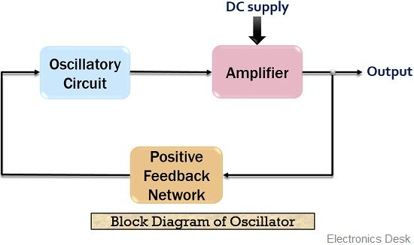  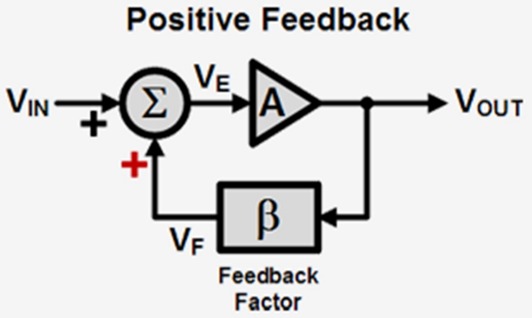  Blocks:  - Amplifier (Gain A)  - Feedback network (β) → decides frequency  - DC supply  🔁 Oscillator vs Amplifier (Crystal Clear)  Feature Amplifier Oscillator  Input signal Required ❌ Not required  Output Amplified input Self-generated periodic signal  Feedback Negative Positive  Purpose Increase signal strength Generate signal  🧪 Everyday Examples  Device Oscillator Inside?  Wall clock ✅  Phone / laptop ✅  MCU / FPGA ✅  Radio ✅  ⚠️ No oscillator = no clock = no digital system  🧠 What Waveforms Can Oscillators Generate?  Oscillator Type Output  Sinusoidal Sine wave  Relaxation Square / triangle  Examples:  - RC, LC, crystal → sine (approximately)  - Ring oscillator → square wave  🔑 One-Line Memory (Lock This)  An oscillator is a circuit that converts DC power into a periodic AC signal using positive feedback, without any external input.  🔍 Tiny Reality Check (Very Important)  You might think:  “If there is no input, how does it start?”  Answer (we’ll expand later):  ➡️ Noise + positive feedback  our microcontrollers use clock generated from crystal oscillator right - what kind of waveform is that  inside the microcontroller, the clock is a DIGITAL SQUARE WAVE.  🧠 The Full Truth (3 layers)  1️⃣ The crystal itself  A quartz crystal is a mechanical resonator.  - It vibrates sinusoidally  - Electrical behavior ≈ sine wave  📌 So at the crystal pins, the signal is:  Small-amplitude, near-sine wave  2️⃣ The crystal oscillator circuit (inside MCU)  Inside the MCU:  - Crystal + inverter + capacitors form an oscillator  - Output here is still:  - Low amplitude  - Analog  - Sine-like / distorted sine  3️⃣ The clock distributed inside the MCU (IMPORTANT)  The MCU cannot use a sine wave for digital logic.  So internally it has:  - Buffer  - Schmitt trigger  - Clock conditioning circuit  This converts the analog oscillation into:  ✅ Clean rail-to-rail square wave  📌 This square wave:  - Drives flip-flops  - Drives counters  - Drives CPU pipeline  - Drives timers  🧠 Summary Table (Remember This)  Location Waveform  Crystal vibration Mechanical sine  Crystal pins Low-amplitude sine-like  After buffer / Schmitt trigger Square wave  Digital logic clock Square wave  🔑 One-Line Interview Answer  Although a crystal oscillator produces a sinusoidal analog signal, microcontrollers internally convert it into a clean square-wave clock for digital logic.  🔍 Bonus Insight (VLSI relevance)  Why not directly use sine wave?  - Flip-flops need sharp edges  - Timing depends on threshold crossing  - Slow slopes cause:  - Jitter  - Metastability  - Power loss  So digital systems always use square clocks.
What is an Oscillator | Link : https://www.youtube.com/watch?v=aJAZHPqEUKU  - Oscillators in electrical means are voltages moving back and forth (like sine wave of 1v amplitude (moving from 1 to -1 and -1 to 1)  - Oscillator can generate periodic signal (ex. - sine wave , triangular wave , square wave , etc)
Oscillator vs. Amplifier | Link : https://www.youtube.com/watch?v=E7C0g_XS_nU&list=WL&index=3  🔹 Amplifier’s goal  Faithfully amplify an external input without changing its shape  So we want:  - Stable gain  - Low distortion  - Controlled output  👉 Negative feedback:  - Opposes changes  - Reduces sensitivity to variations  - Prevents runaway  - Improves linearity  That’s why amplifiers use negative feedback.  🔹 Oscillator’s goal  Generate a signal even when NO input exists  So we want:  - Signal to grow from noise  - Continuous repetition  - No decay  👉 Positive feedback:  - Reinforces the signal  - Adds output back in-phase  - Allows noise to grow  - Sustains oscillation  That’s why oscillators use positive feedback.
How oscillator works | Link : https://www.youtube.com/watch?v=LTsTl3db7Ko&list=WL&index=4  - What is an oscillator  - An oscillator is something that creates oscillations which involves periodic fluctuations between two states or values  - A clock pendulum is basically a mechanical oscillator  - In electronics , we discuss the voltages that are fluctuating from a certain value to value  - So an oscillator is a ckt that generates repetitive waveforms without any input  - Oscillator can produces signal as shown below  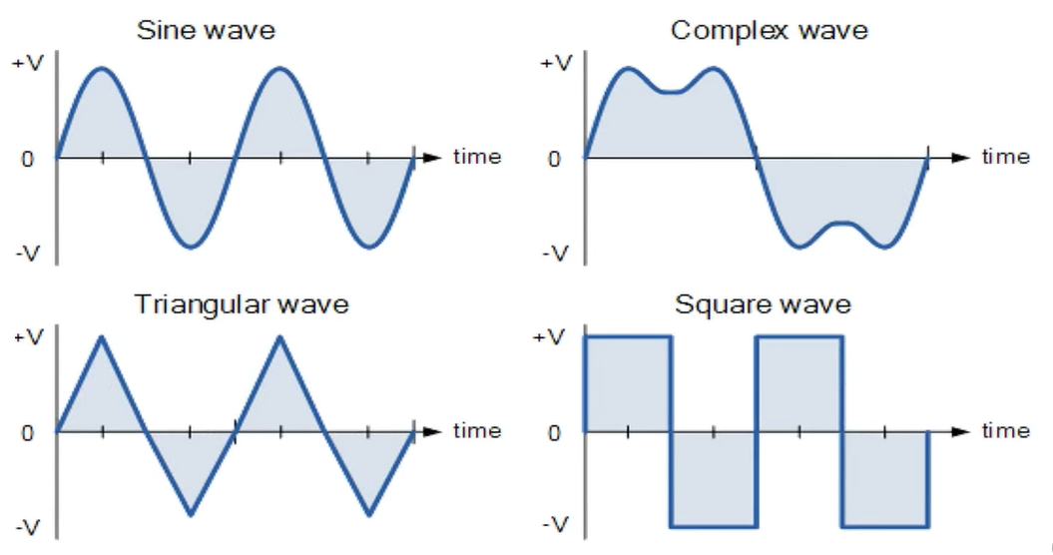  - Electronic oscillators are used in wide ranges of applications – such as watches , computer , radios,etc.  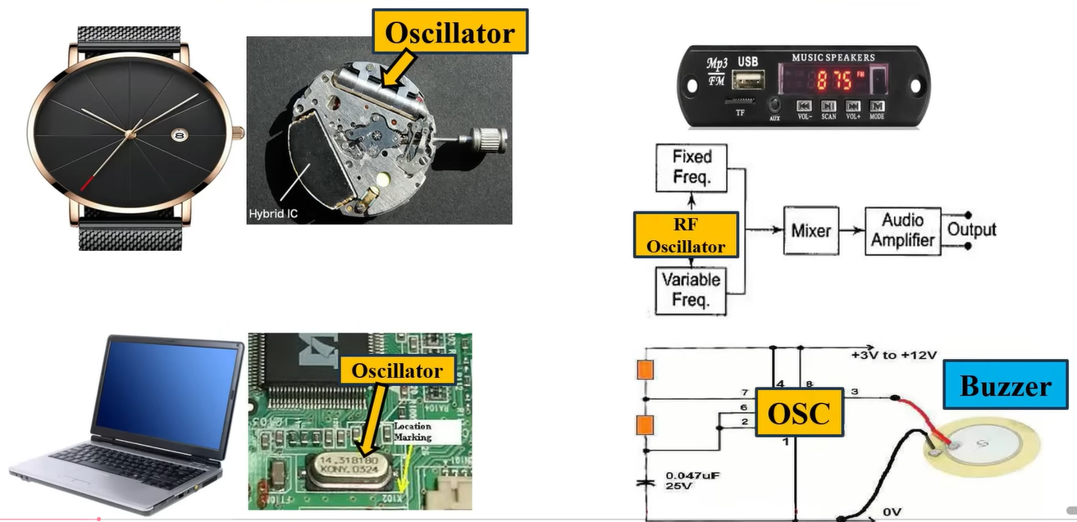  - Few other examples  - Clock generation (most important use case)  - Where: Digital circuits need a timing reference to know when to execute instructions.  - Microcontrollers (Arduino, STM32, AVR)  - CPUs, GPUs, FPGAs, ASICs  - Example : 16 MHz crystal on Arduino , 100 MHz system clock in a CPU  - Communication systems (RF & wireless)  - Where : To generate carrier frequencies and local oscillator (LO) signals.  - Mobile phones  - Wi-Fi, Bluetooth  - Radios, GPS  - Example : Phone uses oscillators at GHz range , FM radio uses oscillator to tune stations  - Oscillator decides which frequency you transmit/receive  - Timekeeping (watches & RTCs)  - Where : To keep accurate time.  - Digital watches  - RTC chips (DS1307, DS3231)  - Phones, laptops  - Example : 32.768 kHz crystal → divided down to 1 Hz  - Audio & sound generation  - Where : To generate audible frequencies (20 Hz – 20 kHz).  - Buzzers  - Musical keyboards  - Alarm systems  - Example : Beep sound = square wave oscillator , Synth = multiple oscillators (sine, sawtooth)  - Sound = vibration = oscillator output  - Power electronics & SMPS  - Where : To create PWM switching signals.  - Buck / Boost converters  - Mobile chargers  - Laptop adapters  - Example : 100 kHz–1 MHz oscillator drives MOSFET , Duty cycle controls output voltage  - No oscillator → no switching → no regulation  - Display & video systems  - Where : To generate pixel clock and synchronization timing.  - LCD / LED displays  - HDMI / VGA  - Camera sensors  - Example : Pixel clock decides refresh rate , Wrong clock → flicker or distorted image  - Oscillator controls visual stability  - Measurement & test equipment  - Where : To generate known reference signals.  - Function generators  - Oscilloscopes  - Frequency counters  - Example : Sine wave generator = oscillator , Time base in CRO = precision oscillator  - Security & digital systems (VLSI angle)  - Where : To generate pixel clock and synchronization timing.  - PLLs  - Clock tree synthesis  - Random number generators  - Why oscillator is needed:  - PLL starts with oscillator  - Ring oscillators used for on-chip variation detection  - Oscillator = foundation of digital silicon  - An oscillator receives DC power and produces AC signal as output (it can generate freq from Hz to GHz)  - Basic oscillator ckt  - Using inductor and capacitor (LC oscillator)  - Take a capacitor – charge it and then connect an inductor  - You will see continuous flow of energy between inductor and capacitor  - This creates oscillations  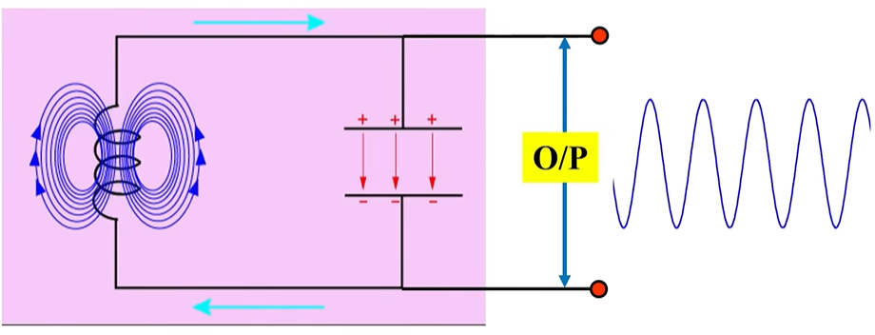  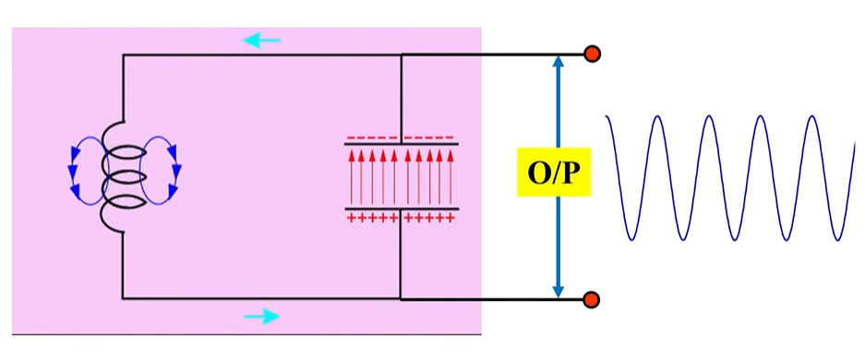  - Oscillator Using 555 timer IC  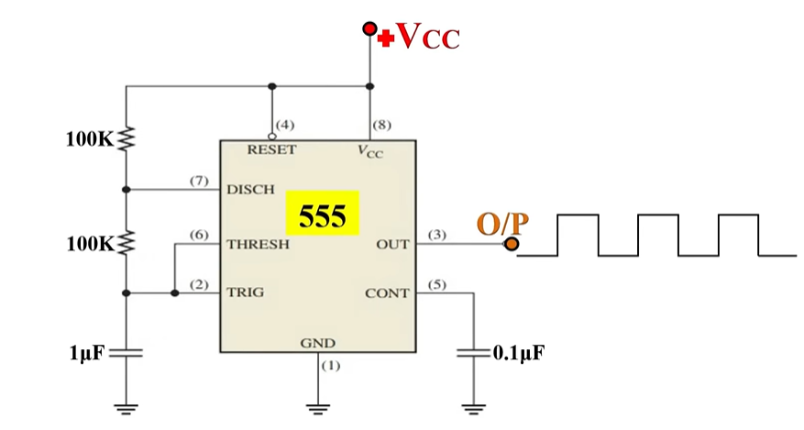  How does an oscillator work  - Practically oscillator is an amplifier with positive feedback  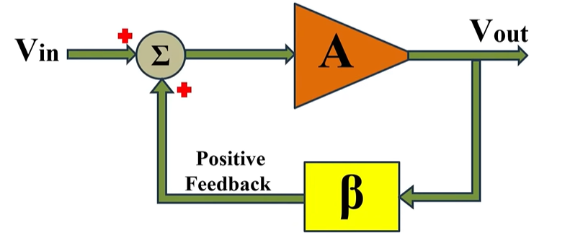  - Working principle  - When input is applied to amplifier it amplifies the signal (so for input = Vin output is A*Vin (where A is gain))  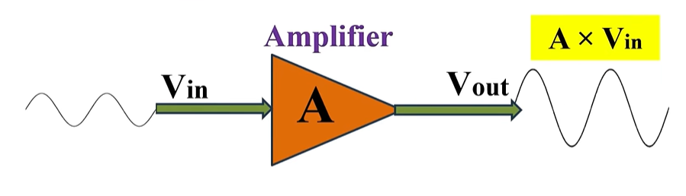  - Here the $β$ = feedback fraction and the feedback section is referred as “freq selective ckt” or “resonance ckt” ($β$ controls the fraction – that how much part of the output is to be fed back to input)  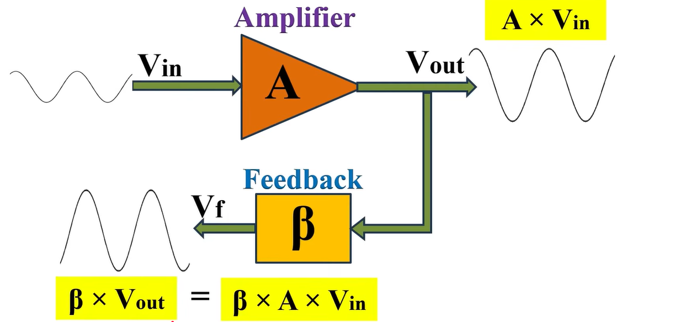  - If the input and output is in phase with each other (0-degree phase shift from input)  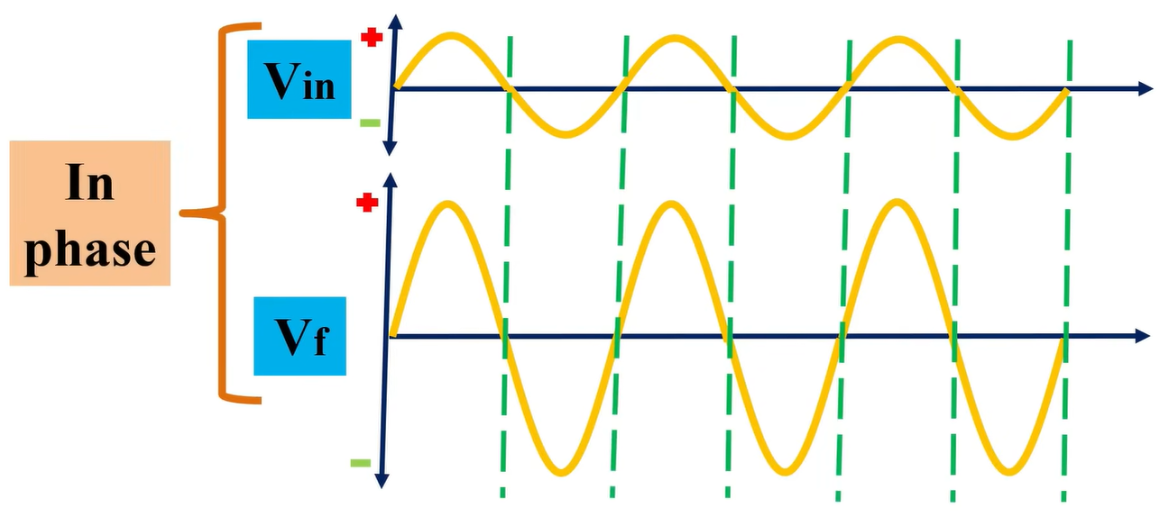  - If we add this inphase output to input we would get positive feedback to the input – and the input signal becomes Vin + Vf ( so this is basically amplifier with positive feedback)  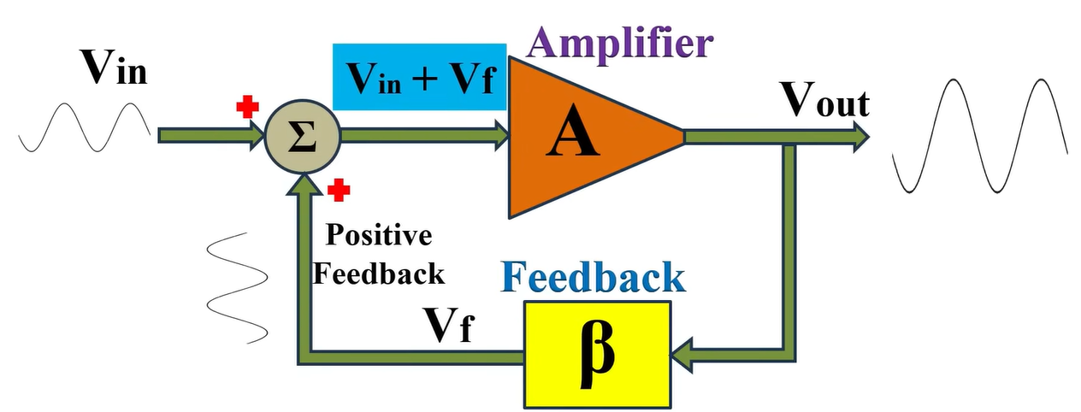  - Now if we remove/disconnect input signal Vin - only Vf will be present at the input (this will act as its input)  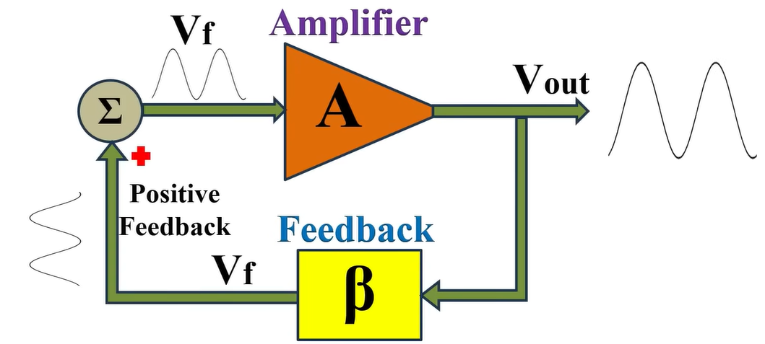  - After removing input weather, we will get sustained oscillation or not depends on the “loop gain” = $A*β$  - If “loop gain” = $A*β$ < 1  - Electrical oscillation amplitude will go on decreasing over a period of time and eventually die (this is called damped oscillation )  - Example :  - Let’s say $A*β=0.6$ and the input volt is 3v  - So, after 1st cycle op = 1.8v  - So, after 2nd cycle op = 1.08v  - So, after 3rd cycle op = 0.648v and so on …  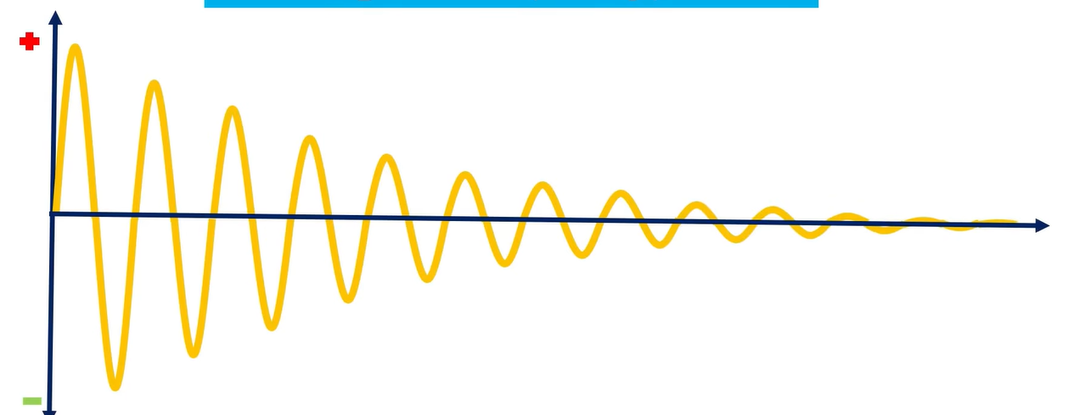  - If “loop gain” = $A*β$ > 1  - Electrical oscillation amplitude will go on increasing over a period of time and after sometime it will reach the rails (Vcc to -Vcc) (damped oscillation)  - Example :  - Let’s say $A*β=1.2$ and the input volt is 3v  - So, after 1st cycle op = 3.6v  - So, after 2nd cycle op = 4.32v  - So, after 3rd cycle op = 5.18v and so on …  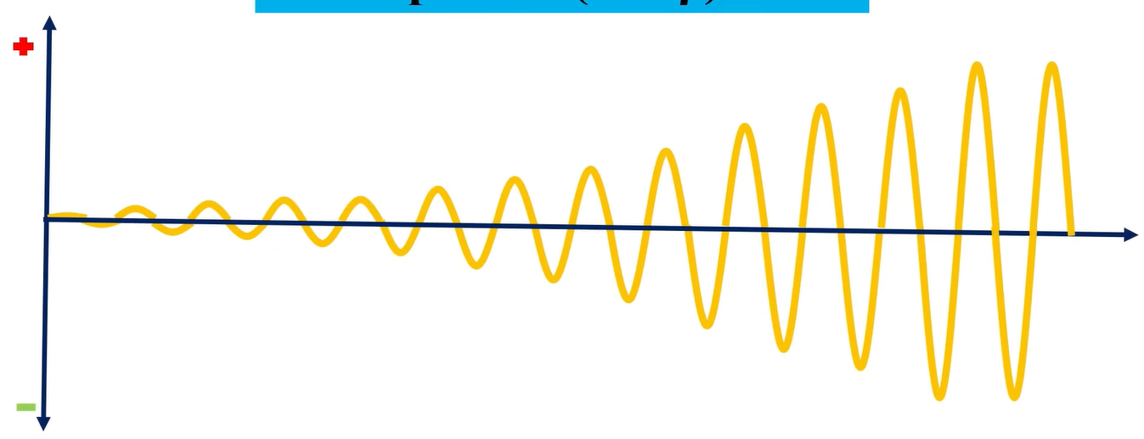  - If “loop gain” = $A*β$ = 1  - Here the output will be same as input – hence we will get sustained oscillation { undamped oscillation}  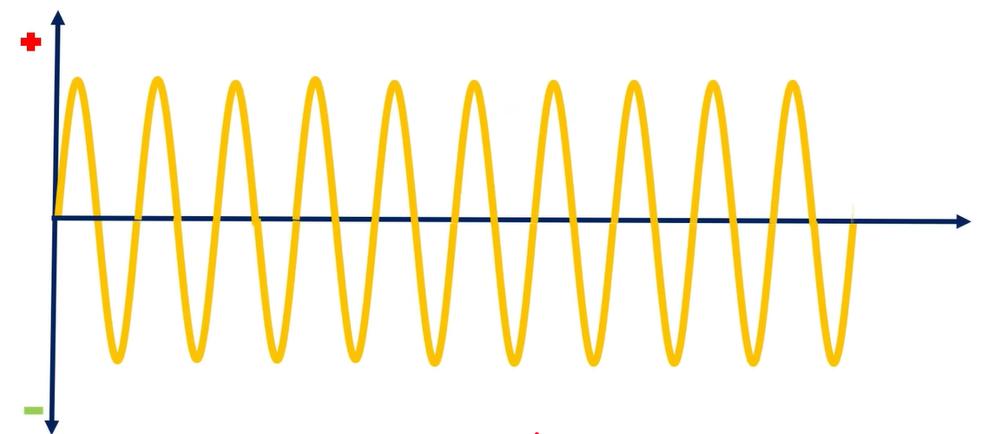  Barkhausen criterion  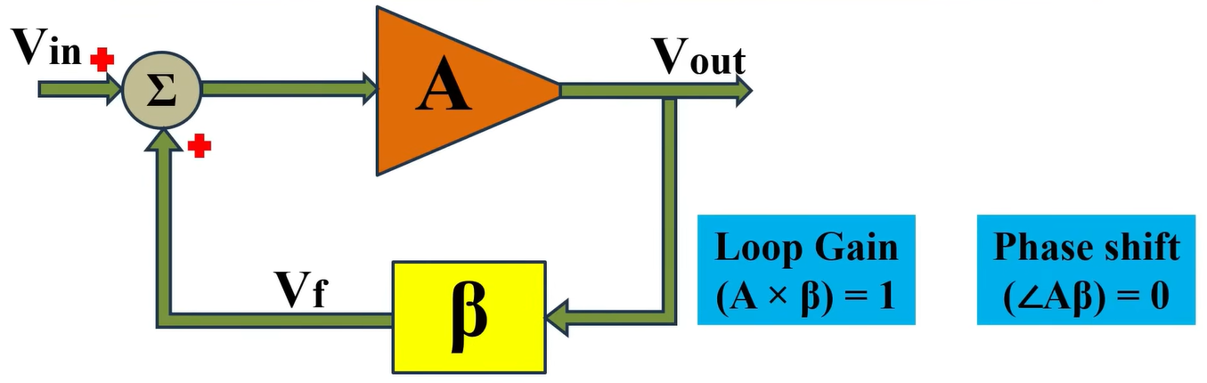  - For sustained oscillations Barkhausen criterion must be followed  - $| Aβ |=1$(loop gain = 1)  - $∠Aβ=0°$ (no phase shift between input and output)  [ note : here we have shown that initially an input voltage is given – but that is just for understanding – in actual no input is given – but the op-Amp (as amplifier) picks up the thermal noise as input (which is always present)  - In reality – this is what happens  - Thermal noise gets picked up as input and is amplified (noise has many signals of different frequencies – all of them gets amplified and fed to the feedback ckt)  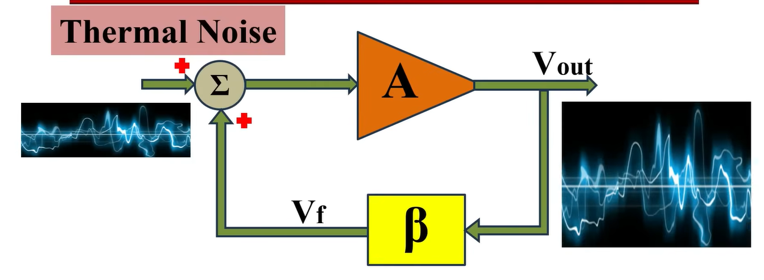  - Which is then fed to feedback ckt – which is also a freq selective ckt – so out of many only few frequencies get selected  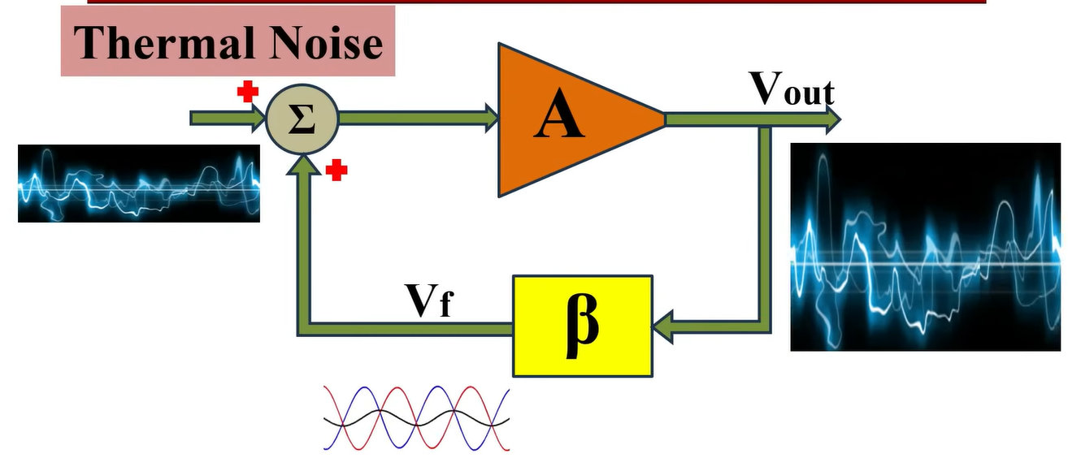  - And out of all these frequencies only 1 has 0 phase shift (so only one left)  - Here initially the loop gain (A$β$) is kept > 1 to increase the volt level of noise signals – until it reaches the volt level we want – and the loop gain (A$β$) is again changed to 1  - Output  $$V_{out}=A*( V_{in}+ βV_{out} )$$  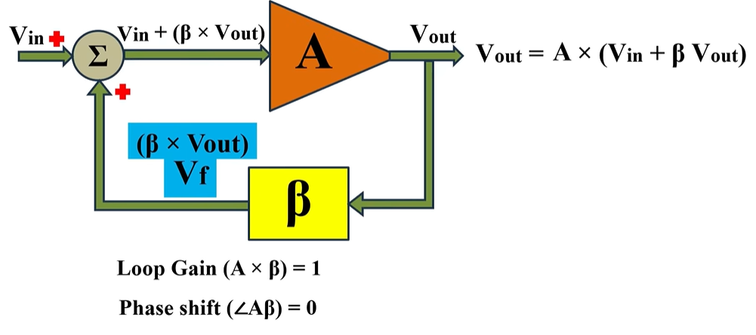  An oscillator oscillates at the frequency where BOTH conditions are met:  - Phase = 0°  - Loop gain ≥ 1  👉 Important insight:  - Many frequencies start (from noise)  - Feedback network kills all except one  - That one frequency satisfies Barkhausen  Why only one frequency survives from noise?  - Thermal noise contains many frequencies  - All random frequencies are initially amplified  - The feedback network is frequency-selective  - It provides different phase shifts and gains at different frequencies  - Only one frequency satisfies BOTH conditions  - Net phase shift = 0° / 360°  - Loop gain ≥ 1 (initially)  - All other frequencies die out  - If phase ≠ 0°, feedback becomes negative → attenuation  - If loop gain < 1 → amplitude decays  - The surviving frequency grows  - Until non-linearity reduces loop gain to exactly 1  - Result → stable oscillation at one frequency  Thermal noise (also called Johnson–Nyquist noise) is the random electrical noise generated due to heat in any conductor or electronic component.  In simple words  Because of temperature, electrons inside a material are always moving randomly.  This random motion causes tiny, unpredictable voltage and current fluctuations — even when no signal is applied.  👉 If something has temperature above 0 K, it has thermal noise.  Key characteristics  - ✅ Always present (can’t be eliminated)  - ✅ Exists even in resistors, wires, ICs  - ❌ Independent of applied voltage or current  - 📈 Increases with temperature  - 📈 Increases with bandwidth  - 🎲 Completely random (white noise=White noise is a random signal that has equal power at all frequencies within a given bandwidth.)  Where it comes from  - Random collisions of electrons with atoms  - Purely a physical phenomenon, not a circuit fault  Oscillator types  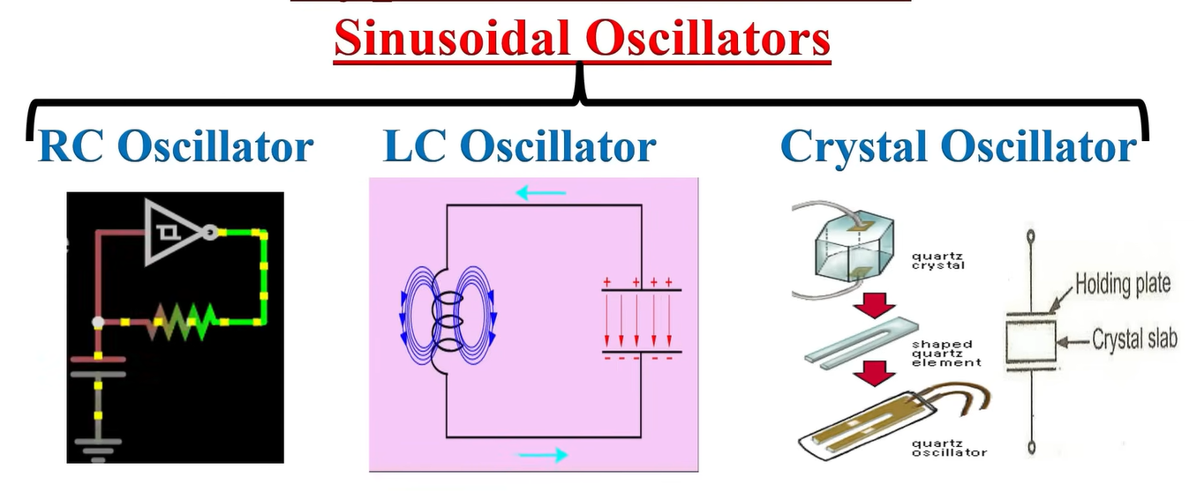  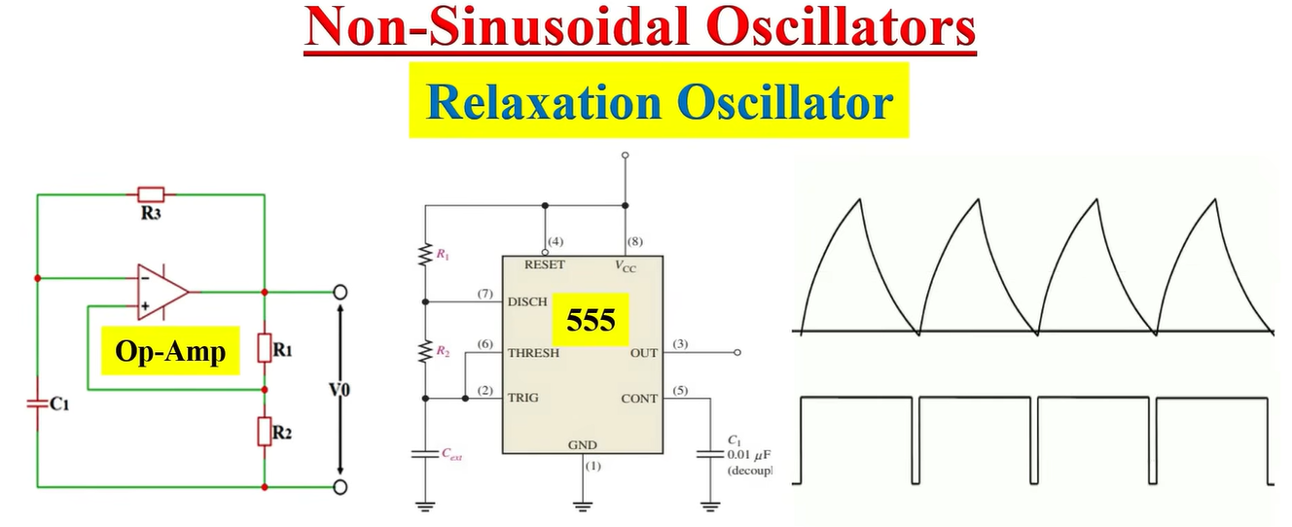  • RC oscillators  • LC oscillators  • Crystal oscillators  • Ring oscillators  • Relaxation oscillators (555, Schmitt)
How oscillator works | Link : https://www.youtube.com/watch?v=skDVcnVwK3A&list=WL&index=9  Two common oscillators  - LC oscillator ckt  - RC oscillator ckt  - LC oscillators  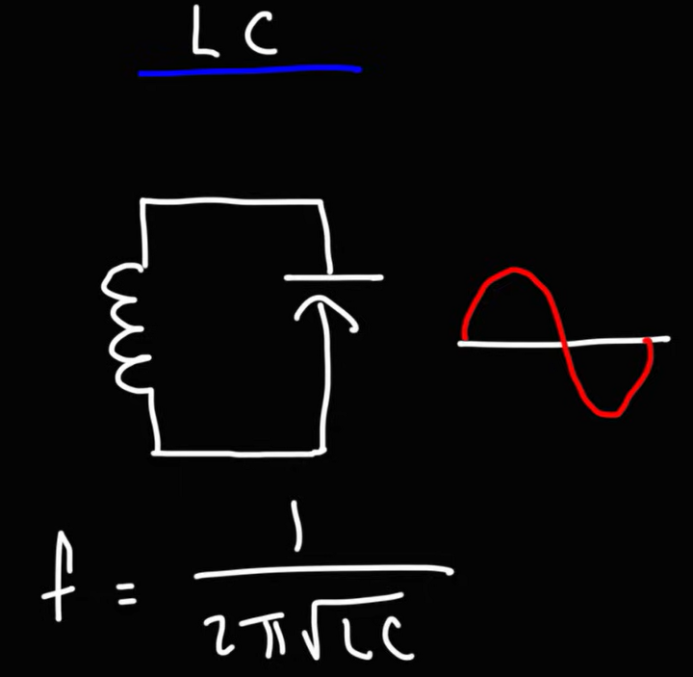  - Energy transfer takes place between capacitor and inductor and we get sinusoidal waves  - Freq of oscillations $f_{r}= \frac{1}{2π \sqrt{LC}}$  - Common LC oscillators  - Heartley oscillator (feedback via two inductors (or a tapped inductor) + one capacitor)  - Colpitts oscillator (feedback via two capacitors + one inductor)  - RC oscillators  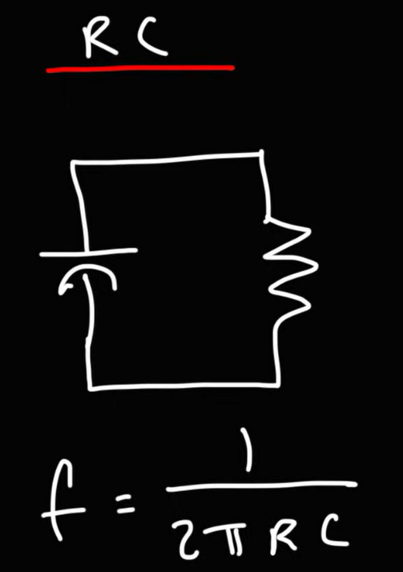  - Freq of oscillations $f_{r}= \frac{1}{2π RC}$ ( specific oscillators have their own variations of this formula – this one is general)  - Common RC oscillators  - RC phase shift oscillator (uses RC network and a transistor / or an opAmp)  - $f_{r}= \frac{1}{2π RC\sqrt{2N}}$  - Wein bridge oscillator (uses network and an opAmp)  - $f_{r}= \frac{1}{2π RC}$  - 555 timer (generates square wave) –  - can be converted to sine wave using additional LC network as shown below  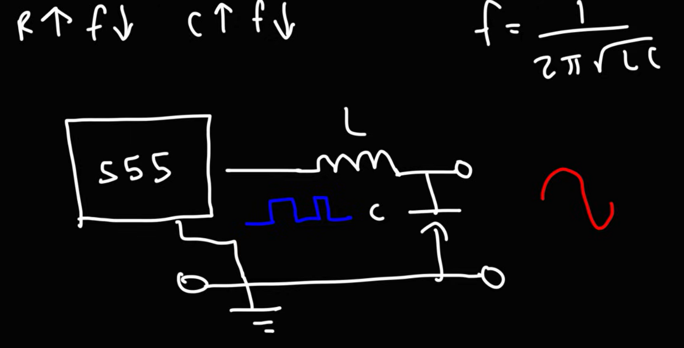  - can be converted to triangular wave using additional RC network  How LC oscillator work and How RC oscillator work  1️⃣ Why LC feels intuitive  You already get this:  - Inductor stores energy → magnetic field  - Capacitor stores energy → electric field  - Energy shuttles back and forth → oscillation  👉 RC has no inductor, so no magnetic energy storage → “then how oscillation?”  Valid question.  2️⃣ Key mindset shift (VERY IMPORTANT)  RC oscillators do NOT oscillate by energy exchange.  They oscillate by phase shift + amplification.  This is the core difference.  3️⃣ What RC actually does  Step-by-step intuition  - Capacitor charges and discharges  - This causes time delay  - Delay = phase shift  - RC networks create frequency-dependent phase shift  - At one particular frequency:  - Total phase shift = 180°  - Amplifier provides the other 180°  - Net phase shift = 360° → positive feedback  - Amplifier supplies energy  - RC network does not store energy  - Amplifier keeps re-injecting energy every cycle  👉 Oscillation is maintained because feedback stays in phase, not because energy swaps.  4️⃣ Compare LC vs RC (THIS WILL LOCK IT)  Feature LC Oscillator RC Oscillator  Energy storage L + C Only C  Oscillation mechanism Energy exchange Phase shift + gain  Frequency set by Resonance RC time constant  Typical frequency High (kHz–GHz) Low (Hz–hundreds of kHz)  Loss compensation Small Larger (amp driven)  5️⃣ One powerful analogy (remember this)  LC oscillator  👉 Pendulum (natural back-and-forth)  RC oscillator  👉 Person pushing a swing at the right time  - Swing alone would stop  - Correct timing (phase) + repeated push = oscillation
RC phase shift oscillator | - Used in low freq sine waveform generation upto KHz (typically range of audio frequencies)  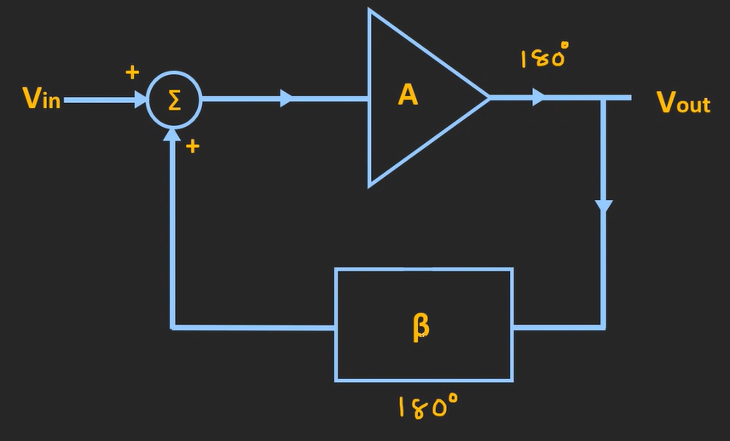  - Amplifier provides 180-degree phase shift (opAmp or transistor is used ((common-emitter BJT or inverting op-amp)) ) and thus feedback ckt needs to be in such a way that it should provide 180-degree phase shift (as per Barkhausen criteria)  - Now let’s dig the RC circuit  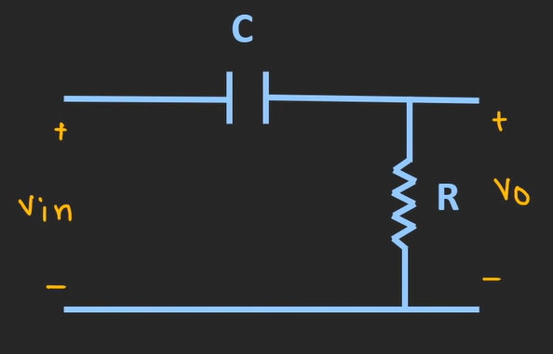  - This is a classic “HPF using RC network” [ $X_{c}=reactance= \frac{1}{2πfc}$ ]  - when low freq signal is passed – capacitor provides high reactance , acting as open ckt – no current flows – no output appears at output  - when high freq signal is passed – capacitor provides low reactance , acting as short ckt – current flows – output appears across R  - The phase shift provided by this ckt $∠θ$ = $\tan^{-1}{( \frac{X_{c}}{R}} )$  - For very small values of $X_{c}$ , phase shift will be 0 degree ($X_{c}=0)$  - For high values of $X_{c}$ , phase shift will be 90 degrees ($X_{c}=∞)$  - So, this ckt provides phase shift from 0$°$ to 90$°$  - So theoretically to get 180$°$ phase shift we need to cascade two RC network  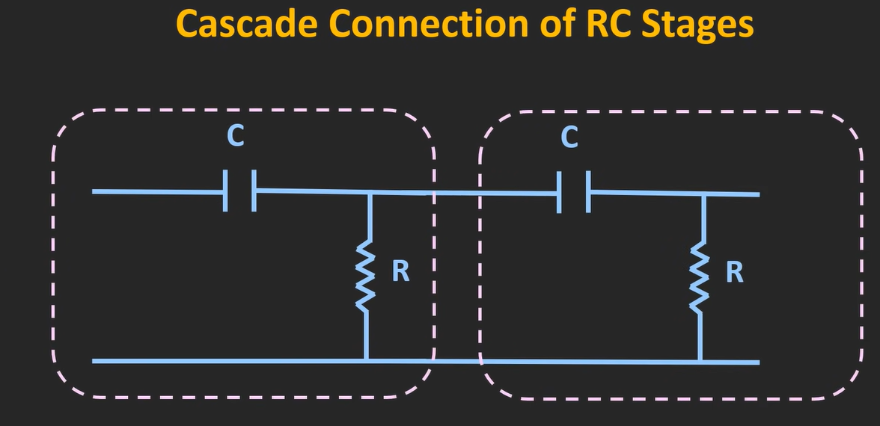  - But what HPF offers  - At low freq ( $X_{c} ↑$ ) means provides 90-degree phase shift (but magnitude = 0) (as $X_{c} is high$- capacitor acts as open ckt and signal doesn’t go ahead – making nothing appear at output) (so 90-degree phase shift also comes with no signal for further stage)  - At High freq ( $X_{c} ↓$ ) means provides 0-degree phase shift (but magnitude = 0) (as $X_{c} is low$- capacitor acts as short ckt and signal goes ahead and appears across resistor–)  - thus 180$°$ phase shift using two 90$°$ phase shift RC stages are not practical [ hence 3 RC stages are used – each providing 60$°$ phase shift (here each won’t provide exact 60$°$ because of the loading effect of prev stages – but the overall would become 180$°$ )  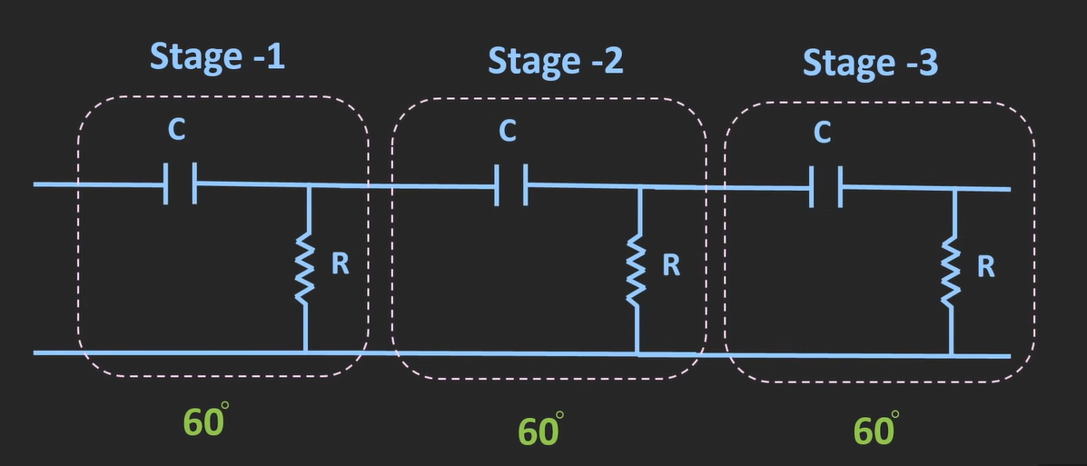  - This way by using more than 2 stages one can achieve 180$°$  - Example : 3 stages of 60$°$ , 4 stages of 45$°$  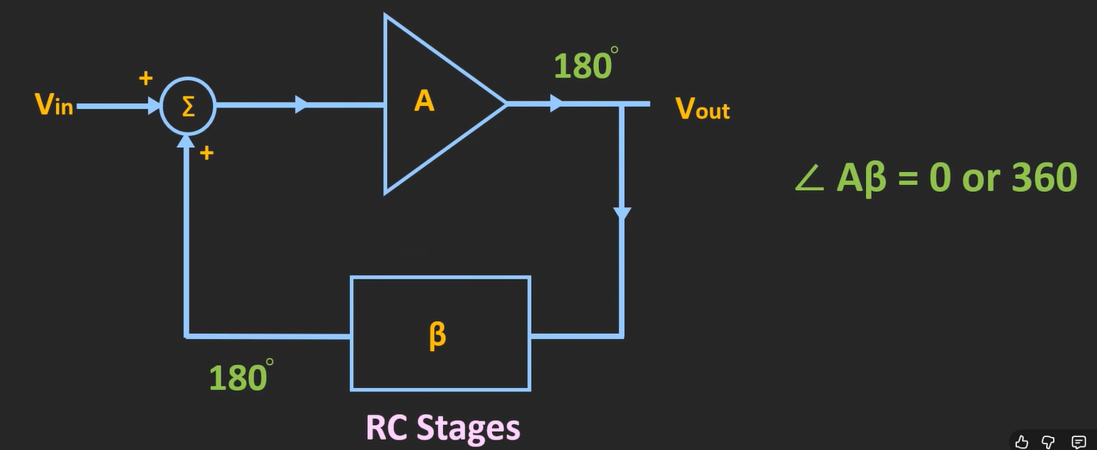  RC phase shift Oscillator using OpAmp  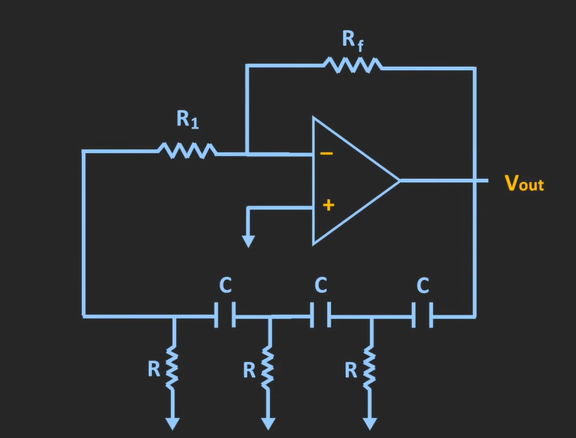  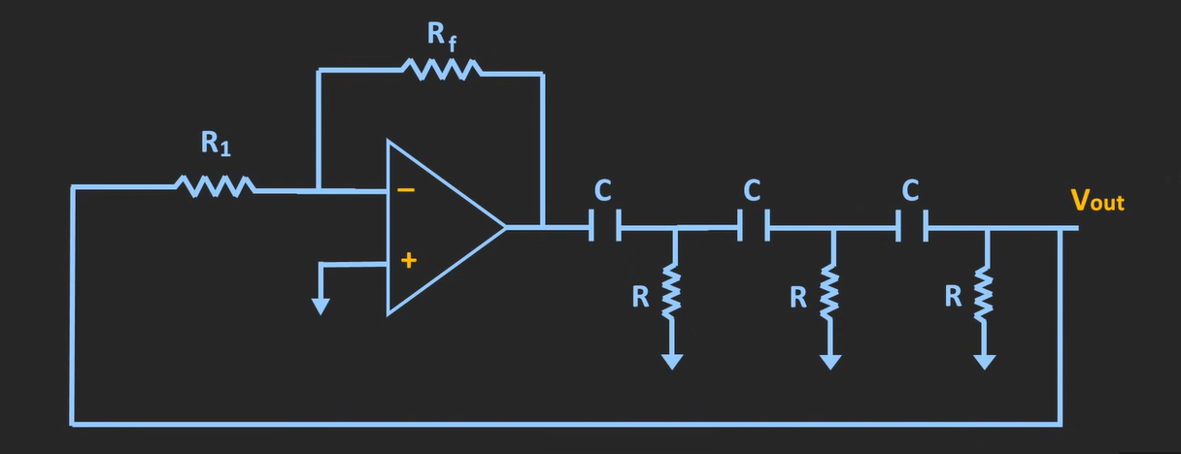  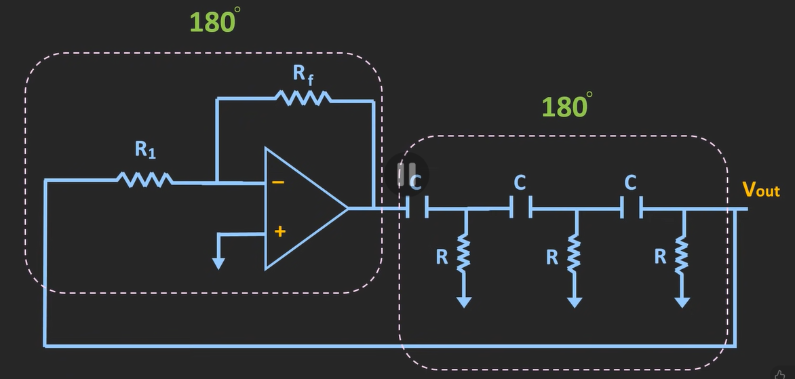  - The attenuation provided by RC circuit is $β=- \frac{1}{29}$ (represent 180-degree phase shifted value (hence ‘-‘ sign))  - So, the gain provided by Amplifier must be A = 29  - Now , this oscillator ckt only provides 0/360-degree phase shift and unity gain at one freq  - $f= \frac{1}{2πRC \sqrt{2N}}$ {N=number of RC stages}{example – in above image it is 3}  - in RC phase shift oscillator – R is kept fix and C is made changeable (that is how u can set the freq of oscillation)

LTspice Demo
555 oscillators | Link : https://www.youtube.com/watch?v=aJAZHPqEUKU  - Generate square wave oscillator based on 555 IC  - Generate sine wave oscillator based on 555 IC (using additional LC network)  - Generate triangular wave oscillator based on 555 IC (using additional RC network)
Sine wave oscillator (Quadrature oscillator) | Link : https://www.youtube.com/watch?v=aJAZHPqEUKU  - Generate sine wave oscillator based on LM324 op-Amp
Generate ckt – which generates sine signal from crystal oscillator and then generate square wave and then develop PLL to generate high freq square wave (multiplier as seen in microcontrollers)

