Volume 2. No 3/2015. ISSN 2313-0008 (Print); ISSN 2313-0016 (Online)

**Research Article**

Malays. j. med. biol. res.

**Protective Effects of Ferulic Acid in Alcohol Withdrawal Induced Anxiety and Depression in Mice**

**Suraj Kotwal1, Aman B. Upaganlawar2*, Manoj Mahajan3, Chandrashekhar Upasani4**

1Research Scholar, Pharmacology, SSDJ College of Pharmacy, Neminagar, Chandwad-423101, Dist: Nashik, Maharashtra, **INDIA** 2Associate Professor, Pharmacology, SSDJ College of Pharmacy, Neminagar, Chandwad-423101, Dist: Nashik, Maharashtra, **INDIA** 3Assistant Professor, Pharmacology, SSDJ College of Pharmacy, Neminagar, Chandwad-423101, Dist: Nashik, Maharashtra, **INDIA** 4Professor, Pharmacology, SSDJ College of Pharmacy, Neminagar, Chandwad-423101, Dist: Nashik, Maharashtra, **INDIA**

*Email: amanrx@yahoo.com, amanrxy@gmail.com

**ABSTRACT**

Background: Anxiety and depression are the most important troubling symptoms of continuous alcoholism. Objective: The present study was designed to examine the protective effects of ferulic acid in alcohol withdrawal-induced anxiety and depression in experimental mice.

Methods: Male albino mice were divided into different groups. They were received 10% ethanol (2 g/kg; p.o.) twice on the first day and once on successive days for total six days, after 24 hrs. Withdrawal symptoms were observed using the different model for anxiety and depression such as elevated plus maze, open field test, hole board test, marble burying test and tail suspension test. Ferulic acid was tested as 10 and 20 mg/ kg, orally.

Results: Treatment with ferulic acid (10 and 20 mg/kg, p.o) showed significant reduction of alcohol withdrawal syndromes in different models. Taken together our result showed a protective effect in alcohol withdrawal anxiety and depression as tested in well-established animal models.

Conclusion: The present study showed that ferulic acid dose-dependently prevents alcohol withdrawal-induced anxiety and depression in mice.

**Key words:** Anxiolytic, Antidepressant, Ethanol withdrawal symptoms, Ferulic acid



**9/18/2015** **Source of Support:** None, **No Conflict of Interest:** Declared

This article is is licensed under a Creative Commons Attribution-NonCommercial 4.0 International License.

**Attribution-NonCommercial (CC BY-NC)** license lets others remix, tweak, and build upon work non-commercially, and although the new works must alsoacknowledge & be non-commercial.

**Introduction**

Alcohol is the most frequently abused drug in our society. Those who stop suddenly or reduced its consumption may experience withdrawal symptoms such as irritability, anxiety, depression, agitation or seizures (Robert and Koob, 1997). Withdrawal from chronic ethanol exposure is associated with heightened anxiety, depression and severe physical symptoms (Heilig et al*.* 2010)**.** Research outcome has demonstrated that acute administration of alcohol can alter the release of neurotransmitters from neurons thereby disrupt the function of proteins in neuronal membranes. Following repeated administration of alcohol, the brain attempts to restore normal functioning through adaptations (tolerance) that reduce alcohol’s initial perturbing effects.

Chronic exposure to alcohol can lead to physical dependence, in which neuronal adaptations to alcohol become sufficiently pronounced that the brain requires to the continued presence of alcohol to function normally. Termination of a prolonged drinking session, the adaptations that developed to offset, alcohol’s initial inhibitory actions are unopposed, resulting in a rebound hyperexcitability or withdrawal syndrome (Kalant, 1993).

Ferulic acid is a derivative of cinnamic acid with molecular formula C10H10O4. It is isolated as the 3-methoxy-4-hydroxycinnamic acid from the genus Ferula for structure determination. Ferulic acid possesses a wide range of

CC-BY-NC 2014. i-Proclaim | MJMBR Page 231

|  |  |
| --- | --- |
| Kotwal et al: Protective Effects of Ferulic Acid in Alcohol Withdrawal Induced Anxiety and Depression in Mice | (231-236) |

pharmacological activities includes anti-depressant (Ying-jin Zhang et al. 2011), anxiolytic (Yoon et al. 2005) and antioxidant (Hundson et al. 2002). There is no scientific report available regarding the effect of ferulic acid in alcohol withdrawal-induced anxiety and depression. Considering these facts the present study was carried out.

**Materials and Methods**

**Animals**

Male albino mice weighing (20-25 g) were procured from Lachmi Biotech, Pune. They were kept at the temperature (25 ± 2° C) and relative humidity of 45-55% and 12/12 h light/dark cycle. They had free access to standard pellet chow and water at labium. Food and water were withdrawn two hr prior to administrations of the drug. The complete experiment was carried out at 10:00 a.m. to 4:00 p.m. The study protocol was approved by the Institutional Animal Ethics Committee (IAEC) of the college (Approval number: SSDJ/IAEC/2012/023).

**Drugs and chemicals**

Ferulic acid was purchased from Spectrachem, Pvt. Ltd, Aurangabad, Maharashtra, India. Ethanol was purchased from Loba Chem, Mumbai Maharashtra, India. 10% ethanol solution was prepared by diluting with distilled water.

**Study design**

**Acute study:** Mice received 10 % ethanol 2 g/kg, intragastrically, after 30 min, its effect on different models of anxietyand depression was assessed.

**Chronic study:** Mice received 10% ethanol, 2 g/kg, intragastrically, twice a day on the 1stday and once a daily for atotal six days. On the 7th day, mice were tested for withdrawal reactions. On the 7th day, the treatments were changed, the group chronically treated with ethanol received saline only. The animals that received ferulic acid (10 & 20 mg/kg, p.o) for longer period were challenged with normal saline only. The animals that received ferulic acid (10 & 20 mg/kg, p.o) alone with ethanol on day 1 through 6, were received only ferulic acid (10 & 20 mg/kg, p.o) on 7th day. Another group that received ethanol chronically was treated with ferulic acid (10 & 20 mg/kg, p.o).

**Assessment of ferulic acid on anxiety and depression**

**Elevated plus maze:** This model of anxiety has been used extensively for evaluation of novel anxiolytic agents. Themodel has been validated pharmacologically (Pellow and File, 1986) and currently considered the gold standard test of anxiety-related behavior (Kliethermes, 2005). The instrument used in the present study consisted of two open arms (25 x 5 cm) crossed with two closed arms (25 x 5 x 20). The arms were connected with a central square of 5 x 5 cm. The apparatus elevated to a height of 25 cm (Lister, 1987). Mice were placed on the central platform of the plus-maze facing an open arm. Time spent and the number of entries in the open and close arms and % preference to closed arm were monitored.

**Hole board test:** Head dipping behavior in rodents has been recorded as a measure of anxiety. The instrument consistsof metal plate floor (40 X 40 cm), placed 3.5 cm above the base of the apparatus include 16 holes with an equivalent distance of 1.5 cm. The apparatus was elevated to a height of 25 cm (Lister, 1987). Treated mice were kept in one corner and observed for next 5 min for the number of head dips.

**Open field test:** The withdrawal-induced changes in the locomotor activity of mice were measured using an openfield apparatus (Crawley and Goodwin, 2002). The apparatus consist of the wooden box (96 x 96 x 5 cm). The floor of the box was divided into 16 (6 x 6 cm) squares. Mice were placed individually at one corner of the apparatus and observed for next 5 min. The parameters noted were ambulation (number of squares travelled) and reared.

**Marble burying test:** This test used to record the number of marbles buried by mice placed in a novel environment.Marble burying test is sensitive to the effects of selective serotonin reuptake inhibitors (Broekkamp et al.1986). In this, a propylene cage (28 x 16 x 12 cm) was used containing 24 clean glass marbles placed equidistance 5 cm deep sawdust. Mice were treated with respective drug 30 minutes before the test. Then mice were placed in the novel cage containing 24 marbles. The number of marbles covered (at least 2/3 of the area) were counted.

**Tail Suspension Test:** Mice suspended by the tail initially struggles, followed by periods of immobility that increasesin duration across the 6 min test. The total duration of immobility induced by tail suspension was measured according to the method facial means of evaluating potential anti-depressants (Steru et al.1985). Each mouse was suspended by the tail on the edge of a hook 58 cm above the floor using adhesive tape placed approximately 1cm from the tip of the tail.

**Statistics**

The data is reported as mean ± S.E.M. from six animals in each group. Analysis was performed by one-way ANOVA using statistical Graph-pad Prism version 5.0 software. A value P<0.05 was considered statistically significant.

Page 232 Malaysian Journal of Medical and Biological Research **** Volume 2 **** Number 3/2015

Volume 2. No 3/2015. ISSN 2313-0008 (Print); ISSN 2313-0016 (Online)

**Results**

**Effect of Ferulic acid in Elevated plus maze test**

Treatment with Ferulic acid (10 and 20 mg/kg) alone and during ethanol withdrawal reversed ethanol withdrawal-induced anxiety behaviors (Fig.1). The vehicle-treated mice spent 42.80 ± 12.03 seconds in open arm. The animals treated chronically with FA (10 and 20 mg/kg) spent 133.4 ± 15.53 and 125.6 ± 11.43 significantly more time in the open arm when compared with vehicle-treated and ethanol withdrawn groups.

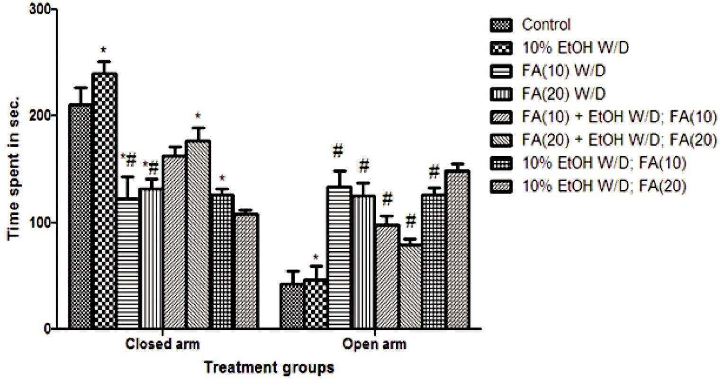

**Figure 1:** Exploratory behavior of animals in Elevated plus maze after treatment with ferulic acid

n = 6, Values are mean ± SEM, calculated by one-way ANOVA followed by Dunnett’s test. * p< 0.05 significant compared with vehicle-treated # p< 0.05 significant compared with the ethanol withdrawal group.

**Effect of ferulic acid in Hole board test**

The vehicle-treated mice showed 40.6 ± 8.05 head dips. FA (10 and 20 mg/kg) significantly 60.6 ± 4.60 and 67.2 ± 5.30 increased the number of head dips, whereas mice treated with FA (10 mg/kg) alone with ethanol also increased 43.4

± 6.74 number of head dips (Table 1).

**Table1. Effect of Ferulic acid on number of head dips in hole board test**

|  |  |  |  |
| --- | --- | --- | --- |
| **Sr. No.** | **Treatment** | **No. of head dips** | |
|  |  |  |  |
| 1 | Vehicle | 40.6 | ± 8.05 |
|  |  |  | |
| 2 | 10% EtOH day 1-6 W/D | 24 ± 6.10 | |
|  |  |  |  |
| 3 | F.A.(10) day 1-6 W/D | 60.6 | ± 4.60 * |
| 4 | F.A.(20) day 1-6 W/D | 67.2 | ± 5.30 *# |
| 5 | F.A.(10) + 10% EtOH day 1-6; F.A.(10) day 7 | 43.4 | ± 6.74 *# |
| 6 | F.A.(20) + 10% EtOH day 1-6; F.A.(20) day 7 | 35.2 | ± 3.85 |
|  |  |  |  |
| 7 | 10% EtOH day 1-6; F.A. (10) day 7 | 38.3 | ± 2.14 # |
| 8 | 10% EtOH day 1-6; F.A. (20) day 7 | 21.23 ± 2.21 | |
|  |  |  |  |

n = 6, Values are mean ± SEM, calculated by one-way ANOVA followed by Dunnett’s test. * p< 0.05 significant compared with vehicle-treated # p< 0.05 significant compared with the ethanol withdrawal group*.*

**Effect of ferulic acid in Open field test**

Figure 2 illustrates the behavioral performance of mice in the open field. The ethanol withdrawal groups exhibited a decreased (41.4 ± 7.7) in distance travelled in the open field test as compared with control group (61.4 ± 9.0). Mice treated chronically with FA (10 mg/kg) exhibited increased 52.8 ± 10.11 in square travelled in open field. Mice treated chronically with FA (10 mg/kg) alone with ethanol exhibited increased 48.2 ± 4.8 in square passed in an open field as compared with ethanol withdrawal group.

CC-BY-NC 2014. i-Proclaim | MJMBR Page 233

|  |  |
| --- | --- |
| Kotwal et al: Protective Effects of Ferulic Acid in Alcohol Withdrawal Induced Anxiety and Depression in Mice | (231-236) |

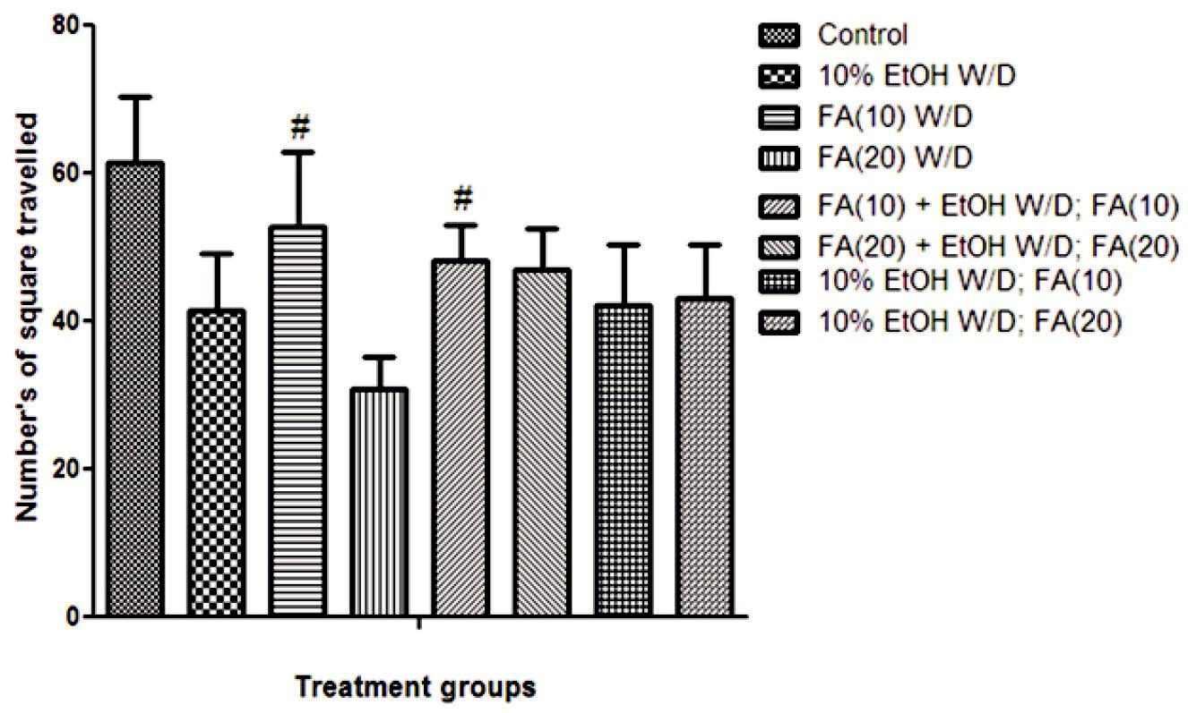

**Figure 2:** Effect of Ferulic acid on the number of squares travelled in open field apparatus

n = 6, Values are mean ± SEM, calculated by one-way ANOVA followed by Dunnett’s test. * p< 0.05 significant compared with vehicle-treated # p< 0.05 significant compared with the ethanol withdrawal group*.*

**Effect of ferulic acid in Marble burying test**

Mice treated chronically with FA (10 and 20 mg/kg) significantly decreased number of marbles buried (11.80 ± 1.24 and 12.40 ± 1.36) as compared with vehicle-treated and ethanol withdrawal group. Mice treated with chronic administration of FA (20 mg/kg) alone with 10% ethanol and challenged with FA (20 mg/kg) showed significant decrease in burying behavior (15.60 ± 1.32) as compared with vehicle-treated group (Table 2).

**Table 2:** Effect of Ferulic acid on the numbers of marble buried in Marble burying test

|  |  |  |  |
| --- | --- | --- | --- |
| **Sr.No.** | **Treatment group (mg/kg)** | **No. of Marbles buried** | |
|  |  |  |  |
| 1. | Vehicle | 21.40 | ± 1.77 |
|  |  |  |  |
| 2. | 10% EtOH day 1-6 | 13.20 | ± 0.95 |
|  |  |  | |
| 3. | F.A.(10) day 1-6 | 11.80 ± 0.24 * | |
| 4. | F.A.(20) day 1-6 | 12.40 | ± 0.36 *# |
| 5. | F.A.(10) + 10% EtOH day 1-6; F.A.(10) day 7 | 17.60 | ± 0.97 |
|  |  |  |  |
| 6. | F.A.(20) + 10% EtOH day 1-6; F.A.(20) day 7 | 15.60 | ± 1.32 |
|  |  |  | |
| 7. | 10% EtOH day 1-6; F.A. (10) day 7 | 15.0 ± 1.09 | |
|  |  |  |  |
| 8. | 10% EtOH day 1-6; F.A. (20) day 7 | 17.40 | ± 1.20 |
|  |  |  |  |

n = 6, Values are mean ± SEM, calculated by one-way ANOVA followed by Dunnett’s test. * p< 0.05 significant compared with vehicle-treated # p< 0.05 significant compared with the ethanol withdrawal group*.*

**Effect of Ferulic acid in Tail suspension test**

Figure 3 illustrates that mice treated with 10% ethanol showed increased in the duration of immobility (116.2 ± 5.75). Mice treated with FA (10 and 20 mg/kg) produced significantly decreased in duration of immobility (68.2 ± 7.99 and 58.6 ± 6.28) showed significant effect as compared with vehicle-treated and ethanol withdrawal.

Page 234 Malaysian Journal of Medical and Biological Research **** Volume 2 **** Number 3/2015

Volume 2. No 3/2015. ISSN 2313-0008 (Print); ISSN 2313-0016 (Online)

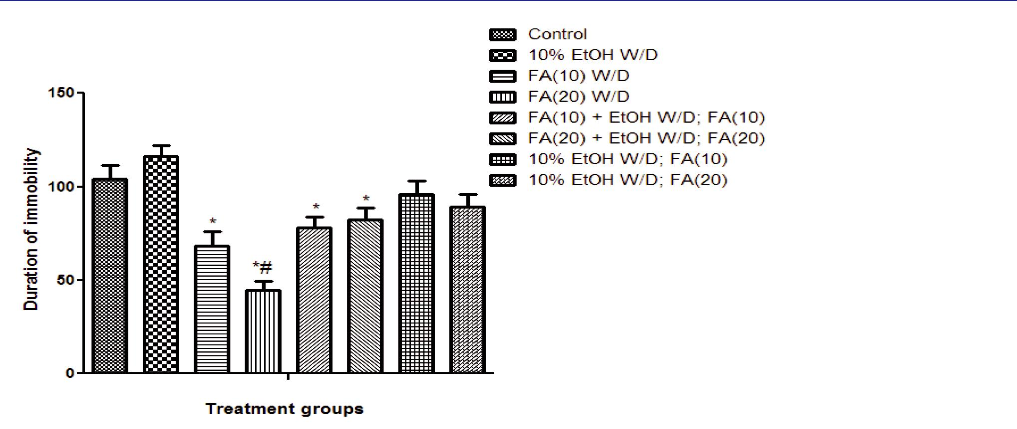

**Figure 3:** Effect of Ferulic acid on the duration of immobility in tail suspension test

n = 6, Values are mean ± SEM, calculated by one-way ANOVA followed by Dunnett’s test. * p< 0.05 significant compared with vehicle-treated # p< 0.05 significant compared with the ethanol withdrawal group*.*

**Discussion**

In the present study, Ferulic acid administered during ethanol withdrawal alleviated anxiety and depression behaviors. It was suggested that a drug withdrawal symptom has a neurobiological level. It is reported that it is caused by dysfunction of one or more neurotransmitters and their receptors like GABA receptors, serotonin receptor, adenosine receptor and adrenergic receptor. It was reported that acute systemic administration of ethanol activated the different neurotransmitter mechanism. Drug withdrawal from the chronic administration is characterized by responses opposite to the acute initial actions of the drug (Di Chiara and Imperato, 1988). Alcohol consumption produced unbalance in the neurochemical equilibrium of the brain. If the alcohol exposure continues, the brain association an opposing adaptation (i.e., neuroadaptation) to balance the effect of the alcohol and restore neurochemical equilibrium. With prolonged use of alcohol, the amount of GABA production decreases to sustain homeostasis. During ethanol withdrawal, ethanol is no longer available to enhance GABA-A receptor thereby the inhibitory function is reduce. Neurotransmitters such as norepinephrine and dopamine produce the opposite effects of alcohol. Ethanol enhances the inhibitory effect of dopamine. Conversely, studies have suggested that ethanol may also inhibit glutamate, which is the main excitatory transmitter. If this were so, excitatory neurotransmissions would increase during withdrawal (Landolt and Gillin, 2001).

Withdrawal symptoms may also involve enhanced serotonin activity at 5HT2 receptors. In an animal model of alcohol withdrawal, drugs that act as activation of this receptors prevented withdrawal increased in anxiety. Serotonin is a key contributor in brain dysfunction caused by alcohol and other drugs abuse. Serotonin does not act alone within the brain. Instead, serotonergic neurons are part of a larger circuit of interconnected neurons that transmit information within and among brain regions (Sellers, *et*. *al*., 1992). Chronic ethanol administration is known to produce behavioral and biochemical changes in humans and animals (Snell, *et*. *al*., 1996). Biochemical studies have provided evidence that enhancement of GABA and serotonin-mediated neuronal activity may contribute to the sedative, anxiolytic and antidepressant profile of ethanol. Withdrawal from chronic intake of ethanol is also known to produce withdrawal reactions, which are from anxiogenic and depression (Kulkarni and Verma, 1993). The present study provides valuable information about the therapeutic potential of FA for the treatment of alcohol withdrawal. Studies reported that FA is a type of hydroxy-cinnamic acid and possesses anxiolytic (Yoon, *et*. *al.*, 2005), antidepressant (Ying J Z *et. al.*, 2011), antidiabetic (Jung, *et*. *al.*, 2007) and antioxidant (Hundson, *et*. *al.*, 2000) activities.

In elevated plus maze acute administration of ethanol produced a significant increase in the time spent on open arms, thereby suggesting an anxiolytic profile of ethanol in mice also chronic administration of FA (10 and 20 mg/kg)spent more in the open arm shows anxiolytic effect in EPM (Hata, *et*. *al*., 2000). The result in Hole board apparatus showed the increase in number of head dips in acute administration of FA (20 mg/kg) indicates the anxiolytic effect. Result of chronic administration of FA shows increase in number of head dips indicates the protective anxiolytic effect FA. The marble burying test is based on a species-specific-burying behaviour expressed when mice are faced with novel objects such as marbles (Broekkamp, *et. al*., 1986). Anxiolytics decreases the number of marbles buried at non-sedative doses (Njung’e and Handley, 1991). This test has some predictive value for antidepressant and anxiolytic drugs. An animal treated

CC-BY-NC 2014. i-Proclaim | MJMBR Page 235

|  |  |
| --- | --- |
| Kotwal et al: Protective Effects of Ferulic Acid in Alcohol Withdrawal Induced Anxiety and Depression in Mice | (231-236) |

with FA (20 mg/kg) also reduces the marble burying behavior it indicates the anxiolytic effect of drugs (Broekkamp, *et. al*., 1986). In an open field test, an increase in the central part of the device without increasing the total locomotionis interpreted as an anxiolytic effect (Westerberg, 1999). In the present study, there was an increase in the number of squares travelled with the treatment of acute and chronic administration FA (10 and 20 mg/kg) which indicate anxiolytic activity. Antidepressants decrease the duration of immobility (i.e. increases the duration of active periods with escape attempts) (Steru, et al. 1985). The present study provides behavioural evidence for the antidepressant activity of acute as well as chronic treatment of FA. Our result demonstrates that FA in different doses when evaluated in classical models, there is significant inhibition of the duration of immobility. These results showed that FA (10 and 20 mg/kg) decreased in duration of immobility indicates the antidepressant activity (Gershenfeld, et. al. 2001).

In conclusion, chronic treatment of FA alone and along with ethanol exposure prevents the ethanol withdrawal, characterized by reduction anxiety and depression. FA can be used in the treatment of such types of disorders or associated diseases. There is a wide scope for the present study includes. Estimation of different neurotransmitters involved in the process and study of the molecular mechanism of FA in ethanol withdrawal-induced anxiety and depression.

**References**

Bhattacharya S K, Bhattacharya A, Sairam K, Ghosal S, (2002) Anxiolytic-antidepressant activity of *Withania Somnifera* glycowithanolides: an experimental study, Phytomedicine, 7, 463-469.

Broekkamp C L, Rijk H W, Joly D, Lloyd K L, (1986). Major tranquillizers can be distinguished from minor tranquillizers on the basis of effects on marble burying in mice, European Journal of Pharmacology, 126, 223-229.

Crawley J, Goodwin K K, (1980). Preliminary report of a simple animal behaviour model for the anxiolytic effect of benzodiazepines, Pharmacology Biochemical Behavior, 13, 167-170.

Di Chiara, Imperato A, (1988). Drugs abused by humans preferentially increase synaptic dopamine concentrations in the mesolimbic system of freely moving rats, Neurobiology, 85, 5274-5278.

Gershenfeld H K, Liu X, (2001). Genetic differences in tail suspension test and its relationship to Imipramine response among inbred strains of mice. Biology of Psychiatry, 49, 575-581.

Hata T, Hiroyunki N, Itoh E, Funakamo Y, (2000). Anxiety-Like Behavior in Elevated Plus-Maze Tests in Repeatedly Cold-Stressed Mice, Japanese Journal of Pharmacology, 85, 89-196.

Heilig M, Egli M, Crabbe J C, Beacker H C, (2010). Acute withdrawal protected abstinence and negative effect in alcoholism: are they linked? Addiction Biology, 15, 169-184.

Hundson E A, Dinh P A, Kokubun T, Simmonds M S, Gescher A C, (2002). Characterization of potentially chemopreventive phenols in extracts of brown rice that inhibit the growth of human breast and colon cancer cells, Cancer Epidemiology Biomarkers, 9,1163-1170.

Jung E H, Kim S R, Hwang I K, (2007). Hypoglycemic effects of a phenolic acid fraction of rice bran and ferulic acid in C57bl/KsJ-db/db mice, Journal of Agriculture Food and Chemical, 55, 9800-9804

Kalant H, (1993). Research and tolerance: What can we learn from history? Alcoholism: Clinical Experimental Research, 22, 67-74. Kliethermes C L, (2005). Anxiety-like behaviors following chronic ethanol exposure, Neuroscience Biobehavioral Research, 28, 837.

Kulkarni S K, (2008). Effect of different novel class of drugs as antianxiety activity, Indian Journal of Experimental Biology, 46, 633-638.

Landolt H P, Gillin J C, (2001). Sleep abnormalities during abstinence in alcohol-dependent patients. Etiology and Management of CNS drugs, 15,413-425.

Lister R G, (1987). The use of a plus maze to measure anxiety in the mouse. Psychopharmacology (Berlin) 92,180-185. Njung’e K and Handley S L, (1991). British Journal of Pharmacology, 104, 105.

Pellow S and File S E, (1986). Anxiolytic and anxiogenic drug effects on exploratory activity in an elevated plus maze: A novel text of anxiety in the rat, Pharmacology Biochemistry Behavior, 24,525.

Robert A J and Koob G F, (1997). The Neurobiology of Addiction: An Overview, Alcohol Health and Research World, 21(2), 101-106. Sellers E M, Higgins G A, Sobel M R, (1992). 5-HT and alcohol abuse. Trends in Pharmacological Science, 13, 69-75.

Snell L D, Nunley K, Lickteig R, Browning M, Hoffman P,(1996). Regional and subunit specific changes in NMDA receptor mRNA and immunoreactivity in mouse brain following chronic ethanol ingestion, Molecular Brain Research, 40, 71-78.

Steru L, Chermat R, Thierry B, Simon P,(1985). The tail suspension test: a new method for screening antidepressants in mice. Psychopharmacology, 85, 367-370.

Westerberg H G, (1999). Facing the challenge of social anxiety disorder, Neuropsychopharmacology, 9(3), 93-99.

Ying-jin Zhang, Xi Huang, Yang Wang, Ying Xie, (2011). Ferulic acid-induced anti-depression and prokinetics similar to Chaihi-Shugan-San, polypharmacology Brain Research Bulletin, 86, 222-228.

Yoon B H, Chori J W, Jung J W, Shin J S, Hyeon, Ryu J H, (2005). Anxiolytic effect of phenylpropanoid compounds using the Elevated plus-maze in mice, Life Science, 49 (5), 437-442.

Page 236 Malaysian Journal of Medical and Biological Research **** Volume 2 **** Number 3/2015